Role of Pediococcus acidilactici J9 in Decreasing the Occurrence of Gastritis Caused by H.pylori Infection and Two-week Repeated-dose Oral Toxicity Study in Mice

Mijung Lee¹, Jin-Young Chung², Ka Yeun Kim³, Wooseok Im ^{1,4*}, Manho Kim^{1,4,5*}

¹Department of Neurology, Biomedical Research Institute, Seoul National University Hospital, Seoul, South Korea
²Department of Veterinary Internal Medicine and Geriatrics, College of Veterinary Medicine, Kangwon National University, Gangwon-do, South Korea
³Department of Psychology, Fordham University, New York, NY, United States of America
⁴Neuroscience Research Institute, Seoul National University College of Medicine, Seoul, South Korea
⁵Protein Metabolism Medical Research Center, College of Medicine, Seoul National University Hospital, Seoul, South Korea

Corresponding author. Department of Neurology, Seoul National University Hospital, 101 Daehak-ro, Jongno-gu, Seoul 110-744, South Korea. Telepone : +82 2 2072 2193. Fax : +82 2 3672 7553. E-mail: kimmanho@snu.ac.kr (M. Kim).
Corresponding author. Department of Neurology, Seoul National University Hospital, 101 Daehak-ro, Jongno-gu, Seoul 110-744, South Korea. Telepone : +82 2 2072 4423. Fax : +82 2 762 5178. E-mail: imwooseok@gmail.com (W. im).

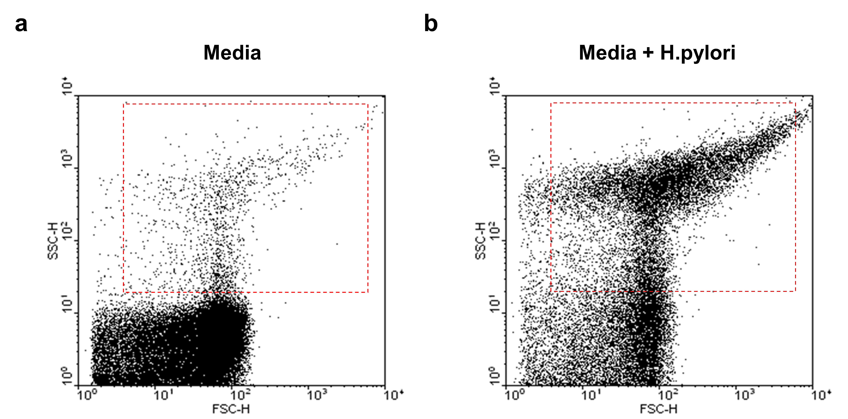
Fig. S1 Populations of H.pylori were analyzed with a flow cytometer. When the chocolate media was filled with over 90 %, Helicobacter pylori was swabbed with sterilized swabs and suspended in RPMI-1640 media 20 ml to form Helicobacter pylori suspension. The population in a red gate were assayed as Helicobacter pylori. a Media, b Media + H. pylori

