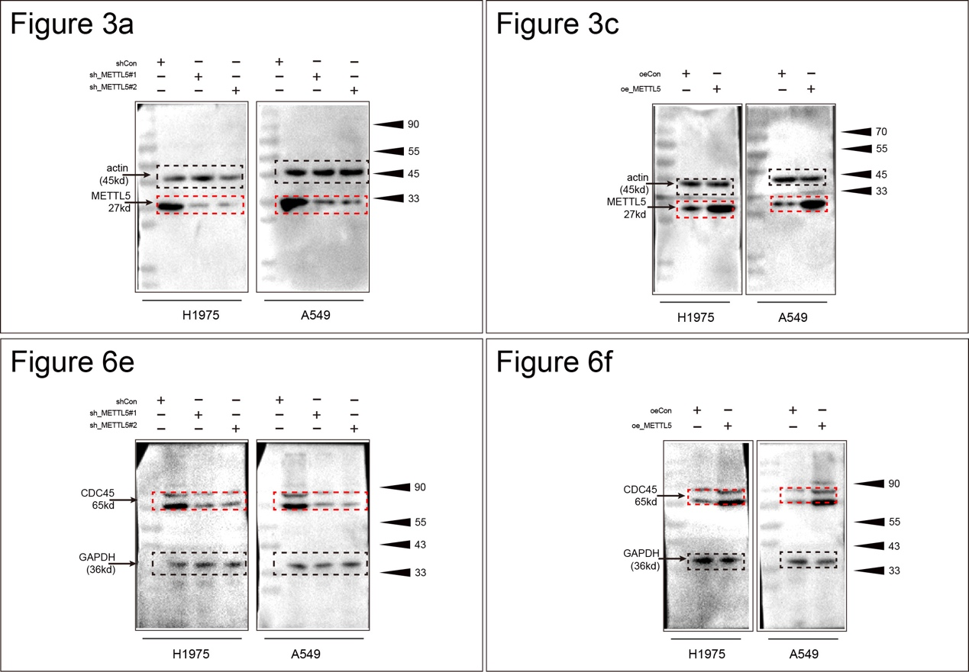
Supplementary Figure S1. Uncropped blots.
Uncropped images of all blots shown in main and supplementary figures. Molecular weight markers are indicated on the left side of each blot, whereas predicted molecular weight of the protein of interest indicated by an arrow on the right.

