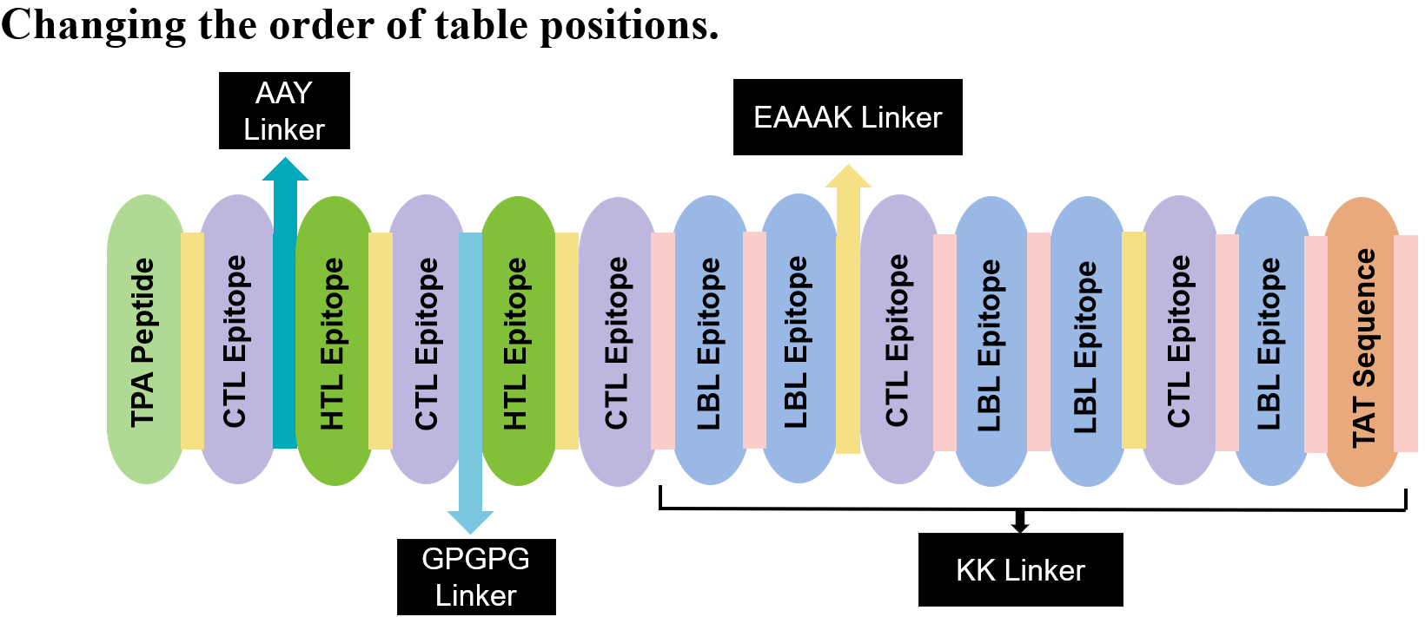
Physiochemical Properties | Measurement | Indication
Total Number of Amino Acids | 257 | Appropriate
Molecular Weight | 28045.04 | Appropriate
Theoretical pI | 8.57 | Basic
Total Number of Negatively Charged Residues (Asp + Glu) | 34 | -
Total Number of Positively Charged Residues (Arg + Lys) | 38 | -
Aliphatic Index (AI) | 74.63 | Thermostable
Grand Average of Hydropathicity (GRAVY) | –0.404 | Hydrophilic
Instability index (II) | 36.72 | Stable
Antigenicity (using Vaxijen) | 0.6327 | Antigenic
Solubility upon overexpression | 0.642 | Soluble
Allergenicity | Non-allergen | Non-Allergenic
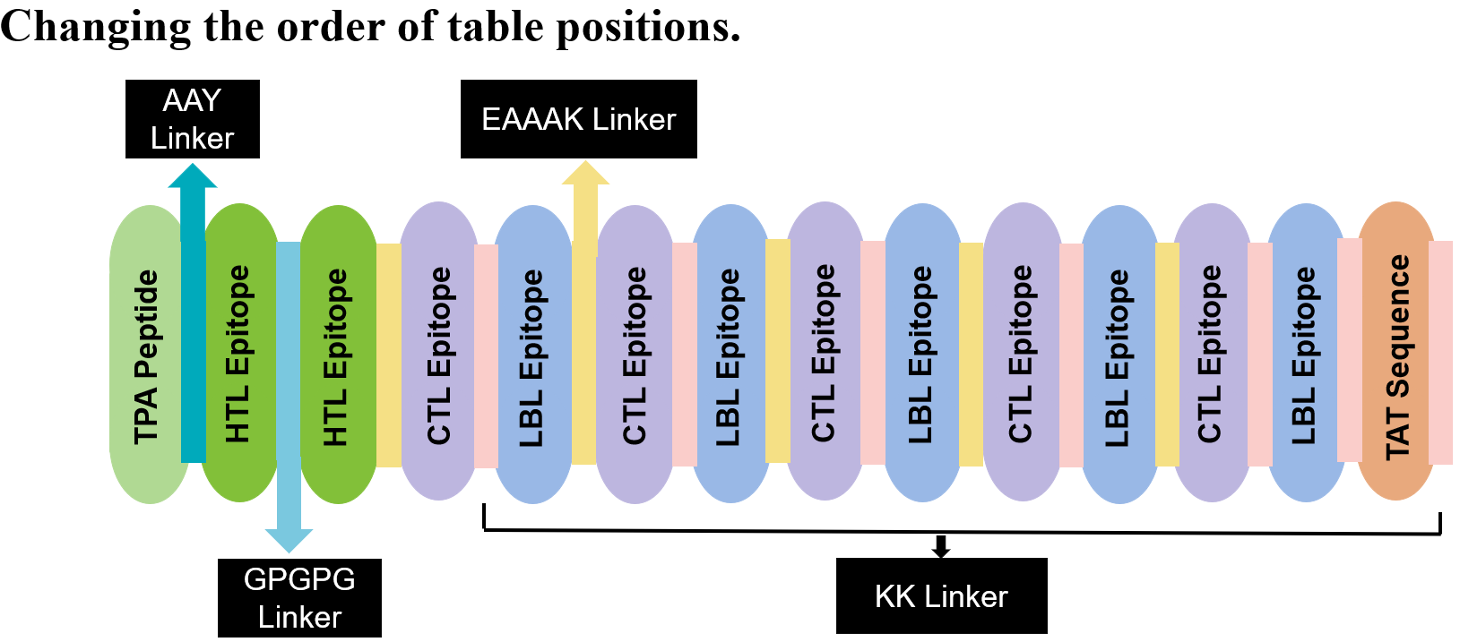
Physiochemical Properties | Measurement | Indication
Total Number of Amino Acids | 257 | Appropriate
Molecular Weight | 28045.04 | Appropriate
Theoretical pI | 8.57 | Basic
Total Number of Negatively Charged Residues (Asp + Glu) | 34 | -
Total Number of Positively Charged Residues (Arg + Lys) | 38 | -
Aliphatic Index (AI) | 74.63 | Thermostable
Grand Average of Hydropathicity (GRAVY) | –0.404 | Hydrophilic
Instability index (II) | 35.57 | Stable
Antigenicity (using Vaxijen) | 0.6288 | Antigenic
Solubility upon overexpression | 0.642 | Soluble
Allergenicity | Non-allergen | Non-Allergenic
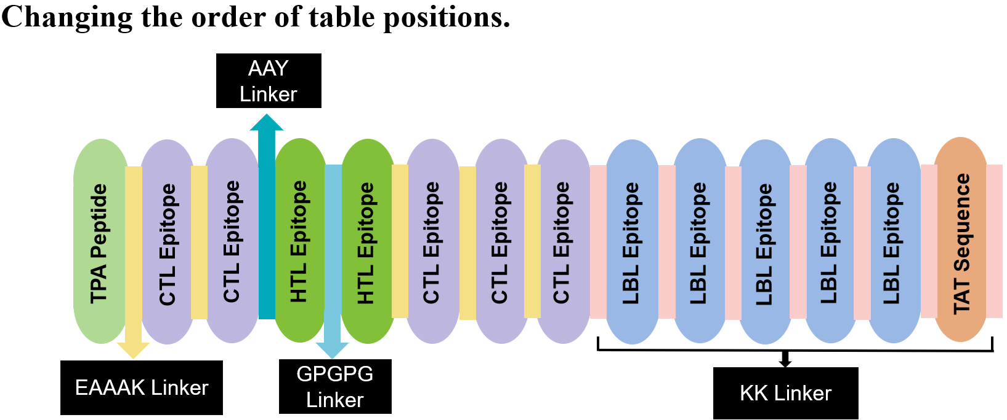
Physiochemical Properties | Measurement | Indication
Total Number of Amino Acids | 257 | Appropriate
Molecular Weight | 28045.04 | Appropriate
Theoretical pI | 8.57 | Basic
Total Number of Negatively Charged Residues (Asp + Glu) | 34 | -
Total Number of Positively Charged Residues (Arg + Lys) | 38 | -
Aliphatic Index (AI) | 74.63 | Thermostable
Grand Average of Hydropathicity (GRAVY) | –0.404 | Hydrophilic
Instability index (II) | 34.72 | Stable
Antigenicity (using Vaxijen) | 0.5968 | Antigenic
Solubility upon overexpression | 0.642 | Soluble
Allergenicity | Non-allergen | Non-Allergenic
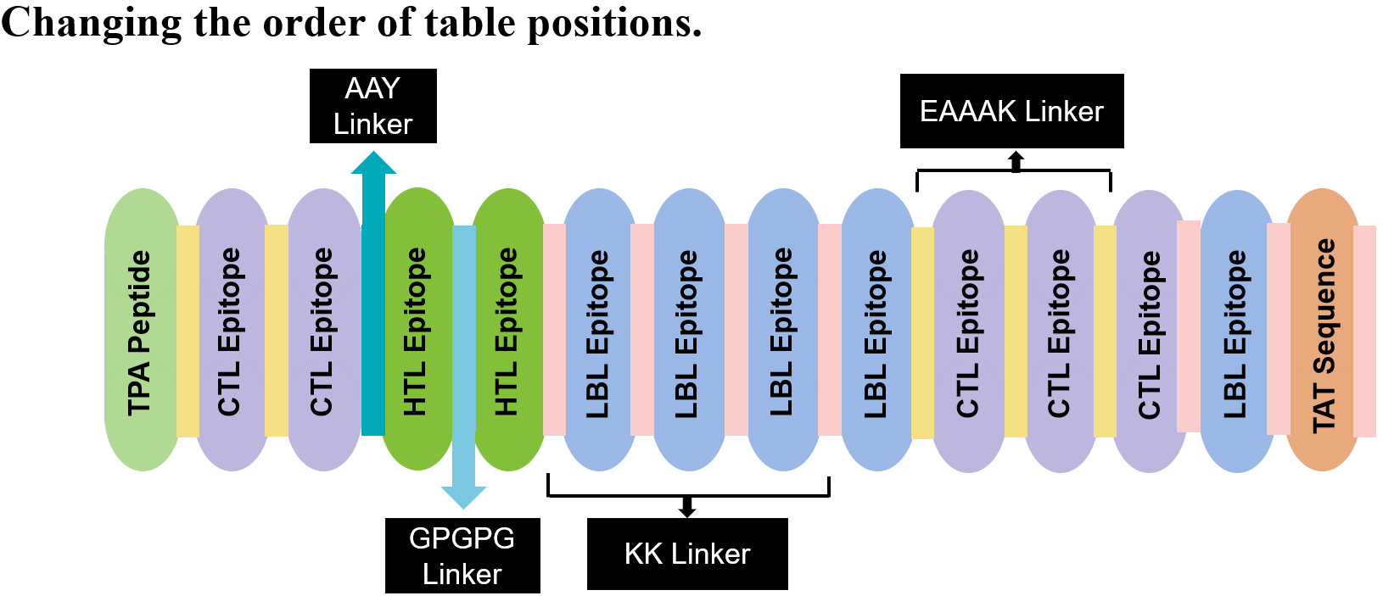
Physiochemical Properties | Measurement | Indication
Total Number of Amino Acids | 256 | Appropriate
Molecular Weight | 28072.04 | Appropriate
Theoretical pI | 9.03 | Basic
Total Number of Negatively Charged Residues (Asp + Glu) | 33 | -
Total Number of Positively Charged Residues (Arg + Lys) | 41 | -
Aliphatic Index (AI) | 71.52 | Thermostable
Grand Average of Hydropathicity (GRAVY) | –0.494 | Hydrophilic
Instability index (II) | 41.02 | Stable
Antigenicity (using Vaxijen) | 0.6234 | Antigenic
Solubility upon overexpression | 0.696 | Soluble
Allergenicity | Non-allergen | Non-Allergenic
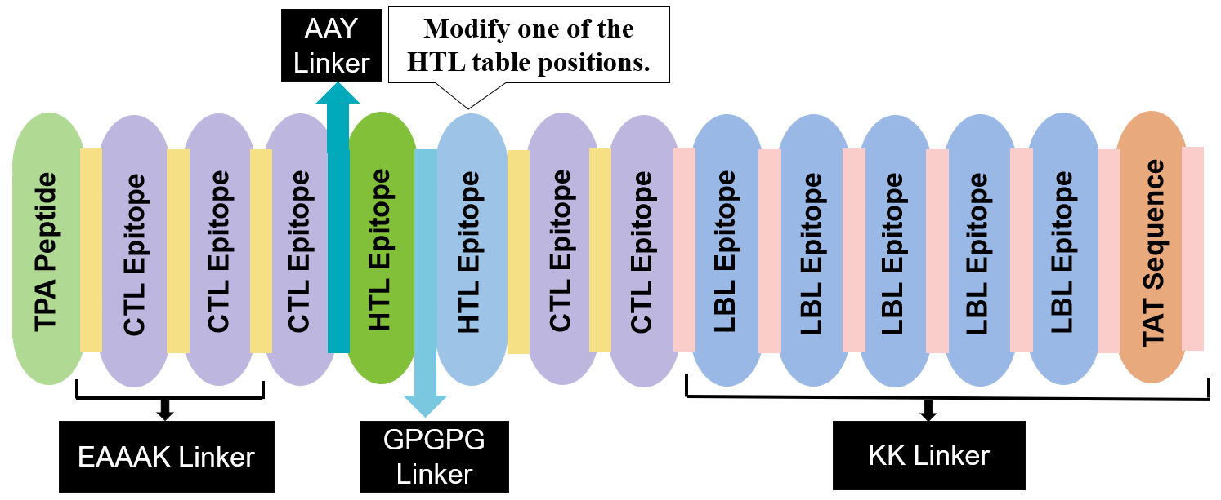
Physiochemical Properties | Measurement | Indication
Total Number of Amino Acids | 255 | Appropriate
Molecular Weight | 27957.93 | Appropriate
Theoretical pI | 9.03 | Basic
Total Number of Negatively Charged Residues (Asp + Glu) | 33 | -
Total Number of Positively Charged Residues (Arg + Lys) | 41 | -
Aliphatic Index (AI) | 71.80 | Thermostable
Grand Average of Hydropathicity (GRAVY) | –0.482 | Hydrophilic
Instability index (II) | 37.58 | Stable
Antigenicity (using Vaxijen) | 0.5973 | Antigenic
Solubility upon overexpression | 0.698 | Soluble
Allergenicity | Non-allergen | Non-Allergenic

