Model score before optimization

PROCHECK

180 B

Ramachandran Plot

saves
~b
THR 184 (A) b
CYS 9 (A)

135 b

LEU 248 (A)
~b

ARLGCYYS6AS(2LLA51A65) 2((2A51)5) (A)
ALAALLA2A520255(3A4()A(A))
LEU 8 (A)

90

45
a
Psi (degrees)

0 A

-45
AASSPP~L1l2Y79(SA(1A9CM)2YE(SAT1)40 ((A) ALA 135 (A)
LEU 13 (lA)

GLU 24 (A)

L

~a
ASP 172 (A)

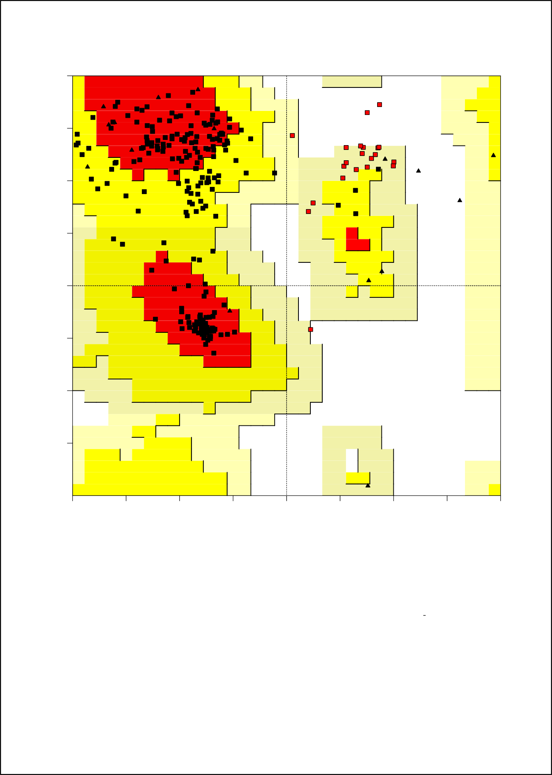

-90

-135 ~b ~p
p
b
~b

-180 | -135 | -90 | -45 | 0 | 45 | 90 | 135 | 180
 |  |  |  | Phi (degrees)
 |  |  |  | Plot statistics
Residues in most favoured regions [A,B,L] |  |  |  |  |  | 151 | 67.1%
Residues in additional allowed regions [a,b,l,p] |  |  |  |  |  | 53 | 23.6%
Residues in generously allowed regions [~a,~b,~l,~p] |  |  |  |  |  | 18 | 8.0%
Residues in disallowed regions |  |  |  |  |  | 3 | 1.3%
Number of non-glycine and non-proline residues |  |  |  |  |  | 225 | 100.0%
Number of end-residues (excl. Gly and Pro) |  |  |  |  |  | 2
Number of glycine residues (shown as triangles) |  |  |  |  |  | 17
Number of proline residues |  |  |  |  |  | 13
Total number of residues |  |  |  |  |  | 257

Based on an analysis of 118 structures of resolution of at least 2.0 Angstroms and R-factor no greater than 20%, a good quality model would be expected to have over 90% in the most favoured regions.

Optimized model score

PROCHECK

180 B
135 b

Ramachandran Plot

saves
THR 184 (A) ~b
b

~b

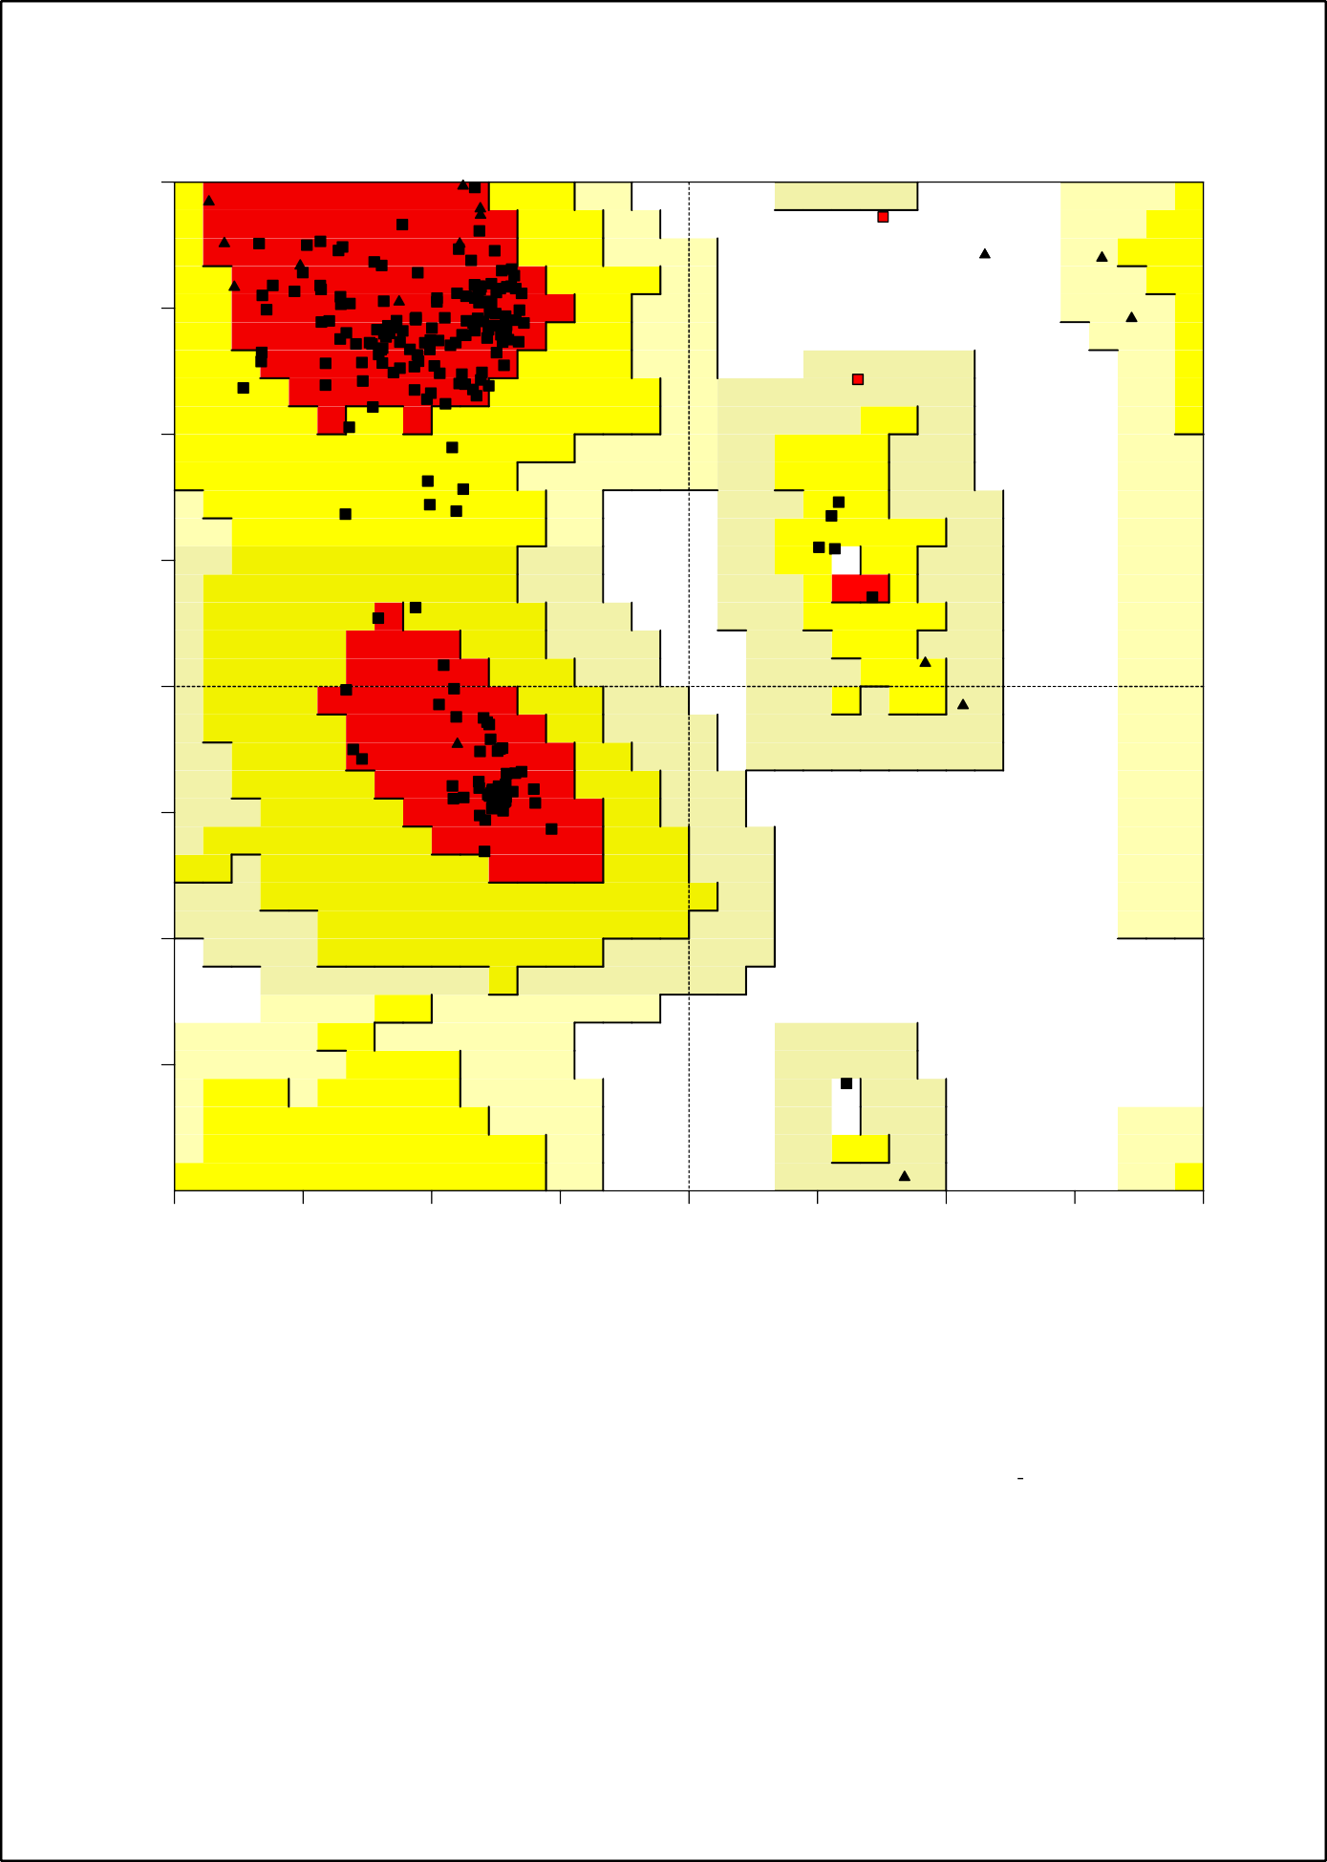
LYS 192 (A)
~l
90
l

45 L
a
Psi (degrees)

0 A
~a

-45

-90

-135 ~b ~p
p
b
~b

-180 | -135 | -90 | -45 | 0 | 45 | 90 | 135 | 180
 |  |  |  | Phi (degrees)
 |  |  |  | Plot statistics
Residues in most favoured regions [A,B,L] |  |  |  |  |  | 210 | 93.3%
Residues in additional allowed regions [a,b,l,p] |  |  |  |  |  | 13 | 5.8%
Residues in generously allowed regions [~a,~b,~l,~p] |  |  |  |  |  | 1 | 0.4%
Residues in disallowed regions |  |  |  |  |  | 1 | 0.4%
Number of non-glycine and non-proline residues |  |  |  |  |  | 225 | 100.0%
Number of end-residues (excl. Gly and Pro) |  |  |  |  |  | 2
Number of glycine residues (shown as triangles) |  |  |  |  |  | 17
Number of proline residues |  |  |  |  |  | 13
Total number of residues |  |  |  |  |  | 257

Based on an analysis of 118 structures of resolution of at least 2.0 Angstroms and R-factor no greater than 20%, a good quality model would be expected to have over 90% in the most favoured regions.

