C-IMMSIM simulation results

February 2, 2024

Abstract
This document includes the plots relative to the simulation and the outcome of the epitope/peptide prediction used.

Produced by the C-IMMSIM Online server available at http://kraken.iac.rm.cnr.it/C-IMMSIM

CITATIONS: For publication of results, please cite:

Nicolas Rapin, Ole Lund, Massimo Bernaschi, Filippo Castiglione. Computational Immunology Meets Bioinfor- matics: The Use of Prediction Tools for Molecular Binding in the Simulation of the Immune System. PLoS ONE 5(4): e9862. doi:10.1371/journal.pone.0009862, 2010.

Original C-IMMSIM model: www.iac.cnr.it/∼filippo/c-immsim

GETTING HELP: Scientific problems: Filippo Castiglione (f dot castiglione at iac dot cnr dot it) Technical problems: Ilaria Gonnella (ilaria dot gonnella at cnr dot it)

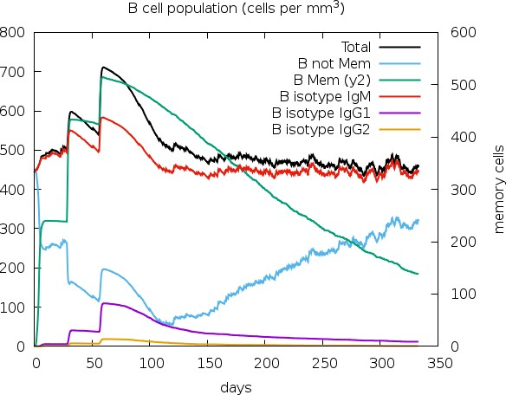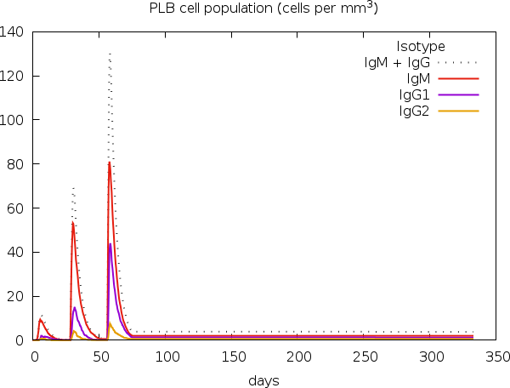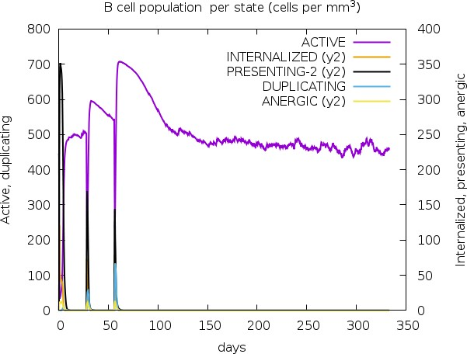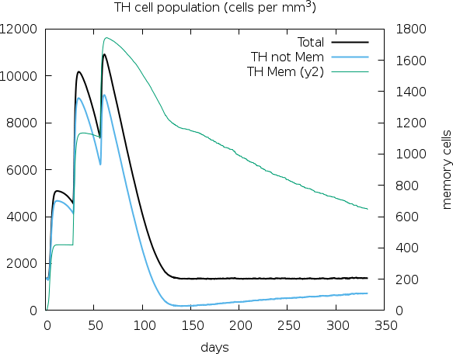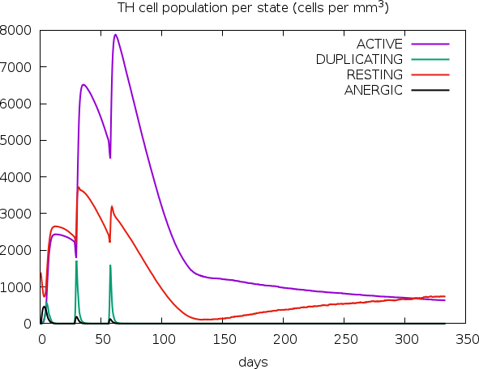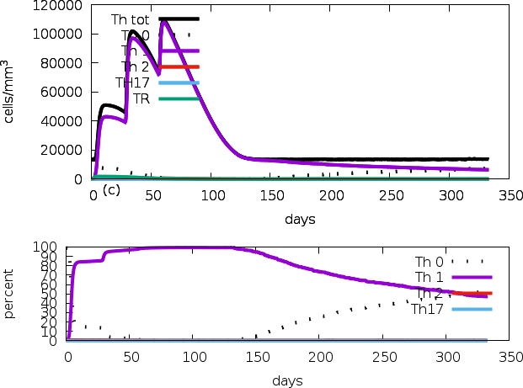
E
F
D
C
B
A

Figure 1: Cell counts shown. Legend: Act=active, Intern=internalized the Ag, Pres II = presenting on MHC II, Dup = in the mitotic cycle, Anergic = anergic, Resting = not active.

G
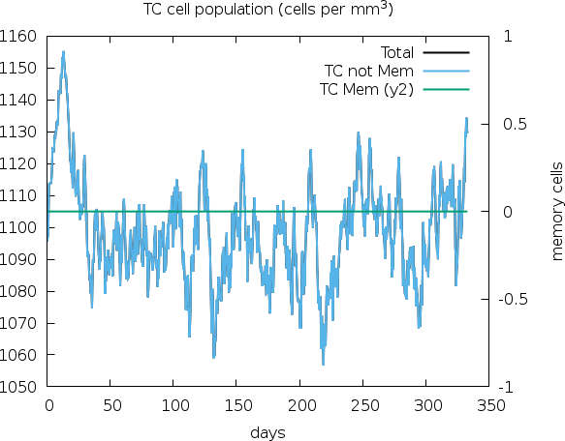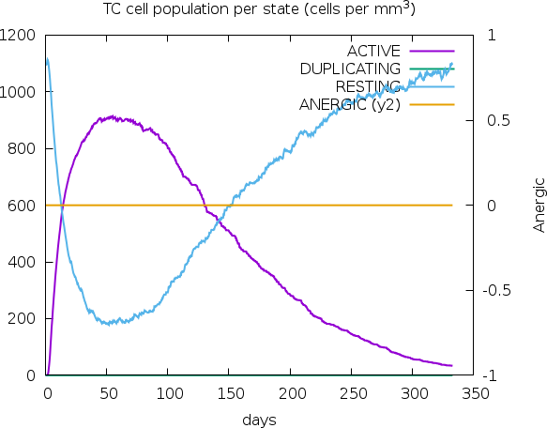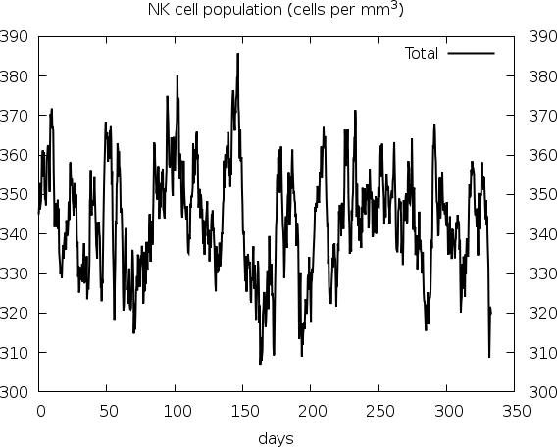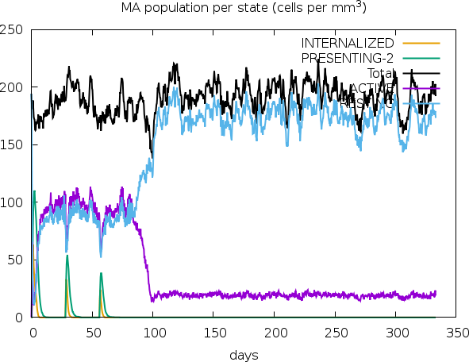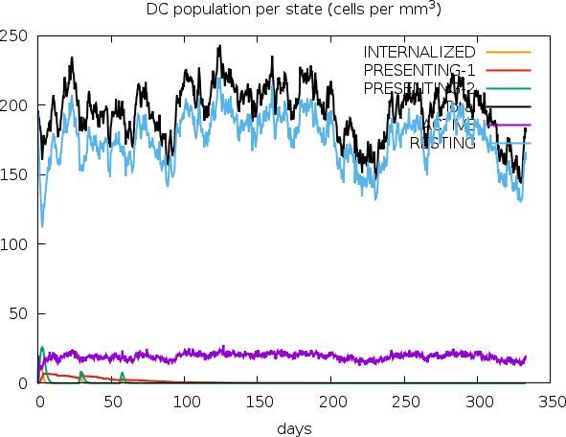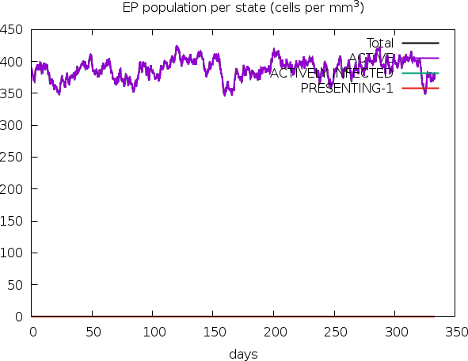
L
K
J
I
H

Figure 2: Legend: symbols as figure above.

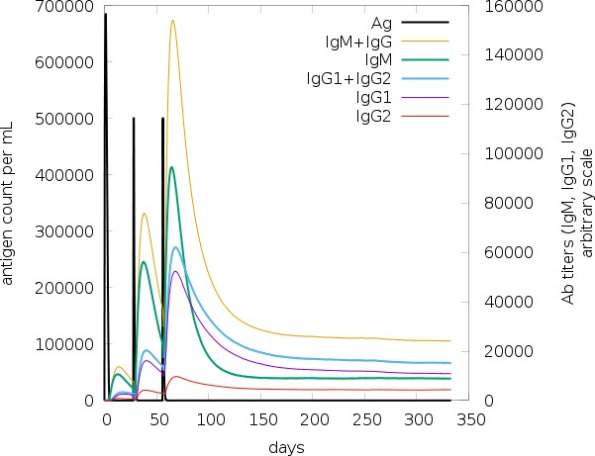
M

Figure 3: The virus, the immunoglobulins and the immunocomplexes.

N
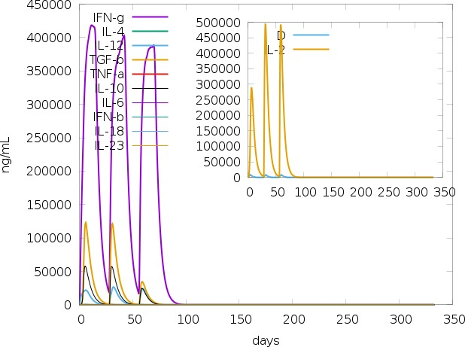

Figure 4: Concentration of cytokines and interleukins. Inset plot shows danger signal together with leukocyte growth factor IL-2.

Parker_B_scale_epitope_find
Use Parker’s propensity scale, takes an antigen block as input, and creates a list of residues that are possible epitopes.

Antigen sequence file: /opt/lampp/htdocs/C-IMMSIM/Jobs/input/19102_20240202-014240_5_bejhrFLbkkI2.FSA_1_001

MDAMKRGLCCVLLLCGAVFVSPSEAAAKEPEQACPEYEAAAKRFQQVEHYYEAAAKRTPHFTVAWAAYKFKAHIYYKNVI VTTGPGPGFVVAFRPLISNELAQLEAAAKALSTGDIVYEAAAKLADTGLLDYKKAFTPGPSEAPDGEYGDLDARKKNCIV EEVEARSVYPYDSFALKKDWAPKTRRVCSLAKWREAEEKKTFEHNGTGVIEGQLGDDNELKKSALEQQEHKARKKNSGPA LLKKTGALLAAGAAAKK

00000000000000000000000111111111100000000000000000000010000000000000000000000000
00001000000000000000000000000000000000000000000000000000000111111111100110100000
00010000000000000000000000000000000011011000010000000111011100000101111111111000
00000000000000000
Epitopes of protein 0 ------------
- pos=23 len=10 EAAAKEPEQA
- pos=139 len=10 PSEAPDGEYG
- pos=227 len=10 QEHKARKKNS

DoPeptideList_I:
Given the antigen injected creates the list of peptides for all the NumAgProts proteins and for all i.e., 4 MHCI molecules

Read class I peptide list from file? NO

=========================================================================

Allele: A0101
Pseudo sequence: KAVHAEQRNKAQTRA Threshold: 9.456400
Max score: 29.236000

Antigen sequence file: /opt/lampp/htdocs/C-IMMSIM/Jobs/input/19102_20240202-014240_5_bejhrFLbkkI2.FSA_1_001

MDAMKRGLCCVLLLCGAVFVSPSEAAAKEPEQACPEYEAAAKRFQQVEHYYEAAAKRTPHFTVAWAAYKFKAHIYYKNVI VTTGPGPGFVVAFRPLISNELAQLEAAAKALSTGDIVYEAAAKLADTGLLDYKKAFTPGPSEAPDGEYGDLDARKKNCIV EEVEARSVYPYDSFALKKDWAPKTRRVCSLAKWREAEEKKTFEHNGTGVIEGQLGDDNELKKSALEQQEHKARKKNSGPA LLKKTGALLAAGAAAKK

Epitopes of protein 0 ------------
- pos= 123 score=0.074372 unnormalised=8.5706000000 LADTGLLDY
- pos= 139 score=0.015868 unnormalised=1.8286000000 PSEAPDGEY
- pos= -1 score=0.909761 unnormalised=104.8410000000 non-binding event

=========================================================================

Allele: A0101
Pseudo sequence: KAVHAEQRNKAQTRA Threshold: 9.456400
Max score: 29.236000

Antigen sequence file: /opt/lampp/htdocs/C-IMMSIM/Jobs/input/19102_20240202-014240_5_bejhrFLbkkI2.FSA_1_001

MDAMKRGLCCVLLLCGAVFVSPSEAAAKEPEQACPEYEAAAKRFQQVEHYYEAAAKRTPHFTVAWAAYKFKAHIYYKNVI VTTGPGPGFVVAFRPLISNELAQLEAAAKALSTGDIVYEAAAKLADTGLLDYKKAFTPGPSEAPDGEYGDLDARKKNCIV EEVEARSVYPYDSFALKKDWAPKTRRVCSLAKWREAEEKKTFEHNGTGVIEGQLGDDNELKKSALEQQEHKARKKNSGPA LLKKTGALLAAGAAAKK

Epitopes of protein 0 ------------
- pos= 123 score=0.074372 unnormalised=8.5706000000 LADTGLLDY
- pos= 139 score=0.015868 unnormalised=1.8286000000 PSEAPDGEY
- pos= -1 score=0.909761 unnormalised=104.8410000000 non-binding event

=========================================================================

Allele: B0702
Pseudo sequence: KAAREEQQIKAQTRE Threshold: 8.702800
Max score: 28.406000

Antigen sequence file: /opt/lampp/htdocs/C-IMMSIM/Jobs/input/19102_20240202-014240_5_bejhrFLbkkI2.FSA_1_001

MDAMKRGLCCVLLLCGAVFVSPSEAAAKEPEQACPEYEAAAKRFQQVEHYYEAAAKRTPHFTVAWAAYKFKAHIYYKNVI VTTGPGPGFVVAFRPLISNELAQLEAAAKALSTGDIVYEAAAKLADTGLLDYKKAFTPGPSEAPDGEYGDLDARKKNCIV EEVEARSVYPYDSFALKKDWAPKTRRVCSLAKWREAEEKKTFEHNGTGVIEGQLGDDNELKKSALEQQEHKARKKNSGPA LLKKTGALLAAGAAAKK

Epitopes of protein 0 ------------
0] pos= -1 score=1.000000 unnormalised=104.8410000000 non-binding event

=========================================================================

Allele: B0702
Pseudo sequence: KAAREEQQIKAQTRE Threshold: 8.702800
Max score: 28.406000

Antigen sequence file: /opt/lampp/htdocs/C-IMMSIM/Jobs/input/19102_20240202-014240_5_bejhrFLbkkI2.FSA_1_001

MDAMKRGLCCVLLLCGAVFVSPSEAAAKEPEQACPEYEAAAKRFQQVEHYYEAAAKRTPHFTVAWAAYKFKAHIYYKNVI VTTGPGPGFVVAFRPLISNELAQLEAAAKALSTGDIVYEAAAKLADTGLLDYKKAFTPGPSEAPDGEYGDLDARKKNCIV EEVEARSVYPYDSFALKKDWAPKTRRVCSLAKWREAEEKKTFEHNGTGVIEGQLGDDNELKKSALEQQEHKARKKNSGPA LLKKTGALLAAGAAAKK

Epitopes of protein 0 ------------
0] pos= -1 score=1.000000 unnormalised=104.8410000000 non-binding event

DoPeptideList_II:
Given the antigen injected creates the list of peptides for all the NumAgProts proteins and for all i.e., 2 MHCII molecules

Read class II peptide list from file? NO

=========================================================================

Allele: DRB1_0101
Pseudo sequence: KAFAHVEQRKAQTRV Threshold: 2.392440
Max score: 26.461000

Antigen sequence file: /opt/lampp/htdocs/C-IMMSIM/Jobs/input/19102_20240202-014240_5_bejhrFLbkkI2.FSA_1_001

MDAMKRGLCCVLLLCGAVFVSPSEAAAKEPEQACPEYEAAAKRFQQVEHYYEAAAKRTPHFTVAWAAYKFKAHIYYKNVI VTTGPGPGFVVAFRPLISNELAQLEAAAKALSTGDIVYEAAAKLADTGLLDYKKAFTPGPSEAPDGEYGDLDARKKNCIV EEVEARSVYPYDSFALKKDWAPKTRRVCSLAKWREAEEKKTFEHNGTGVIEGQLGDDNELKKSALEQQEHKARKKNSGPA LLKKTGALLAAGAAAKK

Epitopes of protein 0 ------------
0] | pos= | 11 | score=0.015373 | unnormalised=1.6725600000 | LLLCGAVFV
1] | pos= | 17 | score=0.015437 | unnormalised=1.6795600000 | VFVSPSEAA
2] | pos= | 18 | score=0.022698 | unnormalised=2.4695600000 | FVSPSEAAA
3] | pos= | 49 | score=0.067385 | unnormalised=7.3315600000 | YYEAAAKRT
4] | pos= | 89 | score=0.011953 | unnormalised=1.3005600000 | VVAFRPLIS
5] | pos= | 92 | score=0.090123 | unnormalised=9.8055600000 | FRPLISNEL
6] | pos= | 100 | score=0.033883 | unnormalised=3.6865600000 | LAQLEAAAK
7] | pos= | 115 | score=0.052624 | unnormalised=5.7255600000 | IVYEAAAKL
8] | pos= | 116 | score=0.009702 | unnormalised=1.0555600000 | VYEAAAKLA
9] | pos= | 135 | score=0.009380 | unnormalised=1.0205600000 | FTPGPSEAP
- pos= 201 score=0.006503 unnormalised=0.7075600000 FEHNGTGVI
- pos= 240 score=0.002285 unnormalised=0.2485600000 LLKKTGALL
- pos= 241 score=0.043322 unnormalised=4.7135600000 LKKTGALLA
- pos= 247 score=0.011181 unnormalised=1.2165600000 LLAAGAAAK
- pos= -1 score=0.608151 unnormalised=66.1680000000 non-binding event

=========================================================================

Allele: DRB1_0101
Pseudo sequence: KAFAHVEQRKAQTRV Threshold: 2.392440
Max score: 26.461000

Antigen sequence file: /opt/lampp/htdocs/C-IMMSIM/Jobs/input/19102_20240202-014240_5_bejhrFLbkkI2.FSA_1_001

MDAMKRGLCCVLLLCGAVFVSPSEAAAKEPEQACPEYEAAAKRFQQVEHYYEAAAKRTPHFTVAWAAYKFKAHIYYKNVI VTTGPGPGFVVAFRPLISNELAQLEAAAKALSTGDIVYEAAAKLADTGLLDYKKAFTPGPSEAPDGEYGDLDARKKNCIV EEVEARSVYPYDSFALKKDWAPKTRRVCSLAKWREAEEKKTFEHNGTGVIEGQLGDDNELKKSALEQQEHKARKKNSGPA LLKKTGALLAAGAAAKK

Epitopes of protein 0 ------------
0] | pos= | 11 | score=0.015373 | unnormalised=1.6725600000 | LLLCGAVFV
1] | pos= | 17 | score=0.015437 | unnormalised=1.6795600000 | VFVSPSEAA
2] | pos= | 18 | score=0.022698 | unnormalised=2.4695600000 | FVSPSEAAA
3] | pos= | 49 | score=0.067385 | unnormalised=7.3315600000 | YYEAAAKRT
4] | pos= | 89 | score=0.011953 | unnormalised=1.3005600000 | VVAFRPLIS
5] | pos= | 92 | score=0.090123 | unnormalised=9.8055600000 | FRPLISNEL
6] | pos= | 100 | score=0.033883 | unnormalised=3.6865600000 | LAQLEAAAK
7] | pos= | 115 | score=0.052624 | unnormalised=5.7255600000 | IVYEAAAKL
8] | pos= | 116 | score=0.009702 | unnormalised=1.0555600000 | VYEAAAKLA
9] | pos= | 135 | score=0.009380 | unnormalised=1.0205600000 | FTPGPSEAP
- pos= 201 score=0.006503 unnormalised=0.7075600000 FEHNGTGVI

- pos= 240 score=0.002285 unnormalised=0.2485600000 LLKKTGALL
- pos= 241 score=0.043322 unnormalised=4.7135600000 LKKTGALLA
- pos= 247 score=0.011181 unnormalised=1.2165600000 LLAAGAAAK
- pos= -1 score=0.608151 unnormalised=66.1680000000 non-binding event

