Supplementary Files

Explaining the adaptation gap in European cities

Table of Contents
Supplementary Results I: Additional descriptive statistics and explanations on plan quality principles 1
1. Fact base: impacts, risks, vulnerabilities 1
2. Stated goals 3
3. Measures, policies, actions 6
4. Implementation tools and processes 9
5. Monitoring & evaluation 10
6. Participation 12
Supplementary Results II: Additional detailed results on consistency 1 to 5 14
Consistency 1: Identified hazards and adaptation goals: 14
Consistency 2: Risks for sectors and related adaptation measures/ actions 15
Consistency 3: Risks for vulnerable groups and related adaptation measures/ actions 16
Consistency 4: Measures/ actions for vulnerable groups and related monitoring and evaluation (M&E) 17
Consistency 5: Risks for vulnerable groups and participation 18

Supplementary Results I: Additional descriptive statistics and explanations on plan quality principles

1. Fact base: impacts, risks, vulnerabilities
In our sample of 167 cities with adaptation plans, 67% of the cities (#112) included a discussion on global or national impacts or risks (Q1 in Table 1 in Methods) in their plans. When we interrogated whether the plan considers specific past, present/recent or future impacts and/or risks on their region (Q2 in Table 1 in Methods), we found that 87% (#146) of cities had done so. Indeed, the largest share of cities, i.e., 38% (#63), had discussed all three aspects, i.e. past, present/recent and future projections of impacts and/or risks, while 34% (#56) had considered two, and 16% (#27) had considered one temporal aspect of impacts. The remaining 13% (#21) did not consider any specific climate change impacts/ risks to the jurisdiction.
Concerning the identification of locally specific climate change impacts/ risks related to hazards (Q3 in Table 1 in Methods), the majority of plans discussed changes in temperature/ heat/ heatwaves (84%; #140), followed by precipitation (83%; #138), inland flooding (#99), drought and water scarcity (53% #89), and storms and wind variation (49%; #81).
Most cities investigated the impacts of multiple hazards on their jurisdiction with an average score of 3 hazards being covered by 39% of the cities and 4 investigated hazards being achieved by 38% of the cities. Five cities are good practice examples (Ajaccio/ France, Waterford/ Ireland, Graz/ Austria, Zagreb/ Croatia and Marseille/ France) analyzing potential changes of all the hazards/impacts coded for, i.e. temperature variation, precipitation variation, storms and wind variation, inland flooding, coastal flooding/ sea level rise/ storm surge, drought and water scarcity, and landslides.

We were also interested in how extensive plans focused on particular social groups potentially affected by climate change (Q4 in Table 1 in Methods). The analysis reveals that 66% (#111) of cities do look at the impacts on vulnerable social groups in some respect; 34% did not. Among those who did, 19% (#31) of cities addressed vulnerable groups, which is the maximum of social groups addressed. Three groups were addressed by 10% of cities (#16), and two forms of vulnerable groups were addressed by 13% (#21). About 17% addressed only 1 vulnerable social group; the second largest category. The best performance was achieved by three German cities (Nuremberg, Berlin and Essen) and one Polish city (Bratislava). The best performer is the city of Nuremberg with the highest score (7 vulnerable groups covered), followed by Berlin, Essen and Bratislava (with 6 groups). Looking at the type of socially vulnerable groups, the elderly are particularly well covered (46% of cities, #76), followed by infants/ kids/ young people (34%; #57) and sick people and those in hospitals/ care institutions (32%; #54). Particularly infrequent covered groups are ethnic communities (#1), lone parents (#3), migrants (#4), and women/ females (#7).
For Q5 of Principle Factbase in Table 1 in Methods we have verified whether plans identify certain economic sectors particularly impacted by climate change and about 80% (#133) of cities do so. With that, adaptation plans of European cities address more often which economic sector is impacted by climate change than which socially vulnerable group, on average. Berlin (Germany) and Vitoria-Gasteiz (Spain) are examples that do this very extensively, investigating the impacts on 12 economic sectors, which is the highest score. However, most plans (13%; #22) address 5 economic sectors or just one (12%; #20). The building sector (#88; 53%), the water sector (#87; 52%), and the transport sector (#84, 50% of cities) are the most frequently highlighted economic sectors. Financial (#12, 7%) and social institutions (#28, 17%) are covered least often.

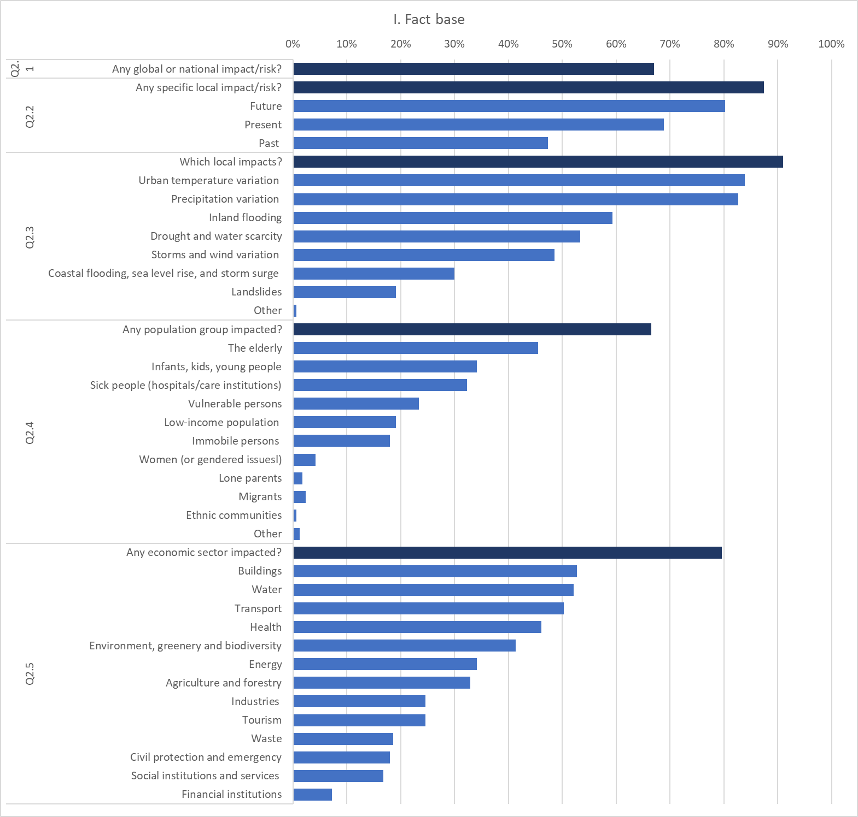

2. Stated goals
Concerning the identification of concrete adaptation goals (Q1 under the principle of Adaptation goals in Table 1 in Methods), we find that two cities (Ajaccio, France, and Waterford, Ireland) achieved the maximum score and set adaptation goals for all listed climate change impacts/risks (temperature variation (i.e. heatwaves), precipitation variation (i.e. heavy rain events), storms and wind variation, Inland flooding, coastal flooding, sea level rise, and storm surge (e.g. hurricanes), inland flooding, drought and water scarcity, and landslides). Most goals are set with respect to inland flooding (#86,52%), followed by precipitation and temperature variation (both #79, 47%).

When checking for at least one quantitative adaptation goal (for any hazard, social group or economic sector) (Q2), 18% of cities (#13; Burgas/ Bulgaria, Copenhagen/ Denmark, Lyon/ France, Marseille/ France, Bochum/ Germany, Székesfehérvár/ Hungary, Budapest/ Hungary, Dublin/ Ireland, Bologna/ Italy, Rotterdam/ Netherlands, Barcelona/ Spain, London/ UK, Cambridge/ UK) were positively identified. Eight of these cities set a single quantitative adaptation target: for example, Copenhagen focused on securing a 1000 year storm surge in 2100, Marseille on reducing water consumption by 20-30%, Bochum on reducing rainwater in the drainage system by 15% until 2020, Dublin on flood protection to ensure that defenses provide a 1 in 200-year standard of protection, Rotterdam to become 100% climate-proof by 2025, London to work with the transport company, boroughs, water companies and other landowners to move from 200 hectares of land draining directly into conventional drains or London's waterways to draining into SuDS by 2030, Cambridge wants to increase tree cover to 19% by 2030.
On the other hand, the other five cities (Lyon, Székesfehérvár, Budapest, Bologna and Barcelona) introduced multiple quantitative adaptation targets. These targets include, inter alia, increasing green roofs and shaded street area, reducing leakage and consumption of water mains, increasing the proportion and renovation of urban green spaces, renovating the drainage system, revitalising blue spaces, planting new trees, building new dams, managing droughts and water scarcity, preventing heat waves, extreme rainfall events and hydrogeological risk, and promoting awareness-raising campaigns.

City | Country | 3.1 Specific adaptation goals: Does the plan identify at least one concrete adaptation goal to a particular CC impact/ risk and, if yes, to which impact/ risk? Please note, this is about goals, not measures.
Burgas | Bulgaria | yes
Copenhagen | Denmark | Storm surge: "securing a 1000 year storm surge in year 2100" (page 14 in the storm surge plan - based on a cost analysis).  Cloud burst: "Once every 10 years, run-up sewage must reach ground level,  and once every 100 years, the average water level can exceed 10 cm above terrain, with the exception of places specifically designated for surface water storage" (page 12 in the cloud burst plan).
Lyon | France | 85% drinking water network efficiency by 2020; -50% clean water use for street cleaning; from 12% to 20% of shaded road surface by 2030; 3 green roofs by 2020;
Marseille | France | 20-30% less water consumption;
Bochum | Germany | -15% rainwater in the drainage system until 2020 (mit der Zukunftsvereinbarung Regenwasser hat sich Bochum, zusammen mit anderen Städten im Einzugsgebiet der Emscher, das Ziel gesetzt, bis zum Jahr 2020 15 Prozent weniger Regenwasser in die Kanalisation einzuleiten)
Székesfehérvár | Hungary | Renewal of urban green spaces (1.601.157 m2); refurbishment of drainage system (9141 m)
Budapest | Hungary | Increase the ratio of green spaces (+5%); revitalisation of blue spaces (27 pcs); planting new trees (10.000 pcs); building new dams (50 km); awareness raising campaign (reach at least 100.000 people)
Dublin | Ireland | Yes, e.g. Dodder flood protection ensure that a 1-in-200-year  standard of protection is provided by defences
Bologna | Italy | Drought and water scarcity: Withdrawals from groundwater <45 Million m3 / year; Flow in Reno upstream of the Casalecchio sluice > 1.87 m3/s; Network losses <18%; Domestic water consumption <130 l / inhab / day; Consumption of drinking water for other uses <5 Mil m3 / year.  Heatwaves: +5000 trees; + 5 hectares urban gardens; greening interventions on 10 public buildings; greening in 4 public spaces in the center; Prevention of heat waves.  Extreme rain events and hydrogeological risk:  increase of waterproofed land <200 hectares; Waterproof surface with drainage systems> 11.5 ha; Pollutant load due to overflow <50%; Increase infrastructure resilience; Adapt cultural heritage maintenance.
Rotterdam | Netherlands | 100% climate-proof before 2025, though there are no more quantitative targets that further explain this
Barcelona | Spain | reduce consumption of domestic drinking water to 110l/hab/day; increase the use of groundwater by 2,7 hm3; 100% population access to green areas less than 5 minutes walking
London | United Kingdom | "The Mayor will work with TfL, boroughs, water companies and other landowners to, by 2030, switch 200 hectares of land from draining directly to conventional sewers or London’s watercourses to draining to SuDS."
Cambridge | United Kingdom | raise tree cover to 19% by the 2030s

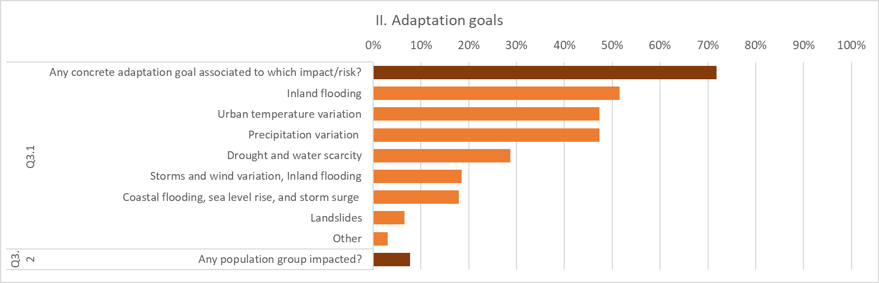

3. Measures, policies, actions
Cities adopt a range of measures, policies, actions from different sectors to adapt to climate change (Q1-Q12 under the principle Adaptation Measure in table 1 in Methods). Of the 167 municipalities with a plan, the majority are introducing initiatives in the areas of environment, greenery, and biodiversity (147 cities, 88%), water (#141, 84%), and the building sector (#129, 77%). A little less attention is placed on health and social care (#106, 63%), the transport sector (#93, 56%), civil protection (#92, 55%) and social or educational institutions (#87, 52%). At the same time, cities do not invest extensively in the agriculture and forestry sector (#57, 34%), the energy (#48, 29%) or waste sector (#45, 27%). Even fewer cities are taking action to help local industry (#41) or tourism (#39). Indeed, it is notable that a number of tourist hotspots (London, Prague, Bologna, Berlin and Athens) do not include specific measures related to this sector.
Within the largest categories, popular areas of activity include increasing or improving green spaces such as tree cover, parks, green roofs (which 132 cities aim to do), and increasing or improving flood plains (74) and watersheds, lakes, streams (72) (in environment and greenery). In the water sector, improvements to the drainage infrastructure (#115), and investing in less water consumption, e.g. via water metering and recycling (#73), are popular. In the building sector, many cities concentrate on changing or enforcing building codes (#72) or increasing/ improving insulation (#53). In the health sector, cities plan actions on clean air, shelter security and other determinants of health (#77) and also to assist institutions such as hospitals or care homes (66) or schools and kindergartens (66) in building early warning systems. In the transport sector, most actions are planned in public transport and transit-oriented development (#69), next to bicycle-oriented development (#55) and pedestrian-oriented development (#35).
Overall, many cities plan actions and measures in multiple sectors, with most of them covering between six to nine of the twelve sectors (#21, #18, #16, #26 cities, respectively). A total of four cities (Barcelona, Maribor, Limerick, Sofia) plan actions in 11 of our 12 sector-scheme, and three cities address all of the sectors (Potsdam, Murcia, Galway). This means these cities have extremely broad and comprehensive strategies that are probably mainstreaming climate change across various urban affairs.
Although cities from most countries are active across various sectors, there are some notable differences between countries. For example, all of the Irish cities included detailed information about measures in nearly every category, and the majority of German, Polish and Spanish cities also perform well across the board. By way of contrast, most cities in Sweden, the Netherlands, Hungary, Belgium and the UK are planning far fewer concrete initiatives. In some cases these differences may be explained by the national contexts: for example, in countries where public transport and utilities are largely in private hands, such as the UK, we would expect the municipal government to be able to exert less influence over how these functions adapt to climate threats. Similarly, some of our 28 countries allocate responsibility for different policy sectors (such as emergency management, flood protection and health or social care) to regional governments rather than municipalities. Therefore some of our cities may feel that they cannot propose measures in these areas. The high performance of cities in Ireland may also partly be due to the clear guidance and structure for adaptation planning provided by the Irish government.
We also looked at whether measures, policies, and actions particularly address certain vulnerable groups, which is the case in 74 cities. Of those 74 cities that explicitly state so, older people (#49), children (#35) and generally vulnerable people (#32) were mentioned most often.

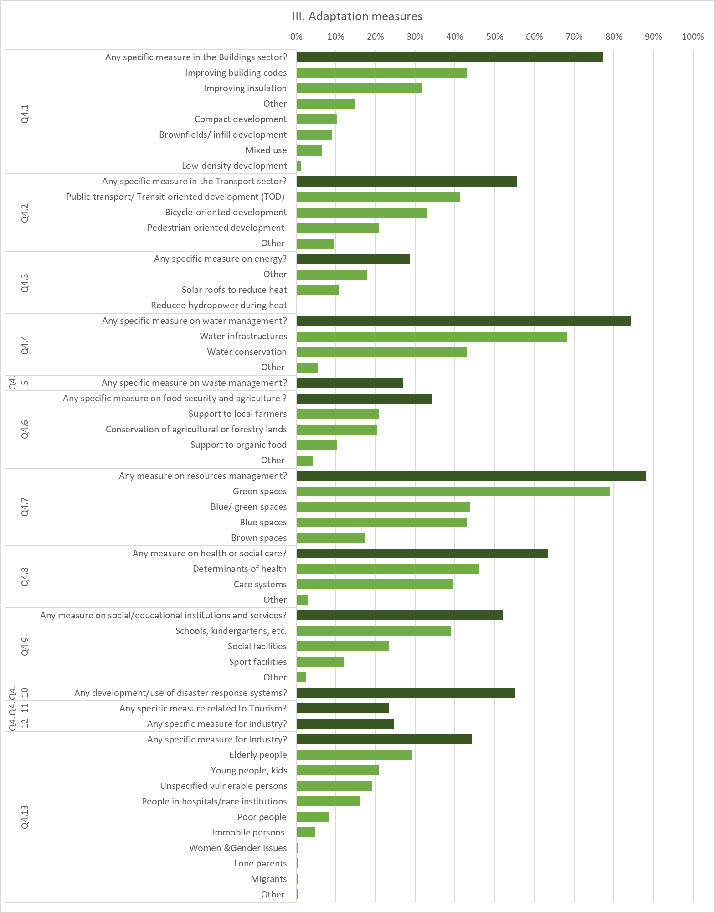

4. Implementation tools and processes
Regarding the implementation phase, four aspects were analyzed: (1) the prioritization of actions/ measures, (2) the responsible parties, (3) a timeline and (4) a budget for implementation. Regarding 1), our data show that about 1/3 (33%, #55 of 167 cities) indicated that they follow a prioritization during the implementation phase, but 60% did not give a reason for that (#33 out of #55). However, 18% indicated that they prioritized actions according to the largest effectiveness (#10 of 55), and according to largest synergies/ conflicts (#10) between actions, respectively. Looking at particular cities, we find that Sofia and Bratislava considerably looked at prioritization, mentioning eight and seven prioritization aspects, respectively, distinguishing a wide range of techniques from analyzing win-win options to testing the effectiveness of impact/vulnerability reduction; however, it is worth noting that both economic feasibility and best/ good practices were not used as prioritization strategies of the top performing cities.
Regarding responsible parties for implementation, two-thirds of the pool of cities (66%; 110 of 167 cities) identified a responsible party in connection with a specific adaptation measure. Almost the same number, i.e. 62% of cities (#104 city strategies) also contained a detailed timeline for the implementation of adaptation options. It is worth noting that positively rated cities do not always overlap: for example, we identified 16 plans (10%) that do not name responsible parties for implementation but provide a timeline for actions. And vice versa, 21 cities (13%) reported certain responsible parties without a timetable for implementation. Finally, about 60% (#99) of cities paid attention to clarifying a budget for implementation, while 68 cities (40%) lacked these specifics.
Summarizing this category, we find that 19 cities (Sofia, Tallinn, Murcia, Barcelona, Nicosia, Aarhus, Copenhagen, Coventry, Potsdam, Galway, Schwerin, Rostock, Athens, Debrecen, Nyíregyháza, Cork, Dublin, Kraków, and Maribor) provided information on all implementation topics investigated, i.e. on prioritization, responsible parties, timelines, and budgets. This represents just over 11% of the total number of municipalities. Still, 71 cities specify three aspects of implementation, 38 cities specify two, and 24 cities specify one. 30 strategies did not focus on the implementation phase and did not mention any of these details regarding implementation.

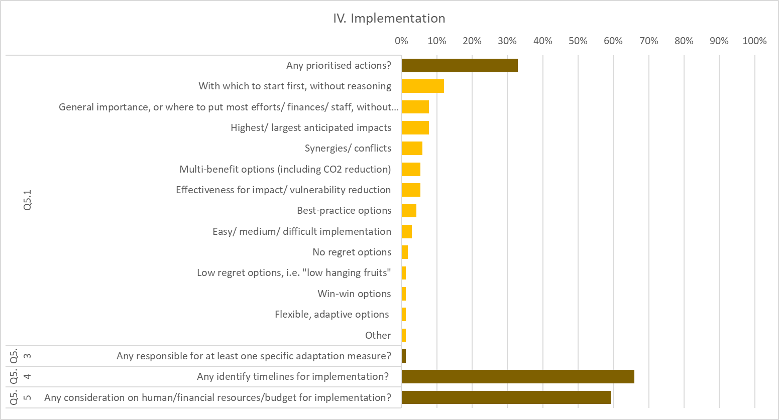

5. Monitoring & evaluation
To investigate the planned M&E activities of cities, we gathered information related to five aspects: (1) the form of M&E coverage, (2) responsible parties, (3) objectives and indicators, (4) the timeline and (5) the consideration or inclusion of vulnerable population groups during the M&E activities.
Our data shows that 62% of the cities with a plan (#103 out of 167) include a section or a separate plan that describes the envisaged M&E activities and 55% of cities with plans (#92 out of 167) name responsible bodies. In 54% of all cases the municipalities themselves are involved, either solely the departments that had developed the plan (#31, 19% of the cases) or different departments within the same municipality (#22, 13%), or both (#37; 22%). Apart from municipalities, external consultancies or companies are mentioned as responsible parties (#22, 13%), as are NGOs (#9, 5%), others (#9, 5% 9, 5%), universities, research centres or scientific communities (#5, 3%). Looking at shared responsibilities, we find that 7% of cases share the responsibility for M&E (#12) between municipalities and other institutions, while in 8% of the cases (#13) the responsibility is solely given to external institutions. One city shares the responsibility between all bodies that we coded for, which is the city of Nice. Another six cities also share the responsibility very broadly among 4 institutions, which are Gent, Lyon, Nantes, Saint Denis (La Réunion), Potsdam, and Valencia.

What has received less focus is the identification of objectives and indicators subject to be monitored or evaluated. We understand objectives as goals including generally positive trends subject to monitoring and evaluation (e.g. increasing green space). Indicators (indicators and metrics as referred to in the broader literature), on the other hand, are composed of specific, quantifiable variables with more or less a degree of detail (e.g. hectares of green space, number of trees). Around 31% of the plans (#52) listed objectives and 46% of the plans (#77) contained indicators to be monitored and evaluated. About 27% of cities with plans (#45) include both objectives and indicators.
Generally, M&E plans have timelines to follow monitoring exercises and report on outcomes to different stakeholders, either local, regional, national or international, if municipalities belong to international city networks. Our data shows that 59% of the plans (99 out of 167) publish their expected timelines providing transparency to the process. Finally, our data shows little focus on equity and justice issues on M&E. We assessed whether specific vulnerable populations were mentioned across plans as being especially considered in M&E activities. We looked at women and gender aspects, kids or young people, the elderly, low-income groups, illness-affected groups, groups with low mobility, lone parents, ethnic communities, migrants or "vulnerable persons" (with no further specification) or others. Only 12 cities out of 167 (7%) mentioned any of these groups. These are Tallinn, Ajaccio, Munich, Cork, Galway, Sibiu, Bratislava, Madrid, Barcelona, Exeter, Derry and Nottingham. Half of these, just referred to vulnerable groups, in general. Low-income groups (3), the sick (2) and the elderly (2) were other groups mentioned. Women and other gender issues, lone parents, ethnic communities or migrants were not considered in any of the plans to monitor and evaluate the impact of adaptation interventions.

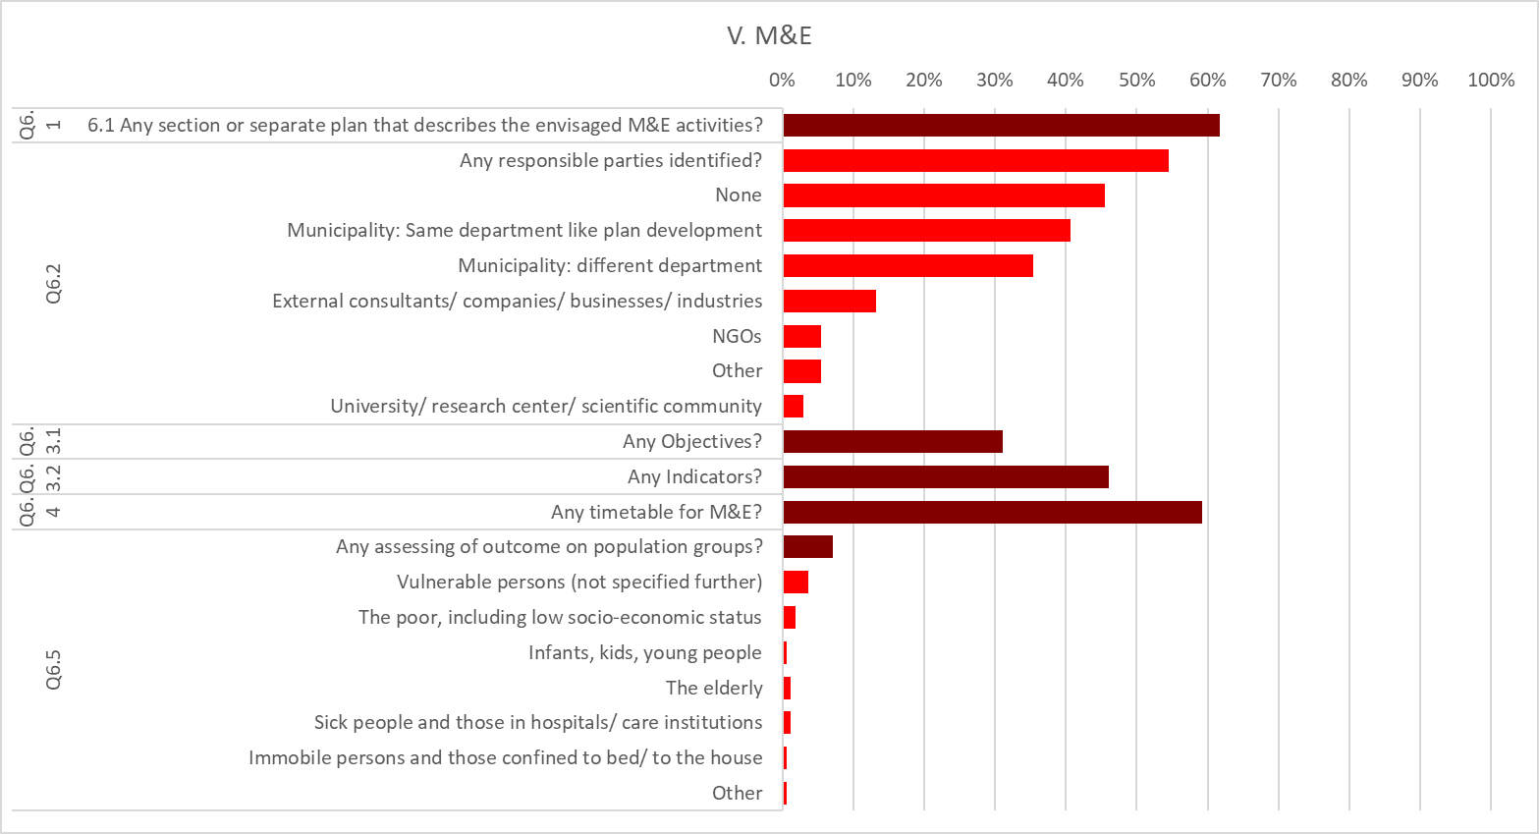

6. Participation
In the principle of participation, we looked at two aspects, namely 1) whether the plan identifies the organizations and stakeholders involved in the plan-making process and, if yes, which ones; and 2) whether there is mentioning of particular population groups being involved/ heard during the plan making process, if any.
Our data shows that 80% (#134) of the 167 cities with adaptation plans include some form of participation and report on it in their plans. Most of them i.e. 68% (#113) involve different departments of the same municipality, external consultants (#75; 45%), the public (#63, 38%) or universities and research institutions (#58; 35%). The least involved groups are NGOs (#46; 28%) and community or neighborhood groups (#35; 21%). A small share of cities, i.e., 13% involve just one group in participation; a good share of 61% of cities let more groups participate–most cities between 2-4 groups (#74; 44%). All in all, 10 cities (6%) involved all groups that we coded for. These cities (Dijon, Cork, Galway, Limerick, Waterford, Dublin, Tilburg, Timisoara, Zaragoza, Murcia) are spread across Europe, with 5 of the cities being in Ireland, one French, one Dutch, one Romanian, and two Spanish cities. Seven of the 10 cities operated under an adaptation plan of a higher government level that might have functioned as a guideline for local adaptation planning. These plans are spread across the years 2010-2019 (with an average of 2016.8), meaning that plans with extensive participation of civil society exist for a long time, but there is a tendency for newer plans to involve a larger number of different actor groups.

Regarding the involvement of particular socially vulnerable groups, our data paints a dire picture. Out of 10 vulnerable groups assessed (women or gender issues; infants, kids, young people; the elderly; the poor, including low socio-economic status; sick people and those in hospitals/ care institutions; immobile persons and those confined to bed/ to the house; lone parents; ethnic communities/ minorities; migrants; "vulnerable persons" not specified further), only one city reported on involving two groups (1% of plans), no city more than two, nine cities involved one group (5% of all plans), and 158 cities did not involve any vulnerable group (95% of plans). The city that documented considering two vulnerable groups in its adaptation plan is Nancy; the cities with documentation of considering one vulnerable group are Sofia ("vulnerable persons"), Galway ("vulnerable persons"), Bologna ("vulnerable persons"), Glasgow (migrants), Manchester (infants, kids, young people), Bordeaux (infants, kids, young people), Potsdam (the elderly), and Kingston upon Hull (sick people and those in hospitals/ care institutions).

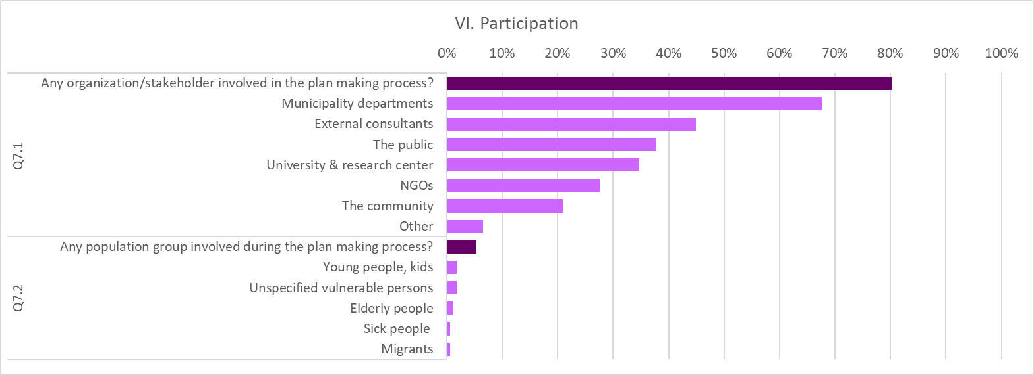

Supplementary Results II: Additional detailed results on consistency 1 to 5

Consistency 1: Identified hazards and adaptation goals:
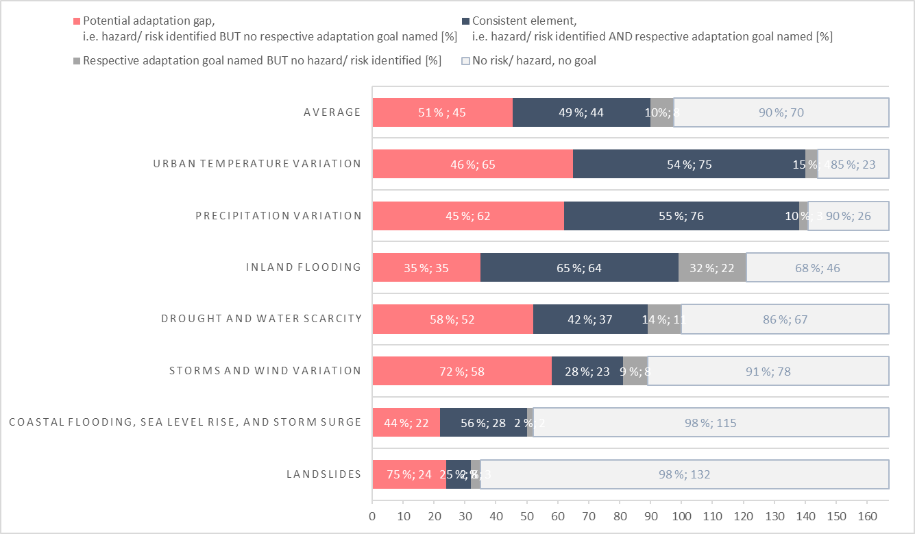
Of the 167 cities with adaptation plans, most cities (#140; 84%) consider variations in temperature and precipitation (#138; 83%). Less often, cities consider risks of inland flooding (#99; 59%), drought (#89; 53%), storms (#81; 49%), coastal flooding (#50, 30%) and landslides (#32;19%). On average 42% of cities with hazard/ risk information unearth a potential adaptation gap, i.e. identify risks/ hazards without a related adaptation goal. Substantial variation across hazards exists. The most substantial adaptation gap likely exists for landslides (75% of plans with risk information) and wind/ storm changes (72% of plans with risk information), which are identified as a risk but not adequately followed up with an adaptation goal. The smallest potential gap is expected regarding inland flooding, as 65% of the plans are consistent. It is remarkable that about 32% of plans state an adaptation goal related to inland flooding without flooding being identified as a risk—the largest such inconsistency among C1.

Consistency 2: Risks for sectors and related adaptation measures/ actions
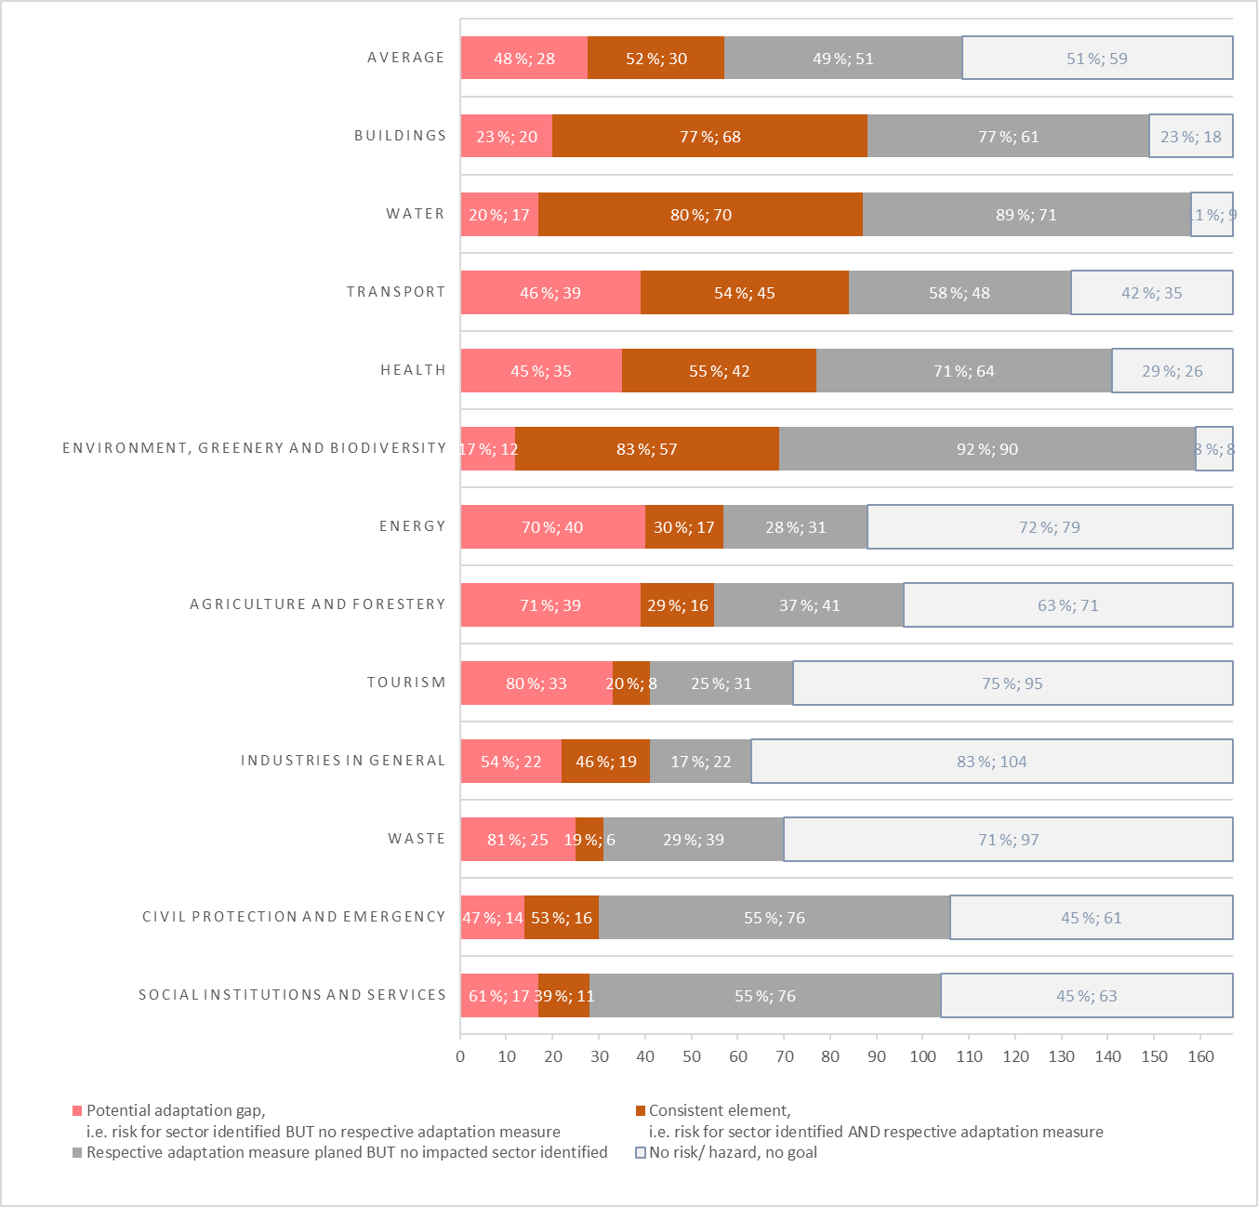
In our sample, about half of the cities identify risks for the building (88 cities; 53% of sample), water (87 cities; 52%), and transport (84 cities; 50%) sectors. Lesser risks in the health (77 cities; 46%) and environment (69 cities; 41%) sectors, with the lowest risk for social institutions and services (28 cities; 17%). The largest consistency score was found for the environment domain, i.e. 83% of plans that identify a risk for the building sector follow up with related actions. Likewise, the water (80% of plans with risks) and building (77% of plans with risks) sectors unearth high levels of consistency. The largest potential adaptation gap has to be expected for the waste (81% of plans with risks) and tourism (80% of plans with risk) sectors, while the environmental domain (17% of plans with risks) shows the lowest potential gap. On average, about half of European cities’ adaptation plans (48% of plans with identified sectoral risks) entail a potential adaptation gap. Remarkable is the large number of sectoral actions that are chosen without an identified sectoral risk, in particular in the environment (92% of plans without risks) and water sectors (89% of plans without risks). Actions in these sectors are praised for their synergies, co-benefits, and as no-regret options, which might explain their choice.

Consistency 3: Risks for vulnerable groups and related adaptation measures/ actions
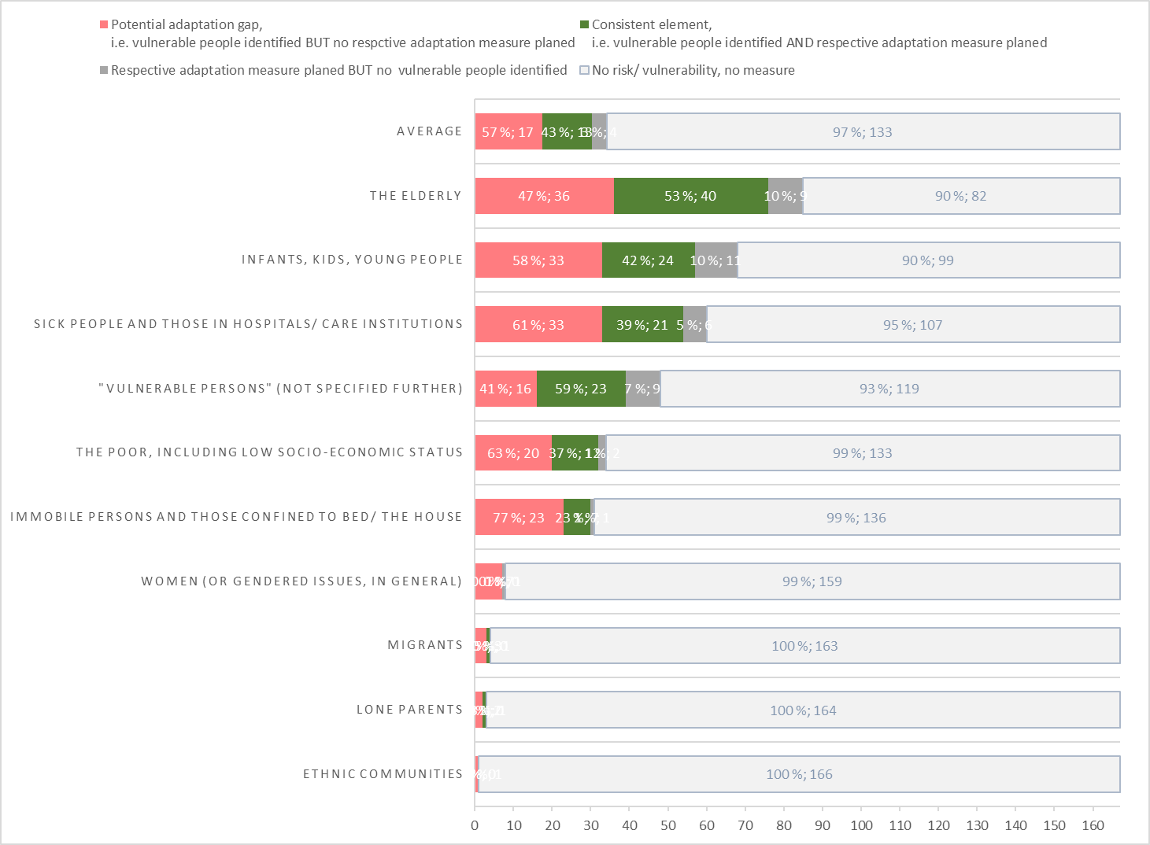
If risks for vulnerable groups are identified this is mostly the case for elderly people (#76; 46%) and children (#57; 34%) and medically challenged people (#54; 32%). Least plans consider risks for migrants, lone parents, or ethnic communities (#4, #3, #1, all below 1%, respectively).
Among those cities that consider risks for vulnerable groups, consistency is largest for plans that generally plan for “vulnerable groups” (59% of plans consistent). The largest adaptation gap could relate to risks of women and ethnic minorities (100% of plans with risks do not follow-up with measures).
On average, cities signify an adaptation gap of 57%.
Moreover, few cities plan actions for vulnerable groups without identifying risks for them (generally below 10% of cities).

Consistency 4: Measures/ actions for vulnerable groups and related monitoring and evaluation (M&E)

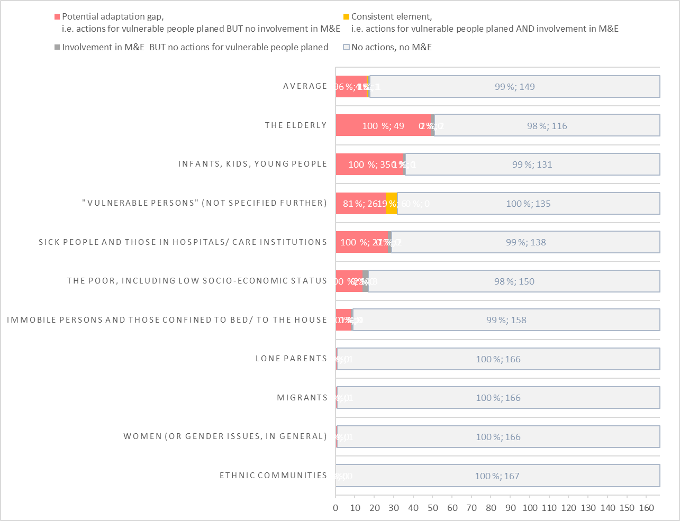
Few cities plan dedicated actions for vulnerable groups, and nearly no city is following up on it by including vulnerable groups in M&E. Most actions are planned for the elderly (#49 cities, 30%), but no city involves them in M&E. The only vulnerable group for which a few consistent plans have been found is for “vulnerable people in general” (#6; 19% of consistent plans). All other groups are not the focus of actions or not involved in M&E. Very few cities without actions for vulnerable groups (#3, 2%) involve vulnerable groups in M&E anyhow.
On average, this translates into an adaptation gap of 96% (#16); only 4% of plans are consistent as regards C5 (#1 out of 17 plans).

Consistency 5: Risks for vulnerable groups and participation

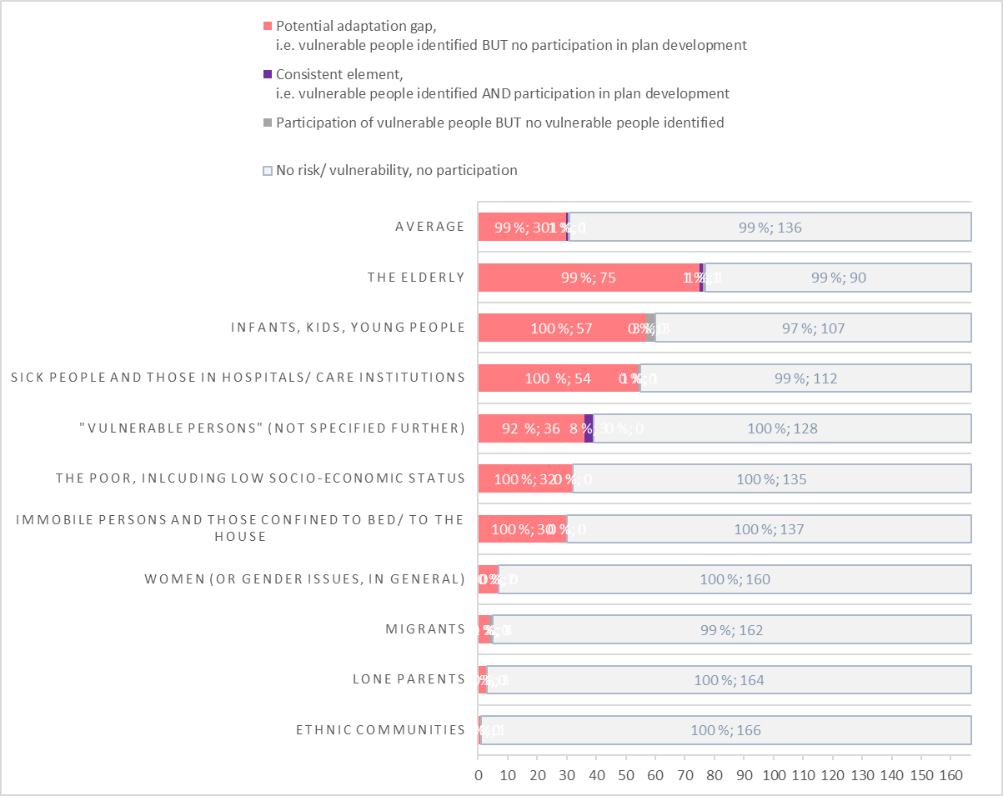
Less than 50% of cities consider risks for vulnerable groups (#76 cities; 46%), and if so, mostly for the elderly (#76; 46%), children (#57; 34%), and health-challenged population (#54; 32%). The adaptation gap is 100% for nearly all plans with risks identified, as only for vulnerable people in general some consistent plans (#3; 8%) were found.

