Crape myrtle bark scale Eriococcus lagerstroemiae (Coccidae: Eriococcidae) infestation seasonally alters the abundance and composition of insect assemblages on crape myrtle trees

Elijah P. Carroll¹, David W. Held ¹*, Nash E. Turley², Selina Bruckner¹

¹Department of Entomology and Plant Pathology, Auburn University, 301 Funchess Hall, Auburn, Alabama 36849 USA
²Department of Entomology, Pennsylvania State University, 501 Agricultural Sciences and Industries Building, State College, PA 16803

Supplementary Table 1. Temperature data from Mesonet. Data is shown for each collection date and each sampling time. Daily minimums, maximums, and averages are also presented.
Sampling date | Year | Air temperature (°F) at each sampling time |  |  |  | Daily max (°F) | Daily min (°F) | Average (°F)
Sampling date | Year | Daybreak | 9 AM | 12 PM | 3 PM | Daily max (°F) | Daily min (°F) | Average (°F)
29-June | 2020 | 73.3 | 76.9 | 86.1 | 91.2 | 91.4 | 70.4 | 79.4
30-June | 2020 | 75.3 | 84.1 | 89.3 | 77 | 90.6 | 72.8 | 78.6
25-July | 2020 | 75.2 | 82.3 | 88.1 | 91.3 | 91.7 | 71.6 | 79.6
26-July | 2020 | 72.8 | 81 | 86.3 | 89.1 | 90.3 | 71.4 | 77.6
22-August | 2020 | 69.2 | 78.3 | 83.1 | 85 | 85.4 | 68.5 | 77.31
23-August | 2020 | 72.2 | 80.6 | 85.4 | 86 | 87 | 72 | 77.47
19-September | 2020 | 69.5 | 70.3 | 71.4 | 71.2 | 71.9 | 65.1 | 69.2
20-September | 2020 | 59.6 | 64.8 | 70.9 | 73.1 | 74.4 | 59.3 | 66.1
24-October | 2020 | 69.5 | 71.8 | 71.2 | n/a | 73 | 67.4 | 69.4
25-October | 2020 | 67.2 | 69.5 | 74.3 | 75.2 | 75.9 | 66.7 | 70.5
27-March | 2021 | 68.6 | 72.4 | 80.2 | 83.3 | 84.5 | 65.5 | 74
28-March | 2021 | 66.9 | 74.6 | 67.9 | 65.3 | 75.9 | 55.3 | 66
29-April | 2021 | 66.6 | 69.2 | 78.2 | 77.1 | 78.2 | 65.2 | 70.6
29-May | 2021 | 68.2 | 73.2 | 76.7 | 77.7 | 78.2 | 60.1 | 70.7
Supplementary data

Supplementary table 2. Precipitation means for each sampling month collected from Alabama Mesonet.
Month | Year | Mean monthly precipitation (mm/m²)
June | 2020 | 2.47
July | 2020 | 6.37
August | 2020 | 5.48
September | 2020 | 5.43
October | 2020 | 3.99
March | 2021 | 6.26
April | 2021 | 3.09
May | 2021 | 1.09
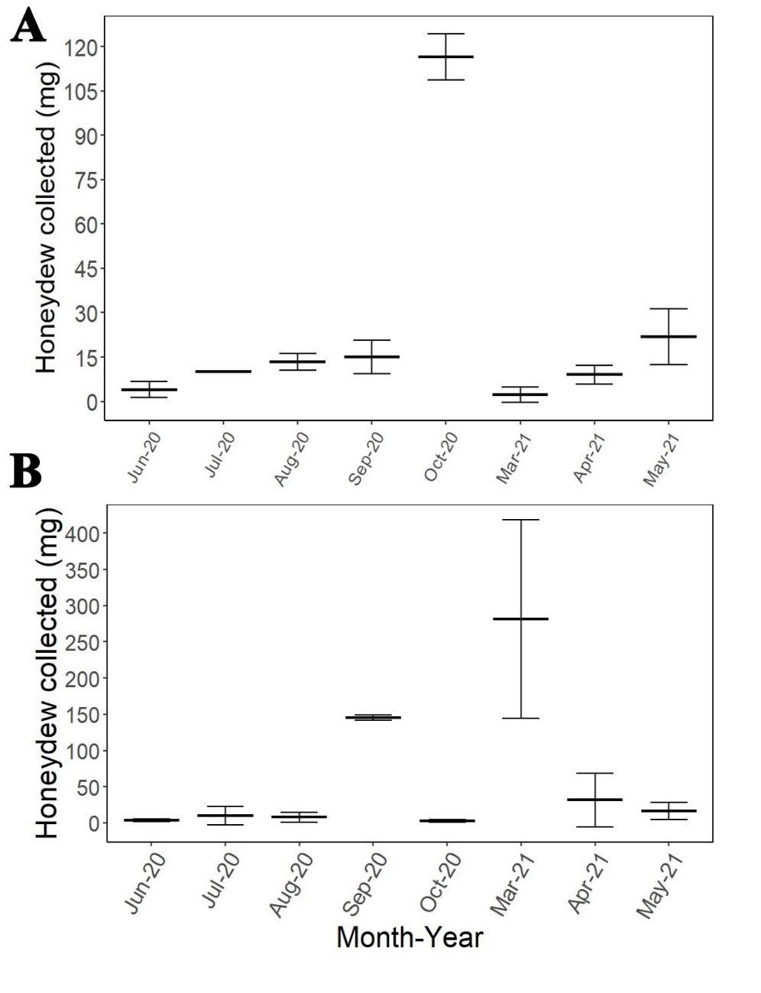
Supplementary Figure 1. Mean dry weight of honeydew collected under A) landscape established, CMBS-infested crape myrtles and B) potted crape myrtles used for the visitation experiments during the months of July-Oct 2020 and March-May 2021. Figures are plotted with 95% confidence intervals. On landscape crape myrtles, mean honeydew dry weight in October was significantly greater than that of all other months. Mean honeydew dry weight in May was significantly greater than honeydew dry weight recorded in April, June, and March (P< 0.05). Mean honeydew dry weight recorded in September was greater than that recorded in March (P<0.05) but did not differ from mean honeydew dry weight recorded in April, June, July, and August. Honeydew collections under infested potted trees confirmed the presence of honeydew coincident with months when trees were sampled for visitation (Figure S1B), ranging between 3.5 mg in October to 281.5 mg in March.

Supplementary Table 3. The orders, families, and abundance of insects observed visiting crape myrtle trees, both infested and non-infested, over an eight-month period, excluding Formicidae. Infested and non-infested show the total abundances recorded on infested and non-infested trees, respectively.
Order | Family | Total abundance | Infested | Non-infested
Coleoptera | Buprestidae | 13 | 4 | 9
Coleoptera | Cantharidae | 1 | 0 | 1
Coleoptera | Chrysomelidae | 16 | 9 | 7
Coleoptera | Coccinellidae | 604 | 419 | 186
Coleoptera | Curculionidae | 1 | 0 | 1
Coleoptera | Elateridae | 1 | 1 | 0
Coleoptera | Meloidae | 6 | 3 | 3
Coleoptera | Mordellidae | 14 | 9 | 5
Coleoptera | Cerambycidae | 1 | 1 | 0
Coleoptera | Scarabaeidae | 16 | 9 | 7
Diptera | Agromyzidae | 7 | 5 | 2
Diptera | Anthomyidae | 2 | 2 | 0
Diptera | Asilidae | 7 | 3 | 4
Diptera | Bibionidae | 8 | 3 | 5
Diptera | Bombyliidae | 1 | 0 | 1
Diptera | Calliphoridae | 25 | 12 | 13
Diptera | Chamaemyiidae | 9 | 6 | 3
Diptera | Chironomidae | 58 | 23 | 35
Diptera | Chloropidae | 14 | 9 | 5
Diptera | Chyromyidae | 1 | 0 | 1
Diptera | Conopidae | 1 | 0 | 1
Diptera | Dolichopodidae | 1773 | 1031 | 742
Diptera | Drosophilidae | 42 | 39 | 3
Diptera | Empedidae | 2 | 1 | 1
Diptera | Lauxaniidae | 5 | 2 | 3
Diptera | Muscidae | 191 | 117 | 74
Diptera | Mycetophilidae | 5 | 2 | 3
Diptera | Phoridae | 226 | 116 | 110
Diptera | Piophilidae | 1 | 0 | 1
Diptera | Platystomatidae | 3 | 3 | 0
Diptera | Sarcophagidae | 82 | 52 | 30
Diptera | Sciaridae | 3 | 1 | 2
Diptera | Sciomyzidae | 3 | 0 | 3
Diptera | Syrphidae | 41 | 29 | 12
Diptera | Tabanidae | 2 | 1 | 1
Diptera | Tachinidae | 15 | 7 | 8
Diptera | Tephritidae | 9 | 8 | 1
Diptera | Therevidae | 4 | 1 | 3
Diptera | Tipulidae | 4 | 2 | 2
Hemiptera | Anthocoridae | 3 | 3 | 0
Hemiptera | Cercopidae | 2 | 0 | 2
Hemiptera | Cicadellidae | 18 | 8 | 10
Hemiptera | Coreidae | 3 | 2 | 1
Hemiptera | Delphacidae | 2 | 1 | 1
Hemiptera | Flattidae | 1 | 1 | 0
Hemiptera | Membracidae | 7 | 4 | 3
Hemiptera | Pentatomidae | 6 | 2 | 4
Hemiptera | Plataspidae | 39 | 16 | 23
Hemiptera | Reduviidae | 7 | 3 | 4
Hymentoptera | Apidae | 3 | 2 | 1
Hymentoptera | Argidae | 1 | 0 | 1
Hymentoptera | Braconidae | 16 | 10 | 6
Hymentoptera | Chalcididae | 1 | 0 | 1
Hymentoptera | Chrysididae | 2 | 2 | 0
Hymentoptera | Crabronidae | 1 | 0 | 1
Hymentoptera | Encyrtidae | 1 | 0 | 1
Hymentoptera | Euchartidae | 0 | 0 | 0
Hymentoptera | Eulophidae | 3 | 1 | 2
Hymentoptera | Eupelmidae | 1 | 1 | 0
Hymentoptera | Eurytomidae | 5 | 2 | 3
Hymentoptera | Halictidae | 12 | 12 | 0
Hymentoptera | Ichneumonidae | 180 | 98 | 82
Hymentoptera | Mutillidae | 2 | 2 | 0
Hymentoptera | Orussidae | 1 | 1 | 0
Hymentoptera | Perilampidae | 1 | 0 | 1
Hymentoptera | Pteromalidae | 3 | 2 | 1
Hymentoptera | Scoliidae | 5 | 3 | 2
Hymentoptera | Sphecidae | 12 | 11 | 1
Hymentoptera | Tiphiidae | 15 | 10 | 5
Hymentoptera | Vespidae | 181 | 161 | 20
Neuroptera | Chrysopidae | 2 | 1 | 1
Neuroptera | Hemerobiidae | 2 | 0 | 2
Psocodea | Psocidae | 11 | 4 | 7

Supplementary table 4. Ant presence/absence data for each month and records to genus/species level.
Month/year | (+/-) Infested | (+/-) Non-infested | Species
June, 2020 | + | - | L. humile
July, 2020 | + | - | F. pallidefulva, S. invicta
August, 2020 | + | - | F. pallidefulva, S. invicta
September, 2020 | + | - | F. pallidefulva, S. invicta
October, 2020 | + | - | L. humile
March, 2021 | - | - | -
April, 2021 | - | - | -
May, 2021 | + | - | L. humile

Supplementary table 5. Averages, standard errors, and pairwise comparisons of insect abundance, family-richness, inverse Simpsons diversity, and evenness among observation months. All data were averaged among the two observation days before obtaining diversity metrics.
Month/Year | Abundance | Inverse Shannon’s Diversity | Family-level Richness | Evenness
June, 2020 | 9.75± 1.09 (b) | 2.03± 0.18 (c) | 4.50± 0.47 (bc) | 0.50± 0.04 (ab)
July, 2020 | 25.65± 3.87 (a) | 2.04± 0.13 (c) | 6± 0.67 (b) | 0.39± 0.04 (b)
August, 2020 | 10.5± 1.60 (b) | 1.95± 0.17 (c) | 4.20± 0.46 (bc) | 0.55± 0.06 (ab)
September, 2020 | 8.2325± 1.73 (b) | 2.77± 0.29 (bc) | 4.90± 0.56 (b) | 0.65± 0.06 (b)
October, 2020 | 6.175± 0.64 (b) | 3.02± 0.30 (bc) | 4.35± 0.38 (bc) | 0.71± 0.04 (ab)
March, 2021 | 1.665625± 0.30 (b) | 2.33± 0.30 (bc) | 2.56± 0.39 (c) | 0.95± 0.02 (a)
April, 2021 | 24.7± 2.57 (a) | 3.39± 0.23 (b) | 5.90± 0.33 (b) | 0.58± 0.03 (b)
May, 2021 | 20.2± 2.51 (a) | 4.75± 0.52 (a) | 10.45± 0.70 (a) | 0.47± 0.05 (c)

Supplementary Table 6. Vespidae samples collected and identified to species-level from crape myrtle trees during the visitation experiment. Infested and non-infested are the abundances of species collected on CMBS infested and non-infested trees.
Species | Total abundance | Infested | Non-infested
Polistes exclamans | 9 | 8 | 1
Polistes carolina | 3 | 0 | 3
Polistes rugibinosus | 2 | 1 | 0
Vespula squamosa | 3 | 2 | 1
Vespula germanica | 11 | 11 | 0
Vespula vulgaris | 7 | 7 | 0
No. species: 6 | Sample size= 34 | 29 | 5

Supplementary Table 7. Species/Genera and total abundances of ladybeetles visiting crape myrtles during the field surveys. Infested and non-infested are the abundances of species collected on CMBS infested and non-infested trees.
Species | Total abundance | Infested | Non-infested
Chilocorus stigma | 17 | 10 | 7
Coccinella septempunctata | 11 | 9 | 2
Coleomegilla maculata | 7 | 3 | 4
Cycloneda munda | 5 | 5 | 0
Harmonia axyridis | 529 | 369 | 160
Hippodamia convergens | 2 | 1 | 1
Hyperaspis bigeminata | 7 | 2 | 5
Scymnus sp. | 26 | 20 | 6
No. genera: 8 | Total abundance= 604 | 419 | 185

