SUPPLEMENTAL MATERIAL

National genomic profiling of Plasmodium falciparum antimalarial resistance in Zambian children participating in the 2018 Malaria Indicator Survey

Abebe A. Fola^{1,2*}, Ilinca I. Ciubotariu^{1,3}, Jack Dorman¹, Mulenga C. Mwenda⁴, Brenda Mambwe⁴, Conceptor Mulube⁴, Rachael Kasaro⁴, Moonga B. Hawela⁵, Busiku Hamainza⁵, John M. Miller⁴, Jeffrey A. Bailey², William J. Moss^{6,7}, Daniel J. Bridges⁴, Giovanna Carpi^{1,6*}

¹ Department of Biological Sciences, Purdue University, West Lafayette, IN, USA
² Department of Pathology and Laboratory Medicine, Brown University, Providence, RI 02903, USA
³ W. Harry Feinstone Department of Molecular Microbiology and Immunology, Johns Hopkins Bloomberg School of Public Health, Baltimore, MD, USA
⁴ PATH Malaria Control and Elimination Partnership in Africa (MACEPA), Lusaka, Zambia
⁵ National Malaria Elimination Centre, Zambia Ministry of Health, Chainama Hospital Grounds, Lusaka, Zambia
⁶ The Johns Hopkins Malaria Research Institute, W. Harry Feinstone Department of Molecular Microbiology and Immunology, Johns Hopkins Bloomberg School of Public Health, Baltimore, MD, USA
⁷ Department of Epidemiology, Johns Hopkins Bloomberg School of Public Health, Baltimore, MD, USA

*Corresponding Authors:
Abebe A.Fola, E-mail: abebe_fola@brown.edu
Giovanna Carpi, E-mail: gcarpi@purdue.edu

SUPPLEMENTAL FIGURES

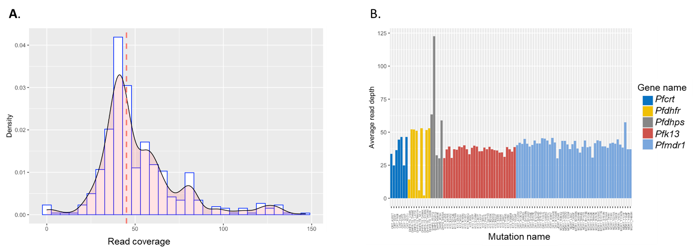

Figure S1. Read coverage per all identified mutations associated with antimalarial drug resistance across 282 samples. A) Density plot showing cumulative read depth and dashed red lines indicate median coverage=45X. B) Read coverage per mutation for top 5 known antimalarial drug resistance genes.

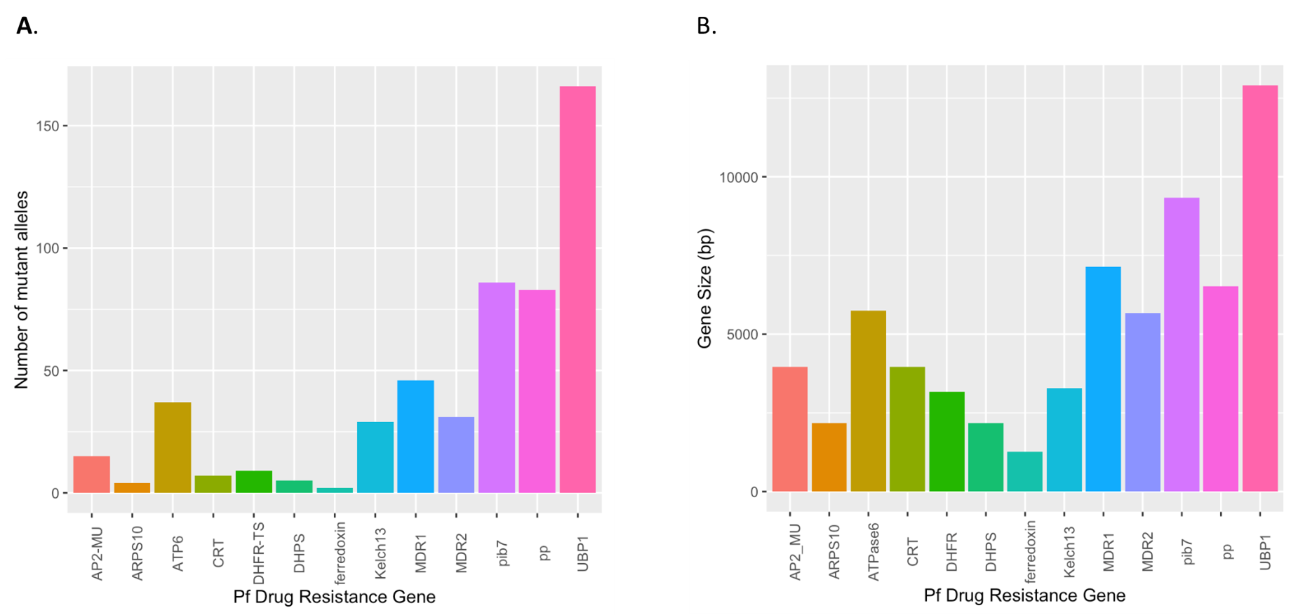
Figure S2. Number of mutations per gene and read depth. A) Number of mutations identified across 13 P. falciparum genes from 282 samples. B) Drug resistance gene size in base pairs.

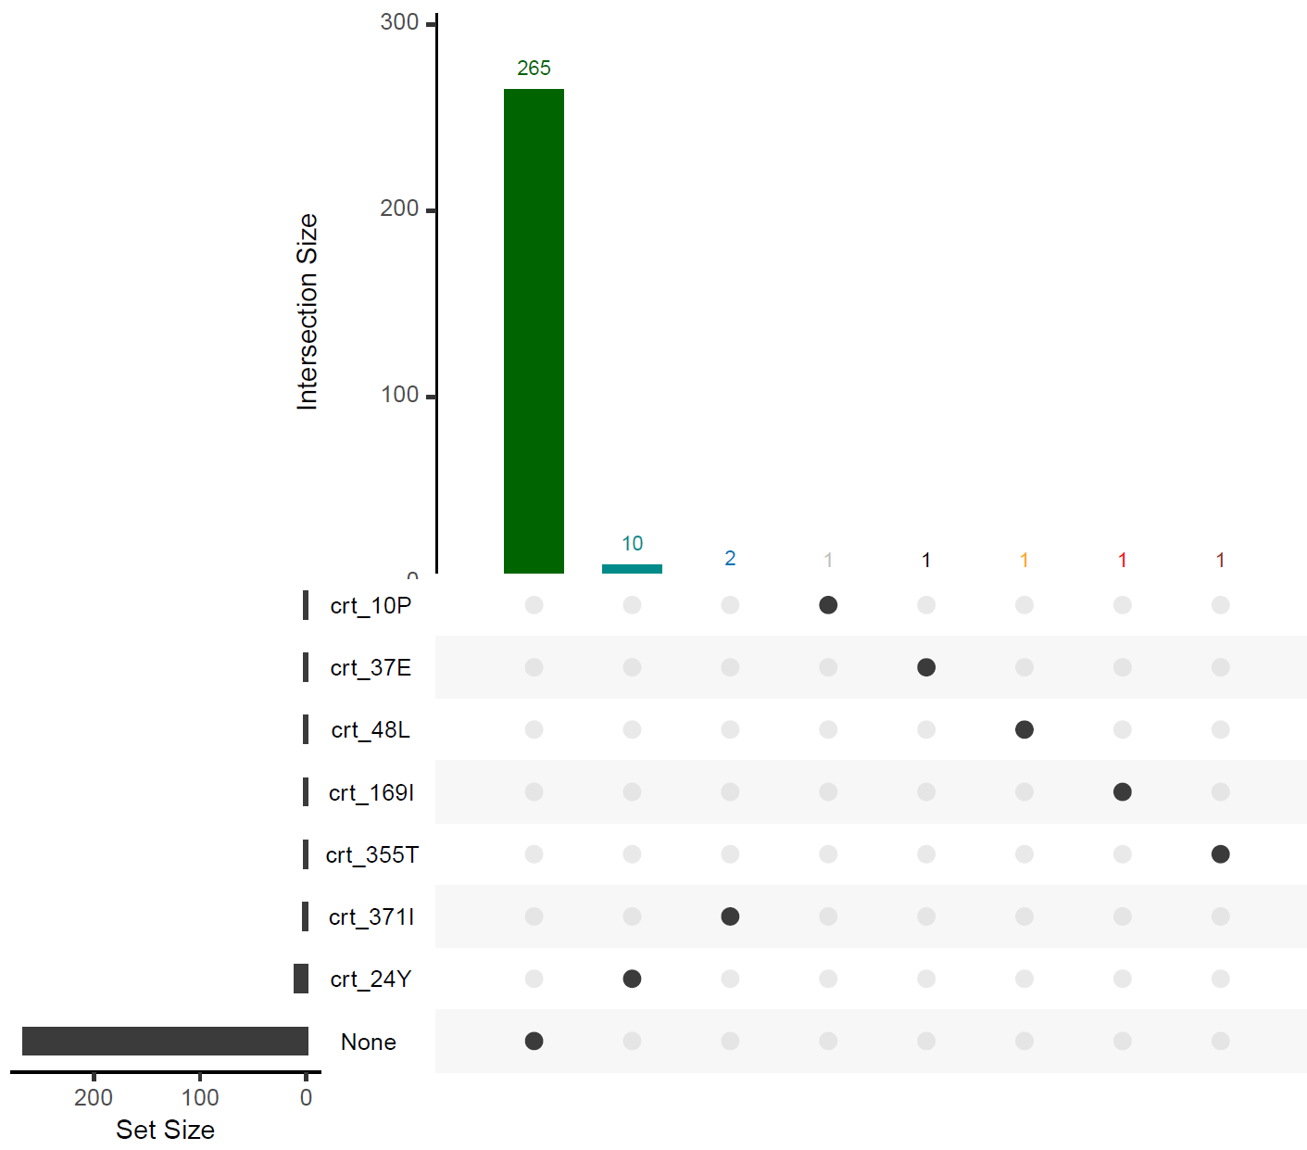
Figure S3. Frequency of mutations in the Pfcrt gene. The intersection size bar plots represent the number of parasites carrying different combinations of antimalarial drug resistance associated mutations in the Pfcrt gene. The circles below the bars represent the different combinations of resistant genotypes in individual samples. The set size represents the number of samples in which individual drug resistance-conferring markers were genotyped. Gene position and nucleotide change for each mutation are shown in Table S1. None = samples carrying synonymous mutations or wild-type alleles

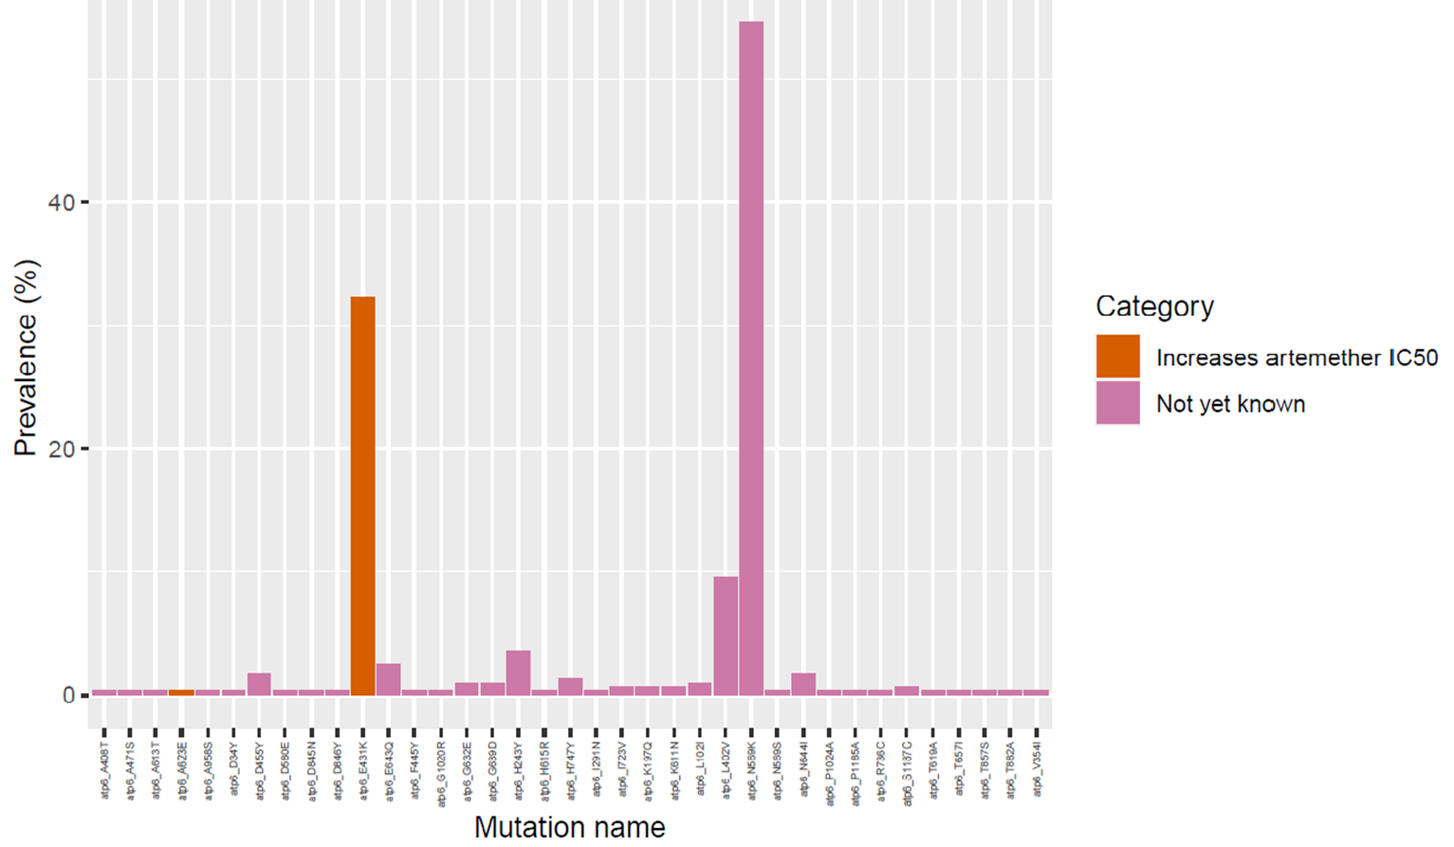
Figure S4. Prevalence of 37 mutations in Pfatpase6 from 282 Zambian samples ordered by genomic loci. Colours indicate whether the mutations are validated or not as resistance markers for ACT.

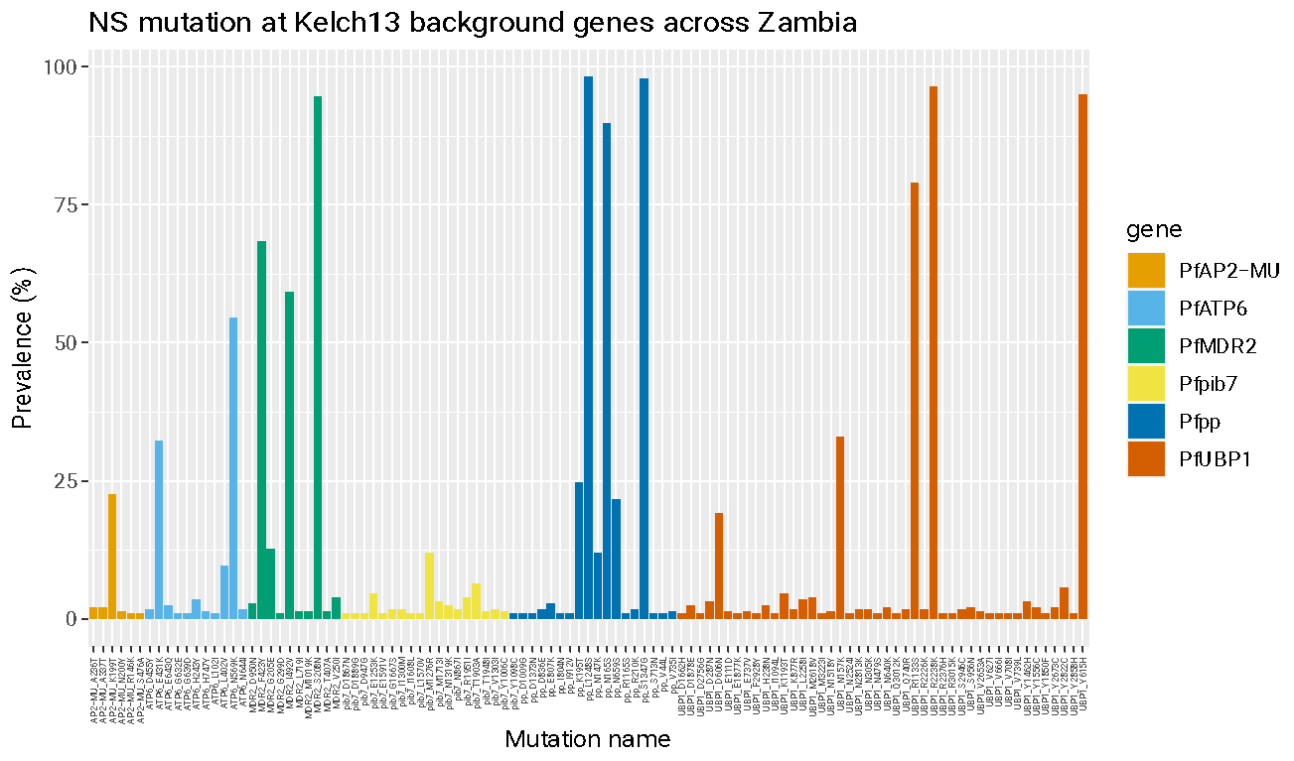

Figure S5. Prevalence of different mutations across genes associated with partial artemisinin resistance other than Kelch13 gene. We identified several mutations across PfATPase6 protein, apicoplast ribosomal protein S10 precursor gene (Pfarps10), (Pfmdr) protein 2 codon, AP-2 complex subunit mu gene (Pfap2-mu), ubiquitin carboxyl-terminal hydrolase 1 gene (Pfubp-1) and Phosphoinositide-binding protein (Pfpib7). No mutation observed in genes: Pfcrt I356T, Pffd D193Y, Pfmdr2 T484I, Pfap2-mu S160N/T and Pfubp-1 E1528D – known background mutations associated with ART in SEA. Also, no mutation was observed in the AP-2 complex subunit mu gene (ap2-mu, S160N/T) and the ubiquitin carboxyl-terminal hydrolase 1 gene (ubp-1, E1528D), mutation that is associated with delayed ACT clearance in Africa.

SUPPLEMENTAL TABLES

Supplementary tables are compiled into a single file for ease of viewing

Table S1. Description of 13 P. falciparum drug resistance genes across successfully sequenced samples and included in this analysis and the drugs with which they are associated.
See uploaded file.

Table S2. Sequencing coverage across successfully sequenced samples and cumulative prevalence of all mutations across 13 genes in Zambia. n = number of samples successfully sequenced samples
See uploaded file.

Table S3. Prevalence of all mutations across 13 genes per region in Zambia. n = number of samples successfully sequenced samples
See uploaded file.

