Supplement:
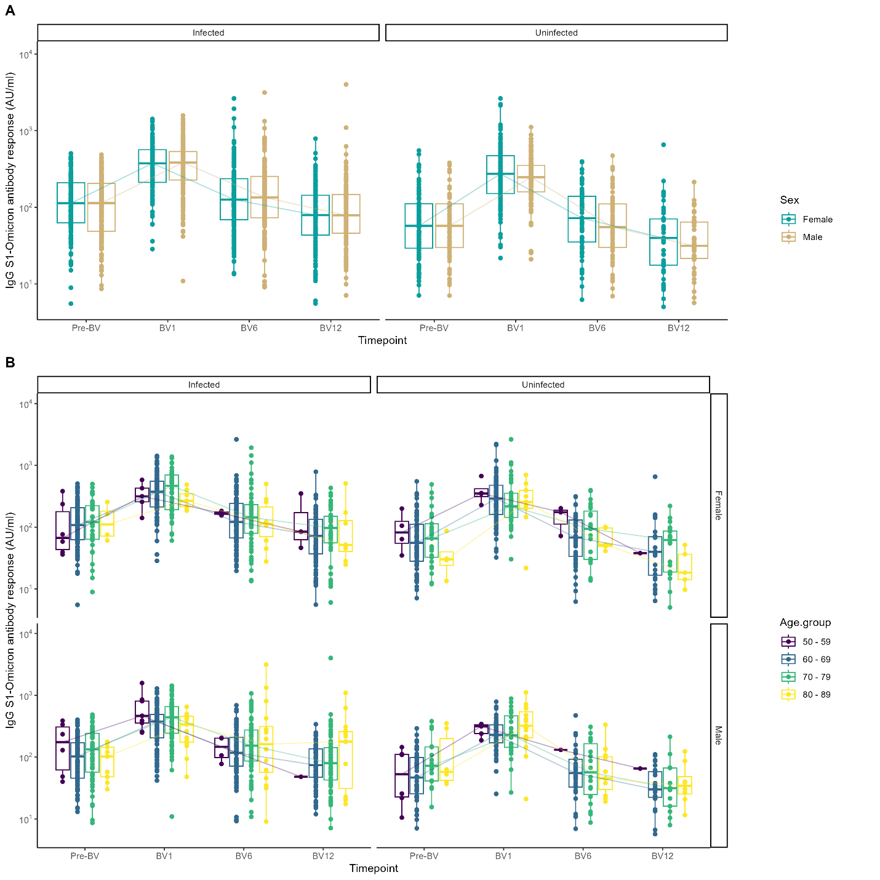Figure S1: A) Omicron BA.1 specific anti SARS-CoV-2-S1 IgG antibody responses (N=656) stratified by infection status following bivalent vaccination. B) Antibody concentrations stratified by infection status and sex, and 10-year age groups based on age at first vaccine dose.

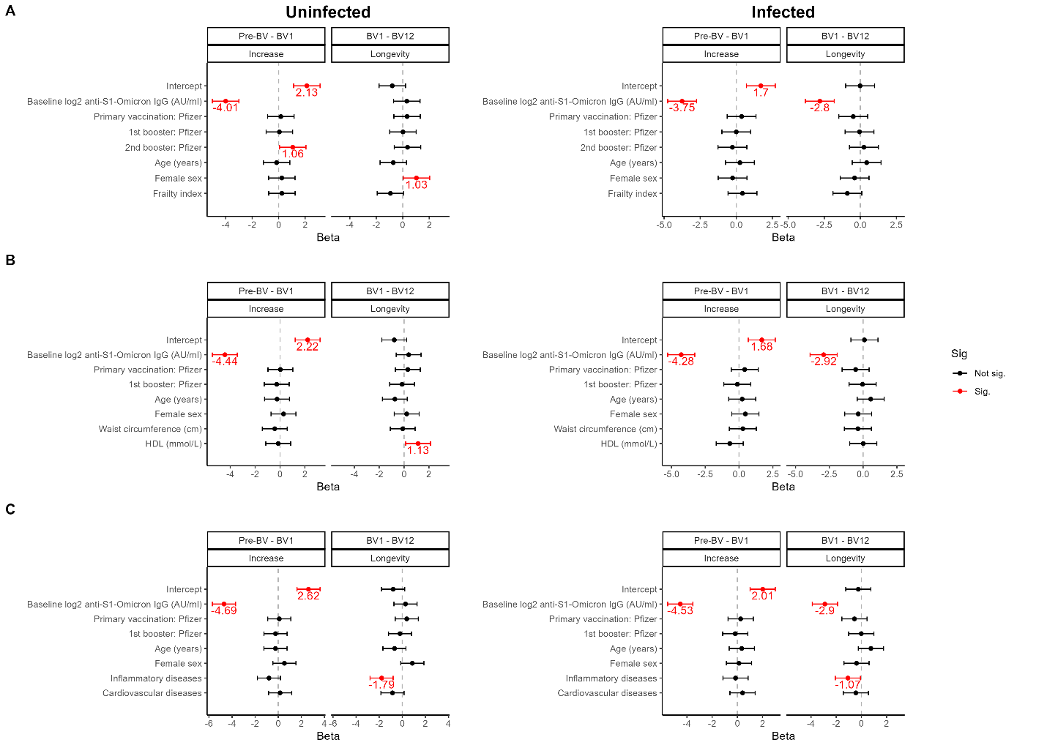Figure S2: Multivariate regression models of changes in Omicron BA.1 specific anti-S1 IgG antibody concentrations 1 month and 1 year following bivalent vaccination stratified by prior infection status with significant associations shown in red. Models are shown separately for A) baseline characteristics, B) cardiometabolic markers, and C) comorbidities.

Table S1: Pairwise comparisons of antibody concentrations of AZD1222 and BNT162b2 vaccinee’s per timepoint stratified by infection status. Tests were performed using the unpaired Wilcoxon sum rank test and were corrected for multiple testing using FDR.
Timepoint | Infection status | Comparison | p | p.adj | p.adj.signif
P2 | Infected | Astra Zeneca versus Pfizer | 1,10E-18 | 9,70E-18 | ****
Pre-B | Infected | Astra Zeneca versus Pfizer | 1,60E-03 | 4,10E-03 | **
B1 | Infected | Astra Zeneca versus Pfizer | 5,40E-02 | 6,50E-02 | ns
2B1 | Infected | Astra Zeneca versus Pfizer | 6,00E-02 | 6,80E-02 | ns
Pre-BV | Infected | Astra Zeneca versus Pfizer | 1,10E-05 | 4,10E-05 | ****
BV1 | Infected | Astra Zeneca versus Pfizer | 4,40E-07 | 2,00E-06 | ****
BV6 | Infected | Astra Zeneca versus Pfizer | 6,50E-03 | 1,10E-02 | *
BV12 | Infected | Astra Zeneca versus Pfizer | 3,80E-02 | 5,30E-02 | ns
P2 | Uninfected | Astra Zeneca versus Pfizer | 5,20E-60 | 9,40E-59 | ****
Pre-B | Uninfected | Astra Zeneca versus Pfizer | 2,40E-09 | 1,40E-08 | ****
B1 | Uninfected | Astra Zeneca versus Pfizer | 3,50E-03 | 7,30E-03 | **
2B1 | Uninfected | Astra Zeneca versus Pfizer | 3,70E-03 | 7,30E-03 | **
Pre-BV | Uninfected | Astra Zeneca versus Pfizer | 1,60E-02 | 2,40E-02 | *
BV1 | Uninfected | Astra Zeneca versus Pfizer | 5,20E-02 | 6,50E-02 | ns
BV6 | Uninfected | Astra Zeneca versus Pfizer | 1,90E-01 | 2,10E-01 | ns
BV12 | Uninfected | Astra Zeneca versus Pfizer | 8,90E-01 | 8,90E-01 | ns

Table S2: Pairwise comparisons of antibody concentrations for vaccinee’s of various 10-year age groups per timepoint, stratified by infection status. Tests were performed using the unpaired Wilcoxon sum rank test and were corrected for multiple testing using FDR.
Timepoint | Infection status | Comparison | p | p.adj | p.adj.signif
P2 | Infected | 50 - 59 versus 60 - 69 | 3,40E-07 | 2,00E-06 | ****
P2 | Infected | 50 - 59 versus 70 - 79 | 5,00E-03 | 8,00E-03 | **
P2 | Infected | 50 - 59 versus 80 - 89 | 3,00E-03 | 6,00E-03 | **
P2 | Infected | 60 - 69 versus 70 - 79 | 1,00E-03 | 3,00E-03 | **
P2 | Infected | 60 - 69 versus 80 - 89 | 5,80E-01 | 5,80E-01 | ns
P2 | Infected | 70 - 79 versus 80 - 89 | 4,20E-02 | 5,10E-02 | ns
Pre-B | Infected | 50 - 59 versus 60 - 69 | 1,90E-02 | 8,30E-02 | ns
Pre-B | Infected | 50 - 59 versus 70 - 79 | 3,70E-02 | 8,30E-02 | ns
Pre-B | Infected | 50 - 59 versus 80 - 89 | 4,20E-02 | 8,30E-02 | ns
Pre-B | Infected | 60 - 69 versus 70 - 79 | 8,40E-01 | 8,40E-01 | ns
Pre-B | Infected | 60 - 69 versus 80 - 89 | 3,40E-01 | 4,10E-01 | ns
Pre-B | Infected | 70 - 79 versus 80 - 89 | 2,40E-01 | 3,60E-01 | ns
B1 | Infected | 50 - 59 versus 60 - 69 | 2,30E-01 | 3,00E-01 | ns
B1 | Infected | 50 - 59 versus 70 - 79 | 9,80E-01 | 9,80E-01 | ns
B1 | Infected | 50 - 59 versus 80 - 89 | 2,40E-01 | 3,00E-01 | ns
B1 | Infected | 60 - 69 versus 70 - 79 | 1,20E-01 | 3,00E-01 | ns
B1 | Infected | 60 - 69 versus 80 - 89 | 1,10E-01 | 3,00E-01 | ns
B1 | Infected | 70 - 79 versus 80 - 89 | 2,50E-01 | 3,00E-01 | ns
2B1 | Infected | 50 - 59 versus 60 - 69 | 2,70E-01 | 7,00E-01 | ns
2B1 | Infected | 50 - 59 versus 70 - 79 | 6,80E-01 | 7,00E-01 | ns
2B1 | Infected | 50 - 59 versus 80 - 89 | 6,30E-01 | 7,00E-01 | ns
2B1 | Infected | 60 - 69 versus 70 - 79 | 7,20E-02 | 4,30E-01 | ns
2B1 | Infected | 60 - 69 versus 80 - 89 | 5,40E-01 | 7,00E-01 | ns
2B1 | Infected | 70 - 79 versus 80 - 89 | 7,00E-01 | 7,00E-01 | ns
Pre-BV | Infected | 50 - 59 versus 60 - 69 | 8,70E-01 | 8,70E-01 | ns
Pre-BV | Infected | 50 - 59 versus 70 - 79 | 7,90E-01 | 8,70E-01 | ns
Pre-BV | Infected | 50 - 59 versus 80 - 89 | 4,70E-01 | 7,00E-01 | ns
Pre-BV | Infected | 60 - 69 versus 70 - 79 | 3,40E-01 | 6,80E-01 | ns
Pre-BV | Infected | 60 - 69 versus 80 - 89 | 3,00E-01 | 6,80E-01 | ns
Pre-BV | Infected | 70 - 79 versus 80 - 89 | 1,50E-01 | 6,80E-01 | ns
BV1 | Infected | 50 - 59 versus 60 - 69 | 5,40E-01 | 7,30E-01 | ns
BV1 | Infected | 50 - 59 versus 70 - 79 | 7,30E-01 | 7,30E-01 | ns
BV1 | Infected | 50 - 59 versus 80 - 89 | 5,70E-01 | 7,30E-01 | ns
BV1 | Infected | 60 - 69 versus 70 - 79 | 8,00E-03 | 4,80E-02 | *
BV1 | Infected | 60 - 69 versus 80 - 89 | 6,50E-01 | 7,30E-01 | ns
BV1 | Infected | 70 - 79 versus 80 - 89 | 8,00E-02 | 2,40E-01 | ns
BV6 | Infected | 50 - 59 versus 60 - 69 | 5,00E-01 | 1,00E+00 | ns
BV6 | Infected | 50 - 59 versus 70 - 79 | 9,00E-01 | 1,00E+00 | ns
BV6 | Infected | 50 - 59 versus 80 - 89 | 1,00E+00 | 1,00E+00 | ns
BV6 | Infected | 60 - 69 versus 70 - 79 | 7,10E-02 | 4,20E-01 | ns
BV6 | Infected | 60 - 69 versus 80 - 89 | 4,30E-01 | 1,00E+00 | ns
BV6 | Infected | 70 - 79 versus 80 - 89 | 9,10E-01 | 1,00E+00 | ns
BV12 | Infected | 50 - 59 versus 60 - 69 | 6,20E-01 | 8,00E-01 | ns
BV12 | Infected | 50 - 59 versus 70 - 79 | 4,30E-01 | 8,00E-01 | ns
BV12 | Infected | 50 - 59 versus 80 - 89 | 8,70E-01 | 8,70E-01 | ns
BV12 | Infected | 60 - 69 versus 70 - 79 | 3,40E-02 | 2,10E-01 | ns
BV12 | Infected | 60 - 69 versus 80 - 89 | 2,30E-01 | 6,80E-01 | ns
BV12 | Infected | 70 - 79 versus 80 - 89 | 6,60E-01 | 8,00E-01 | ns
P2 | Uninfected | 50 - 59 versus 60 - 69 | 1,70E-07 | 5,10E-07 | ****
P2 | Uninfected | 50 - 59 versus 70 - 79 | 3,40E-02 | 4,10E-02 | *
P2 | Uninfected | 50 - 59 versus 80 - 89 | 7,10E-05 | 1,40E-04 | ***
P2 | Uninfected | 60 - 69 versus 70 - 79 | 1,10E-07 | 5,10E-07 | ****
P2 | Uninfected | 60 - 69 versus 80 - 89 | 8,20E-01 | 8,20E-01 | ns
P2 | Uninfected | 70 - 79 versus 80 - 89 | 6,60E-04 | 9,90E-04 | ***
Pre-B | Uninfected | 50 - 59 versus 60 - 69 | 1,00E-03 | 3,00E-03 | **
Pre-B | Uninfected | 50 - 59 versus 70 - 79 | 1,10E-02 | 1,30E-02 | *
Pre-B | Uninfected | 50 - 59 versus 80 - 89 | 5,30E-05 | 3,20E-04 | ***
Pre-B | Uninfected | 60 - 69 versus 70 - 79 | 3,70E-01 | 3,70E-01 | ns
Pre-B | Uninfected | 60 - 69 versus 80 - 89 | 5,00E-03 | 7,00E-03 | **
Pre-B | Uninfected | 70 - 79 versus 80 - 89 | 5,20E-04 | 2,00E-03 | **
B1 | Uninfected | 50 - 59 versus 60 - 69 | 1,00E-03 | 9,00E-03 | **
B1 | Uninfected | 50 - 59 versus 70 - 79 | 6,00E-03 | 1,80E-02 | *
B1 | Uninfected | 50 - 59 versus 80 - 89 | 1,40E-01 | 2,90E-01 | ns
B1 | Uninfected | 60 - 69 versus 70 - 79 | 6,10E-01 | 8,20E-01 | ns
B1 | Uninfected | 60 - 69 versus 80 - 89 | 6,80E-01 | 8,20E-01 | ns
B1 | Uninfected | 70 - 79 versus 80 - 89 | 9,20E-01 | 9,20E-01 | ns
2B1 | Uninfected | 50 - 59 versus 60 - 69 | 2,10E-01 | 3,20E-01 | ns
2B1 | Uninfected | 50 - 59 versus 70 - 79 | 1,90E-01 | 3,20E-01 | ns
2B1 | Uninfected | 50 - 59 versus 80 - 89 | 8,70E-01 | 8,70E-01 | ns
2B1 | Uninfected | 60 - 69 versus 70 - 79 | 7,50E-01 | 8,70E-01 | ns
2B1 | Uninfected | 60 - 69 versus 80 - 89 | 1,70E-01 | 3,20E-01 | ns
2B1 | Uninfected | 70 - 79 versus 80 - 89 | 1,20E-01 | 3,20E-01 | ns
Pre-BV | Uninfected | 50 - 59 versus 60 - 69 | 5,40E-01 | 6,50E-01 | ns
Pre-BV | Uninfected | 50 - 59 versus 70 - 79 | 9,30E-01 | 9,30E-01 | ns
Pre-BV | Uninfected | 50 - 59 versus 80 - 89 | 1,30E-01 | 3,90E-01 | ns
Pre-BV | Uninfected | 60 - 69 versus 70 - 79 | 3,20E-01 | 4,90E-01 | ns
Pre-BV | Uninfected | 60 - 69 versus 80 - 89 | 2,10E-01 | 4,10E-01 | ns
Pre-BV | Uninfected | 70 - 79 versus 80 - 89 | 7,30E-02 | 3,90E-01 | ns
BV1 | Uninfected | 50 - 59 versus 60 - 69 | 2,00E-02 | 6,10E-02 | ns
BV1 | Uninfected | 50 - 59 versus 70 - 79 | 7,00E-03 | 4,30E-02 | *
BV1 | Uninfected | 50 - 59 versus 80 - 89 | 1,00E-01 | 2,00E-01 | ns
BV1 | Uninfected | 60 - 69 versus 70 - 79 | 4,30E-01 | 5,20E-01 | ns
BV1 | Uninfected | 60 - 69 versus 80 - 89 | 5,90E-01 | 5,90E-01 | ns
BV1 | Uninfected | 70 - 79 versus 80 - 89 | 3,90E-01 | 5,20E-01 | ns
BV6 | Uninfected | 50 - 59 versus 60 - 69 | 5,00E-03 | 1,40E-02 | *
BV6 | Uninfected | 50 - 59 versus 70 - 79 | 8,00E-03 | 1,60E-02 | *
BV6 | Uninfected | 50 - 59 versus 80 - 89 | 2,00E-03 | 9,00E-03 | **
BV6 | Uninfected | 60 - 69 versus 70 - 79 | 9,30E-01 | 9,30E-01 | ns
BV6 | Uninfected | 60 - 69 versus 80 - 89 | 4,10E-01 | 5,00E-01 | ns
BV6 | Uninfected | 70 - 79 versus 80 - 89 | 4,20E-01 | 5,00E-01 | ns
BV12 | Uninfected | 50 - 59 versus 60 - 69 | 9,80E-02 | 2,40E-01 | ns
BV12 | Uninfected | 50 - 59 versus 70 - 79 | 1,20E-01 | 2,40E-01 | ns
BV12 | Uninfected | 50 - 59 versus 80 - 89 | 5,90E-02 | 2,40E-01 | ns
BV12 | Uninfected | 60 - 69 versus 70 - 79 | 6,80E-01 | 6,80E-01 | ns
BV12 | Uninfected | 60 - 69 versus 80 - 89 | 2,00E-01 | 3,00E-01 | ns
BV12 | Uninfected | 70 - 79 versus 80 - 89 | 3,00E-01 | 3,60E-01 | ns

Table S3: Pairwise comparisons of Omicron specific antibody concentrations following bivalent vaccination of men and women per timepoint, stratified by infection status. Tests were performed using the unpaired Wilcoxon sum rank test and were corrected for multiple testing using FDR.
Timepoint | Infection status | Comparison | p | p.adj | p.adj.signif
Pre-BV | Infected | Female versus Male | 0,37 | 0,74 | ns
BV1 | Infected | Female versus Male | 0,89 | 0,89 | ns
BV6 | Infected | Female versus Male | 0,59 | 0,81 | ns
BV12 | Infected | Female versus Male | 0,61 | 0,81 | ns
Pre-BV | Uninfected | Female versus Male | 0,75 | 0,86 | ns
BV1 | Uninfected | Female versus Male | 0,36 | 0,74 | ns
BV6 | Uninfected | Female versus Male | 0,11 | 0,56 | ns
BV12 | Uninfected | Female versus Male | 0,14 | 0,56 | ns

Table S4: Pairwise comparisons of Omicron specific antibody concentrations following bivalent vaccination for vaccinee’s of various 10-year age groups per timepoint, stratified by infection status. Tests were performed using the unpaired Wilcoxon sum rank test and were corrected for multiple testing using FDR.
Timepoint | Infection status | Comparison | p | p.adj | p.adj.signif
Pre-BV | Infected | 50 - 59 versus 60 - 69 | 0,69 | 0,82 | ns
Pre-BV | Infected | 50 - 59 versus 70 - 79 | 0,97 | 0,97 | ns
Pre-BV | Infected | 50 - 59 versus 80 - 89 | 0,57 | 0,82 | ns
Pre-BV | Infected | 60 - 69 versus 70 - 79 | 0,26 | 0,82 | ns
Pre-BV | Infected | 60 - 69 versus 80 - 89 | 0,69 | 0,82 | ns
Pre-BV | Infected | 70 - 79 versus 80 - 89 | 0,35 | 0,82 | ns
BV1 | Infected | 50 - 59 versus 60 - 69 | 0,28 | 0,34 | ns
BV1 | Infected | 50 - 59 versus 70 - 79 | 0,86 | 0,86 | ns
BV1 | Infected | 50 - 59 versus 80 - 89 | 0,12 | 0,23 | ns
BV1 | Infected | 60 - 69 versus 70 - 79 | 0,013 | 0,077 | ns
BV1 | Infected | 60 - 69 versus 80 - 89 | 0,22 | 0,34 | ns
BV1 | Infected | 70 - 79 versus 80 - 89 | 0,026 | 0,078 | ns
BV6 | Infected | 50 - 59 versus 60 - 69 | 0,5 | 0,98 | ns
BV6 | Infected | 50 - 59 versus 70 - 79 | 0,97 | 0,98 | ns
BV6 | Infected | 50 - 59 versus 80 - 89 | 0,8 | 0,98 | ns
BV6 | Infected | 60 - 69 versus 70 - 79 | 0,079 | 0,47 | ns
BV6 | Infected | 60 - 69 versus 80 - 89 | 0,98 | 0,98 | ns
BV6 | Infected | 70 - 79 versus 80 - 89 | 0,56 | 0,98 | ns
BV12 | Infected | 50 - 59 versus 60 - 69 | 0,78 | 0,99 | ns
BV12 | Infected | 50 - 59 versus 70 - 79 | 0,99 | 0,99 | ns
BV12 | Infected | 50 - 59 versus 80 - 89 | 0,97 | 0,99 | ns
BV12 | Infected | 60 - 69 versus 70 - 79 | 0,27 | 0,81 | ns
BV12 | Infected | 60 - 69 versus 80 - 89 | 0,22 | 0,81 | ns
BV12 | Infected | 70 - 79 versus 80 - 89 | 0,5 | 0,99 | ns
Pre-BV | Uninfected | 50 - 59 versus 60 - 69 | 0,58 | 0,84 | ns
Pre-BV | Uninfected | 50 - 59 versus 70 - 79 | 0,75 | 0,84 | ns
Pre-BV | Uninfected | 50 - 59 versus 80 - 89 | 0,65 | 0,84 | ns
Pre-BV | Uninfected | 60 - 69 versus 70 - 79 | 0,078 | 0,47 | ns
Pre-BV | Uninfected | 60 - 69 versus 80 - 89 | 0,84 | 0,84 | ns
Pre-BV | Uninfected | 70 - 79 versus 80 - 89 | 0,24 | 0,7 | ns
BV1 | Uninfected | 50 - 59 versus 60 - 69 | 0,34 | 0,54 | ns
BV1 | Uninfected | 50 - 59 versus 70 - 79 | 0,16 | 0,54 | ns
BV1 | Uninfected | 50 - 59 versus 80 - 89 | 0,86 | 0,86 | ns
BV1 | Uninfected | 60 - 69 versus 70 - 79 | 0,45 | 0,54 | ns
BV1 | Uninfected | 60 - 69 versus 80 - 89 | 0,37 | 0,54 | ns
BV1 | Uninfected | 70 - 79 versus 80 - 89 | 0,22 | 0,54 | ns
BV6 | Uninfected | 50 - 59 versus 60 - 69 | 0,04 | 0,12 | ns
BV6 | Uninfected | 50 - 59 versus 70 - 79 | 0,28 | 0,39 | ns
BV6 | Uninfected | 50 - 59 versus 80 - 89 | 0,026 | 0,12 | ns
BV6 | Uninfected | 60 - 69 versus 70 - 79 | 0,32 | 0,39 | ns
BV6 | Uninfected | 60 - 69 versus 80 - 89 | 0,42 | 0,42 | ns
BV6 | Uninfected | 70 - 79 versus 80 - 89 | 0,28 | 0,39 | ns
BV12 | Uninfected | 50 - 59 versus 60 - 69 | 0,52 | 0,78 | ns
BV12 | Uninfected | 50 - 59 versus 70 - 79 | 0,77 | 0,84 | ns
BV12 | Uninfected | 50 - 59 versus 80 - 89 | 0,29 | 0,67 | ns
BV12 | Uninfected | 60 - 69 versus 70 - 79 | 0,84 | 0,84 | ns
BV12 | Uninfected | 60 - 69 versus 80 - 89 | 0,33 | 0,67 | ns
BV12 | Uninfected | 70 - 79 versus 80 - 89 | 0,28 | 0,67 | ns

