Valorization of Red Pitahaya (Hylocereus sp.) peel through a Multi-Product Cascade Biorefinery Approach towards Bioactive Food Packaging Films
Laura Arroyo Esquivel¹*, Esther Rincón², Víctor Jiménez³, Fabian Vásquez⁴, Patricia Esquive^{l,5}, Eduardo Espinosa², Alejandro Rodríguez²
SUPPLEMENTARY MATERIAL

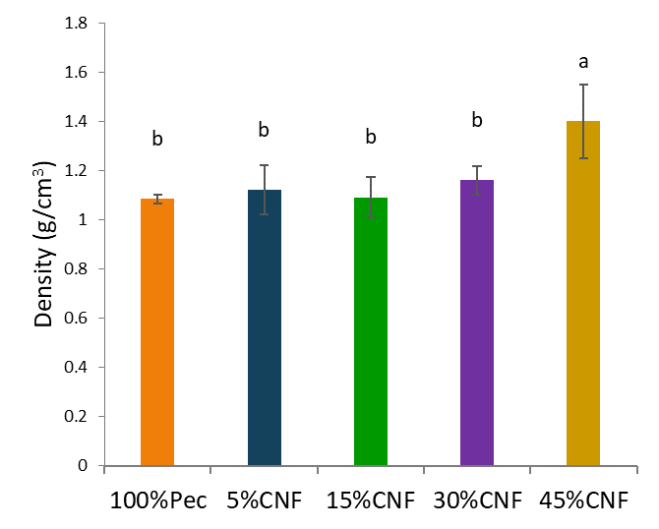
Figure S1 Density of pectin films reinforced with cellulose nanofibers.

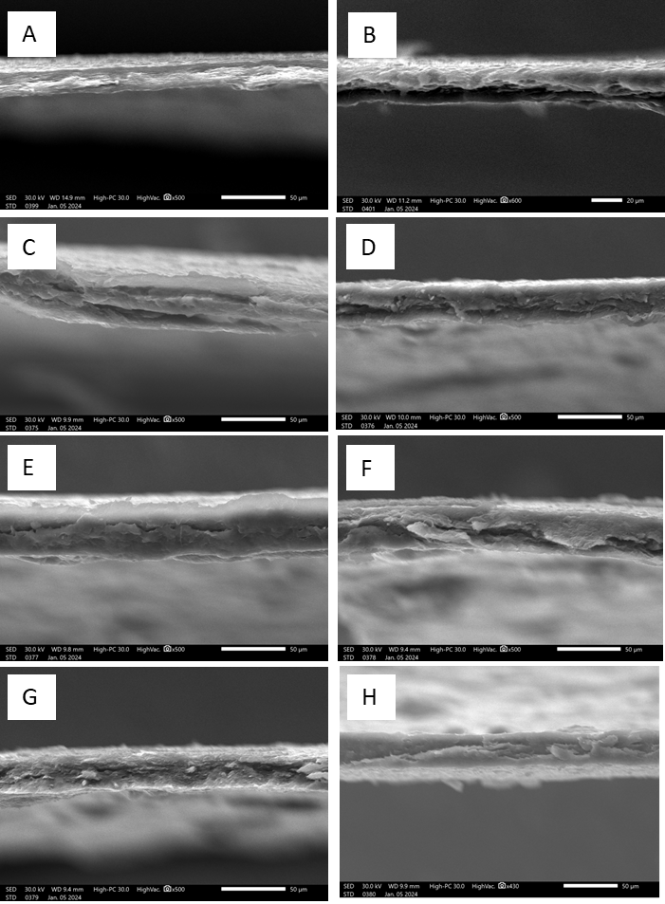
Figure S2 SEM micrographs spectra from betalains rich-extract-enriched films. Transversal images. A. 45%CNF. B. 5%Bet C. 10%Bet. D. 15%Bet E. 20%Bet F. 30%Bet G. 40%Bet H. 50% Bet

Figure S3 FTIR spectra from betalains rich-extract-enriched films.

