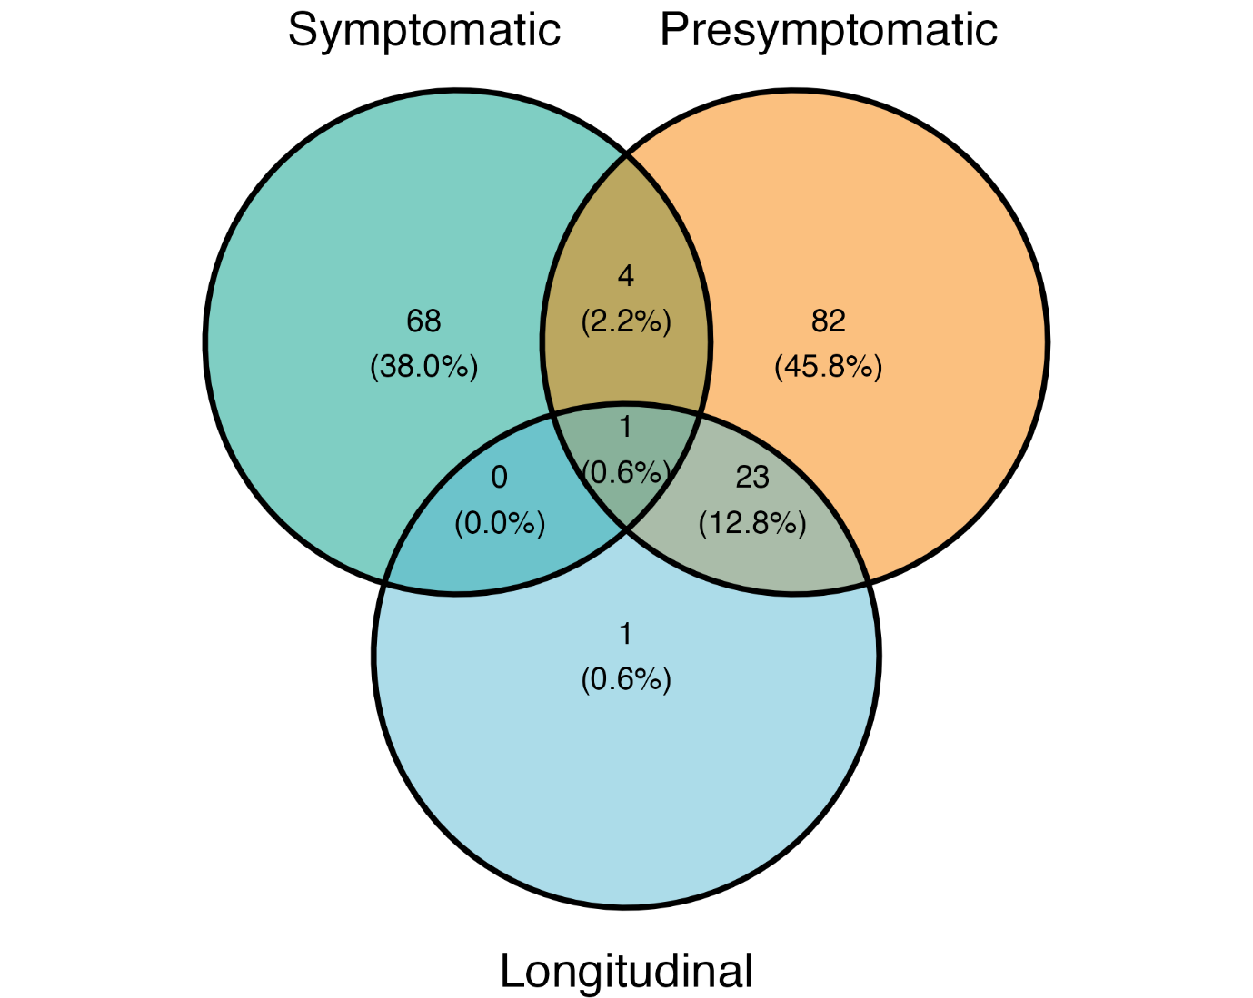
Supplementary figure 1 Representation of individual inclusion in the different cohorts.
Percentage shown as a fraction of the total number of included individuals. Overlapping individuals have multiple samples that are included in multiple cohorts. Overlapping individuals between symptomatic and presymptomatic cohorts are removed during comparisons to achieve independent cohorts.

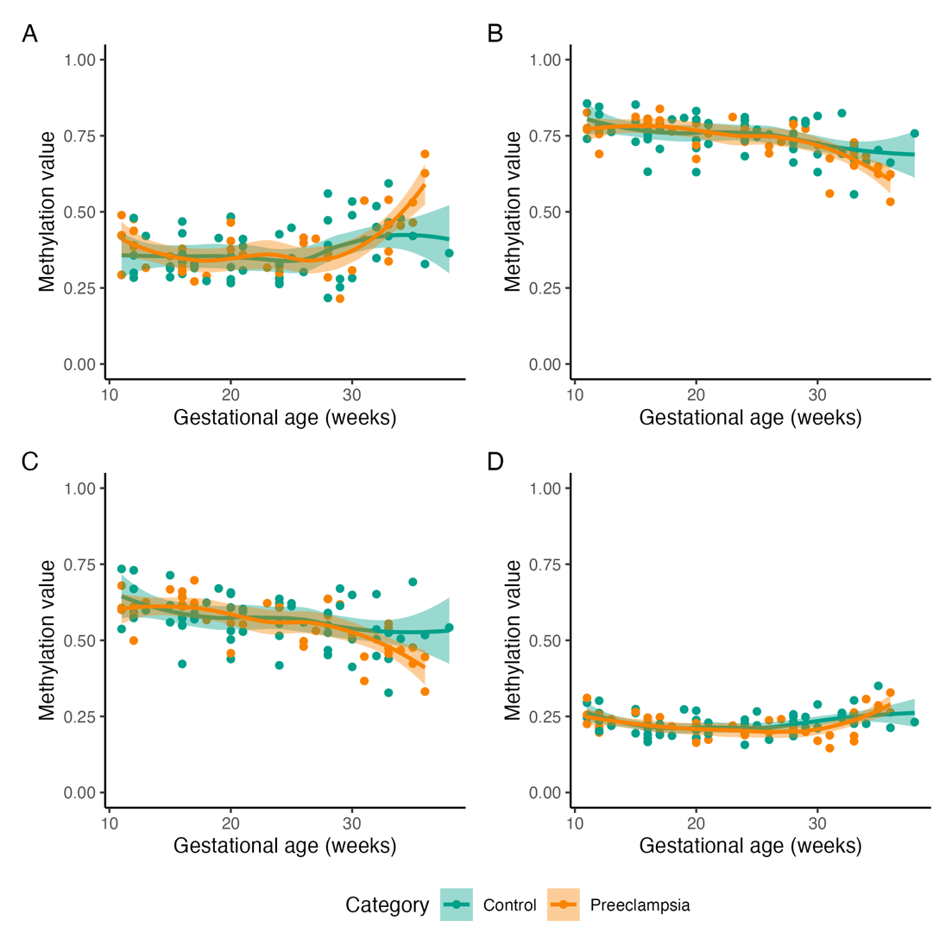
Supplementary figure 2 Four distinct genome-wide DMR trends can be observed between normal and complicated pregnancies in DMRs that are significant in late pregnancy
Each plot shows the mean methylation trend of a cluster of regions that follow a similar trend. DMRs were clustered based on their methylation trend and grouped together into four groups. Four methylation trends can be observed in these groups. DMRs were computed on the symptomatic cohort. Smoothing was performed with local polynomial regression fitting, SE is shown as band.

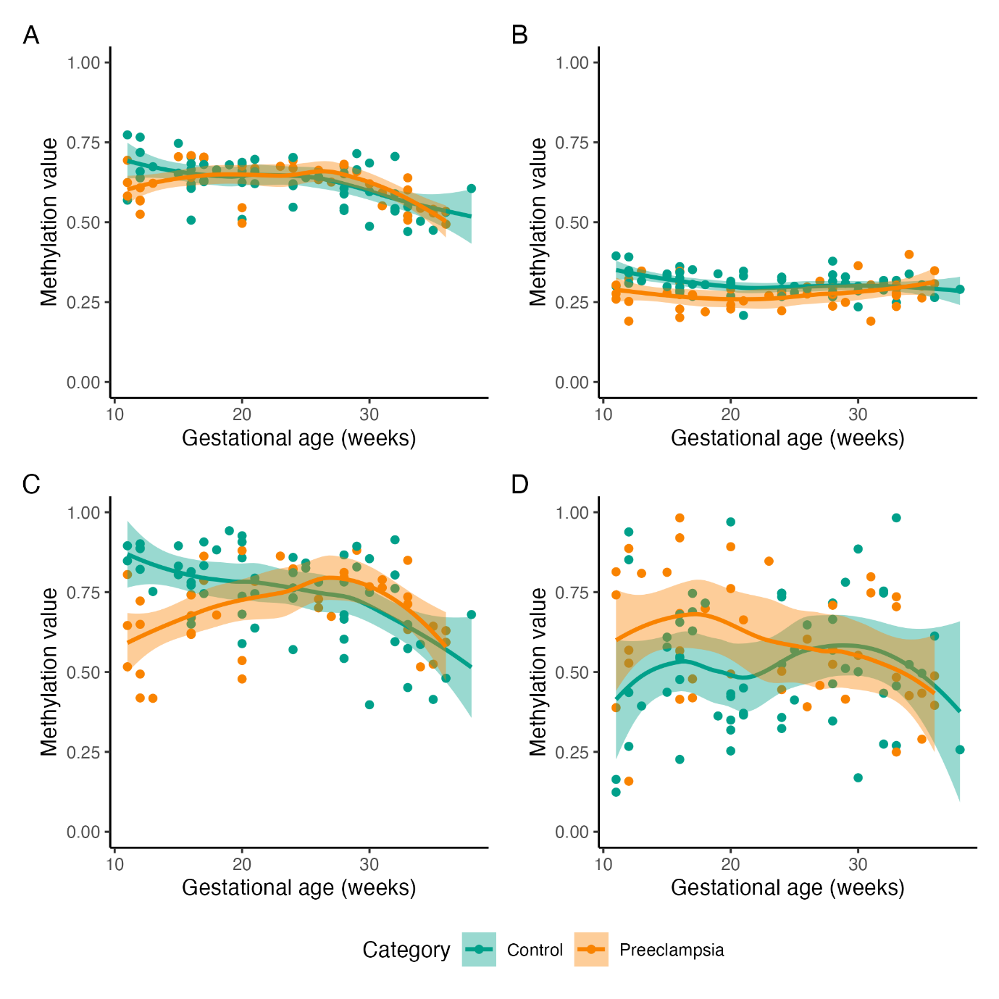
Supplementary figure 3 Four distinct genome-wide DMR trends can be observed between normal and complicated pregnancies in DMRs that are significant in early pregnancy
Each plot shows the mean methylation trend of a cluster of regions that follow a similar trend. DMRs were clustered based on their methylation trend and grouped into four groups. Four methylation trends can be observed in these groups. DMRs were computed on the presymptomatic cohort. Smoothing was performed with local polynomial regression fitting; SE is shown as a band.

