Supplementary Information
Enzyme- and GSH-responsive gelatin coated magnetic multi-shell hollow mesoporous organosilicon nanoparticles for avermectin controlled-release
Jiazhen Gaoª, Pengyu Luo^{b}, Siqiang Shen^{c}, Ying Liu^{a,} *, Xiaoyun Li^{a,} *, Xiaoying Wangª

ªState Key Laboratory of Pulp and Paper Engineering, South China University of Technology, 381 Wushan Road, Guangzhou, 510640, China
^{b}Guangzhou Furui High Energy Technology Co., Ltd., Guangdong Industrial ⁶⁰Co Gamma Ray Application Engineering Technology Research Center, Guangzhou, 511458, China
^{c}Guangzhou Fruit Science Research Institute, 433 Baiyun Avenue South, Guangzhou, 510422, China
* Corresponding author: Ying Liu, Xiaoyun Li
E-mail: amyliu@scut.edu.cn, lxy26@scut.edu.cn
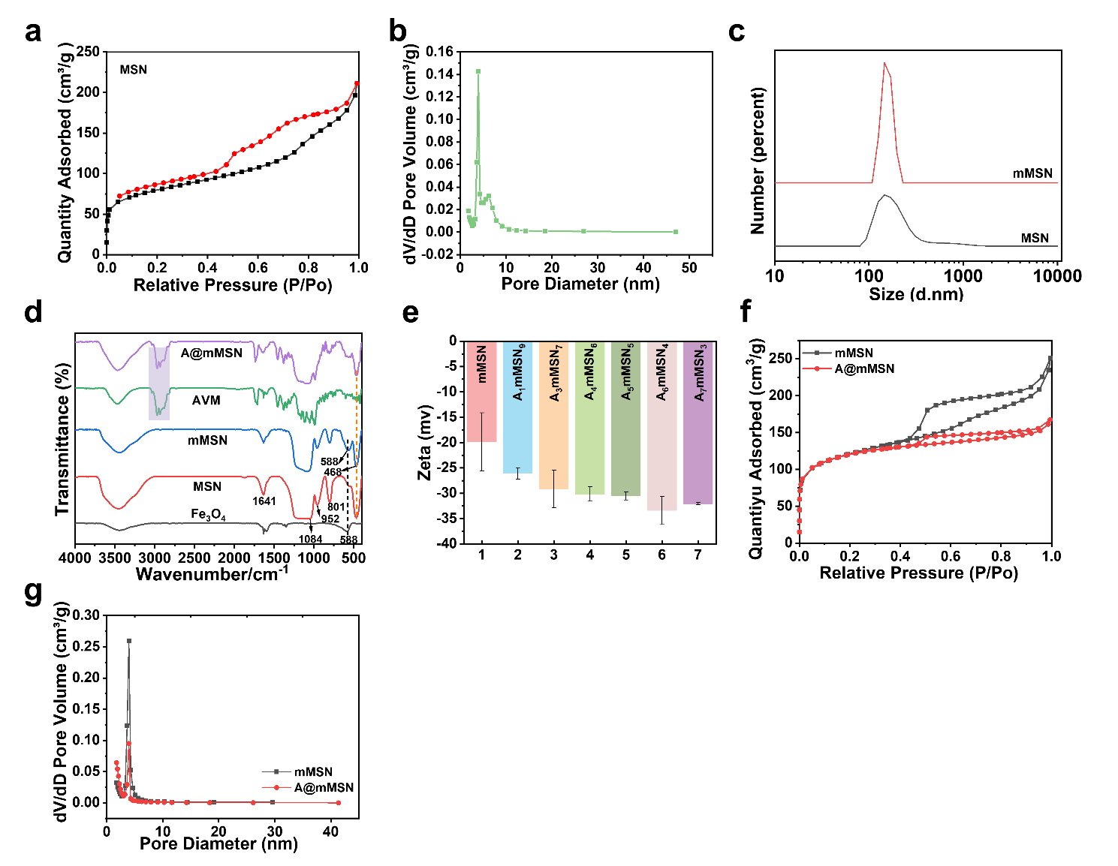
Fig. S1 (a) N₂ adsorption desorption curve and (b) the pore size distribution of MSN. (c) Particle size of MSN and mMSN. (d) FT-IR spectra of Fe₃O₄, MSN, mMSN, AVM and A@mMSN. (e) Zeta potential of A@mMSN. (f) N₂ adsorption desorption curve and (g) the pore size distribution of mMSN and A@mMSN.

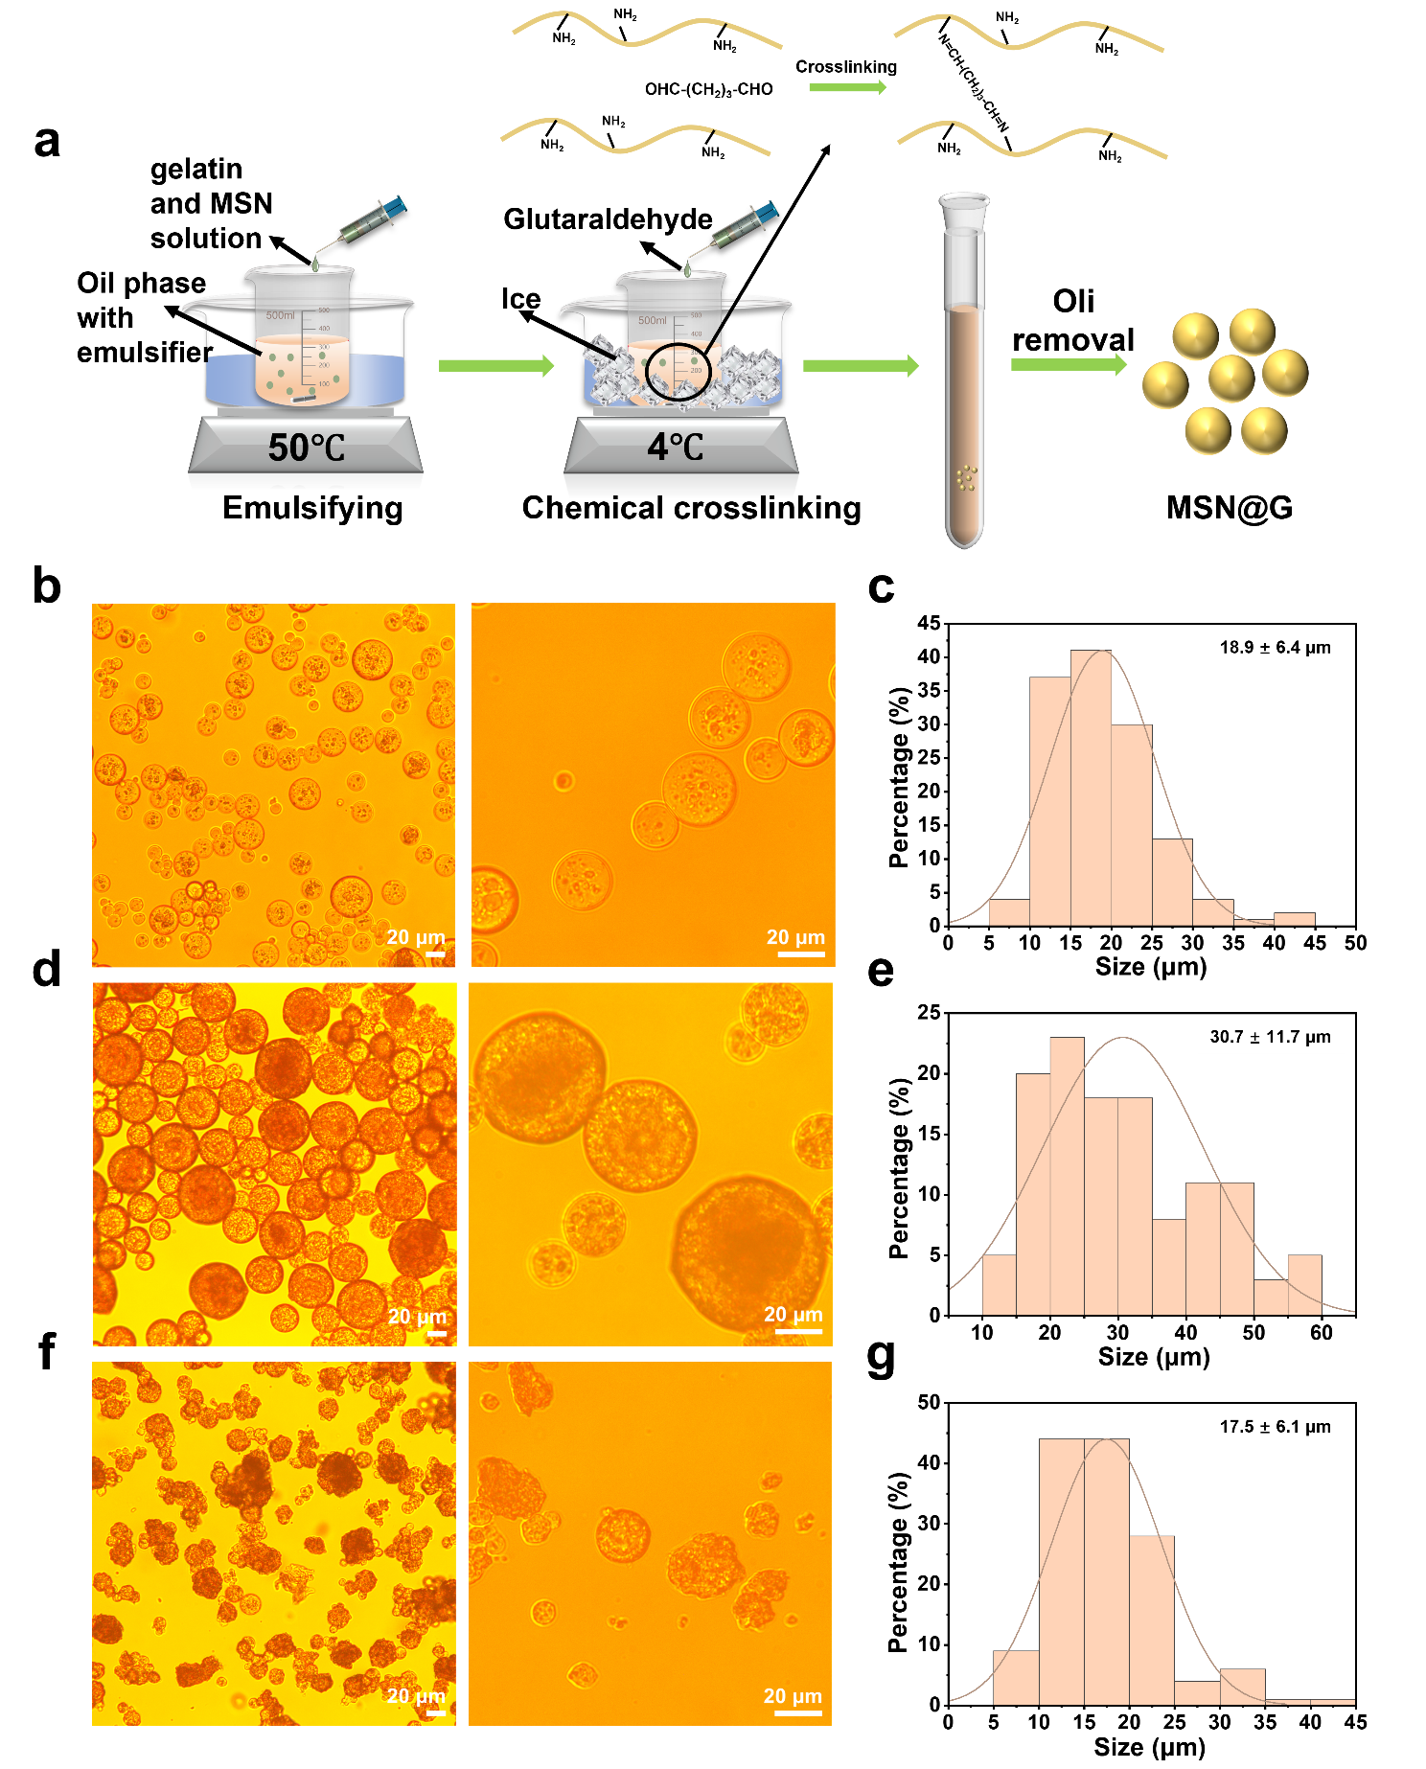
Fig. S2 (a) Preparation process of MSN@G microspheres. Microscopy and the size distribution of microspheres with different MSN: gelatin mass ratios of (b-c) 1:9, (d-e) 3:7 and (f-g) 5:5.

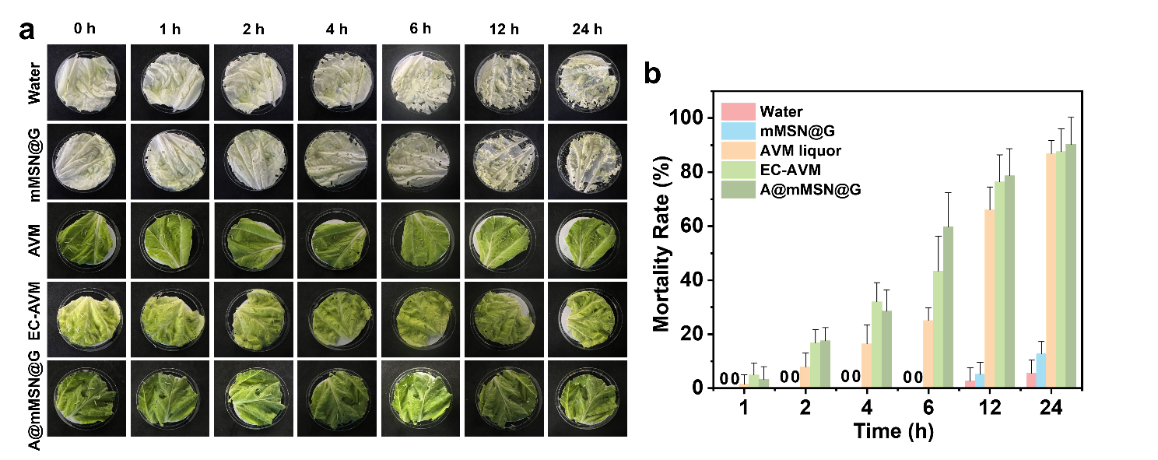
Fig. S3 (a) The monitor of leaves images during the 24 hours of treatments and (b) the corresponding insecticidal activity against diamondback moth.

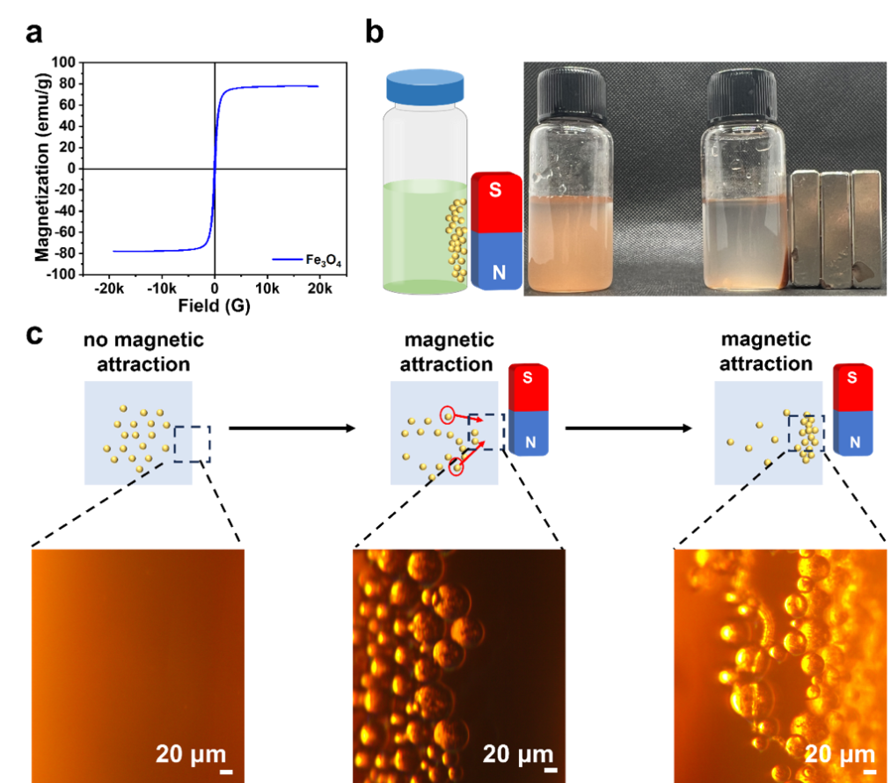
Fig. S4 (a) Hysteresis loop of Fe₃O₄ nanoparticles. (b) Magnetic recoverable appearance picture. (c) Images of A@mMSN@G microspheres at the edge of solution under magnetic attraction.
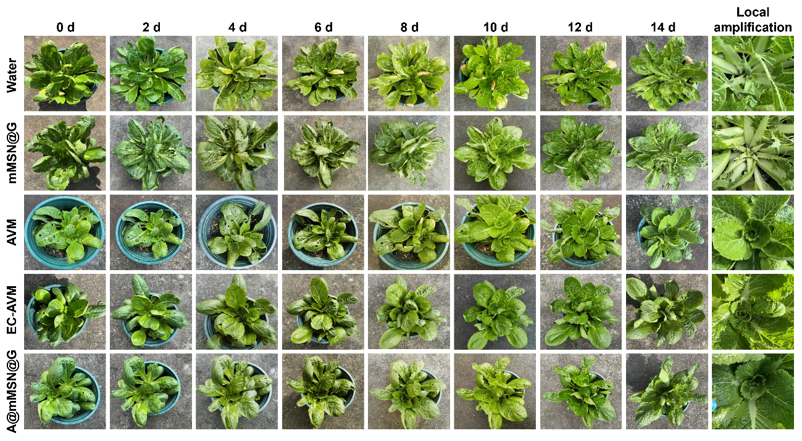
Fig. S5 Photos of potted Chinese cabbage at different times after treatment.

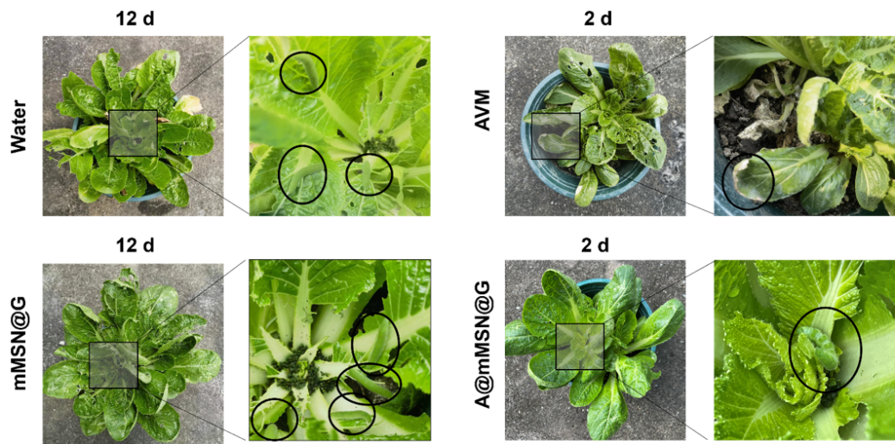
Fig. S6 The statistics of cabbage pests.

Table S1 Representative models used for describing kinetics of AVM release
Material type | Model | Equation | R²
A@mMSN@G microspheres | Zero-order model | y = 1.0120x + 0.1205 | 0.55972
A@mMSN@G microspheres | First-order model | ln(100-Q) = -1.03747t + 4.59302 | 0.56458
A@mMSN@G microspheres | Ritger-Peppas equation | ln Q = 0.21987lnt + 0.0387 | 0.56172
A@mMSN@G microspheres | Higuchi equation | Q = 0.21876t^{1/2} + 0.45634 | 0.71702
A@mMSN@G microspheres | Weibull equation | lnln[1/(1-Q/100)] = 0.22291lnt - 4.56524 | 0.56185
A@mMSN@G microspheres + neutral protease | Zero-order model | y = 3.71879x + 0.04455 | 0.61111
A@mMSN@G microspheres + neutral protease | First-order model | ln(100-Q) = -4.05918t + 4.55899 | 0.63176
A@mMSN@G microspheres + neutral protease | Ritger-Peppas equation | ln Q = 0.23909lnt + 1.2775 | 0.86176
A@mMSN@G microspheres + neutral protease | Higuchi equation | Q = 20.81906t^{1/2} + 1.59357 | 0.81270
A@mMSN@G microspheres + neutral protease | Weibull equation | lnln[1/(1-Q/100)] = 0.25169lnt - 3.32699 | 0.86223
A@mMSN@G microspheres + GSH | Zero-order model | y = 0.00195x - 0.02655 | 0.98649
A@mMSN@G microspheres + GSH | First-order model | ln(100-Q) = -0.00304t + 4.66945 | 0.95381
A@mMSN@G microspheres + GSH | Ritger-Peppas equation | ln Q = 1.52804lnt - 4.53092 | 0.96373
A@mMSN@G microspheres + GSH | Higuchi equation | Q = 3.48998t^{1/2} - 11.76662 | 0.86611
A@mMSN@G microspheres + GSH | Weibull equation | lnln[1/(1-Q/100)] = 1.70504lnt - 9.79474 | 0.97722
A@mMSN@G microspheres + neutral protease + GSH | Zero-order model | y = 0.00256x + 0.00338 | 0.98851
A@mMSN@G microspheres + neutral protease + GSH | First-order model | ln(100-Q) = -0.00542t + 4.7047 | 0.94581
A@mMSN@G microspheres + neutral protease + GSH | Ritger-Peppas equation | ln Q = 0.96804lnt - 1.25064 | 0.97583
A@mMSN@G microspheres + neutral protease + GSH | Higuchi equation | Q = 4.70163t^{1/2} - 13.21601 | 0.91124
A@mMSN@G microspheres + neutral protease + GSH | Weibull equation | lnln[1/(1-Q/100)] = 1.15642lnt - 6.4271 | 0.95755

