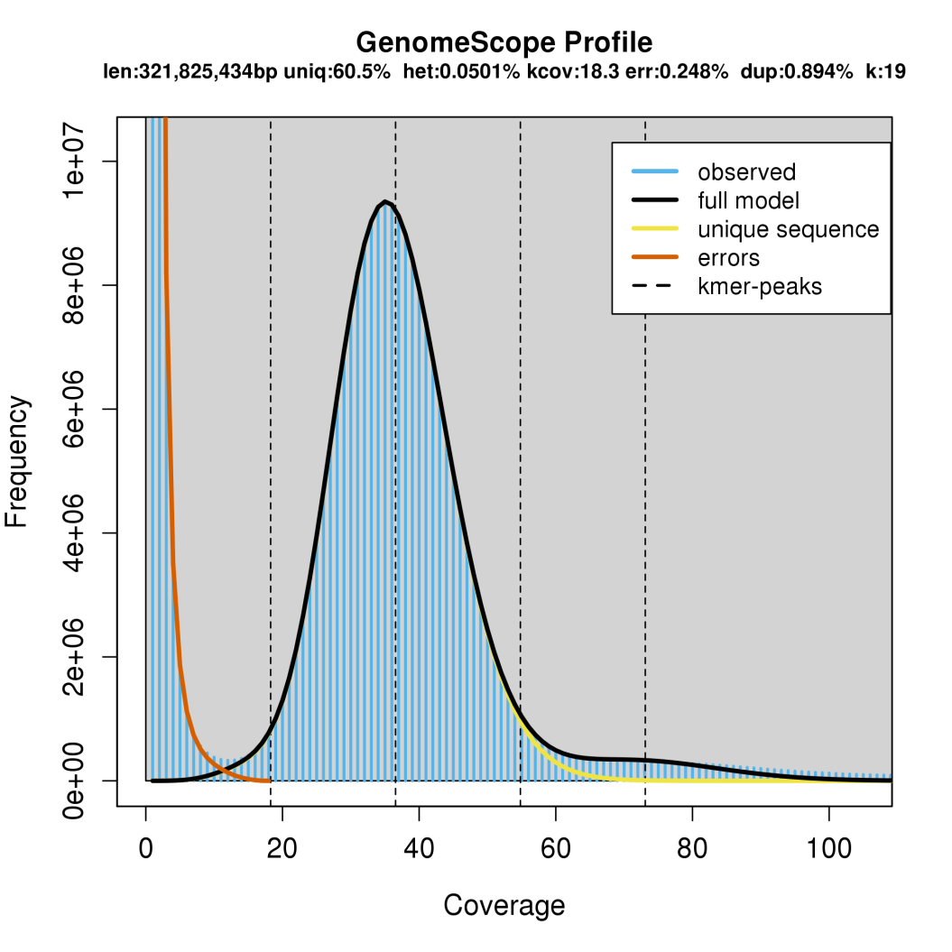
Supplementary Figure 1. GenomeScope profile of Sesamum indicum var. Goenbaek using Illumina short reads via k-mer prediction at k = 19
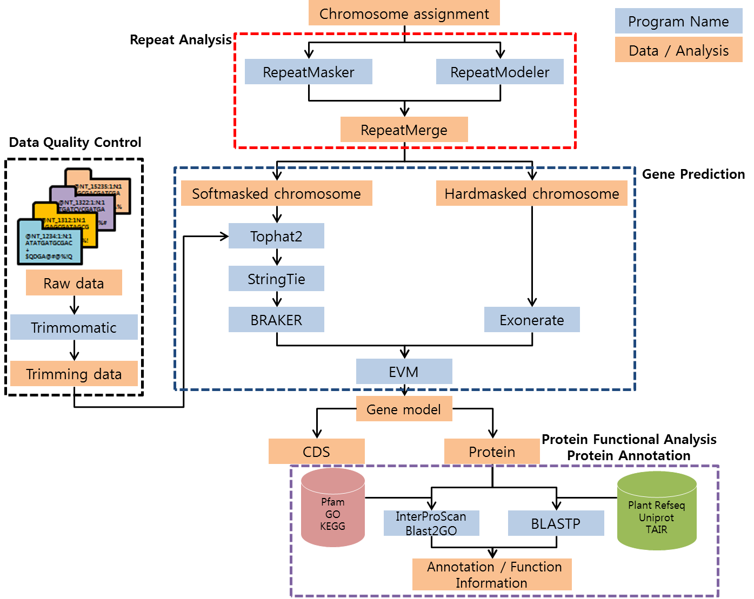
Supplentary Figure 2. Diagrammatic of the genome annotation of Sesamum indicum var. Goenbaek.

Supplementary Figure 3. NG(x) chart showing the contiguity of both genome assemblies. The NG50 value is shown as a dotted line.

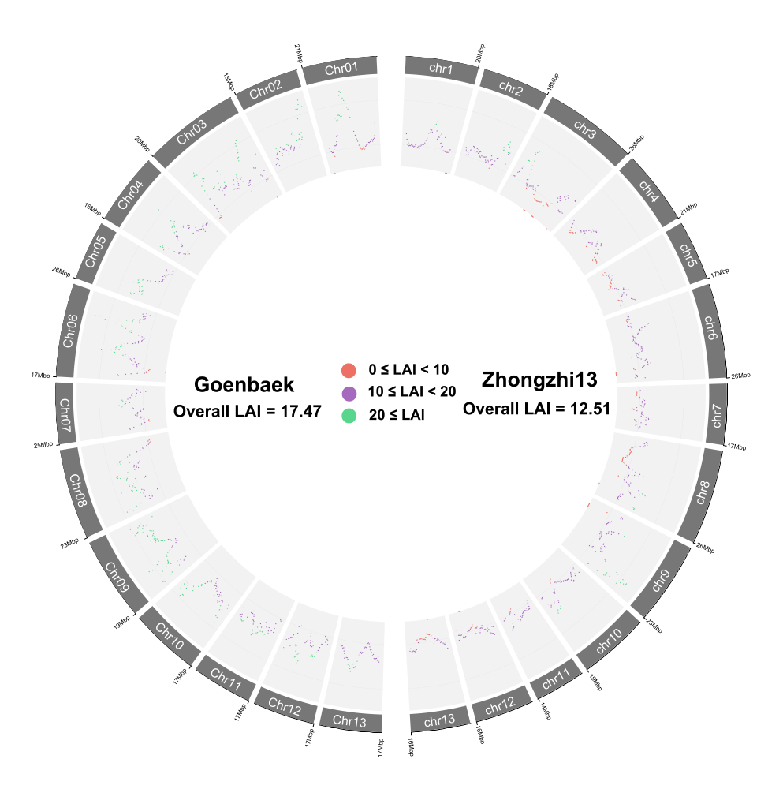

Supplementary Figure 4. Dot plot showing the LTR Assembly Index (LAI) distribution within each chromosome of Goenbaek and Zhongzhi13. The LAI values are colored as follows: red for LAI values between 0 and 10, purple for LAI values between 10 and 20, green for LAI values superior to 20. Tracks were summed in 500 Kbp windows with 25 Kbp step size.

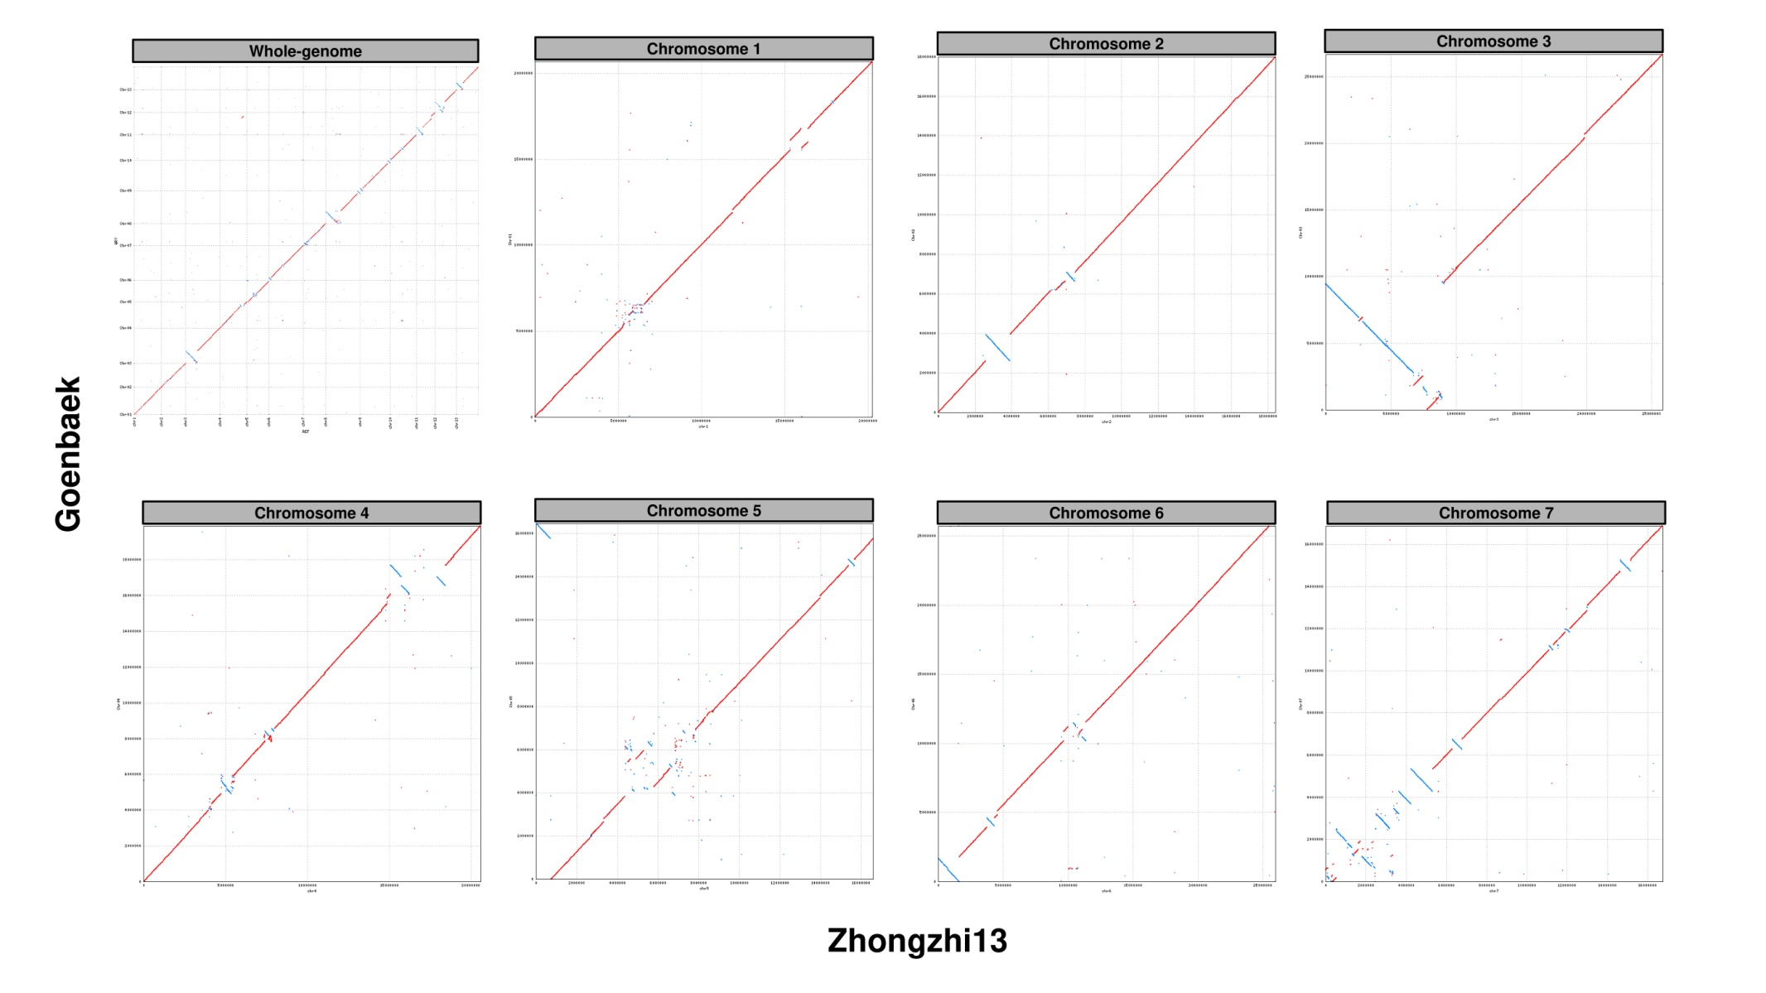
Supplementary Figure 5. MUMmer plot of the alignment of Goenbaek onto Zhongzhi13 (Whole genome, and from chromosome 1 to 7)
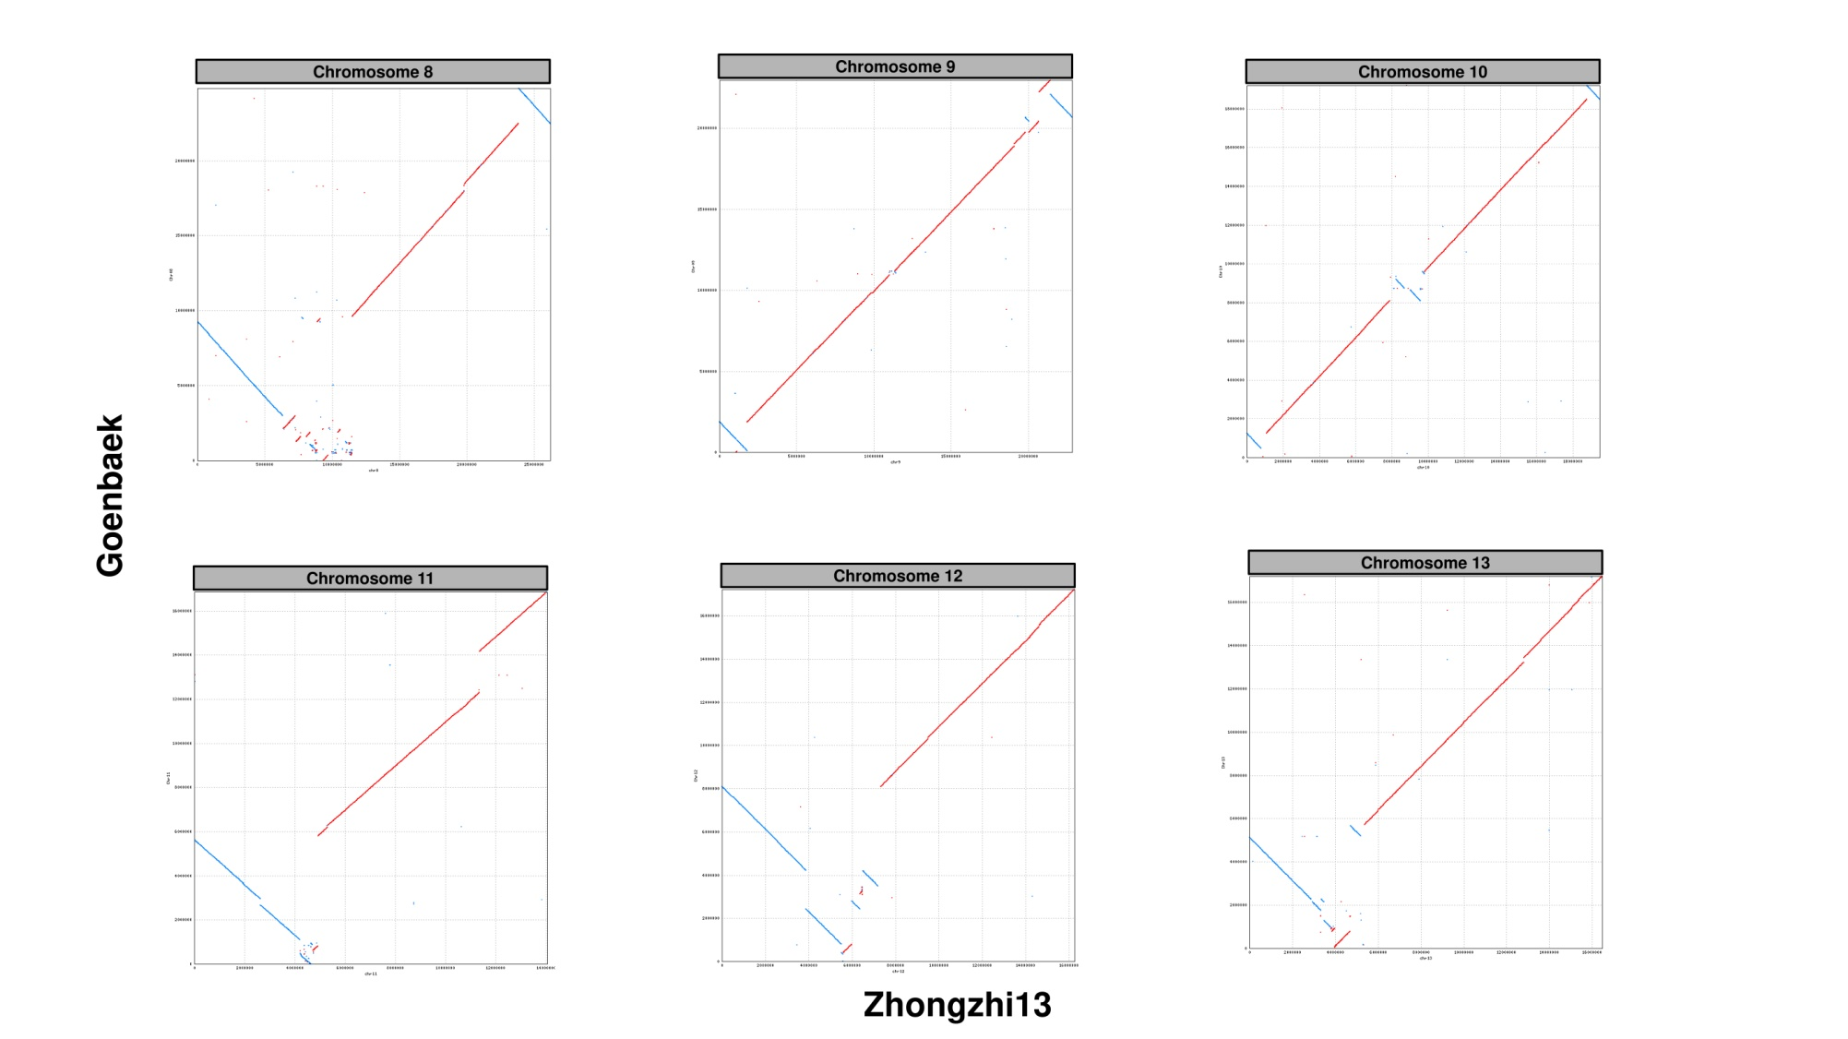
Supplementary Figure 6. MUMmer plot of the alignment of Goenbaek onto Zhongzhi13 (From chromosome 8 to 13)

