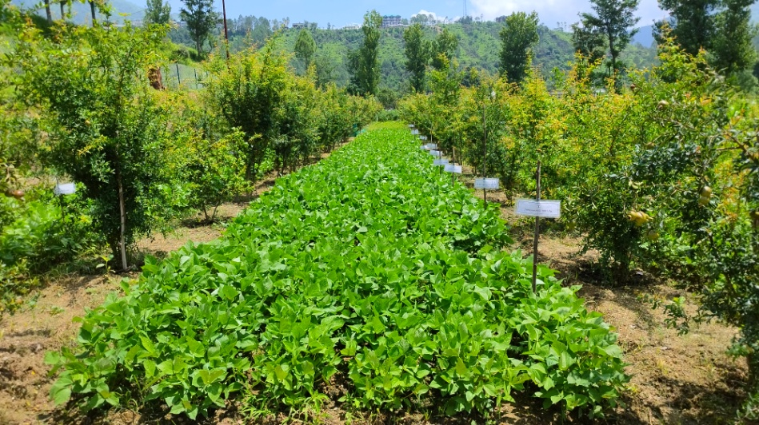
Plate 1 Mash (Vigna mungo) + wild pomegranate based agroforestry system
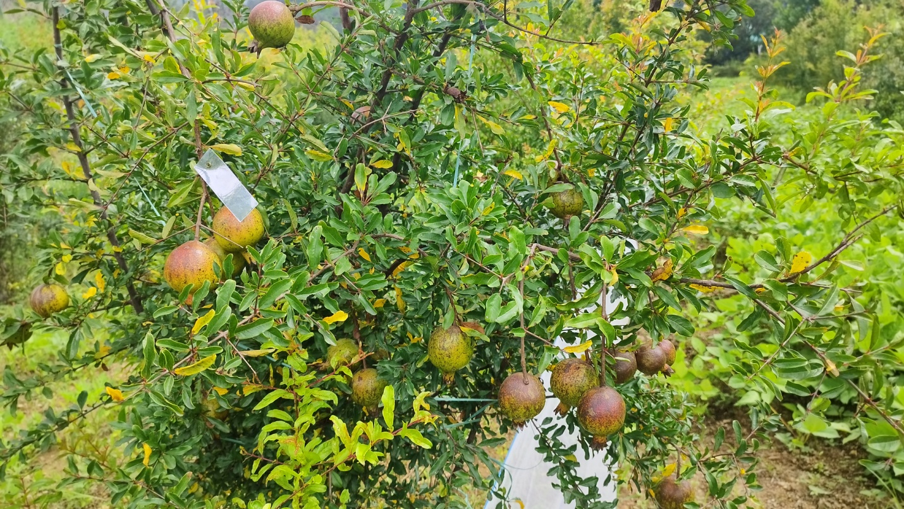
Plate 1 Wild pomegranate (Punica granatum) in fruiting
Plate 4.5 Mash (Vigna mungo) + wild pomegranate based agroforestry system
Plate 4.5 Mash (Vigna mungo) + wild pomegranate based agroforestry system
APPENDIX-IV: Cost of cultivation of Vigna mungo (Mash) Rs. ha⁻¹
Cost components | Unit | Cost/unit  (Rs.) | Quantity | Value  (Rs.)
A. Variable costs
1) Non-labour input
- Seeds | kg | 100 | 20 | 2000
Sub-total (1) | Rs. |  |  | 2000
2) Labour input |  |  |  | 0
- Ploughing | hour | 700 | 3 | 2100
- Field preparation | MD | 300 | 12 | 3600
- Sowing | MD | 300 | 10 | 3000
- Weeding/hoeing | MD | 300 | 10 | 3000
- Irrigation | MD | 300 | 5 | 1500
- Harvesting | MD | 300 | 10 | 3000
- Threshing/Cleaning | Rs. | 300 | 10 | 3000
- Others (Transportation/electricity) | Rs. |  |  | 2500
Sub-total (2) | Rs. |  |  | 21700
Total variable costs {Sub-total (1) + Sub-total (2)} | Rs. |  |  | 23700
3) Miscellaneous (2% of total variable cost) | Rs. |  |  | 474
4) Interest on working capital (5 %) | Rs. |  |  | 1185
B. Fixed costs
- Depreciation | Rs. |  | 300 | 300
- Land revenue | Rs. |  | 31.25 | 31.25
- Rental value of owned land | Rs. |  | 10000 | 10000
Sub-total (3) | Rs. |  |  | 10331.25
iv) Interest on fixed capital (5%) | Rs. |  |  | 516.56
Sub-total (4) | Rs. |  |  | 516.56
Total fixed cost {Sub-total (3) + Sub-total (4)} | Rs. |  |  | 10847.81
Total Cost of cultivation (A+B) | Rs. |  |  | 36206.81
Amount and Cost of manure and fertilizer on nitrogen equivalence basis
Urea | Rs. | 6.40 | 43.40 | 277.76
SSP | Rs. | 11 | 250 | 2750
MOP | Rs. | 19 | 33.2 | 630.8
FYM | Rs. | 2.85 | 4000 | 11400
Vermicompost | Rs. | 10 | 1300 | 13000
Goat Manure | Rs. | 10 | 600 | 6000
Jeevamrut | Rs. | 2 | 500 | 1000
* MD= Man Days
Vigna mungo was sold @100Rs./kg in the university sale center.
APPENDIX-VI: Cost of cultivation and returns of wild pomegranate for the year 2023 (Rs. ha⁻¹)
Items | Unit | Qty | Unit Rate | 2023 | Total Cost (Rs.)
Site preparation | MD | 20 | 275 | 5500 | 5500
Digging of pits | MD | 35 | 275 | 9625 | 9625
Planting and filling of pits | MD | 15 | 275 | 4125 | 4125
Cost of seedling | Seedlings | 1250 | 30 | 37500 | 37500
Cost of FYM | kg | 2500 | 2.85 | 7125 | 7125
Fruit extraction | MD | 13 | 300 | 3900 | 3900
Sub-total (A) |  |  |  |  | 67775
Cost calculated on the basis of annuity | Rs. |  |  |  | 7441.331
Weeding | MD | 18 | 275 | 4975 | 4975
Pruning | MD | 19 | 300 | 5675 | 5675
Insecticide/pesticide | Rs. |  |  | 1600 | 1600
Sub-total (B) |  |  |  |  | 19691.33
Miscellaneous (2% on total working capital) | Rs. |  |  |  | 393.82
Interest on working capital (5%) | Rs. |  |  |  | 984.56
Land rent | Rs. |  |  | 3200 | 3200
Depreciation and maintenance | Rs. |  |  | 300 | 300
Sub-total (C) |  |  |  |  | 4878.38
Total cost of cultivation (A+B+C) | Rs. |  |  | 83525 | 24569.72
Returns
Fruit yield (kg) | Rs. | 250 | 300 | 75000 | 75000

APPENDIX-VII: Cost of cultivation and returns of wild pomegranate for the year 2022 (Rs. ha⁻¹)
Items | Unit | Qty | Unit Rate | 2022 | Total Cost (Rs.)
Site preparation | MD | 20 | 275 | 5500 | 5500
Digging of pits | MD | 35 | 275 | 9625 | 9625
Planting and filling of pits | MD | 15 | 275 | 4125 | 4125
Cost of seedling | Seedlings | 1250 | 30 | 37500 | 37500
Cost of FYM | kg | 2500 | 2.85 | 7125 | 7125
Fruit extraction | MD | 5 | 300 | 1500 | 1500
Sub-total (A) |  |  |  |  | 65375
Cost calculated on the basis of annuity | Rs. |  |  |  | 7177.824
Weeding | MD | 12 | 275 | 3475 | 3475
Pruning | MD | 11 | 300 | 3275 | 3275
Insecticide/pesticide | Rs. |  |  | 800 | 800
Sub-total (B) |  |  |  |  | 14727.82
Miscellaneous (2% on total working capital) | Rs. |  |  |  | 294.55
Interest on working capital (5%) | Rs. |  |  |  | 736.39
Land rent | Rs. |  |  | 3200 | 3200
Depreciation and maintenance | Rs. |  |  | 300 | 300
Sub-total (C) |  |  |  |  | 4530.94
Total cost of cultivation (A+B+C) | Rs. |  |  | 76425 | 19258.77
Returns
Fruit yield (kg) | Rs. | 80 | 300 | 24000 | 24000

