Determinants of locally acquired malaria infections in Zanzibar: a cross-sectional study
Bakar S. Fakih^{1,2,3*}; Osama Seidahmed^{2,3}; Aurel Holzschuh²; Ramadhan Abdul^{1,4}; Imani Irema¹; Shija J. Shija⁵; Safia M. Aliy⁵; Abdullah Ali⁵; Günther Fink^{2,3}; Joshua Yukich⁶; Manuel W. Hetzel^{2,3}
¹ Ifakara Health Institute, Dar es Salaam, Tanzania
² Swiss Tropical and Public Health Institute, Allschwil, Switzerland
³ University of Basel, Basel, Switzerland
⁴Current affiliation: Amsterdam Institute for Global Health and Development, Amsterdam, Netherlands
⁵Zanzibar Malaria Elimination Programme, Zanzibar, United Republic of Tanzania
⁶Tulane University School of Public Health and Tropical Medicine, New Orleans, Louisiana, United States

*Corresponding author: Bakar Shariff Fakih: bakar.fakih@swisstph.ch, bfakih@ihi.or.tz

Supplementary figures and tables
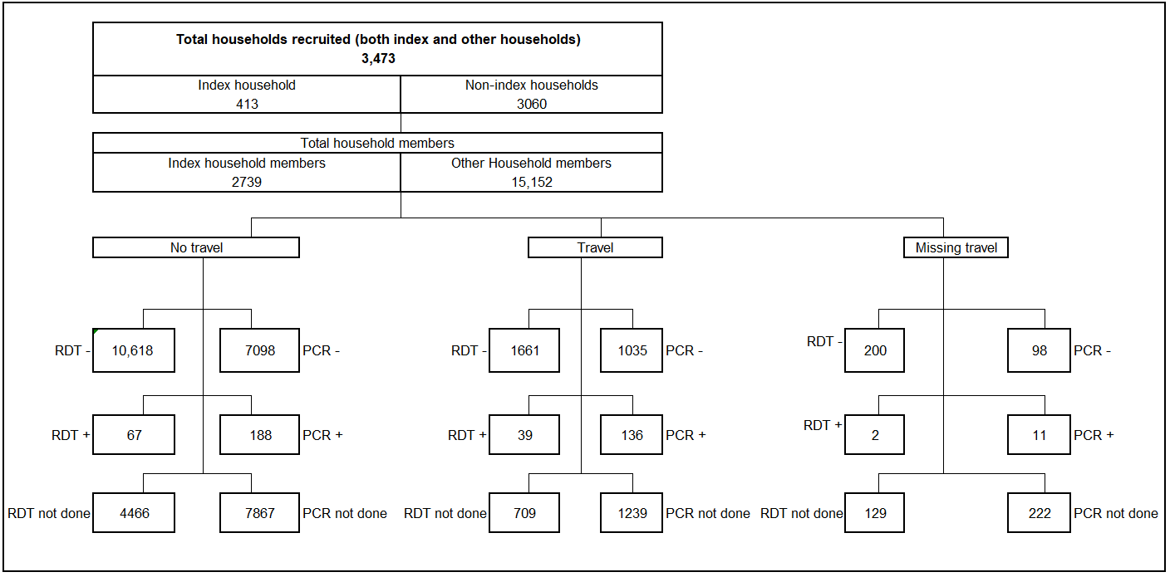
Figure S1. Study flow chart and description of the study population

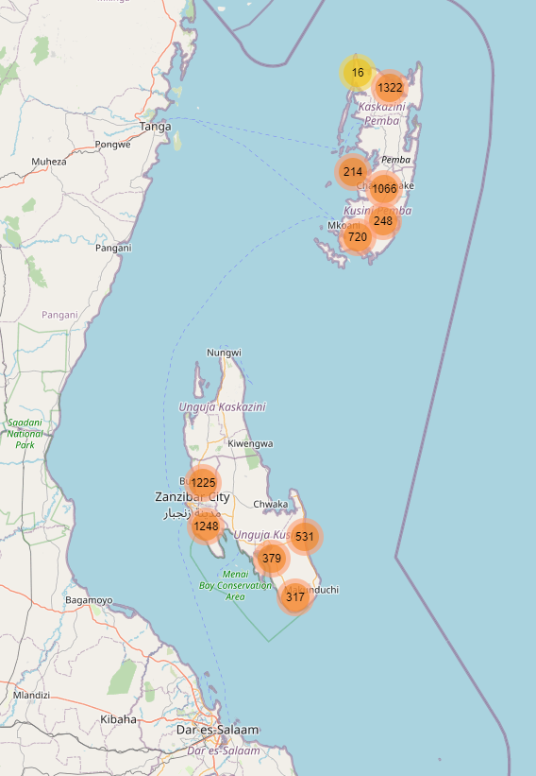
Figure S2, preview: Spatial Distribution of Malaria-Positive Individuals among individuals with no recent travel outside Zanzibar. The interactive figure can be access on Zenodo: [DOI: 10.5281/zenodo.10372119]

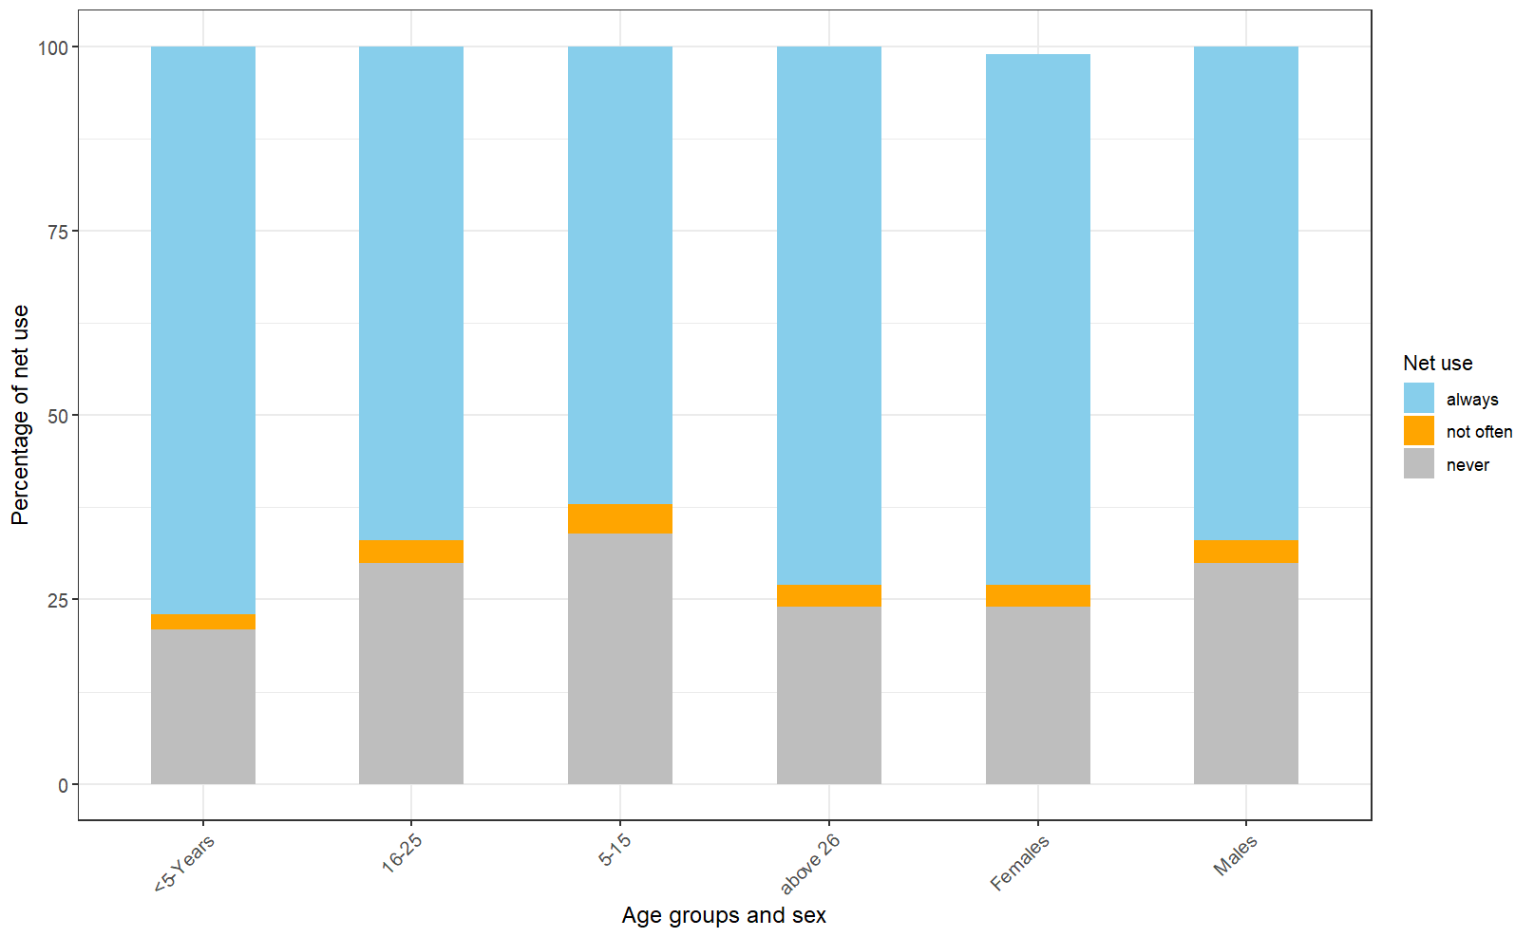
Figure S3: Participants’ mosquito regular net use

Table S1: Study participants’ household characteristics related to water, sanitation and housing structures
Variables | n (%)
Water and sanitation
Main source of drinking water
Piped water | 5251 (72)
Well or borehole | 2031 (28)
Missing | 4 (0)
Toilets
Households with toilets facility | 5851 (80)
No facility/bush/field | 1431 (20)
Missing | 4 (0)
Houses structures
Roofing status
Finished roofing | 6154 (84)
Natural roofing | 1128 (15)
Missing | 4 (0.1)
Window can be closed
Yes | 3840 (53)
No | 3442 (47)
Missing | 4 (0)
Eaves open
Open | 5468 (75)
Closed | 1814 (24.9)
Missing | 4 (0.1)
Number of rooms
One room | 729 (10)
2-3 rooms | 4857 (67)
4+ rooms | 1696 (23)
Missing | 4 (0.1)
Low quality house
No | 6986 (96)
Yes | 300 (4)
Total | 7286 (100)

Table S2: Summary of study participants’ characteristics related remote sensing attributes
Variables | n (%)
Types of households
Other households members | 6397 (89)
Index households members | 889 (12)
Human behavior
Sleep net
Yes | 5880 (81)
No | 1391 (19)
Missing | 15 (0.2)
Sleep net (how often)
Always | 5108 (70)
Not often | 216 (3)
Never | 1947 (27)
Missing | 15 (0)
Indoor time
Early evening (18-20hrs) | 3640 (50)
Early night (20-22hrs) | 2432 (33)
More than 21.30hrs | 1192 (16)
Missing | 22 (0.3)
Sleep time
Early evening (18-20hrs) | 1934 (27)
Early night (20-22hrs) | 4334 (59)
More than 21.30hrs | 960 (13)
Missing | 58 (1)
Vector control measures
IRS
Yes | 2787 (38)
No | 4356 (60)
Missing | 143 (2)
Household with any net
Yes | 6399 (88)
No | 883 (12)
Missing | 4 (0.1)
Sleeping spaces covered with net
No space covered with net | 140 (2)
One space covered | 937 (15)
Two spaces covered | 1561 (24)
Three spaces covered | 1716 (27)
More than four spaces covered | 2045 (32)
Total | 7286 (100)

Table S3: Prevalence of malaria across variables of interest
Socio-demographic variables | N=7286
 | Negative | Positive | p-value
Gender
Males | 2938 (41) | 82 (44) | 0.541
Females | 4160 (59) | 106 (56) | 0.541
Age groups
Less than 5 years | 538 (8) | 9 (5) | <0.001
5 - 15 | 1383 (19) | 64 (34) | <0.001
16 - 25 | 1303 (18) | 46 (24) | <0.001
26 + | 3874 (55) | 69 (37) | <0.001
Households types
Other households members | 6319 (89) | 78 (41) | <0.001
Index households members | 779 (11) | 110 (59) | <0.001
Districts of residence
West (Unguja) | 2401 (34) | 72 (38) | 0.006
South (Unguja) | 1208 (17) | 19 (10) | 0.006
Micheweni (Pemba) | 1289 (18) | 49 (26) | 0.006
Chakechake (Pemba) | 1251 (18) | 29 (15) | 0.006
Mkoani (Pemba) | 949 (13) | 19 (10) | 0.006
Island of residence
Pemba | 3489 (49) | 97 (52) | 0.509
Unguja | 3609 (51) | 91 (48) | 0.509
Occupation
Entrepreneur | 1650 (23) | 56 (30) | 0.207
Not employed | 2844 (40) | 68 (36) | 0.207
Student | 2364(33) | 57 (30) | 0.207
Wage Job | 233 (3) | 6 (3) | 0.207
Wealth quintile
Lowest | 1416 (20) | 56 (30) | 0.022
2nd | 1500 (21) | 38 (20) | 0.022
Middle | 1363 (19) | 32 (17) | 0.022
4th | 1681 (24) | 37 (20) | 0.022
Highest | 1138 (16) | 25 (13) | 0.022
Water and sanitation
Main source of drinking water
Piped water | 5138 (72) | 113 (60) | <0.001
well / borehole | 1957 (28) | 74 (39) | <0.001
Missing | 3 (0) | 1 (1) | <0.001
Toilets types
With toilet facility | 5720 (81) | 131 (70) | <0.001
No facility/bush/field | 1375 (19) | 56 (30) | <0.001
Missing | 3 (0) | 1 (1) | <0.001
Houses structures
Roofing status
Finished roofing | 6013 (85) | 141 (75) | <0.001
Natural/unfinished roofing | 1082 (15) | 46 (24) | <0.001
Missing | 3 (0) | 1 (1) | <0.001
Screened window available
Yes | 3772 (53) | 68 (36) | <0.001
No | 3323 (47) | 119 (63) | <0.001
Missing | 3 (0) | 1 (1) | <0.001
Eaves open
Open | 5322 (75) | 146 (77) | 0.012
Closed | 1773 (25) | 41 (22) | 0.012
Missing | 3 (0) | 1 (1) | 0.012
Quality house
Not high quality house | 6547 (92) | 175 (93) | 0.668
High quality house | 551 (8) | 13 (7) | 0.668
Low quality house
No | 6818 (96) | 168 (89) | <0.001
Yes | 280 (4) | 20 (11) | 0.668
Number of rooms
One room | 701 (10) | 28 (15) | 0.004
2-3 rooms | 4737 (67) | 120 (64) | 0.004
4+ rooms | 1657 (23) | 39 (21) | 0.004
Missing | 3 (0) | 1 (1) | 0.004
Human behavior
Sleep net
Yes | 5741 (89) | 139 (74) | 0.043
No | 1343 (19) | 48 (25) | 0.043
Missing | 14 (0) | 1 (1) | 0.043
Sleep net (how often)
Always | 5007 (71) | 101 (54) | <0.001
Not often | 207 (3) | 9 (5) | <0.001
Never | 1870 (26) | 77 (41) | <0.001
Missing | 14 (0) | 1 (0) | <0.001
Indoor time
Early evening (18-20hrs) | 3537 (50) | 103 (55) | 0.001
Early night (20-22hrs) | 2384 (34) | 48 (26) | 0.001
More than 22hrs | 1158 (16) | 34 (18) | 0.001
Missing | 19 (0) | 3 (2) | 0.001
Sleep time
Early evening (18-20hrs) | 1862 (26) | 72 (38) | 0.001
Early night (20-22hrs) | 4244 (60) | 90 (48) | 0.001
More than 22hrs | 937 (13) | 23 (12) | 0.001
Missing | 55 (1) | 3 (2) | 0.001
Vector control measures
IRS any time in the past 12 months
Yes | 2712 (38) | 75 (40) | 0.169
No | 4250 (60) | 106 (56) | 0.169
Missing | 136 (2) | 7 (4) | 0.169
Household with any net
Yes | 6257 (88) | 142 (75) | <0.001
No | 838 (12) | 45 (24) | <0.001
Missing | 3 (0) | 1 (1)
Environmental variables
Average minimum temperature (°C )
Minimum low (<22) | 3195 (45) | 110 (41) | 0.001
Minimum high (> 22) | 3689 (52) | 73 (39) | 0.001
Missing | 214 (3) | 5 (3) | 0.001
Average maximum temperature (°C )
Maximum low (<30) | 4486 (63) | 113 (60) | 0.607
Maximum high (> 30) | 2398 (34) | 70 (37)
Missing | 214 (3) | 5 (3)
Average soil moisture (kPa)
Low (<45) | 1316 (19) | 52 (28) | <0.001
Moderate (46-46) | 2950 (42) | 88 (47) | <0.001
High (>46) | 2618 (37) | 43 (23) | <0.001
Missing | 214 (3) | 5 (3) | <0.001
Average precipitation (mm)
Low (<120) | 2655 (37) | 88 (47) | 0.006
Moderate (121-220) | 3391 (48) | 86 (46) | 0.006
High (>220) | 838 (12) | 9 (5) | 0.006
Missing | 214 (3) | 5 (3) | 0.006
Average relative humidity (RH)
Low (<80) | 2006 (28) | 68 (36) | <0.001
Moderate (80 - 83) | 3468 (49) | 100 (53) | <0.001
High (>83) | 1410 (20) | 15 (8) | <0.001
Missing | 214 (3) | 5 (3) | <0.001
Palmer Drought Severity Index
Low (<-1.0) | 3400 (48) | 40 (21)
Moderate (-1.01 - 1.0) | 2127 (30) | 93 (49)
High (>1.0) | 1357 (19) | 50 (27) | <0.001
Missing | 214 (3) | 5 (3)
Seasons
Long rains | 1765 (25) | 19 (10) | <0.001
Dry season | 3358 (47) | 98 (52) | <0.001
Short rains | 1975 (28) | 71 (38) | <0.001

Table S4: Participants characteristics by age
Variable N=7286 | All participants | Only positive
Mean | 21 | 20
Median | 16 | 17
25th percentile | 7 | 11
75th percentile | 30 | 26
IQR | 23 | 15

Table S5: Metrological, environmental parameters by island (Unguja and Pemba)
 | Island
Variable N=7286 | Pemba | Unguja | P-value
Average minimum temperature (°C )
Minimum low (<22) | 1699 (47) | 1606 (43) | 0.002
Minimum high (> 22) | 1776 (50) | 1986 (54) | 0.002
Missing | 111 (3) | 108 (3) | 0.002
Average maximum temperature (°C )
Maximum low (<30) | 2613 (73) | 1986 (54) | <0.001
Maximum high (> 30) | 862 (24) | 1606 (43) | <0.001
Missing | 111 (3) | 108 (3) | <0.001
Soil moisture (kPa)
Low (<499) | 411 (11) | 957 (26) | <0.001
Moderate (502.0-599) | 1477 (41) | 1561 (42) | <0.001
High (>600) | 1587 (44) | 1074 (29) | <0.001
Missing | 111 (3) | 108 (3) | <0.001
Average precipitation (mm)
Low (<120) | 1146 (32) | 1597 (43) | <0.001
Moderate (121-220) | 1995 (56) | 1482 (40) | <0.001
High (>220) | 334 (9) | 513 (14) | <0.001
Missing | 111 (3) | 108 (3) | <0.001
Relative humidity (RH)
Low (<80) | 161 (4) | 1913 (52) | <0.001
Moderate (80 - 83) | 2291 (64) | 1277 (35) | <0.001
High (>83) | 1023 (29) | 402 (11) | <0.001
Missing | 111 (3) | 108 (3) | <0.001
Palmer Drought Severity Index
Low (<-1.0) | 1681 (47) | 1759 (48) | <0.001
Moderate (-1.01 - 1.0) | 1180 (33) | 1040 (28) | <0.001
High (>1.0) | 614 (17) | 793 (21) | <0.001
Missing | 111 (3) | 108 (3) | <0.001

Table S6: Crude odds ratios for metrological, environmental parameters and risk factors associated with malaria infection
Environmental variables | N=7286 |  | Univariate analysis
Average minimum temperature (°C ) | Negative | Positive | OR | 95% CI | p-value
Minimum low (<22) | 3195 (97) | 110 (3) | ref | - | 0.002
Minimum high (> 22) | 3689 (98) | 73 (2) | 0.5 | 0.29-0. 69
Missing | 214 (98) | 5 (2) | 0.8 | 0.22-2.66
Average maximum temperature (°C )
Maximum low (<30) | 4486 (98) | 113 (2) | ref | -
Maximum high (> 30) | 2398 (97) | 70 (3) | 1.4 | 0.90-2.18 | 0.318
Missing | 214 (98) | 5 (2) | 1.2 | 0.36- 4.31
Average soil moisture (kPa)
Low (<499) | 1316 (96) | 52 (4) | ref | - | 0.001
Moderate (502.0-599) | 2950 (97) | 88 (3) | 0.6 | 0.35-0.99
High (>600) | 2618 (98) | 43 (2) | 0.3 | 0.17-0.55
Missing | 214 (98) | 5 (2) | 0.6 | 0.17-2.78
Average precipitation (mm)
Low (<120) | 2655 (97) | 88 (3) | ref | - | 0.021
Moderate (121-220) | 3391 (98) | 86 (3) | 0.6 | 0.41-0.99
High (>220) | 838 (99) | 9 (2) | 0.3 | 0.12-0.69
Missing | 214 (98) | 5 (2) | 0.8 | 0.23-3.88
Average relative humidity (RH)
Low (<80) | 2006 (97) | 68 (3) | ref | - | 0.010
Moderate (80 - 83) | 3468 (97) | 100 (3) | 0.8 | 0.56-1.28 | 0.010
High (>83) | 1410 (99) | 15 (1) | 0.3 | 0.15-0.61 | 0.010
Missing | 214 (98) | 5 (2) | 0.8 | 0.24-2.87 | 0.010
Palmer Drought Severity Index
Low (<-1.0) | 3400 (99) | 40 (1) | ref | - | <0.001
Moderate (-1.01 - 1.0) | 2127 (96) | 93 (4) | 4.3 | 2.61-7.09
High (>1.0) | 1357 (96) | 50 (2) | 3.3 | 1.87-5.91
Missing | 214 (98) | 5 (2) | 2.5 | 0.73-8.81

Table S7 Households with at least one bed net (N=7286)
 | Negative n (%) | Positive n (%) | Total n (%)
Yes | 6,257 (88) | 142 (76) | 6399 (88)
No | 838 (12) | 45 (24) | 883 (12)
Missing | 3 (0) | 1 (0) | 4 (0)

Table S8: Frequency of household members using bed nets versus members sleeping time (N=7286)
 | Bed net use
Sleeping time | Always n (%) | Not often n (%) | Never n (%) | Missing n (%)
18.00 – 20.00hrs | 1457 (75) | 52 (3) | 421 (22) | 4 (0.2)
20.00 - 22.00hrs | 3055 (70) | 113 (3) | 1162 (27) | 4 (0.1)
More than 22.00hrs | 558 (58) | 50 (5) | 350 (36) | 2 (0.2)
Missing | 38 (66) | 1 (2) | 14 (24) | 5 (9)

Includes variables presented in Table 2 of the manuscript
Model includes random effect to account for clustering at household level

