Supporting Information
Aza-[4+2]-cycloaddition of benzocyclobutenones into isoquinolinone derivatives enabled by photoinduced regio-specific C–C bond cleavage
Liangkun Yang¹⁺, Shiyang Li¹⁺, Hansen Zhao¹, Liang Zhou¹, Weidi Cao*¹, and Xiaoming Feng*¹

Table of Contents
Table of Contents 2
1. General information 3
2. General procedure for the catalytic reaction 4
2.1 General procedure for the catalytic reactions between benzocyclobutenones and 3,4-dihydroisoquinoline 4
2.2 General procedure for the catalytic asymmetric reactions between benzocyclobutenones and benzosulfonimides. 4
2.3 Experimental procedure for the scale-up reaction 5
3. Experimental procedure for further transformations of the products. 5
4. Mechanistic studies 7
4.1 Radical trapping experiments 7
4.2 Ortho-quinoid ketene methides trapping experiments 7
5. Optimization of the reaction conditions 8
5.1 Optimization of the reaction conditions of benzocyclobutenones with 3,4-dihydroisoquinoline 8
5.2 Optimization of the reaction conditions of benzocyclobutenones with benzosulfonimides 10
6. Limitations of the asymmetric reaction 14
7. X-ray crystallography Data 14
8. The analytical and spectral characterization data for the products 16
9. Copies of NMR spectra 43
10. References 108

1. General information
¹H NMR spectra were recorded at Bruker Ascend 400 MHz. The chemical shifts were recorded in ppm relative to tetramethylsilane and with the solvent resonance as the internal standard. Data were reported as follows: chemical shift, multiplicity (s = singlet, d = doublet, t = triplet, q = quartet, dd = doublet of doublet, m = multiple), coupling constants (Hz), integration. ¹³C NMR spectra were collected at 101 MHz with complete proton decoupling. ¹⁹F NMR spectra were collected were collected at 377 MHz with complete proton decoupling. Enantiomeric excesses (ee) were determined by chiral UPC² analysis by using the corresponding commercial chiralpak column as stated in the experimental procedures at 35 °C with UV detector at 254 nm. Optical rotations were reported as follows: [α]^{T}_{D} (c: g/100 mL, solvent). High resolution mass spectra (HRMS) analyses were recorded on a Thermo Scientific LTQ Orbitrap XL with positive ion mode and methanol were used to dissolve the sample. IR spectra were recorded on Pierkin Elmer 100 FT/IR spectrometer, and the wave numbers of the absorption peaks are given in cm⁻¹. Solvents were dried and distilled prior to use according to the standard methods. Unless noted, other commercially available reagents were used without further purification.
The chiral N,N′-dioxide ligands were synthesized by the same procedure in the literature¹⁻³.
Benzocyclobutenone A1 and 3,4-dihydroisoquinoline B was purchased from Bide Pharmatech Ltd and used directly without further purification.
Benzocyclobutenones A were prepared according to literature procedure⁴⁻⁷.
Benzosulfonimides D were prepared according to literature procedure⁸⁻¹⁰.

2. General procedure for the catalytic reaction

2.1 General procedure for the catalytic reactions between benzocyclobutenones and 3,4-dihydroisoquinoline
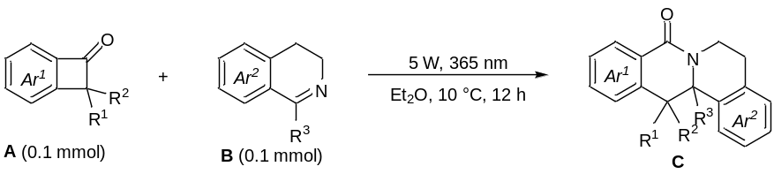
To a 20 ml dry quartz tube was added benzocyclobutenones A (0.1 mmol), 3,4-dihydroisoquinoline B (0.1 mmol) and Et₂O (3.0 mL) under N₂ atmosphere and the resulting mixture was stirred under UV LED (5 W, λ_{max} = 365 nm) irradiation at 10 °C. After starting material was fully consumed (detected by TLC), the mixture was purified by column chromatography (petroleum ether:ethyl acetate = 5:1) on silica gel to afford the product C.

2.2 General procedure for the catalytic asymmetric reactions between benzocyclobutenones and benzosulfonimides.
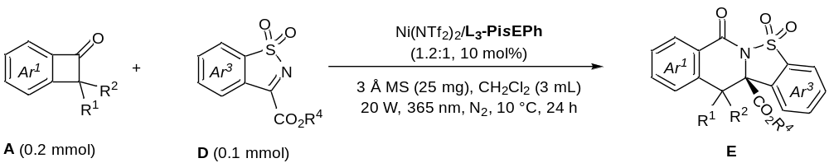
To a 20 ml dry quartz tube was added L₃-PisEPh (10 mol%), Ni(NTf₂)₂ (12 mol%), 3 Å MS (25 mg), benzocyclobutenones A (0.2 mmol), benzosulfonimides D (0.1 mmol) and CH₂Cl₂ (3.0 mL), and the mixture was stirred at 35 °C for 30 minutes. Then the resulting mixture was stirred under UV LED (20 W, λ_{max} = 365 nm) irradiation at 10 °C. After the benzosulfonimides was fully consumed (detected by TLC), the solvent was removed in vacuo, and the residue was purified by column chromatography (petroleum ether/ethyl acetate = 2:1) on silica gel to afford the product E.

The corresponding racemic products were obtained by using racemic N,N'-dioxide (±)-L₃-PiAd as the ligand under the respective catalytic reaction conditions.
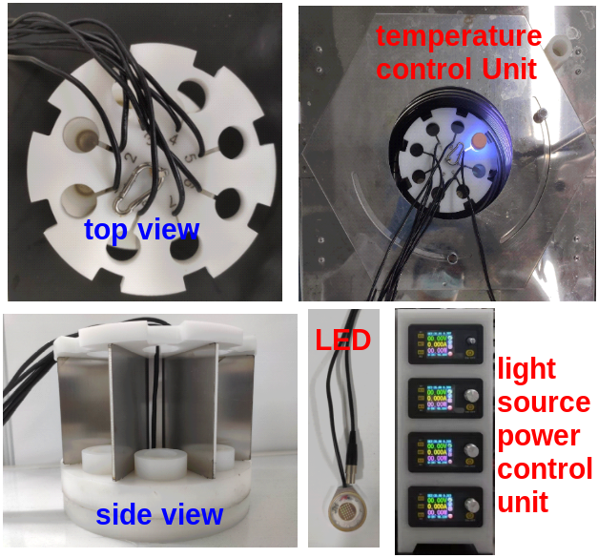
Figure S1. Photochemical setup with UV LED under 0 – 20 °C
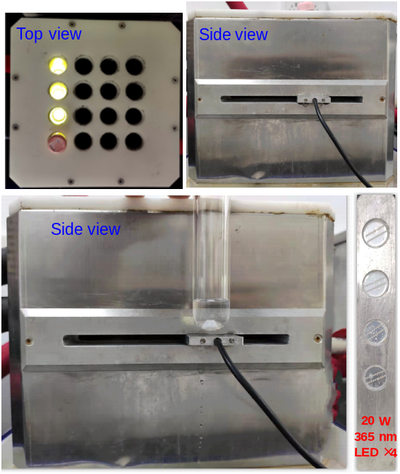
Figure S2. Photochemical setup with UV LED under room temperature

2.3 Experimental procedure for the scale-up reaction
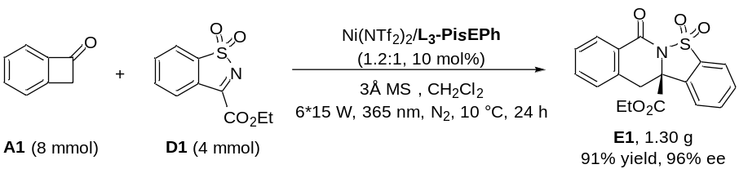
A dry round-bottom quartz flask was charged with L₃-PisEPh (214.8 mg, 10 mol%), Ni(NTf₂)₂ (297.1 mg, 12 mol%) and D1 (956 mg, 4 mmol) under N₂ atmosphere. Then CH₂Cl₂ (120 mL) was added and the mixture was stirred at 35 °C for 24 hours. Then A1 (8 mmol, 944 mg) was added and stirred under UV LED (6 × 15 W λ_{max} = 365 nm) irradiation at 10 °C. After D1 was fully consumed (168 h), the residue was purified by column chromatography (petroleum ether/ethyl acetate = 2:1) on silica gel to afford the product E1 as white solid (1.30 g, 91% yield, 96% ee), the remaining A1 (500 mg) was recovered.

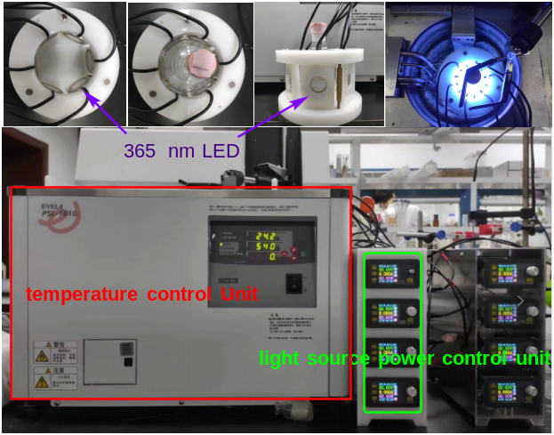
Figure S3. Gram-scale photochemical setup

3. Experimental procedure for further transformations of the products.
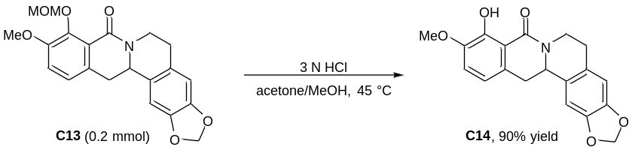
In a reaction tube was added C13 (0.2 mmol, 76.6 mg) and acetone/MeOH (3:1, 1.5 mL/0.5 mL) under nitrogen atmosphere, then HCl (3 N, 0.67 mL, 2.0 mmol) was added and reacted at 45 °C. After the reaction was completed (12 h), saturated aqueous NaHCO₃ solution (1.0 mL) was added and the mixture was dried and filtered, the solvent was concentrated in vacuum. Then the residue was subjected to column chromatography (petroleum ether:ethyl acetate = 2:1) on silica gel to afford C14 (60.6 mg) in 90% yield.

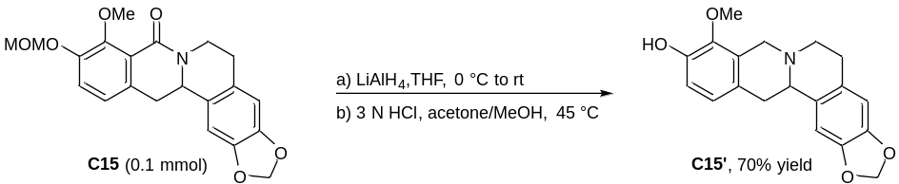
- In a reaction tube was added LiAlH₄ (0.28 mmol, 10.7 mg) and THF (0.5 mL) under nitrogen atmosphere, a solution of C15 (0.094 mmol, 35.9 mg) in THF (1.0 mL) was added dropwise at 0 °C, and the reaction mixture was allowed to warm to room temperature. After the reaction was completed (5 h), saturated aqueous NH₄Cl solution (0.5 mL) was added and the mixture was dried and filtered, the solvent was concentrated in vacuum and the crude reduction product was used without further purification.
- In a reaction tube was added the crude reduction product and acetone/MeOH (3:1, 0.75 mL/0.25 mL) under nitrogen atmosphere, then HCl (3 N, 0.33 mL, 1.0 mmol) was added and reacted at 45 °C. After the reaction was completed (12 h), saturated aqueous NaHCO₃ solution (0.5 mL) was added and the mixture was dried and filtered, the solvent was concentrated in vacuum. Then the residue was subjected to column chromatography (petroleum ether:ethyl acetate = 1:1) on silica gel to afford C15′ (21.4 mg) in 70% yield.
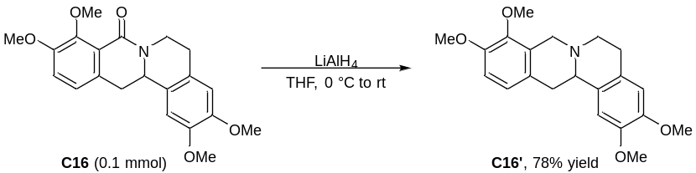
In a reaction tube was added LiAlH₄ (0.3 mmol, 11.4 mg) and THF (0.5 mL) under nitrogen atmosphere, a solution of C16 (0.1 mmol, 36.5 mg) in THF (1.0 mL) was added dropwise at 0 °C, and the reaction mixture was allowed to warm to room temperature. After the reaction was completed (5 h), saturated aqueous NH₄Cl solution (0.5 mL) was added and the mixture was dried and filtered, the solvent was concentrated in vacuum. Then the residue was subjected to column chromatography (petroleum ether:ethyl acetate = 2:1) on silica gel to afford C16′ (26.4 mg) in 78% yield.

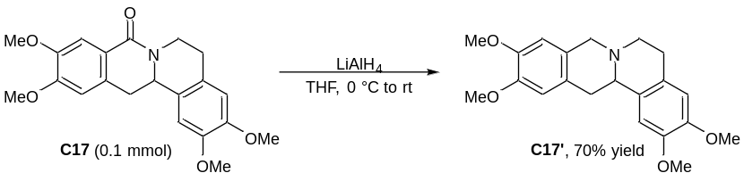
In a reaction tube was added LiAlH₄ (0.17 mmol, 6.5 mg) and THF (0.5 mL) under nitrogen atmosphere, a solution of C17 (0.056 mmol, 20.4 mg) in THF (1.0 mL) was added dropwise at 0 °C, and the reaction mixture was allowed to warm to room temperature. After the reaction was completed (5 h), saturated aqueous NH₄Cl solution (0.5 mL) was added and the mixture was dried and filtered, the solvent was concentrated in vacuum. Then the residue was subjected to column chromatography (petroleum ether:ethyl acetate = 1:1) on silica gel to afford C17′ (13.8 mg) in 70% yield.

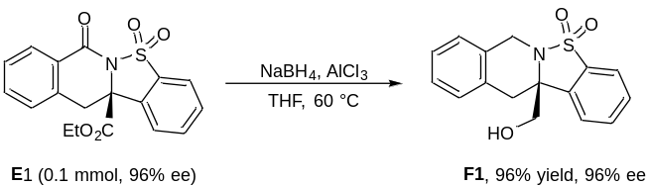
E1 (0.1 mmol, 35.7 mg, 96% ee), NaBH₄ (0.5 mmol, 19.1 mg), AlCl₃ (0.1 mmol, 13.3 mg) were weighed into a reaction tube and 1.5 mL THF was added and reacted at 60 °C. After the reaction was completed (36 h), saturated aqueous NH₄Cl solution (0.5 mL) was added and the mixture was dried and filtered, the solvent was concentrated in vacuum. Then the residue was subjected to column chromatography (petroleum ether:ethyl acetate = 1:1) on silica gel to afford F1 (28.8 mg) in 96% yield with 96% ee.

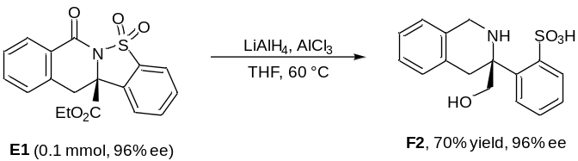
E1 (0.1 mmol, 35.7 mg, 96% ee), LiAlH₄ (0.5 mmol, 19.0 mg), AlCl₃ (0.1 mmol, 13.3 mg) were weighed into a reaction tube and THF (1.5 mL) was added and reacted at 60 °C. After the reaction was completed (36 h), saturated aqueous NH₄Cl solution (0.5 mL) was added and the mixture was dried and filtered, the solvent was concentrated in vacuo. Then the residue was subjected to column chromatography (petroleum ether:ethyl acetate = 1:2) on silica gel to afford F2 (22.3 mg) in 70% yield with 96% ee.

4. Mechanistic studies

4.1 Radical trapping experiments
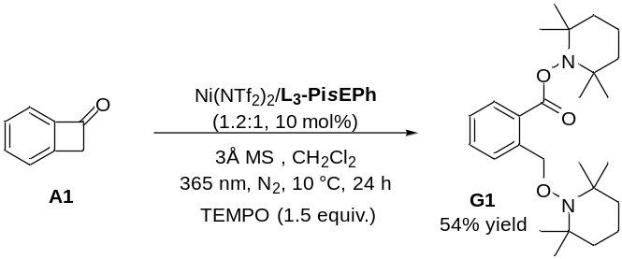
To a 20 ml dry quartz tube was added L₃-PisEPh (10 mol%), Ni(NTf₂)₂ (12 mol%), 3Å MS (25 mg), A1 (0.2 mmol), 2,2,6,6-tetramethyl-1-piperidinyloxyl (TEMPO, 0.3 mmol) and CH₂Cl₂ (3.0 mL) under N₂ atmosphere, and the mixture was stirred at 35 °C for 30 minutes. Then the resulting mixture was stirred under UV LED (20 W, λ_{max} = 365 nm) irradiation at 10 °C. After 24 h, the mixture residue was purified by column chromatography (petroleum ether:ethyl acetate: = 20:1) on silica gel to afford the product G1 as white solid (46.5 mg, 54% yield).
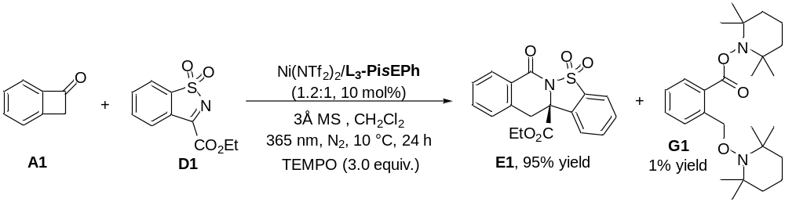
To a 20 ml dry quartz tube was added L₃-PisEPh (10 mol%), Ni(NTf₂)₂ (12 mol%), 3Å MS (25 mg), A1 (0.2 mmol), D1 (0.1 mmol), 2,2,6,6-tetramethyl-1-piperidinyloxyl (TEMPO, 0.3 mmol) and CH₂Cl₂ (3.0 mL) under N₂ atmosphere, and the mixture was stirred at 35 °C for 30 minutes. Then the resulting mixture was stirred under UV LED (20 W, λ_{max} = 365 nm) irradiation at 10 °C. After 24 h, the mixture residue was purified by column chromatography (petroleum ether:ethyl acetate = 20:1 to 2:1 gradient) on silica gel to afford the product G1 (1.1 mg, 1% yield) and E1 (33.9 mg, 95% yield).

4.2 Ortho-quinoid ketene methides trapping experiments
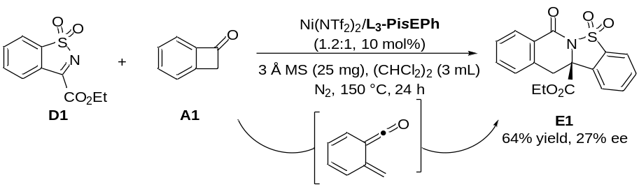
To a test tube was added L₃-PisEPh (0.01 mmol), Ni(NTf₂)₂ (0.012 mmol), 3 Å MS (25 mg), A1 (0.2 mmol), D1 (0.1 mmol) and in (CHCl₂)₂ (3.0 mL) under N₂ atmosphere, and the mixture was stirred at 150 °C for 24 h. The yield was determined by ¹H NMR, 1,1,2,2-tetrabromoethane (1.0 equiv.) as the internal standard. The ee value was determined by UPC² on a chiral stationary phase.

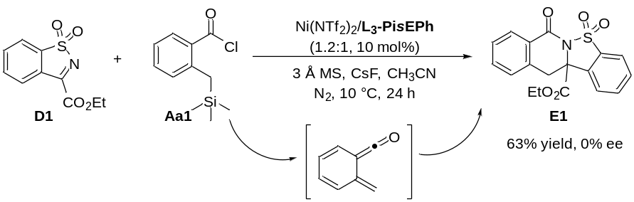
To a test tube was added L₃-PisEPh (0.01 mmol), Ni(NTf₂)₂ (0.012 mmol), 3 Å MS (25 mg), D1 (0.1 mmol) and CsF (0.4 mmol) in CH₃CN (2.0 mL) under N₂ atmosphere, and the mixture was stirred at 35 °C for 30 minutes. Then a solution of benzoyl chloride Aa1 (0.2 mmol in 1.0 mL CH₃CN) was added and the resulting mixture was stirred 10 °C for 24 h. The yield was determined by ¹H NMR, 1,1,2,2-tetrabromoethane (1.0 equiv.) as the internal standard. The ee value was determined by UPC² on a chiral stationary phase.

5. Optimization of the reaction conditions

5.1 Optimization of the reaction conditions of benzocyclobutenones with 3,4-dihydroisoquinoline
Table 1. Screening of solvents
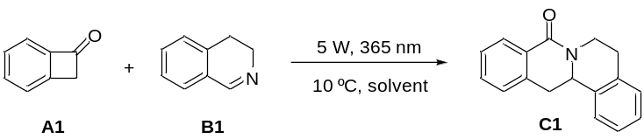
Entry^{[a]} | Solvent | Yield (%)^{[b]}
1 | CH₂Cl₂ | 56
2 | EtOAc | 86
3 | CH₃OH | 34
4 | CH₃CN | 51
5 | Toluene | 78
6 | THF | 77
7 | 1,4-dioxane | 90
8 | DME | 91
9 | MTBE | 93
10 | Et₂O | 99
ª Unless otherwise noted, the reactions were carried out with A1 (0.1 mmol), B1 (0.1 mmol) in solvent (1.0 mL) under N₂ protection and 5 W LED (λ_{max} = 365 nm) irradiation at 10 °C for 12 h. ^{b} The yield was determined by ¹H NMR analysis of the crude products, 1,1,2,2-tetrachlorethane (1.0 equiv.) as the internal standard.
Table 2. Screening of the light sources
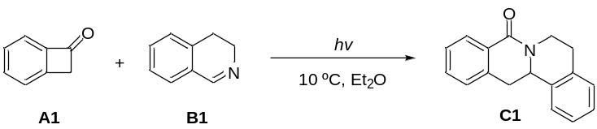
Entry^{[a]} | Light source | Yield (%)^{[b]}
1 | 5W, 365 nm | 99
2 | 5 W, 385 nm | 22
3 | 5 W, 400 nm | 3
4^{[c]} | 2 W, 365 nm | 89
5^{[d]} | 10 W, 365 nm | 95
6^{[e]} | 20 W, 365 nm | 90
ª Unless otherwise noted, the reactions were carried out with A1 (0.1 mmol), B1 (0.1 mmol) in Et₂O (1.0 mL) under N₂ protection and 5 − 20 W LED (λ_{max} = 365 − 400 nm) irradiation at 10 °C for 12 h. ^{b} The yield was determined by ¹H NMR analysis of the crude products, 1,1,2,2-tetrachlorethane (1.0 equiv.) as the internal standard. ^{c} For 24 h. ^{d} For 6 h. ^{e} For 4 h.
Table 3. Screening of the temperature
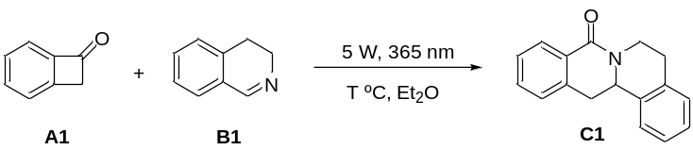
Entry^{[a]} | T (°C) | Yield (%)^{[b]}
1 | -10 | 88
2 | 0 | 95
3 | 10 | 99
4 | 20 | 97
ª Unless otherwise noted, the reactions were carried out with A1 (0.1 mmol), B1 (0.1 mmol) in Et₂O (1.0 mL) under N₂ protection and 5 W LED (λ_{max} = 365 nm) irradiation at a certain temperture for 12 h. ^{b} The yield was determined by ¹H NMR analysis of the crude products, 1,1,2,2-tetrachlorethane (1.0 equiv.) as the internal standard.
Table 4. The exploration of asymmetric version - metal salts
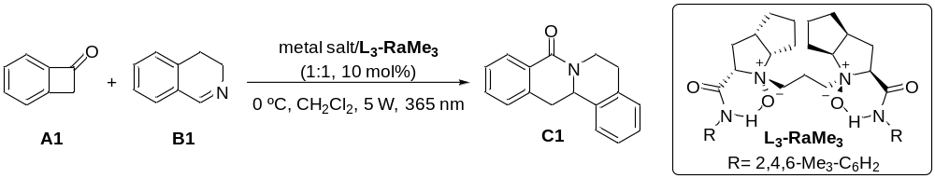
Entry^{[a]} | Metal salt | Yield (%)^{[b]} | ee (%)^{[c]}
1 | Mg(OTf)₂ | 33 | 0
2 | Al(OTf)₃ | 22 | 0
3 | In(OTf)₃ | 26 | 0
4 | Sc(OTf)₃ | 21 | 0
5 | Ni(OTf)₂ | 17 | 0
6 | Zn(OTf)₂ | 26 | 0
7 | Y(OTf)₃ | 29 | 0
8 | Ce(OTf)₃ | 18 | 0
9 | Eu(OTf)₃ | 19 | 0
10 | Tb(OTf)₃ | 20 | 0
11 | Tm(OTf)₃ | 26 | 0
ª Unless otherwise noted, the reactions were carried out with A1 (0.1 mmol), B1 (0.1 mmol), metal salt/L₃-RaMe₃ (1:1, 10 mol%) in CH₂Cl₂ (1.0 mL) under N₂ protection and 5 W LED (λ_{max} = 365 nm) irradiation at 0 °C for 12 h. ^{b}Yield of the isolated product. ^{c}The ee values were determined by UPC² on a chiral stationary phase.
Table 5. The exploration of asymmetric version – solvents
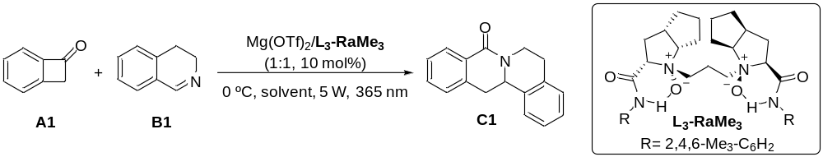
Entry^{[a]} | Solvent | Yield (%)^{[b]} | ee (%)^{[c]}
1 | CH₂Cl₂ | 33 | 0
2 | CHCl₃ | 30 | 0
3 | CH₂ClCH₂Cl | 30 | 0
4 | Toluene | 56 | 0
5 | EtOAc | 55 | 0
6 | Acetone | 49 | 0
7 | MeCN | 26 | 0
8 | THF | 80 | 0
9 | DME | 84 | 0
ª Unless otherwise noted, the reactions were carried out with A1 (0.1 mmol), B1 (0.1 mmol), Mg(OTf)₂/L₃-RaMe₃ (1:1, 10 mol%) in CH₂Cl₂ (1.0 mL) under N₂ protection and 5 W LED (λ_{max} = 365 nm) irradiation at 0 °C for 12 h. ^{b}Yield of the isolated product. ^{c}The ee values were determined by UPC² on a chiral stationary phase.
Table 6. The exploration of asymmetric version – ligands
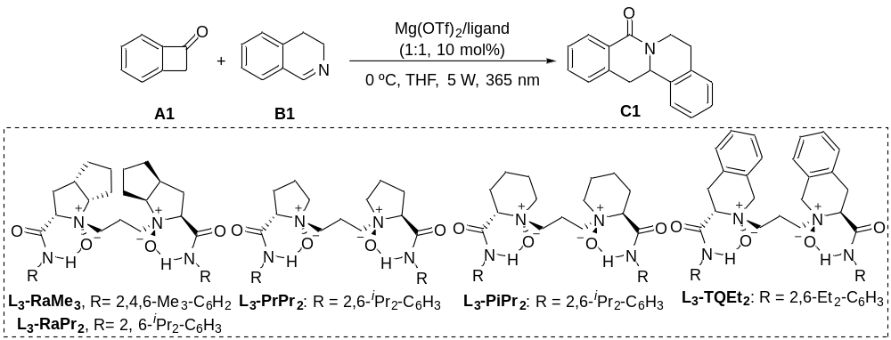
Entry^{[a]} | Ligand | Yield (%)^{[b]} | ee (%)^{[c]}
1 | L₃-RaMe₃ | 80 | 0
2 | L₃-RaPr₂ | 68 | 0
3 | L₃-PrPr₂ | 71 | 0
4 | L₃-PiPr₂ | 72 | 0
5 | L₃-TQEt₂ | 56 | 0
ª Unless otherwise noted, the reactions were carried out with A1 (0.1 mmol), B1 (0.1 mmol), Mg(OTf)₂/ligand (1:1, 10 mol%) in THF (1.0 mL) under N₂ protection and 5 W LED (λ_{max} = 365 nm) irradiation at 0 °C for 12 h. ^{b}Yield of the isolated product. ^{c}The ee values were determined by UPC² on a chiral stationary phase.

5.2 Optimization of the reaction conditions of benzocyclobutenones with benzosulfonimides
Table 7. Screening of chiral N,N’-dioxide ligands
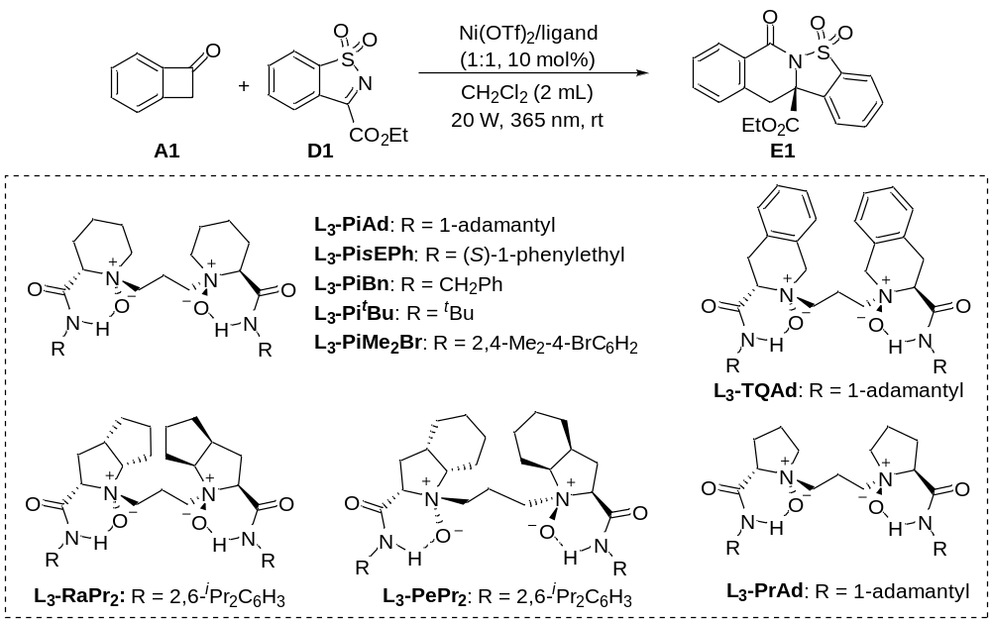
Entry^{[a]} | Ligand | Yield (%)^{[b]} | ee (%)^{[c]}
1^{[d]} | - | 76 | -
2 | - | 55 | -
3 | L₃-PiMe₂Br | 86 | 45
4 | L₃-Pi^{t}Bu | 99 | 55
5 | L₃-PiBn | 99 | 72
6 | L₃-PiAd | 92 | 83
7 | L₃-PisEPh | 62 | 91
8 | L₃-RaPr₂ | 86 | 18
9 | L₃-TQAd | 77 | 23
10 | L₃-PePr₂ | 89 | 10
11 | L₃-PrAd | 81 | 33
ª Unless otherwise noted, the reactions were carried out with A1 (0.2 mmol), D1 (0.1 mmol), Ni(OTf)₂ (10 mol%), ligand (10 mol%) in CH₂Cl₂ (2.0 mL) under N₂ protection and 20 W LED (λ_{max} = 365 nm) irradiation at room temperature for 5 h. ^{b} The yield was determined by ¹H NMR analysis of the crude products, 1,1,2,2-tetrachlorethane (1.0 equiv.) as the internal standard. ^{c} The ee values were determined by UPC² on a chiral stationary phase. ^{d} Without Ni(OTf)₂.
Table 8. Screening of the light sources
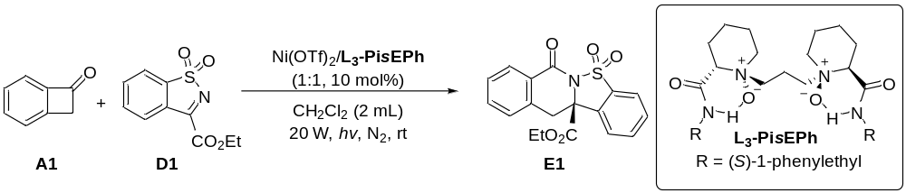
Entry^{[a]} | Wavelength (nm) | Yield (%)^{[b]} | ee (%)^{[c]}
1 | 365 nm | 62 | 91
2 | 385 nm | 74 | 90
3 | 400 nm (24 h) | 13 | 74
4 | 420 nm (24 h) | N.R. | -
ª Unless otherwise noted, the reactions were carried out with A1 (0.2 mmol), D1 (0.1 mmol), Ni(OTf)₂ (10 mol%), L₃-PisEPh (10 mol%) in CH₂Cl₂ (2.0 mL) under N₂ protection and 20 W LED irradiation at room temperature for 5 h. ^{b} The yield was determined by ¹H NMR analysis of the crude products, 1,1,2,2-tetrachlorethane (1.0 equiv.) as the internal standard. ^{c} The ee values were determined by UPC² on a chiral stationary phase.
Table 9. Screening of solvents
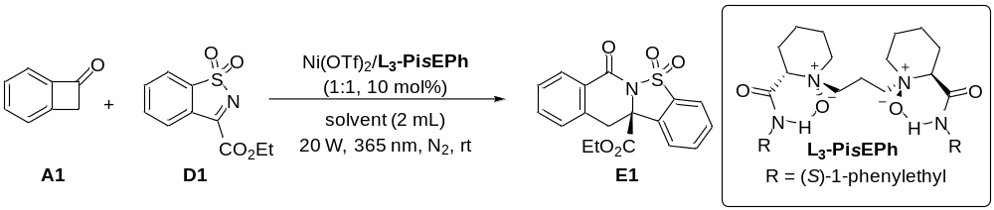
Entry^{[a]} | Solvent | Yield (%)^{[b]} | ee (%)^{[c]}
1 | CH₂Cl₂ | 62 | 91
2 | CH₂ClCH₂Cl | 56 | 89
3 | PhCl | 84 | 51
4 | Toluene | 38 | 11
5 | EA | 96 | 14
6 | CH₃CN | 94 | 0
7 | THF | 84 | 0
8 | Et₂O | 69 | 2

ª Unless otherwise noted, the reactions were carried out with A1 (0.2 mmol), D1 (0.1 mmol), Ni(OTf)₂ (10 mol%), L₃-PisEPh (10 mol%) in solvent (2.0 mL) under N₂ protection and 20 W LED (λ_{max} = 365 nm) irradiation at room temperature for 5 h. ^{b} The yield was determined by ¹H NMR analysis of the crude products, 1,1,2,2-tetrachlorethane (1.0 equiv.) as the internal standard. ^{c} The ee values were determined by UPC² on a chiral stationary phase.
Table 10. Screening of metal salts
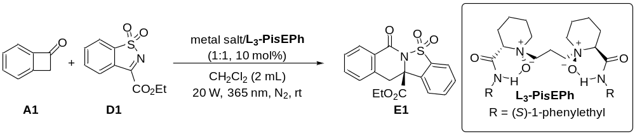
Entry^{[a]} | Metal Salt | Yield (%)^{[b]} | ee (%)^{[c]}
1 | Mg(OTf)₂ | 77 | 0
2 | Ca(OTf)₂ | 80 | 0
3 | Ba(OTf)₂ | 60 | 0
4 | Al(OTf)₃ | 46 | 0
5 | Sc(OTf)₃ | 67 | 0
6 | Fe(OTf)₃ | 28 | 0
7 | Co(OTf)₂ | 99 | 83
8 | Ni(OTf)₂ | 62 | 91
9 | Ni(NTf₂)₂ | 37 | 92
10 | Ni(ClO₄)₂⋅6H₂O | 73 | 19
11 | Ni(BF₄)₂⋅6H₂O | 85 | 21
12 | Cu(OTf)₂ | 69 | 0
13 | Zn(OTf)₂ | 83 | 5
14 | La(OTf)₃ | 63 | 0
15 | Dy(OTf)₃ | 71 | 0
16 | Yb(OTf)₃ | 62 | 0
17 | Lu(OTf)₃ | 70 | 0
ªUnless otherwise noted, the reactions were carried out with A1 (0.2 mmol), D1 (0.1 mmol), metal salt (10 mol%), L₃-PisEPh (10 mol%) in CH₂Cl₂ (2.0 mL) under N₂ protection and 20 W LED (λ_{max} = 365 nm) irradiation at room temperature for 5 h. ^{b} The yield was determined by ¹H NMR analysis of the crude products, 1,1,2,2-tetrachlorethane (1.0 equiv.) as the internal standard. ^{c} The ee values were determined by UPC² on a chiral stationary phase.
Table 11. Screening the ratio of metal salt and ligand
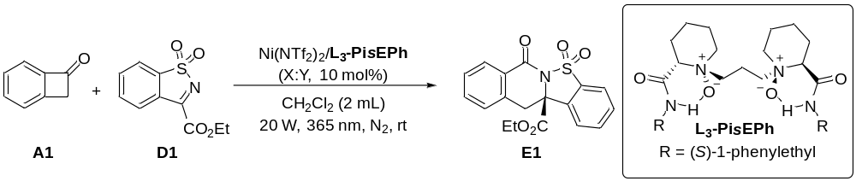
Entry^{[a]} | X:Y | t (h) | Yield (%)^{[b]} | ee (%)^{[c]}
1 | 1.3:1 | 12 | 92 | 93
2 | 1.2:1 | 12 | 96 | 93
3 | 1.1:1 | 12 | 93 | 91
4 | 1:1 | 12 | 90 | 90
5 | 1:1 | 5 | 37 | 92
6 | 1:1.1 | 12 | 98 | 85

ª Unless otherwise noted, the reactions were carried out with A1 (0.2 mmol), D1 (0.1 mmol), Ni(NTf₂)₂/L₃-PisEPh (X:Y, 10 mol%) in CH₂Cl₂ (2.0 mL) under N₂ protection and 20 W LED (λ_{max} = 365 nm) irradiation at room temperature for 12 h. ^{b} The yield was determined by ¹H NMR analysis of the crude products, 1,1,2,2-tetrachlorethane (1.0 equiv.) as the internal standard. ^{c} The ee values were determined by UPC² on a chiral stationary phase.
Table 12. Screening of the ratio of substrate A1 and D1
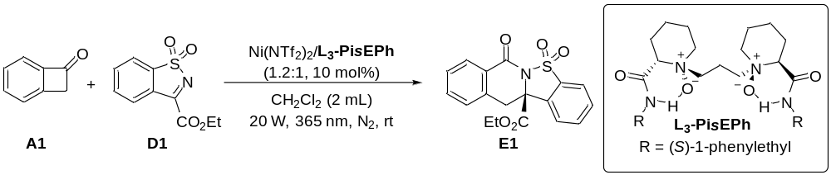
Entry^{[a]} | A1:D1 | Yield (%)^{[b]} | ee (%)^{[c]}
1 | 1.2:1 | 32 | 93
2 | 1.5:1 | 52 | 93
3 | 2:1 | 96 | 93
4^{[d]} | 2:1 | 80 | 79
ª Unless otherwise noted, the reactions were carried out with A1 (0.12 - 0.2 mmol), D1 (0.1 mmol) Ni(NTf₂)₂ (12 mol%), L₃-PisEPh (10 mol%) in CH₂Cl₂ (2.0 mL) under N₂ protection and 20 W LED (λ_{max} = 365 nm) irradiation at room temperature for 12 h. ^{b} The yield was determined by ¹H NMR analysis of the crude products, 1,1,2,2-tetrachlorethane (1.0 equiv.) as the internal standard. ^{c} The ee values were determined by UPC² on a chiral stationary phase. ^{d} 5 mol% catalyst.

Table 13. Screening of molecular sieves
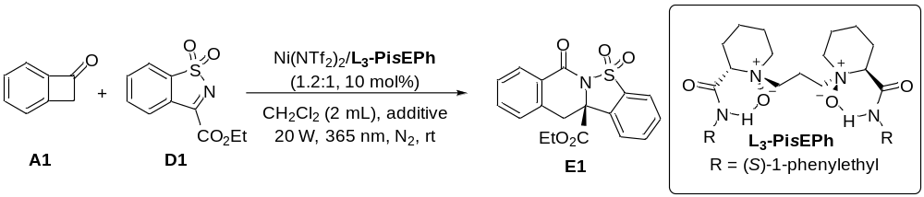
Entry^{[a]} | additive | Yield (%)^{[b]} | recovery of D1 (%)^{[b]} | ee (%)^{[c]}
1 | none | 96 | 0 | 93
2 | 3 Å MS (25 mg) | 56 | 42 | 93
3 | 4 Å MS (25 mg) | 53 | 47 | 87
4 | 5 Å MS (25 mg) | 52 | 48 | 92
ª Unless otherwise noted, the reactions were carried out with A1 (0.2 mmol), D1 (0.1 mmol), Ni(NTf₂)₂ (12 mol%), L₃-PisEPh (10 mol%) and additive in CH₂Cl₂ (2.0 mL) under N₂ protection and 20 W LED (λ_{max} = 365 nm) irradiation at room temperature for 12 h. ^{b} The yield was determined by ¹H NMR analysis of the crude products, 1,1,2,2-tetrachlorethane (1.0 equiv.) as the internal standard. ^{c} The ee values were determined by UPC² on a chiral stationary phase.
Table 14. Screening of the temperature
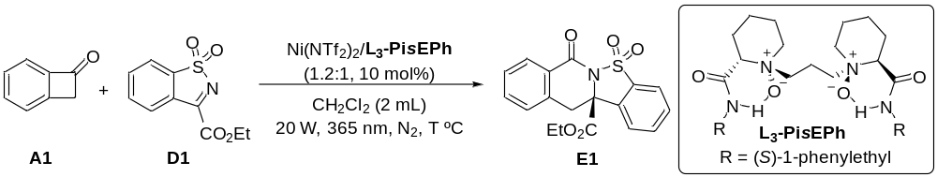
Entry^{[a]} | T (°C) | Yield (%)^{[b]} | ee (%)^{[c]}
1 | rt | 96 | 93
2 | 20 | 80 | 93
3 | 10 | 70 | 94
4^{[d]} | 10 | 95 | 95
5 | 0 | 86 | 90
ª Unless otherwise noted, the reactions were carried out with A1 (0.2 mmol), D1 (0.1 mmol), Ni(NTf₂)₂ (12 mol%), L₃-PisEPh (10 mol%) in CH₂Cl₂ (2.0 mL) under N₂ protection and 20 W LED (λ_{max} = 365 nm) irradiation at a certain temperature for 12 h. ^{b} The yield was determined by ¹H NMR analysis of the crude products, 1,1,2,2-tetrachlorethane (1.0 equiv.) as the internal standard. ^{c} The ee values were determined by UPC² on a chiral stationary phase. ^{d} Addition of 3 Å MS (25 mg) in CH₂Cl₂ (3.0 mL) and extension of reaction time to 24 h.

6. Limitations of the asymmetric reaction
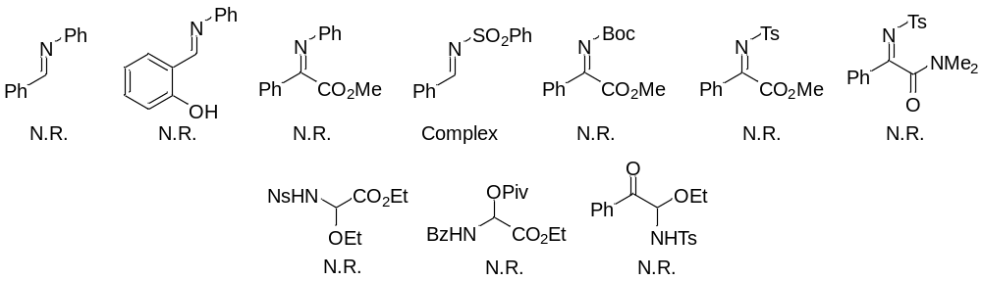

7. X-ray crystallography Data
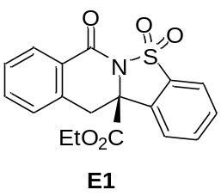
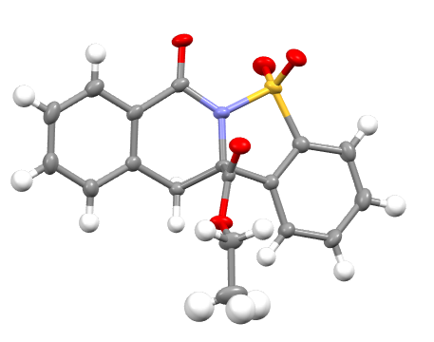
Figure S4. X-ray crystal structure of the product E1
The crystal of the product E1 was obtained in the solvents of anhydrous CH₂Cl₂ and n-hexane. CCDC: 2293174 contains the supplementary crystallographic data for this paper. These data can be obtained free of charge from The Cambridge Crystallographic Data Center via https://www.ccdc.cam.ac.uk/structures/.

Crystallographic Data for C18 H15 N O5 S.
Formula | C18 H15 N O5 S
Formula mass (amu) | 357.37
Space group | P 21
a (Å) | 7.0812 (2)
b (Å) | 14.4327 (5)
c (Å) | 8.6119 (3)
α (deg) | 90
β (deg) | 112.835 (1)
γ (deg) | 90
V (Å³) | 811.16 (5)
Z | 2
λ (Å) | 1.54178
T (K) | 173 K
ρ_{calcd} (g cm⁻³) | 1.463
μ (mm⁻¹) | 2.044
Transmission factors | 0.760-0.885
θ _{max} (deg) | 68.263
No. of unique data, including F_{o}² < 0 | 2920
No. of unique data, with F_{o}² > 2σ(F_{o}²) | 2868
No. of variables | 227
R(F) for F_{o}² > 2σ(F_{o}²) ª | 0.0242
R_{w}(F_{o}²) ^{b} | 0.0590
Goodness of fit | 1.056
ª R(F) = ∑||F_{o}| – |F_{c}|| / ∑|F_{o}|.
^{b} R_{w}(F_{o}²) = [∑[w(F_{o}² – F_{c}²)²] / ∑wF_{o}⁴]^{1/2}; w^{–1} = [σ²(F_{o}²) + (Ap)² + Bp], where p = [max(F_{o}²,0) + 2F_{c}²] / 3.

8. The analytical and spectral characterization data for the products
5,6,13,13a-tetrahydro-8H-isoquinolino[3,2-a]isoquinolin-8-one (C1)
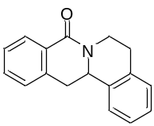
White solide; 24.7 mg, 99% yield.
¹H NMR (400 MHz, CDCl₃) δ 8.15 (d, J = 7.6 Hz, 1H), 7.51 – 7.43 (m, 1H), 7.39 (t, J = 7.6 Hz, 1H), 7.31 – 7.22 (m, 5H), 5.04 − 4.97 (m, 1H), 4.95 (dd, J = 13.6, 4.0 Hz, 1H), 3.25 (dd, J = 15.6, 3.6 Hz, 1H), 3.09 – 2.96 (m, 3H), 2.92 − 2.84 (dt, J = 10.6, 5.4 Hz, 1H).
¹³C NMR (101 MHz, CDCl₃) δ 164.6, 137.3, 135.9, 135.0, 131.8, 129.0, 129.0, 128.5, 127.3, 126.9, 126.8, 126.7, 125.9, 55.2, 38.6, 37.8, 29.7.
ESI-HRMS: calcd for C₁₇H₁₅NONa⁺ ([M + Na]⁺) = 272.1046, found 272.1001.
IR (neat): 1646, 1606, 1462, 1405, 1330, 1296, 1150, 1117, 758 cm⁻¹.

9-methyl-5,6,13,13a-tetrahydro-8H-isoquinolino[3,2-a]isoquinolin-8-one (C2)
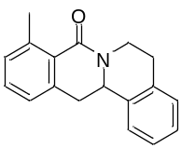
White solide; 19.7 mg, 75% yield.
¹H NMR (400 MHz, CDCl₃) δ 8.03 (d, J = 7.2 Hz, 1H), 7.36 – 7.22 (m, 6H), 5.04 – 4.93 (m, 1H), 4.90 (dd, J = 13.2, 3.6 Hz, 1H), 3.33 (dd, J = 16.0, 3.6 Hz, 1H), 3.07 – 2.97 (m, 2H), 2.92 – 2.84 (m, 1H), 2.77 (dd, J = 15.6, 13.6 Hz, 1H), 2.36 (s, 3H).
¹³C NMR (101 MHz, CDCl₃) δ 164.9, 136.1, 135.8, 135.1, 134.4, 133.4, 129.1, 129.0, 126.8, 126.8, 126.7, 126.5, 126.0, 54.7, 38.6, 34.8, 29.7, 19.0.
ESI-HRMS: calcd for C₁₈H₁₇NONa⁺ ([M + Na]⁺) = 286.1202, found 286.1205.
IR (neat): 1647, 1594, 1494, 1473, 1409, 1364, 1330, 1299, 1155, 1060, 753 cm⁻¹.

11-methyl-5,6,13,13a-tetrahydro-8H-isoquinolino[3,2-a]isoquinolin-8-one (C3)
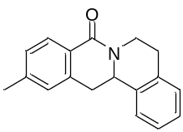
White solid; 23.7 mg, 90% yield.
¹H NMR (400 MHz, CDCl₃) δ 8.02 (d, J = 8.0 Hz, 1H), 7.31 – 7.15 (m, 5H), 7.05 (s, 1H), 5.03 – 4.94 (m, 1H), 4.90 (dd, J = 13.6, 3.6 Hz, 1H), 3.19 (dd, J = 15.4, 3.6 Hz, 1H), 3.06 – 2.90 (m, 3H), 2.90 – 2.81 (m, 1H), 2.39 (s, 3H).
¹³C NMR (101 MHz, CDCl₃) δ 164.7, 142.3, 137.3, 136.0, 135.1, 128.9, 128.6, 128.1, 127.5, 126.8, 126.7, 126.4, 125.9, 55.2, 38.5, 37.8, 29.7, 21.5.
ESI-HRMS: calcd for C₁₈H₁₇NONa⁺ ([M + Na]⁺) = 286.1202, found 286.1199.
IR (neat): 1646, 1613, 1456, 1428, 1397, 1363, 1328, 1297, 1144, 769, 706 cm⁻¹.

11-methoxy-5,6,13,13a-tetrahydro-8H-isoquinolino[3,2-a]isoquinolin-8-one (C4)
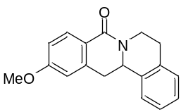
White solide; 24.6 mg, 88% yield.
¹H NMR (400 MHz, CDCl₃) δ 8.09 (d, J = 8.8 Hz, 1H), 7.33 – 7.17 (m, 4H), 6.90 (dd, J = 8.4, 2.0 Hz, 1H), 6.78 – 6.71 (m, 1H), 5.04 – 4.87 (m, 2H), 3.86 (s, 3H), 3.20 (dd, J = 15.6, 3.6 Hz, 1H), 3.08 – 2.92 (m, 3H), 2.91 – 2.80 (m, 1H).
¹³C NMR (101 MHz, CDCl₃) δ 164.6, 162.3, 139.4, 136.0, 135.1, 130.6, 129.0, 126.8, 126.6, 125.9, 121.9, 112.8, 111.9, 55.4, 55.2, 38.5, 38.2, 29.7.
ESI-HRMS: calcd for C₁₈H₁₇NO₂Na⁺ ([M + Na]⁺) = 302.1152, found 302.1157.
IR (neat): 1644, 1606, 1456, 1399, 1328, 1298, 1255, 1152, 1115, 1032, 850, 771 cm⁻¹.

10,11-dimethyl-5,6,13,13a-tetrahydro-8H-isoquinolino[3,2-a]isoquinolin-8-one (C5)
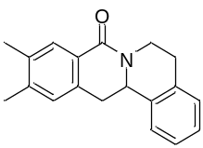
White solide; 25.6 mg, 93% yield.
¹H NMR (400 MHz, CDCl₃) δ 7.90 (s, 1H), 7.32 – 7.17 (m, 4H), 7.02 (s, 1H), 5.03 − 4.93 (m, 1H), 4.88 (dd, J = 13.6, 3.2 Hz, 1H), 3.17 (dd, J = 15.6, 3.6 Hz, 1H), 3.08 – 2.80 (m, 4H), 2.31 (s, 6H).
¹³C NMR (101 MHz, CDCl₃) δ 164.9, 141.0, 136.1, 135.7, 135.1, 134.8, 129.4, 128.9, 128.0, 126.7, 126.6, 126.6, 125.9, 55.4, 38.5, 37.4, 29.7, 19.9, 19.4.
ESI-HRMS: calcd for C₁₉H₁₉NONa⁺ ([M + Na]⁺) = 300.1359, found 300.1366.
IR (neat): 1647, 1614, 1457, 1426, 1384, 1365, 1328, 1300, 780, 756, 707 cm⁻¹.

11-fluoro-5,6,13,13a-tetrahydro-8H-isoquinolino[3,2-a]isoquinolin-8-one (C6)
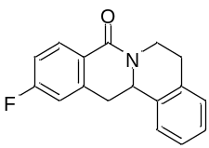
White solide; 23.1 mg, 87% yield.
¹H NMR (400 MHz, CDCl₃) δ 8.15 (dd, J = 8.4, 5.6 Hz, 1H), 7.35 − 7.18 (m, 4H), 7.07 (td, J = 8.4, 2.0 Hz, 1H), 6.96 (d, J = 8.8 Hz, 1H), 5.03 – 4.89 (m, 2H), 3.23 (dd, J = 16.0, 3.6 Hz, 1H), 3.09 – 2.95 (m, 3H), 2.93 – 2.82 (m, 1H).
¹³C NMR (101 MHz, CDCl₃) δ 164.7 (d, J = 251.2 Hz), 163.8, 140.0 (d, J = 8.9 Hz), 135.5, 135.0, 131.3 (d, J = 9.4 Hz), 129.0, 127.0, 126.8, 125.9, 125.4 (d, J = 2.8 Hz), 114.6 (d, J = 21.6 Hz), 113.7 (d, J = 21.8 Hz), 55.0, 38.6, 37.8, 29.6.
¹⁹F NMR (377 MHz, CDCl₃) δ -107.51.
ESI-HRMS: calcd for C₁₇H₁₄FNONa⁺ ([M + Na]⁺) = 290.0952, found 290.0956.
IR (neat): 1649, 1610, 1493, 1441, 1400, 1330, 1299, 1249, 1145, 952, 858, 770 cm⁻¹.

5,6,15,15a-tetrahydro-8H-benzo[f]isoquinolino[2,1-b]isoquinolin-8-one (C7)
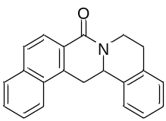
White solide; 29.9 mg, 99% yield.
¹H NMR (400 MHz, CDCl₃) δ 8.24 (d, J = 8.4 Hz, 1H), 8.13 – 8.03 (m, 1H), 7.94 – 7.87 (m, 1H), 7.85 (d, J = 8.8 Hz, 1H), 7.64 – 7.53 (m, 2H), 7.42 – 7.31 (m, 2H), 7.30 – 7.21 (m, 2H), 5.08 – 4.93 (m, 2H), 3.92 (dd, J = 16.0, 4.0 Hz, 1H), 3.18 – 3.01 (m, 3H), 2.98 – 2.84 (m, 1H).
¹³C NMR (101 MHz, CDCl₃) δ 165.0, 136.0, 135.1, 135.1, 135.0, 130.0, 129.1, 128.8, 127.5, 127.3, 126.9, 126.8, 126.6, 126.3, 126.0, 124.6, 124.0, 54.7, 38.6, 33.9, 29.7.
ESI-HRMS: calcd for C₂₁H₁₇NONa⁺ ([M + Na]⁺) = 322.1202, found 322.1207.
IR (neat): 1644, 1465, 1438, 1411, 1364, 1327, 1300, 1150, 1116, 831, 758 cm⁻¹.

13,13-difluoro-5,6,13,13a-tetrahydro-8H-isoquinolino[3,2-a]isoquinolin-8-one (C8)
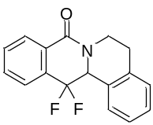
White solide; 23.6 mg, 83% yield.
¹H NMR (400 MHz, CDCl₃) δ 8.22 (d, J = 6.8 Hz, 1H), 7.81 – 7.72 (m, 1H), 7.72 − 7.61 (m, 2H), 7.53 − 7.45 (m, 1H), 7.40 − 7.30 (m, 2H), 7.27 (d, J = 8.8 Hz, 1H), 5.42 – 5.18 (m, 1H), 5.14 – 5.00 (m, 1H), 3.12 – 3.00 (m, 1H), 3.00 – 2.90 (m, 1H), 2.86 (d, J = 14.8 Hz, 1H).
¹³C NMR (101 MHz, CDCl₃) δ 162.5, 138.0, 133.0 (dd, J = 23.4, 27.7 Hz), 132.7 (d, J = 2.0 Hz), 131.4 (d, J = 2.4 Hz), 129.1 (d, J = 7.4 Hz), 128.8, 128.7, 128.3 (dd, J = 8.2, 3.1 Hz), 128.2, 127.0, 126.4, 123.2 (d, J = 6.4 Hz), 115.3 (dd, J = 250.0, 243.2 Hz), 60.4 (dd, J = 27.9, 27.0 Hz), 39.3, 29.7.
¹⁹F NMR (377 MHz, CDCl₃) δ -100.27, -100.95, -116.32, -117.01.
ESI-HRMS: calcd for C₁₇H₁₃F₂NONa⁺ ([M + Na]⁺) = 308.0857, found 308.0864.
IR (neat): 1660, 1587, 1462, 1410, 1337, 1301, 1263, 1170, 1067, 999, 772, 750, 698 cm⁻¹.

2-chloro-5,6,13,13a-tetrahydro-8H-isoquinolino[3,2-a]isoquinolin-8-one (C9)
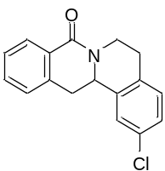
White solide; 25.5 mg, 90% yield.
¹H NMR (400 MHz, CDCl₃) δ 8.14 (d, J = 7.6 Hz, 1H), 7.52 – 7.44 (m, 1H), 7.40 (t, J = 7.6 Hz, 1H), 7.31 – 7.24 (m, 2H), 7.24 – 7.14 (m, 2H), 5.06 – 4.95 (m, 1H), 4.90 (dd, J = 13.6, 3.6 Hz, 1H), 3.24 (dd, J = 15.6, 3.6 Hz, 1H), 3.07 – 2.91 (m, 3H), 2.90 − 2.80 (m, 1H).
¹³C NMR (101 MHz, CDCl₃) δ 164.5, 137.7, 136.9, 133.5, 132.4, 132.0, 130.3, 128.8, 128.6, 127.4, 127.0, 126.9, 126.0, 54.9, 38.5, 37.6, 29.2.
ESI-HRMS: calcd for C₁₇H₁₄³⁵ClNONa⁺ ([M + Na]⁺) = 306.0656, found 306.0656. C₁₇H₁₄³⁷ClNONa⁺ ([M + Na]⁺) = 308.0627, found 306.0622.
IR (neat): 1648, 1604, 1462, 1403, 1321, 1297, 816, 744 cm⁻¹.

13a-methyl-5,6,13,13a-tetrahydro-8H-isoquinolino[3,2-a]isoquinolin-8-one (C10)
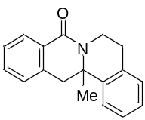
White solide; 17.3 mg, 66% yield.
¹H NMR (400 MHz, CDCl₃) δ 8.20 – 8.08 (m, 1H), 7.47 (td, J = 7.2, 1.2 Hz, 1H), 7.38 (t, J = 7.6 Hz, 1H), 7.35 – 7.27 (m, 2H), 7.22 (q, J = 7.2 Hz, 3H), 5.17 – 5.02 (m, 1H), 3.20 (d, J = 3.2 Hz, 2H), 3.09 – 2.91 (m, 2H), 2.87 (dd, J = 14.4, 3.2 Hz, 1H), 1.50 (s, 3H).
¹³C NMR (101 MHz, CDCl₃) δ 163.4, 141.7, 136.0, 134.0, 131.9, 129.2, 128.5, 128.4, 127.6, 127.2, 126.7, 126.6, 125.4, 58.5, 43.1, 35.5, 29.9, 25.2.
ESI-HRMS: calcd for C₁₈H₁₇NONa⁺ ([M + Na]⁺) = 286.1202, found 286.1203.
IR (neat): 1643, 1462, 1401, 1299, 1153, 766, 730 cm⁻¹.

5,6,13,13a-tetrahydro-8H-[1,3]dioxolo[4,5-g]isoquinolino[3,2-a]isoquinolin-8-one (C11)
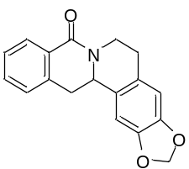
White solide; 18.2 mg, 62% yield.
¹H NMR (400 MHz, CDCl₃) δ 8.13 (d, J = 7.6 Hz, 1H), 7.51 – 7.42 (m, 1H), 7.38 (t, J = 7.6 Hz, 1H), 7.24 (d, J = 7.2 Hz, 1H), 6.71 (s, 1H), 6.66 (s, 1H), 5.95 (s, 2H), 4.99 – 4.89 (m, 1H), 4.83 (dd, J = 13.2, 3.2 Hz, 1H), 3.17 (dd, J = 15.6, 3.6 Hz, 1H), 3.03 – 2.86 (m, 3H), 2.80 – 2.70 (m, 1H).
¹³C NMR (101 MHz, CDCl₃) δ 164.5, 146.7, 146.5, 137.2, 131.8, 129.0, 128.8, 128.5, 128.5, 127.3, 126.9, 108.6, 105.8, 101.1, 55.2, 38.7, 38.1, 29.6.
ESI-HRMS: calcd for C₁₈H₁₅NO₃Na⁺ ([M + Na]⁺) = 316.0944, found 316.0948.
IR (neat): 1645, 1486, 1463, 1411, 1284, 1241, 1037, 936, 743 cm⁻¹.

9,10-dimethoxy-5,6,13,13a-tetrahydro-8H-[1,3]dioxolo[4,5-g]isoquinolino[3,2-a]isoquinolin-8-one (C12)
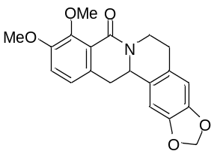
White solide; 27.2 mg, 77% yield.
¹H NMR (400 MHz, CDCl₃) δ 6.99 (d, J = 8.4 Hz, 1H), 6.92 (d, J = 8.4 Hz, 1H), 6.66 (s, 1H), 6.65 (s, 1H), 5.94 (s, 2H), 5.02 − 4.91 (m, 1H), 4.68 (dd, J = 13.2, 2.4 Hz, 1H), 4.00 (s, 3H), 3.87 (s, 3H), 2.99 (dd, J = 15.2, 3.2 Hz, 1H), 2.94 – 2.68 (m, 4H).
¹³C NMR (101 MHz, CDCl₃) δ 162.5, 153.0, 150.0, 146.6, 146.4, 130.7, 128.8, 128.7, 123.5, 122.0, 115.1, 108.5, 106.1, 101.0, 61.5, 56.1, 55.2, 39.1, 38.1, 29.8.
ESI-HRMS: calcd for C₂₀H₁₉NO₅Na⁺ ([M + Na]⁺) = 376.1155, found 376.1149.
IR (neat): 1647, 1484, 1423, 1335, 1270, 1240, 1036, 929, 857 cm⁻¹.

10-methoxy-9-(methoxymethoxy)-5,6,13,13a-tetrahydro-8H-[1,3]dioxolo[4,5-g]isoquinolino[3,2-a]isoquinolin-8-one (C13)
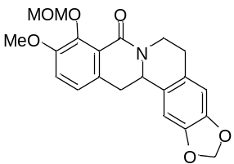
White solide; 38.2 mg, 99% yield.
¹H NMR (400 MHz, CDCl₃) δ 7.03 – 6.90 (m, 2H), 6.65 (d, J = 5.2 Hz, 2H), 5.93 (s, 2H), 5.22 (s, 2H), 5.01 – 4.90 (m, 1H), 4.67 (d, J = 2.4 Hz, 1H), 3.86 (s, 3H), 3.65 (s, 3H), 2.99 (dd, J = 15.2, 3.2 Hz, 1H), 2.95 – 2.68 (m, 4H).
¹³C NMR (101 MHz, CDCl₃) δ 162.4, 152.9, 146.9, 146.6, 146.4, 131.0, 128.8, 128.6, 123.1, 122.4, 115.4, 108.5, 106.0, 101.0, 100.0, 57.4, 56.3, 55.2, 39.1, 38.2, 29.8.
ESI-HRMS: calcd for C₂₁H₂₁NO₆Na⁺ ([M + Na]⁺) = 406.1261, found 406.1263.
IR (neat): 1646, 1484, 1437, 1407, 1272, 1240, 1152, 1032, 931, 857 cm⁻¹.

9-hydroxy-10-methoxy-5,6,13,13a-tetrahydro-8H-[1,3]dioxolo[4,5-g]isoquinolino[3,2-a]isoquinolin-8-one (C14)
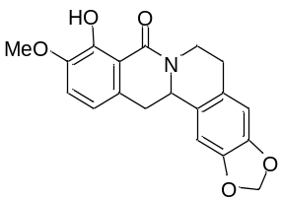
White solide; 60.6 mg, 90% yield.
¹H NMR (400 MHz, CDCl₃) δ 12.83 (s, 1H), 6.91 (d, J = 8.0 Hz, 1H), 6.66 (d, J = 18.4 Hz, 2H), 6.61 (d, J = 8.0 Hz, 1H), 5.94 (s, 2H), 4.87 − 4.70 (m, 2H), 3.87 (s, 3H), 3.11 (dd, J = 15.6, 3.6 Hz, 1H), 3.00 – 2.68 (m, 4H).
¹³C NMR (101 MHz, CDCl₃) δ 168.4, 151.6, 147.3, 146.7, 146.6, 128.6, 128.2, 127.9, 116.1, 115.2, 111.3, 108.5, 105.7, 101.1, 56.1, 55.5, 38.2, 36.9, 29.2.
ESI-HRMS: calcd for C₁₉H₁₇NO₅Na⁺ ([M + Na]⁺) = 362.0999, found 362.1006.
IR (neat): 2896, 1614, 1581, 1485, 1455, 1262, 1240, 1037, 932, 858, 794 cm⁻¹.

9-methoxy-10-(methoxymethoxy)-5,6,13,13a-tetrahydro-8H-[1,3]dioxolo[4,5-g]isoquinolino[3,2-a]isoquinolin-8-one (C15)
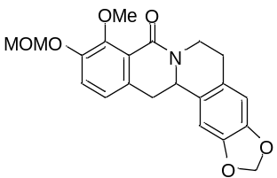
White solide; 35.9 mg, 94% yield.
¹H NMR (400 MHz, CDCl₃) δ 7.23 (d, J = 8.4 Hz, 1H), 6.91 (d, J = 8.0 Hz, 1H), 6.70 – 6.62 (m, 2H), 5.94 (s, 2H), 5.22 (s, 2H), 5.02 – 4.91 (m, 1H), 4.68 (dd, J = 12.8, 2.8 Hz, 1H), 4.01 (s, 3H), 3.52 (s, 3H), 3.00 (dd, J = 15.6, 3.2 Hz, 1H), 2.96 – 2.70 (m, 4H).
¹³C NMR (101 MHz, CDCl₃) δ 162.4, 151.0, 150.5, 146.6, 146.5, 132.7, 128.7, 128.7, 123.6, 122.2, 120.2, 108.5, 106.1, 101.0, 95.6, 61.7, 56.2, 55.1, 39.1, 38.1, 29.8.
ESI-HRMS: calcd for C₂₁H₂₁NO₆Na⁺ ([M + Na]⁺) = 406.1261, found 406.1259.
IR (neat): 1646, 1483, 1423, 1266, 1238, 1152, 1040, 993, 927, 857 cm⁻¹.

9-methoxy-5,8,13,13a-tetrahydro-6H-[1,3]dioxolo[4,5-g]isoquinolino[3,2-a]isoquinolin-10-ol (C15′)
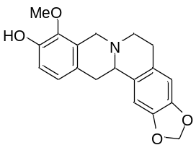
White solide; 21.4 mg, 70% yield.
¹H NMR (400 MHz, CDCl₃) δ 6.85 – 6.75 (m, 2H), 6.73 (s, 1H), 6.59 (s, 1H), 5.92 (s, 2H), 4.22 (d, J = 15.4 Hz, 1H), 3.80 (s, 3H), 3.65 – 3.48 (m, 2H), 3.27 – 3.05 (m, 3H), 2.81 (dd, J = 15.6, 11.6 Hz, 1H), 2.76 – 2.56 (m, 2H).
¹³C NMR (101 MHz, CDCl₃) δ 146.5, 146.2, 146.0, 143.1, 130.6, 127.7, 127.6, 127.0, 124.9, 114.2, 108.4, 105.5, 100.8, 60.7, 59.7, 53.7, 51.3, 36.2, 29.4.
ESI-HRMS: calcd for C₁₉H₂₀NO₄⁺ ([M + H]⁺) = 327.1465, found 327.1422.
IR (neat): 2927, 1486, 1388, 1301, 1246, 1223, 1064, 1039, 999, 937, 862, 809 cm⁻¹.

2,3,9,10-tetramethoxy-5,6,13,13a-tetrahydro-8H-isoquinolino[3,2-a]isoquinolin-8-one (C16)
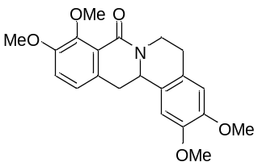
White solide; 36.5 mg, 99% yield.
¹H NMR (400 MHz, CDCl₃) δ 7.02 – 6.90 (m, 2H), 6.67 (d, J = 4.4 Hz, 2H), 5.08 – 4.98 (m, 1H), 4.70 (dd, J = 13.2, 2.8 Hz, 1H), 4.00 (s, 3H), 3.87 (d, J = 2.4 Hz, 9H), 3.02 (dd, J = 15.2, 3.2 Hz, 1H), 2.90 (d, J = 10.0 Hz, 2H), 2.86 – 2.79 (m, 1H), 2.78 – 2.71 (m, 1H).
¹³C NMR (101 MHz, CDCl₃) δ 162.6, 153.0, 149.9, 147.9, 147.8, 130.8, 127.6, 127.4, 123.5, 122.0, 115.0, 111.3, 109.0, 61.5, 56.1, 56.0, 55.8, 54.9, 39.1, 38.1, 29.3.
ESI-HRMS: calcd for C₂₁H₂₃NO₅Na⁺ ([M + Na]⁺) = 392.1468, found 392.1466.
IR (neat): 1647, 1514, 1484, 1454, 1422, 1334, 1311, 1257, 1234, 1118, 1059, 1018, 784 cm⁻¹.

2,3,9,10-tetramethoxy-5,8,13,13a-tetrahydro-6H-isoquinolino[3,2-a]isoquinoline (C16′)
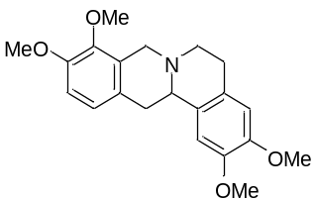
Colourless oil; 26.4 mg, 78% yield.
¹H NMR (400 MHz, CDCl₃) δ 6.88 (d, J = 8.4 Hz, 1H), 6.79 (d, J = 8.4 Hz, 1H), 6.73 (s, 1H), 6.62 (s, 1H), 4.25 (d, J = 15.6 Hz, 1H), 3.89 (s, 3H), 3.87 (s, 3H), 3.85 (s, 3H), 3.85 (s, 3H), 3.61 – 3.49 (m, 2H), 3.32 – 3.08 (m, 3H), 2.84 (dd, J = 15.6, 11.8 Hz, 1H), 2.74 − 2.57 (m, 2H).
¹³C NMR (101 MHz, CDCl₃) δ 150.2, 147.4, 147.3, 145.0, 129.5, 128.5, 127.6, 126.7, 123.8, 111.2, 110.8, 108.4, 60.1, 59.3, 56.0, 55.8, 53.9, 51.4, 36.2, 29.0.
ESI-HRMS: calcd for C₂₁H₂₆NO₄⁺ ([M + H]⁺) = 356.1856, found 356.1855.
IR (neat): 2935, 1610, 1610, 1514, 1495, 1459, 1332, 1277, 1258, 1230, 1142, 1107, 1084, 999, 859, 785 cm⁻¹.

2,3,10,11-tetramethoxy-5,6,13,13a-tetrahydro-8H-isoquinolino[3,2-a]isoquinolin-8-one (C17)
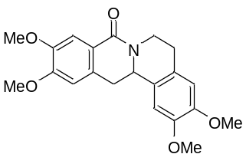
White solide; 20.4 mg, 56% yield.
¹H NMR (400 MHz, CDCl₃) δ 7.63 (s, 1H), 6.82 – 6.60 (m, 3H), 5.05 – 4.90 (m, 1H), 4.83 (dd, J = 13.6, 3.6 Hz, 1H), 3.94 (d, J = 2.0 Hz, 6H), 3.89 (d, J = 4.8 Hz, 6H), 3.13 (dd, J = 15.6, 3.6 Hz, 1H), 3.01 – 2.86 (m, 3H), 2.82 – 2.71 (m, 1H).
¹³C NMR (101 MHz, CDCl₃) δ 164.7, 151.8, 148.1, 147.9, 147.8, 130.9, 127.7, 127.3, 121.6, 111.4, 110.6, 109.1, 108.7, 56.1, 56.1, 56.0, 55.9, 55.2, 38.6, 37.6, 29.2.
ESI-HRMS: calcd for C₂₁H₂₃NO₅Na⁺ ([M + Na]⁺) = 392.1468, found 392.1478.
IR (neat): 1642, 1603, 1514, 1461, 1430, 1386, 1332, 1298, 1270, 1223, 1098, 1031, 787, 765 cm⁻¹.

2,3,10,11-tetramethoxy-5,8,13,13a-tetrahydro-6H-isoquinolino[3,2-a]isoquinoline (C17′)
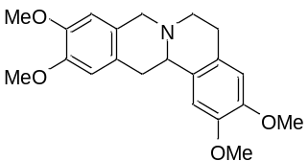
Colourless oil; 13.8 mg, 70% yield.
¹H NMR (400 MHz, CDCl₃) δ 6.74 (s, 1H), 6.66 (s, 1H), 6.62 (s, 1H), 6.58 (s, 1H), 3.95 (d, J = 14.8 Hz, 1H), 3.89 (s, 3H), 3.87 (s, 3H), 3.86 (s, 3H), 3.85 (s, 3H), 3.69 (d, J = 14.4 Hz, 1H), 3.60 (dd, J = 10.8, 3.2 Hz, 1H), 3.25 (dd, J = 16.0, 3.6 Hz, 1H), 3.20 − 3.09 (m, 2H), 2.85 (dd, J = 15.2, 11.6 Hz, 1H), 2.74 – 2.57 (m, 2H).
¹³C NMR (101 MHz, CDCl₃) δ 147.6, 147.4, 147.4, 147.3, 129.6, 126.6, 126.2, 111.2, 108.9, 108.4, 59.5, 58.2, 56.0, 55.9, 55.9, 55.8, 51.3, 36.3, 29.0.
ESI-HRMS: calcd for C₂₁H₂₆NO₄⁺ ([M + H]⁺) = 356.1856, found 356.1866.
IR (neat): 1611, 1516, 1462, 1352, 1261, 1236, 1144, 1105, 1024, 729 cm⁻¹.

ethyl (S)-7-oxo-7,12-dihydro-12aH-benzo[4,5]isothiazolo[2,3-b]isoquinoline-12a-carboxylate 5,5-dioxide (E1)
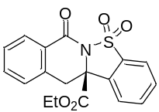
White solid; 95% yield, 95% ee. [α]_{D}^{23.5} = -174.7 (c = 0.60, in CH₂Cl₂), dissolved in MeOH for UPC² (Daicel Chiralcel AD-3, CO₂/MeOH = 80/20, flow rate = 1.5 mL/min, λ = 254 nm), retention time: t_{R1} = 2.62 min, t_{R2} = 3.48 min.
¹H NMR (400 MHz, CDCl₃) δ 8.19 (d, J = 7.1 Hz, 1H), 7.90 (d, J = 7.8 Hz, 1H), 7.86 – 7.75 (m, 2H), 7.75 – 7.67 (m, 1H), 7.57 (td, J = 7.5, 1.2 Hz, 1H), 7.46 (t, J = 7.6 Hz, 1H), 7.34 (d, J = 7.6 Hz, 1H), 4.18 – 3.89 (m, 3H), 3.41 (d, J = 15.3 Hz, 1H), 0.96 (t, J = 7.1 Hz, 3H).
¹³C NMR (101 MHz, CDCl₃) δ 168.5, 160.7, 135.0, 134.6, 134.4, 134.1, 132.4, 131.2, 129.1, 128.6, 128.2, 127.8, 124.3, 122.0, 68.6, 63.5, 38.4, 13.6.
ESI-HRMS: calcd for C₁₈H₁₅NO₅SNa⁺ ([M + Na]⁺) = 380.0563, found 380.0560.
IR (neat): 1744, 1693, 1605, 1457, 1341, 1323, 1288, 1189, 1147, 1065, 856, 751 cm⁻¹.
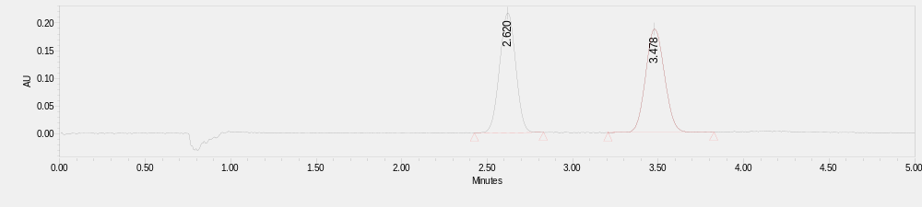
 | Retention Time | Area | % Area
1 | 2.620 | 1414158 | 49.82
2 | 3.478 | 1424136 | 50.18

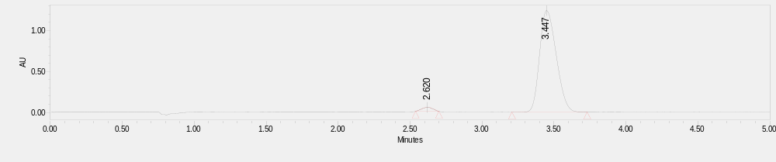
 | Retention Time | Area | % Area
1 | 2.620 | 263629 | 2.57
2 | 3.447 | 10011208 | 97.43

methyl (S)-7-oxo-7,12-dihydro-12aH-benzo[4,5]isothiazolo[2,3-b]isoquinoline-12a-carboxylate 5,5-dioxide (E2)
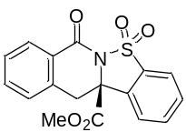
White solid; 96% yield, 94% ee. [α]_{D}^{23.4} = -182.0 (c = 0.66, in CH₂Cl₂), dissolved in MeOH for UPC² (Daicel Chiralcel OZ-3, CO₂/MeOH = 80/20, flow rate = 1.5 mL/min, λ = 254 nm), retention time: t_{R1} = 7.04 min, t_{R2} = 8.42 min.
¹H NMR (400 MHz, CDCl₃) δ 8.23 – 8.15 (m, 1H), 7.91 (dd, J = 7.6, 1.0 Hz, 1H), 7.85 – 7.76 (m, 2H), 7.74 – 7.68 (m, 1H), 7.61 – 7.53 (m, 1H), 7.46 (t, J = 7.6 Hz, 1H), 7.35 (d, J = 7.6 Hz, 1H), 4.07 (d, J = 15.2 Hz, 1H), 3.58 (s, 3H), 3.40 (d, J = 15.2 Hz, 1H).
¹³C NMR (101 MHz, CDCl₃) δ 169.2, 160.6, 135.0, 134.5, 134.2, 132.4, 131.3, 129.2, 128.6, 128.2, 127.5, 124.3, 122.0, 68.5, 54.2, 38.3.
ESI-HRMS: calcd for C₁₇H₁₃NO₅SNa⁺ ([M + Na]⁺) = 366.0407, found 366.0406.
IR (neat): 1741, 1693, 1453, 1341, 1323, 1286, 1211, 1189, 1147, 1034, 750, 706 cm⁻¹.
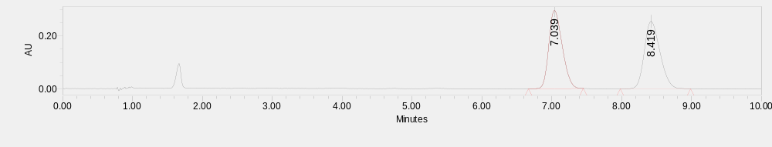
 | Retention Time | Area | % Area
1 | 7.039 | 3896230 | 49.91
2 | 8.419 | 3910437 | 50.09

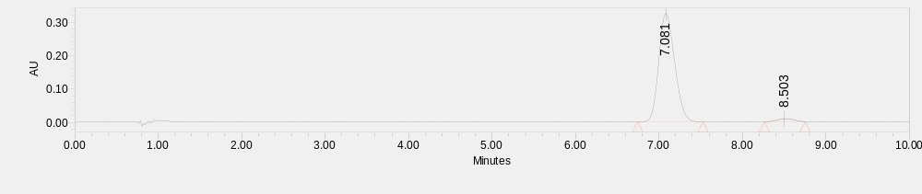
 | Retention Time | Area | % Area
1 | 7.081 | 4288771 | 97.05
2 | 8.503 | 130291 | 2.95

isopropyl (S)-7-oxo-7,12-dihydro-12aH-benzo[4,5]isothiazolo[2,3-b]isoquinoline-12a-carboxylate 5,5-dioxide (E3)
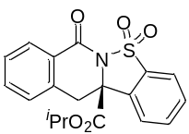
White solid; 90% yield, 94% ee. [α]_{D}^{23.3} = -159.5 (c = 0.66, in CH₂Cl₂), dissolved in MeOH for UPC² (Daicel Chiralcel IG-3, CO₂/MeOH = 80/20, flow rate = 1.5 mL/min, λ = 254 nm), retention time: t_{R1} = 5.22 min, t_{R2} = 6.17 min.
¹H NMR (400 MHz, CDCl₃) δ 8.23 – 8.13 (m, 1H), 7.90 (d, J = 7.6 Hz, 1H), 7.86 – 7.76 (m, 2H), 7.74 – 7.67 (m, 1H), 7.59 – 7.53 (m, 1H), 7.45 (t, J = 7.6 Hz, 1H), 7.33 (d, J = 7.6 Hz, 1H), 4.87 – 4.71 (m, 1H), 4.01 (d, J = 15.2 Hz, 1H), 3.40 (d, J = 15.2 Hz, 1H), 1.02 (d, J = 6.4 Hz, 3H), 0.90 (d, J = 6.4 Hz, 3H).
¹³C NMR (101 MHz, CDCl₃) δ 167.9, 160.8, 135.0, 134.7, 134.3, 134.0, 132.4, 131.1, 129.0, 128.5, 128.2, 128.0, 124.3, 121.9, 71.7, 68.6, 38.5, 21.1, 20.9.
ESI-HRMS: calcd for C₁₉H₁₇NO₅SNa⁺ ([M + Na]⁺) = 394.0720, found 394.0712.
IR (neat): 1739, 1693, 1458, 1340, 1322, 1287, 1209, 1187, 1147, 1102, 1065, 859 cm⁻¹.
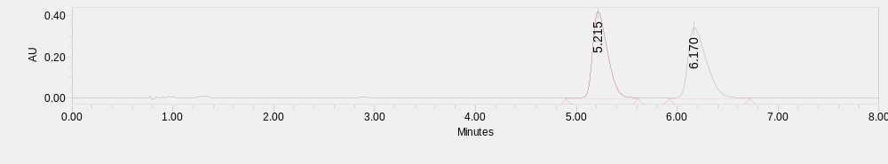
 | Retention Time | Area | % Area
1 | 5.215 | 4483509 | 49.95
2 | 6.170 | 4491626 | 50.05
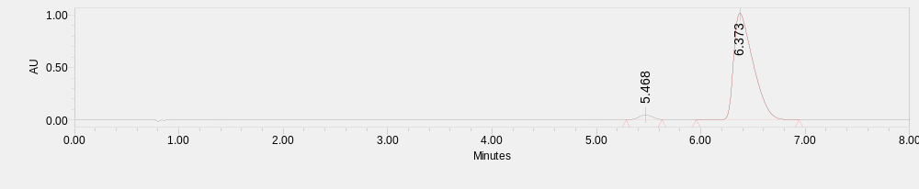
 | Retention Time | Area | % Area
1 | 5.468 | 407921 | 3.04
2 | 6.373 | 13011362 | 96.96
benzyl (S)-7-oxo-7,12-dihydro-12aH-benzo[4,5]isothiazolo[2,3-b]isoquinoline-12a-carboxylate 5,5-dioxide (E4)
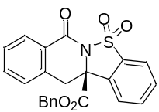
White solid; 94% yield, 94% ee. [α]_{D}^{22.9} = -153.7 (c = 0.65, in CH₂Cl₂), dissolved in MeOH for UPC² (Daicel Chiralcel IG-3, CO₂/MeOH = 80/20, flow rate = 1.5 mL/min, λ = 254 nm), retention time: t_{R1} = 13.62 min, t_{R2} = 15.38 min.
¹H NMR (400 MHz, CDCl₃) δ 8.16 – 8.05 (m, 1H), 7.91 (d, J = 7.6 Hz, 1H), 7.80 – 7.73 (m, 2H), 7.72 – 7.66 (m, 1H), 7.54 – 7.45 (m, 1H), 7.40 (t, J = 7.6 Hz, 1H), 7.26 – 7.10 (m, 4H), 7.00 – 6.89 (m, 2H), 5.01 (q, J = 12.4 Hz, 2H), 4.01 (d, J = 15.6 Hz, 1H), 3.40 (d, J = 15.2 Hz, 1H).
¹³C NMR (101 MHz, CDCl₃) δ 168.4, 160.6, 134.8, 134.6, 134.4, 134.2, 134.1, 132.1, 131.2, 129.2, 128.5, 128.4, 128.3, 128.1, 127.7, 127.6, 124.3, 122.0, 68.8, 68.6, 38.3.
ESI-HRMS: calcd for C₂₃H₁₇NO₅SNa⁺ ([M + Na]⁺) = 442.0720, found 442.0730.
IR (neat): 1747, 1694, 1604, 1454, 1342, 1323, 1287, 1191, 1094, 759, 701 cm⁻¹.
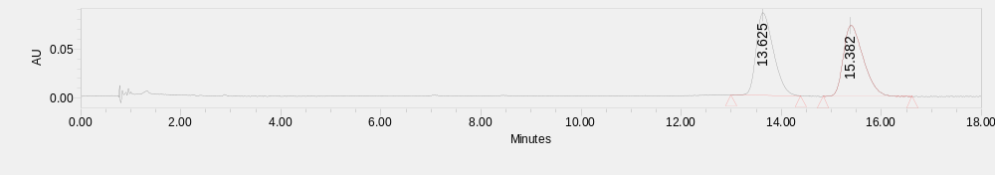
 | Retention Time | Area | % Area
1 | 13.625 | 2023175 | 50.28
2 | 15.382 | 2000945 | 49.72
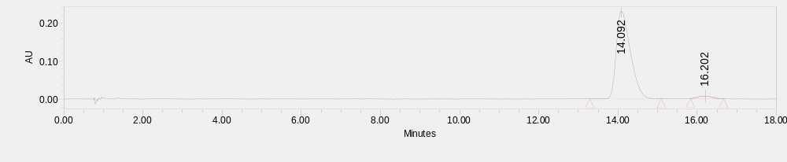
 | Retention Time | Area | % Area
1 | 14.092 | 5671348 | 96.96
2 | 16.202 | 177910 | 3.04

ethyl (S)-2-methyl-7-oxo-7,12-dihydro-12aH-benzo[4,5]isothiazolo[2,3-b]isoquinoline-12a-carboxylate 5,5-dioxide (E5)
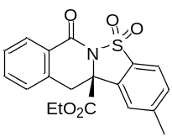
White solid; 54% yield, 95% ee. [α]_{D}^{22.9} = -150.5 (c = 0.40, in CH₂Cl₂), dissolved in MeOH for UPC² (Daicel Chiralcel IG-3, CO₂/MeOH = 80/20, flow rate = 1.5 mL/min, λ = 254 nm), retention time: t_{R1} = 7.64 min, t_{R2} = 8.42 min.
¹H NMR (400 MHz, CDCl₃) δ 8.23 – 8.17 (m, 1H), 7.79 (d, J = 8.0 Hz, 1H), 7.61 – 7.54 (m, 2H), 7.47 (q, J = 7.8 Hz, 2H), 7.33 (d, J = 7.6 Hz, 1H), 4.13 – 3.93 (m, 3H), 3.39 (d, J = 15.2 Hz, 1H), 2.54 (s, 3H), 0.96 (t, J = 7.2 Hz, 3H).
¹³C NMR (101 MHz, CDCl₃) δ 168.8, 160.7, 145.7, 135.1, 134.1, 132.7, 132.1, 131.9, 129.1, 128.5, 128.2, 127.9, 124.4, 121.8, 68.4, 63.4, 38.5, 22.0, 13.6.
ESI-HRMS: calcd for C₁₉H₁₇NO₅SNa⁺ ([M + Na]⁺) = 394.0720, found 394.0716.
IR (neat): 1743, 1693, 1603, 1455, 1338, 1322, 1287, 1194, 1164, 1066, 742, 697 cm⁻¹.
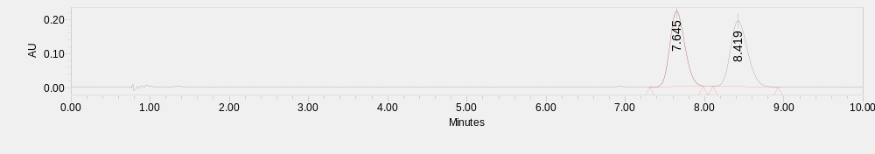
 | Retention Time | Area | % Area
1 | 7.645 | 2864515 | 49.98
2 | 8.419 | 2866472 | 50.02
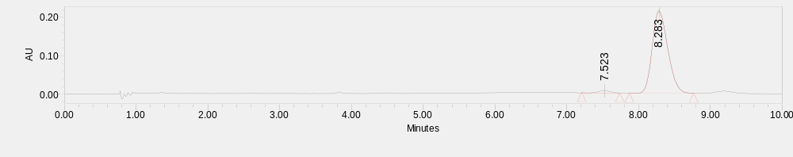
 | Retention Time | Area | % Area
1 | 7.523 | 75011 | 2.27
2 | 8.283 | 3224081 | 97.73

ethyl (S)-2-(tert-butyl)-7-oxo-7,12-dihydro-12aH-benzo[4,5]isothiazolo[2,3-b]isoquinoline-12a-carboxylate 5,5-dioxide (E6)
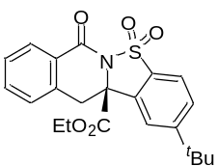
White solid; 47% yield, 95% ee. [α]_{D}^{22.8} = -117.8 (c = 0.40, in CH₂Cl₂), dissolved in MeOH for UPC² (Daicel Chiralcel IG-3, CO₂/MeOH = 80/20, flow rate = 1.5 mL/min, λ = 254 nm), retention time: t_{R1} = 4.80 min, t_{R2} = 6.79 min.
¹H NMR (400 MHz, CDCl₃) δ 8.24 – 8.16 (m, 1H), 7.83 (d, J = 8.4 Hz, 1H), 7.80 – 7.75 (m, 1H), 7.75 – 7.69 (m, 1H), 7.61 – 7.54 (m, 1H), 7.46 (t, J = 7.6 Hz, 1H), 7.35 (d, J = 7.6 Hz, 1H), 4.14 – 3.92 (m, 3H), 3.42 (d, J = 15.2 Hz, 1H), 1.40 (s, 9H), 0.97 (t, J = 7.2 Hz, 3H).
¹³C NMR (101 MHz, CDCl₃) δ 168.7, 160.8, 159.0, 135.1, 134.1, 132.4, 131.8, 129.1, 128.8, 128.5, 128.1, 127.9, 121.6, 120.7, 68.7, 63.4, 38.5, 35.7, 31.1, 13.6.
ESI-HRMS: calcd for C₂₂H₂₃NO₅SNa⁺ ([M + Na]⁺) = 436.1189, found 436.1199.
IR (neat): 1747, 1696, 1604, 1460, 1341, 1322, 1288, 1195, 1152, 1061 cm⁻¹.
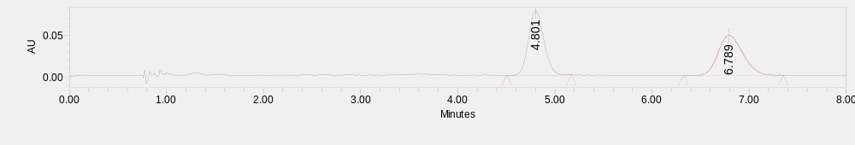
 | Retention Time | Area | % Area
1 | 4.801 | 840227 | 49.97
2 | 6.789 | 841376 | 50.03
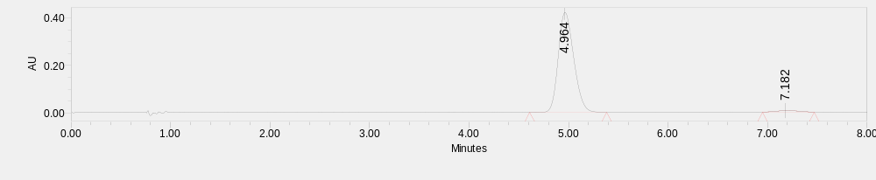
 | Retention Time | Area | % Area
1 | 4.964 | 4558659 | 97.79
2 | 7.182 | 102794 | 2.21

ethyl (S)-2-methoxy-7-oxo-7,12-dihydro-12aH-benzo[4,5]isothiazolo[2,3-b]isoquinoline-12a-carboxylate 5,5-dioxide (E7)
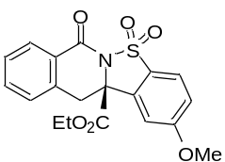
White solid; 54% yield, 96% ee. [α]_{D}^{22.8} = -161.9 (c = 0.44, in CH₂Cl₂), dissolved in MeOH for UPC² (Daicel Chiralcel OZ-3, CO₂/MeOH = 85/15, flow rate = 1.5 mL/min, λ = 254 nm), retention time: t_{R1} = 16.46 min, t_{R2} = 17.59 min.
¹H NMR (400 MHz, CDCl₃) δ 8.18 (dd, J = 7.6, 1.2 Hz, 1H), 7.80 (d, J = 8.8 Hz, 1H), 7.56 (td, J = 7.6, 1.2 Hz, 1H), 7.45 (t, J = 7.6 Hz, 1H), 7.33 (d, J = 7.6 Hz, 1H), 7.21 (d, J = 2.0 Hz, 1H), 7.17 (dd, J = 8.8, 2.4 Hz, 1H), 4.10 – 3.96 (m, 3H), 3.95 (s, 3H), 3.41 (d, J = 15.2 Hz, 1H), 0.97 (t, J = 7.2 Hz, 3H).
¹³C NMR (101 MHz, CDCl₃) δ 168.6, 164.4, 160.6, 135.0, 134.8, 134.0, 129.1, 128.5, 128.2, 127.9, 126.4, 123.5, 117.8, 108.4, 68.3, 63.5, 56.1, 38.5, 13.6.
ESI-HRMS: calcd for C₁₉H₁₇NO₆SNa⁺ ([M + Na]⁺) = 410.0669, found 410.0640.
IR (neat): 1744, 1692, 1597, 1485, 1460, 1337, 1313, 1285, 1192, 1171, 1067, 1016, 705 cm⁻¹.
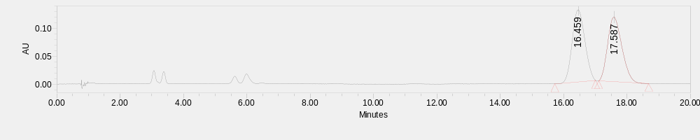
 | Retention Time | Area | % Area
1 | 16.459 | 3585495 | 49.96
2 | 17.587 | 3591458 | 50.04
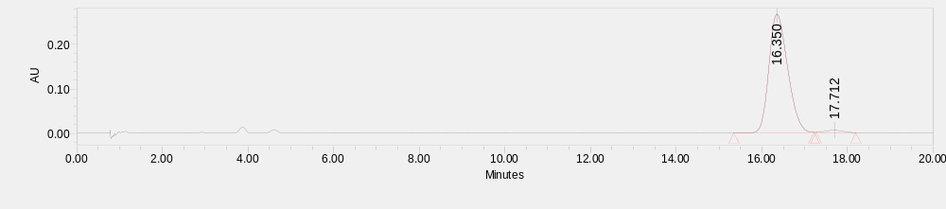
 | Retention Time | Area | % Area
1 | 16.350 | 8020351 | 98.30
2 | 17.712 | 138857 | 1.70

ethyl (S)-7-oxo-2-(trifluoromethoxy)-7,12-dihydro-12aH-benzo[4,5]isothiazolo[2,3-b]isoquinoline-12a-carboxylate 5,5-dioxide (E8)
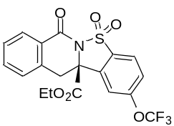
White solid; 63% yield, 84% ee. [α]_{D}^{23.4} = -94.9 (c = 0.56, in CH₂Cl₂), dissolved in MeOH for UPC² (Daicel Chiralcel IG-3, CO₂/MeOH = 85/15, flow rate = 1.5 mL/min, λ = 254 nm), retention time: t_{R1} = 2.04 min, t_{R2} = 2.37 min.
¹H NMR (400 MHz, CDCl₃) δ 8.24 – 8.17 (m, 1H), 7.97 (d, J = 7.6 Hz, 1H), 7.65 (s, 1H), 7.62 – 7.52 (m, 2H), 7.48 (t, J = 7.6 Hz, 1H), 7.35 (d, J = 7.6 Hz, 1H), 4.16 – 3.93 (m, 3H), 3.46 (d, J = 15.2 Hz, 1H), 0.98 (t, J = 7.2 Hz, 3H).
¹³C NMR (101 MHz, CDCl₃) δ 167.9, 160.5, 153.3, 135.1, 134.4, 134.3, 132.8, 129.2, 128.8, 128.2, 127.6, 124.2, 123.6, 120.1 (q, J = 258.5 Hz), 116.5, 68.2, 63.8, 38.4, 13.5.
¹⁹F NMR (377 MHz, CDCl₃) δ -57.73.
ESI-HRMS: calcd for C₁₉H₁₄F₃NO₆SNa⁺ ([M + Na]⁺) = 464.0386, found 464.0389.
IR (neat): 1748, 1696, 1604, 1456, 1347, 1323, 1255, 1211, 1192, 1169, 1067, 1011, 695 cm⁻¹.
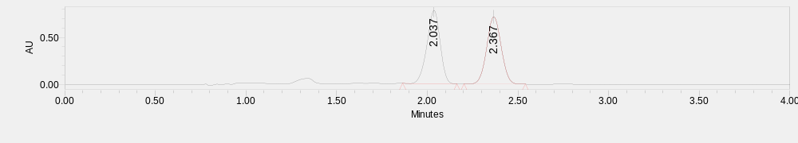
 | Retention Time | Area | % Area
1 | 2.037 | 3884327 | 49.63
2 | 2.367 | 3941771 | 50.37
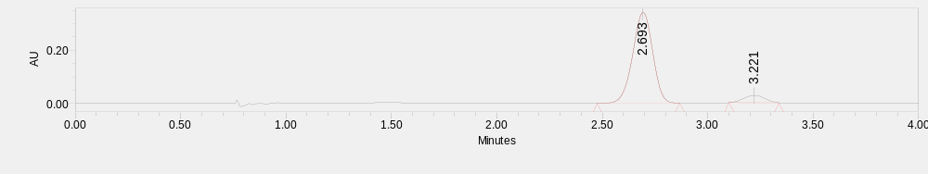
 | Retention Time | Area | % Area
1 | 2.693 | 2251507 | 92.13
2 | 3.221 | 192229 | 7.87

ethyl (S)-2-fluoro-7-oxo-7,12-dihydro-12aH-benzo[4,5]isothiazolo[2,3-b]isoquinoline-12a-carboxylate 5,5-dioxide (E9)
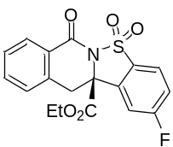
White solid; 63% yield, 90% ee. [α]_{D}^{23.0} = -162.0 (c = 0.47, in CH₂Cl₂), dissolved in MeOH for UPC² (Daicel Chiralcel OZ-3, CO₂/MeOH = 80/20, flow rate = 1.5 mL/min, λ = 254 nm), retention time: t_{R1} = 5.34 min, t_{R2} = 5.79 min.
¹H NMR (400 MHz, CDCl₃) δ 8.23 – 8.16 (m, 1H), 7.92 (dd, J = 8.4, 4.4 Hz, 1H), 7.58 (td, J = 7.6, 1.6 Hz, 1H), 7.52 (dd, J = 7.8, 2.4 Hz, 1H), 7.47 (t, J = 7.6 Hz, 1H), 7.40 (td, J = 8.4, 2.4 Hz, 1H), 7.34 (d, J = 7.6 Hz, 1H), 4.13 – 3.94 (m, 3H), 3.44 (d, J = 15.2 Hz, 1H), 0.97 (t, J = 7.2 Hz, 3H).
¹³C NMR (101 MHz, CDCl₃) δ 168.1, 165.0 (d, J = 256.1 Hz), 160.5, 135.4 (d, J = 9.4 Hz), 134.6, 134.2, 130.7 (d, J = 2.8 Hz), 129.1, 128.7, 128.2, 127.6, 124.5 (d, J = 9.8 Hz), 119.3 (d, J = 23.8 Hz), 111.9 (d, J = 25.1 Hz), 68.1 (d, J = 2.1 Hz), 63.8, 38.4, 13.6.
¹⁹F NMR (377 MHz, CDCl₃) δ -100.73.
ESI-HRMS: calcd for C₁₈H₁₄FNO₅SNa⁺ ([M + Na]⁺) = 398.0469, found 398.0448.
IR (neat): 1743, 1690, 1597, 1457, 1340, 1281, 1207, 1192, 1169, 1066, 742 cm⁻¹.
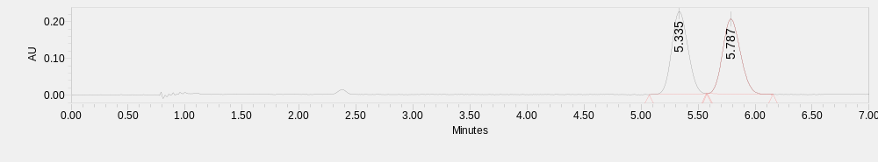
 | Retention Time | Area | % Area
1 | 5.335 | 2194514 | 49.84
2 | 5.787 | 2208214 | 50.16
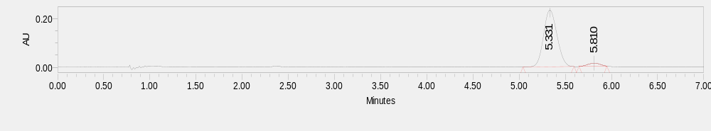
 | Retention Time | Area | % Area
1 | 5.331 | 2370206 | 95.06
2 | 5.810 | 123187 | 4.94

ethyl (S)-7-oxo-2-(trifluoromethyl)-7,12-dihydro-12aH-benzo[4,5]isothiazolo[2,3-b]isoquinoline-12a-carboxylate 5,5-dioxide (E10)
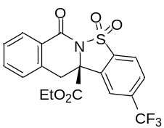
White solid; 93% yield, 87% ee. [α]_{D}^{23.2} = -130.3 (c = 0.79, in CH₂Cl₂), dissolved in MeOH for UPC² (Daicel Chiralcel IH-3, CO₂/MeOH = 92/8, flow rate = 1.5 mL/min, λ = 254 nm), retention time: t_{R1} = 3.07 min, t_{R2} = 4.01 min.
¹H NMR (400 MHz, CDCl₃) δ 8.21 (d, J = 7.6 Hz, 1H), 8.11 (s, 1H), 8.06 (d, J = 8.4 Hz, 1H), 7.98 (d, J = 8.0 Hz, 1H), 7.64 – 7.57 (m, 1H), 7.49 (t, J = 7.6 Hz, 1H), 7.36 (d, J = 7.6 Hz, 1H), 4.17 – 3.95 (m, 3H), 3.47 (d, J = 15.2 Hz, 1H), 0.98 (t, J = 7.2 Hz, 3H).
¹³C NMR (101 MHz, CDCl₃) δ 167.9, 160.5, 136.4 (q, J = 33.3 Hz), 135.9, 134.5, 134.4, 133.6, 129.2, 128.8, 128.5 (q, J = 3.5 Hz), 128.3, 127.5, 123.1, 122.7 (q, J = 271.9 Hz) 122.0 (q, J = 3.9 Hz), 68.5, 63.9, 38.5, 13.6.
¹⁹F NMR (377 MHz, CDCl₃) δ -62.84.
ESI-HRMS: calcd for C₁₉H₁₄F₃NO₅SNa⁺ ([M + Na]⁺) = 448.0437, found 448.0425.
IR (neat): 1746, 1696, 1605, 1458, 1428, 1323, 1290, 1267, 1194, 1172, 1136, 1083, 715 cm⁻¹.
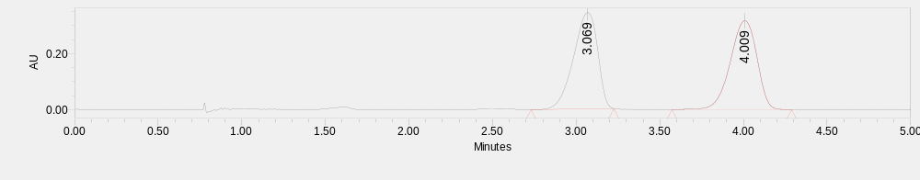
 | Retention Time | Area | % Area
1 | 3.069 | 3441510 | 49.54
2 | 4.009 | 3505016 | 50.46
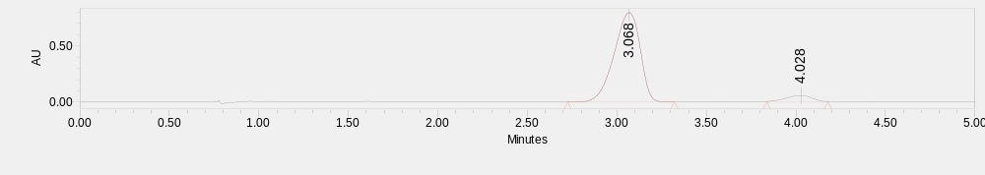
 | Retention Time | Area | % Area
1 | 3.068 | 8029109 | 93.64
2 | 4.028 | 545674 | 6.36

ethyl (S)-3-methyl-7-oxo-7,12-dihydro-12aH-benzo[4,5]isothiazolo[2,3-b]isoquinoline-12a-carboxylate 5,5-dioxide (E11)
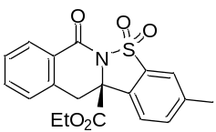
White solid; 60% yield, 95% ee. [α]_{D}^{23.7} = -170.5 (c = 0.44, in CH₂Cl₂), dissolved in MeOH for UPC² (Daicel Chiralcel IG-3, CO₂/MeOH = 80/20, flow rate = 1.5 mL/min, λ = 254 nm), retention time: t_{R1} = 8.24 min, t_{R2} = 11.69 min.
¹H NMR (400 MHz, CDCl₃) δ 8.19 (dd, J = 7.6, 0.8 Hz, 1H), 7.73 – 7.65 (m, 2H), 7.62 – 7.52 (m, 2H), 7.45 (t, J = 7.6 Hz, 1H), 7.33 (d, J = 7.6 Hz, 1H), 4.13 – 3.90 (m, 3H), 3.37 (d, J = 15.2 Hz, 1H), 2.50 (s, 3H), 0.96 (t, J = 7.2 Hz, 3H).
¹³C NMR (101 MHz, CDCl₃) δ 168.7, 160.7, 142.2, 135.4, 135.1, 134.6, 134.0, 129.6, 129.1, 128.5, 128.2, 127.8, 124.0, 121.9, 68.4, 63.4, 38.4, 21.4, 13.6.
ESI-HRMS: calcd for C₁₉H₁₇NO₅SNa⁺ ([M + Na]⁺) = 394.0720, found 394.0703.
IR (neat): 1744, 1693, 1606, 1457, 1340, 1320, 1289, 1183, 1155, 1063, 743 cm⁻¹.
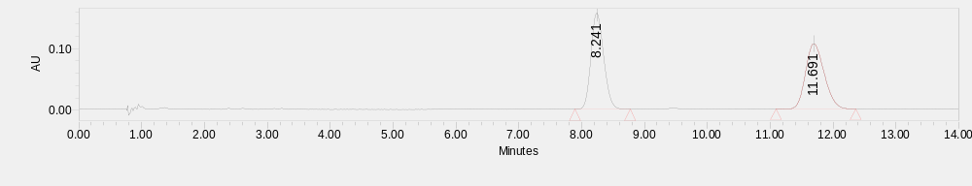
 | Retention Time | Area | % Area
1 | 8.241 | 2203815 | 50.14
2 | 11.691 | 2191200 | 49.86
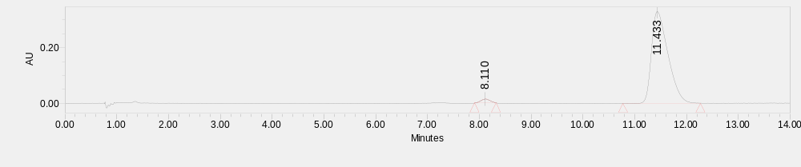
 | Retention Time | Area | % Area
1 | 8.110 | 175854 | 2.36
2 | 11.433 | 7290185 | 97.64

ethyl (S)-1,3-dimethyl-7-oxo-7,12-dihydro-12aH-benzo[4,5]isothiazolo[2,3-b]isoquinoline-12a-carboxylate 5,5-dioxide (E12)
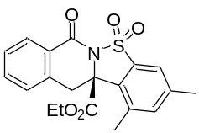
White solid; 78% yield, 93% ee. [α]_{D}^{23.6} = -207.2 (c = 0.56, in CH₂Cl₂), dissolved in MeOH for UPC² (Daicel Chiralcel IG-3, CO₂/MeOH = 80/20, flow rate = 1.5 mL/min, λ = 254 nm), retention time: t_{R1} = 8.15 min, t_{R2} = 10.83 min.
¹H NMR (400 MHz, CDCl₃) δ 8.17 (d, J = 7.6 Hz, 1H), 7.61 – 7.52 (m, 2H), 7.44 (t, J = 7.6 Hz, 1H), 7.40 – 7.31 (m, 2H), 4.31 (d, J = 15.6 Hz, 1H), 4.10 – 3.89 (m, 2H), 3.40 (d, J = 15.2 Hz, 1H), 2.68 (s, 3H), 2.44 (s, 3H), 0.98 (t, J = 7.2 Hz, 3H).
¹³C NMR (101 MHz, CDCl₃) δ 168.1, 160.7, 141.8, 138.2, 136.1, 135.7, 135.4, 134.2, 128.9, 128.4, 128.3, 127.1, 120.1, 69.7, 63.2, 36.2, 21.0, 19.7, 13.5.
ESI-HRMS: calcd for C₂₀H₁₉NO₅SNa⁺ ([M + Na]⁺) = 408.0876, found 408.0857.
IR (neat): 1740, 1694, 1605, 1455, 1337, 1319, 1288, 1181, 1158, 1126, 1066, 701 cm⁻¹.
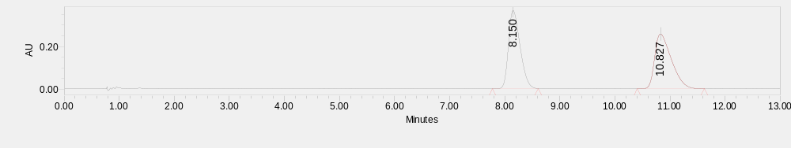
 | Retention Time | Area | % Area
1 | 8.150 | 5360540 | 49.92
2 | 10.827 | 5377453 | 50.08
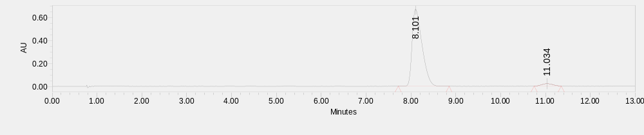
 | Retention Time | Area | % Area
1 | 8.101 | 10260561 | 96.43
2 | 11.034 | 380036 | 3.57

ethyl (S)-2,3-dimethoxy-7-oxo-7,12-dihydro-12aH-benzo[4,5]isothiazolo[2,3-b]isoquinoline-12a-carboxylate 5,5-dioxide (E13)
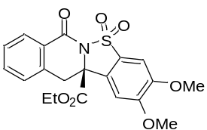
White solid; 90% yield, 95% ee. [α]_{D}^{23.9} = -192.2 (c = 0.75, in CH₂Cl₂), dissolved in MeOH for UPC² (Daicel Chiralcel OZ-3, CO₂/MeOH = 80/20, flow rate = 1.5 mL/min, λ = 254 nm), retention time: t_{R1} = 9.73 min, t_{R2} = 12.95 min.
¹H NMR (400 MHz, CDCl₃) δ 8.20 (d, J = 7.6 Hz, 1H), 7.57 (td, J = 7.6, 1.2 Hz, 1H), 7.46 (t, J = 7.6 Hz, 1H), 7.34 (d, J = 7.6 Hz, 1H), 7.28 (d, J = 5.6 Hz, 2H), 7.15 (s, 1H), 4.13 – 3.94 (m, 9H), 3.39 (d, J = 15.2 Hz, 1H), 0.97 (t, J = 7.2 Hz, 3H).
¹³C NMR (101 MHz, CDCl₃) δ 168.9, 160.6, 154.4, 151.7, 135.1, 134.0, 129.1, 128.5, 128.2, 127.9, 126.2, 125.5, 104.9, 102.7, 68.1, 63.3, 56.6, 56.6, 38.5, 13.6.
ESI-HRMS: calcd for C₂₀H₁₉NO₇SNa⁺ ([M + Na]⁺) = 440.0774, found 440.0746.
IR (neat): 1743, 1692, 1604, 1506, 1460, 1365, 1335, 1282, 1190, 1154, 1063, 1007, 855 cm⁻¹.
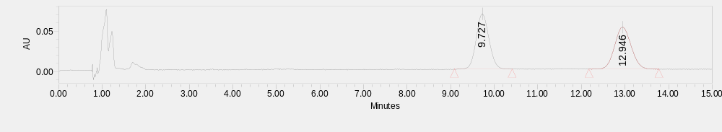
 | Retention Time | Area | % Area
1 | 9.727 | 1393007 | 50.55
2 | 12.946 | 1362840 | 49.45
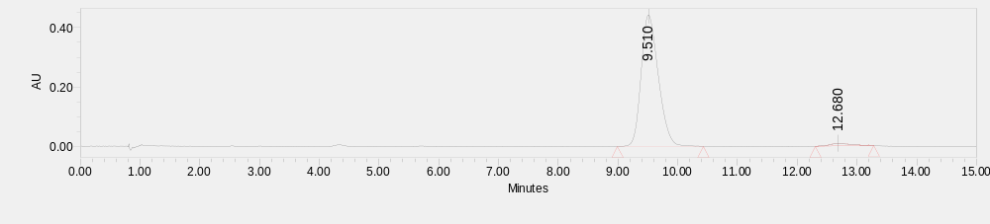
 | Retention Time | Area | % Area
1 | 9.510 | 8837564 | 97.54
2 | 12.680 | 223082 | 2.46

ethyl (S)-4-fluoro-7-oxo-7,12-dihydro-12aH-benzo[4,5]isothiazolo[2,3-b]isoquinoline-12a-carboxylate 5,5-dioxide (E14)
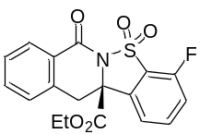
White solid; 62% yield, 91% ee. [α]_{D}^{23.9} = -154.5 (c = 0.46, in CH₂Cl₂), dissolved in MeOH for UPC² (Daicel Chiralcel As-3, CO₂/MeOH = 80/20, flow rate = 1.5 mL/min, λ = 254 nm), retention time: t_{R1} = 1.95 min, t_{R2} = 2.82 min.
¹H NMR (400 MHz, CDCl₃) δ 8.19 (d, J = 7.6 Hz, 1H), 7.79 (td, J = 8.0, 4.8 Hz, 1H), 7.66 – 7.54 (m, 2H), 7.47 (t, J = 7.6 Hz, 1H), 7.36 (t, J = 8.4 Hz, 2H), 4.16 – 3.93 (m, 3H), 3.44 (d, J = 15.2 Hz, 1H), 0.98 (t, J = 7.2 Hz, 3H).
¹³C NMR (101 MHz, CDCl₃) δ 168.2, 160.5, 156.6 (d, J = 259.8 Hz), 136.6 (d, J = 7.3 Hz), 135.1, 134.8, 134.3, 129.2, 128.7, 128.3, 127.6, 122.8 (d, J = 18.6 Hz), 120.0 (d, J = 4.1 Hz), 118.2 (d, J = 18.1 Hz), 68.5, 63.7, 38.5, 13.6.
¹⁹F NMR (377 MHz, CDCl₃) δ -113.33.
ESI-HRMS: calcd for C₁₈H₁₄FNO₅SNa⁺ ([M + Na]⁺) = 398.0469, found 398.0470.
IR (neat): 1742, 1689, 1607, 1475, 1347, 1326, 1289, 1210, 1189, 1064, 792, 697 cm⁻¹.
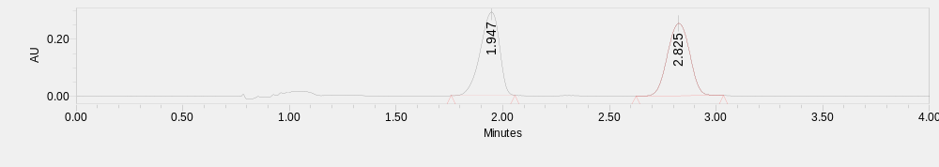
 | Retention Time | Area | % Area
1 | 1.947 | 1816530 | 49.82
2 | 2.825 | 1829590 | 50.18
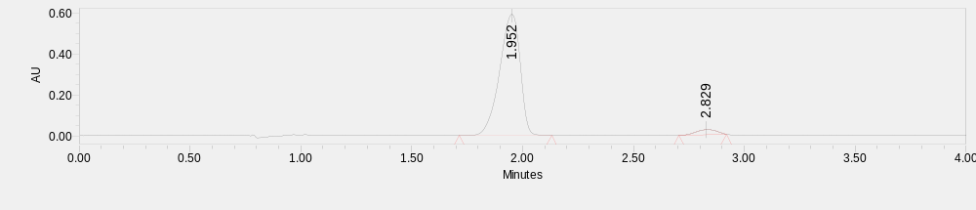
 | Retention Time | Area | % Area
1 | 1.952 | 3784532 | 95.85
2 | 2.829 | 163886 | 4.15
ethyl (S)-4-chloro-7-oxo-7,12-dihydro-12aH-benzo[4,5]isothiazolo[2,3-b]isoquinoline-12a-carboxylate 5,5-dioxide (E15)
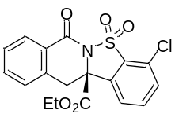
White solid; 40% yield, 91% ee. [α]_{D}^{24.3} = -169.7 (c = 0.31, in CH₂Cl₂), dissolved in MeOH for UPC² (Daicel Chiralcel OZ-3, CO₂/MeOH = 80/20, flow rate = 1.5 mL/min, λ = 254 nm), retention time: t_{R1} = 8.94 min, t_{R2} = 11.50 min.
¹H NMR (400 MHz, CDCl₃) δ 8.19 (d, J = 7.6 Hz, 1H), 7.76 – 7.68 (m, 2H), 7.62 (dd, J = 6.8, 2.0 Hz, 1H), 7.58 (td, J = 7.6, 1.2 Hz, 1H), 7.47 (t, J = 7.6 Hz, 1H), 7.34 (d, J = 7.6 Hz, 1H), 4.14 – 3.92 (m, 3H), 3.41 (d, J = 15.2 Hz, 1H), 0.97 (t, J = 7.2 Hz, 3H).
¹³C NMR (101 MHz, CDCl₃) δ 168.3, 160.5, 135.2, 135.0, 134.8, 134.2, 132.6, 132.1, 129.8, 129.2, 128.7, 128.3, 127.7, 122.5, 67.7, 63.7, 38.4, 13.6.
ESI-HRMS: calcd for C₁₈H₁₄³⁵ClNO₅SNa⁺ ([M + Na]⁺) = 414.0173, found 414.0165. C₁₈H₁₄³⁷ClNO₅SNa⁺ ([M + Na]⁺) = 416.0144, found 416.0132.
IR (neat): 1742, 1688, 1606, 1458, 1345, 1321, 1287, 1211, 1189, 1162, 1064, 1016, 859 cm⁻¹.
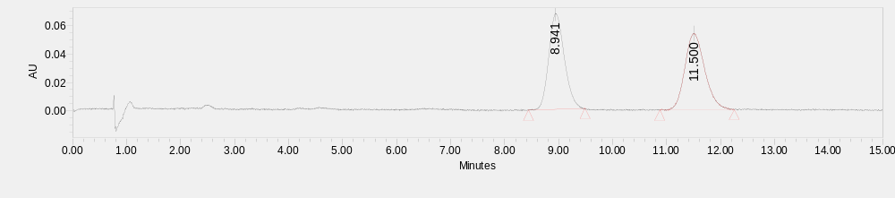
 | Retention Time | Area | % Area
1 | 8.941 | 1354104 | 49.43
2 | 11.500 | 1385167 | 50.57
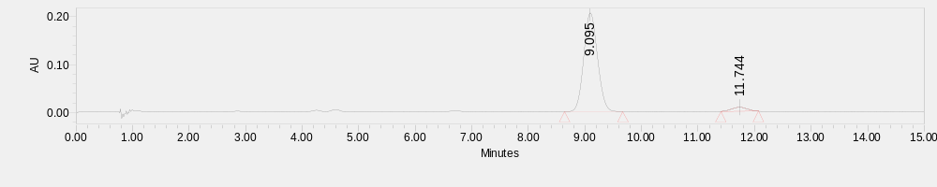
 | Retention Time | Area | % Area
1 | 9.095 | 3464641 | 95.57
2 | 11.744 | 160750 | 4.43

ethyl (S)-7-oxo-4-(trifluoromethyl)-7,12-dihydro-12aH-benzo[4,5]isothiazolo[2,3-b]isoquinoline-12a-carboxylate 5,5-dioxide (E16)
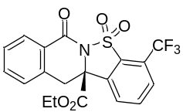
White solid; 85% yield, 87% ee. [α]_{D}^{24.4} = -144.8 (c = 0.36, in CH₂Cl₂), dissolved in MeOH for UPC² (Daicel Chiralcel OZ-3, CO₂/MeOH = 80/20, flow rate = 1.5 mL/min, λ = 254 nm), retention time: t_{R1} = 3.54 min, t_{R2} = 4.08 min.
¹H NMR (400 MHz, CDCl₃) δ 8.20 (d, J = 7.6 Hz, 1H), 8.13 – 8.05 (m, 1H), 8.00 – 7.89 (m, 2H), 7.59 (td, J = 7.6, 1.2 Hz, 1H), 7.48 (t, J = 7.6 Hz, 1H), 7.35 (d, J = 7.6 Hz, 1H), 4.18 – 3.89 (m, 3H), 3.44 (d, J = 15.2 Hz, 1H), 0.97 (t, J = 7.2 Hz, 3H).
¹³C NMR (101 MHz, CDCl₃) δ 168.3, 160.3, 134.7, 134.5, 134.5, 134.3, 132.6, 129.2 (q, J = 5.1 Hz), 128.8, 128.3, 128.3, 127.7, 126.6 (q, J = 36.1 Hz), 122.0 (q, J = 272.9 Hz), 67.8, 63.8, 38.7, 13.6.
¹⁹F NMR (377 MHz, CDCl₃) δ -59.13.
ESI-HRMS: calcd for C₁₉H₁₄F₃NO₅SNa⁺ ([M + Na]⁺) = 448.0437, found 448.0413.
IR (neat): 1750, 1695, 1605, 1353, 1322, 1283, 1209, 1184, 1151, 1065, 1008, 822, 712 cm⁻¹.
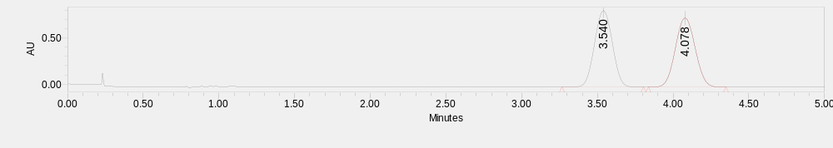
 | Retention Time | Area | % Area
1 | 3.540 | 6777730 | 50.04
2 | 4.078 | 6767359 | 49.96
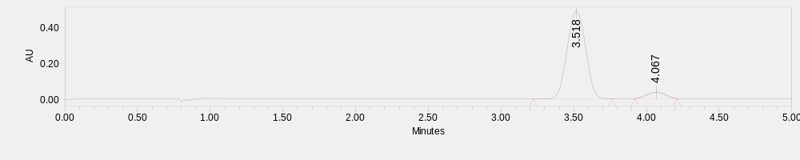
 | Retention Time | Area | % Area
1 | 3.518 | 4303601 | 93.42
2 | 4.067 | 302938 | 6.58

ethyl (S)-8-oxo-8,13-dihydro-13aH-naphtho[2',3':4,5]isothiazolo[2,3-b]isoquinoline-13a-carboxylate 6,6-dioxide (E17)
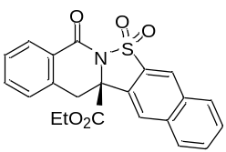
White solid; 55% yield, 86% ee. [α]_{D}^{24.2} = -212.9 (c = 0.45, in CH₂Cl₂), dissolved in MeOH for UPC² (Daicel Chiralcel IH-3, CO₂/MeOH = 80/20, flow rate = 1.5 mL/min, λ = 254 nm), retention time: t_{R1} = 4.87 min, t_{R2} = 7.64 min.
¹H NMR (400 MHz, CDCl₃) δ 8.49 (d, J = 8.0 Hz, 1H), 8.22 (d, J = 8.0 Hz, 2H), 8.02 (d, J = 8.0 Hz, 1H), 7.85 – 7.76 (m, 2H), 7.76 – 7.69 (m, 1H), 7.59 (td, J = 7.6, 1.2 Hz, 1H), 7.47 (t, J = 7.6 Hz, 1H), 7.37 (d, J = 7.6 Hz, 1H), 4.14 (d, J = 15.2 Hz, 1H), 4.10 – 3.92 (m, 2H), 3.45 (d, J = 15.2 Hz, 1H), 0.97 (t, J = 7.2 Hz, 3H).
¹³C NMR (101 MHz, CDCl₃) δ 168.5, 160.6, 135.4, 135.1, 134.1, 134.0, 131.3, 130.1, 129.8, 129.1, 128.9, 128.7, 128.6, 128.3, 127.9, 125.1, 123.2, 119.3, 68.5, 63.5, 38.3, 13.6.
ESI-HRMS: calcd for C₂₂H₁₇NO₅SNa⁺ ([M + Na]⁺) = 430.0720, found 430.0723.
IR (neat): 1744, 1694, 1605, 1457, 1337, 1314, 1290, 1206, 1186, 1155, 1064, 1018, 702 cm⁻¹.
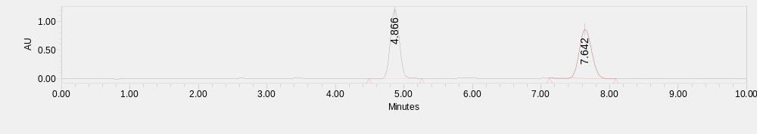
 | Retention Time | Area | % Area
1 | 4.866 | 10962344 | 50.42
2 | 7.642 | 10778296 | 49.58
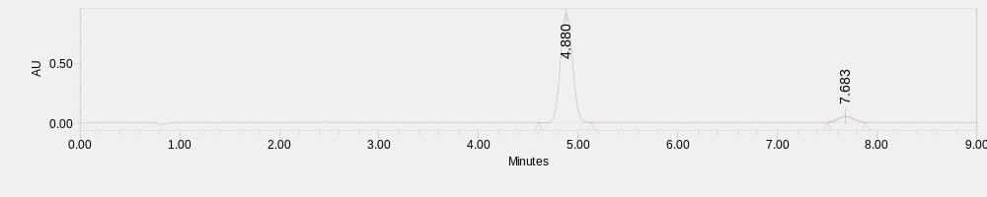
 | Retention Time | Area | % Area
1 | 4.880 | 7724658 | 93.15
2 | 7.683 | 568019 | 6.85

ethyl (S)-8-methyl-7-oxo-7,12-dihydro-12aH-benzo[4,5]isothiazolo[2,3-b]isoquinoline-12a-carboxylate 5,5-dioxide (E18)
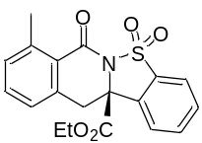
White solid; 89% yield, 92% ee. [α]_{D}^{24.2} = -200.8 (c = 0.66, in CH₂Cl₂), dissolved in MeOH for UPC² (Daicel Chiralcel IG-3, CO₂/MeOH = 80/20, flow rate = 1.5 mL/min, λ = 254 nm), retention time: t_{R1} = 5.57 min, t_{R2} = 6.67 min.
¹H NMR (400 MHz, CDCl₃) δ 8.05 (d, J = 7.6 Hz, 1H), 7.93 – 7.84 (m, 2H), 7.83 – 7.77 (m, 1H), 7.75 – 7.66 (m, 1H), 7.43 (d, J = 7.2 Hz, 1H), 7.34 (t, J = 7.6 Hz, 1H), 4.17 (d, J = 15.6 Hz, 1H), 4.08 – 3.96 (m, 2H), 3.14 (d, J = 15.6 Hz, 1H), 2.41 (s, 3H), 0.97 (t, J = 7.2Hz, 3H).
¹³C NMR (101 MHz, CDCl₃) δ 168.7, 161.0, 136.0, 135.6, 134.6, 134.4, 133.7, 132.5, 131.2, 127.9, 127.0, 124.3, 122.0, 68.1, 63.4, 35.1, 19.3, 13.6.
ESI-HRMS: calcd for C₁₉H₁₇NO₅SNa⁺ ([M + Na]⁺) = 394.0720, found 394.0736.
IR (neat): 1745, 1692, 1469, 1341, 1324, 1209, 1069, 752 cm⁻¹.
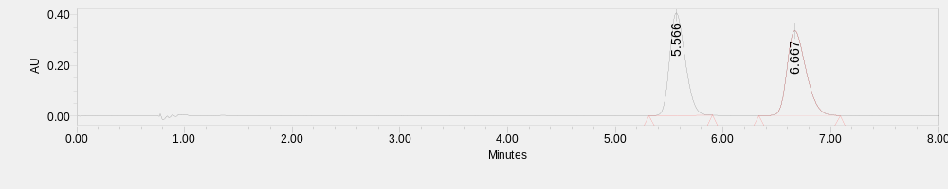
 | Retention Time | Area | % Area
1 | 5.566 | 4059191 | 49.97
2 | 6.667 | 4063620 | 50.03
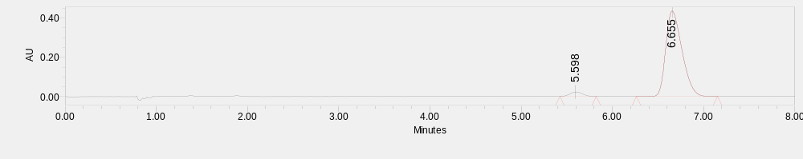
 | Retention Time | Area | % Area
1 | 5.598 | 223718 | 3.99
2 | 6.655 | 5388629 | 96.01

ethyl (S)-9-methyl-7-oxo-7,12-dihydro-12aH-benzo[4,5]isothiazolo[2,3-b]isoquinoline-12a-carboxylate 5,5-dioxide (E19)
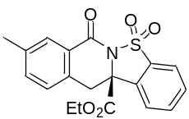
White solid; 77% yield, 93% ee. [α]_{D}^{23.9} = -169.6 (c = 0.57, in CH₂Cl₂), dissolved in MeOH for UPC² (Daicel Chiralcel IG-3, CO₂/MeOH = 80/20, flow rate = 1.5 mL/min, λ = 254 nm), retention time: t_{R1} = 7.26 min, t_{R2} = 9.92 min.
¹H NMR (400 MHz, CDCl₃) δ 7.99 (s, 1H), 7.90 (d, J = 7.8 Hz, 1H), 7.85 – 7.75 (m, 2H), 7.73 – 7.65 (m, 1H), 7.40 – 7.31 (m, 1H), 7.22 (d, J = 7.7 Hz, 1H), 4.12 – 3.93 (m, 3H), 3.35 (d, J = 15.2Hz, 1H), 2.40 (s, 3H), 0.98 (t, J = 7.2Hz, 3H).
¹³C NMR (101 MHz, CDCl₃) δ 168.6, 160.9, 138.6, 135.0, 134.6, 134.3, 132.5, 132.0, 131.1, 129.3, 128.1, 127.5, 124.3, 122.0, 68.7, 63.4, 38.1, 21.0, 13.6.
ESI-HRMS: calcd for C₁₉H₁₇NO₅SNa⁺ ([M + Na]⁺) = 394.0720, found 394.0719.
IR (neat): 1744, 1693, 1341, 1295, 1213, 1181, 1064, 1015, 759 cm⁻¹.
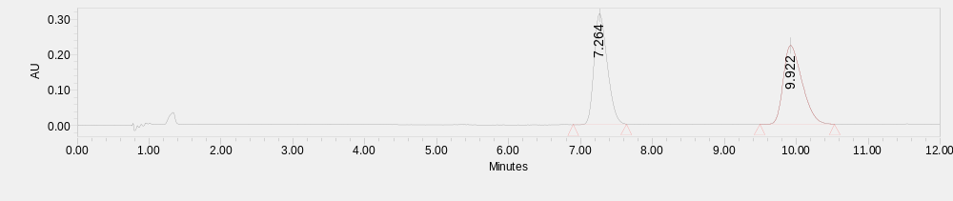
 | Retention Time | Area | % Area
1 | 7.264 | 4002704 | 49.85
2 | 9.922 | 4026981 | 50.15
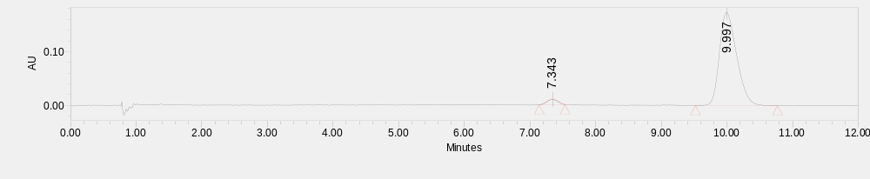
 | Retention Time | Area | % Area
1 | 7.343 | 113716 | 3.50
2 | 9.997 | 3131715 | 96.50

ethyl (S)-9-fluoro-7-oxo-7,12-dihydro-12aH-benzo[4,5]isothiazolo[2,3-b]isoquinoline-12a-carboxylate 5,5-dioxide (E20)
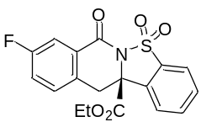
White solid; 99% yield, 96% ee. [α]_{D}^{23.4} = -165.7 (c = 0.75, in CH₂Cl₂), dissolved in MeOH for UPC² (Daicel Chiralcel IG-3, CO₂/MeOH = 70/30, flow rate = 1.5 mL/min, λ = 254 nm), retention time: t_{R1} = 3.08 min, t_{R2} = 4.01 min.
¹H NMR (400 MHz, CDCl₃) δ 7.97 – 7.78 (m, 4H), 7.76 – 7.69 (m, 1H), 7.37 (dd, J = 8.4, 5.2 Hz, 1H), 7.33 – 7.23 (m, 1H), 4.18 – 3.95 (m, 3H), 3.38 (d, J = 15.2 Hz, 1H), 1.01 (t, J = 7.2 Hz, 3H).
¹³C NMR (101 MHz, CDCl₃) δ 168.3, 162.4 (d, J = 247.7 Hz), 159.7 (d, J = 2.7 Hz), 134.5, 134.4, 132.1, 131.3, 130.8 (d, J = 3.4 Hz), 130.2 (d, J = 7.5 Hz), 129.7 (d, J = 7.8 Hz), 124.4, 122.0, 121.4 (d, J = 22.1 Hz), 115.6 (d, J = 23.6 Hz), 68.6, 63.6, 37.7, 13.6.
¹⁹F NMR (377 MHz, CDCl₃) δ -111.44.
ESI-HRMS: calcd for C₁₈H₁₄FNO₅SNa⁺ ([M + Na]⁺) = 398.0469, found 398.0453.
IR (neat): 1744, 1689, 1494, 1435, 1339, 1290, 1205, 1177, 1060, 938, 724 cm⁻¹.
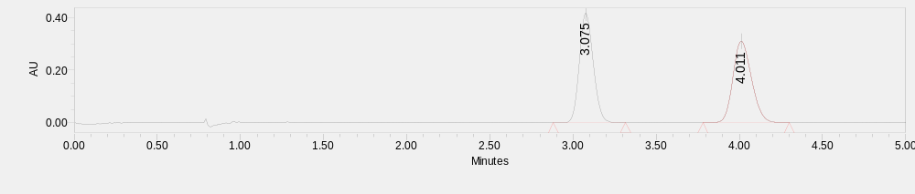
 | Retention Time | Area | % Area
1 | 3.075 | 2401752 | 49.97
2 | 4.011 | 2404698 | 50.03
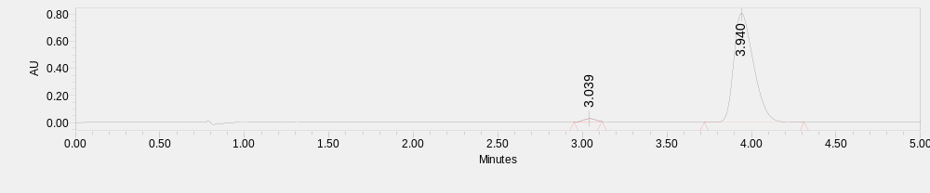
 | Retention Time | Area | % Area
1 | 3.039 | 118265 | 1.78
2 | 3.940 | 6540943 | 98.22

ethyl (S)-9-chloro-7-oxo-7,12-dihydro-12aH-benzo[4,5]isothiazolo[2,3-b]isoquinoline-12a-carboxylate 5,5-dioxide (E21)
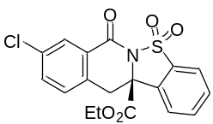
White solid; 86% yield, 96% ee. [α]_{D}^{23.8} = -167.1 (c = 0.67, in CH₂Cl₂), dissolved in MeOH for UPC² (Daicel Chiralcel IG-3, CO₂/MeOH = 70/30, flow rate = 1.5 mL/min, λ = 254 nm), retention time: t_{R1} = 4.30 min, t_{R2} = 7.76 min.
¹H NMR (400 MHz, CDCl₃) δ 8.15 (d, J = 2.0 Hz, 1H), 7.90 (d, J = 8.0 Hz, 1H), 7.86 – 7.77 (m, 2H), 7.75 – 7.67 (m, 1H), 7.53 (dd, J = 8.0, 2.4 Hz, 1H), 7.31 (d, J = 8.0 Hz, 1H), 4.14 – 3.94 (m, 3H), 3.36 (d, J = 15.2 Hz, 1H), 1.01 (t, J = 7.2 Hz, 3H).
¹³C NMR (101 MHz, CDCl₃) δ 168.2, 159.5, 134.8, 134.5, 134.4, 134.1, 133.3, 132.1, 131.3, 129.7, 129.3, 128.8, 124.3, 122.0, 68.4, 63.7, 37.8, 13.6.
ESI-HRMS: calcd for C₁₈H₁₄³⁵ClNO₅SNa⁺ ([M + Na]⁺) = 414.0173, found 414.0144. C₁₈H₁₄³⁷ClNO₅SNa⁺ ([M + Na]⁺) = 416.0144, found 416.0111.
IR (neat): 1744, 1696, 1417, 1344, 1287, 1188, 1064, 895, 756, 712 cm⁻¹.
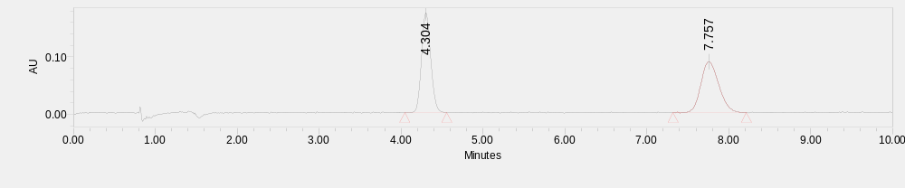
 | Retention Time | Area | % Area
1 | 4.304 | 1351878 | 50.13
2 | 7.757 | 1344777 | 49.87
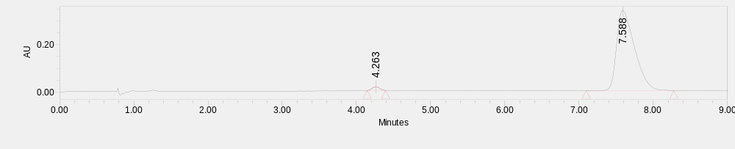
 | Retention Time | Area | % Area
1 | 4.263 | 118303 | 2.05
2 | 7.588 | 5642201 | 97.95

ethyl (S)-10-methyl-7-oxo-7,12-dihydro-12aH-benzo[4,5]isothiazolo[2,3-b]isoquinoline-12a-carboxylate 5,5-dioxide (E22)
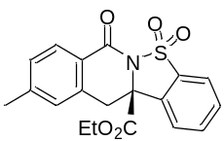
White solid; 78% yield, 85% ee. [α]_{D}^{24.5} = -145.8 (c = 0.58, in CH₂Cl₂), dissolved in MeOH for UPC² (Daicel Chiralcel OZ-3, CO₂/MeOH = 80/20, flow rate = 1.5 mL/min, λ = 254 nm), retention time: t_{R1} = 7.71 min, t_{R2} = 9.05 min.
¹H NMR (400 MHz, CDCl₃) δ 8.08 (d, J = 8.0 Hz, 1H), 7.91 (d, J = 7.6 Hz, 1H), 7.86 - 7.76 (m, 2H), 7.74 – 7.66 (m, 1H), 7.26 (d, J = 9.0 Hz, 1H), 7.14 (s, 1H), 4.14 – 3.95 (m, 3H), 3.37 (d, J = 15.2 Hz, 1H), 2.42 (s, 3H), 0.99 (t, J = 7.2 Hz, 3H).
¹³C NMR (101 MHz, CDCl₃) δ 168.7, 160.7, 145.2, 135.1, 134.7, 134.3, 132.5, 131.1, 129.4, 129.1, 128.8, 125.1, 124.2, 122.0, 68.6, 63.4, 38.3, 21.7, 13.6.
ESI-HRMS: calcd for C₁₉H₁₇NO₅SNa⁺ ([M + Na]⁺) = 394.0720, found 394.0703.
IR (neat): 1743, 1692, 1611, 1340, 1321, 1285, 1192, 1169, 1064, 833, 759, 708 cm⁻¹.
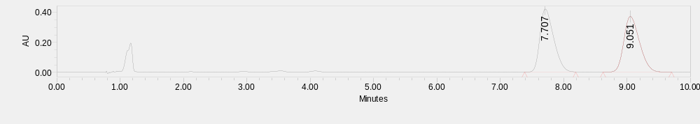
 | Retention Time | Area | % Area
1 | 7.707 | 6339184 | 49.93
2 | 9.051 | 6358144 | 50.07
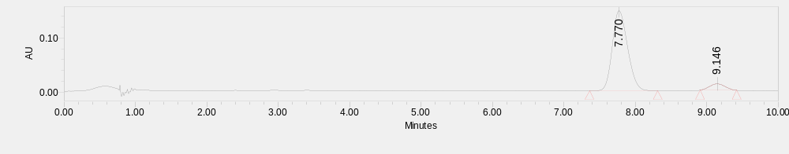
 | Retention Time | Area | % Area
1 | 7.770 | 2180997 | 92.44
2 | 9.146 | 178246 | 7.56

ethyl (S)-10-methoxy-7-oxo-7,12-dihydro-12aH-benzo[4,5]isothiazolo[2,3-b]isoquinoline-12a-carboxylate 5,5-dioxide (E23)
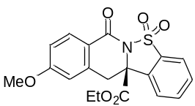
White solid; 31% yield, 73% ee. [α]_{D}^{24.1} = -131.6 (c = 0.12, in CH₂Cl₂), dissolved in MeOH for UPC² (Daicel Chiralcel IH-3, CO₂/MeOH = 80/20, flow rate = 1.5 mL/min, λ = 254 nm), retention time: t_{R1} = 3.57 min, t_{R2} = 4.58 min.
¹H NMR (400 MHz, CDCl₃) δ 8.15 (d, J = 8.8 Hz, 1H), 7.91 (d, J = 8.0 Hz, 1H), 7.82 – 7.74 (m, 2H), 7.73 – 7.66 (m, 1H), 6.95 (dd, J = 8.8, 2.4 Hz, 1H), 6.80 (d, J = 1.6 Hz, 1H), 4.14 – 3.95 (m, 3H), 3.89 (s, 3H), 3.37 (d, J = 15.2 Hz, 1H), 1.01 (t, J = 7.2 Hz, 3H).
¹³C NMR (101 MHz, CDCl₃) δ 168.8, 164.1, 160.4, 137.5, 134.9, 134.3, 132.6, 131.5, 131.2, 124.1, 122.1, 120.4, 114.0, 113.4, 68.5, 63.5, 55.6, 38.6, 13.7.
ESI-HRMS: calcd for C₁₉H₁₇NO₆SNa⁺ ([M + Na]⁺) = 410.0669, found 410.0680.
IR (neat): 1744, 1690, 1605, 1497, 1450, 1336, 1284, 1193, 1163, 1065, 834 cm⁻¹.
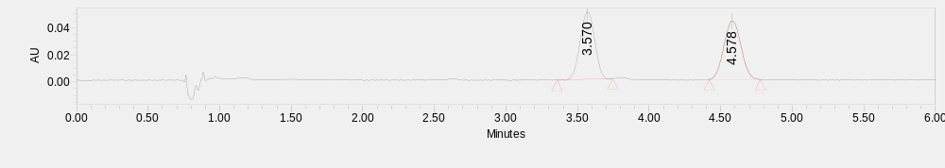
 | Retention Time | Area | % Area
1 | 3.570 | 351953 | 49.49
2 | 4.578 | 359141 | 50.51
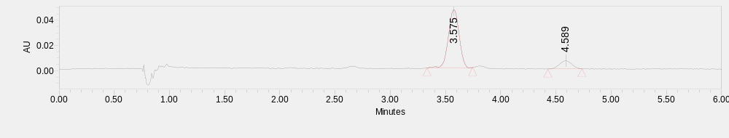
 | Retention Time | Area | % Area
1 | 3.575 | 309744 | 86.42
2 | 4.589 | 48655 | 13.58

ethyl (S)-10-fluoro-7-oxo-7,12-dihydro-12aH-benzo[4,5]isothiazolo[2,3-b]isoquinoline-12a-carboxylate 5,5-dioxide (E24)
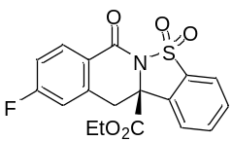
White solid; 54% yield, 97% ee. [α]_{D}^{24.1} = -176.5 (c = 0.39, in CH₂Cl₂), dissolved in MeOH for UPC² (Daicel Chiralcel IG-3, CO₂/MeOH = 80/20, flow rate = 1.5 mL/min, λ = 254 nm), retention time: t_{R1} = 5.10 min, t_{R2} = 6.32 min.
¹H NMR (400 MHz, CDCl₃) δ 8.23 (dd, J = 8.8, 5.6 Hz, 1H), 7.92 (d, J = 7.6 Hz, 1H), 7.83 – 7.78 (m, 2H), 7.76 – 7.67 (m, 1H), 7.15 (td, J = 8.4, 2.0 Hz, 1H), 7.09 – 6.99 (m, 1H), 4.14 – 3.94 (m, 3H), 3.41 (d, J = 15.6 Hz, 1H), 1.01 (t, J = 7.2 Hz, 3H).
¹³C NMR (101 MHz, CDCl₃) δ 168.4, 165.9 (d, J = 255.8 Hz), 159.7, 138.2 (d, J = 9.4 Hz), 134.6, 134.5, 132.1 (d, J = 3.7 Hz), 132.1, 131.3, 124.2, 124.1 (d, J = 2.9 Hz), 122.1, 116.2 (d, J = 22.1 Hz), 115.3 (d, J = 22.7 Hz), 68.4, 63.7, 38.3, 13.6.
¹⁹F NMR (377 MHz, CDCl₃) δ -102.48.
ESI-HRMS: calcd for C₁₈H₁₄FNO₅SNa⁺ ([M + Na]⁺) = 398.0469, found 398.0445.
IR (neat): 1744, 1696, 1611, 1491, 1451, 1342, 1289, 1204, 1189, 1065, 833, 707 cm⁻¹.
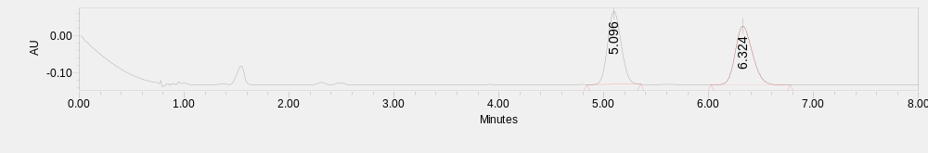
 | Retention Time | Area | % Area
1 | 5.096 | 1779364 | 49.77
2 | 6.324 | 1796101 | 50.23
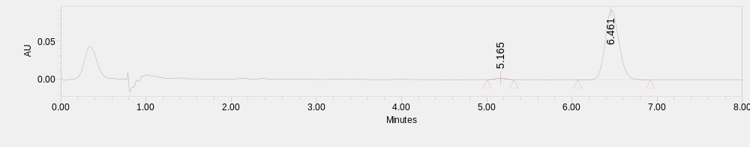
 | Retention Time | Area | % Area
1 | 5.165 | 16671 | 1.58
2 | 6.461 | 1035526 | 98.42

ethyl (S)-10-chloro-7-oxo-7,12-dihydro-12aH-benzo[4,5]isothiazolo[2,3-b]isoquinoline-12a-carboxylate 5,5-dioxide (E25)
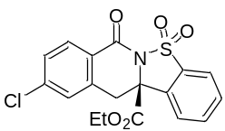
White solid; 79% yield, 92% ee. [α]_{D}^{23.7} = -110.4 (c = 0.62, in CH₂Cl₂), dissolved in MeOH for UPC² (Daicel Chiralcel IG-3, CO₂/MeOH = 70/30, flow rate = 1.5 mL/min, λ = 254 nm), retention time: t_{R1} = 4.40 min, t_{R2} = 7.63 min.
¹H NMR (400 MHz, CDCl₃) δ 8.14 (d, J = 8.4 Hz, 1H), 7.92 (d, J = 7.6Hz, 1H), 7.84 – 7.77 (m, 2H), 7.76 – 7.68 (m, 1H), 7.47 – 7.41 (m, 1H), 7.35 (s, 1H), 4.16 – 3.91 (m, 3H), 3.39 (d, J = 15.6 Hz, 1H), 1.01 (t, J = 7.2 Hz, 3H).
¹³C NMR (101 MHz, CDCl₃) δ 168.3, 159.8, 140.5, 136.8, 134.5, 132.1, 131.4, 130.6, 129.1, 128.3, 126.2, 124.3, 122.1, 68.4, 63.7, 38.1, 13.6.
ESI-HRMS: calcd for C₁₈H₁₄³⁵ClNO₅SNa⁺ ([M + Na]⁺) = 414.0173, found 414.0175. C₁₈H₁₄³⁷ClNO₅SNa⁺ ([M + Na]⁺) = 416.0144, found 416.0143.
IR (neat): 1744, 1695, 1597, 1343, 1322, 1282, 1193, 1148, 1064, 827, 758, 706 cm⁻¹.
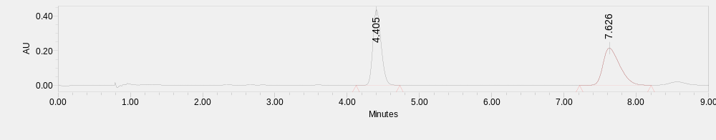
 | Retention Time | Area | % Area
1 | 4.405 | 3438075 | 50.06
2 | 7.626 | 3429252 | 49.94
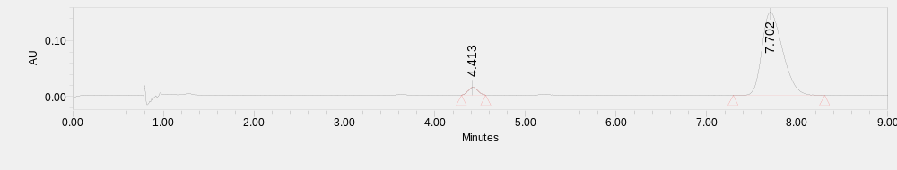
 | Retention Time | Area | % Area
1 | 4.413 | 99355 | 4.04
2 | 7.702 | 2362387 | 95.96

ethyl (S)-7-oxo-7,14-dihydro-13bH-benzo[f]benzo[4,5]isothiazolo[2,3-b]isoquinoline-13b-carboxylate 9,9-dioxide (E26)
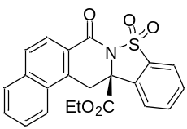
White solid; 94% yield, 93% ee. [α]_{D}^{25.1} = -280.1 (c = 0.78, in CH₂Cl₂), dissolved in MeOH for UPC² (Daicel Chiralcel IG-3, CO₂/MeOH = 80/20, flow rate = 1.5 mL/min, λ = 254 nm), retention time: t_{R1} = 11.94 min, t_{R2} = 15.45 min.
¹H NMR (400 MHz, CDCl₃) δ 8.20 (d, J = 8.8 Hz, 1H), 8.18 – 8.10 (m, 1H), 8.00 – 7.82 (m, 5H), 7.73 (t, J = 7.6 Hz, 1H), 7.70 – 7.62 (m, 2H), 4.80 (d, J = 16.0 Hz, 1H), 4.07 – 3.86 (m, 2H), 3.47 (d, J = 16.0 Hz, 1H), 0.90 (t, J = 7.2 Hz, 3H).
¹³C NMR (101 MHz, CDCl₃) δ 168.7, 160.9, 135.9, 134.7, 134.5, 133.9, 132.6, 131.3, 130.1, 129.0, 128.9, 128.7, 127.6, 125.4, 124.3, 124.3, 123.6, 122.1, 68.1, 63.5, 34.4, 13.6.
ESI-HRMS: calcd for C₂₂H₁₇NO₅SNa⁺ ([M + Na]⁺) = 430.0720, found 430.0725.
IR (neat): 1744, 1689, 1341, 1298, 1201, 1183, 1154, 1073, 1016, 763 cm⁻¹.
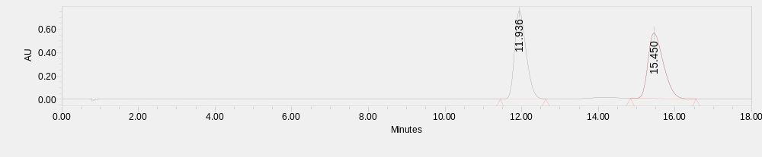
 | Retention Time | Area | % Area
1 | 11.936 | 15710264 | 50.17
2 | 15.450 | 15605213 | 49.83
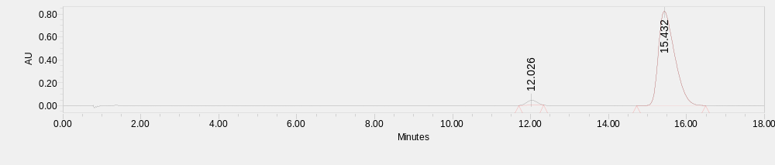
 | Retention Time | Area | % Area
1 | 12.026 | 804750 | 3.27
2 | 15.432 | 23784165 | 96.73

ethyl (12aS)-12-methyl-7-oxo-7,12-dihydro-12aH-benzo[4,5]isothiazolo[2,3-b]isoquinoline-12a-carboxylate 5,5-dioxide (E27)
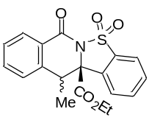
White solid; 98% yield, 3:1 dr, 98%/77% ee. [α]_{D}^{24.5} = -186.3 (c = 0.78, in CH₂Cl₂), dissolved in MeOH for UPC² (Daicel Chiralcel IG-3, CO₂/MeOH = 80/20, flow rate = 1.5 mL/min, λ = 254 nm), retention time: t_{R1} = 4.28 min, t_{R2} = 5.22 min, t_{R3} = 6.88 min, t_{R4} = 7.52 min.
¹H NMR (400 MHz, CDCl₃) δ 8.18 (d, J = 7.6 Hz, 1H), 8.03 (d, J = 8.0 Hz, 1H), 7.93 (d, J = 8.0 Hz, 1H), 7.84 – 7.79 (m, 1H), 7.76 – 7.70 (m, 1H), 7.67 – 7.61 (m, 1H), 7.48 (d, J = 7.6 Hz, 1H), 7.43 (d, J = 8.0 Hz, 1H), 4.03 – 3.95 (m, 1H), 3.89 – 3.80 (m, 1H), 3.65 (q, J = 7.2 Hz, 1H), 1.94 (d, J = 7.2 Hz, 3H), 0.81 (t, J = 7.2 Hz, 3H).
¹³C NMR (101 MHz, CDCl₃) δ 167.1, 161.7, 139.3, 135.1, 134.2, 133.6, 131.2, 130.6, 128.6, 128.4, 128.2, 127.2, 125.1, 122.1, 71.4, 62.8, 43.9, 13.4, 12.4.
ESI-HRMS: calcd for C₁₉H₁₇NO₅SNa⁺ ([M + Na]⁺) = 394.0720, found 394.0722.
IR (neat): 1742, 1693, 1457, 1323, 1297, 1189, 1144, 1069, 767 cm⁻¹.
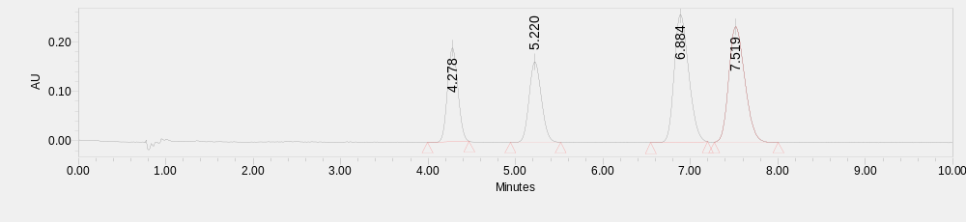
 | Retention Time | Area | % Area
1 | 4.278 | 1572485 | 17.28
2 | 5.220 | 1589758 | 17.47
3 | 6.884 | 2968571 | 32.63
4 | 7.519 | 2968050 | 32.62
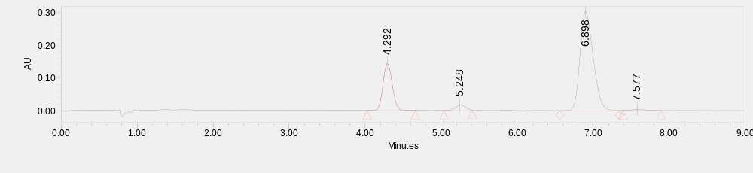
 | Retention Time | Area | % Area
1 | 4.292 | 1216589 | 24.21
2 | 5.248 | 143449 | 2.85
3 | 6.898 | 3627340 | 72.18
4 | 7.577 | 38218 | 0.76

ethyl (12aS)-12-cyclopropyl-7-oxo-7,12-dihydro-12aH-benzo[4,5]isothiazolo[2,3-b]isoquinoline-12a-carboxylate 5,5-dioxide (E28)
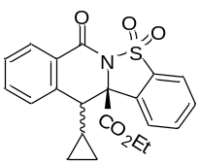
Analytic data of the less polar isomer:
White solid; 34% yield, 90% ee. [α]_{D}^{24.4} = -152.6 (c = 0.27, in CH₂Cl₂), dissolved in MeOH for UPC² (Daicel Chiralcel AD-3, CO₂/MeOH = 80/20, flow rate = 1.5 mL/min, λ = 254 nm), retention time: t_{R1} = 2.25 min, t_{R2} = 3.78 min.
¹H NMR (400 MHz, CDCl₃) δ 8.33 – 8.24 (m, 1H), 8.16 (dd, J = 7.6, 1.2 Hz, 1H), 7.96 – 7.88 (m, 2H), 7.79 – 7.68 (m, 2H), 7.65 (td, J = 7.6, 1.2 Hz, 1H), 7.48 (t, J = 7.6 Hz, 1H), 4.01 (dq, J = 10.8, 7.2 Hz, 1H), 3.85 (dq, J = 10.8, 7.2 Hz, 1H), 2.65 (d, J = 10.4 Hz, 1H), 2.01 – 1.86 (m, 1H), 1.12 – 1.02 (m, 1H), 0.95 – 0.86 (m, 1H), 0.81 (t, J = 7.2 Hz, 3H), 0.22 (dq, J = 10.4, 5.2 Hz, 1H), 0.13 (dq, J = 10.4, 5.2 Hz, 1H).
¹³C NMR (101 MHz, CDCl₃) δ 167.8, 161.6, 139.3, 135.0, 134.0, 132.8, 131.2, 129.9, 128.6, 128.5, 128.3, 126.3, 121.7, 71.8, 62.9, 55.0, 13.4, 8.3, 8.0, 5.3.
ESI-HRMS: calcd for C₂₁H₁₉NO₅SNa⁺ ([M + Na]⁺) = 420.0876, found 420.0875.
IR (neat): 1742, 1695, 1454, 1324, 1297, 1267, 1189, 1142, 1069, 859, 751 cm⁻¹.
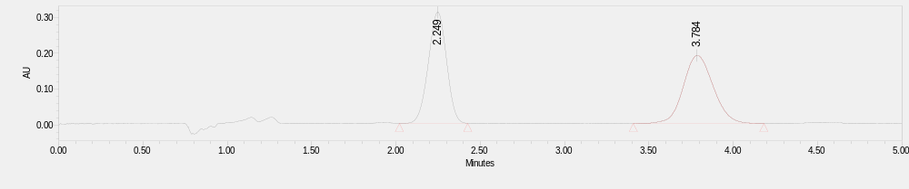
 | Retention Time | Area | % Area
1 | 2.249 | 2332219 | 49.72
2 | 3.784 | 2358045 | 50.28
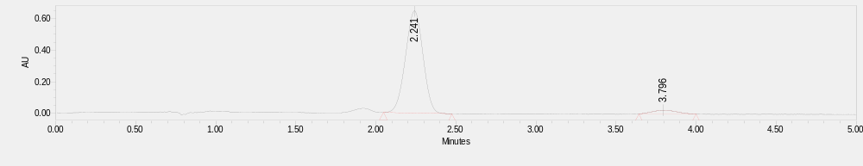
 | Retention Time | Area | % Area
1 | 2.241 | 4920657 | 95.11
2 | 3.796 | 252920 | 4.89

Analytic data of the more polar isomer:
White solid; 53% yield, 65% ee. [α]_{D}^{24.4} = -170.9 (c = 0.42, in CH₂Cl₂), dissolved in MeOH for UPC² (Daicel Chiralcel AD-3, CO₂/MeOH = 80/20, flow rate = 1.5 mL/min, λ = 254 nm), retention time: t_{R1} = 1.92 min, t_{R2} = 2.21 min.
¹H NMR (400 MHz, CDCl₃) δ 8.22 – 8.13 (m, 1H), 7.93 (d, J = 7.8 Hz, 1H), 7.83 (d, J = 7.8 Hz, 1H), 7.81 – 7.75 (m, 1H), 7.74 – 7.67 (m, 1H), 7.57 (td, J = 7.6, 1.2 Hz, 1H), 7.51 – 7.42 (m, 1H), 7.24 (d, J = 7.6 Hz, 1H), 4.03 (dq, J = 10.8, 7.2 Hz, 1H), 3.92 (dq, J = 10.8, 7.2 Hz, 1H), 3.52 (d, J = 8.0 Hz, 1H), 0.88 (t, J = 7.2 Hz, 3H), 0.81 – 0.68 (m, 1H), 0.33 – 0.23 (m, 1H), 0.23 – 0.09 (m, 2H), 0.04 – 0.00 (m, 1H).
¹³C NMR (101 MHz, CDCl₃) δ 168.9, 160.9, 139.1, 134.9, 133.9, 133.8, 131.1, 130.8, 128.9, 128.6, 128.5, 127.4, 125.2, 122.0, 72.8, 63.3, 49.9, 13.5, 12.0, 5.7, 1.4.
ESI-HRMS: calcd for C₂₁H₁₉NO₅SNa⁺ ([M + Na]⁺) = 420.0876, found 420.0872.
IR (neat): 1745, 1692, 1457, 1324, 1281, 1191, 1068, 758, 708 cm⁻¹.
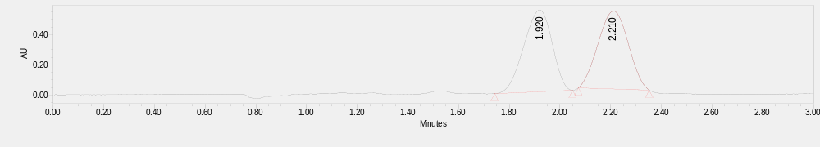
 | Retention Time | Area | % Area
1 | 1.920 | 4189221 | 49.59
2 | 2.210 | 4258434 | 50.41
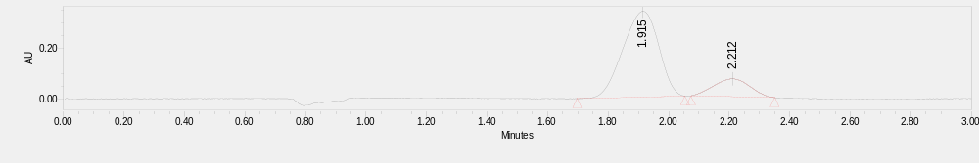
 | Retention Time | Area | % Area
1 | 1.915 | 2767905 | 82.69
2 | 2.212 | 579272 | 17.31

ethyl (S)-12,12-dimethyl-7-oxo-7,12-dihydro-12aH-benzo[4,5]isothiazolo[2,3-b]isoquinoline-12a-carboxylate 5,5-dioxide (E29)
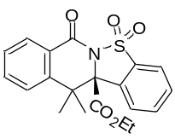
White solid; 64% yield, 73% ee. [α]_{D}^{24.2} = -89.8 (c = 0.49, in CH₂Cl₂), dissolved in MeOH for UPC² (Daicel Chiralcel IG-3, CO₂/MeOH = 80/20, flow rate = 1.5 mL/min, λ = 254 nm), retention time: t_{R1} = 4.57 min, t_{R2} = 5.57 min.
¹H NMR (400 MHz, CDCl₃) δ 8.24 – 8.18 (m, 1H), 8.11 (d, J = 8.0 Hz, 1H), 7.97 – 7.90 (m, 1H), 7.82 – 7.76 (m, 1H), 7.76 – 7.70 (m, 1H), 7.64 – 7.58 (m, 1H), 7.46 (t, J = 7.2 Hz, 2H), 4.00 (dq, J = 10.8, 7.2 Hz, 1H), 3.84 (dq, J = 10.8, 7.2 Hz, 1H), 2.00 (s, 3H), 1.11 (s, 3H), 0.80 (t, J = 7.2 Hz, 3H).
¹³C NMR (101 MHz, CDCl₃) δ 167.5, 161.6, 144.8, 135.2, 134.2, 133.7, 131.1, 130.1, 128.9, 128.0, 127.5, 127.2, 124.1, 122.0, 74.4, 62.9, 44.5, 28.0, 21.3, 13.3.
ESI-HRMS: calcd for C₂₀H₁₉NO₅S ([M]) = 408.0876, found 408.0851.
IR (neat): 1740, 1693, 1452, 1326, 1273, 1240, 1191, 1142, 1027, 760, 698 cm⁻¹.
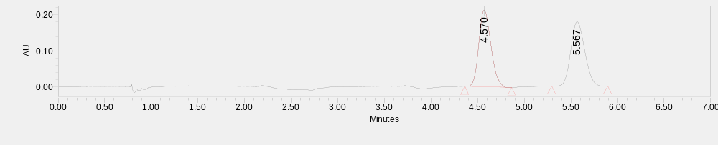
 | Retention Time | Area | % Area
1 | 4.570 | 1920567 | 50.84
2 | 5.567 | 1857244 | 49.16
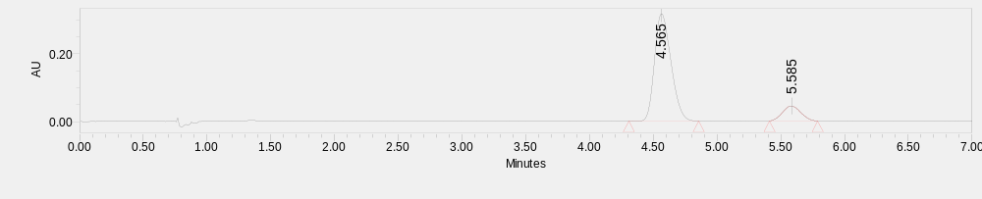
 | Retention Time | Area | % Area
1 | 4.565 | 2847918 | 86.66
2 | 5.585 | 438372 | 13.34

ethyl (S)-7-oxo-7H,12aH-spiro[benzo[4,5]isothiazolo[2,3-b]isoquinoline-12,1'-cyclopropane]-12a-carboxylate 5,5-dioxide (E30)
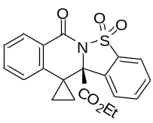
White solid; 99% yield, 87% ee. [α]_{D}^{24.2} = -271.9 (c = 0.75, in CH₂Cl₂), dissolved in MeOH for UPC² (Daicel Chiralcel IG-3, CO₂/MeOH = 70/30, flow rate = 1.5 mL/min, λ = 254 nm), retention time: t_{R1} = 2.77 min, t_{R2} = 3.79 min.
¹H NMR (400 MHz, CDCl₃) δ 8.19 (dd, J = 7.6, 1.2 Hz, 1H), 7.98 – 7.90 (m, 1H), 7.85 – 7.78 (m, 1H), 7.78 – 7.69 (m, 2H), 7.57 (td, J = 7.6, 1.2 Hz, 1H), 7.46 – 7.38 (m, 1H), 7.14 (d, J = 7.6 Hz, 1H), 4.05 (dq, J = 10.8, 7.2 Hz, 1H), 3.94 (dq, J = 10.8, 7.2 Hz, 1H), 1.94 (dt, J = 9.6, 7.2 Hz, 1H), 1.78 (dt, J = 10.0, 7.2 Hz, 1H), 0.90 (t, J = 7.2 Hz, 3H), 0.61 – 0.40 (m, 2H).
¹³C NMR (101 MHz, CDCl₃) δ 168.1, 161.6, 140.4, 135.7, 134.3, 133.7, 131.7, 129.1, 129.0, 128.0, 127.8, 125.3, 122.8, 122.4, 72.0, 63.1, 28.4, 13.5, 8.8.
ESI-HRMS: calcd for C₂₀H₁₇NO₅S ([M]) = 406.0720, found 406.0724.
IR (neat): 1745, 1690, 1459, 1326, 1274, 1235, 1190, 1143, 1027, 763 cm⁻¹.
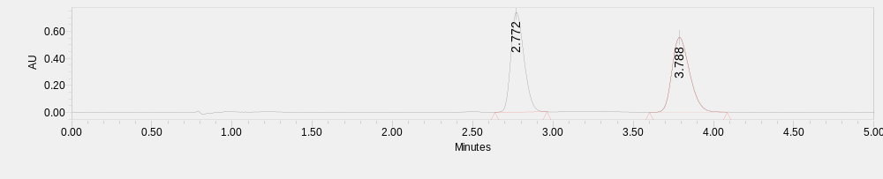
 | Retention Time | Area | % Area
1 | 2.772 | 4190851 | 50.01
2 | 3.788 | 4188676 | 49.99
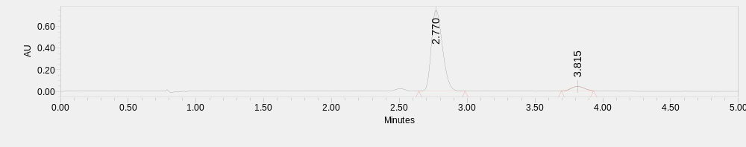
 | Retention Time | Area | % Area
1 | 2.770 | 4282781 | 93.62
2 | 3.815 | 291698 | 6.38

ethyl (S)-12,12-difluoro-7-oxo-7,12-dihydro-12aH-benzo[4,5]isothiazolo[2,3-b]isoquinoline-12a-carboxylate 5,5-dioxide (E31)
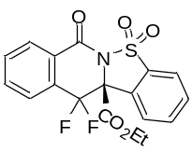
White solid; 92% yield, 96% ee. [α]_{D}^{24.7} = -129.7 (c = 0.49, in CH₂Cl₂), dissolved in MeOH for UPC² (Daicel Chiralcel OX-H, CO₂/MeOH = 70/30, flow rate = 1.5 mL/min, λ = 254 nm), retention time: t_{R1} = 5.99 min, t_{R2} = 6.86 min.
¹H NMR (400 MHz, CDCl₃) δ 8.29 (d, J = 7.6 Hz, 1H), 8.15 (d, J = 8.0 Hz, 1H), 7.93 (d, J = 7.6 Hz, 1H), 7.89 – 7.82 (m, 1H), 7.82 – 7.71 (m, 4H), 4.16 – 3.97 (m, 2H), 0.97 (t, J = 7.2 Hz, 3H).
¹³C NMR (101 MHz, CDCl₃) δ 163.9 (dd, J = 6.7, 2.4 Hz), 158.9, 135.0, 134.4 (d, J = 2.0 Hz), 134.3, 132.5 (d, J = 2.8 Hz), 131.9, 131.0 (dd, J = 26.4, 23.2 Hz), 129.1, 127.5 (dd, 7.5, 3.0), 126.9 (d, J = 3.7 Hz), 126.3, 124.1 (dd, J = 7.3, 1.1 Hz), 121.7, 114.3 (dd, J = 254.8, 251.6 Hz), 70.8 (dd, J = 28.7, 26.2 Hz), 64.2, 13.4.
¹⁹F NMR (377 MHz, CDCl₃) δ -87.83, -88.51, -120.91, -121.59.
ESI-HRMS: calcd for C₁₈H₁₃F₂NO₅SNa⁺ ([M + Na]⁺) = 416.0375, found 416.0377.
IR (neat): 1751, 1707, 1459, 1353, 1324, 1282, 1202, 1146, 1079, 1019, 764 cm⁻¹.
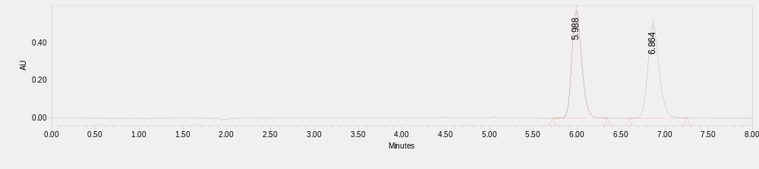
 | Retention Time | Area | % Area
1 | 5.988 | 4500251 | 50.10
2 | 6.864 | 4482826 | 49.90
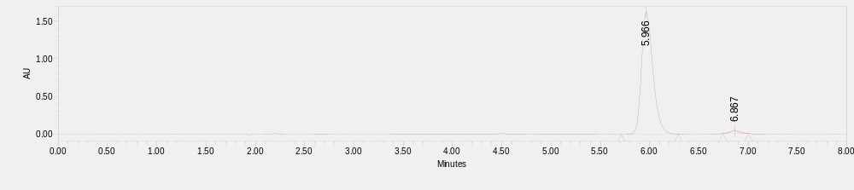
 | Retention Time | Area | % Area
1 | 5.966 | 13032402 | 97.96
2 | 6.867 | 271594 | 2.04

(S)-12a-(hydroxymethyl)-12,12a-dihydro-7H-benzo[4,5]isothiazolo[2,3-b]isoquinoline 5,5-dioxide (F1)
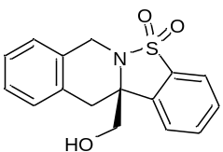
White solid; 96% yield, 96% ee. [α]_{D}^{13.7} = -128.8 (c = 0.53, in CH₂Cl₂), dissolved in MeOH for UPC² (Daicel Chiralcel AD-3, CO₂/MeOH = 70/30, flow rate = 1.5 mL/min, λ = 254 nm), retention time: t_{R1} = 3.21 min, t_{R2} = 3.53 min.
¹H NMR (400 MHz, CDCl₃) δ 7.77 (d, J = 7.6 Hz, 1H), 7.70 – 7.61 (m, 1H), 7.61 – 7.48 (m, 2H), 7.26 – 7.17 (m, 3H), 7.12 (d, J = 7.2 Hz, 1H), 4.85 (d, J = 15.6 Hz, 1H), 4.39 (d, J = 15.6 Hz, 1H), 3.85 – 3.66 (m, 2H), 3.31 (d, J = 15.6 Hz, 1H), 3.07 (d, J = 15.6 Hz, 1H), 2.41 – 2.16 (m, 1H).
¹³C NMR (101 MHz, CDCl₃) δ 140.5, 135.2, 133.2, 131.6, 131.2, 129.6, 128.7, 127.6, 127.2, 126.4, 123.2, 121.3, 66.0, 66.0, 41.4, 35.4.
ESI-HRMS: calcd for C₁₆H₁₅NO₃SNa⁺ ([M + Na]⁺) = 324.0664, found 324.0665.
IR (neat): 3494, 1456, 1364, 1288, 1170, 1137, 1062, 757 cm⁻¹.
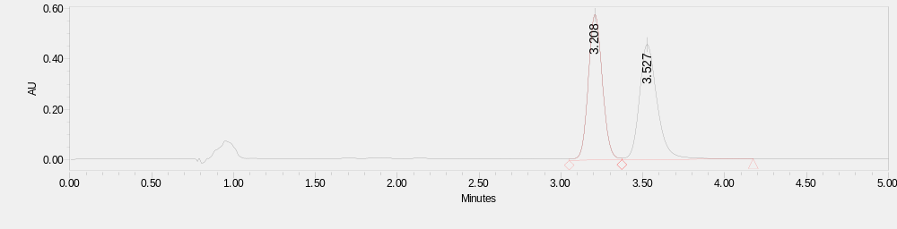
 | Retention Time | Area | % Area
1 | 3.208 | 3458889 | 49.84
2 | 3.527 | 3481362 | 50.16
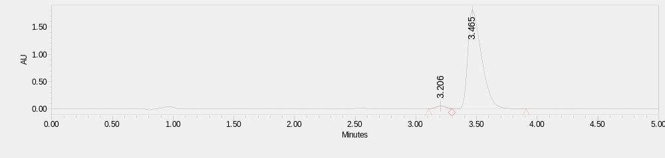
 | Retention Time | Area | % Area
1 | 3.206 | 291292 | 2.00
2 | 3.465 | 14276415 | 98.00

(S)-2-(3-(hydroxymethyl)-1,2,3,4-tetrahydroisoquinolin-3-yl)benzenesulfonic acid (F2)
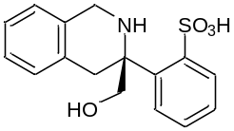
White solid; 70% yield, 96% ee. [α]_{D}^{13.5} = -109.3 (c = 0.34, in CH₂Cl₂), dissolved in MeOH for UPC² (Daicel Chiralcel AD-3, CO₂/MeOH = 70/30, flow rate = 1.5 mL/min, λ = 254 nm), retention time: t_{R1} = 3.39 min, t_{R2} = 4.45 min.
¹H NMR (400 MHz, CDCl₃) δ 7.72 (t, J = 7.6 Hz, 1H), 7.67 (d, J = 7.6 Hz, 1H), 7.62 (d, J = 8.0 Hz, 1H), 7.59 – 7.51 (m, 2H), 7.27 (d, J = 8.0 Hz, 1H), 7.18 (t, J = 7.2 Hz, 1H), 7.00 (t, J = 7.2 Hz, 1H), 6.58 (d, J = 7.6 Hz, 1H), 4.76 (d, J = 11.6 Hz, 1H), 4.57 (d, J = 11.6 Hz, 1H), 3.82 (s, 3H), 3.60 (d, J = 14.0 Hz, 1H), 3.36 (s, 1H), 3.16 (d, J = 14.4 Hz, 1H).
¹³C NMR (101 MHz, CDCl₃) δ 140.6, 138.5, 136.1, 133.6, 133.2, 131.2, 130.8, 129.8, 128.2, 127.7, 124.1, 121.5, 68.4, 68.3, 63.3, 38.0.
ESI-HRMS: calcd for C₁₆H₁₇NO₄SNa⁺ ([M + Na]⁺) = 342.0770, found 342.0770.
IR (neat): 3452, 3068, 2926, 1453, 1409, 1283, 1163, 1131, 1055, 1004, 758 cm⁻¹.
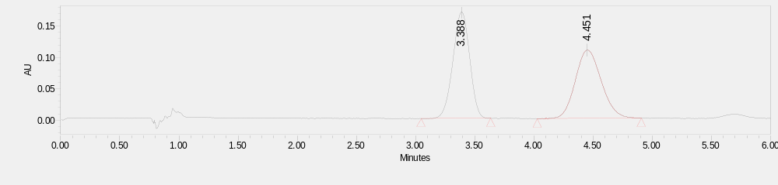
 | Retention Time | Area | % Area
1 | 3.388 | 1673933 | 50.18
2 | 4.451 | 1662187 | 49.82
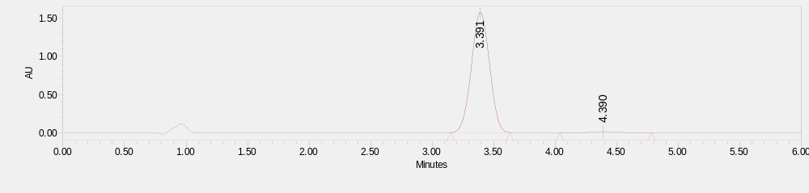
 | Retention Time | Area | % Area
1 | 3.391 | 16070420 | 98.10
2 | 4.390 | 311049 | 1.90

2,2,6,6-tetramethylpiperidin-1-yl 2-(((2,2,6,6-tetramethylpiperidin-1-yl)oxy)methyl)benzoate (G1)
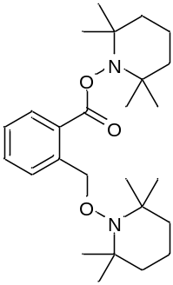
White solid.
¹H NMR (400 MHz, CDCl₃) δ 7.91 (d, J = 7.6 Hz, 1H), 7.85 (d, J = 8.0 Hz, 1H), 7.55 (t, J = 7.6 Hz, 1H), 7.32 (t, J = 7.6 Hz, 1H), 5.24 (s, 2H), 1.83 – 1.65 (m, 3H), 1.64 – 1.54 (m, 3H), 1.52 − 1.39 (m, 5H), 1.37 – 1.30 (m, 1H), 1.25 (s, 6H), 1.17 (s, 12H), 1.13 (s, 6H).
¹³C NMR (101 MHz, CDCl₃) δ 166.8, 141.2, 131.9, 129.3, 127.2, 127.1, 126.2, 76.2, 60.2, 59.7, 39.6, 39.1, 32.9, 31.9, 20.9, 20.3, 17.1, 16.9.
ESI-HRMS: calcd for C₂₆H₄₂N₂O₃Na⁺ ([M + Na]⁺) = 450.3088, found 450.3091.
IR (neat): 2972, 2931, 1748, 1466, 1364, 1244, 1128, 1032, 993, 954, 918, 796, 735 cm⁻¹.

9. Copies of NMR spectra
C1
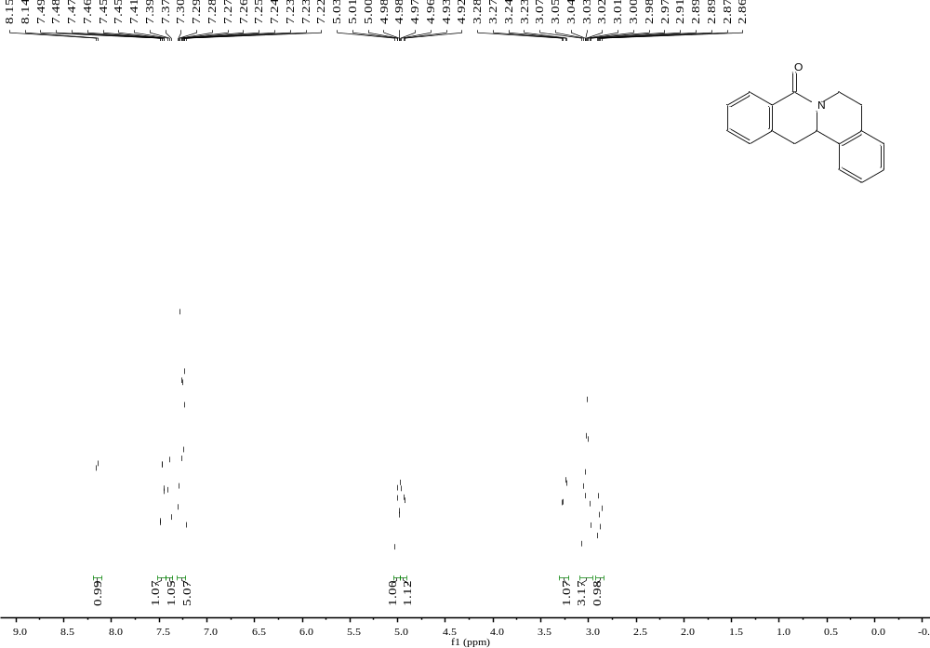
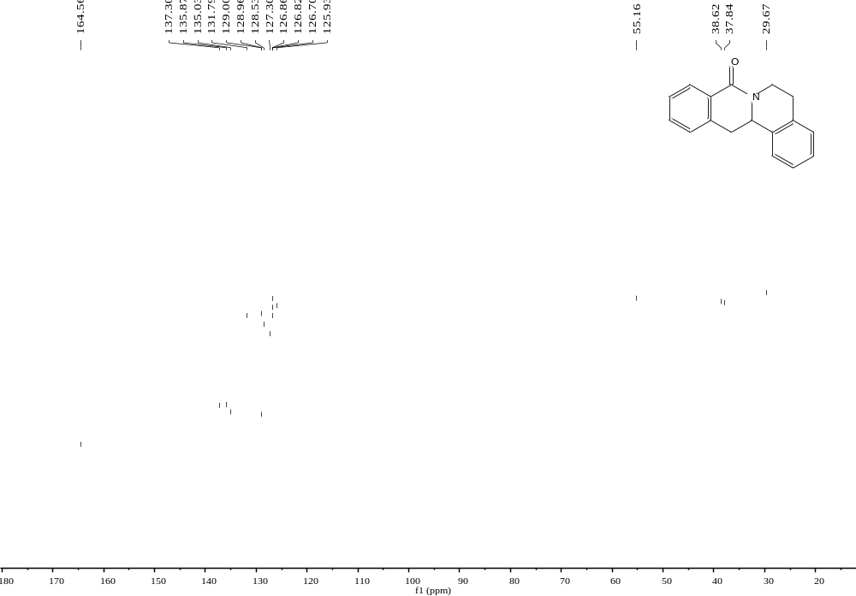
C2
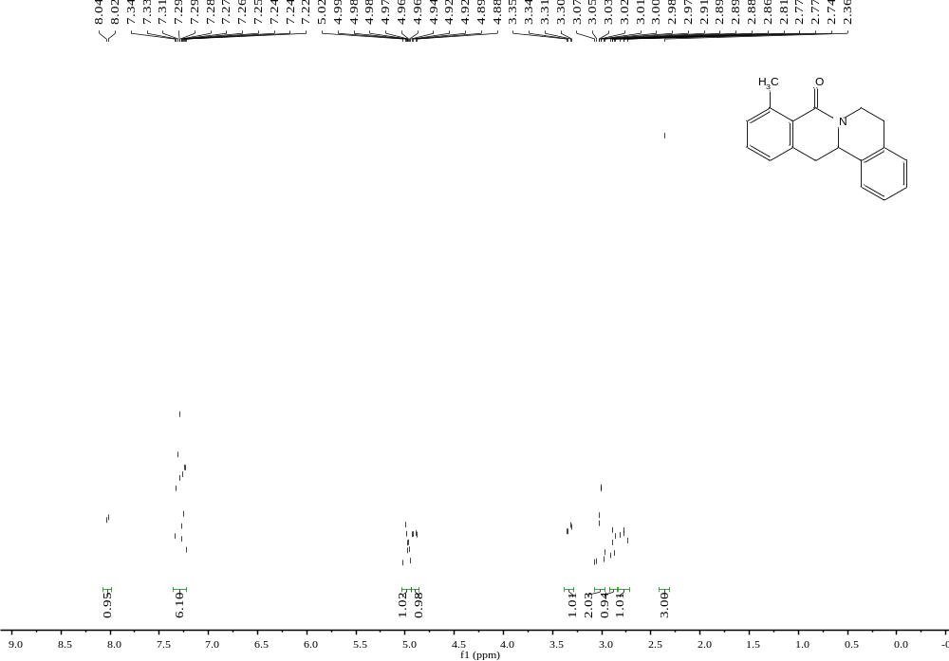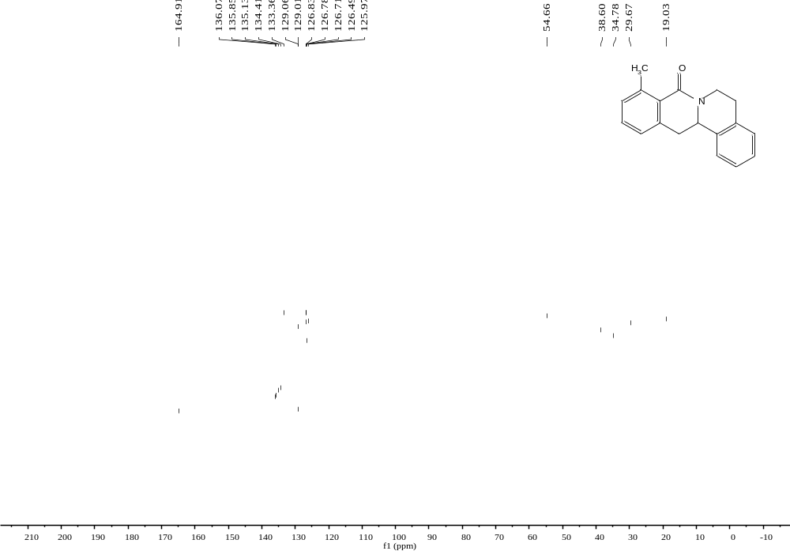
C3
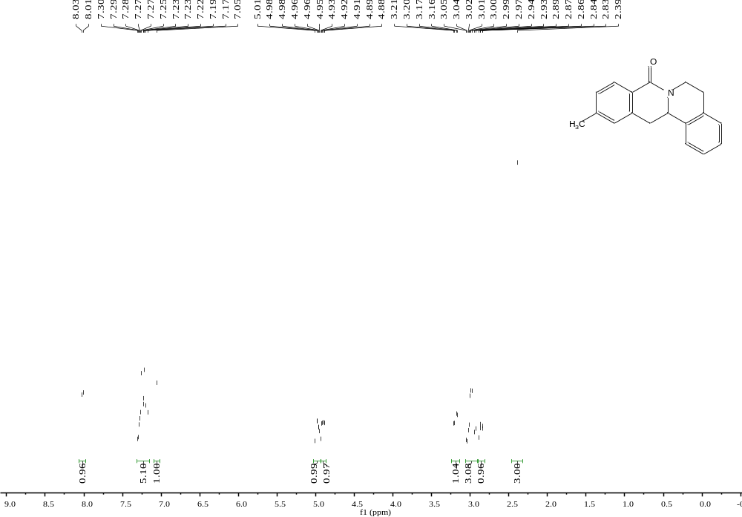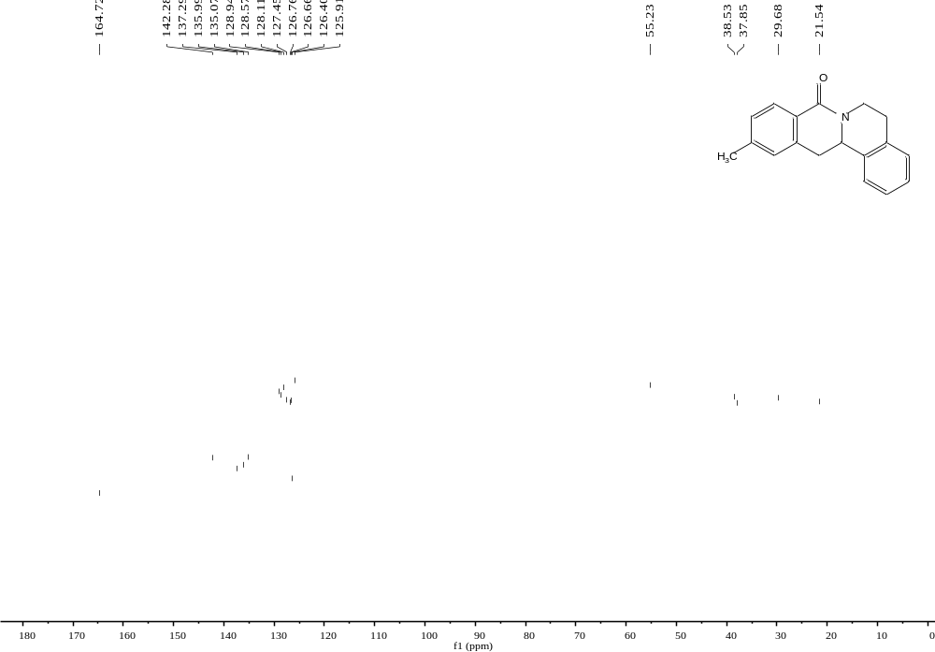
C4
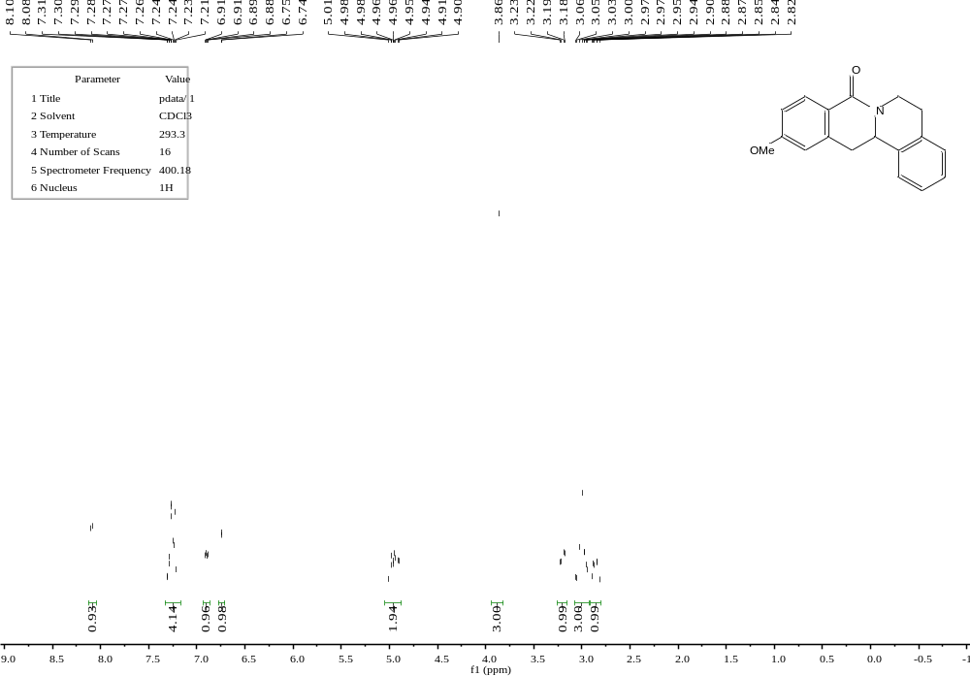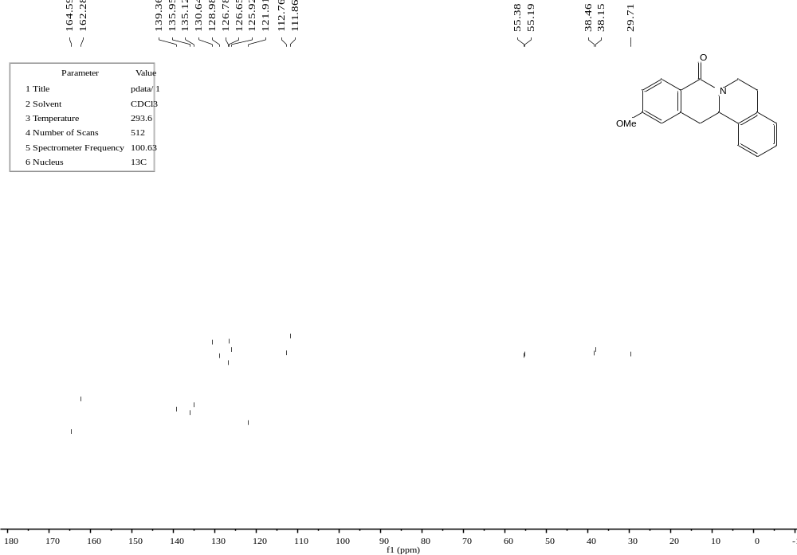
C5
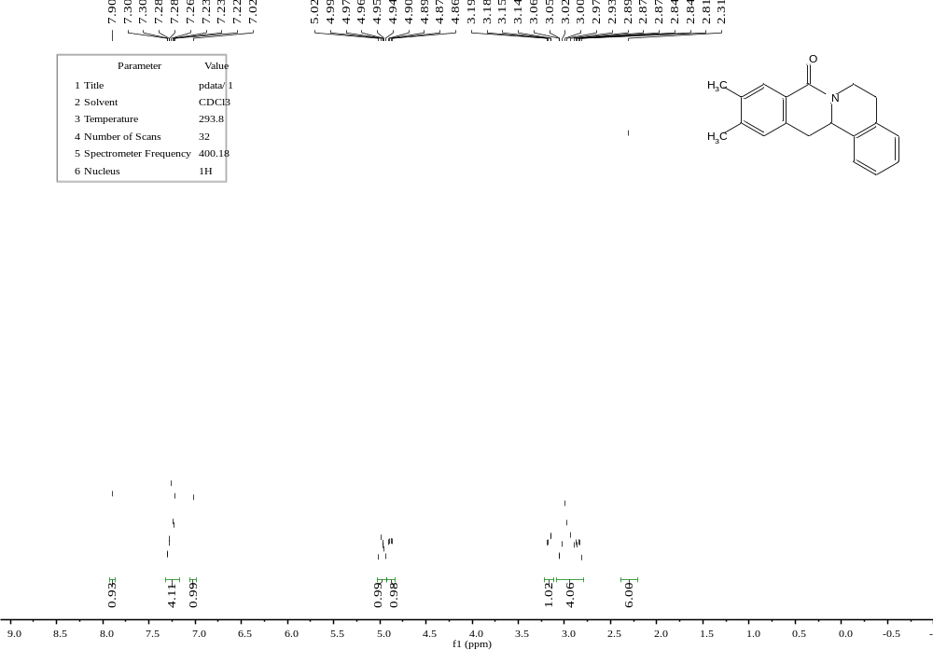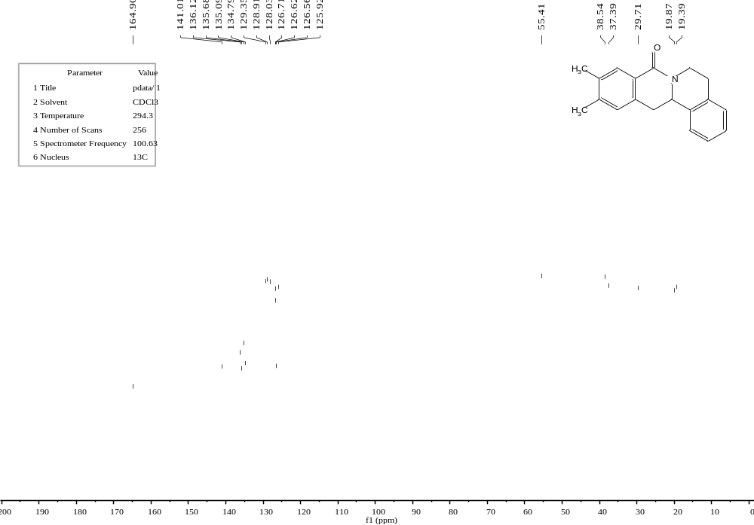

C6
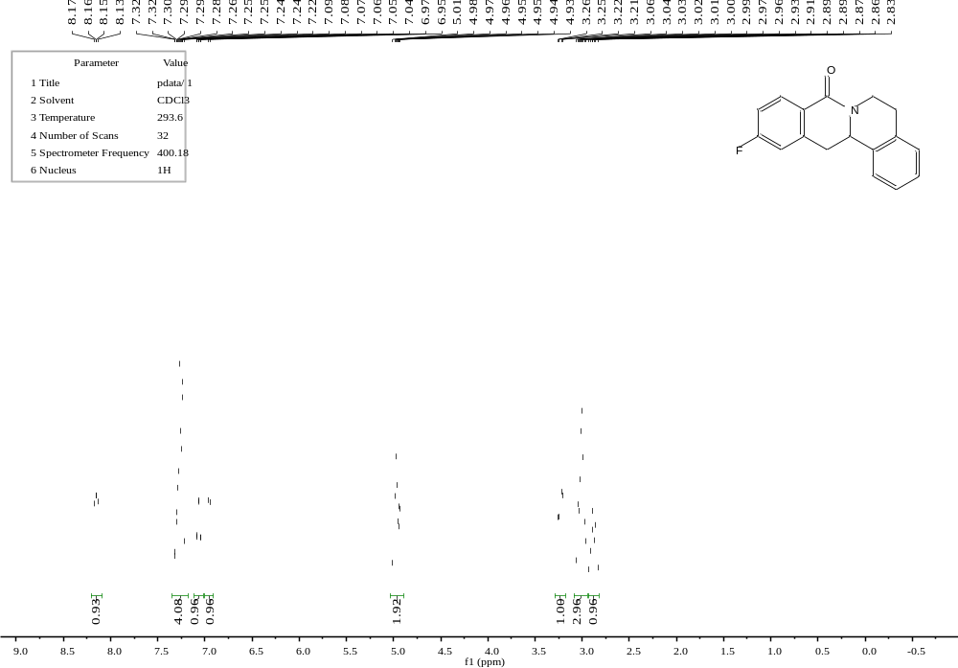

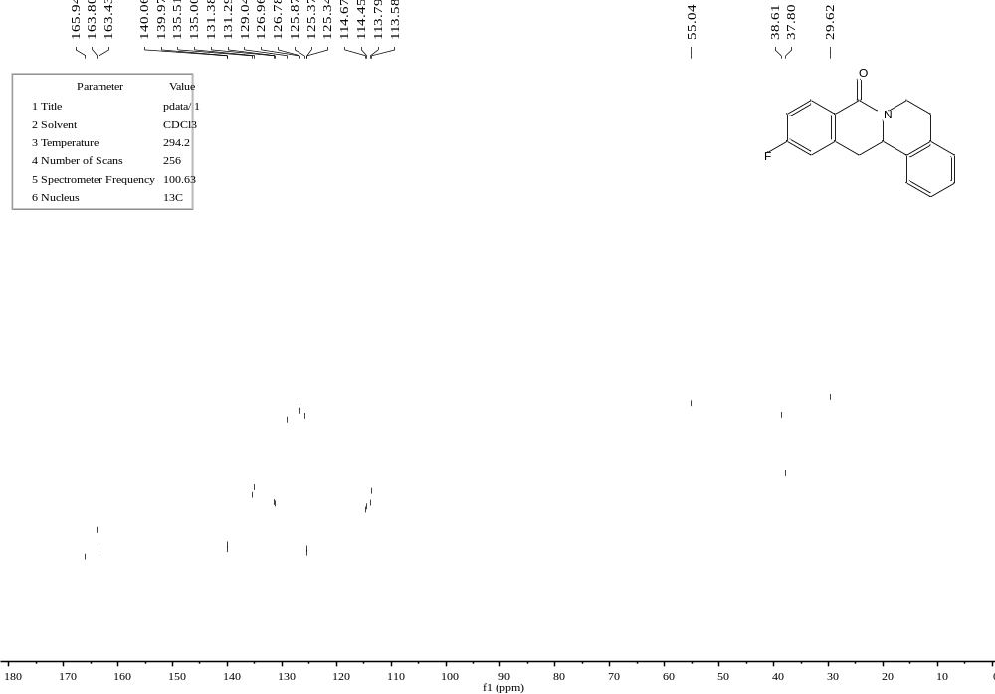
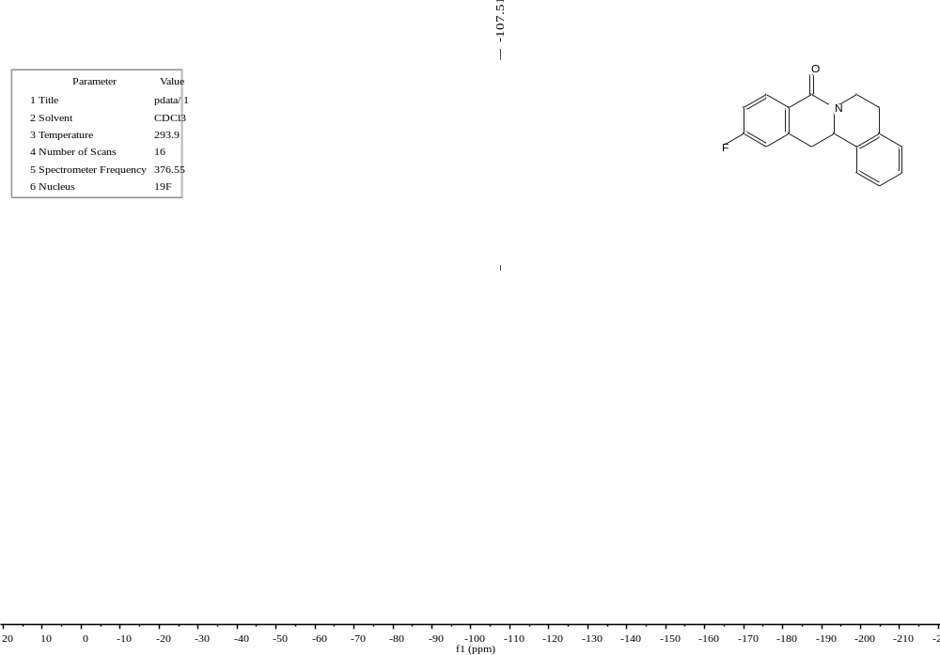
C7
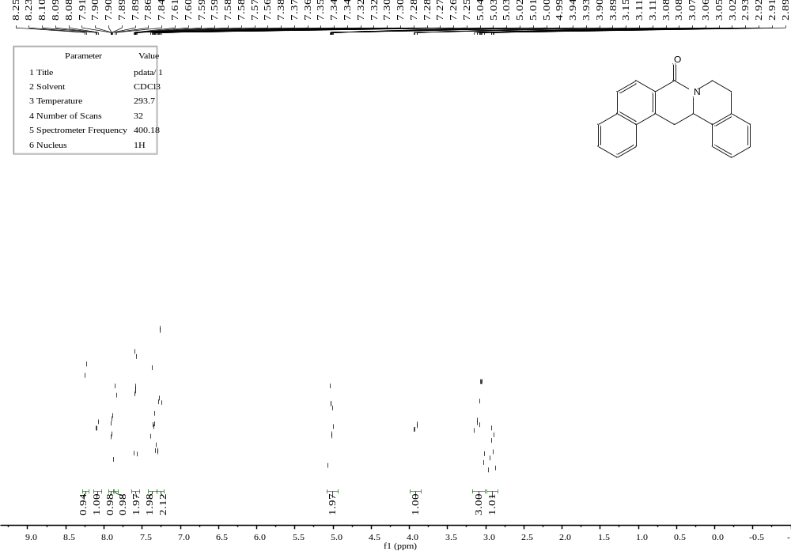
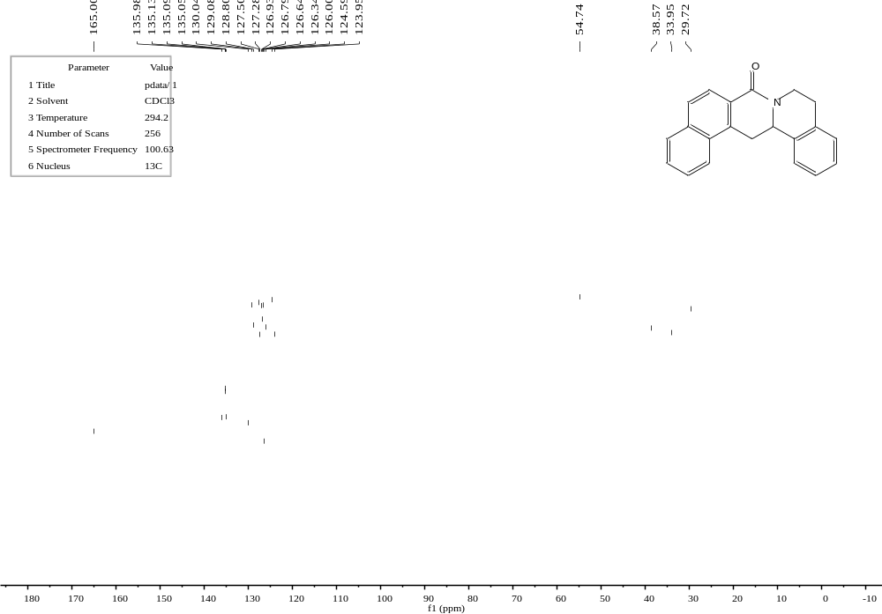
C8
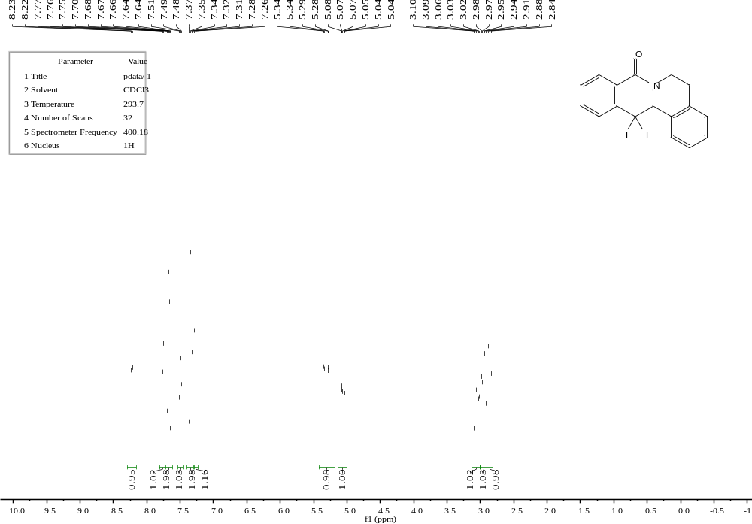

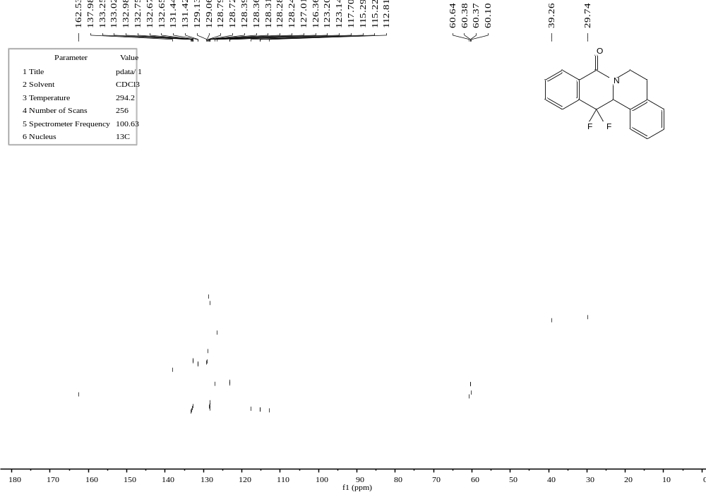
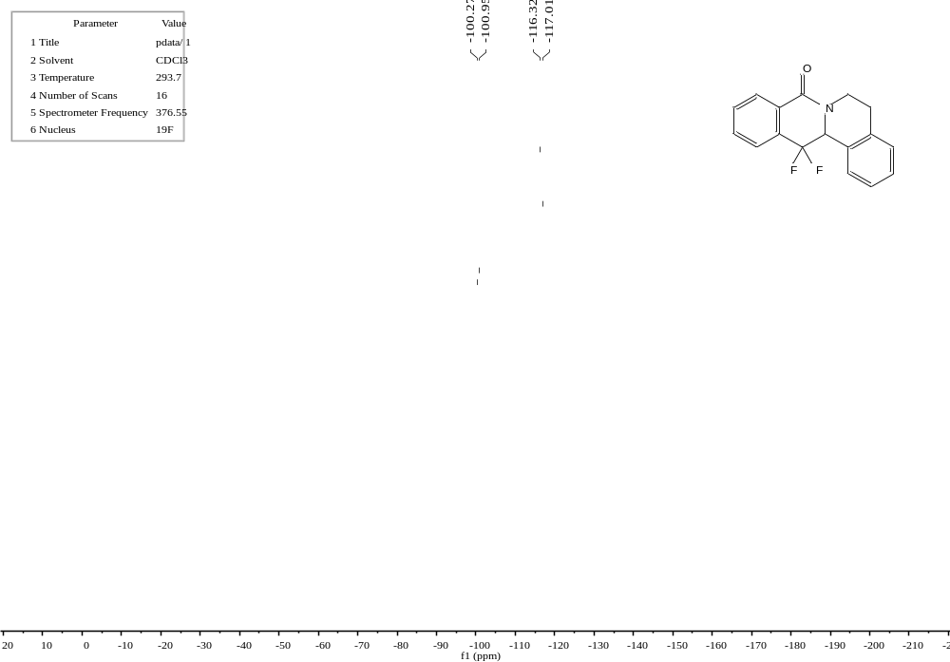

C9 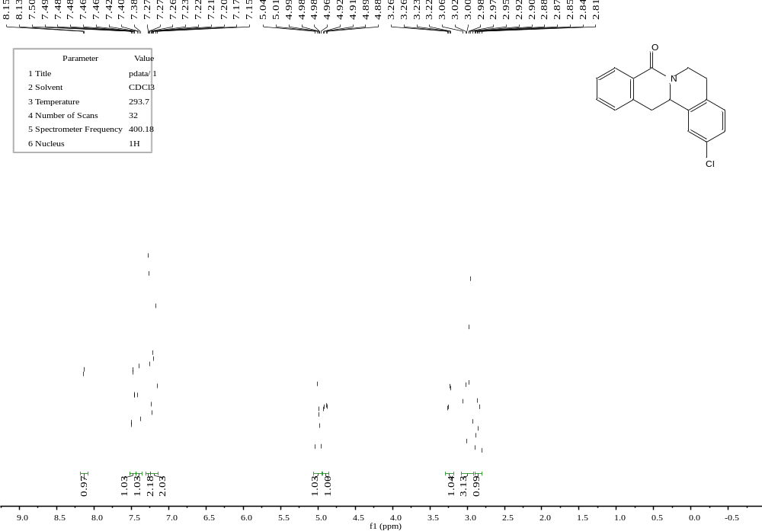 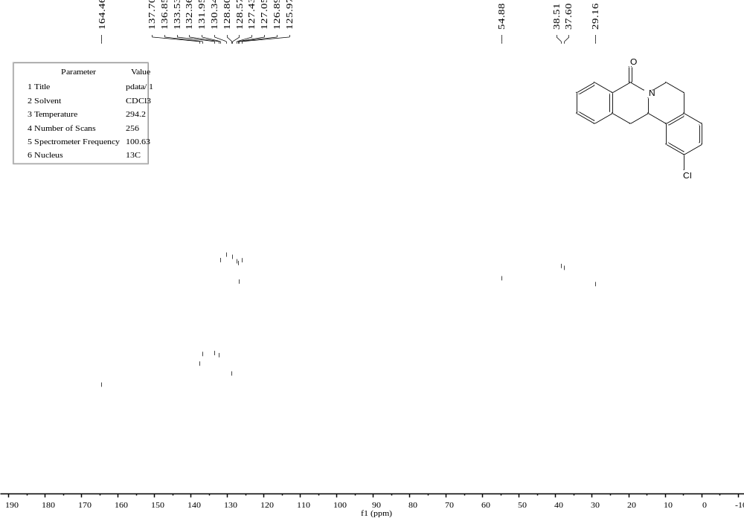
C10
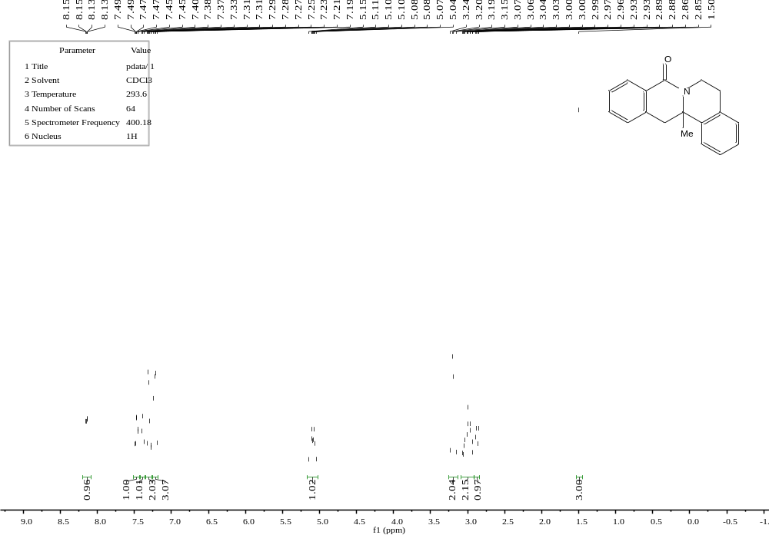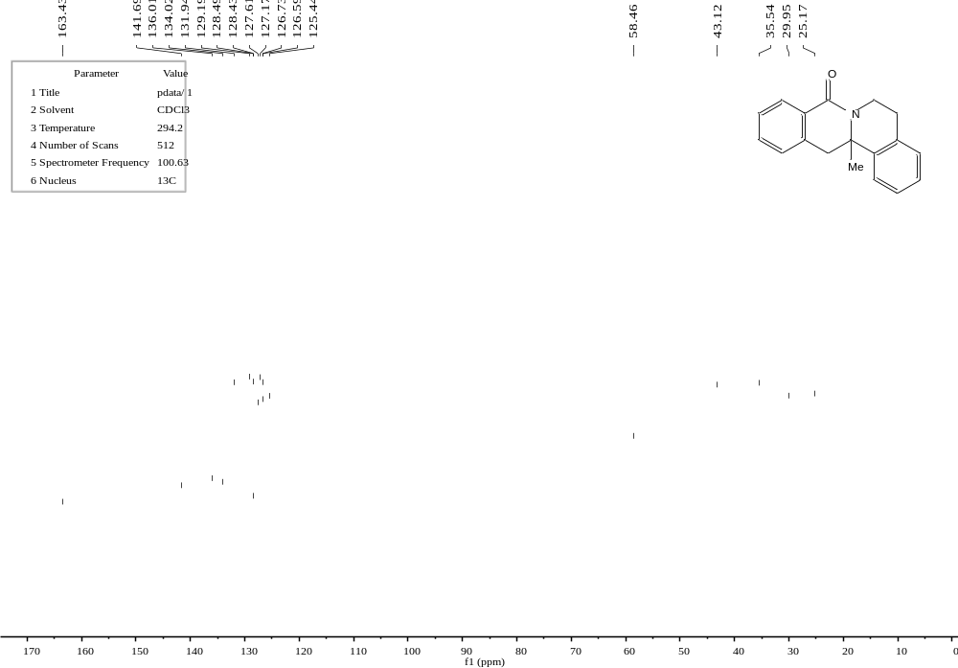
C11
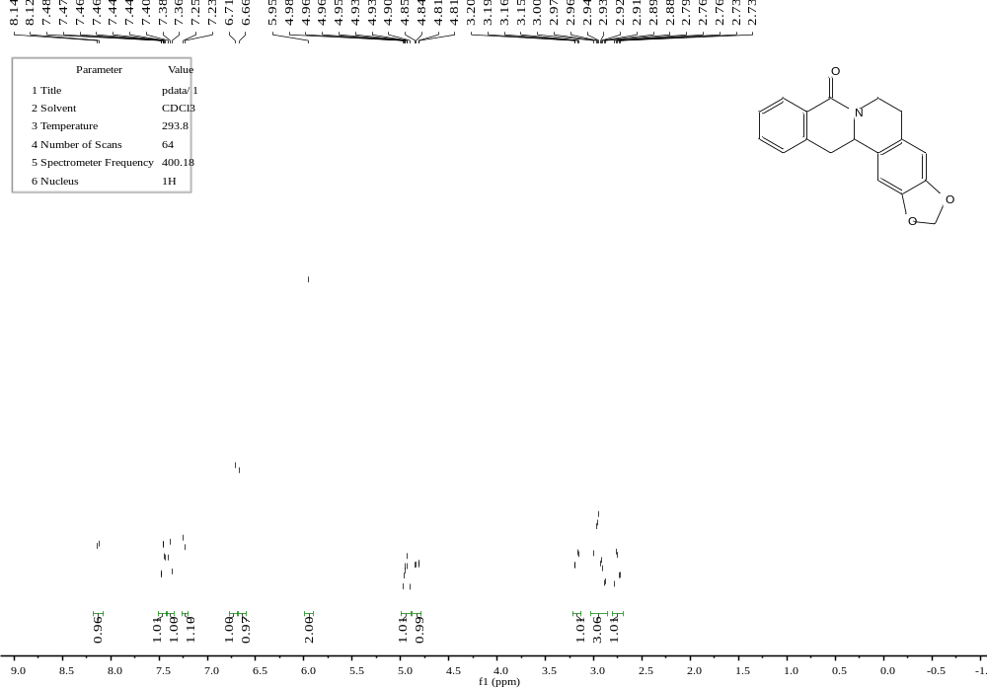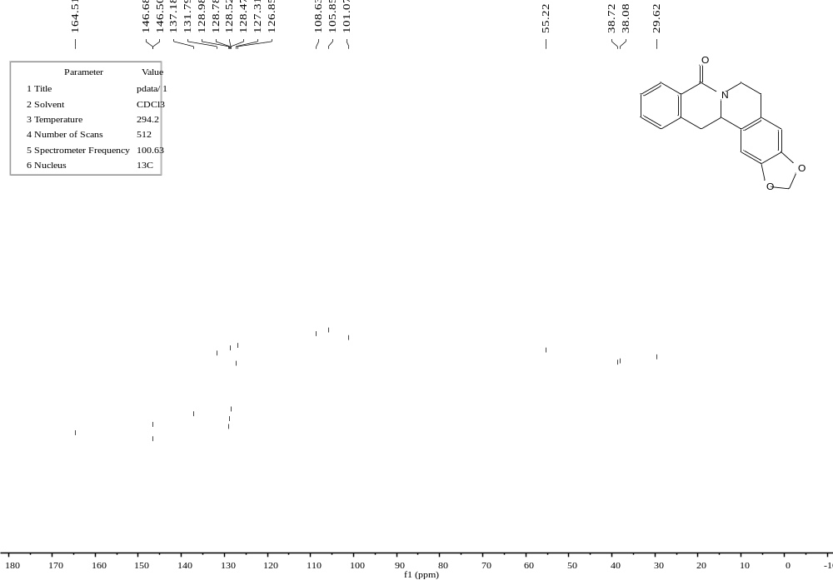
C12
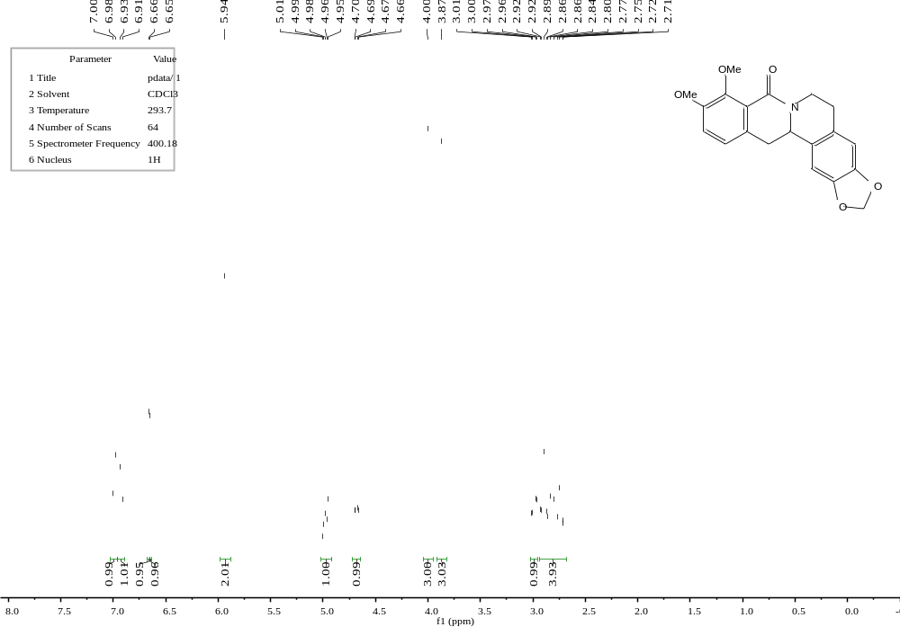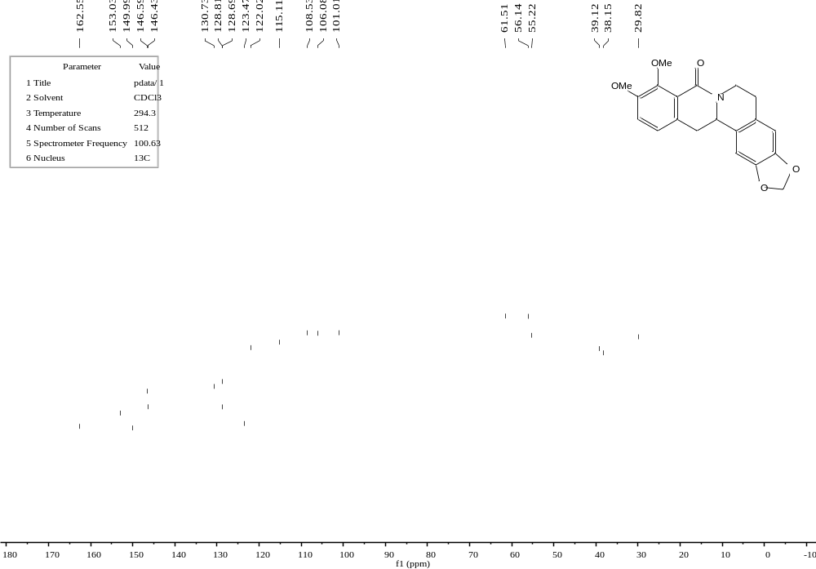
C13
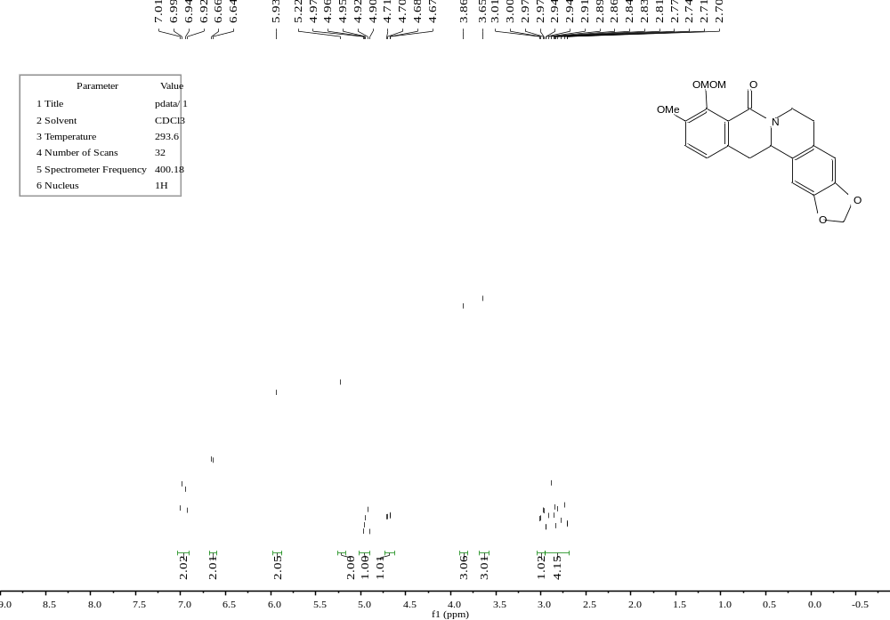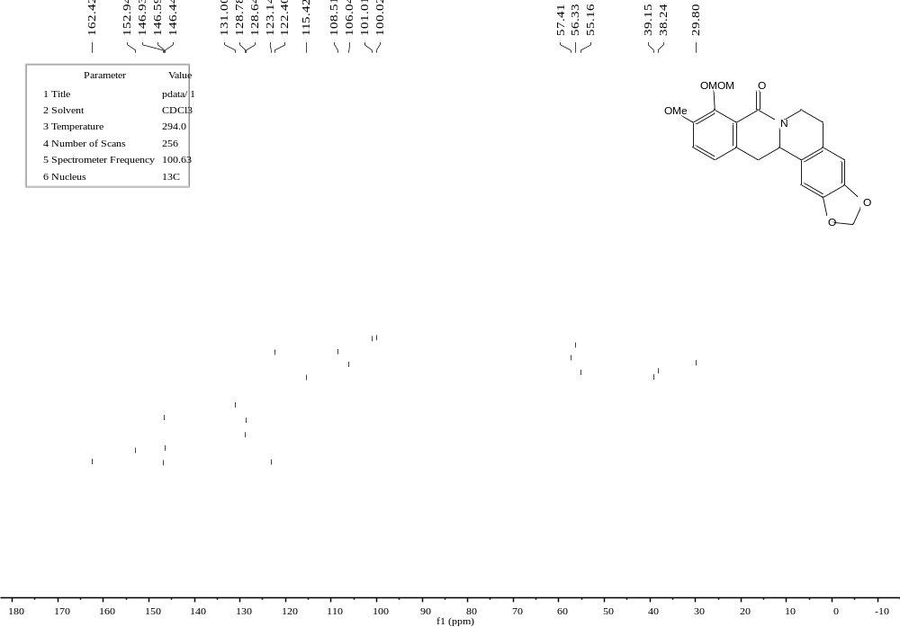

C14
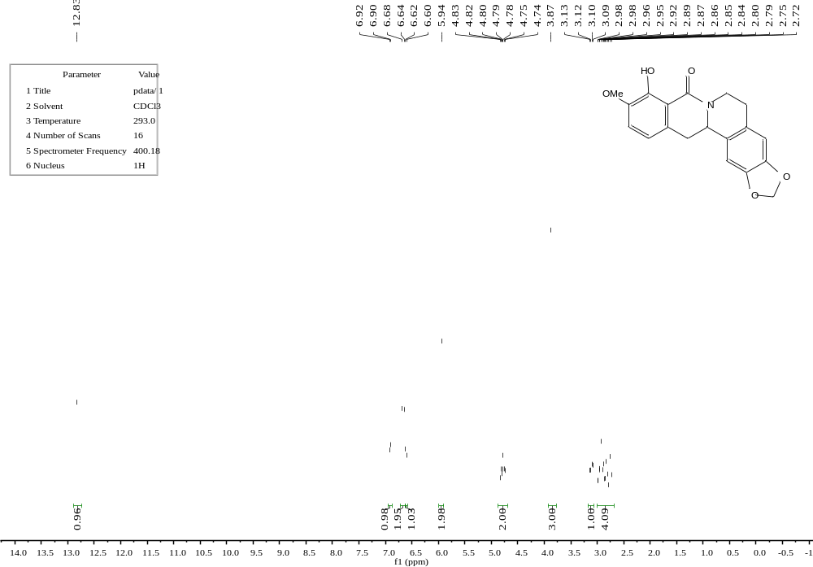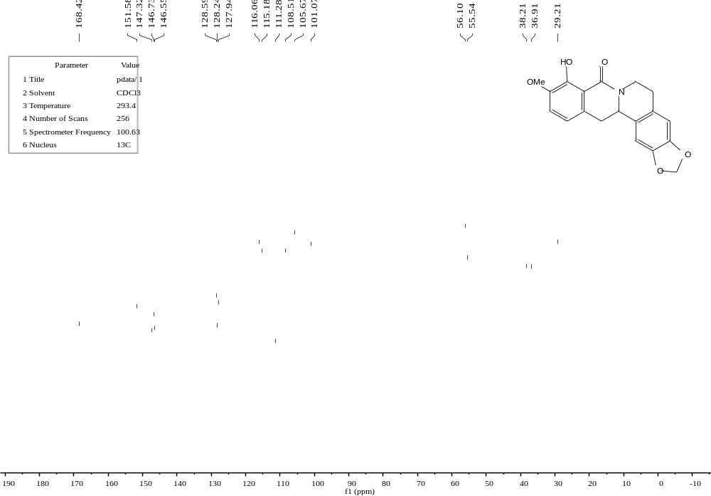
C15
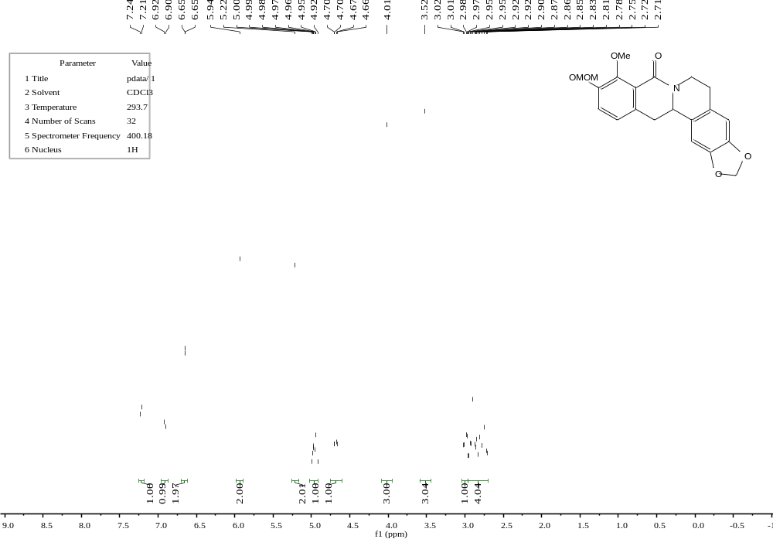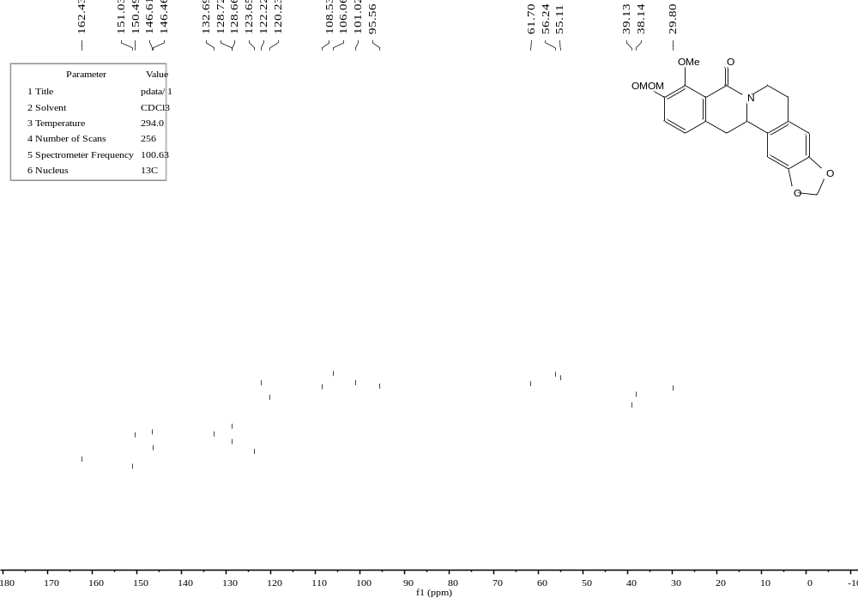

C15′
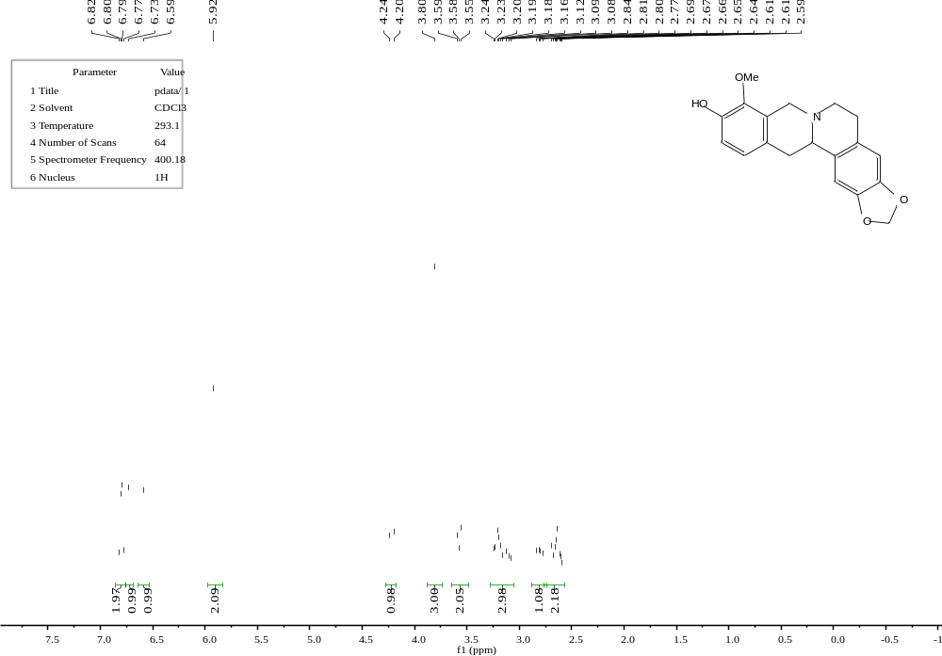
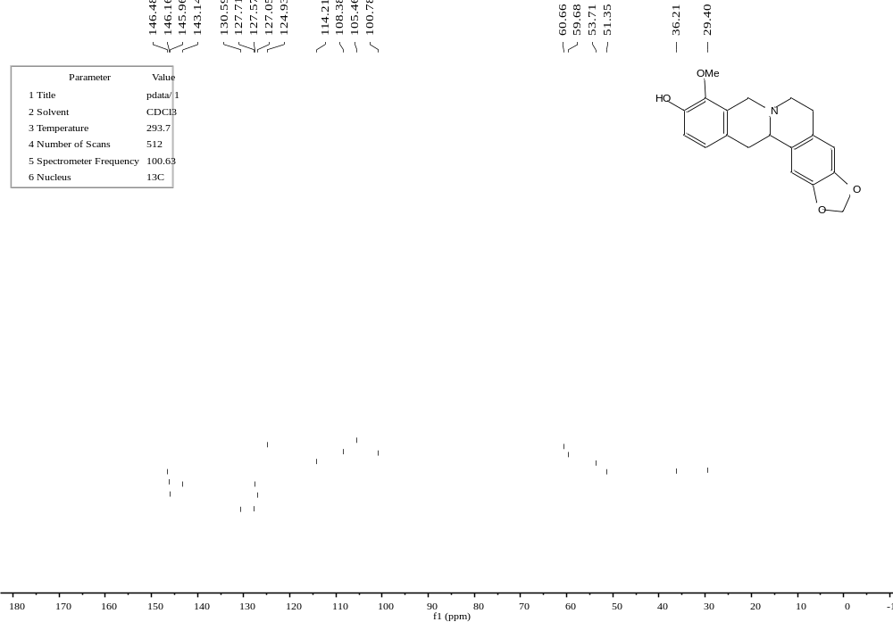
C16
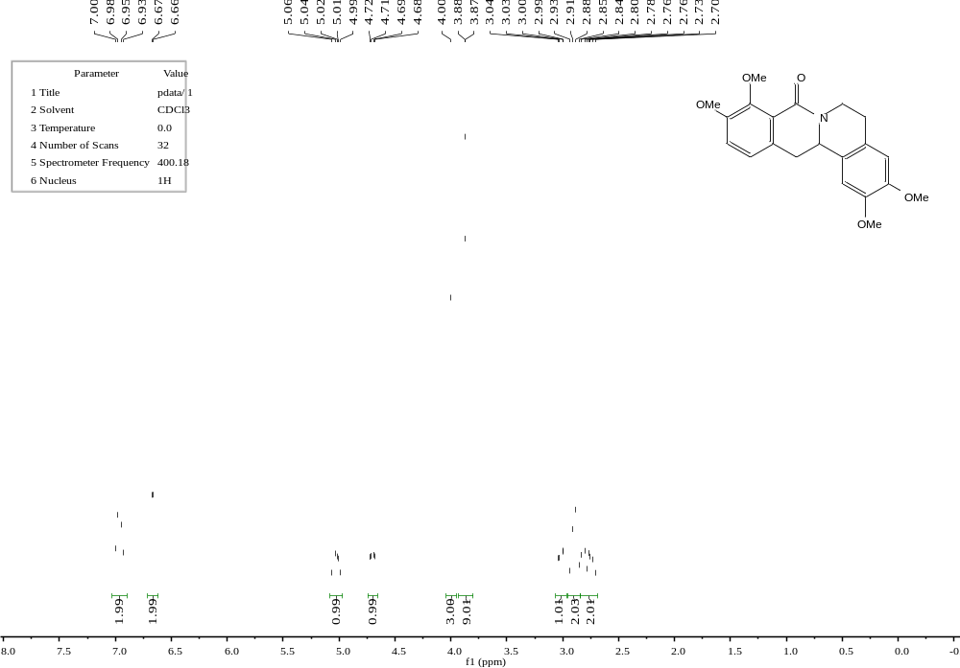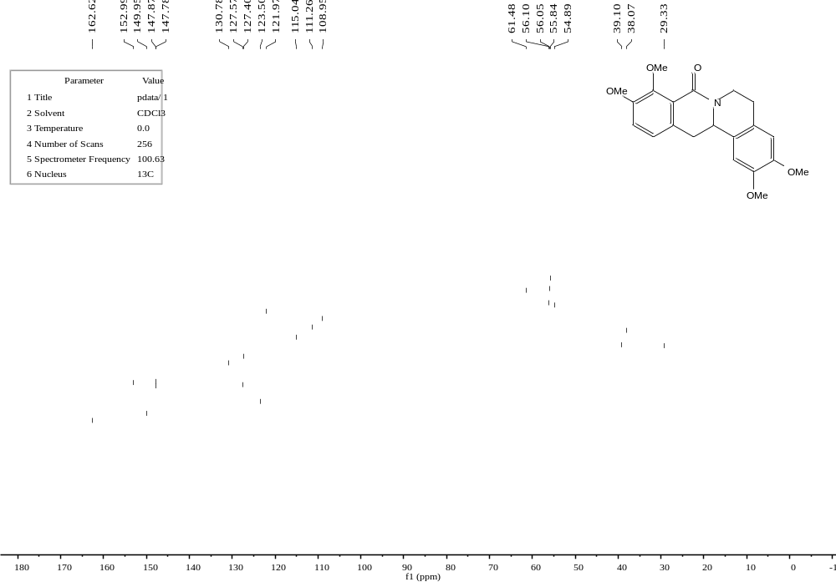
C16′
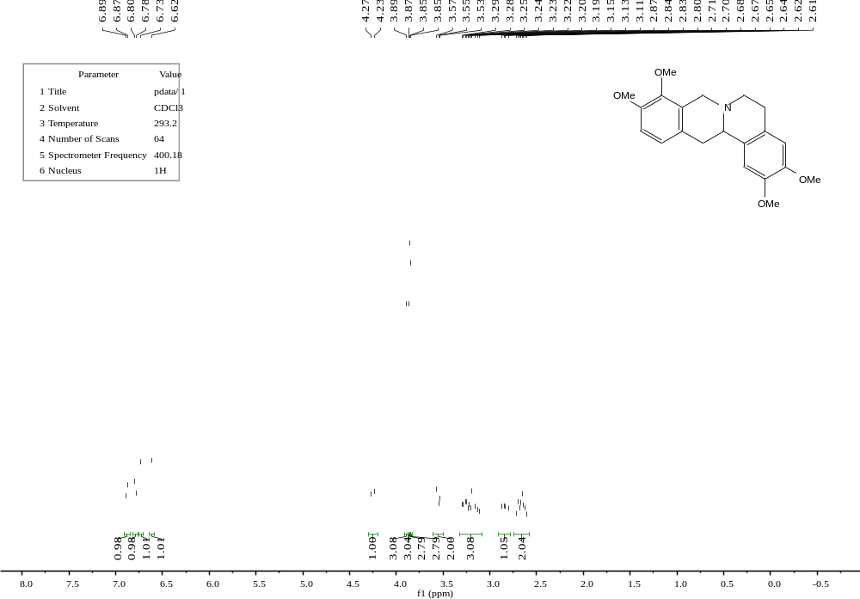
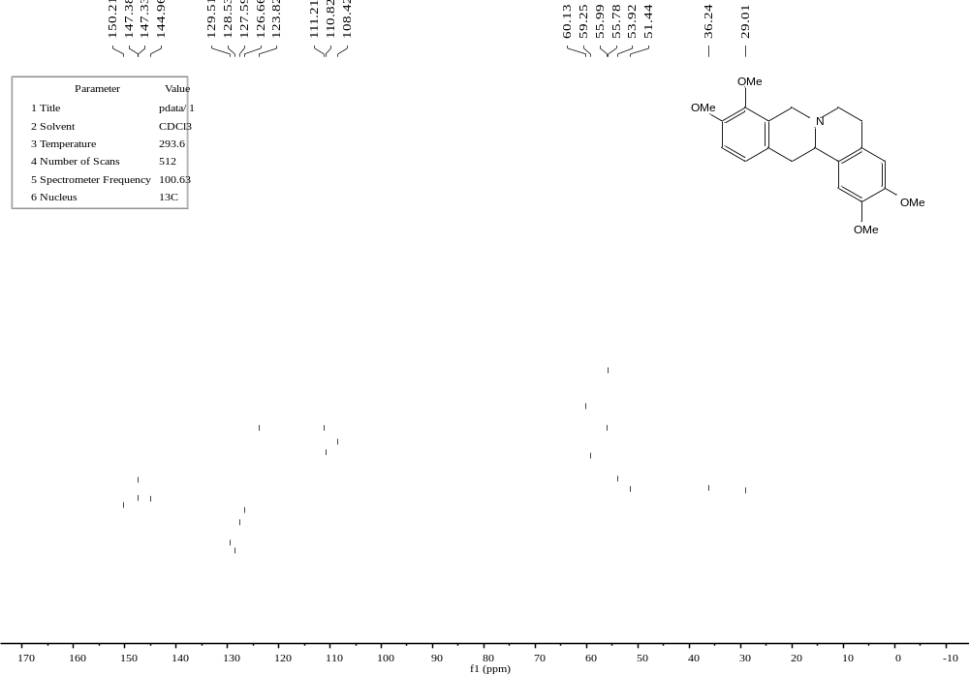
C17
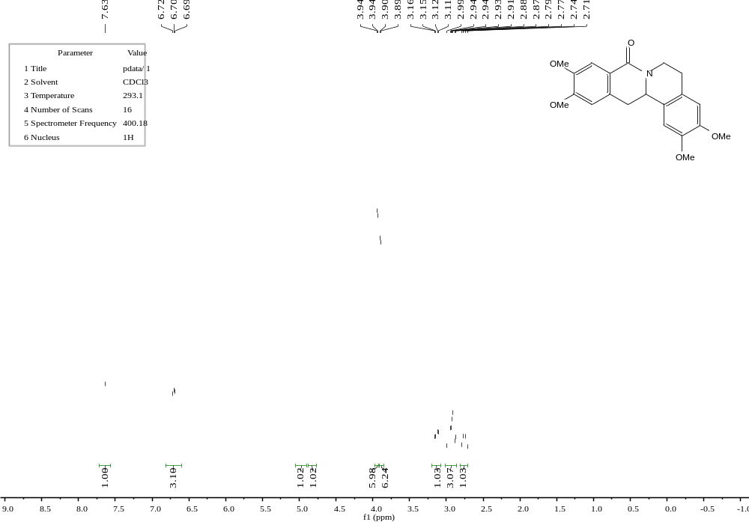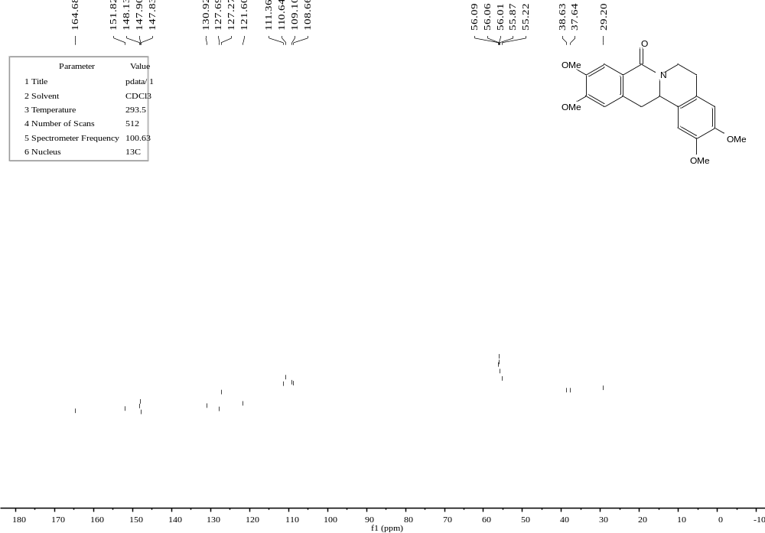
C17′
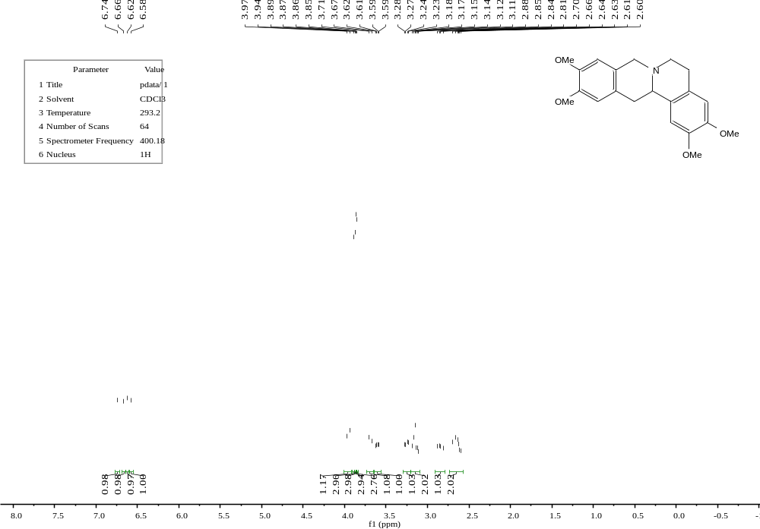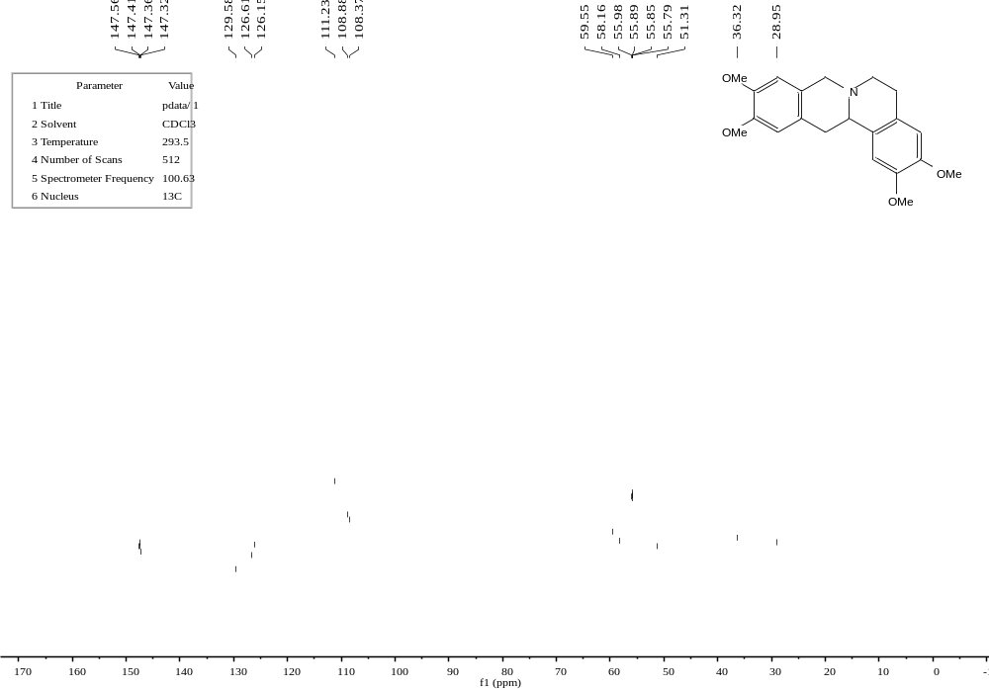
E1
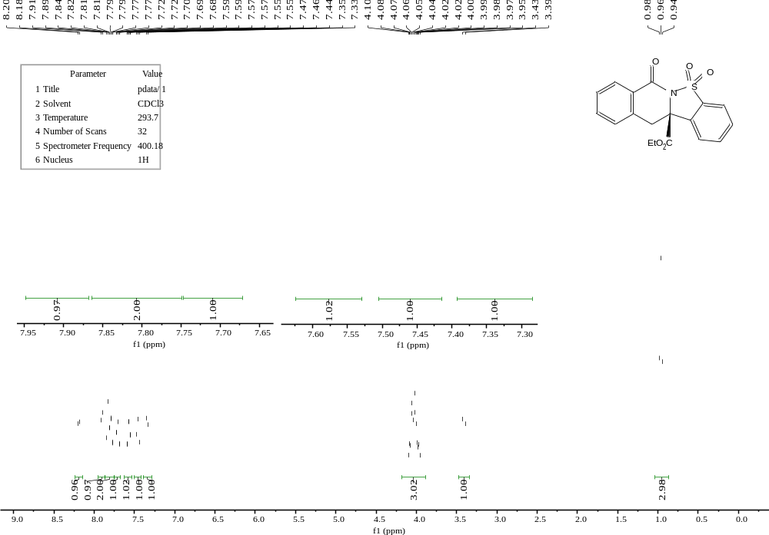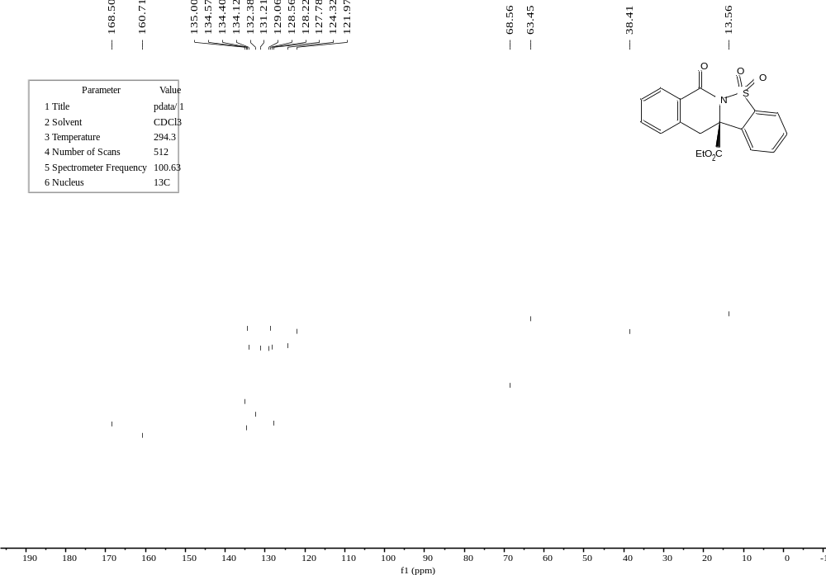
E2
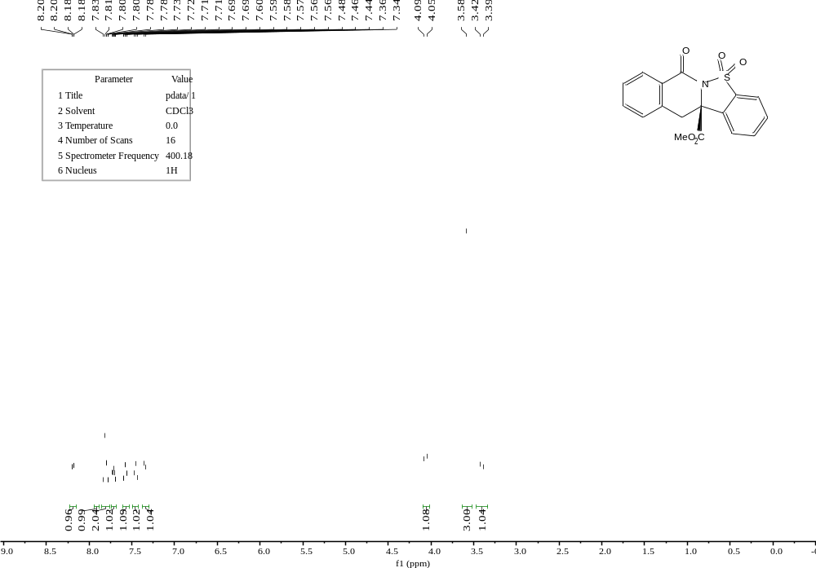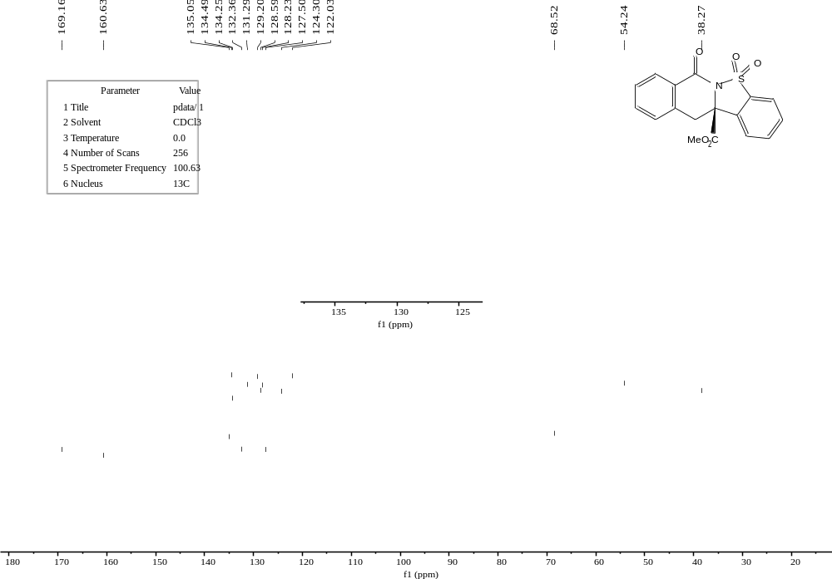
E3
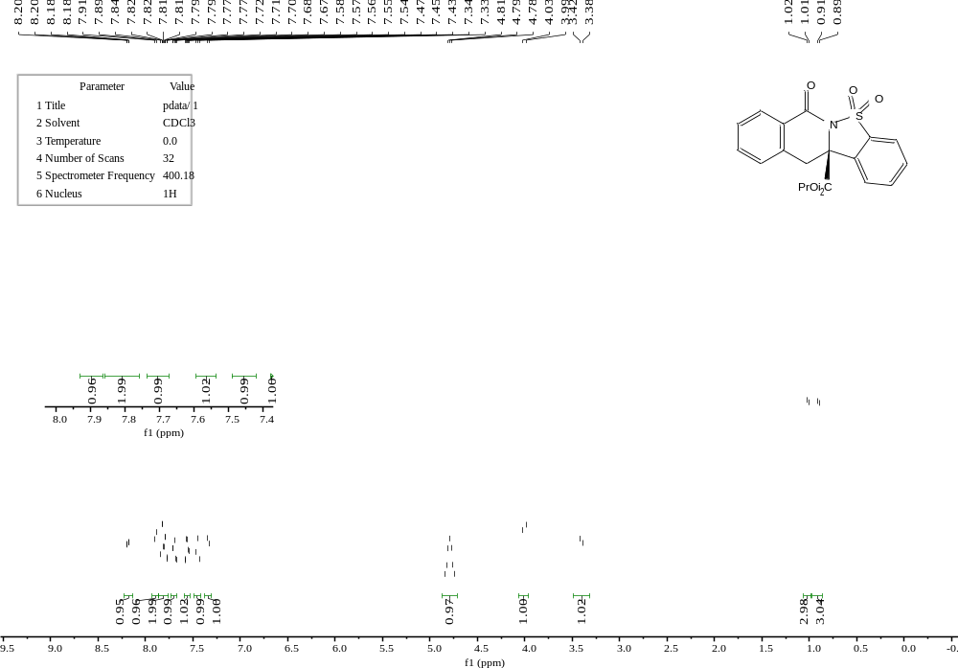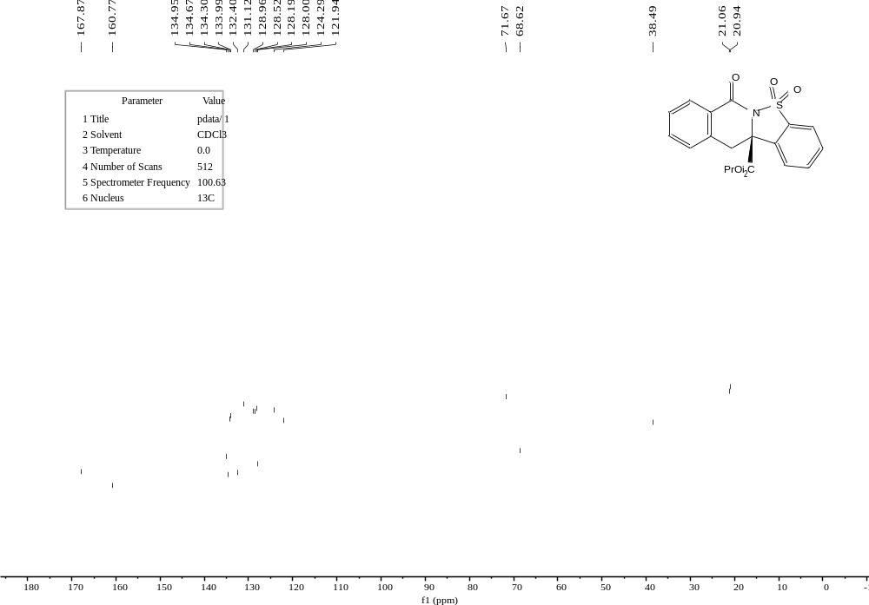
E4
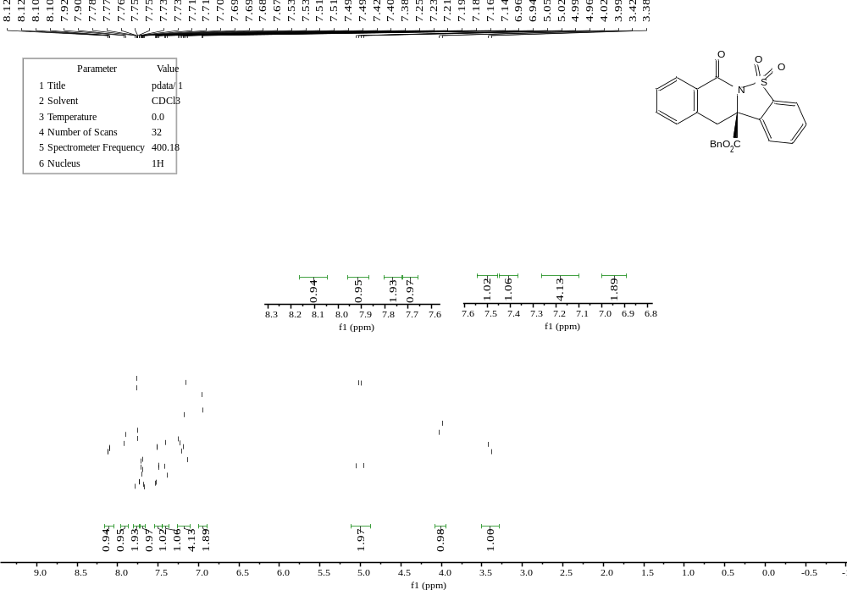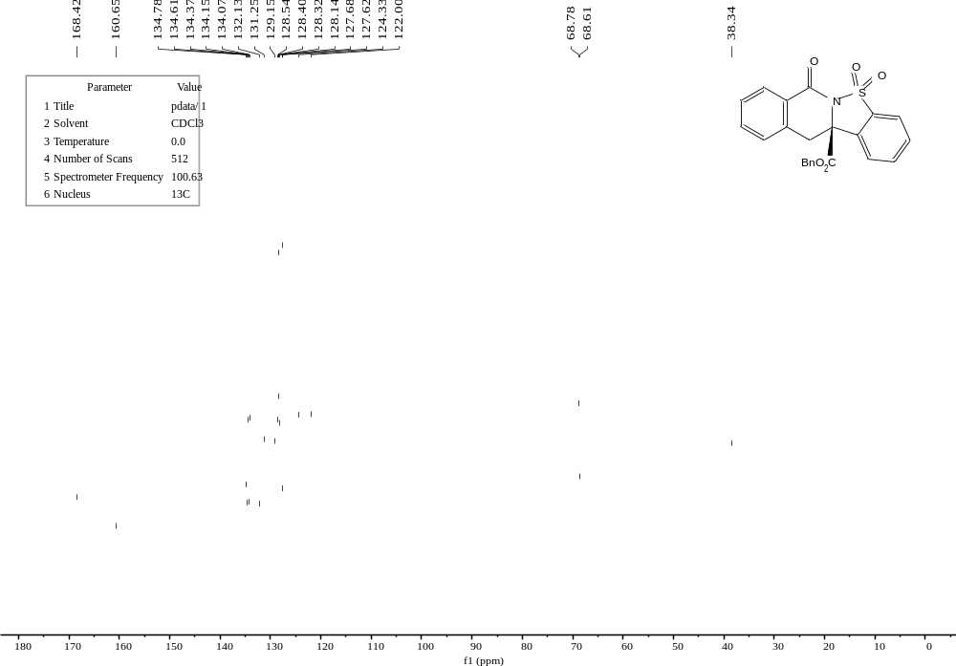
E5
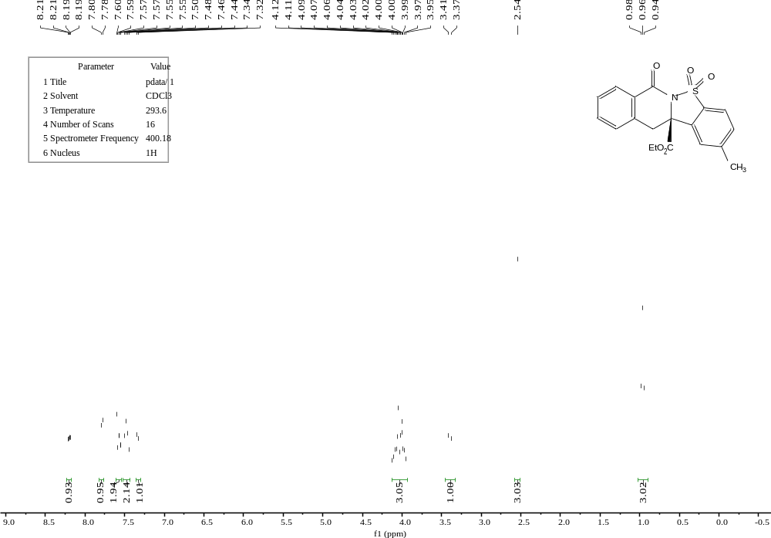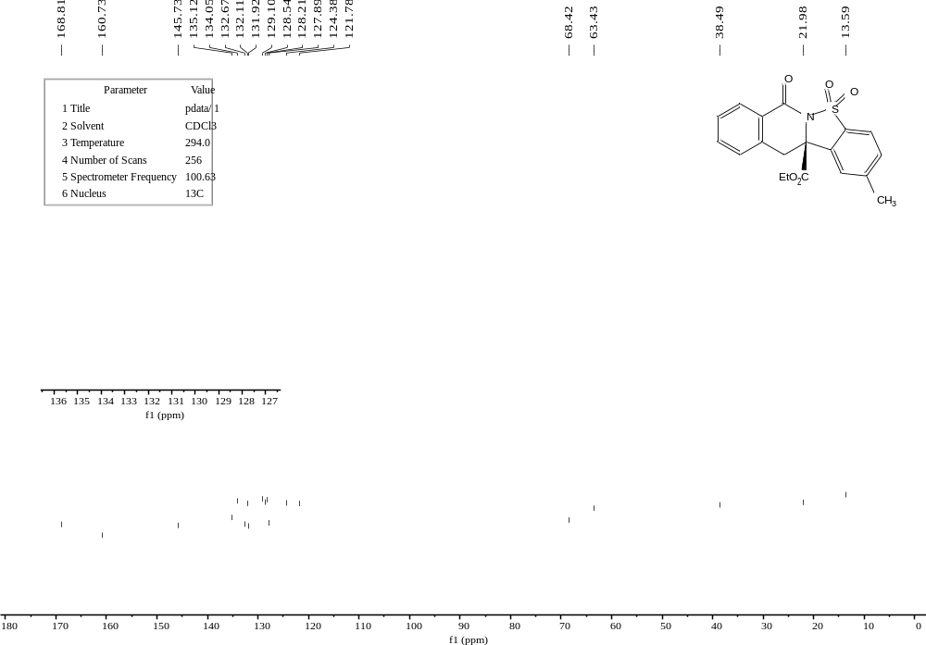
E6
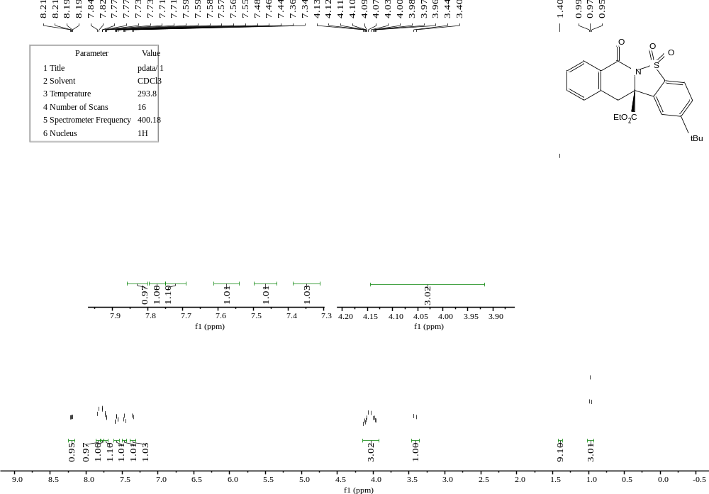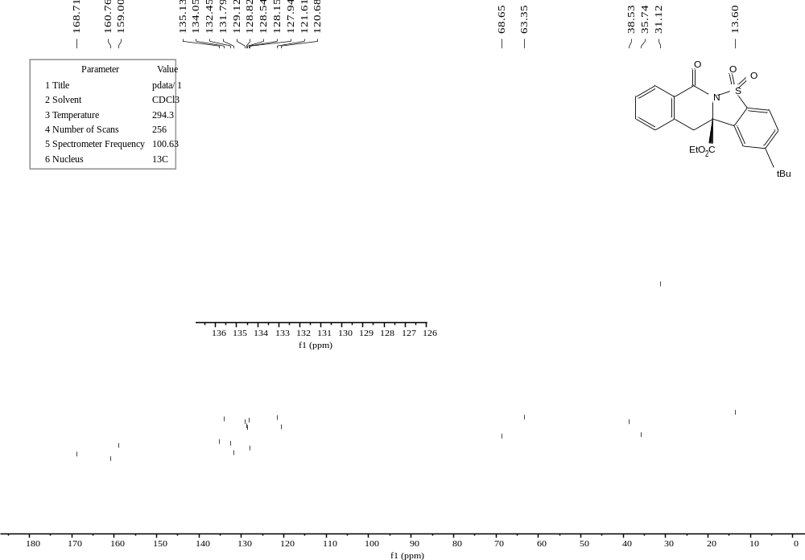
E7
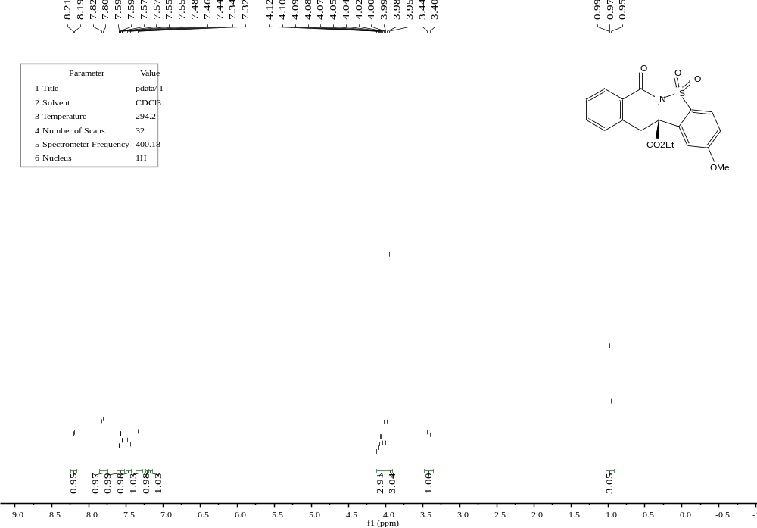
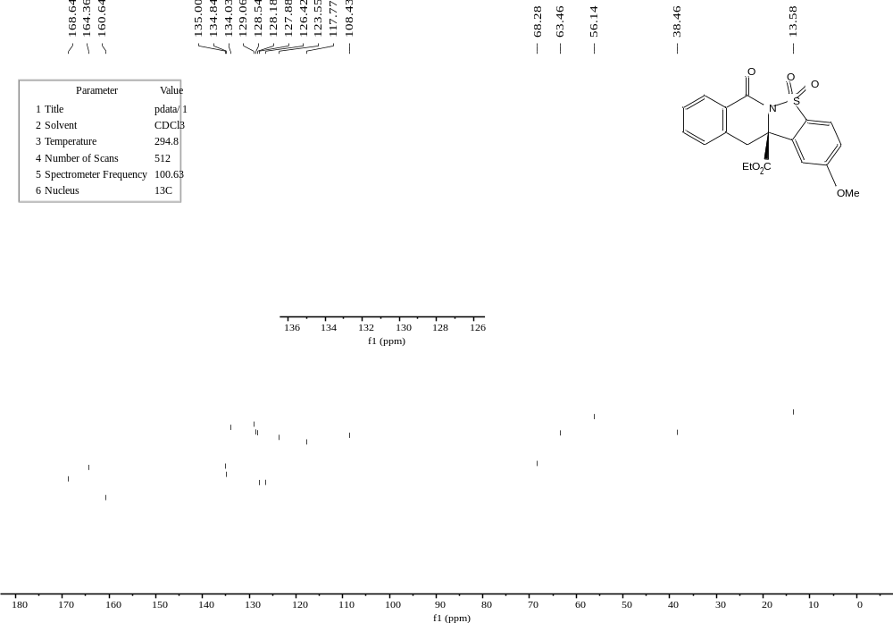
E8
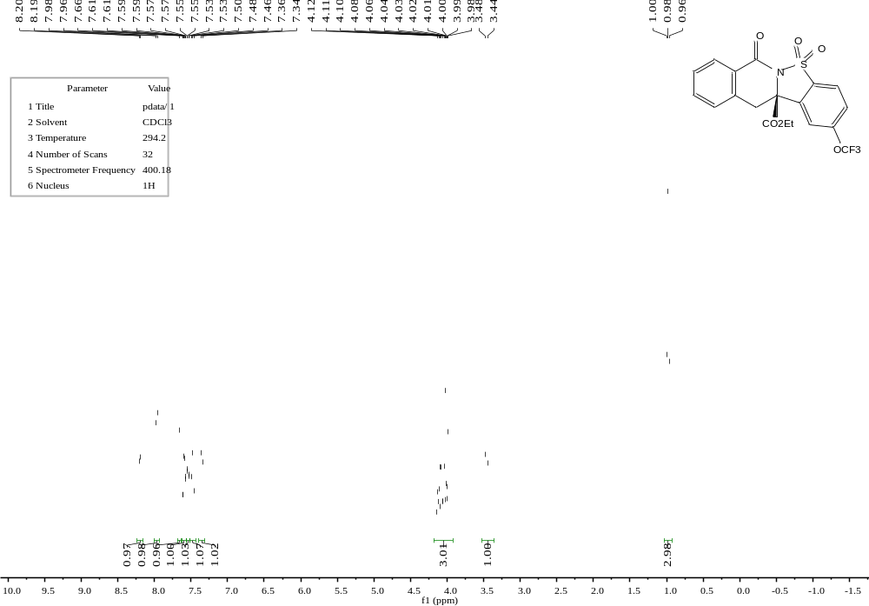
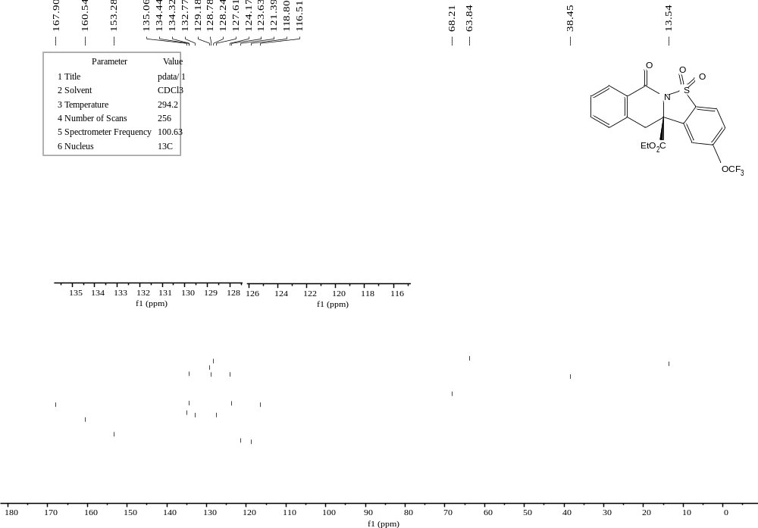
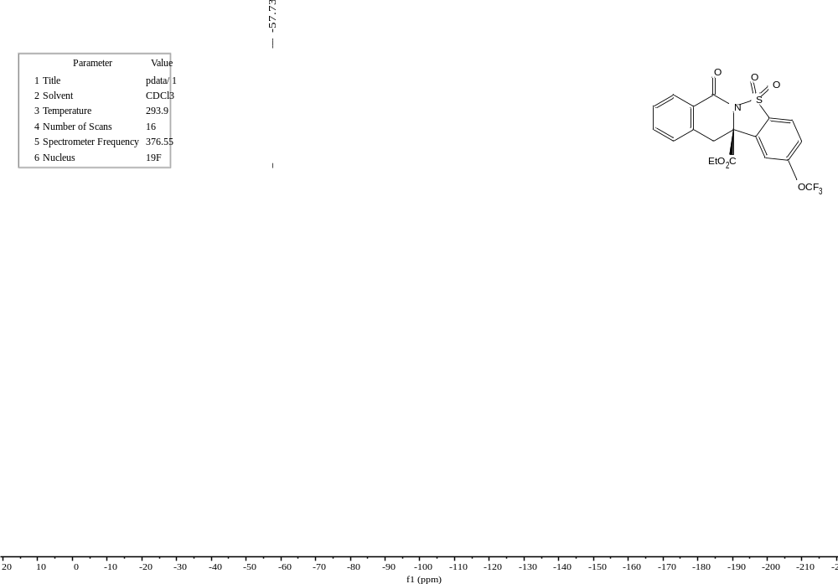
E9
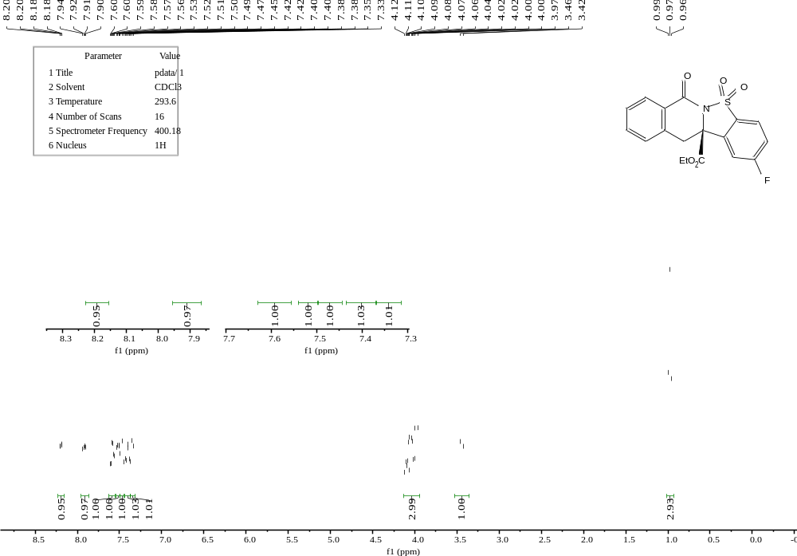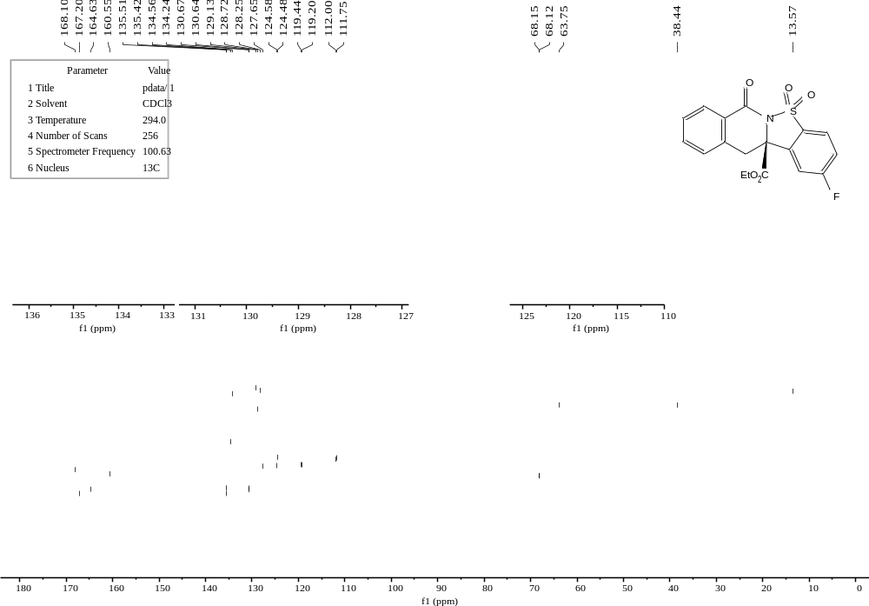
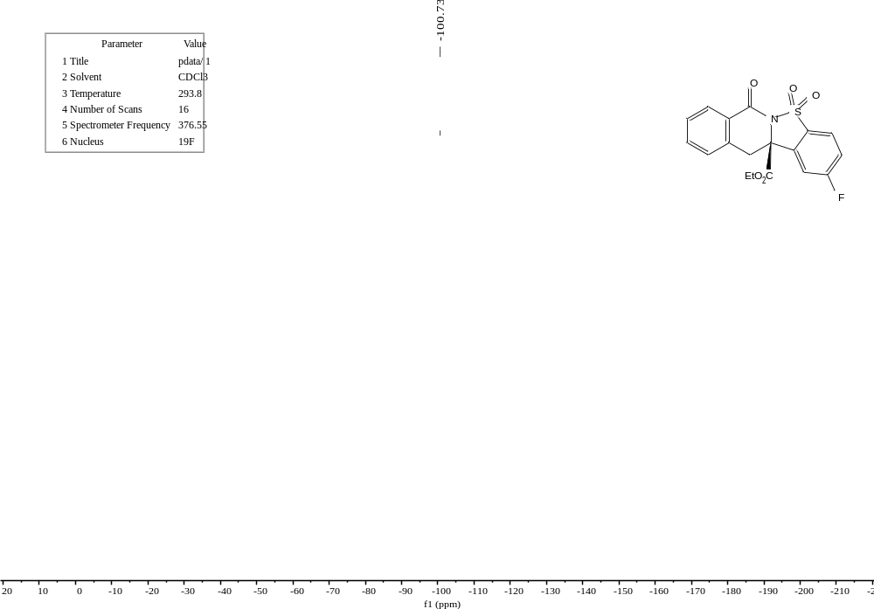
E10
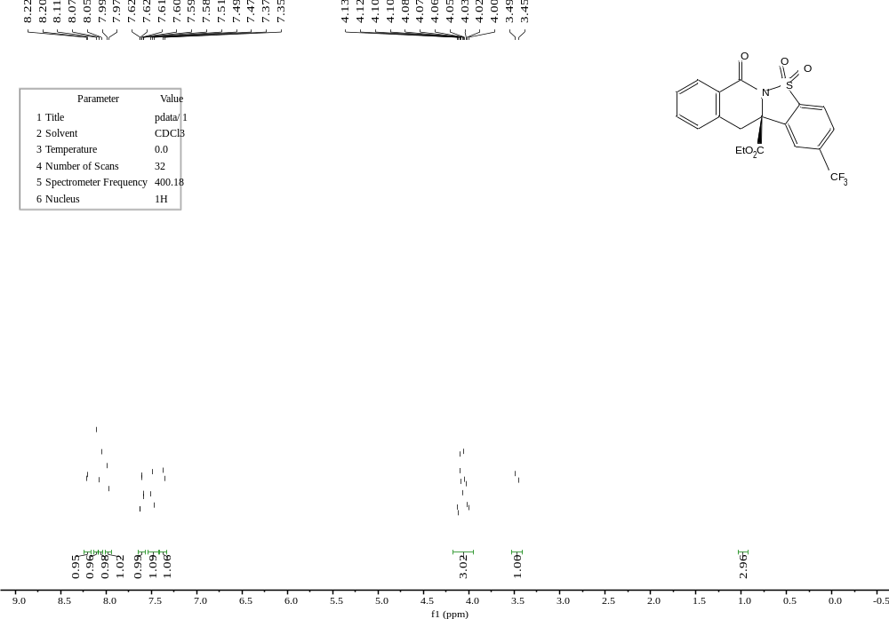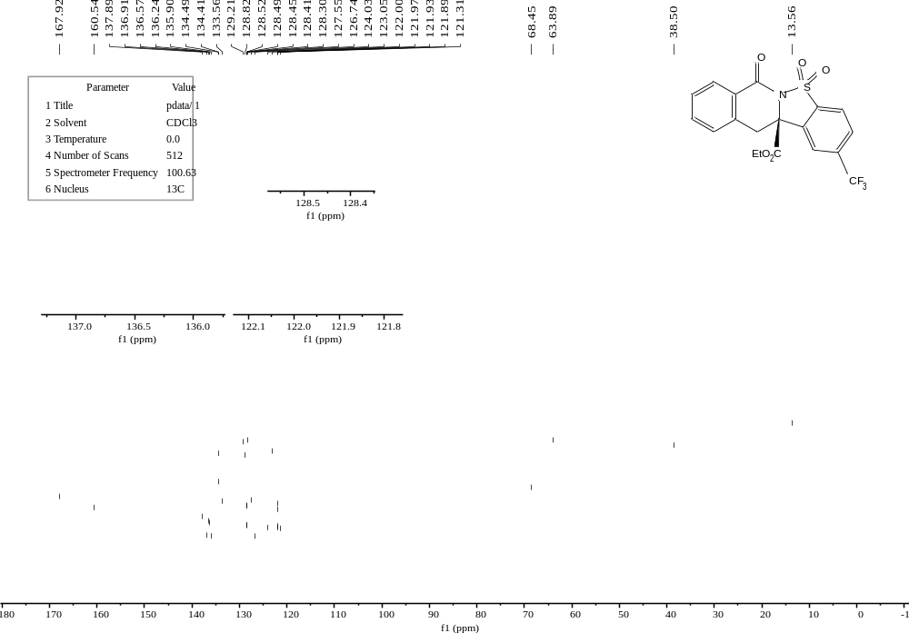
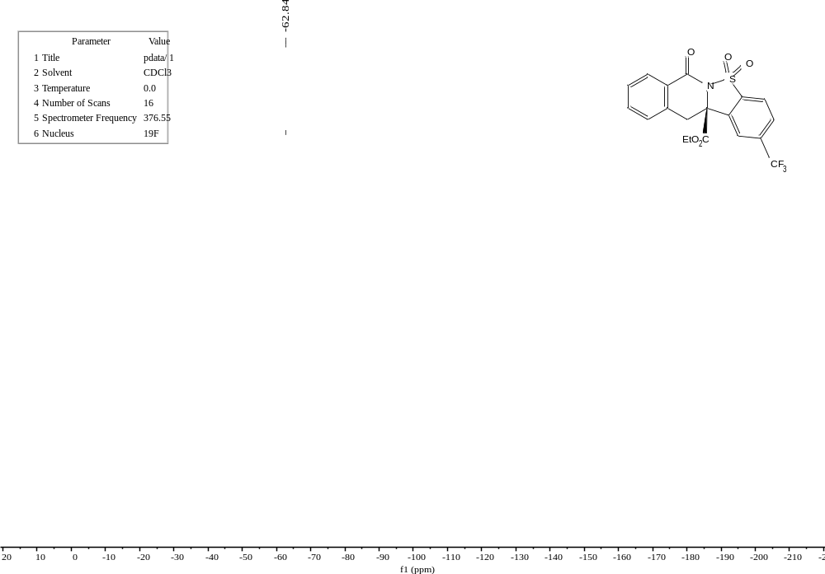
E11
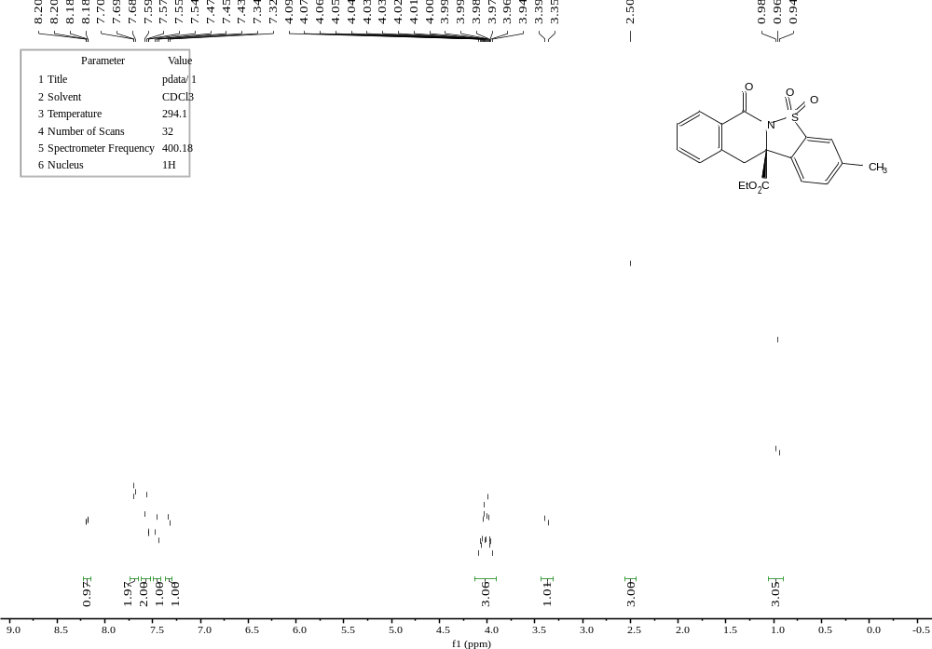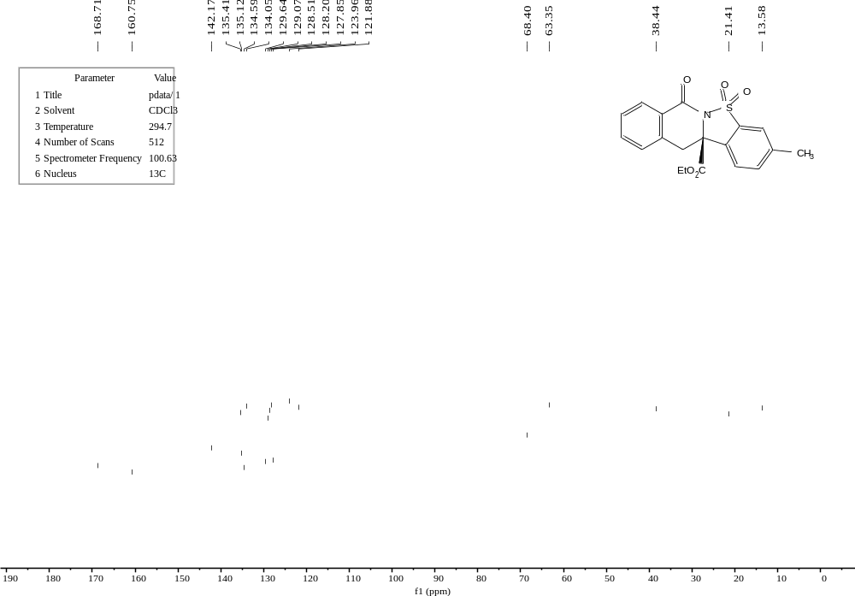
E12
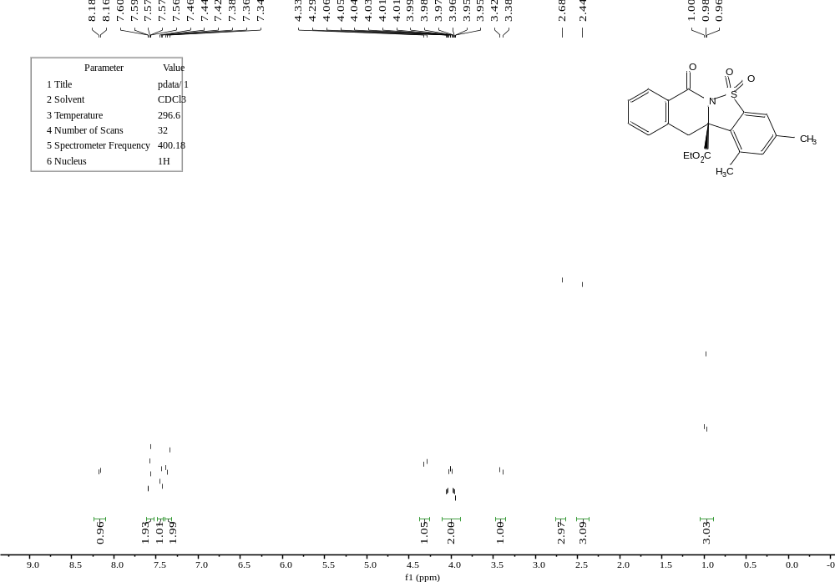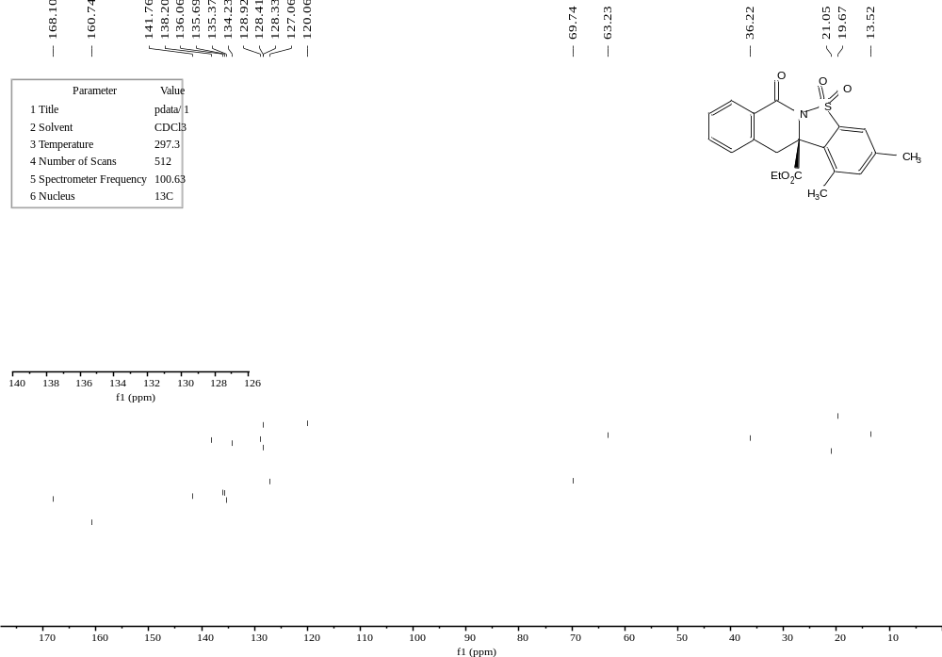
E13
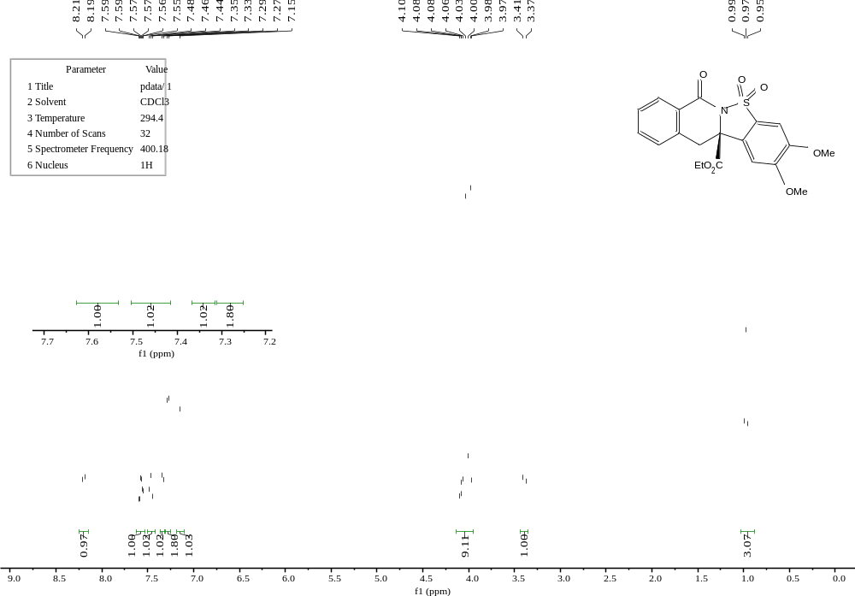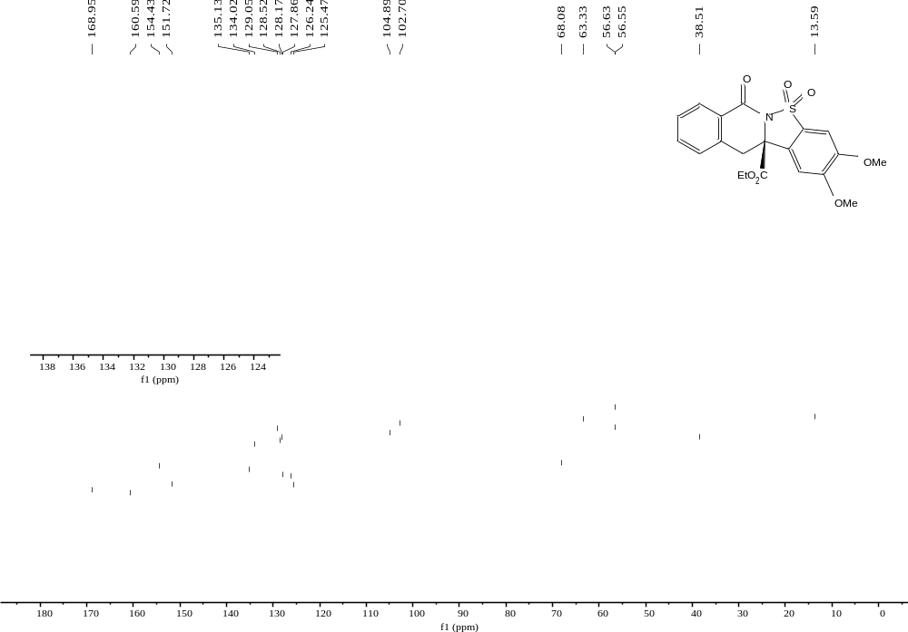
E14
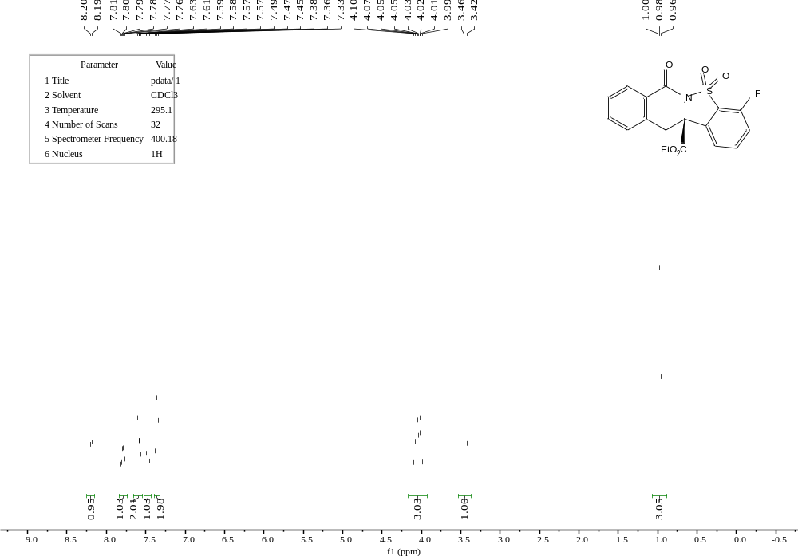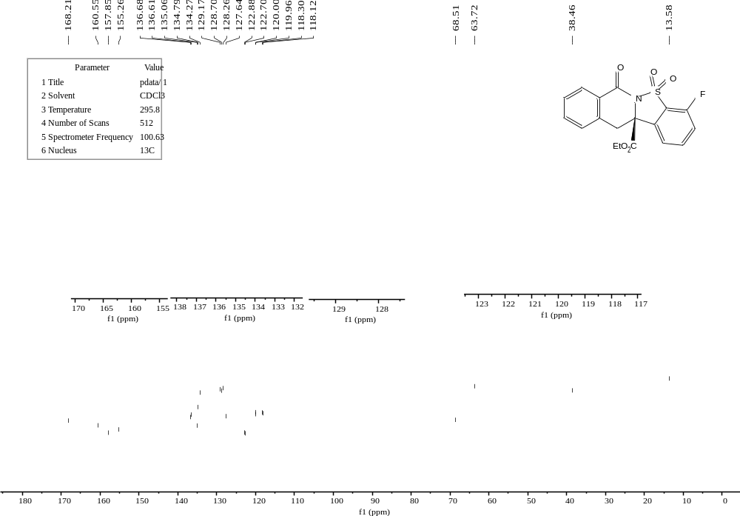
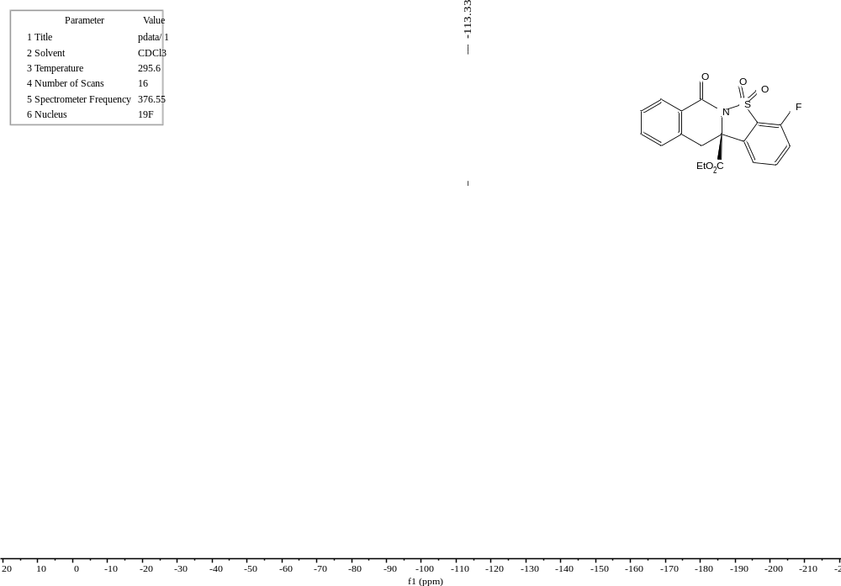
E15
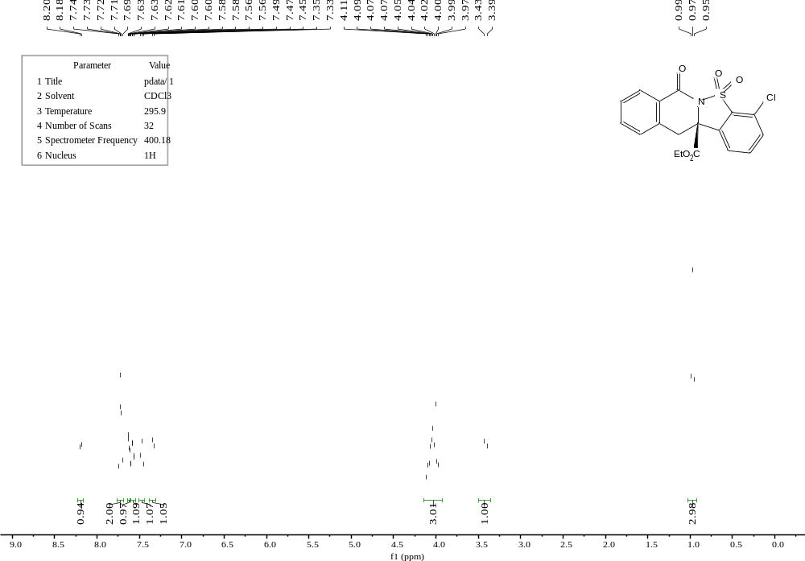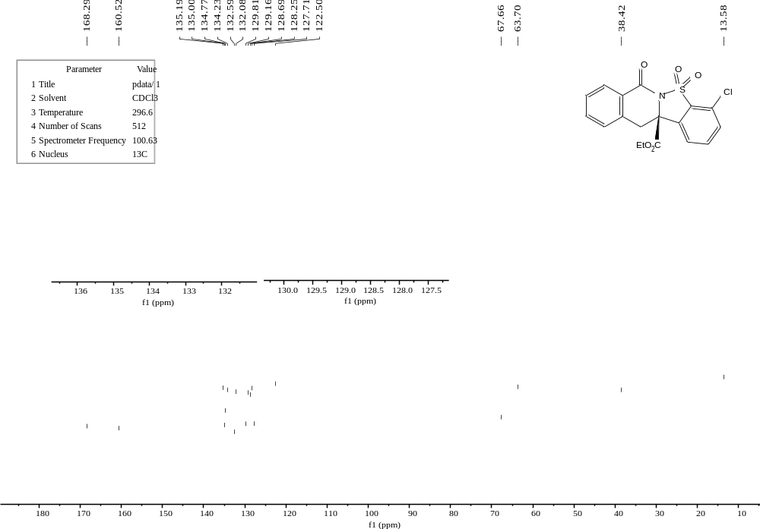
E16
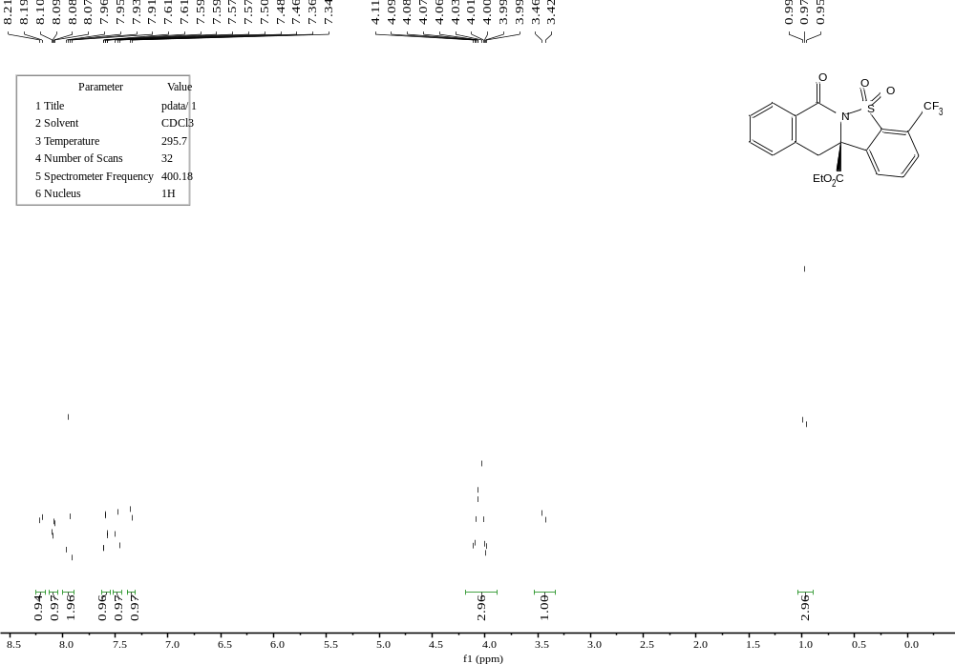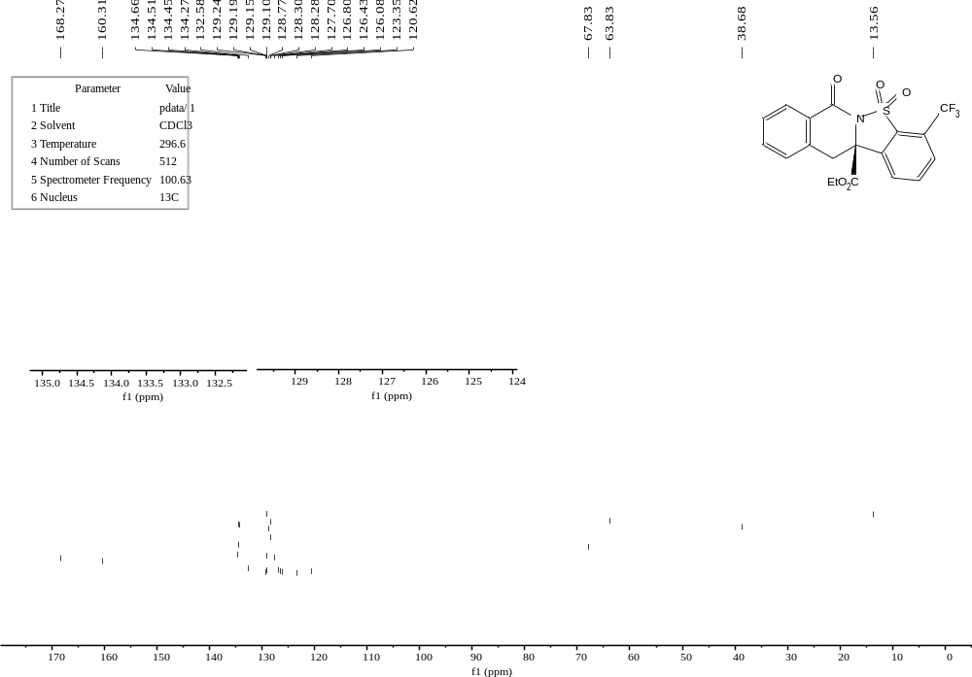
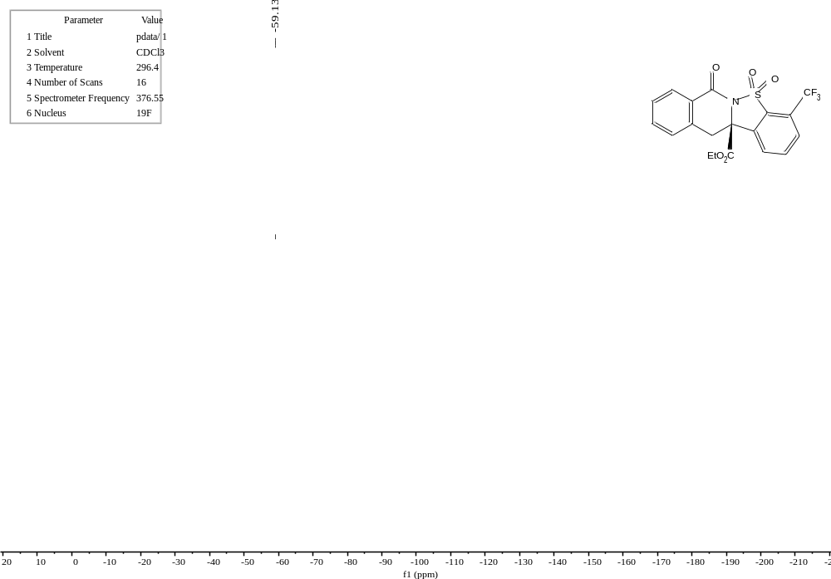
E17
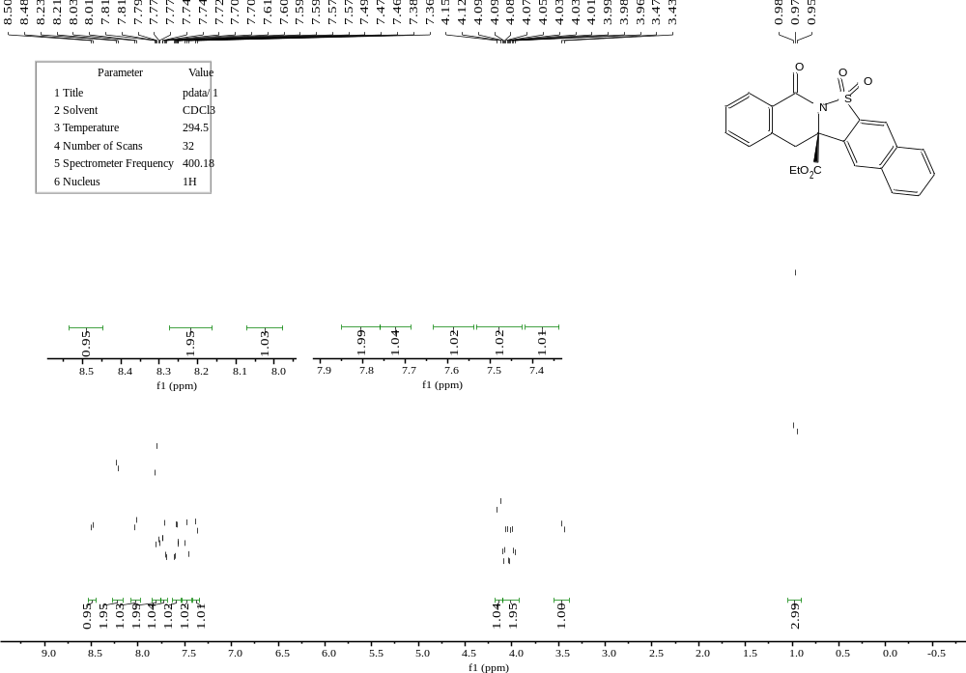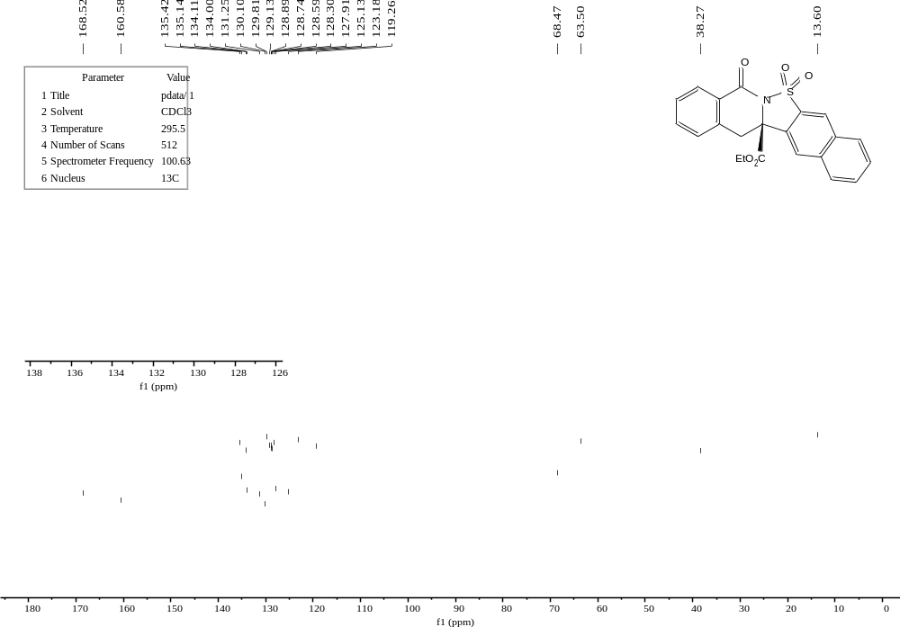
E18
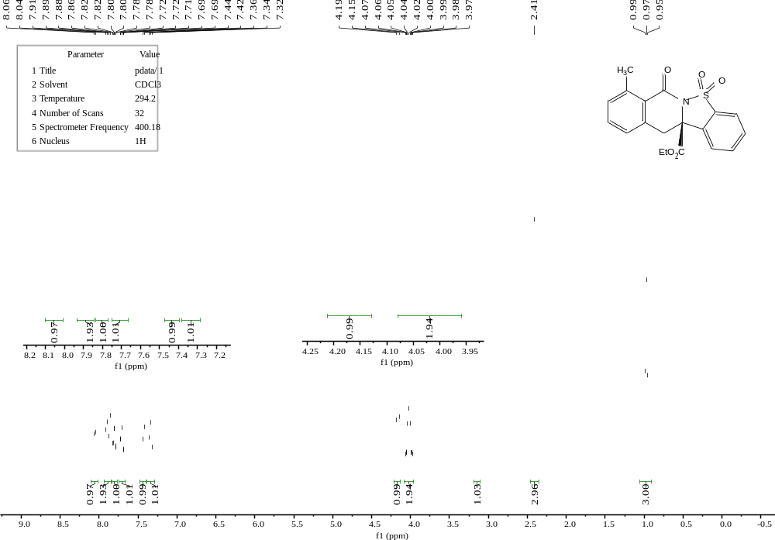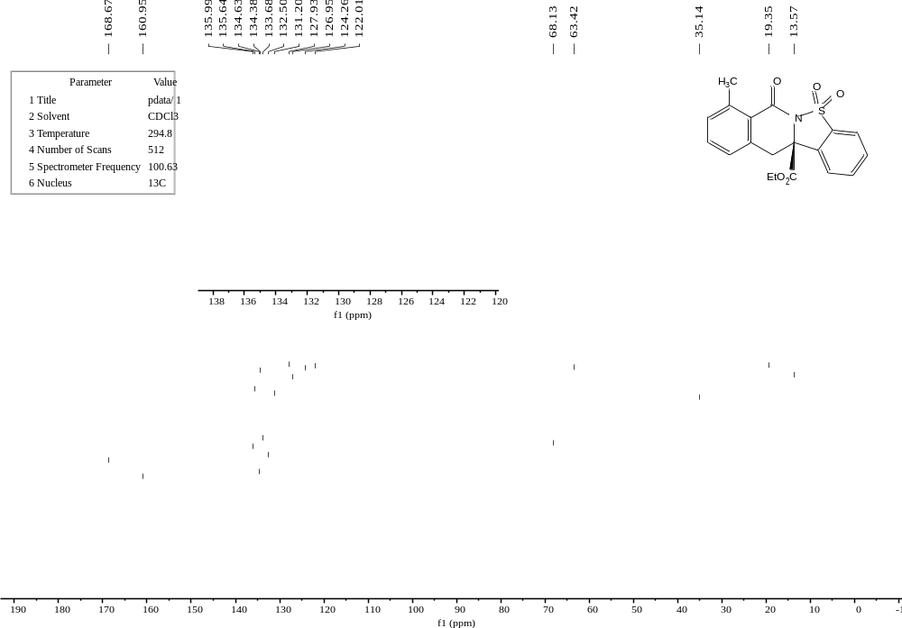
E19
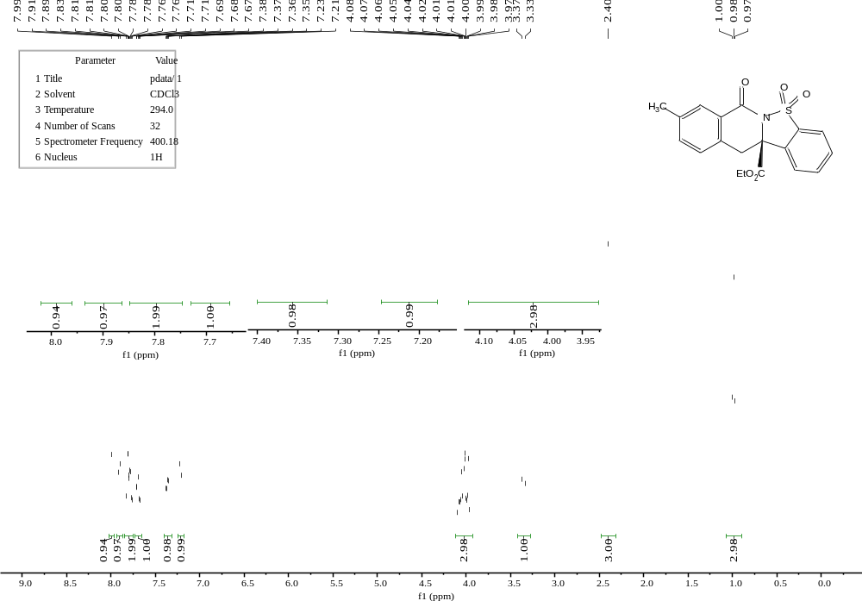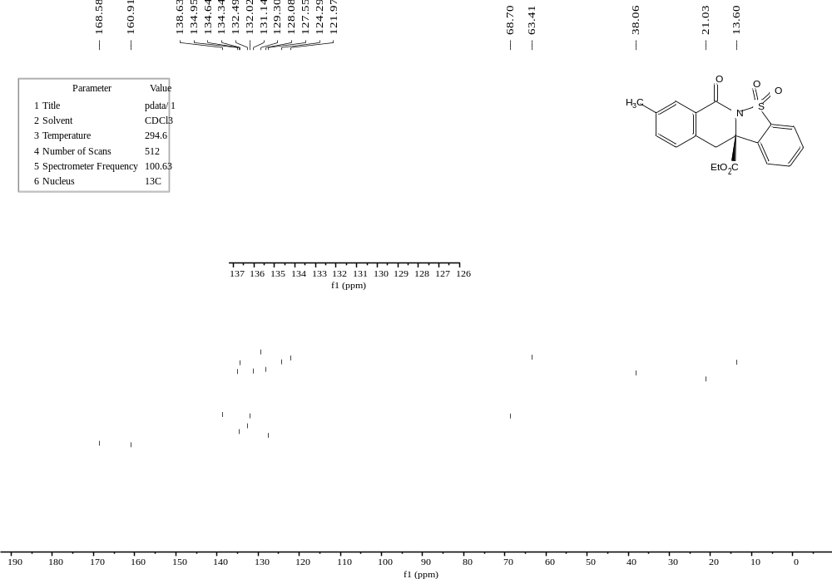
E20
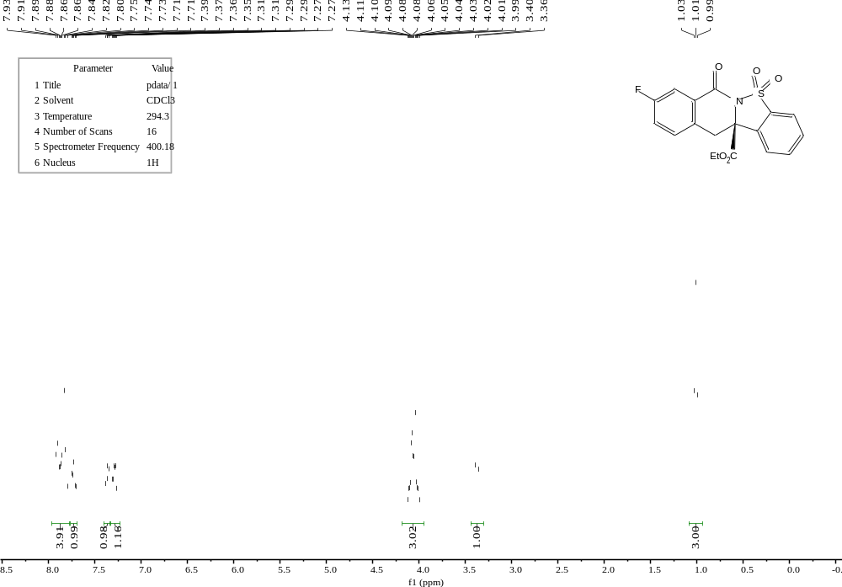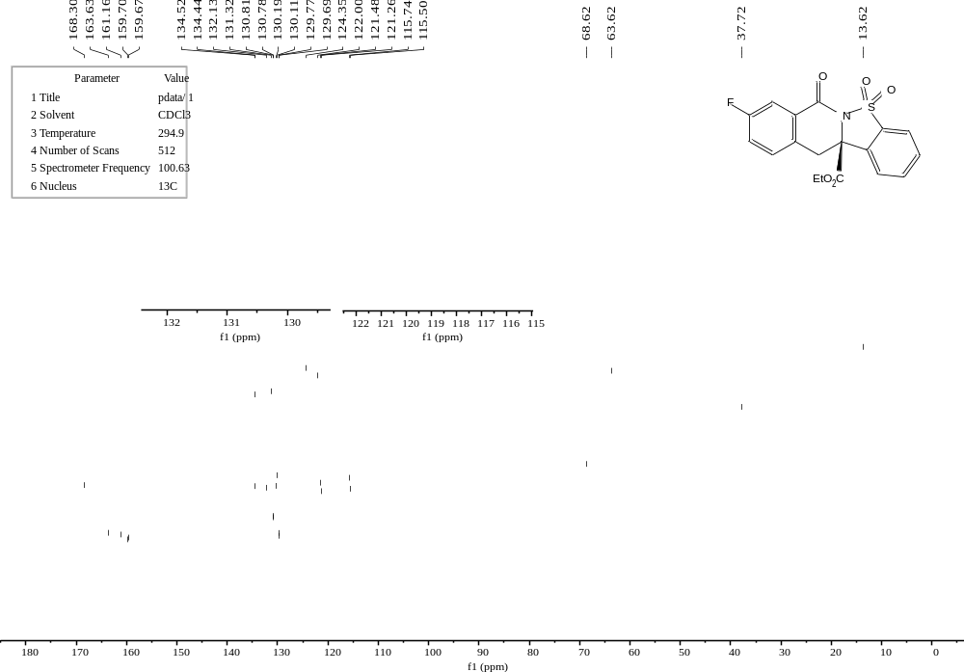
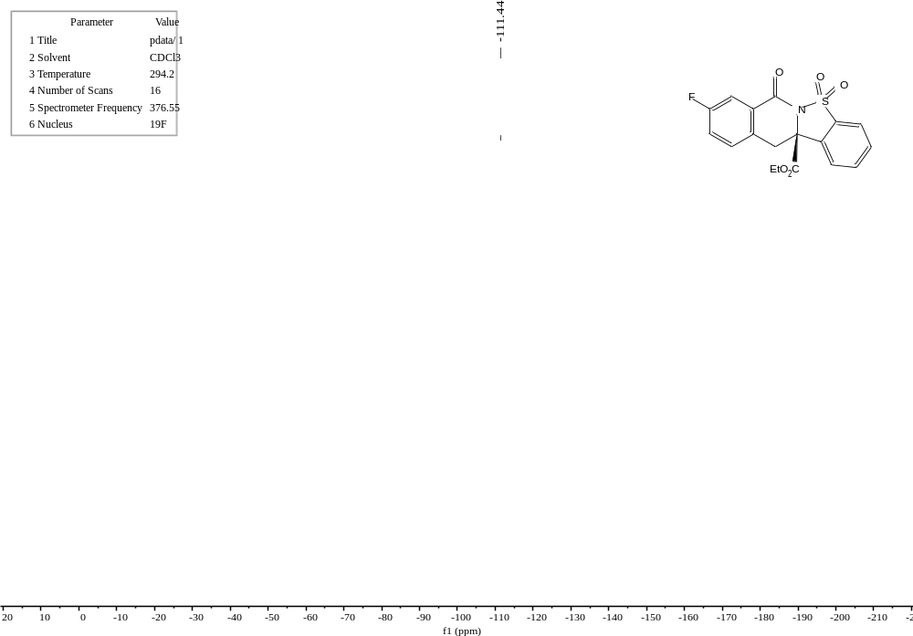
E21
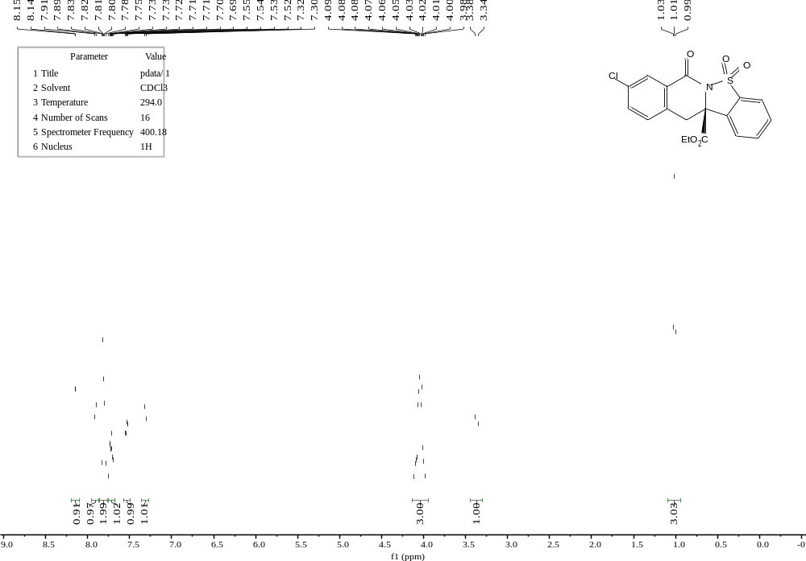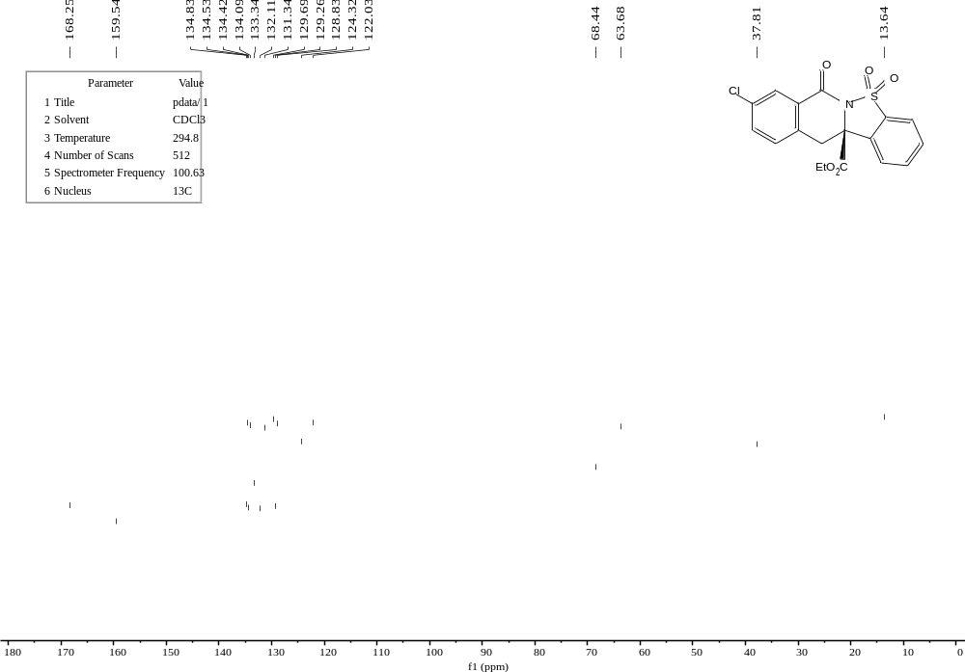
E22
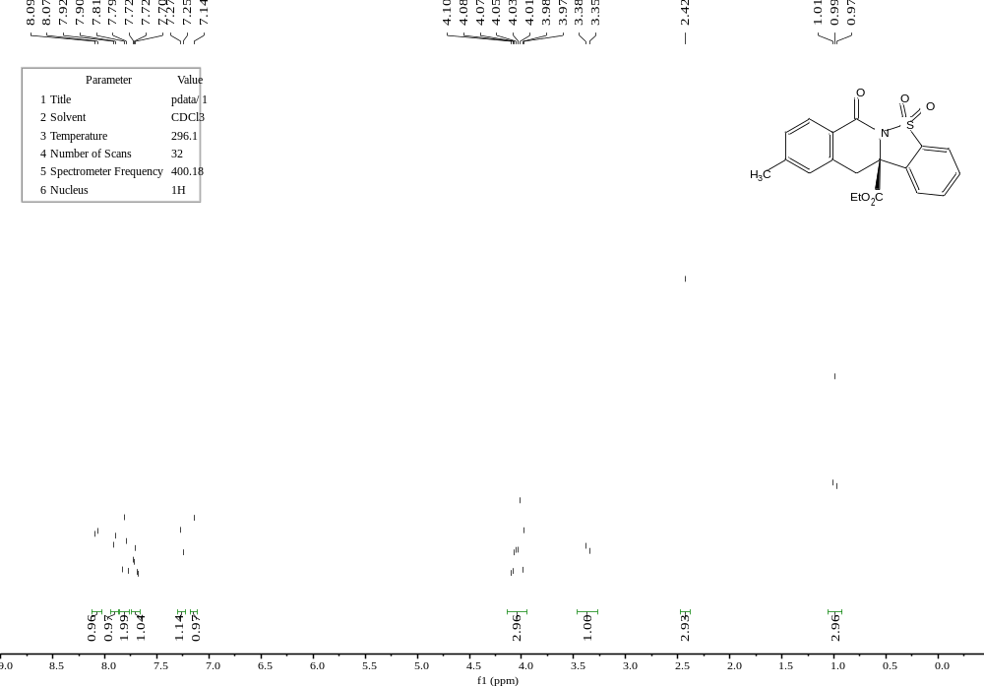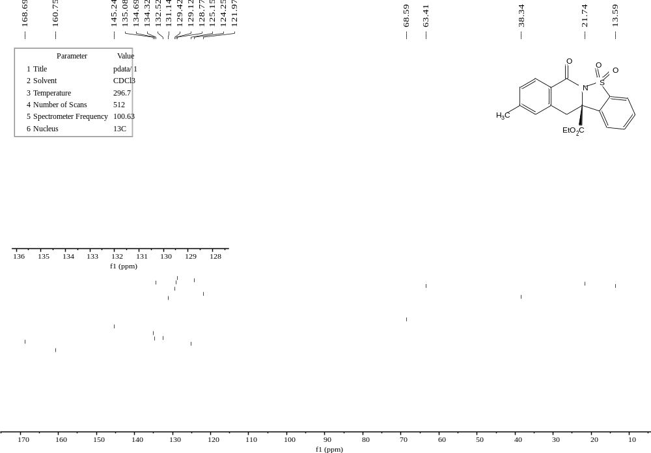
E23
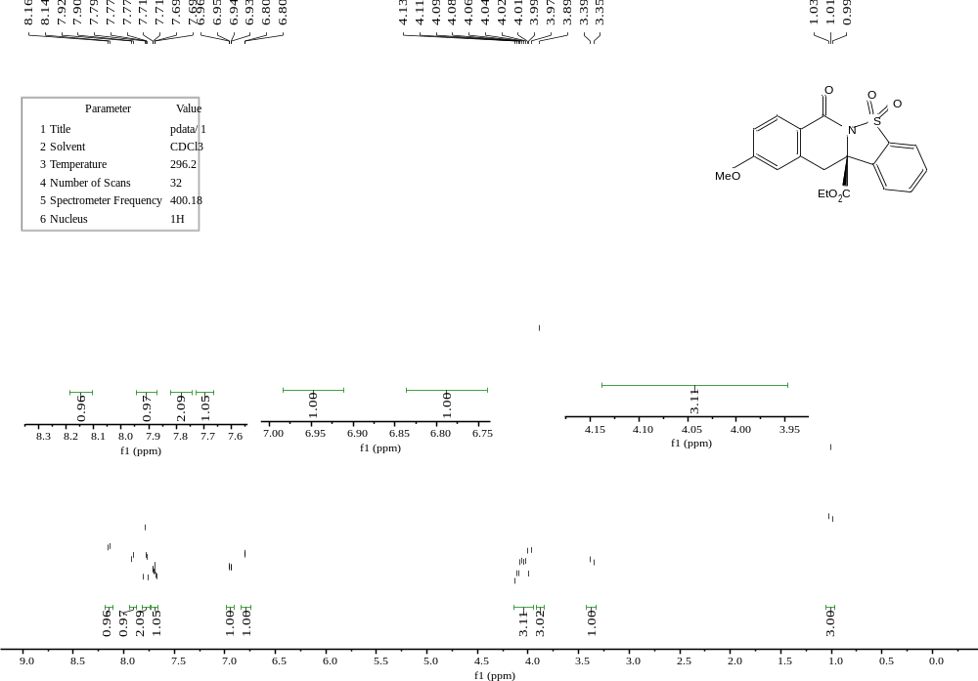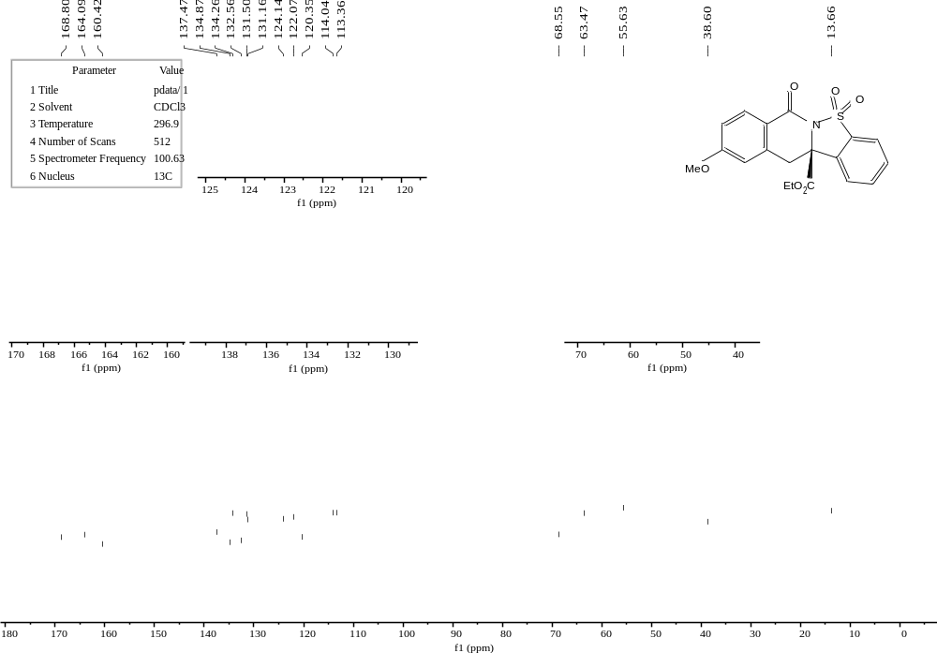
E24
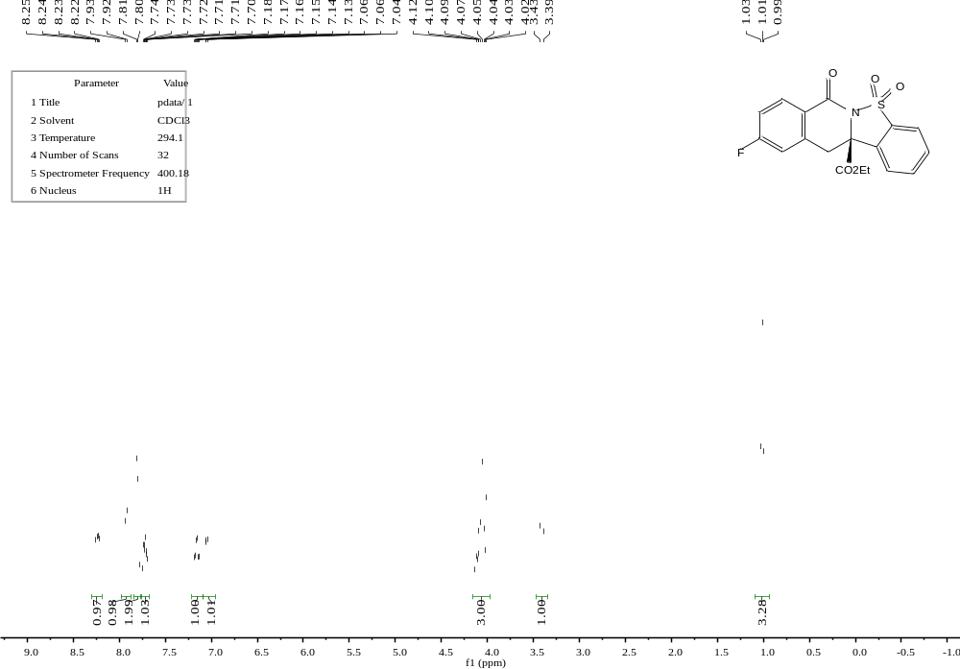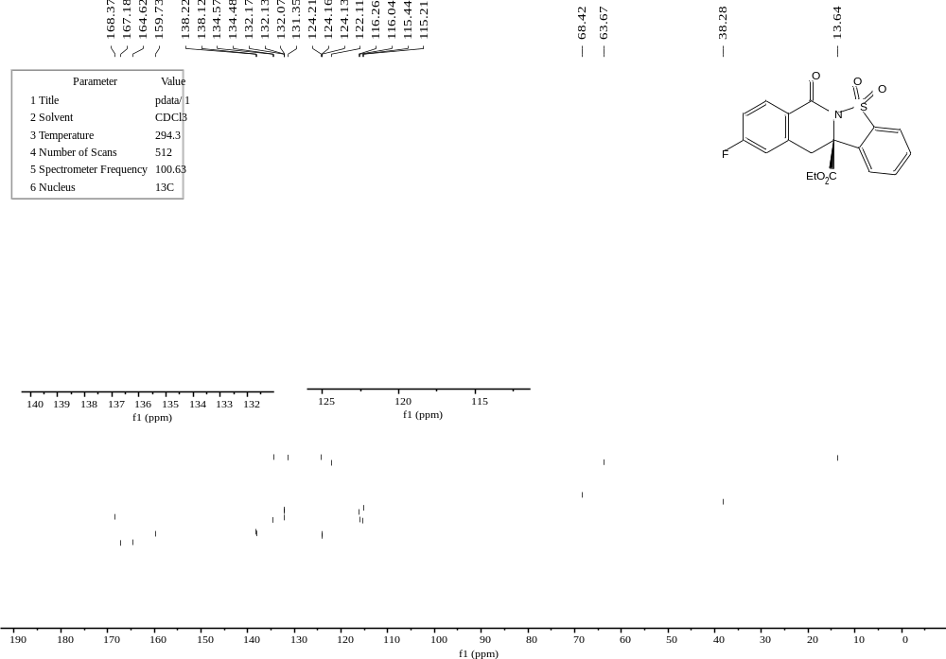
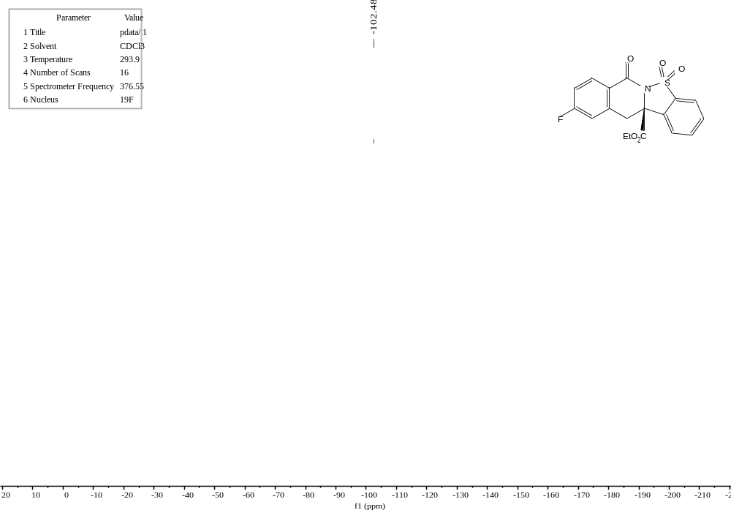
E25
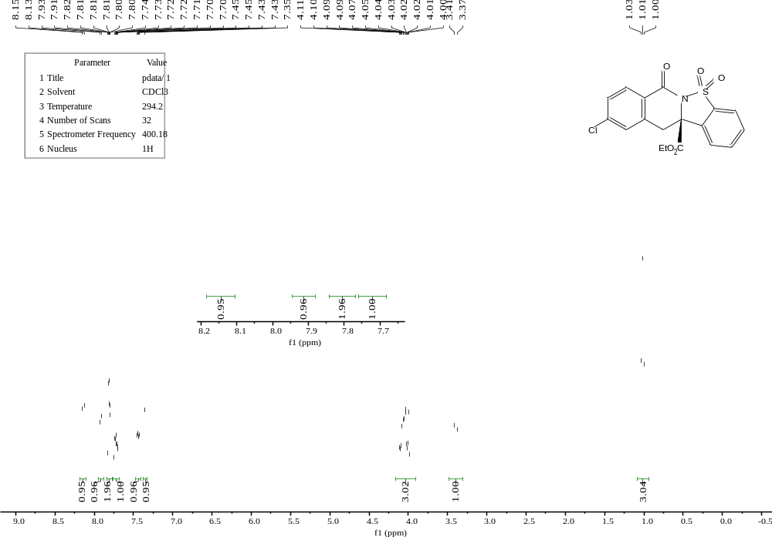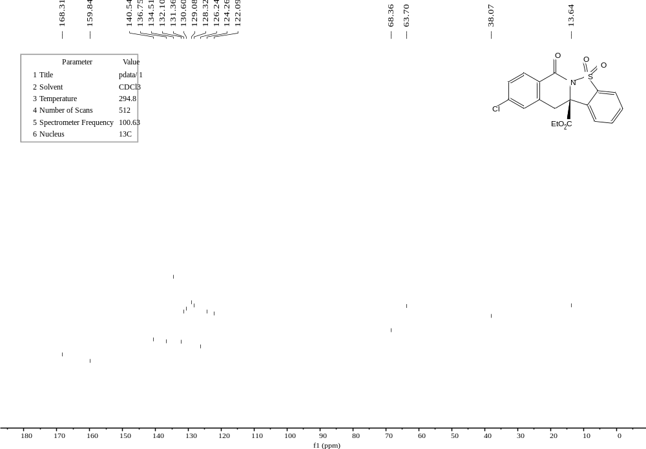
E26
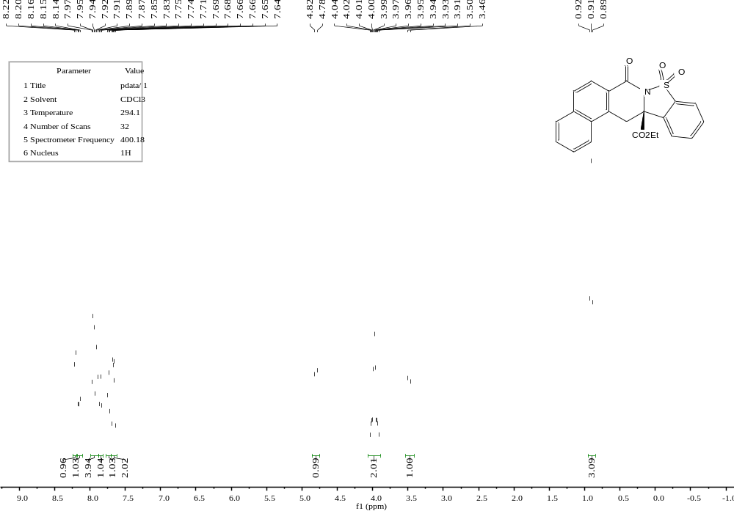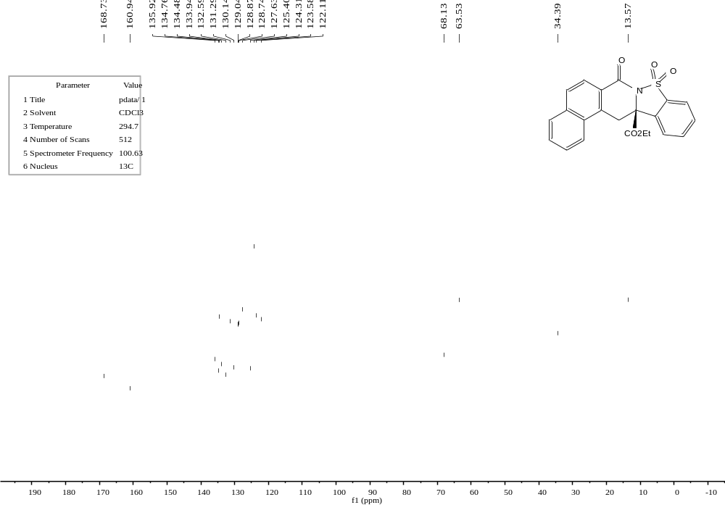
E27
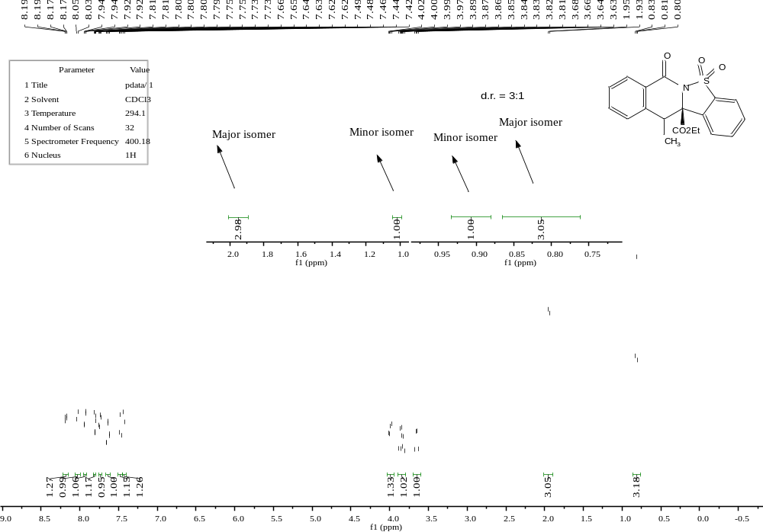
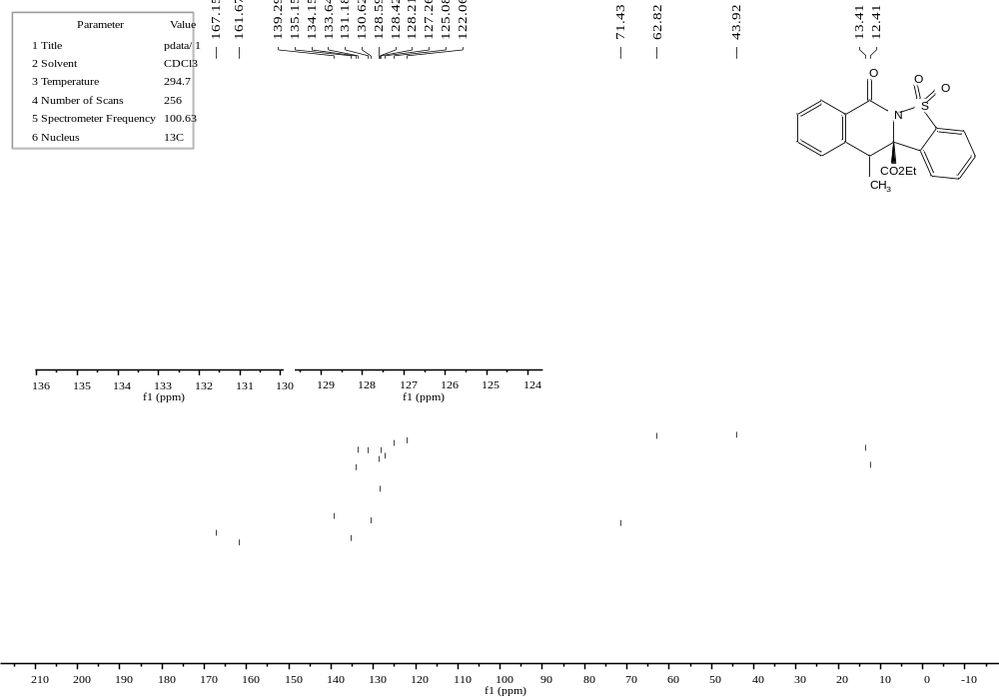

E28 (less polar isomer)
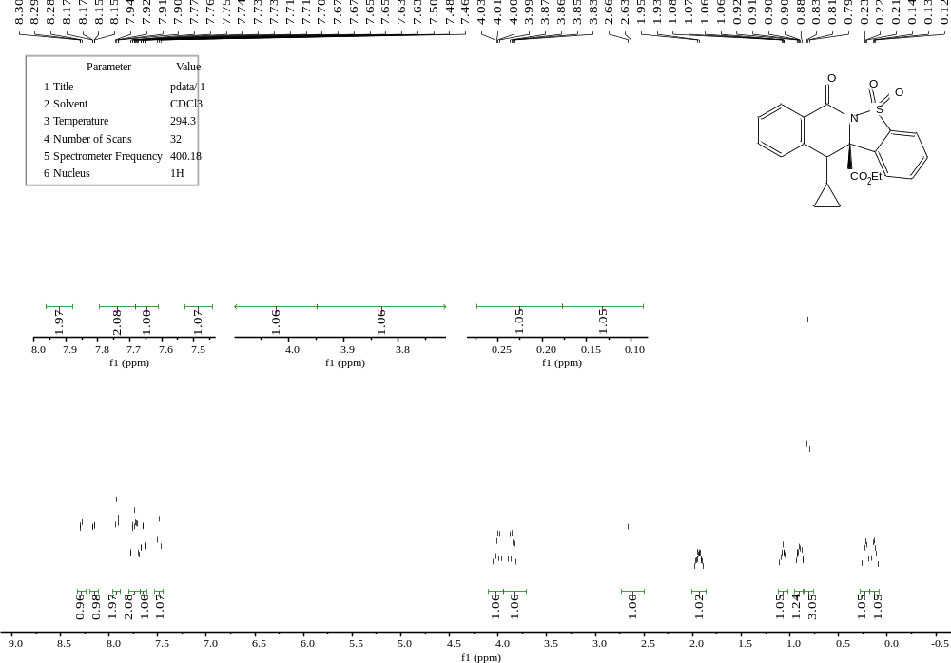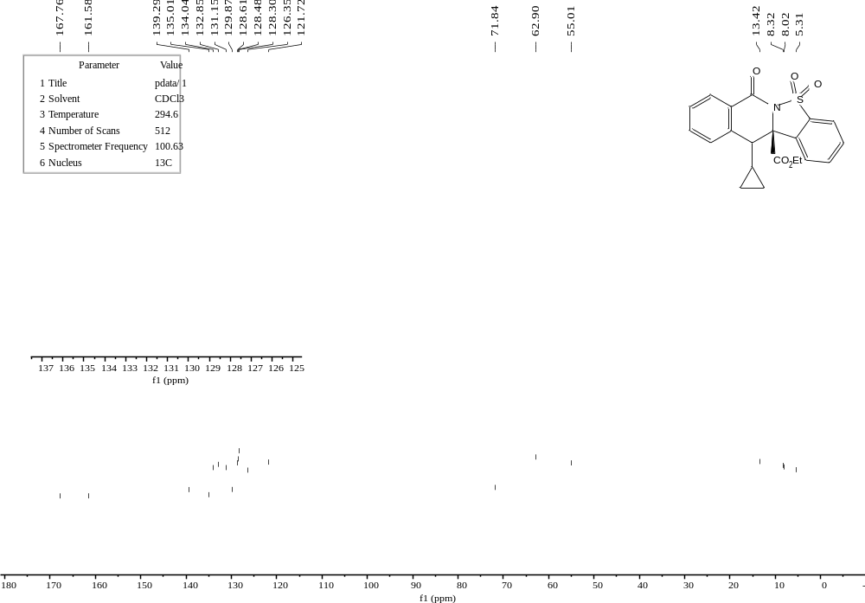
E28 (more polar isomer)
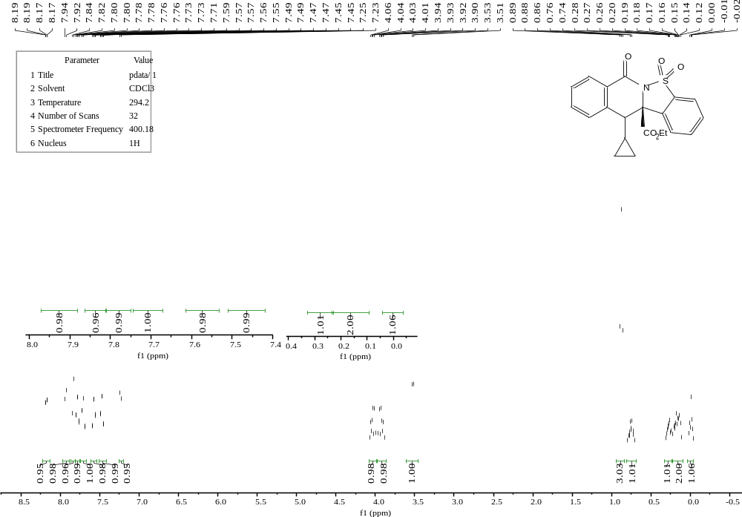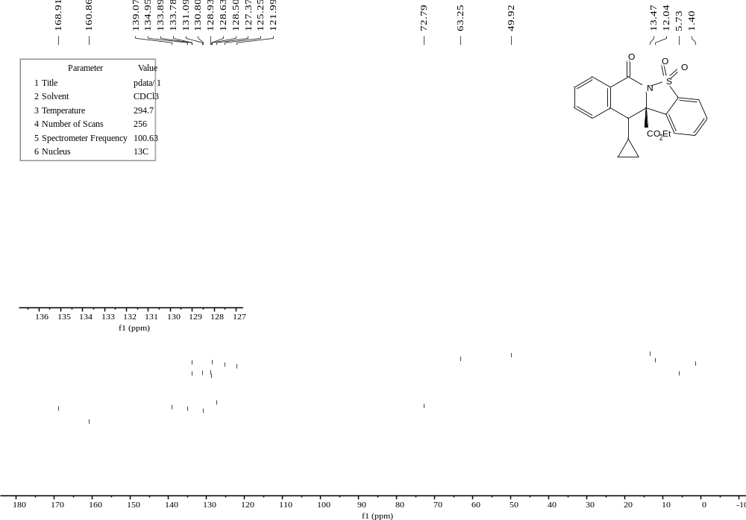
E29
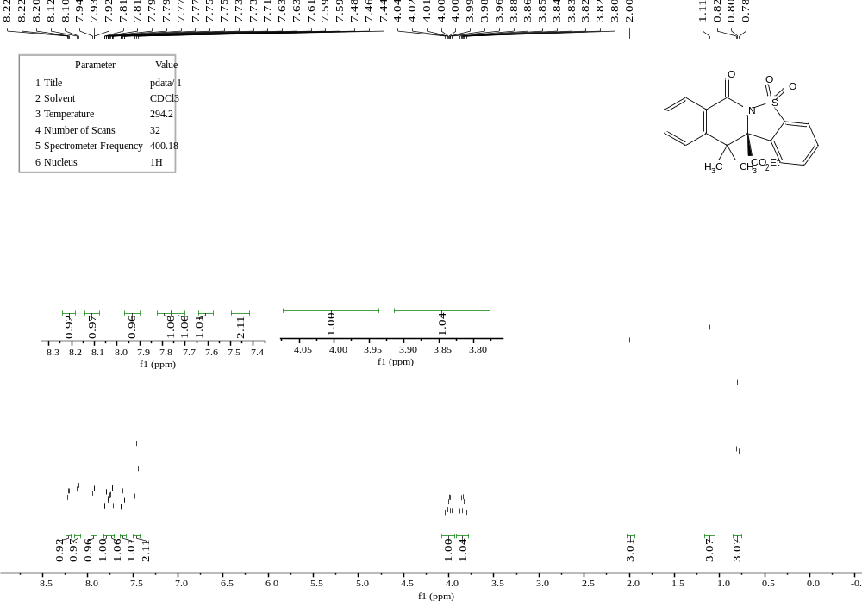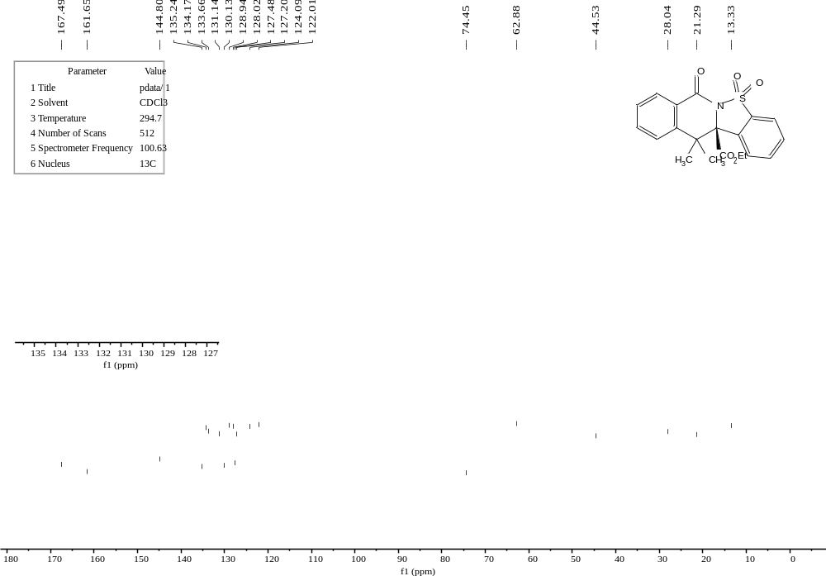
E30
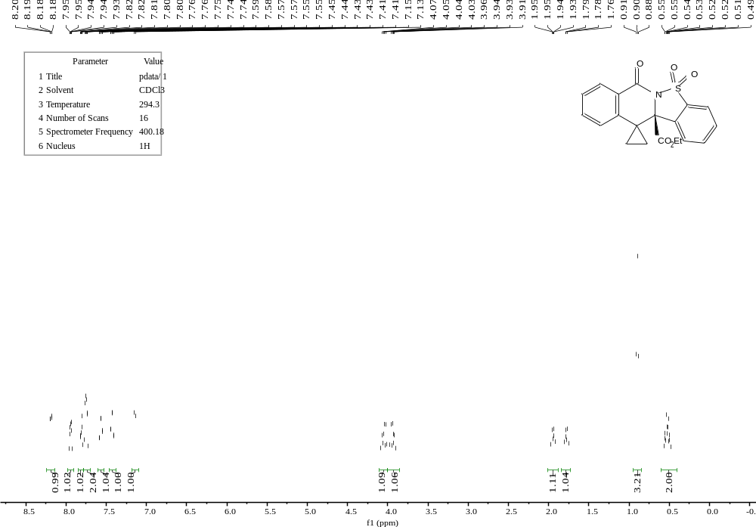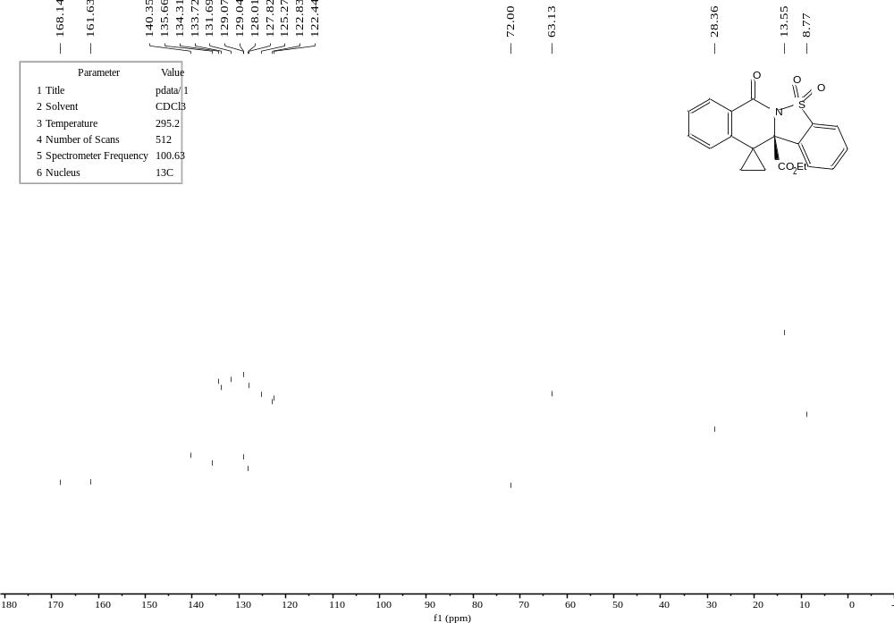
E31
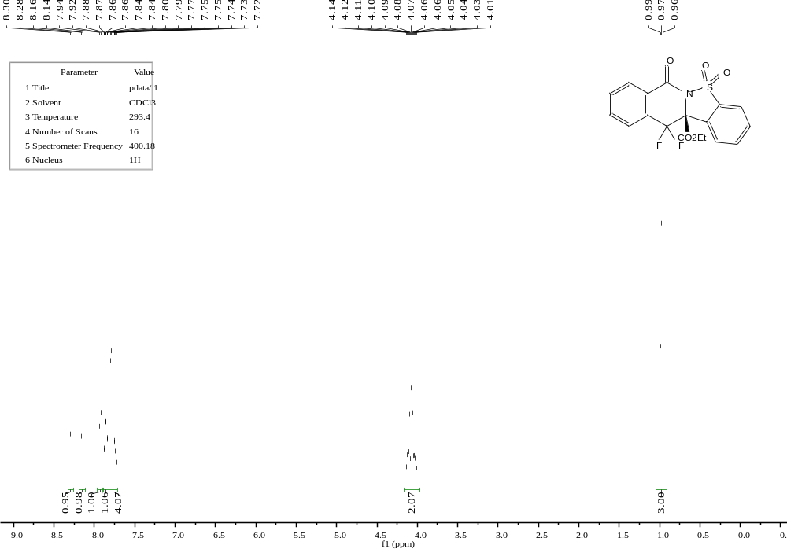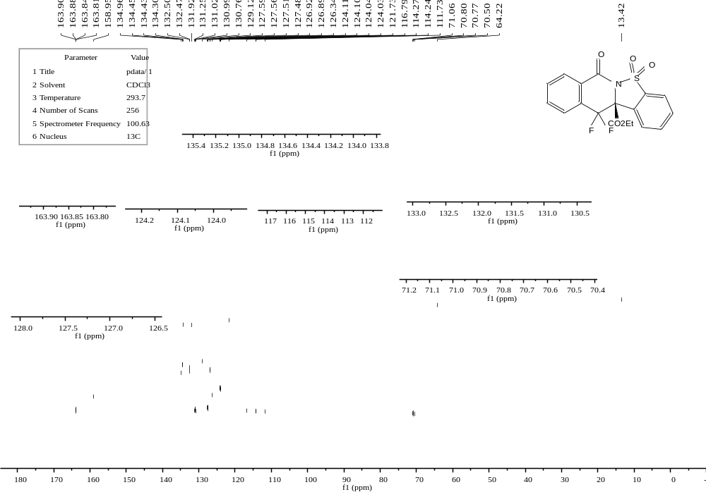
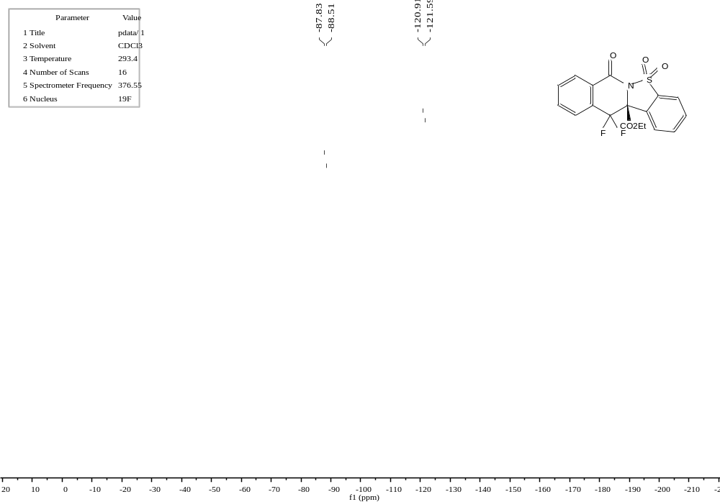
F1
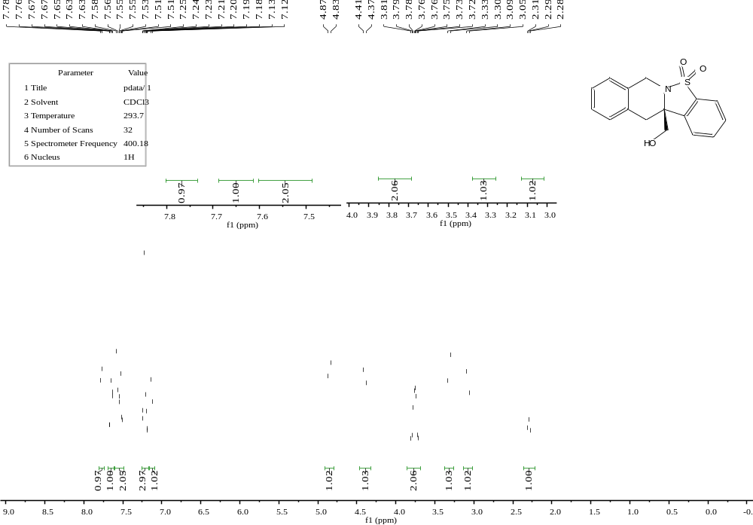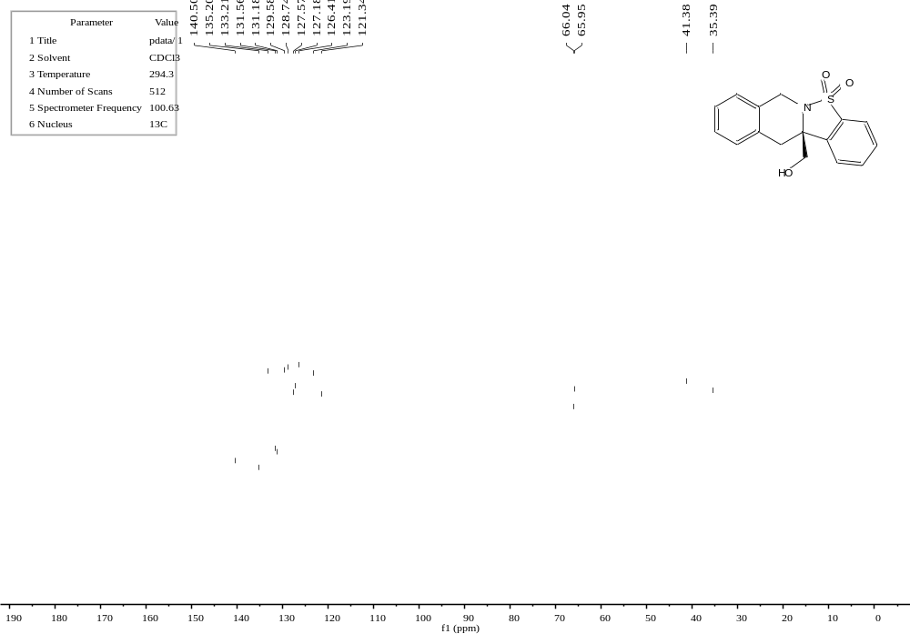
F2
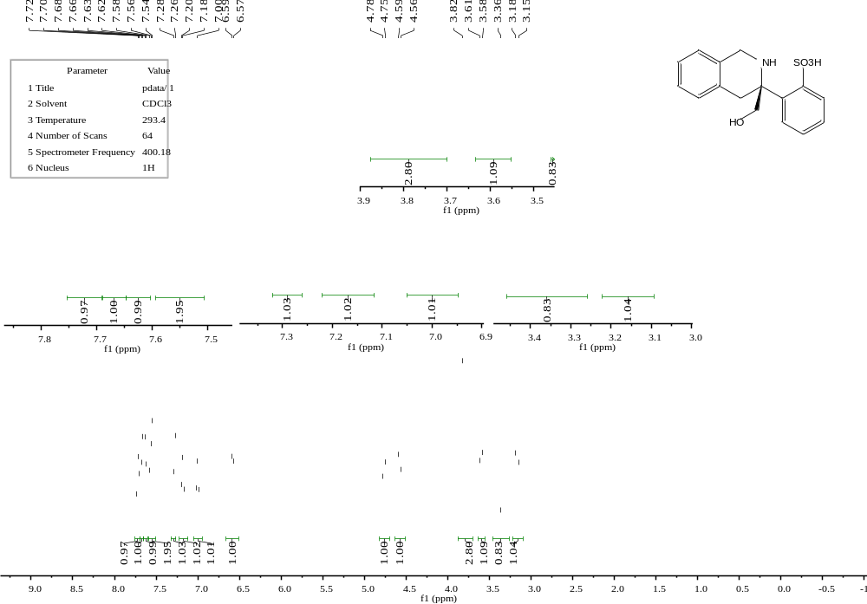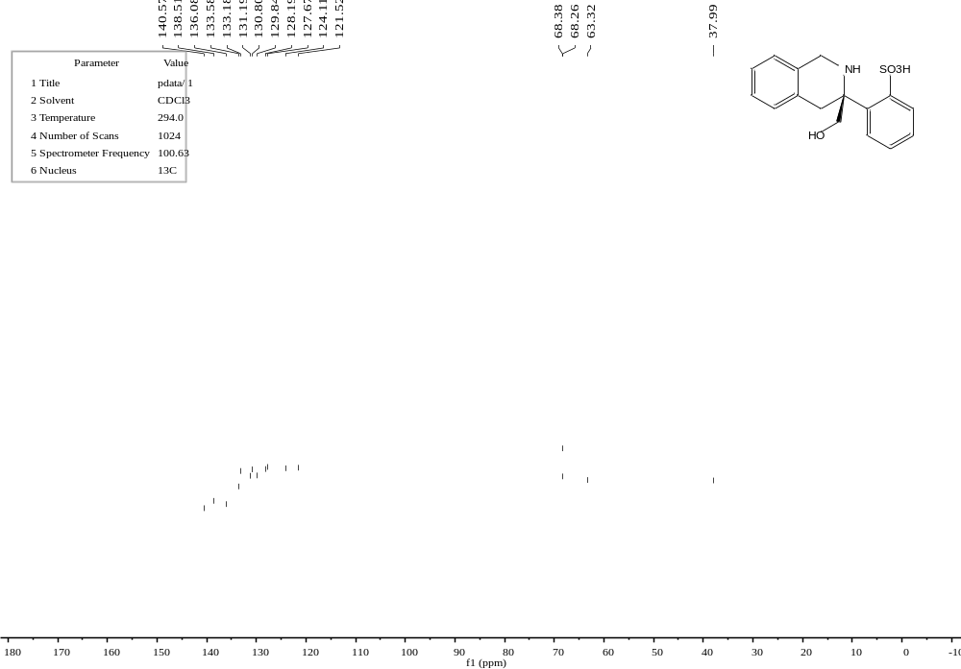
G1
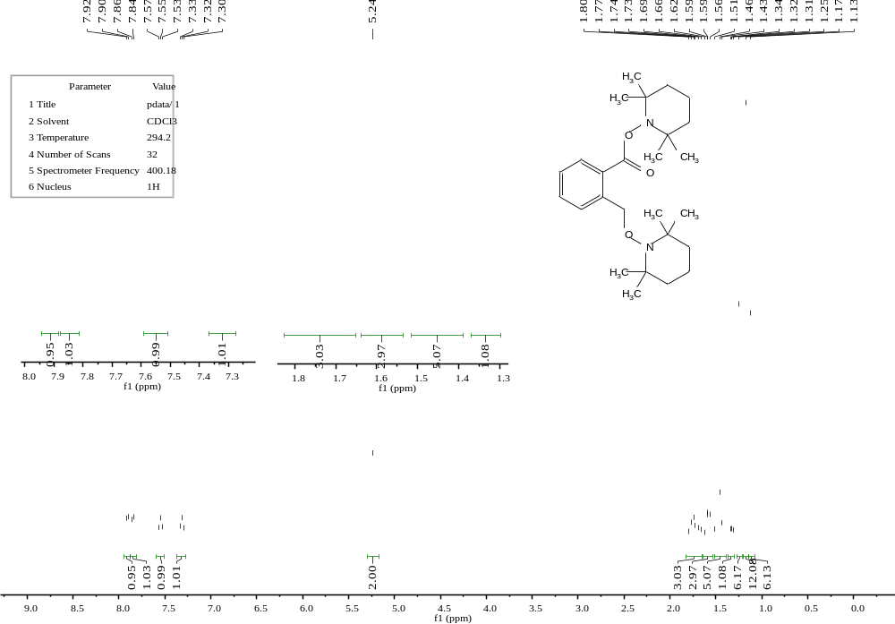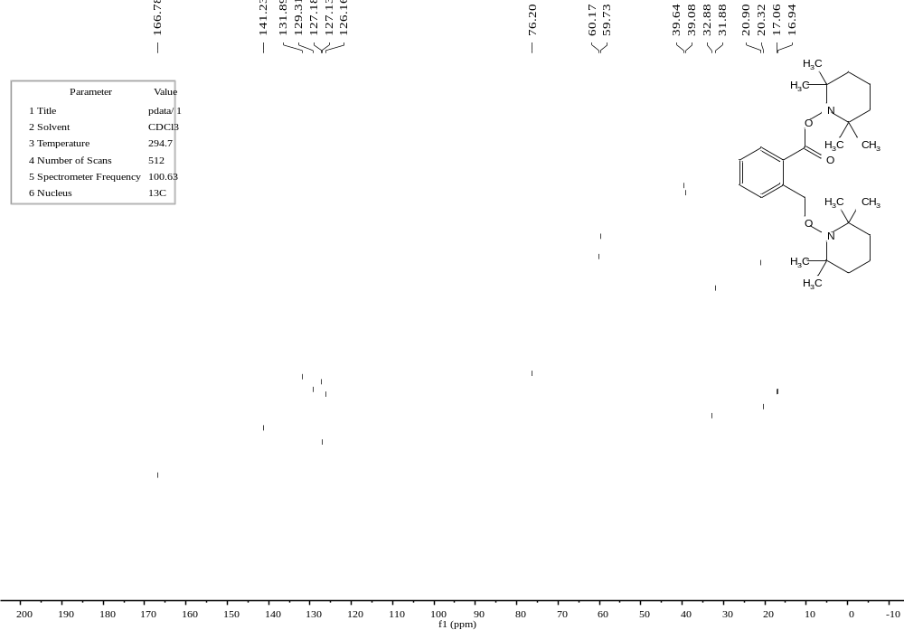

10. References
- Wen, Y. H., et al. Asymmetric cyanosilylation of aldehydes catalyzed by novel organo-catalysts. Synlett, 2445-2448 (2005).
- Yu, Z. P., Liu, X. H., Dong, Z. H., Xie, M. S. & Feng, X. M. An N,N′-dioxide/In(OTf)₃ catalyst for the asymmetric hetero-Diels–Alder reaction between Danishefsky's dienes and aldehydes: Application in the total synthesis of triketide. Angew. Chem. Int. Ed. 47, 1308-1311 (2008).
- Zhou, X., et al. Enantioselective three-component Kabachnik−Fields reaction catalyzed by chiral scandium(III)−N,N′-dioxide complexes. Org. Lett. 11, 1401-1404 (2009).
- Chen, P.-H., Sieber, J., Senanayake, C. H. & Dong, G. Rh-catalyzed reagent-free ring expansion of cyclobutenones and benzocyclobutenones. Chem. Sci. 6, 5440-5445 (2015).
- Zhang, H., et al. Discovery of amino-cyclobutarene-derived indoleamine-2,3-dioxygenase 1 (IDO1) inhibitors for cancer immunotherapy. ACS Medicinal Chemistry Letters 10, 1530-1536 (2019).
- Zhang, Y., Shen, S., Fang, H. & Xu, T. Total synthesis of galanthamine and lycoramine featuring an early-stage c–c and a late-stage dehydrogenation via c–h activation. Org. Lett. 22, 1244-1248 (2020).
- Yang, L. K., et al. Catalytic asymmetric photocycloaddition of triplet aldehydes with benzocyclobutenones. CCS Chem. (2024) accepted, doi: 10.31635/ccschem.024.202404257.
- Wang, H., Jiang, T. & Xu, M.-H. Simple branched sulfur–olefins as chiral ligands for Rh-catalyzed asymmetric arylation of cyclic ketimines: Highly enantioselective construction of tetrasubstituted carbon stereocenters. J. Am. Chem. Soc. 135, 971-974 (2013).
- Zhang, S., et al. Bifunctional amino sulfonohydrazide catalyzed direct asymmetric mannich reaction of cyclic ketimines with ketones: Highly diastereo- and enantioselective construction of quaternary carbon stereocenters. Org. Lett. 17, 1050-1053 (2015).
- Yan, Z., Wu, B., Gao, X., Chen, M.-W. & Zhou, Y.-G. Enantioselective synthesis of α-amino phosphonates via Pd-catalyzed asymmetric hydrogenation. Org. Lett. 18, 692-695 (2016).

