Extended data figures
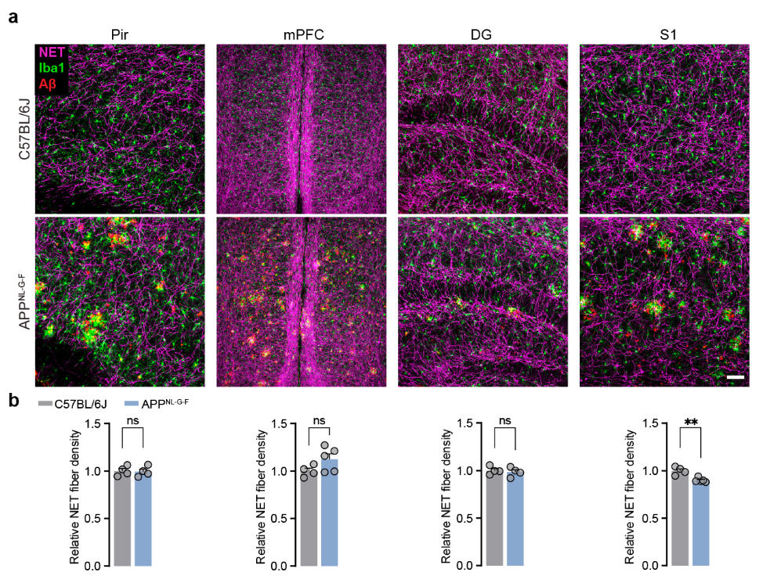
Extended Data Fig. 1: LC axon density in different brain regions
a, Immunostaining against LC axons (NET, magenta), microglia (Iba1, green) and Aβ plaques (A, red) in the piriform cortex (Pir), medial prefrontal cortex (mPFC), dentate gyrus of the hippocampus (DG) and in the somatosensory cortex (S1) of 6 months old C57BL/6J and APP^{NL-G-F} mice. Scale bar: 50 µm. b, Quantification of LC axon density per region; Data expressed as mean ± s.e.m.; ns, not significant; **p<0.01. Statistics shown in Supplementary Table 2.

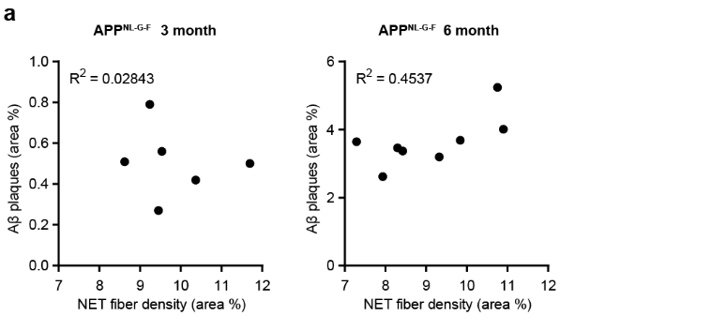
Extended Data Fig. 2: LC axon loss is independent of extracellular Aβ plaques
a, Correlation between NET fibre density and Aβ plaque load in the OB of APP^{NL-G-F} mice at 3 and 6 months of age; Data expressed as mean. Statistics shown in Supplementary Table 2
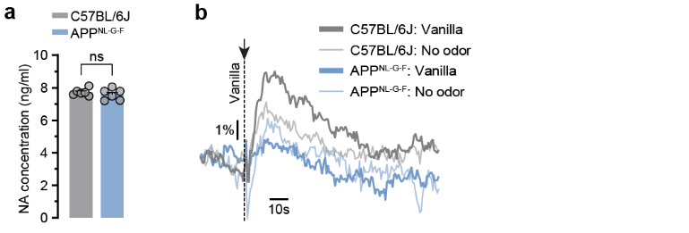
Extended Data Fig. 3: Noradrenaline measurements
a, Noradrenaline (NA) concentration in the olfactory bulb assessed by NA ELISA shows no difference between the groups in 3 months old animals. b, NA response to a vanilla air puff or a control air puff compared between C57BL/6J and APP^{NL-G-F} mice; Data expressed as mean ± s.e.m.; ns, not significant. Statistics shown in Supplementary Table 2.

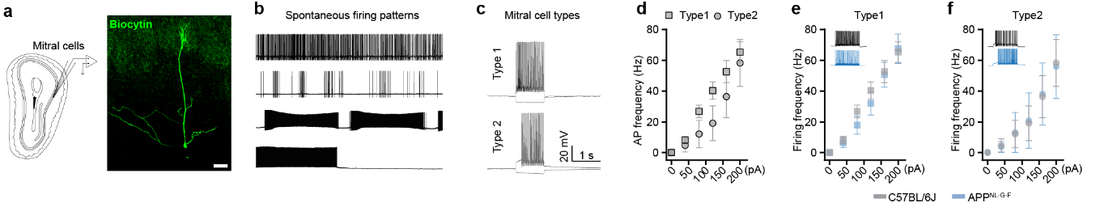
Extended Data Fig. 4: Electrophysiological properties of mitral cells in the olfactory bulb
a, Perforated patch-clamp recordings with subsequent biocytin-filling and post-hoc staining (green) visualizes a mitral cell in the OB. Scale bar: 20 µm. b, Diverse spontaneous firing patterns of mitral cells. c, Two different mitral cell cell-types were identified based on the cell’s response to current stimulations. d, Current-frequency curve comparing type 1 and type 2 mitral cells in C57BL/6J animals. e, Current-frequency curve of type 1 mitral cells and f, type 2 mitral cells in C57BL/6J and APP^{NL-G-F} mice; Data expressed as mean ± s.e.m.

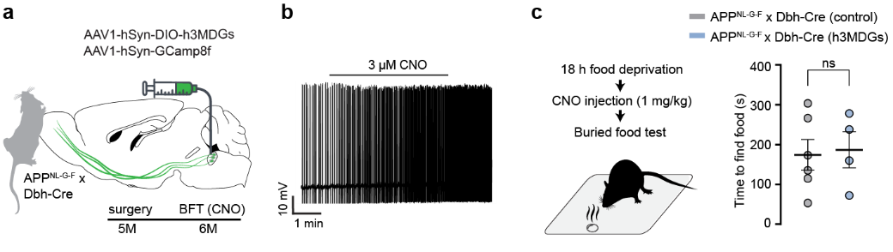
Extended Data Fig. 5: Chemogenetic over-activation of LC neurons cannot reinstate olfaction
a, Experimental setup of DREADD-virus injection into the LC of APP^{NL-G-F} x Dbh-Cre mice at 5 months of age. b, Electrophysiological recording of the spontaneous action potential firing of an LC neuron. Bath application of CNO increases the spontaneous firing frequency. c, Buried foot test after CNO injection showed no change in the time to find a buried food pellet; Data expressed as mean ± s.e.m.; ns, not significant; Statistics shown in Supplementary Table 2.

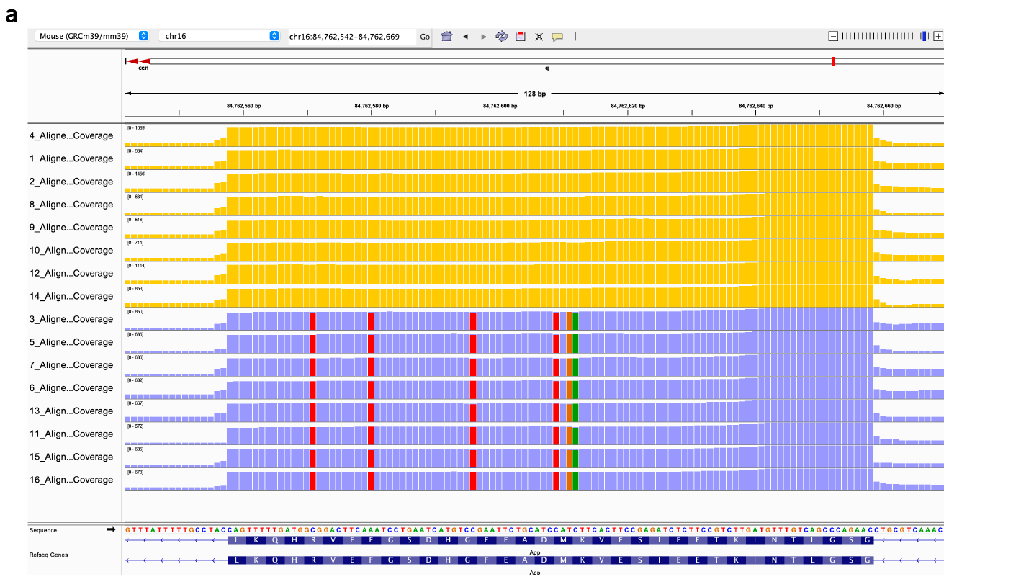
Extended Data Fig. 6: RNA sequencing control
a, IGV browser screenshot showing RNA-Seq alignments to the APP gene (GRCm39) and confirming the APP^{NL-G-F} transgene presence in transgene animals (blue bars) compared to C57BL/6J animals (yellow bars). Red bars in the sequence demonstrate C->T or A->T mutations, while ochre bars indicate T->C and green bars C->A mutations.
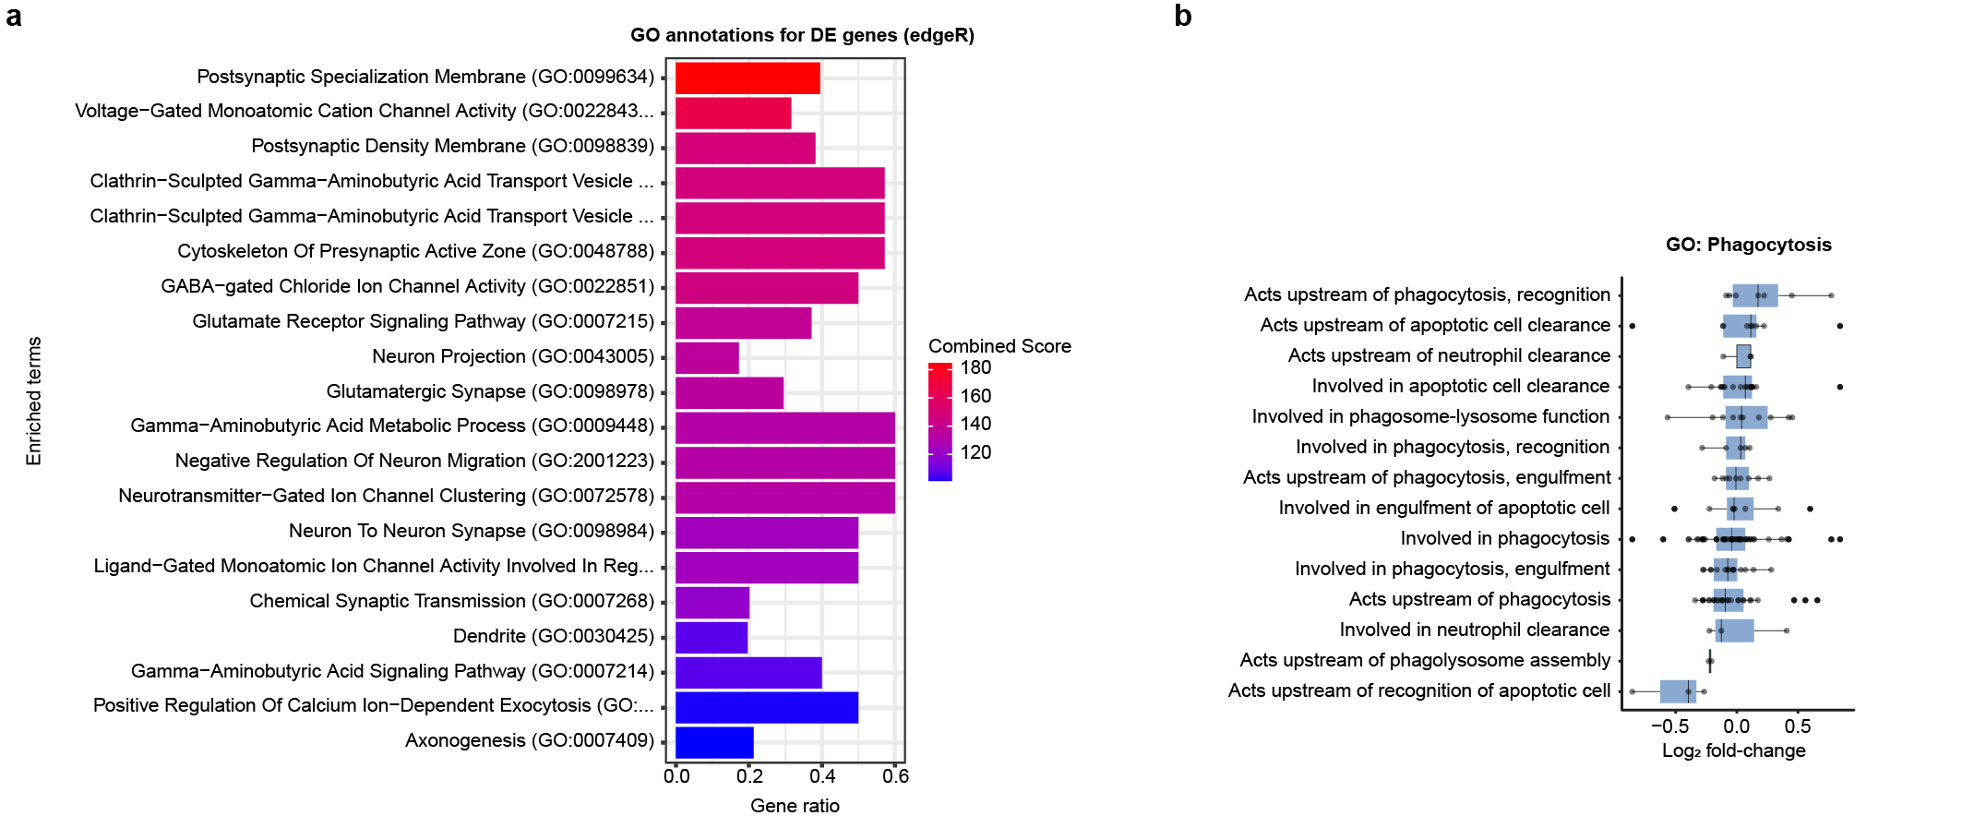
Extended Data Fig. 7: Gene ontology annotations
a, 20 most enriched gene ontology (GO) annotations for differentially upregulated genes. b, GO enrichment analysis of genes involved in phagocytosis. Source data can be found in Extended Data Table 1.

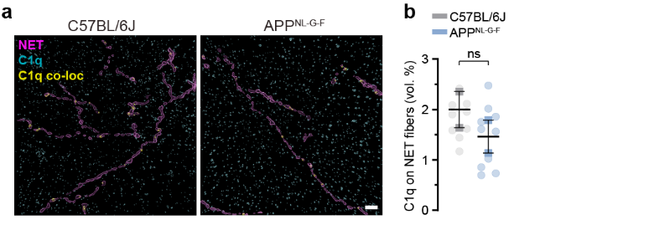
Extended Data Fig. 8: C1q does not serve as “eat-me” signal on LC axons
a, 3D reconstruction of LC axons (NET, magenta), C1q (cyan) and C1q signals colocalised to LC axons (yellow). Scale bar: 5 µm. b, Quantification of C1q signal colocalised to LC axons; Data expressed as mean ± s.e.m.; ns, not significant. Statistics shown in Supplementary Table 2.

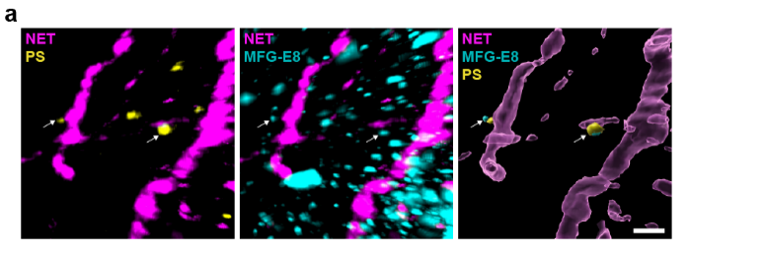
Extended Data Fig. 9: LC axons are tagged with phosphatidylserine (PS) and MFG-E8
a, Immunostaining and 3D reconstruction of PS (yellow) and MFG-E8 (cyan), colocalised to LC axons (NET, magenta). Scale bar: 2 µm.

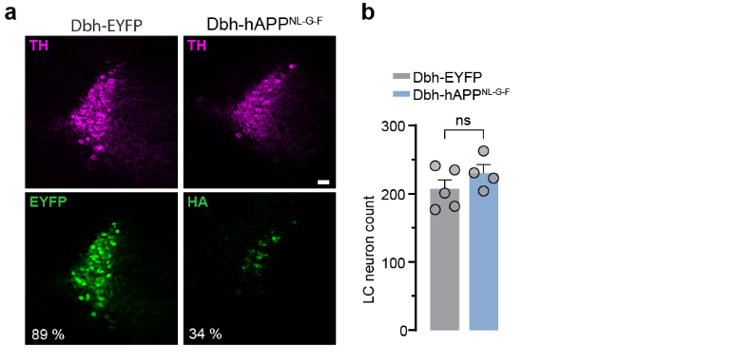
Extended Data Fig. 10: Expression of APP^{NL-G-F} virus in the LC
a, Immunostaining of LC neurons (TH, magenta) and the respective fluorophore expression of each virus (Dbh-EYFP: EYFP and Dbh-hAPP^{NL-G-F}: HA-tag). Scale bar: 50 µm b, Neuron count shows no difference in LC neuron number; Data expressed as mean ± s.e.m.; ns, not significant. Statistics shown in Supplementary Table 2.

