Degradation of enrofloxacin by Fe⁰ activated PDS
Yaru Zhang Zhenguo Li Wenlong Bi* Bo Sun Huanhuan Pei Junmei Qin Liu Fenwu

College of Resources and Environment, Shanxi Agricultural University, Taigu 030801, PR China

*Corresponding author. E-mail: jiayangbihu@126.com

Supplementary Material

- The standard curve for enrofloxacin
Figure S1 The standard curve for enrofloxacin
- Before and after pH of ENR degradation in different systems
Table S1 The pH before and after the degradation of ENR with Fe⁰/PS under optimal
conditions ([ENR] =20 μmol/L, [Fe⁰] = 0.15 g/L, [PS] =0.4 mM).
Condition | Fe⁰ | PS | Fe⁰/PS
Before | 6.35 | 6.35 | 6.35
After | 6.66±0.02 | 6.11±0.01 | 5.84±0.02
- EPR Detection Mapping
Figure S2 EPR Detection Mapping
([ENR] =20 μmol/L, [Fe⁰] = 0.15 g/L).
- Ultraviolet spectrum of ENR degraded at different time points in Fe⁰/PS system
Figure S3 Ultraviolet spectrum of ENR degraded at different time points in Fe⁰/PS system
([ENR] =20 μmol/L, [Fe⁰] = 0.15 g/L, [PS] =0.4 mM).
- Table S2 The pH before and after free radical contribution in Fe⁰/PS system
([ENR] =20 μmol/L, [Fe⁰] = 0.15 g/L, [PS] =0.4 mM).
Condition | MeOH | TBA | Control
Before | 6.35 | 6.35 | 6.35
After | 5.93 | 5.77 | 5.88
6. pH in the degradation of ENR in Fe⁰/PS system
Figure S4. pH in the degradation of ENR in the FeS₂/PS system with time
([ENR] =20 μmol/L, [Fe⁰] = 0.15 g/L, [PS] =0.4 mM).
- Changes in iron ion concentration during ENR removal by Fe⁰/PDS system
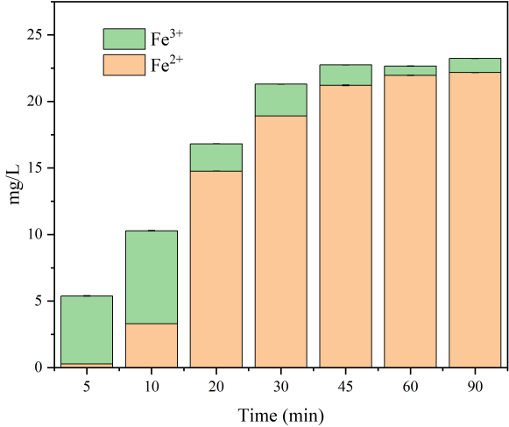
Figure S5. Variation of Fe²⁺ and Fe³⁺ concentration in the Fe⁰/PDS system ([ENR]=20 μmol/L, [Fe⁰]=0.15 g/L, [PDS]=0.4 mmol/L)

TOC change after reaction

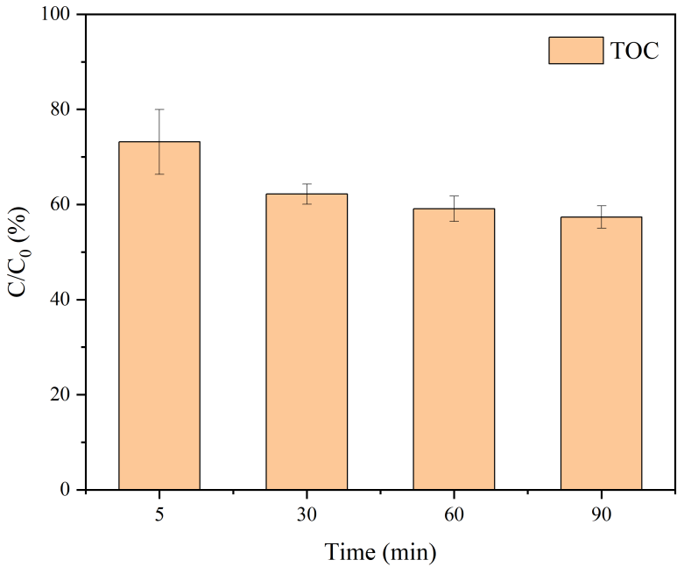
Figure S6. Determination of TOC after ENR degradation in Fe⁰/PDS system ([ENR]=20 μmol/L, [Fe⁰]=0.15 g/L, [PDS]=0.4 mmol/L)

- The pH before and after the degradation of ENR by Fe⁰/PS system under different pH conditions
Table S3 The pH before and after the degradation of ENR by Fe⁰/PS system under different pH conditions ([ENR] =20 μmol/L, [Fe⁰] = 0.15 g/L, [PS] =0.4 mM)
Condition | pH = 2 | pH = 4 | pH = 6 | pH = 8 | pH = 10 | Control
Before | 1.98 | 4.00 | 5.98 | 7.98 | 10.01 | 6.35
After | 2.38 | 5.95 | 6.24 | 6.01 | 6.08 | 5.88
- The pH before and after the reaction of different anions
Table S4 After adding different concentrations of Cl–, HCO₃–, NO₃–, the Fe⁰/PS system degrades the pH before and after the methyl orange reaction ([ENR] =20 μmol/L, [Fe⁰] = 0.15 g/L, [PS] =0.4 mM)
Anion/ENR | Cl– |  | HCO₃– |  | NO₃–
Reaction | Before | After | Before | After | Before | After
0 | 6.35 | 5.88 | 6.35 | 5.88 | 6.35 | 5.88
0.1 | 6.30 | 6.16 | 6.53 | 5.66 | 6.54 | 5.55
1 | 6.18 | 6.02 | 6.74 | 5.72 | 7.05 | 5.53
10 | 6.08 | 5.99 | 7.78 | 5.55 | 7.11 | 5.50
100 | 6.05 | 5.92 | 7.98 | 7.71 | 7.45 | 5.60
- Basic physical and chemical properties of different water substrates
Table S5 Physical and chemical properties of different water substrates.
Physicochemical property | Tap water | River water
Water temperature | 20.3ºC | 21.6ºC
pH | 7.90 | 8.02
Electrical conductivity | 535 μS/cm | 655 μS/cm
TOC | 11.12 mg/L | 18.65 mg/L
Na⁺ | 4.02 mg/L | 7.69 mg/L
K⁺ | 0.11 mg/L | 1.021 mg/L
Ca²⁺ | 24.16 mg/L | 15.09 mg/L
Mg²⁺ | 80.15 mg/L | 60.25 mg/L
Cl– | 59.32 mg/L | 23.45 mg/L
HCO₃– | 265.16 mg/L | 254.63 mg/L
Note: The river water was taken from the Wuma River, Taigu, Jinzhong City, Shanxi Province on April 25, 2024 ( 37°27′11′′N, 112°33′18′′E )

