Supplementary information
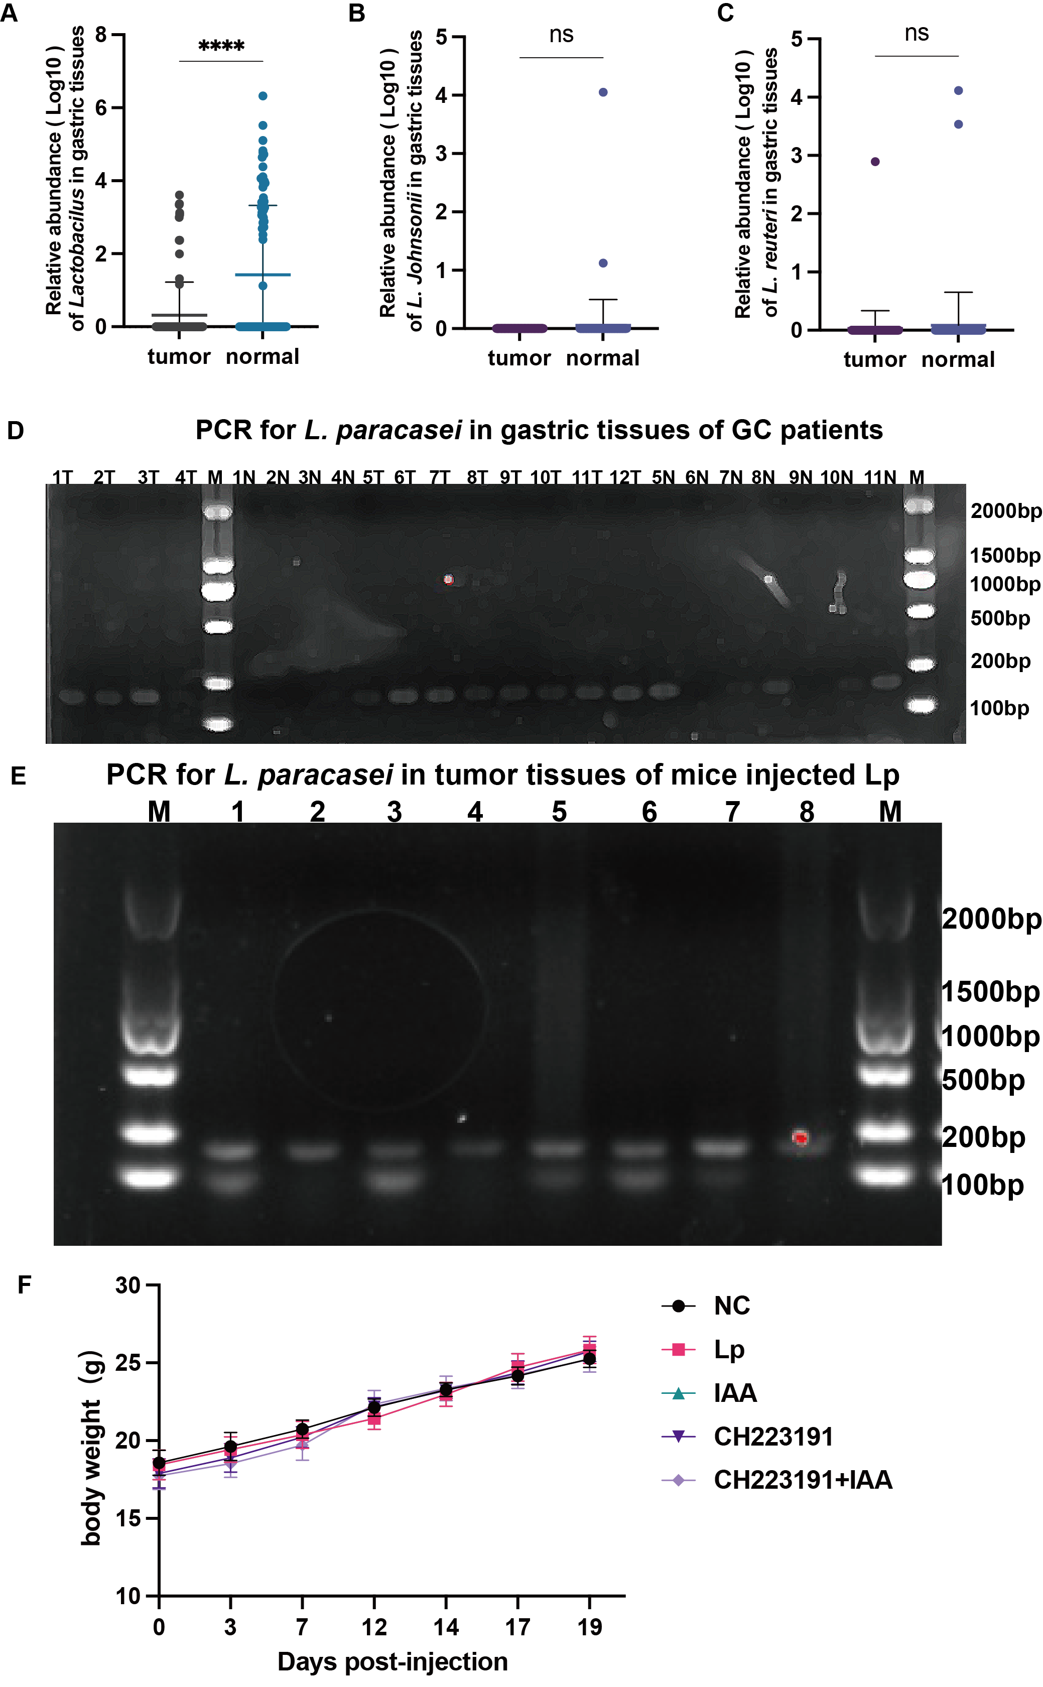
Supplementary Figure1
(A-C) The relative abundance of (A) Lactobacillus (B) L. johnsonii (C) L. reuteri in tumor tissues and normal tissues of GC patients. ns p≧0.05, *p < 0.05, ** p < 0.01, ***p < 0.001, **** p < 0.0001.
- PCR was used to determined the colonization of L. paracasei in both tumor or normal tissues of GC patients.
- PCR was used to determined the colonization of L. paracasei in tumor tissues of HGC27 xenograft.
- The body weight curve of HGC27 xenograft injected with PBS, Lp, IAA, CH223191 and CH223191+IAA.

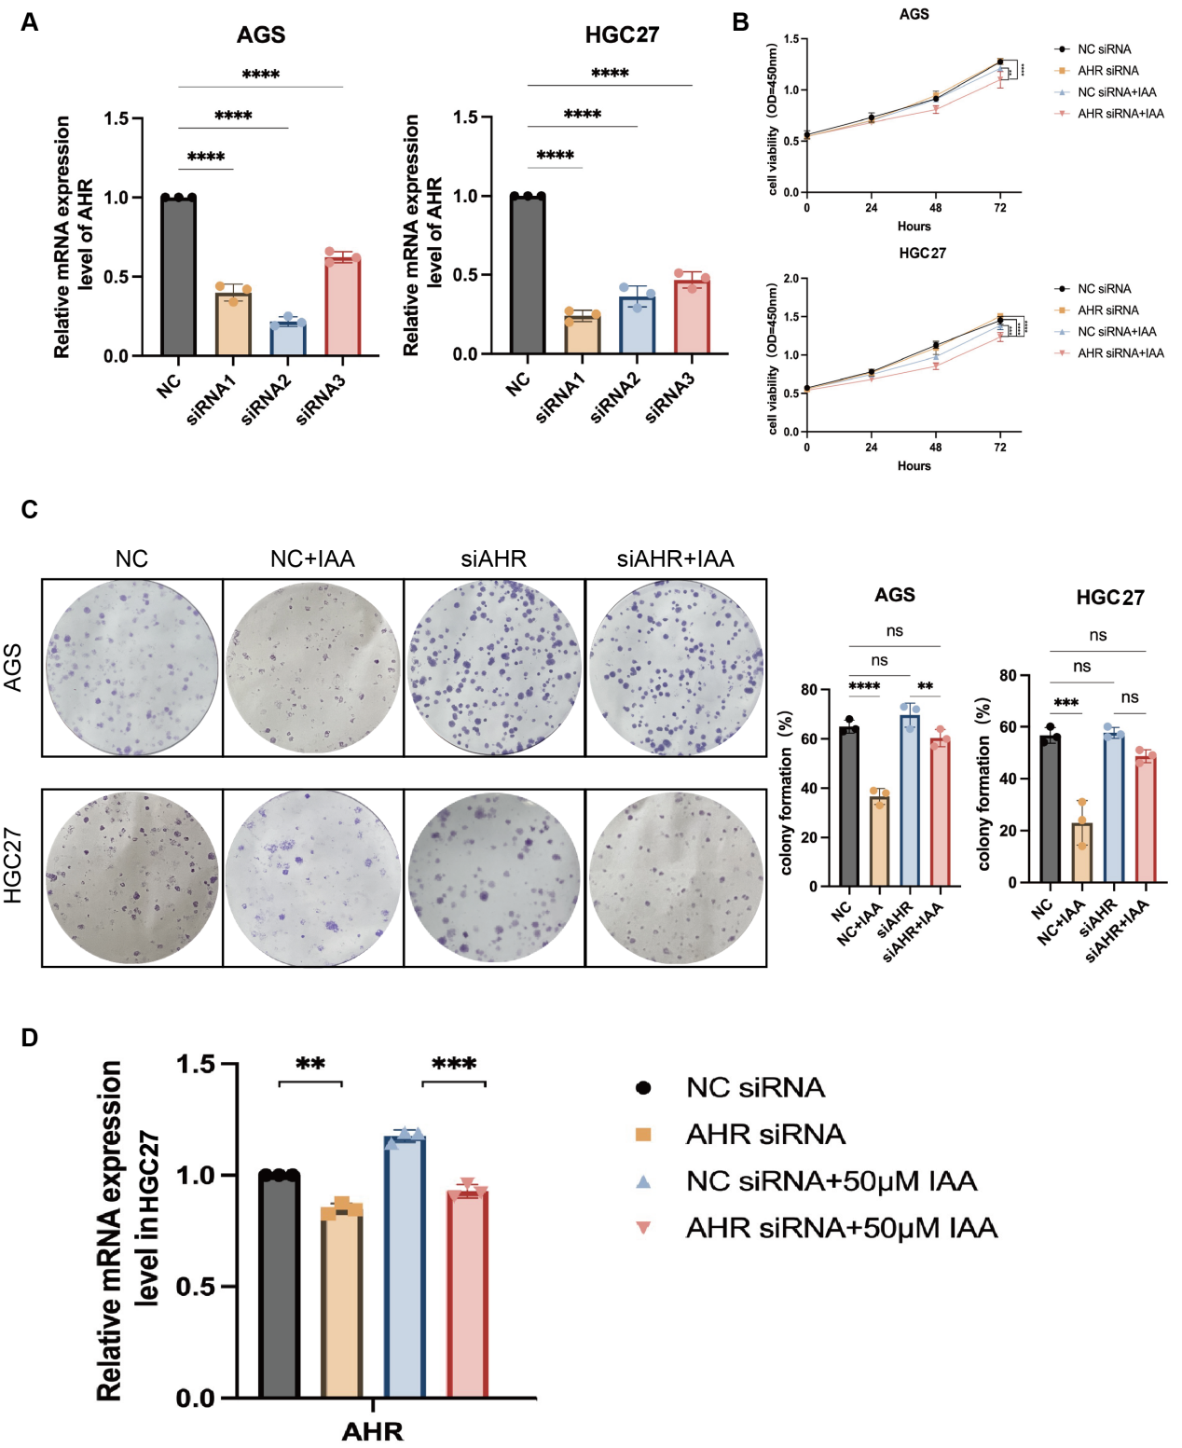
Supplementary Figure2
- The knockdown effect of AHR of human GC cells through qPCR.
(B, C) (B)Cell viability at OD450nm (C) colony formation of human GC cells with PBS, IAA, siAHR and siAHR+IAA.
(D)The mRNA level of AHR and CYP1A1 of HGC27 with siAHR and IAA.

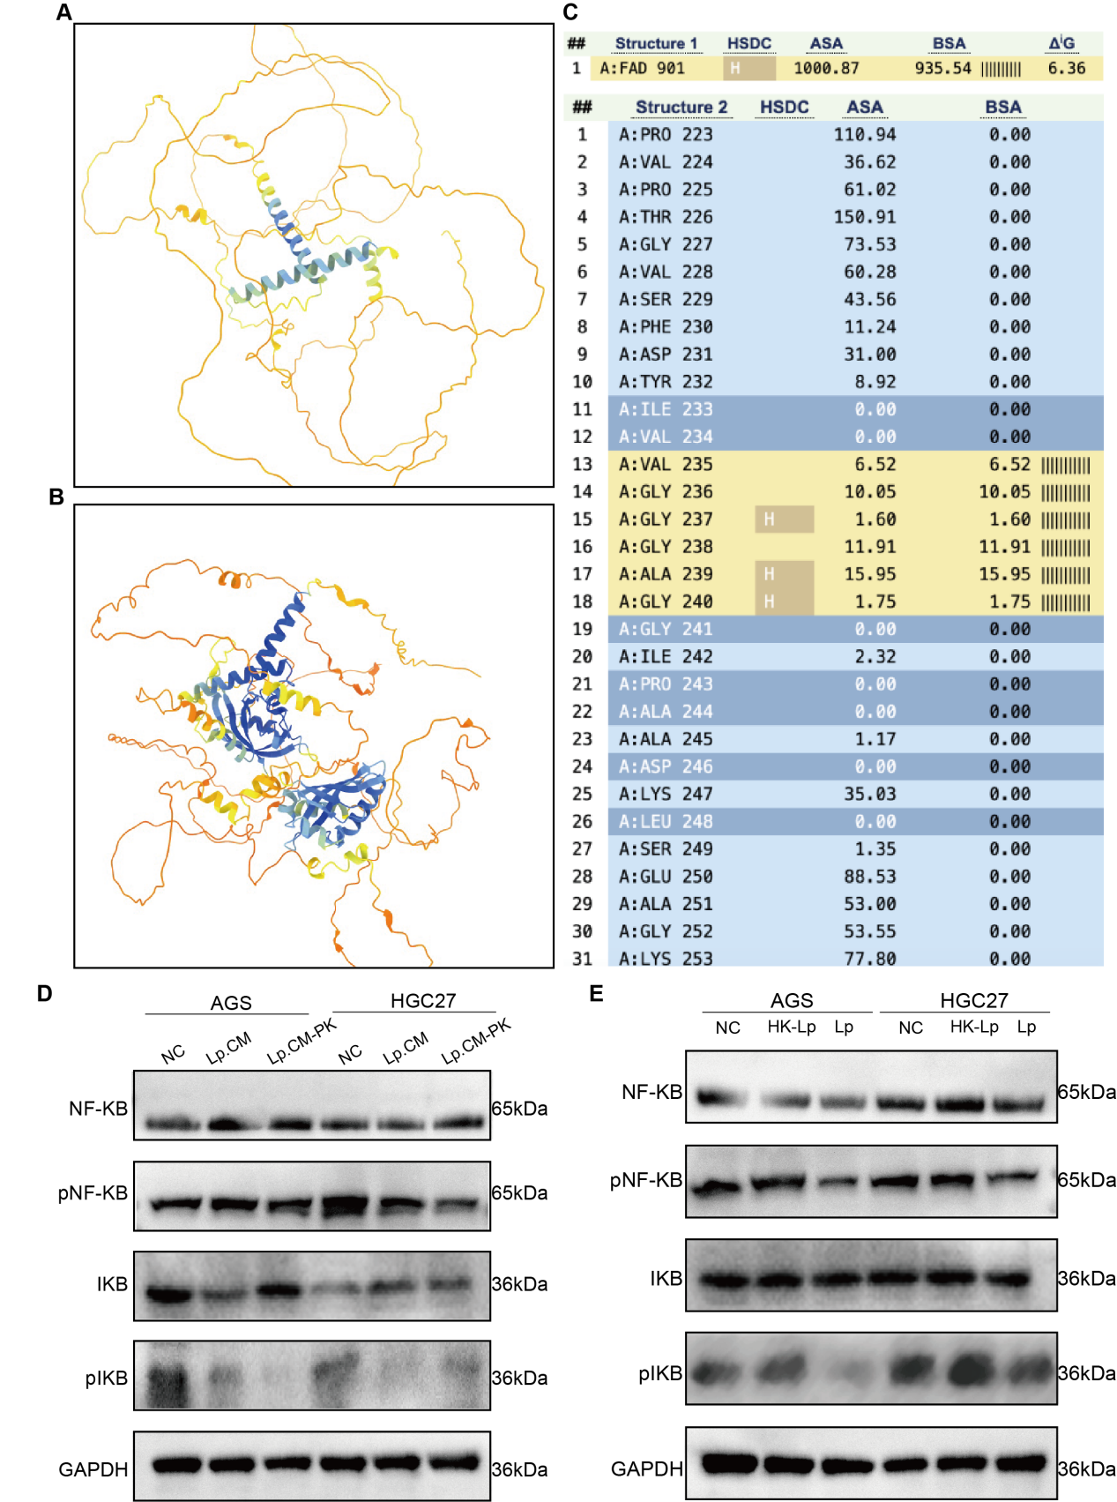
Supplementary Figure3
(A, B) The 3D structure of (A)MTDH and (B)AHR using ChimeraX.
(C) The receptor protein is located above, and the ligand protein is located below. Each row contains an amino acid residue, with the yellow region indicating the predicted binding region. HSDC is predicted for hydrogen bonding, BSA is the area of interaction encapsulation, and the more vertical lines there are, the higher the degree of encapsulation, indicating a tighter interaction.
Table 1 The proteins binding to AHR by COIP
