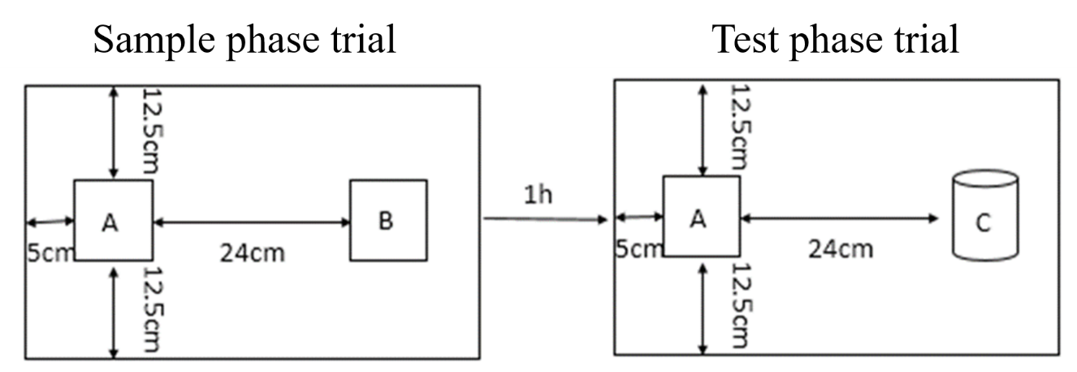
Supplemental Figure 1. Object recognition test (ORT) design

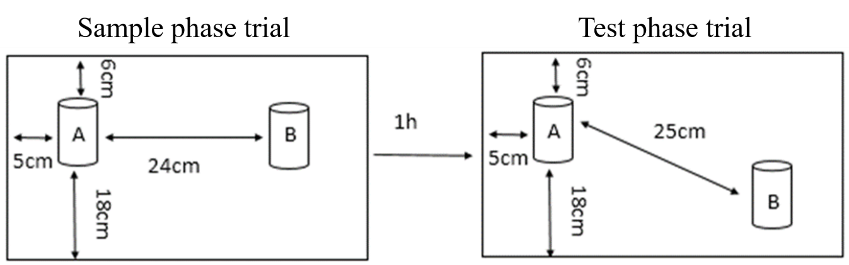
Supplemental Figure 2. Object location test (OLT) design

Supplemental Table 1. The daily milk consumption in pasteurized and high-temperature sterilized buffalo milk group
Groups (n=10) | Average (ml) | Standard error | Maximum value | Minimum value | CV (%)
Pasteurized buffalo milk | 11.50 | 0.04 | 13.82 | 8.91 | 12
High temperature sterilized buffalo milk | 11.59 | 0.03 | 14.09 | 9.00 | 12

