Product | Lactic Acid Bacteria (LAB)
Cheese (Mesophilic starter) | Lc. lactis. Lactis, Lc. lactis spp. cremoris, Lc. lactis spp. lactis var. diacetylactis
Cheese (Thermophilic starter) | Streptococcus thermoplillus, Lb. delbrueckii spp. bulgaricus, Lb. helveticus, Lb. delbrueckii spp. lactis
Cheese (Mixed starter) | Lc. lactis spp. lactis, Lc. lactis spp. cremoris, S. thermoplillus
Yogurt | Lb. delbrueckii spp. bulgaricus, S. thermophiles
Fermented milks | Lb. delbrueckii spp. bulgaricus, S. thermophilus Lb. casei, Lb. acidophilus, Lb. rhamnosus, Lb. johnsonii
Yakult | Lb. casei spp. casei
Acidophilus milk | Lb. acidophilus
Butter and buttermilk | Lc. lactis spp. lactis, Lc. lactis spp. lactis var. diacetylactis, Lc. lactis spp. cremoris, Leuc. menesteroides spp. cremoris
Kefir | Lb. kefir, Lb. kefiranofacies, Lb. brevis, Lb. plantarum, Lb. paracasei spp. paracasei, Lc. lactis spp. lactis, Leuc. mesenteroides
Cabbage (Sauerkraut) | Leuc. mesenteroides, Lb. plantarum, Lb. brevis, Lb. fermentum
Cucumber | Lb. brevis, Lb. plantarum, Lb. pentosus, Lb. acidophilus, Lb. fermentum, Leuc. mesenteroides
Olives | Lb. brevis, Lb. plantarum, Lb. pentosus
Supplementary Table 1. Common source of lactic acid bacteria

Supplementary Table 2. Identification and biochemical characterization of bacterial isolates from various food matrices
SI.No | Isolate | Gram’s staining | Catalase test | Homofermentative/ Heterofermentative | Lactic acid concentration (g/L)
 | Source: Milk
 | DFRM1 | +(ve) | -(ve) | Homofermentative | 7.2
 | DFRM2 | +(ve) | -(ve) | Homofermentative | 8.1
 | DFRM4 | +(ve) | -(ve) | Homofermentative | 6.3
 | DFRM8 | +(ve) | -(ve) | Homofermentative | 12.6
 | DFRM9 | +(ve) | -(ve) | Homofermentative | 10.8
 | DFRCMK1 | +(ve | -(ve) | Homofermentative | 3.6
 | DFRCMK2 | +(ve) | -(ve) | Homofermentative | 4.5
 | DFRMN1 | +(ve) | -(ve) | Homofermentative | 6.3
 | DFRMN2 | +(ve) | -(ve) | Homofermentative | 6.3
 | DFRMN3 | +(ve) | -(ve) | Heterofermentative | 3.6
 | Source: Fermented milk
 | DFRFM1 | +(ve) | -(ve) | Homofermentative | 8.1
 | DFRFM2 | +(ve) | -(ve) | Heterofermentative | 7.2
 | DFRFM3 | +(ve) | -(ve) | Homofermentative | 6.3
 | DFRFM4 | +(ve) | -(ve) | Homofermentative | 6.3
 | DFRFM5 | +(ve) | -(ve) | Homofermentative | 3.6
 | DFRFM8 | +(ve) | -(ve) | Homofermentative | 9.8
 | DFRFM9 | +(ve) | -(ve) | Homofermentative | 9.0
 | Source: Homemade curd
 | DFRC1 | +(ve) | -(ve) | Homofermentative | 8.1
 | DFRC2 | +(ve) | -(ve) | Heterofermentative | 7.2
 | DFRC3 | +(ve) | -(ve) | Homofermentative | 7.2
 | DFRC4 | +(ve) | -(ve) | Homofermentative | 4.5
 | DFRC6 | +(ve) | -(ve) | Homofermentative | 5.4
 | DFRC8 | +(ve) | -(ve) | Homofermentative | 3.6
 | DFRC11 | +(ve) | -(ve) | Heterofermentative | 4.5
 | Source: Commercially available curd
 | DFRCM2 | +(ve) | -(ve) | Heterofermentative | 7.2
 | DFRCM1 | +(ve) | -(ve) | Homofermentative | 8.1
 | DFRCM3 | +(ve) | -(ve) | Homofermentative | 7.2
 | DFRCM4 | +(ve) | -(ve) | Homofermentative | 5.4
 | DFRCM6 | +(ve) | -(ve) | Homofermentative | 3.6
 | Source: Commercially available yoghurt
 | DFRMY4 | +(ve) | -(ve) | Homofermentative | 9.0
 | DFRMY1 | +(ve) | -(ve) | Heterofermentative | 7.2
 | DFRMY2 | +(ve) | -(ve) | Homofermentative | 7.2
 | DFRMY3 | +(ve) | -(ve) | Homofermentative | 4.5
 | DFRMY4 | +(ve) | -(ve) | Homofermentative | 5.4
 | DFRMY5 | +(ve) | -(ve) | Homofermentative | 3.6
 | Source: Dairy waste
 | DFRMW1 | +(ve) | -(ve) | Homofermentative | 5.4
 | DFRMW2 | +(ve) | -(ve) | Homofermentative | 5.4
 | Source: Fruit waste
 | DFRL1 | +(ve) | -(ve) | Homofermentative | 8.1
 | DFRL2 | +(ve) | -(ve) | Heterofermentative | 7.2
 | DFRL3 | +(ve) | -(ve) | Homofermentative | 7.2
 | Source: Appam batter
 | DFRA3 | +(ve) | -(ve) | Homofermentative | 6.3
 | DFRA4 | +(ve) | -(ve) | Heterofermentative | 6.3
 | DFRA9 | +(ve) | -(ve) | Homofermentative | 9.9
 | DFRA3 | +(ve) | -(ve) | Homofermentative | 6.3
 | DFRA4 | +(ve) | -(ve) | Heterofermentative | 6.3
 | Source: Rava dosa batter
 | DFRRD1 | +(ve) | -(ve) | Homofermentative | 7.2
 | DFRRD2 | +(ve) | -(ve) | Homofermentative | 7.2
 | DFRRD3 | +(ve) | -(ve) | Homofermentative | 8.1
 | DFRRD4 | +(ve) | -(ve) | Homofermentative | 9.9
 | DFRRD11 | +(ve) | -(ve) | Homofermentative | 9.0
 | Source: Idly batter
 | DFRI1 | +(ve) | -(ve) | Homofermentative | 7.2
 | DFRI2 | +(ve) | -(ve) | Homofermentative | 8.1
 | DFRI3 | +(ve) | -(ve) | Heterofermentative | 6.3
 | DFRI4 | +(ve) | -(ve) | Homofermentative | 12.6
 | DFRI5 | +(ve) | -(ve) | Homofermentative | 10.8
 | DFRI6 | +(ve) | -(ve) | Homofermentative | 8.1
 | Source: Dosa batter
 | DFRD1 | +(ve) | -(ve) | Homofermentative | 7.2
 | DFRD2 | +(ve) | -(ve) | Homofermentative | 7.2
 | DFRD3 | +(ve) | -(ve) | Homofermentative | 8.1
 | DFRD4 | +(ve) | -(ve) | Homofermentative | 9.9
 | DFRD11 | +(ve) | -(ve) | Homofermentative | 9.0

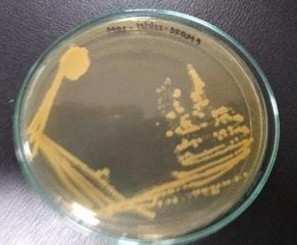
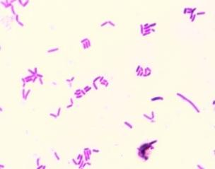

Supplementary Figure 1. Colony morphology on MRS agar and microscopic view of Limosilactobacillus fermentum DFRM9

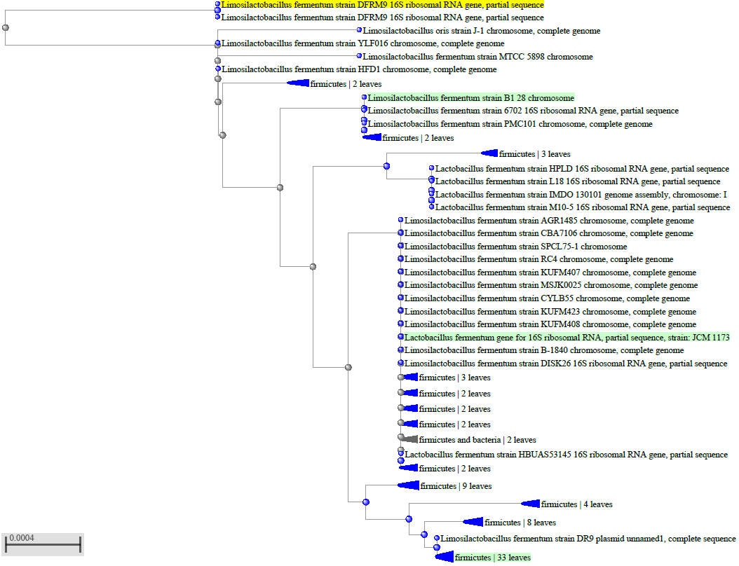

Supplementary Figure 2. Phylogenetic tree of the LAB isolate Limosilactobacillus fermentum DFRM9 along with reference sequences available in NCBI.

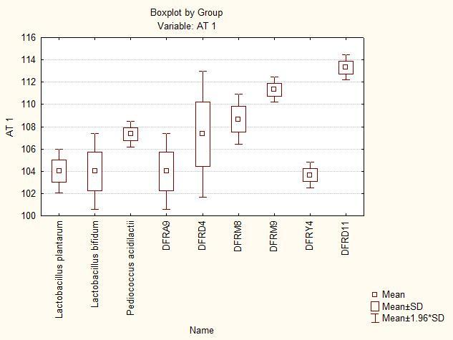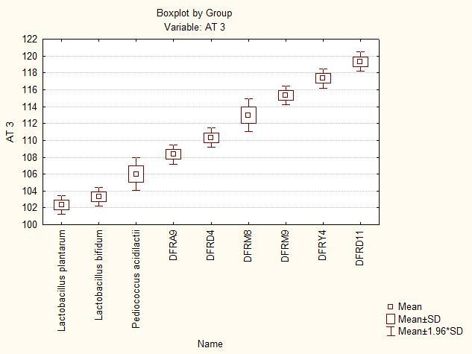
(B)
(A)

Supplementary Figure 3. Box and whisker plots for comparison of acid tolerance among selected isolates at 0th (A) and 3rd (B) hour of incubation at 37ºC

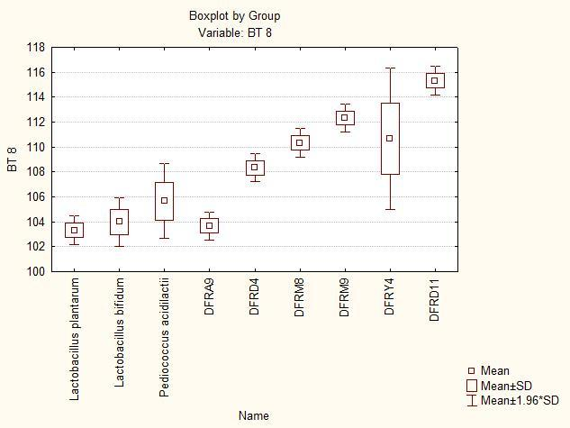

Supplementary Figure 4. Box and whisker plots for comparison of bile tolerance among selected isolates

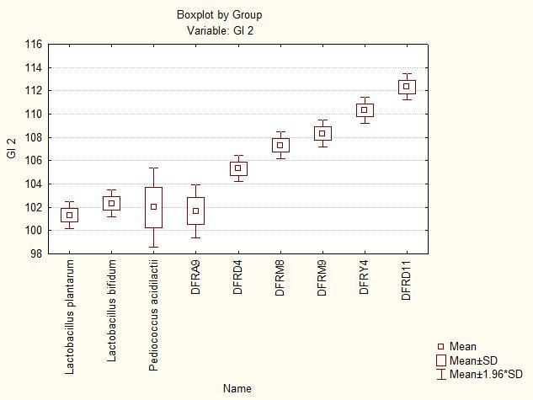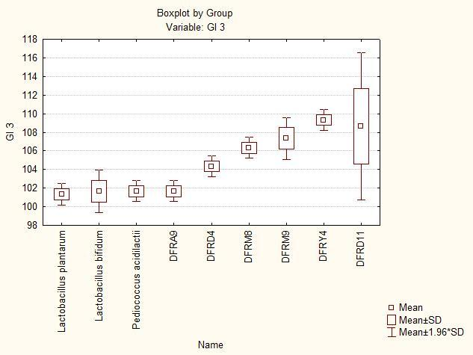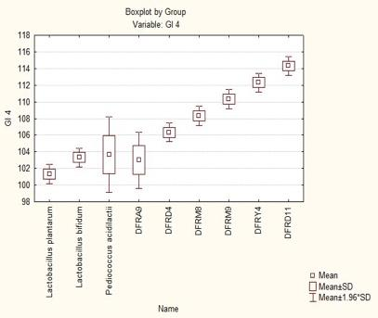
(C)
(B)
(A)

Supplementary Figure 5. Box and whisker plots for comparison of gastrointestinal tract tolerance among
selected isolates at pH 2.0 (A), pH 3.0 (B) and pH 4.0 (C)

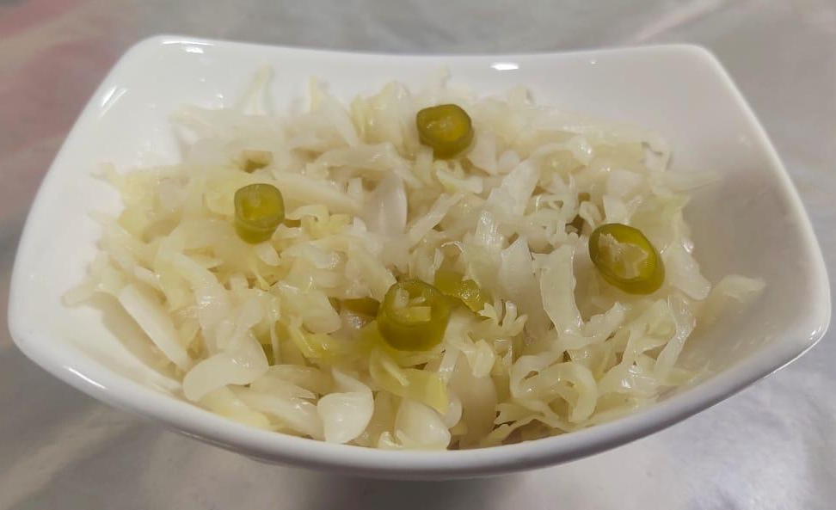

Supplementary Figure 6. Sauerkraut prepared using LAB isolate Limosilactobacillus fermentum DFRM9

