Supplementary Information

A “shuttle-relay” lithium metal battery enabled by heteroatom-based gel polymer electrolyte

Supplementary Figures
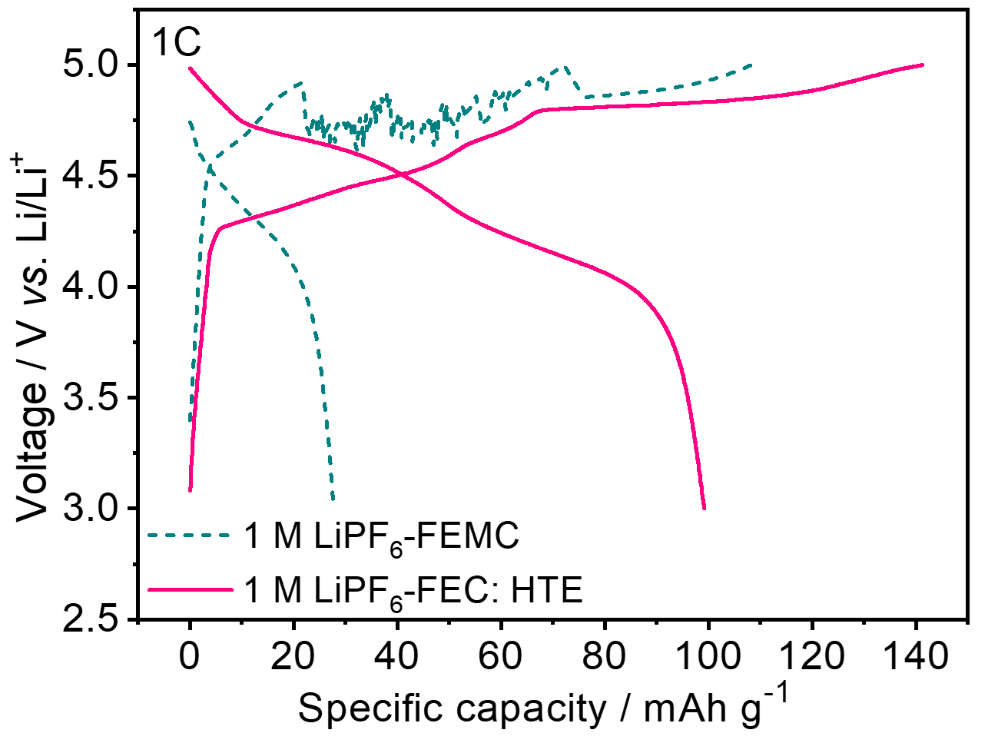
Supplementary Fig. 1 The charge-discharge voltage profiles of a Li||KS6 graphite cell using different electrolytes at 2nd cycle.

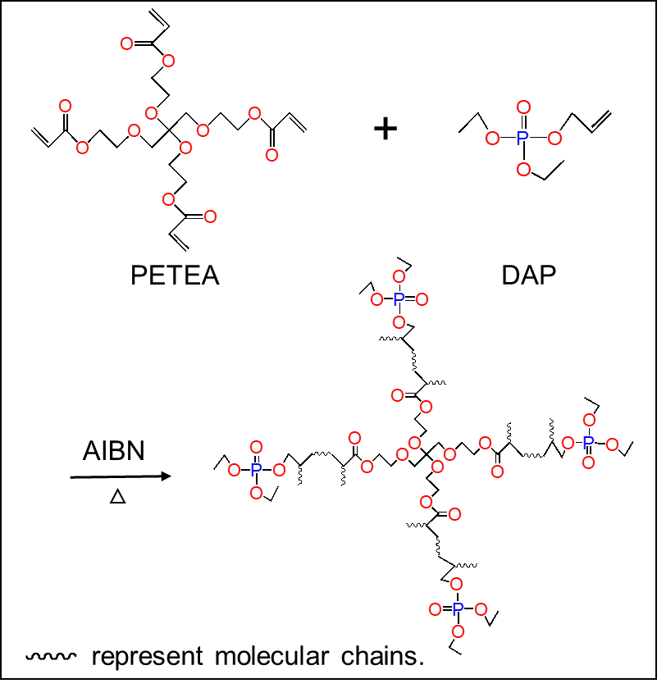
Supplementary Fig. 2. In-situ co-polymerization mechanism of DAP and PETEA monomers in liquid electrolyte.

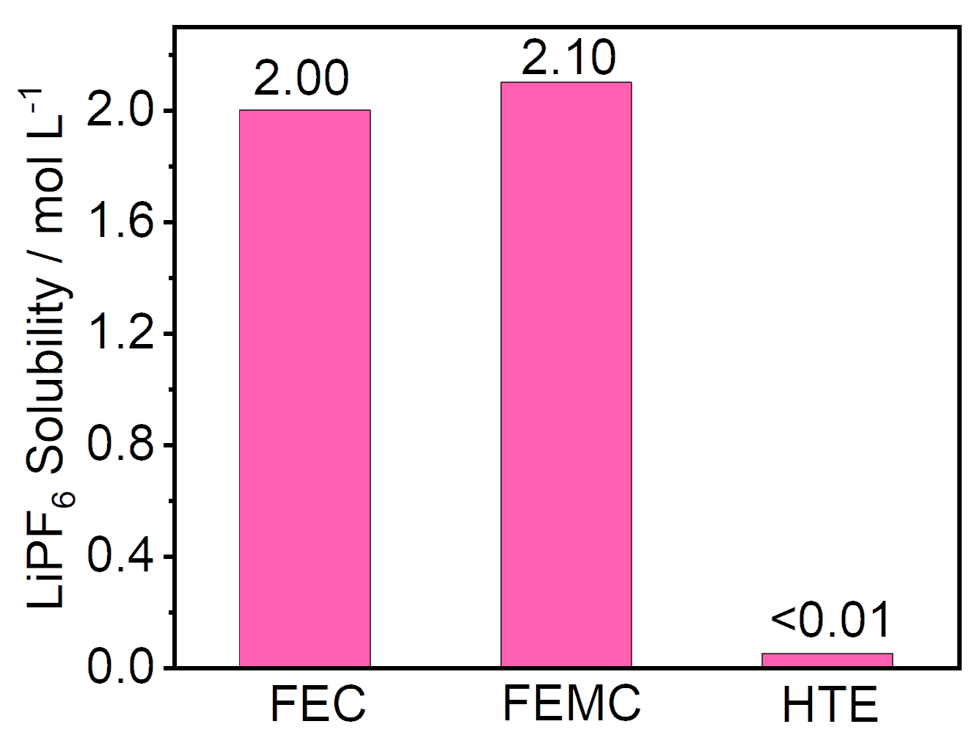
Supplementary Fig. 3 The room temperature (25 ºC) solubility of LiPF₆ in FEC, FEMC and HTE solvents.

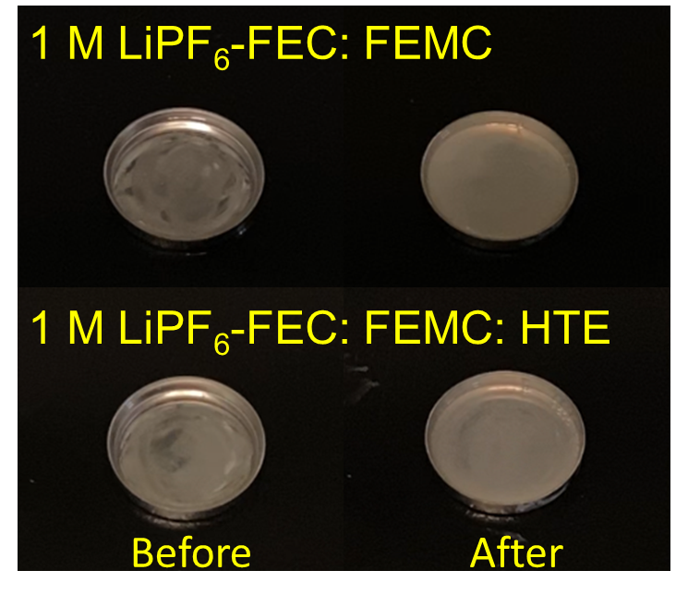
Supplementary Fig. 4 Combustion tests of 1 M LiPF₆- FEC: FEMC (upper panels) and 1 M LiPF₆- FEC: FEMC: HTE (lower panels) electrolytes. The mass of each sample is set as 1 g.
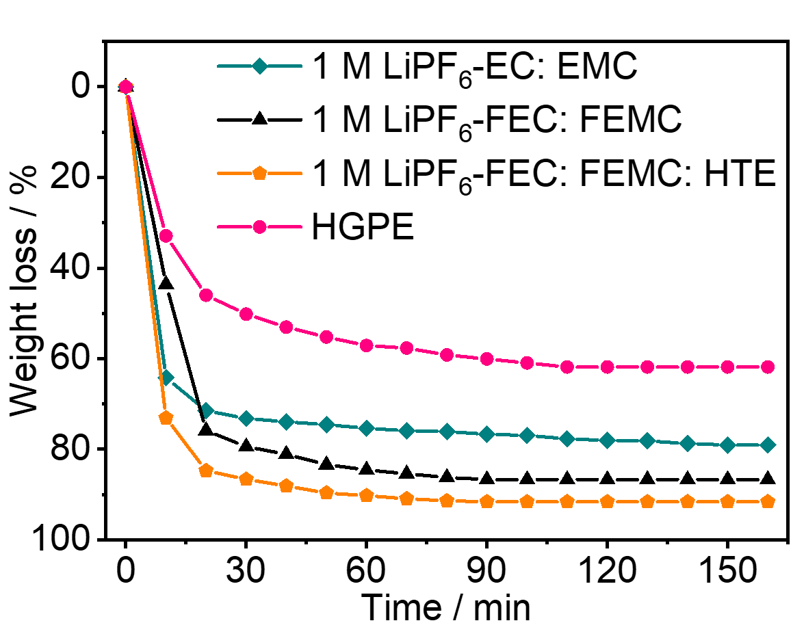
Supplementary Fig. 5 Weight losses of the four electrolyte samples with aging time at 60 ºC (Supplementary Note 3).

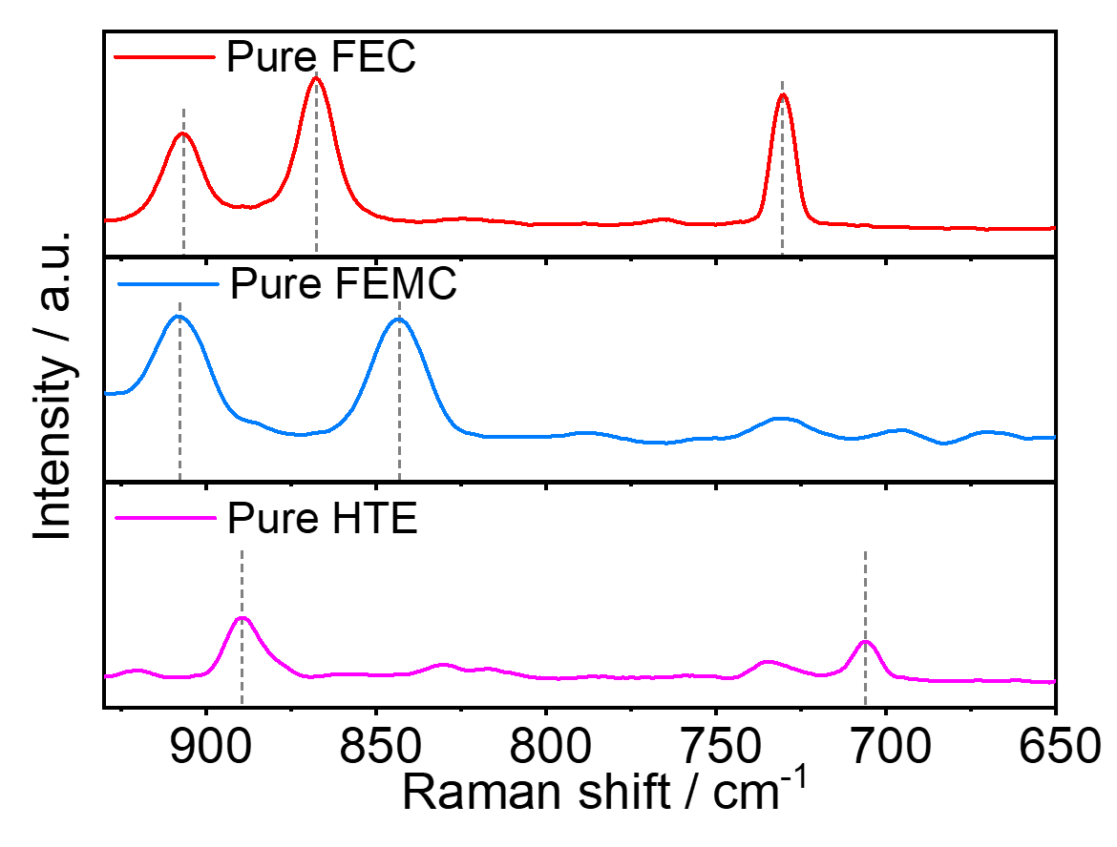
Supplementary Fig. 6 Raman spectra of pure FEC, FEMC and HTE solvents.

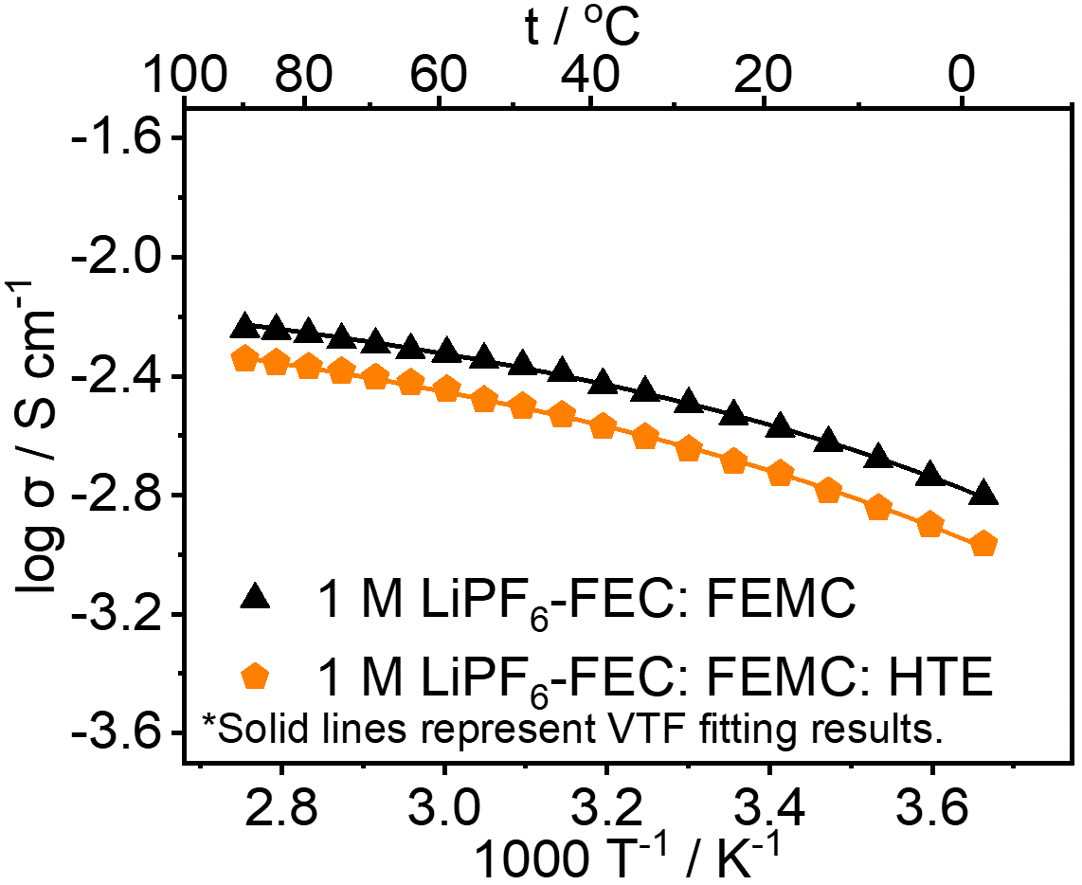
Supplementary Fig. 7 The ionic conductivities for 1 M LiPF₆-FEC: FEMC and 1 M LiPF₆-FEC: FEMC: HTE at various temperatures from 0-90 °C. The plots represent the experimental data while the solid lines represent VTF fitting results.

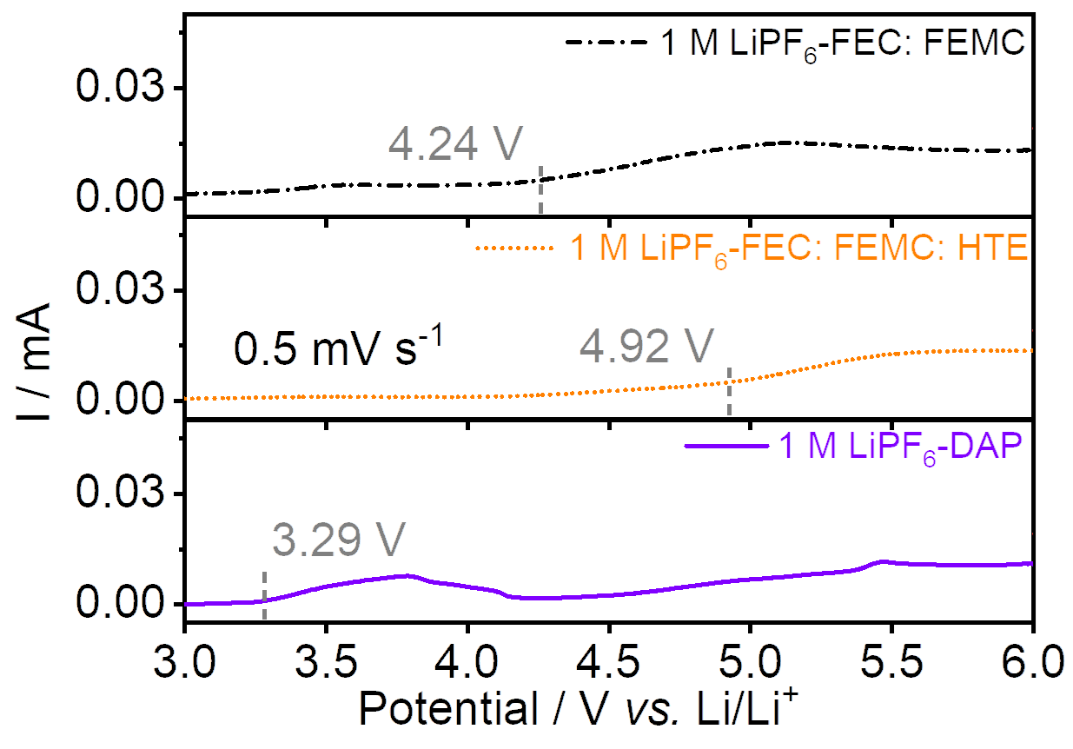
Supplementary Fig. 8 The regional CV curves of the 1 M LiPF₆-FEC: FEMC, 1 M LiPF₆-FEC: FEMC: HTE, and 1 M LiPF₆-DAP electrolyte samples. The scan rate is 0.5 mV s⁻¹. Stainless steels are used as the working electrodes while Li foil is used as the counter and reference electrodes.

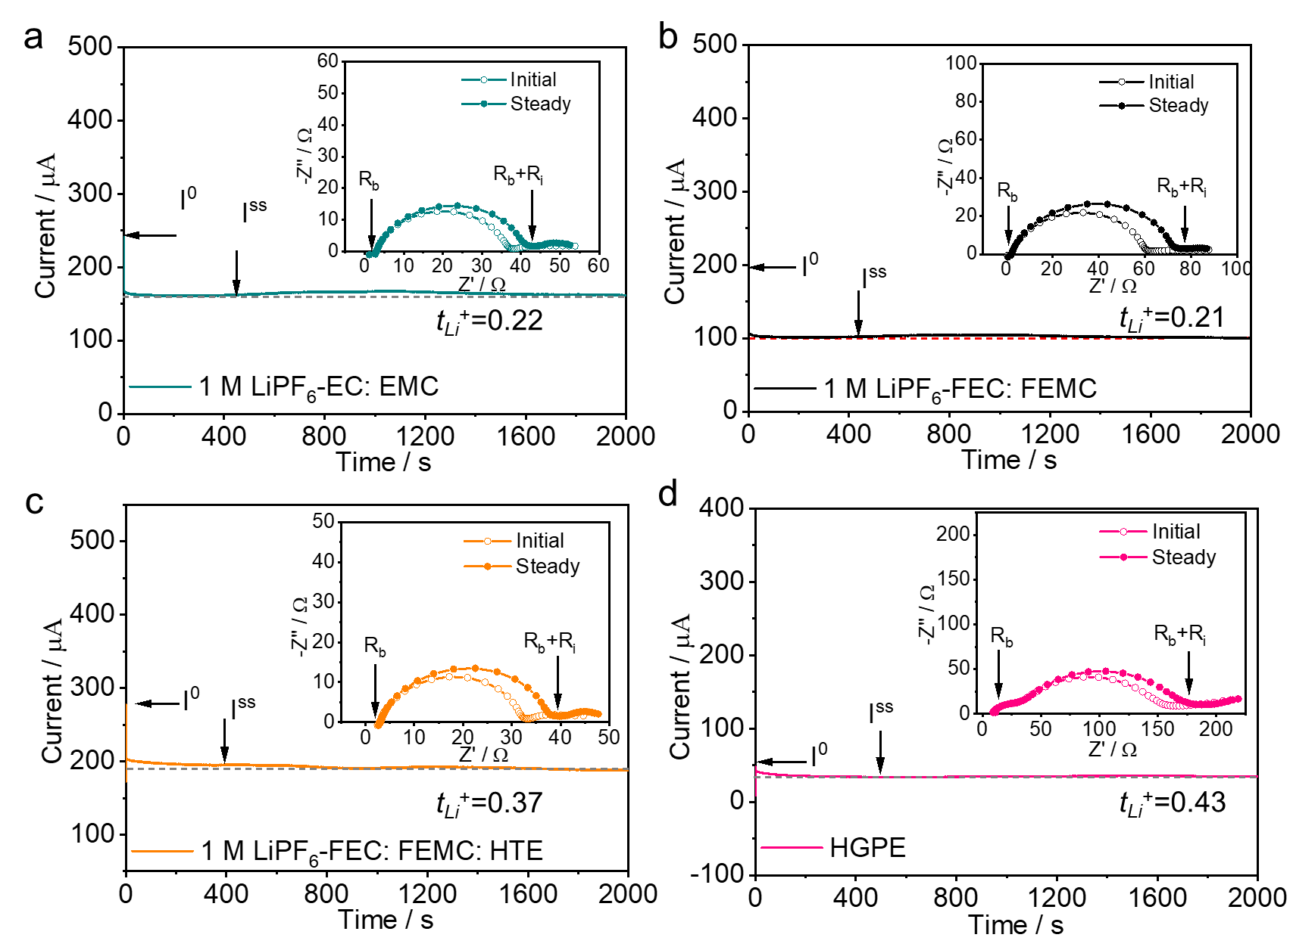
Supplementary Fig. 9 The chronoamperometry profile of the symmetric Li||Li cells using different electrolytes. a Li|1 M LiPF₆-EC: EMC |Li cell; b Li|1 M LiPF₆-FEC: FEMC |Li cell; c Li|1 M LiPF₆-FEC: FEMC: HTE |Li cell and d Li|HGPE|Li cell. The applied polarization voltage is 10 mV. The EIS spectra before and after the polarization are shown in inset.

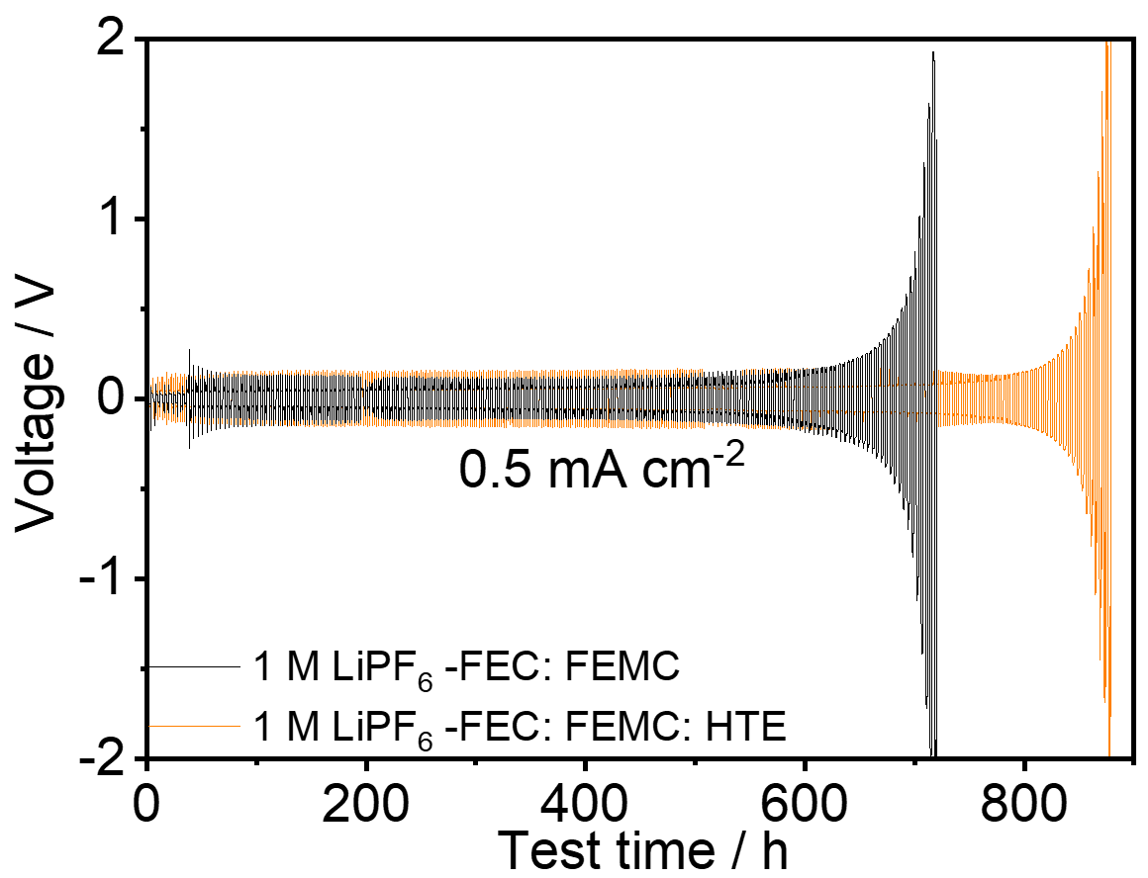
Supplementary Fig. 10 Voltage profiles of the Li||Li symmetric cells using 1 M LiPF₆-FEC: FEMC and 1 M LiPF₆-FEC: FEMC: HTE electrolytes at 0.5 mA cm⁻² with cut-off capacity of 1 mAh cm⁻².
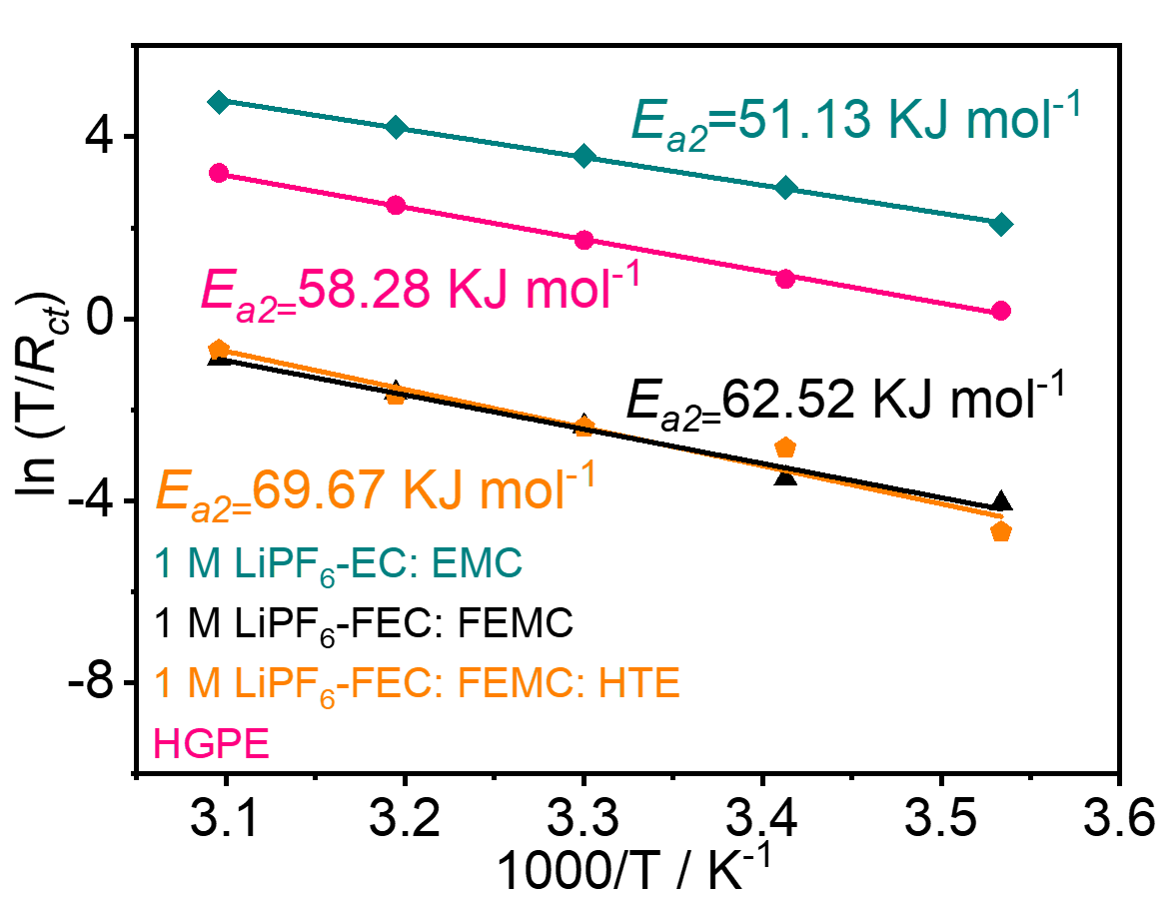
Supplementary Fig. 11 The activation energies of R_{ct} derived from Nyquist plots.

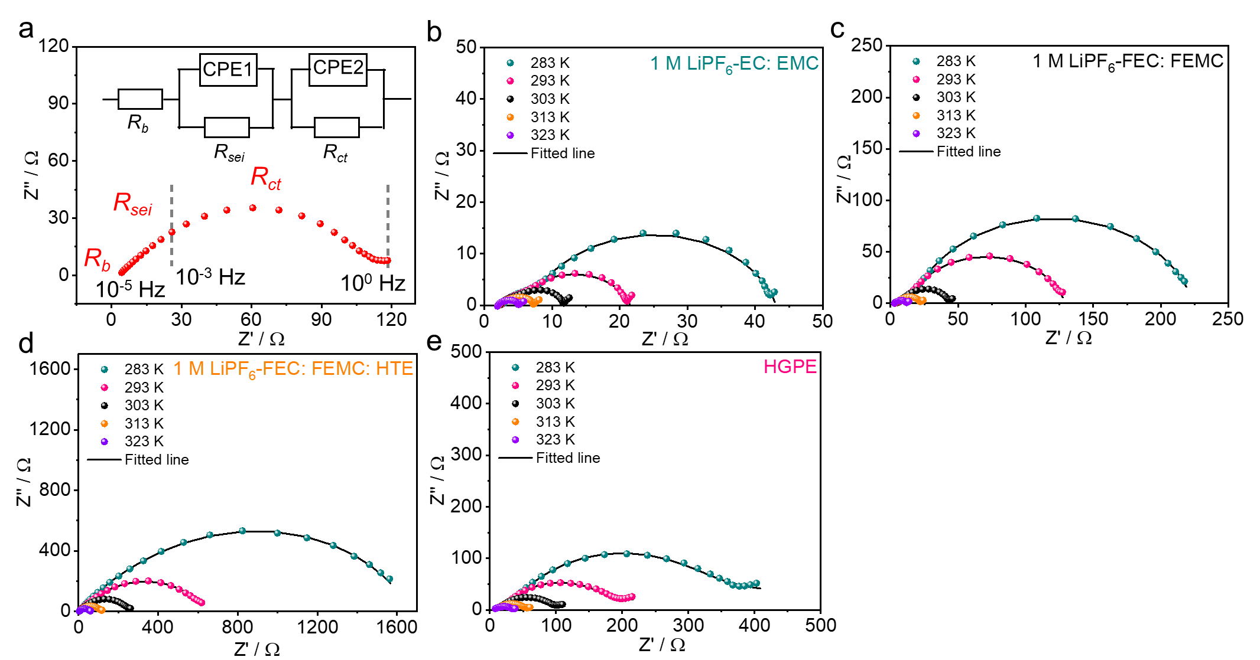
Supplementary Fig. 12 Nyquist plots for Li||Li symmetric cells in the different electrolytes. a The equivalent circuit model and the corresponding Nyquist plot of Li||Li symmetric cells. R_{b} represents the bulk resistance, reflecting the resistance of electrodes, electrolyte, and separator. The semic-circle of R_{sei} in the high-middle frequency range represents the resistance of Li⁺ transport through the SEI, while the semi-circle of R_{ct} in the low frequency range represents the de-solvation resistance of Li⁺ before it enters the SEI. b-e Nyquist plots of cells using b 1 M LiPF₆-EC: EMC electrolyte, c 1 M LiPF₆-FEC: FEMC electrolyte, d 1 M LiPF₆-FEC: FEMC: HTE electrolyte and e HGPE at different temperatures.

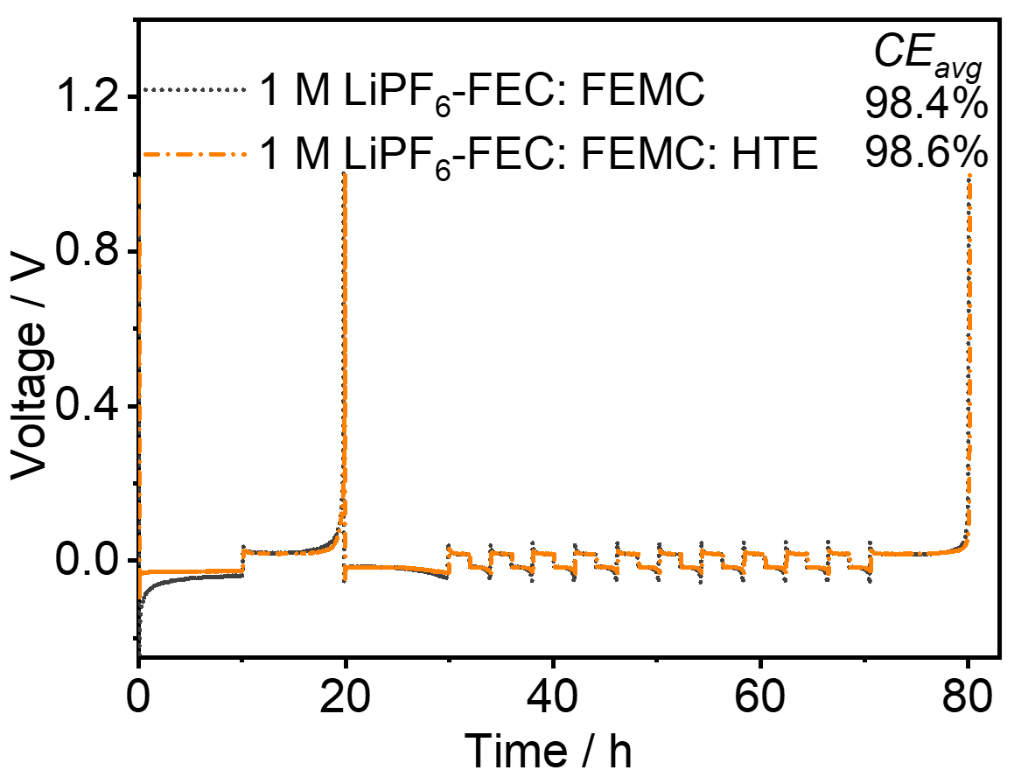
Supplementary Fig. 13 CE_{avg} tests of Li plating-stripping in Li|1 M LiPF₆-FEC: FEMC|Cu and Li| 1 M LiPF₆-FEC: FEMC: HTE|Cu cells at 0.5 mA cm⁻² with a capacity of 1 mAh cm⁻².

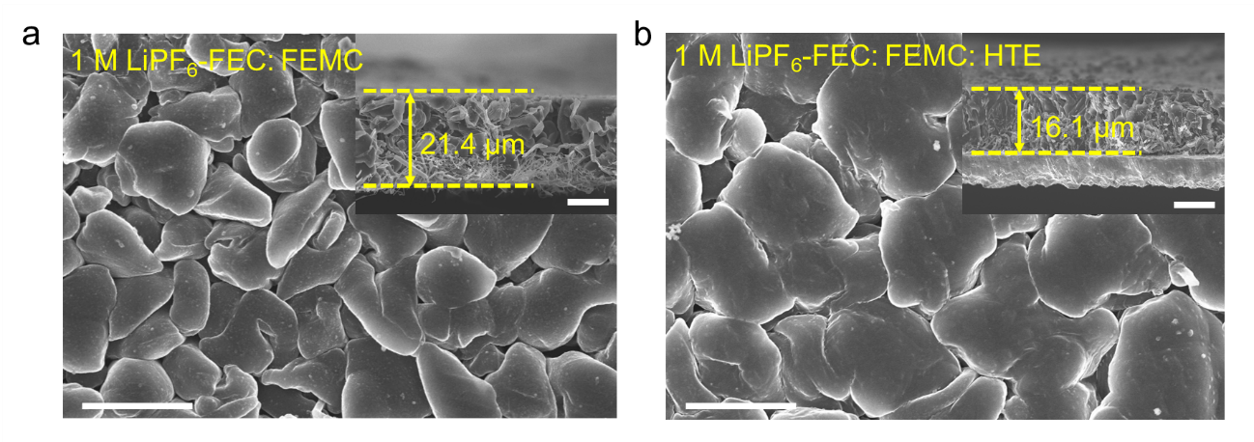
Supplementary Fig. 14 Top and cross-sectional (shown in inset) FE-SEM images of the Li deposition obtained by plating 1 mAh cm⁻² Li on Cu substrate at 0.1 mA cm⁻² in Li||Cu cells using a 1 M LiPF₆ -FEC: FEMC and b 1 M LiPF₆ -FEC: FEMC: HTE electrolytes. Scale bars: 5 μm in Supplementary Fig. 14a, b; 10 μm in the inset of Supplementary Fig. 14a, b.

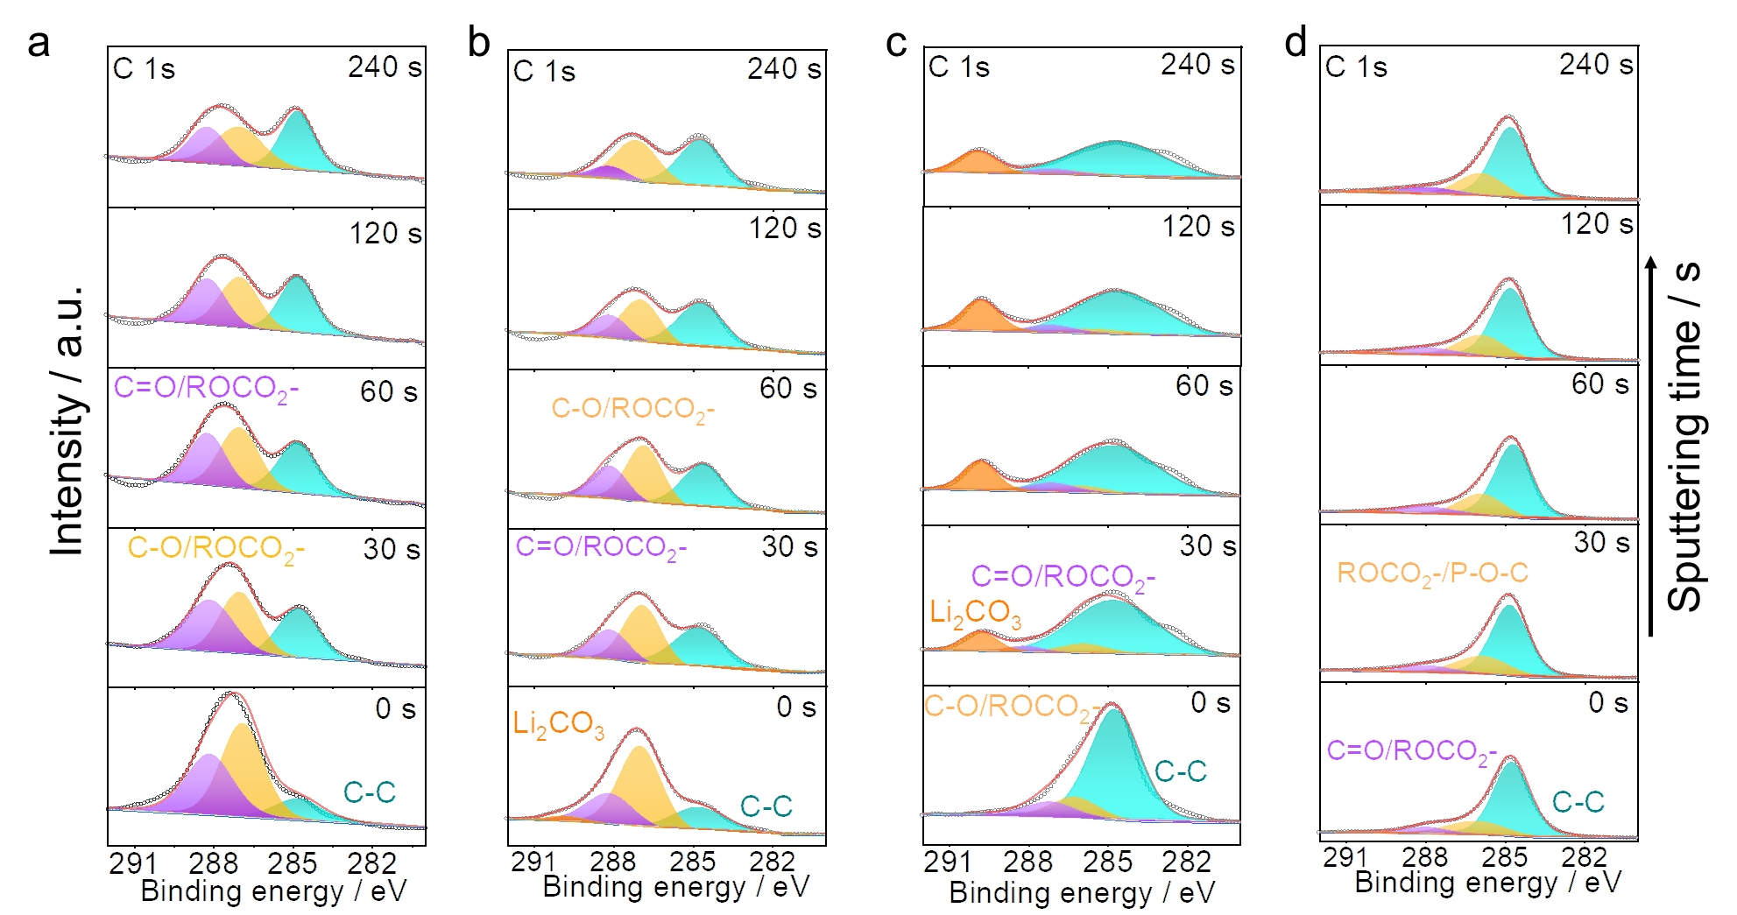
Supplementary Fig. 15 C 1s in-depth XPS spectra of the Cu substrate obtained from a Li|1 M LiPF₆-EC: EMC|Cu, b Li|1 M LiPF₆-FEC: FEMC|Cu, c Li|1 M LiPF₆-FEC: FEMC: HTE|Cu and d Li|HGPE|Cu cells after 10 cycles. During the cycling, 1 mAh cm⁻² Li was repeatedly plated on-stripped off the Cu foil at 0.2 mA cm⁻². C-C: 284.8 eV, C-O: 286.5 eV; C=O:288 eV¹; Li₂CO₃:290 eV².

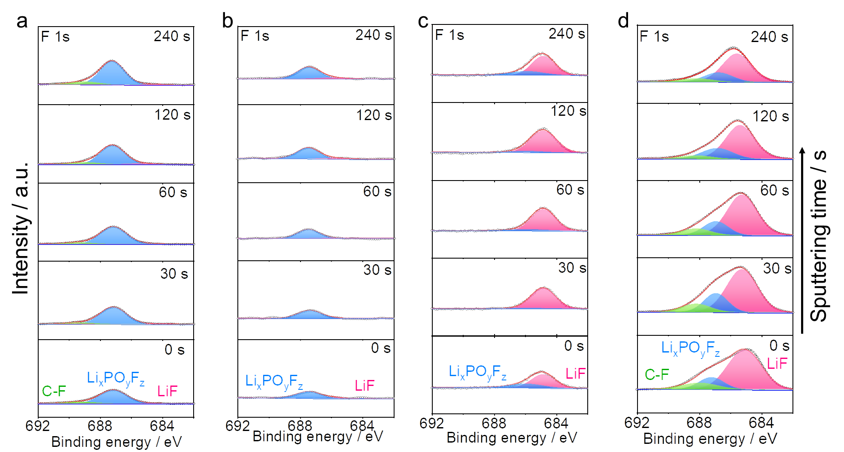
Supplementary Fig. 16 F 1s in-depth XPS spectra of the Cu substrate obtained from a Li|1 M LiPF₆-EC: EMC|Cu, b Li|1 M LiPF₆-FEC: FEMC|Cu, c Li|1 M LiPF₆-FEC: FEMC: HTE|Cu and d Li|HGPE|Cu cells after 10 cycles. During the cycling, 1 mAh cm⁻² Li was repeatedly plated on-stripped off the Cu foil at 0.2 mA cm⁻² C-F: 688 eV; LiF: 685 eV³; Li_{x}PO_{y}F_{z}: 687 eV⁴.
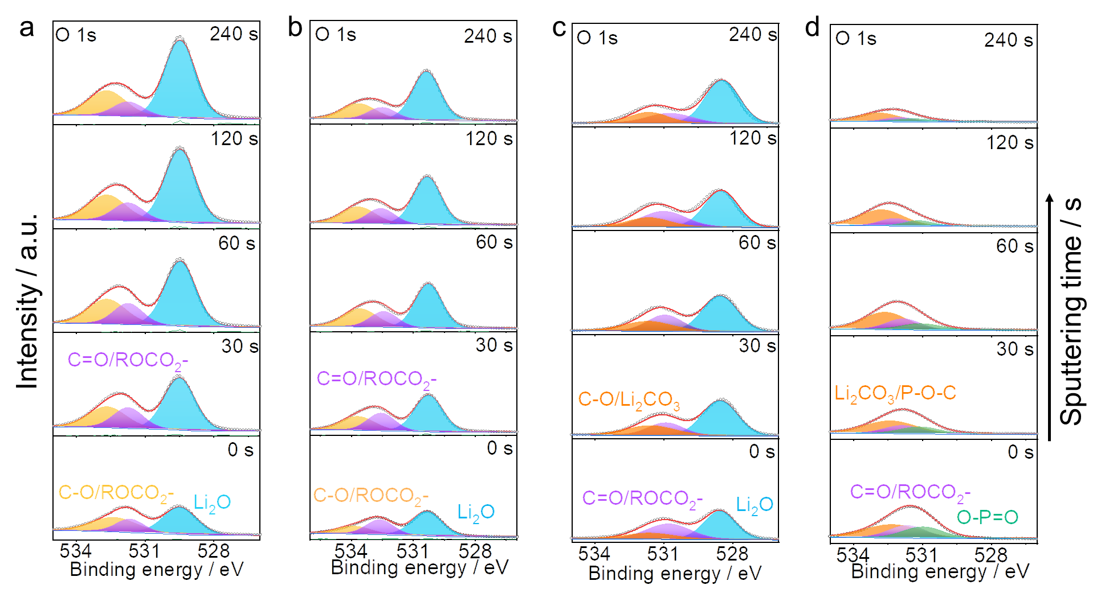
Supplementary Fig. 17 O 1s in-depth XPS spectra of the Cu substrate obtained from a Li|1 M LiPF₆-EC: EMC|Cu, b Li|1 M LiPF₆-FEC: FEMC|Cu, c Li|1 M LiPF₆-FEC: FEMC: HTE|Cu and d Li|HGPE|Cu cells after 10 cycles. During the cycling, 1 mAh cm⁻² Li was repeatedly plated on-stripped off the Cu foil at 0.2 mA cm⁻² Li₂O: 529 eV⁵; C=O: 531.5 eV²;C-O=533 eV⁶; Li₂CO₃: 532 eV⁵; P-O: 532.5 eV⁷; O-P=O: 531 eV⁸.

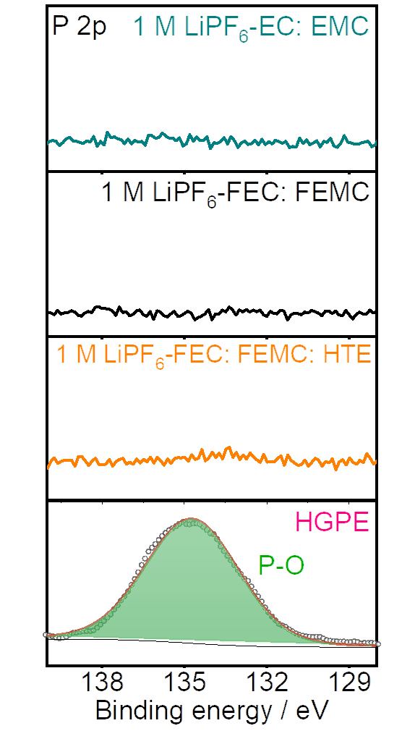
Supplementary Fig. 18 The P 2p XPS spectra of the Cu substrate obtained from Li||Cu cells after 10 cycles. P-O: 135 eV⁹.

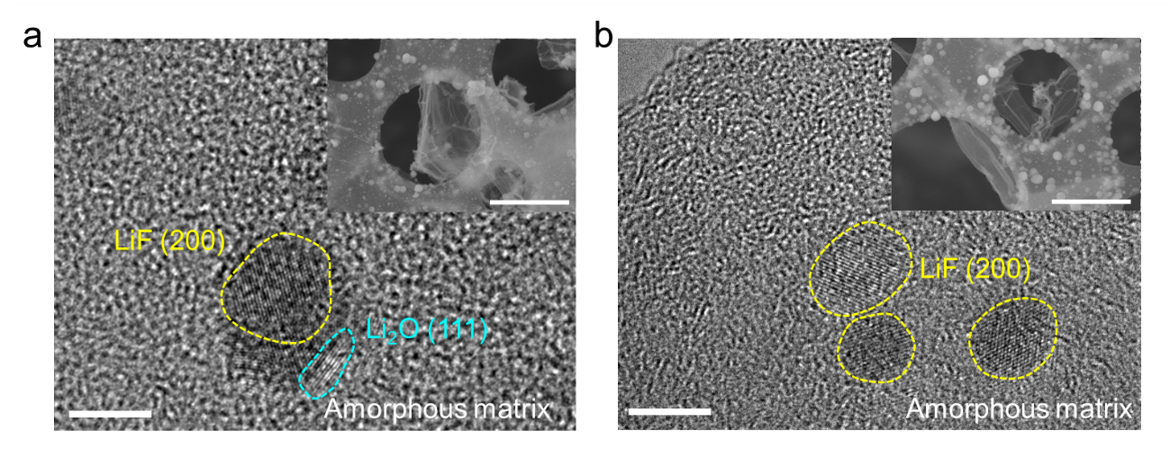
Supplementary Fig. 19 TEM images of the SEI shell formed by plating/stripping Li on Cu grids in a 1 M LiPF₆-FEC: FEMC and b 1 M LiPF₆-FEC: FEMC: HTE electrolytes. Scale bars: 5 nm in Supplementary Fig. 19a, b; 2 μm in the insets of Supplementary Fig. 19a, b.

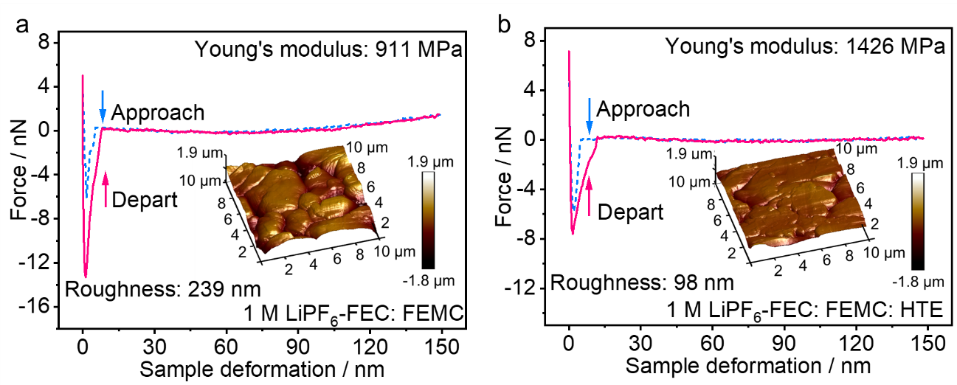
Supplementary Fig. 20 Force-displacement plots of a 1 M LiPF₆ -FEC: FEMC derived SEI and b 1 M LiPF₆ -FEC: FEMC: HTE derived SEI. The corresponding 3D AFM scanning images of SEI layers are shown in insets.
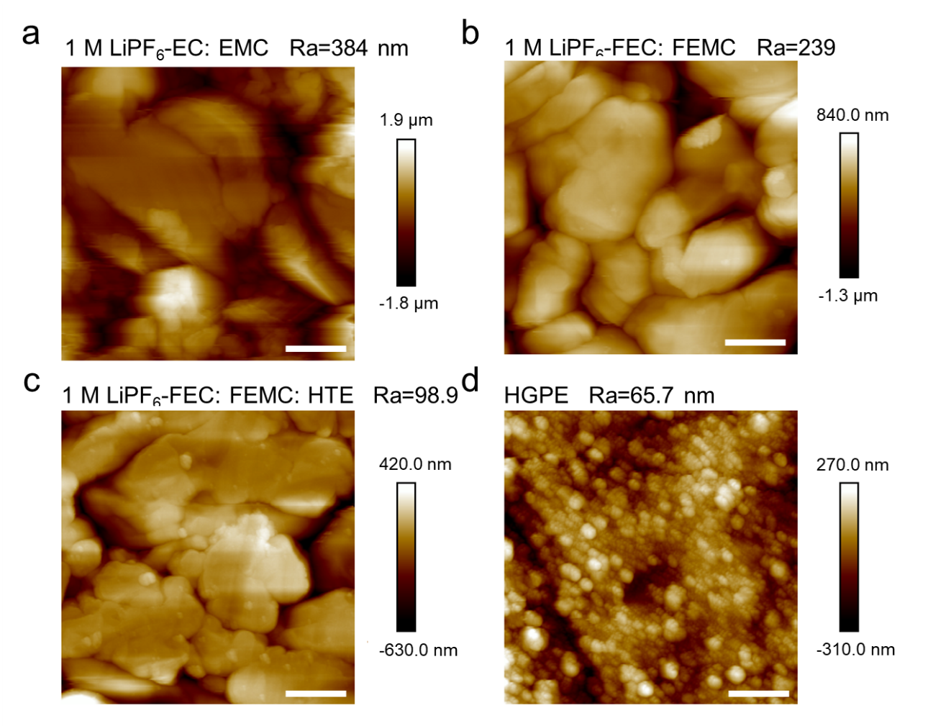
Supplementary Fig. 21 Two-dimensional (2D) AFM images of a 1 M LiPF₆ -EC: EMC derived SEI, b 1 M LiPF₆ -FEC: FEMC derived SEI, c 1 M LiPF₆ -FEC: FEMC: HTE derived SEI and d HGPE derived SEI. The roughnesses are 384 nm, 239 nm, 98.9 nm and 65.7 nm, respectively. Scale bars: 2.0 μm in Supplementary Fig. 21a-d.

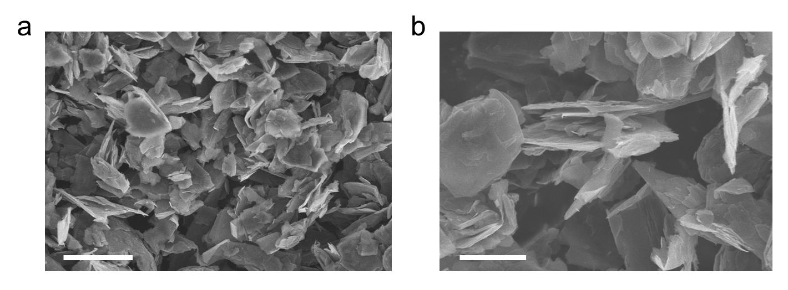
Supplementary Fig. 22 The SEM of KS6 graphite particle. Scale bars: 5 μm in Supplementary Fig. 22a; 2 μm in Supplementary Fig. 22b.

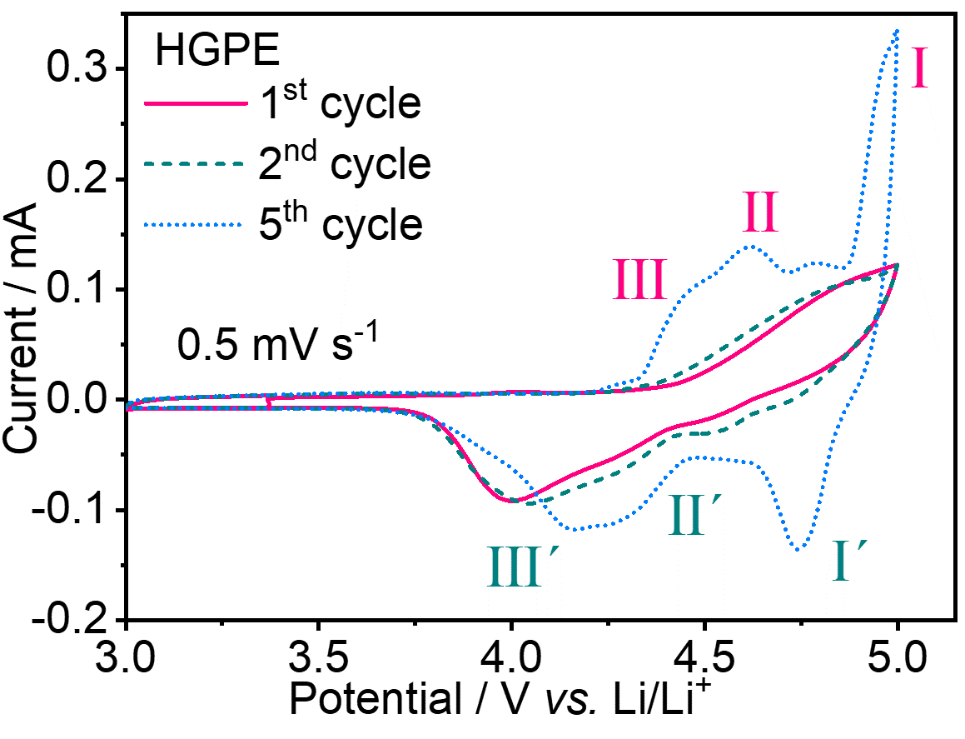
Supplementary Fig. 23 The CV curve of the Li|HGPE|KS6 graphite cell. The scan rate is 0.5 mV s⁻¹.

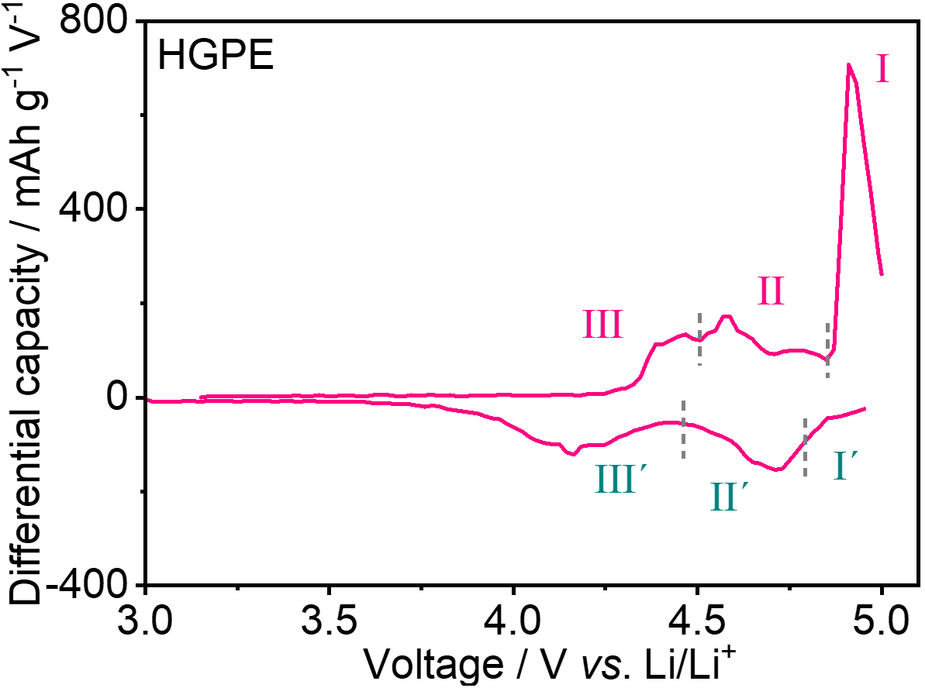
Supplementary Fig. 24 The dQ/dV curve of the Li|HGPE|KS6 graphite cell (Supplementary Note 5).

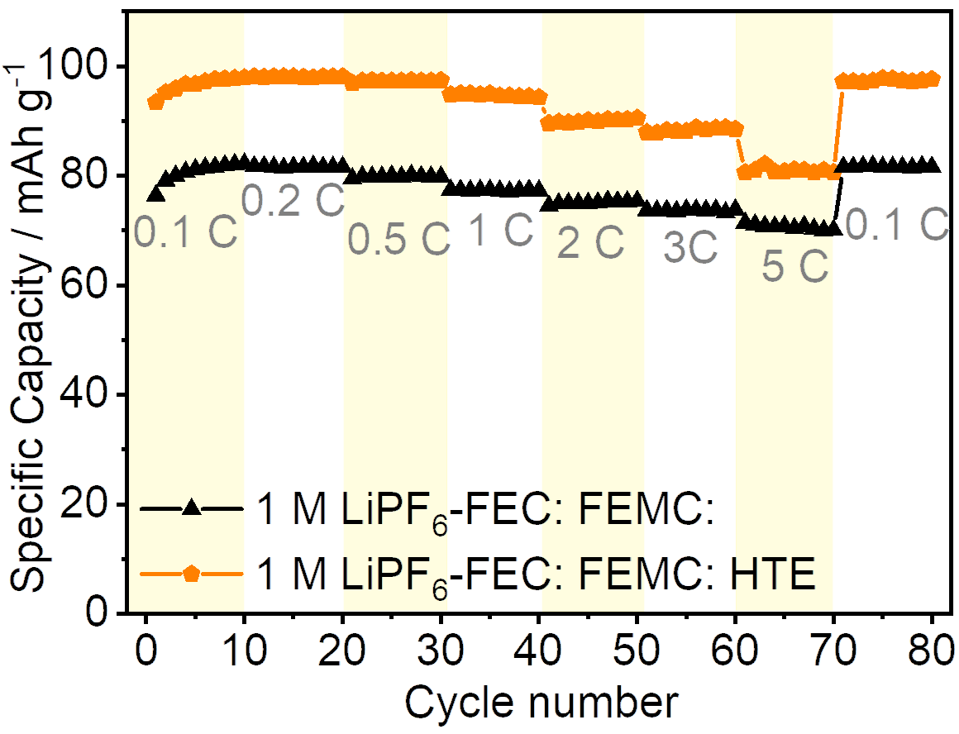
Supplementary Fig. 25 Rate performances of Li||KS6 graphite cells employing 1 M LiPF₆-FEC: FEMC and 1 M LiPF₆-FEC: FEMC: HTE electrolytes under different current densities.

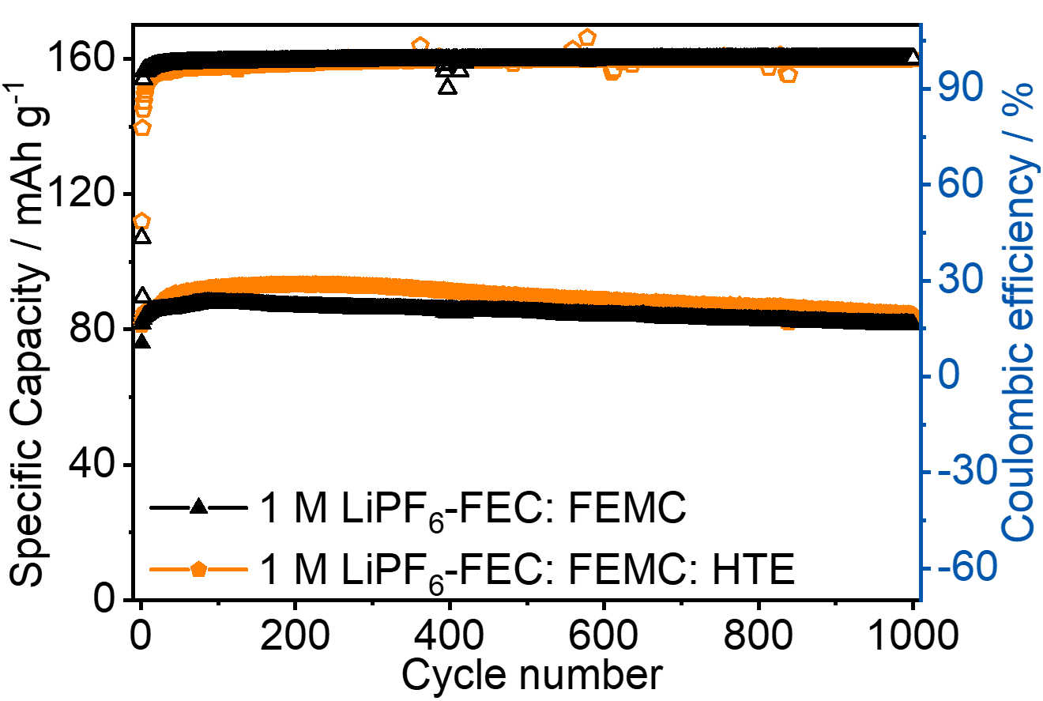
Supplementary Fig. 26 Long-term cycling performance Li||KS6 graphite DIBs at 100 mA g⁻¹ using 1 M LiPF₆-FEC: FEMC and 1 M LiPF₆-FEC: FEMC: HTE electrolytes.

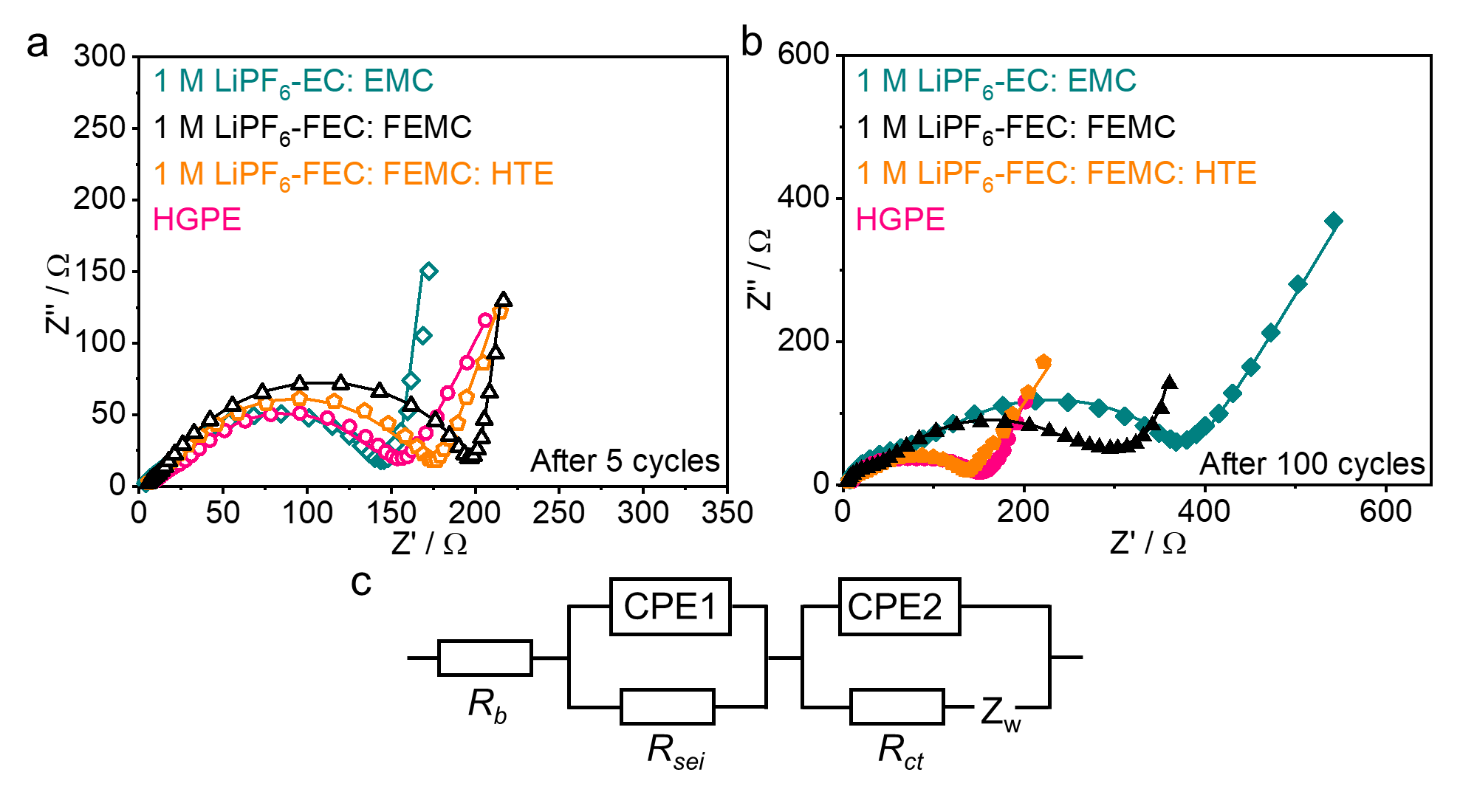
Supplementary Fig. 27 a b EIS spectra of the Li||KS6 graphite cells using four electrolyte samples after a 5 cycles and b 100 cycles at 100 mA g⁻¹. c The corresponding equivalent circuit diagram.

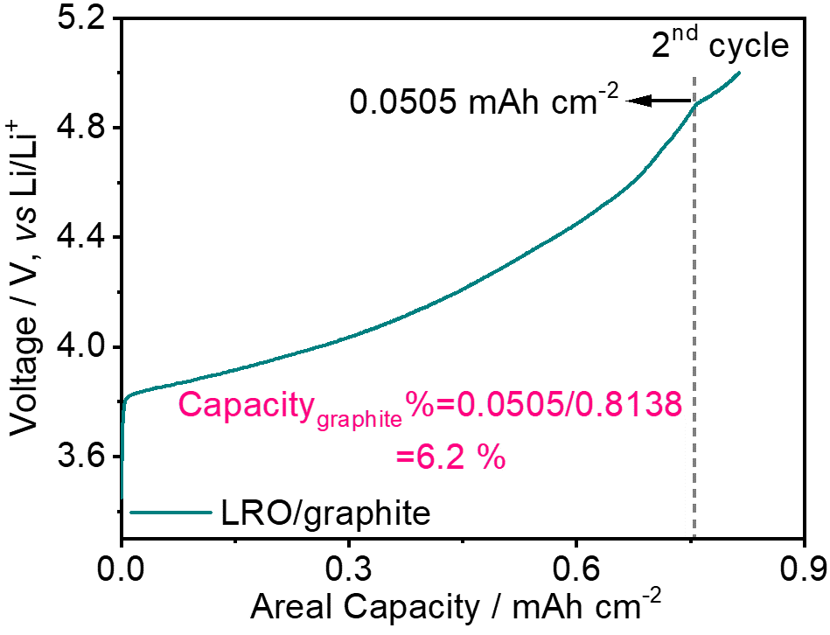
Figure S28. Estimation of the capacity contribution of KS6 graphite.

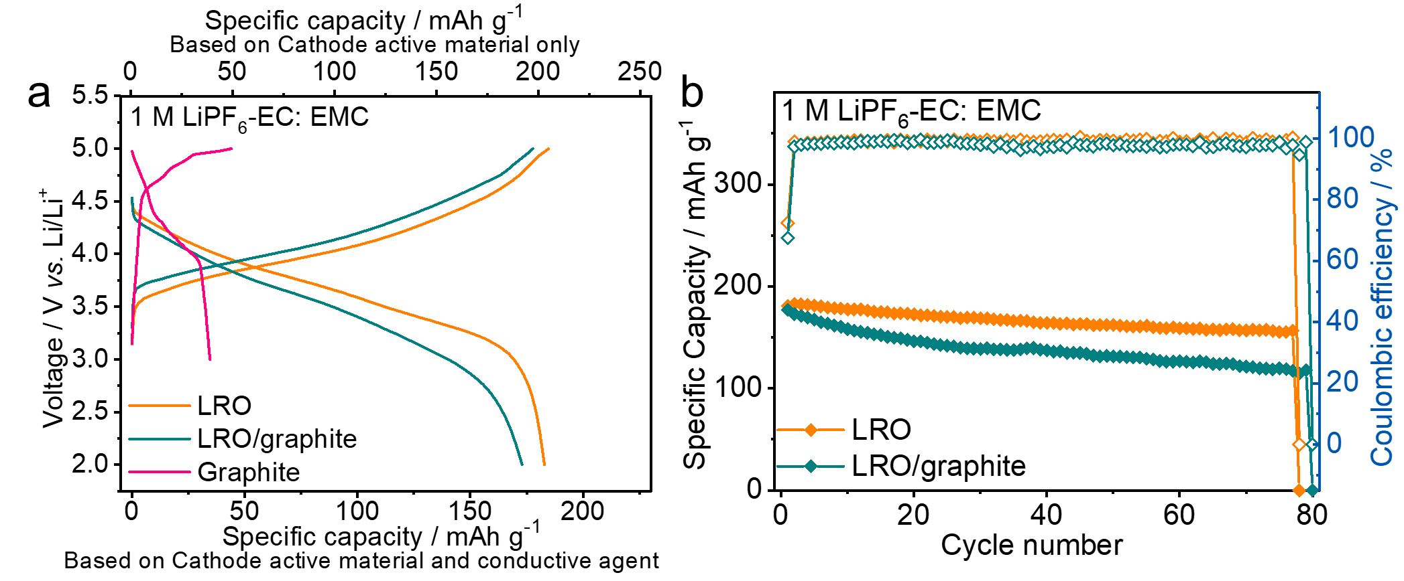
Supplementary Fig. 29 a Charge-discharge curves of the Li||KS6 graphite, Li||LRO, and Li||LRO/graphite hybrid cells using 1 M LiPF₆-EC: EMC electrolyte at 0.2 C. b Cyclic performances of Li||LRO and Li||LRO/graphite hybrid cells using 1 M LiPF₆-EC: EMC electrolyte at 0.2 C. The capacity is calculated based the total mass of LRO and conductive agent.

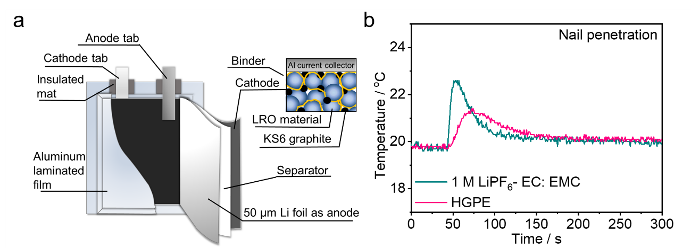
Supplementary Fig. 30 a Schematic illustration of a SRLMB pouch cell configuration. b Temperature changes of fully charged Li|1 M LiPF₆-EC: EMC|LRO and Li|HGPE|LRO pouch cells during nail penetration tests.

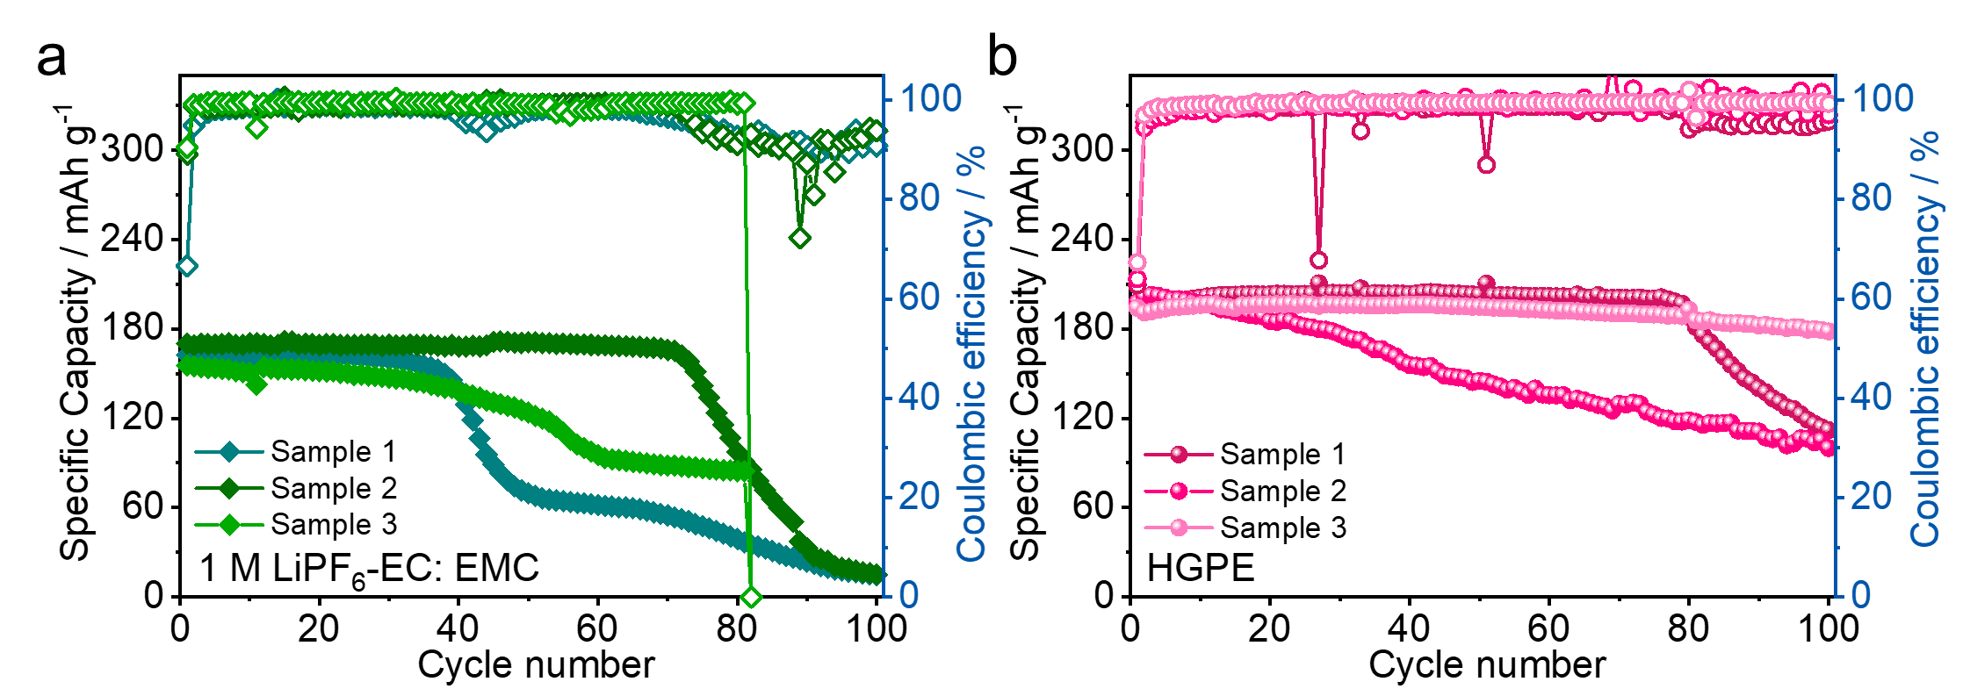
Supplementary Fig. 31 a Cycling performances of Li||LRO/graphite pouch cells using a 1 M LiPF₆-EC: EMC electrolyte and b HGPE at 0.2 C.

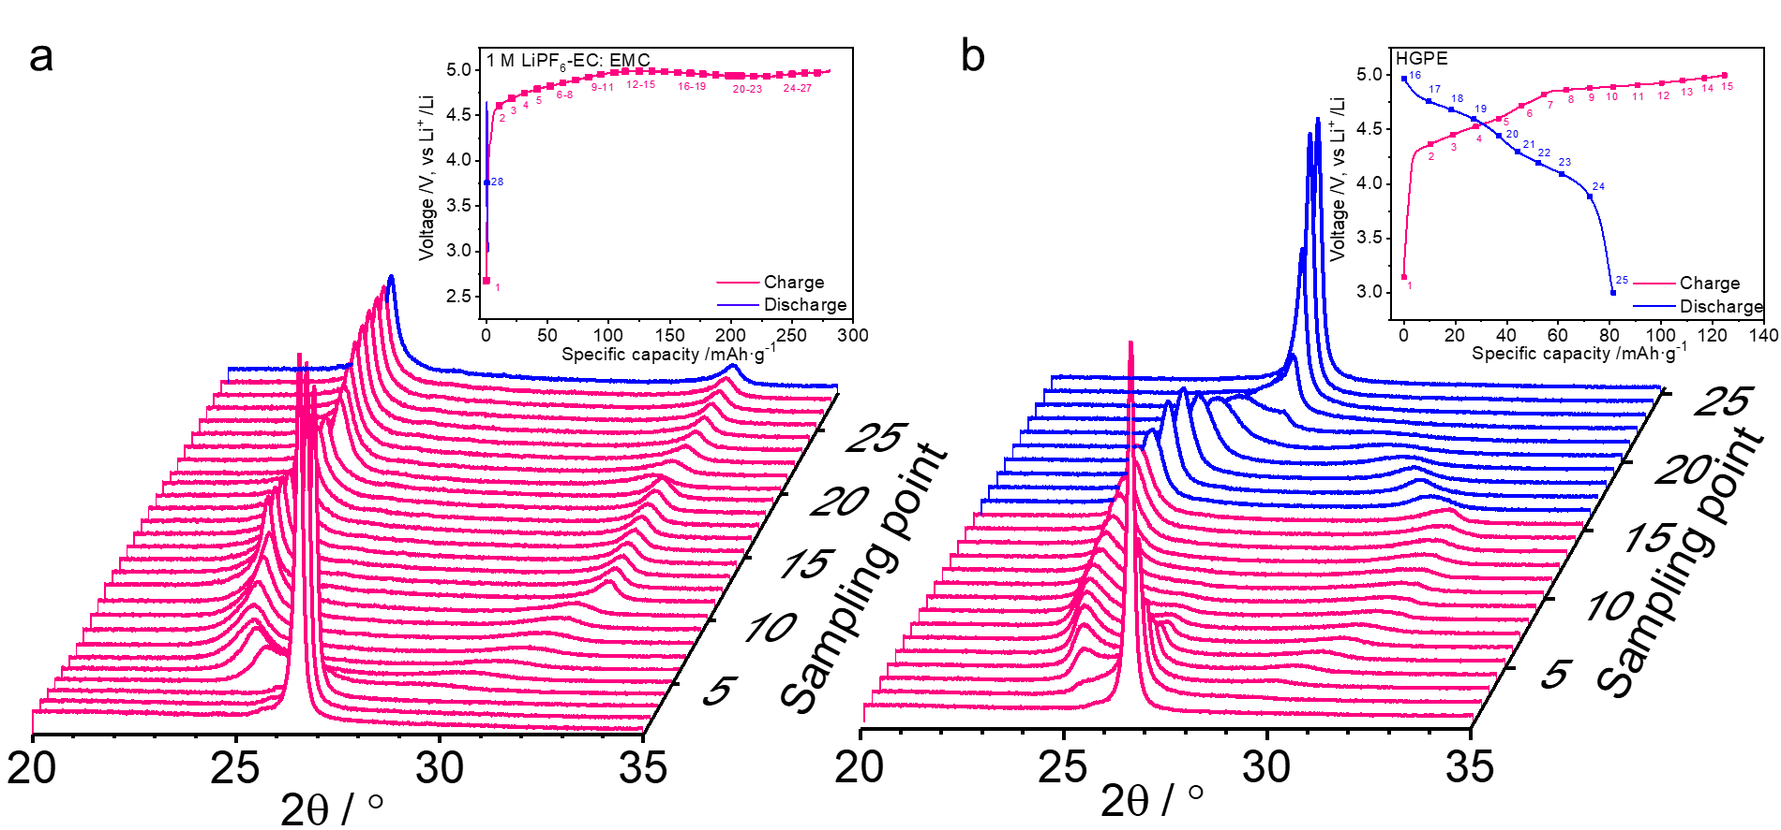
Supplementary Fig. 32 In-situ XRD patterns of the graphite cathode in a Li|1 M LiPF₆-EC: EMC|KS6 graphite and b Li|HGPE|KS6 graphite cells during the initial charge-discharge processes at 0.05 C. The numbers labeled in the charge-discharge profiles in the insets correspond to the ordinate values in the XRD patterns.
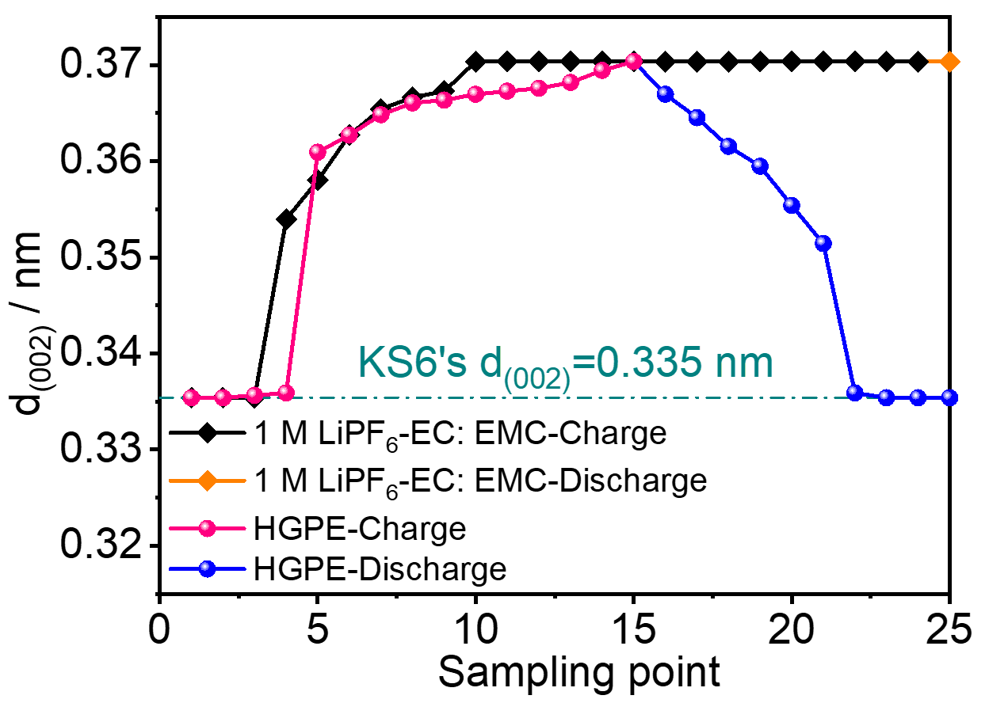
Supplementary Fig. 33 The calculated d₍₀₀₂₎ interplanar spacings of the KS6 graphite cathode materials. The results were obtained from the in-situ XRD patterns of Li|1 M LiPF₆-EC: EMC|KS6 graphite and Li|HGPE|KS6 graphite cells during the initial charge-discharge processes.

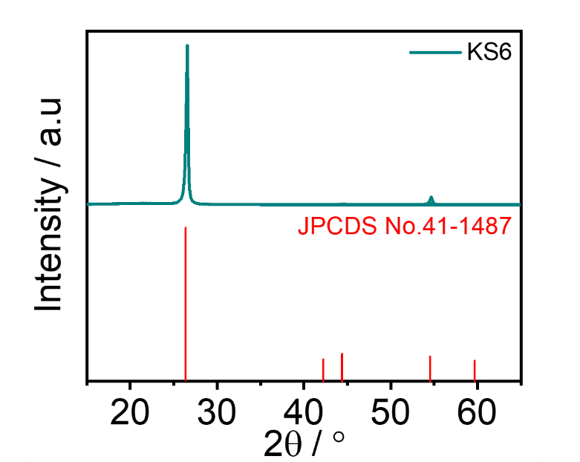
Supplementary Fig. 34 The XRD pattern of pristine KS6 graphite powders.
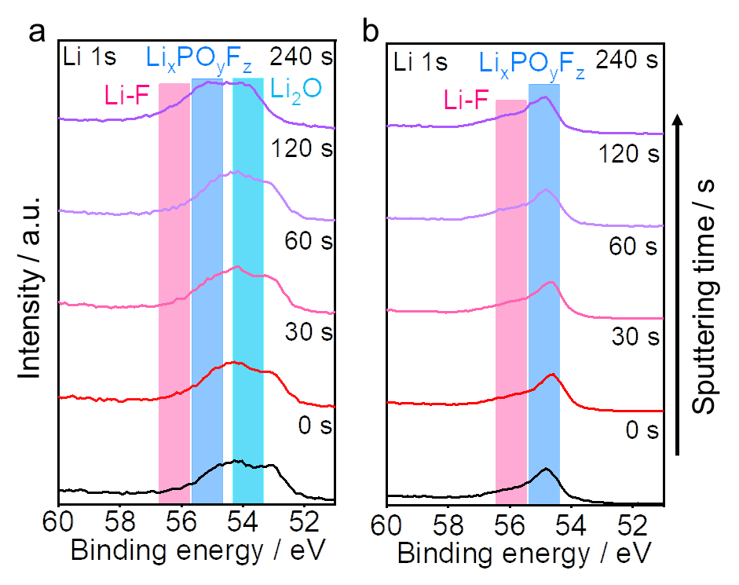
Supplementary Fig. 35 Li 1s XPS depth spectra of in KS6 graphite cathodes obtained from a Li|1 M LiPF₆-EC: EMC|KS6 graphite and b Li|HGPE|KS6 graphite cells graphite after one cycle at 0.05 C.
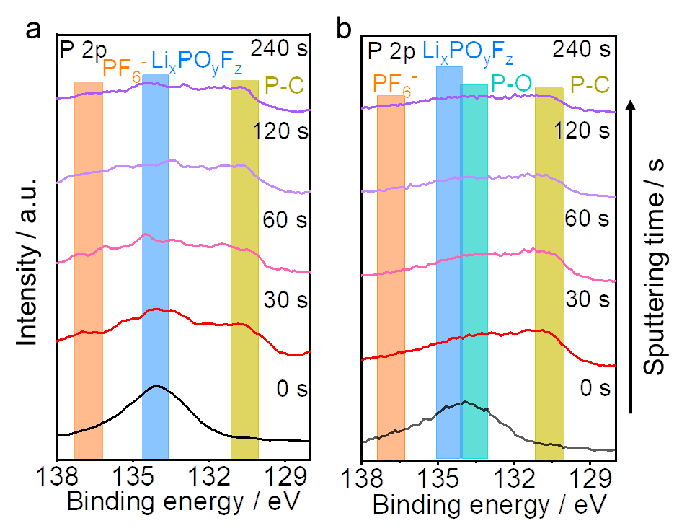
Supplementary Fig. 36 P 1s XPS depth spectra of the KS6 graphite cathodes obtained from a Li|1 M LiPF₆-EC: EMC|KS6 graphite and b Li|HGPE|KS6 graphite cells after one cycle at 0.05 C.
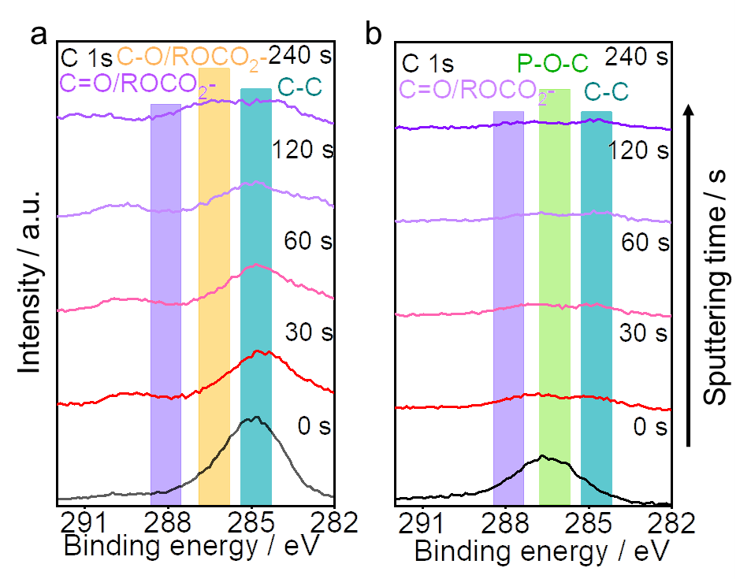
Supplementary Fig. 37 C 1s XPS depth spectra of the KS6 graphite cathodes obtained from a Li|1 M LiPF₆-EC: EMC|KS6 graphite and b Li|HGPE|KS6 graphite cells after one cycle at 0.05 C.
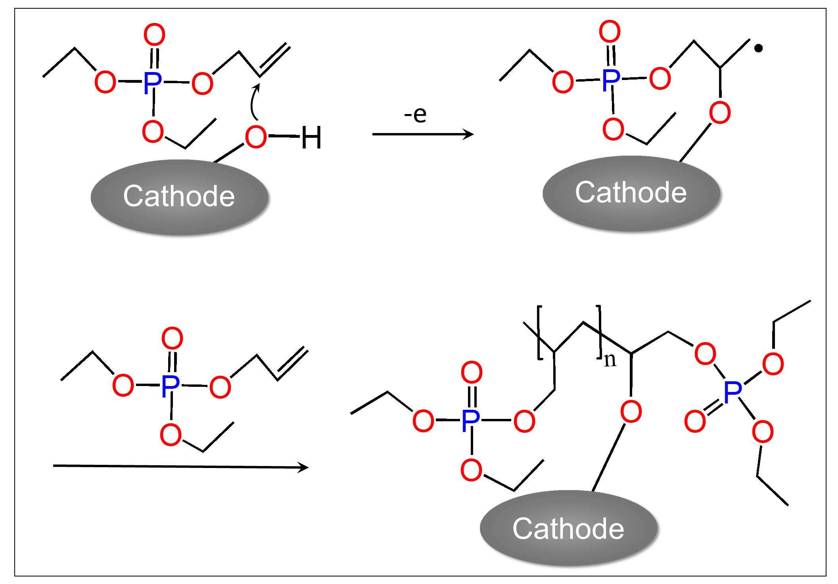
Supplementary Fig. 38. A possible electro polymerization mechanism of residual DAP monomer on the graphite surface.

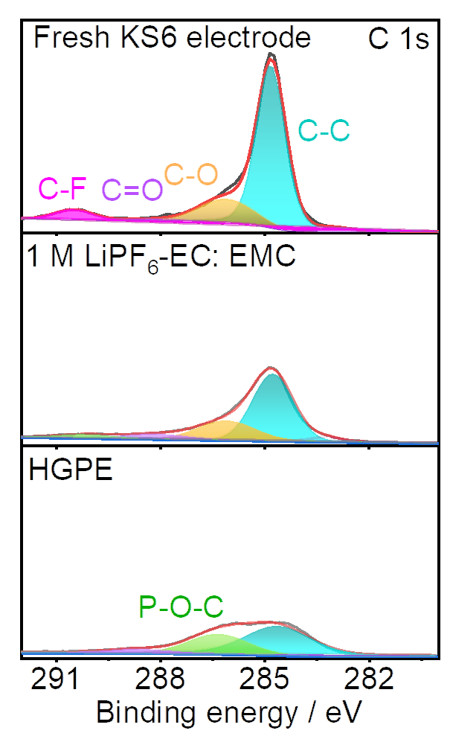
Supplementary Fig. 39 The C 1s XPS spectra of fresh KS6 graphite electrode and cycled KS6 graphite electrodes in various electrolytes.

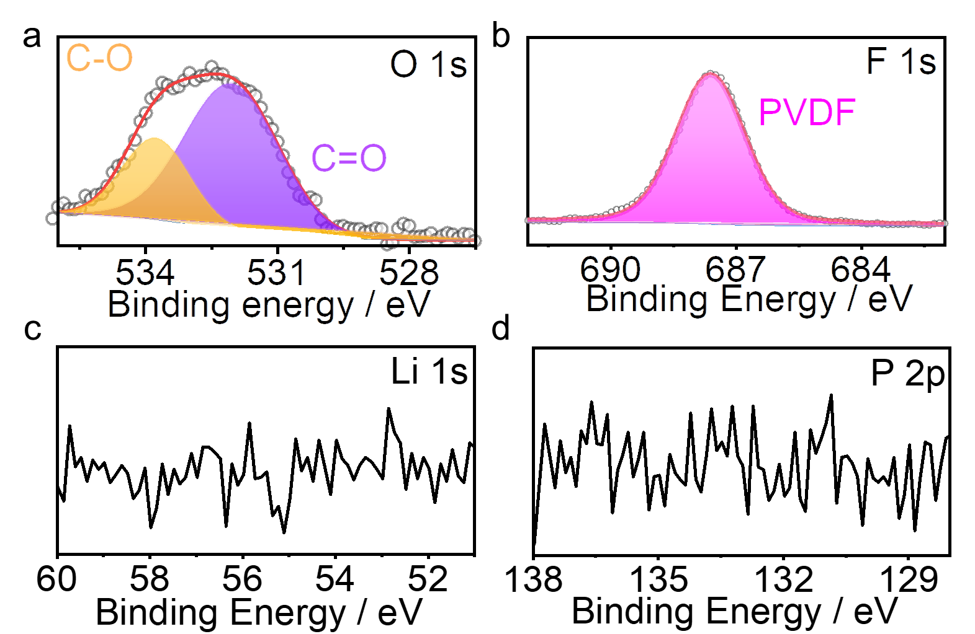
Supplementary Fig. 40 The O 1s, F 1s, Li 1s and P 2p XPS spectra of fresh KS6 graphite electrode.
Supplementary Tables
Supplementary Table 1 The ionic conductivity values at 25 ºC and VTF fitting parameters of the four electrolyte samples.
Electrolytes | σ。at 25 ºC  (S cm⁻¹) | σ。  (S cm⁻¹ K^{−1/2}) | E_{a}  (eV) | T。  (K)
1 M LiPF₆-EC: EMC | 7.47×10⁻³ | 0.711 | 6.95×10⁻³ | 193.76
1 M LiPF₆-FEC: FEMC | 2.92×10⁻³ | 0.381 | 7.46×10⁻³ | 199.08
1 M LiPF₆-FEC: FEMC: HTE | 2.05×10⁻³ | 0.372 | 9.30×10⁻³ | 191.90
HGPE | 1.99×10⁻³ | 0.351 | 1.00×10⁻² | 183.27

Supplementary Table 2 The t_{Li}⁺ values of different electrolytes.
Electrolytes | R_{b}⁰ | R_{i}⁰ | R_{b}^{SS} | R_{i}^{SS} | I⁰ | I^{SS} | t_{Li}⁺
1 M LiPF₆-EC: EMC | 2.85 | 36.6 | 3.02 | 39.2 | 0.24 | 0.16 | 0.22
1 M LiPF₆-FEC: FEMC | 2.22 | 59.3 | 2.33 | 70.9 | 0.188 | 0.10 | 0.21
1 M LiPF₆-FEC: FEMC: HTE | 2.79 | 29.7 | 2.96 | 35.3 | 0.277 | 0.19 | 0.37
HGPE | 8.83 | 154.2 | 9.16 | 176.18 | 0.048 | 0.033 | 0.43

Supplementary Table 3 Fitted values of the impedance spectra in a Li|1 M LiPF₆-EC: EMC |Li cell (Supplementary Fig. 12b).
T(K) | 1000/T(1/K⁻¹) | R_{sei} | Ln(T/R_{sei}) | R_{ct} | Ln(T/R_{ct})
283 | 3.533569 | 4.482 | 4.145378 | 35.7 | 2.070296
293 | 3.412969 | 2.432 | 4.791459 | 16.38 | 2.884112
303 | 3.30033 | 1.078 | 5.638625 | 8.434 | 3.581462
313 | 3.194888 | 0.546 | 6.351339 | 4.622 | 4.215376
323 | 3.095975 | 0.06848 | 8.458866 | 2.755 | 4.764235

Supplementary Table 4 Fitted values of the impedance spectra in a Li|1 M LiPF₆-FEC: FEMC|Li cell (Supplementary Fig. 12c).
T (K) | 1000/T (1/K⁻¹) | R_{sei} | Ln(T/R_{sei}) | R_{ct} | Ln(T/R_{ct})
283 | 3.533569 | 15.29 | -1.46489 | 203.5 | -4.05336
293 | 3.412969 | 10.27 | -1.10164 | 114.1 | -3.50949
303 | 3.30033 | 4.686 | -0.35056 | 34.81 | -2.35588
313 | 3.194888 | 2.17 | 0.386825 | 16.24 | -1.62592
323 | 3.095975 | 0.99 | 1.140155 | 7.416 | -0.87354

Supplementary Table 5 Fitted values of the impedance spectra in a Li|1 M LiPF₆-FEC: FEMC: HTE|Li cell (Supplementary Fig. 12d).

T (K) | 1000/T (1/K⁻¹) | R_{sei} | Ln(T/R_{sei}) | R_{ct} | Ln(T/R_{ct})
283 | 3.533569 | 1279 | -5.89153 | 380.6 | -4.67944
293 | 3.412969 | 573.2 | -5.12365 | 58.12 | -2.83493
303 | 3.30033 | 230.1 | -4.24449 | 35.79 | -2.38365
313 | 3.194888 | 98.81 | -3.43165 | 17.29 | -1.68858
323 | 3.095975 | 50.77 | -2.7972 | 6.164 | -0.68862

Supplementary Table 6 Fitted values of the impedance spectra in a Li|HGPE|Li cell (Supplementary Fig. 12e).
T (K) | 1000/T (1/K⁻¹) | R_{sei} | Ln(T/R_{sei}) | R_{ct} | Ln(T/R_{ct})
283 | 3.533569 | 328.9 | -0.15031 | 237.1 | 0.176965
293 | 3.412969 | 250.2 | 0.157912 | 122.6 | 0.871246
303 | 3.30033 | 91.76 | 1.194556 | 53.88 | 1.726973
313 | 3.194888 | 45.45 | 1.92959 | 25.85 | 2.493893
323 | 3.095975 | 28.72 | 2.420059 | 13.13 | 3.202753

Supplementary Table 7 The EIS simulation results of the Li||KS6 graphite cells in the four electrolyte samples. The results are obtained from the four electrolyte samples after selected cycles corresponding to Supplementary Fig. 27.
Electrolytes | R_{sei}  at 5th | R_{sei}  at 100th | R_{ct}  at 5th | R_{ct}  at 100th
1 M LiPF₆-EC: EMC | 30.2 | 79.9 | 100.5 | 297.7
1 M LiPF₆-FEC: FEMC | 40 | 46.7 | 156.8 | 212.5
1 M LiPF₆-FEC: FEMC: HTE | 38.7 | 35.8 | 113.7 | 77.1
HGPE | 42.9 | 16.11 | 80 | 125.7

Supplementary Notes
Supplementary Note 1. Separation and purification of the polymer matrix from the HGPE.
The as-obtained HGPE was firstly mashed into pieces and washed with acetone. Subsequently, the mixture was centrifuged at 10,000 rpm for 15 min to separate the white precipitates. Above procedures were repeated for three times. After vacuum drying at 120 ºC, the as-obtained precipitates were dialyzed against deionized water for 3 days to further remove the residual ions. Then the precipitates were vacuum-dried at 120 ºC to obtain the separated polymer matrix.
The conversion ratio of monomers before and after polymerization was calculated by weighing the mass of the monomer (M_{monomer}, including the mass of DAP and PETEA) as raw material and the mass of the separated polymer matrix (M_{matrix}) based on the following equation:
$${\text{R}}_{\text{conver}}\text{=}\frac{{\text{M }}_{\text{monomer}}}{{\text{M }}_{\text{matrix}}} \text{(1)}$$

Supplementary Note 2. Lithium ions transference number measurement
Symmetric Li|HGPE|Li cell was assembled and then the polarization currents, including the initial (Iº) and steady-state (I^{ss}) current values, were recorded under a small polarization potential (ΔV) at 10 mV. Simultaneously, the initial and steady-state values of the bulk resistances (R_{b}º and R_{b}^{ss}) and electrode|electrolyte interfacial resistances (R_{i}º and R_{i}^{ss}) were examined via EISs before and after the potentiostatic polarization. The t_{Li}⁺ was calculated based on the following equation:¹⁰
$${\text{t}}_{\text{Li}}^{\text{+}}\text{=}\frac{{\text{I}}^{\text{ss}}\text{(ΔV-}{\text{I}}^{\text{o}}{\text{R}}_{\text{i}}^{\text{o}}\text{)}}{{\text{I}}^{\text{o}}\text{(ΔV-}{\text{I}}^{\text{ss}}{\text{R}}_{\text{i}}^{\text{ss}}\text{)}} \text{(2)}$$

Supplementary Note 3. Activation energy measurement for Li deposition.
Symmetric Li||Li cells using various electrolytes were assembled and then cycled at a current density of 0.5 mA cm⁻¹ for 20 cycles. Then the cycled cells were kept under 283, 293, 303, 313 and 323 K to record the temperature-dependent EISs. The SEI resistance (R_{sei}) and ion transfer resistance (R_{ct}) values were obtained by fitting the EISs via an equivalent circuit shown in the inset of Supplementary Fig. 11. Then the activation energy (E_{a}) was derived from the Arrhenius equation as follows:
$$\text{k=}\frac{\text{T}}{{\text{R}}_{\text{res}}}\text{=}\text{Aexp}\text{(}\text{-}\frac{\text{Ea}}{\text{R}}\text{)} \text{(3)}$$
where k represents the rate constant, T is the absolute temperature, R_{res} represents R_{ct} or R_{sei}, A is the preexponential constant, E_{a} is the activation energy, and R is the standard gas constant^{11,12}.

Supplementary Note 4. Coulombic efficiency test of Li plating/stripping.
The average Coulombic efficiency (CE_{avg}) of Li plating and stripping in different electrolytes was conducted in a Li||Cu cell configuration using the method reported by Zhang et al¹³. The Cu substrate was preconditioned with one Li deposition/stripping cycle with a capacity of 5 mAh cm⁻² at 0.5 mA cm⁻². After depositing 5 mAh cm⁻² Li reservoir (Q_{T}) on the Cu substrate at 0.5 mA cm⁻², the cell was charged-discharged with a capacity of 1 mA cm⁻² (Q_{C}) for n cycles, followed by a final exhaustive stripping of the remaining Li reservoir to 1 V at 0.5 mA cm⁻². The final stripping charge (Q_{S}), corresponding to the quantity of Li remaining after cycling, is measured. The average CE over n cycles can be calculated as¹³:
$${\text{CE}}_{\text{avg}}\text{=}\frac{\text{n}{\text{Q}}_{\text{C}}\text{+}{\text{Q}}_{\text{S}}}{\text{n}{\text{Q}}_{\text{C}}\text{+}{\text{Q}}_{\text{T}}} \text{(4)}$$

Supplementary Note 5. Analysis on the dQ/dV and CV results.
A dQ/dV differential curve of the Li|HGPE|KS6 graphite cell is shown in Supplementary Fig. 24. Peaks in the profile correspond to electrochemical processes in the HGPE-based DIB during charging-discharging (Fig. 4a). Stage III contains a broad weak peak, while stage II contains a strong peak and a small shoulder peak, consistent with previous reports¹⁴. The strong peaks in stage I represent both the formation of the corresponding graphite intercalation compound and the construction of the CEI film during the initial charging process. Such distinct identification of the different voltage stages in the cycling process indicates that PF₆ anions successfully intercalate into the graphite layer, resulting in the generation of a stage phase of graphite. Moreover, the de-intercalation peak is in agreement with the intercalation peak, with a potential downshift of 0.1-0.3 V, indicating a reversible electrochemical behavior. Accordingly, three pairs of redox peaks are also observed in the CV curve of the Li|HGPE|graphite cell (Supplementary Fig. 23), corresponding to the three main processes of the anion intercalation in graphite. It is seen that the redox peaks in the first two loops exhibit relatively low repeatability with the subsequent cycles, which is attributed to the irreversibility of the CEI formation process¹⁵.

Supplementary Note 6. EIS spectra of the Li||graphite cells using different electrolytes.
EIS measurements were performed to evaluate the interfacial characteristics and reversibility of the cells employing these different electrolytes. Fig. 5c and Supplementary Fig. 27a and b show the EIS results of Li||KS6 graphite cells with various electrolytes after different cycles, which were simulated by the equivalent circuit shown in Supplementary Fig. 27c. The corresponding simulation results are summarized in Table S7.
According to the equivalent circuit in Supplementary Fig. 27c, the intersection with the real axis refers to a bulk resistance (R_{b}) that reflects the resistance of the electrodes and the electrolyte/separator.The depressed semicircle at high frequencies can be ascribed to the SEI (R_{sei}) and CPE1, while the depressed semicircle at medium frequency can be attributed to the charge transfer resistance (R_{ct}) and CPE2. Instead of interfacial capacitors (C_{f}) and double-layer capacitors (C_{dl}), CPE1 and CPE2 are normal-phase elements used to account for the roughness of the particle surface. The line at low frequencies corresponds to the Warburg impedance (Z_{w}), which is associated with the diffusion of Li ions within the particle¹⁶.
It is seen that the R_{sei} of the cell with 1 M LiPF₆-EC: EMC electrolyte increased dramatically from 30.2 Ω in the 5th cycle to 79.9 Ω in the 100th cycle. This can be attributed to the thick CEI and unstable SEI layers resulted from severe electrolyte decomposition on the cathode and Li dendrite growth on the anode, respectively (Fig. 5c and Supplementary Fig. 27a and b). The significantly increased R_{ct} (from 100.5 Ω to 297.7 Ω) can be ascribed to the high barrier of electron/ion transport in the electrode|electrolyte interface, resulting in the irreversibility of batteries. Notably, after the introduction of fluorinated solvents, the values of R_{sei} and R_{ct} was significantly reduced after cycling, probably due to the stabilized CEI/SEI layers and the enhanced electron/ion transport in the electrode|electrolyte interface^{17,18}. Moreover, it is seen that the value changes of R_{ct} and R_{sei} in the Li|HGPE|KS6 graphite cells is relatively small during cycling (R_{sei}: from 42.9 Ω to 16.1 Ω; R_{ct}: from 80.0 Ω to 125.7 Ω. Fig. 5c and Supplementary Fig. 27a and b). Such high stability of the electrode|HGPE interface facilitates the cycling performance improvement in Fig. 5c.

Supplementary Note 7. Estimation of the areal capacity contribution of KS6 graphite in SRLMBs.
We calculated the areal capacity contribution of KS6 graphite based on the charging curve of Li||LRO/KS6 graphite. The areal capacity originating from the anion intercalation between the graphite layers was approximately 0.0505 mAh cm⁻². And the average voltage of Li||KS battery and Li||LRO/KS6 graphite are 4.7628 V and 4.1549 V, respectively. Therefore, the areal capacity and areal energy density contribution of KS6 graphite can be estimated as:
${\text{Capacity}}_{\text{graphite}}\text{=}\frac{\text{0.0505}}{\text{0.8138}}×\text{100 \%=6.2 \%}$ (5)
${\text{Energy density}}_{\text{graphite}}\text{=}\frac{\text{0.0505}×4.7628}{\text{0.8138}×4.1549}×\text{100 \%=7.1 \%}$ (6)

Supplementary Note 8. Assembly of soft-packing SRLMBs.
A Li|HGPE|LRO/graphite hybrid pouch cells were assembled in a glove box. The compositions of electrodes and precursor solution were the same as the above-mentioned coin cells. Nickel and Al strips were joined anchored to the side of anode and cathode as the electrode tabs, respectively. The electrodes and separator were laminated together to construct the battery core and assembled into Al-plastic film packages, followed by injecting the precursor solution (~ 250 μL) into the packages and sealing them under vacuum. Subsequently, the assembled cells were aged at room temperature for 6 hours to ensure the precursor solution well-wetted into the electrodes, and then heated at 70 ºC to gelate the precursor solution. Finally, the cells were aged at 25º C for 12 h, and degassed after the initial cycle. The assembled HGPE-based cells were cycled at between 2-5 V at 0.2 C. The pouch cell was charged to 5 V and held at the charge cutoff voltage for 1 h before the safety tests. The nail penetration test of pouch cells was conducted by Battery Nail Puncture Tester (DMS-9982) at a depth of 130 mm with a piercing speed of 25 mm s⁻¹. The high-temperature stability test of electrolytes was performed by detecting the voltage change of the pouch cells at 130 ºC in half an hour with a High-temperature Isolation Equipment.

Supplementary Note 9. The XPS analysis of fresh KS6 graphite cathode.
As seen in the C1s spectrum of the fresh KS6 graphite cathode in Supplementary Fig. 39, the peaks at 286.0 eV and 288.0 eV are associated with the PVDF binder (consistent with the peaks at 531.4 eV and 533 eV attributed to C=O and C-O in the O1s spectrum, and the peak at 687.5 eV ascribed to PVDF in the F 1s spectrum of the fresh graphite electrode, Supplementary Fig. 40), while the C=C peak at 284.8 eV is attributed to the sp2 hybridization in the graphite structure¹⁹.

Supplementary references
1 He, M. et al. High Voltage LiNi0.5Mn0.3Co0.2O2/Graphite Cell Cycled at 4.6 V with a FEC/HFDEC-Based Electrolyte. Advanced Energy Materials 7, 1700109, doi:https://doi.org/10.1002/aenm.201700109 (2017).
2 Fan, X. et al. Non-flammable electrolyte enables Li-metal batteries with aggressive cathode chemistries. Nature Nanotechnology 13, 715-722, doi:10.1038/s41565-018-0183-2 (2018).
3 Jiang, L.-L. et al. Inhibiting Solvent Co-Intercalation in a Graphite Anode by a Localized High-Concentration Electrolyte in Fast-Charging Batteries. Angewandte Chemie International Edition n/a, doi:https://doi.org/10.1002/anie.202009738 (2020).
4 Li, W.-H. et al. Highly Improved Cycling Stability of Anion De-/Intercalation in the Graphite Cathode for Dual-Ion Batteries. Advanced Materials 31, 1804766, doi:https://doi.org/10.1002/adma.201804766 (2019).
5 Chen, J. et al. Electrolyte design for LiF-rich solid–electrolyte interfaces to enable high-performance microsized alloy anodes for batteries. Nature Energy 5, 386-397, doi:10.1038/s41560-020-0601-1 (2020).
6 Zhang, Y. et al. Solvent Molecule Cooperation Enhancing Lithium Metal Battery Performance at Both Electrodes. Angewandte Chemie International Edition 59, 7797-7802, doi:https://doi.org/10.1002/anie.202000023 (2020).
7 Xia, J. et al. Study of triallyl phosphate as an electrolyte additive for high voltage lithium-ion cells. Journal of Power Sources 295, 203-211, doi:https://doi.org/10.1016/j.jpowsour.2015.06.151 (2015).
8 Zhu, X. et al. Black Phosphorus Revisited: A Missing Metal-Free Elemental Photocatalyst for Visible Light Hydrogen Evolution. Advanced Materials 29, 1605776, doi:https://doi.org/10.1002/adma.201605776 (2017).
9 Wang, Z. et al. Phosphorus-doped reduced graphene oxide as an electrocatalyst counter electrode in dye-sensitized solar cells. Journal of Power Sources 263, 246-251, doi:https://doi.org/10.1016/j.jpowsour.2014.03.118 (2014).
10 Abraham, K., Jiang, Z. & Carroll, B. Highly conductive PEO-like polymer electrolytes. Chem Mater 9, 1978-1988 (1997).
11 Xu, K. “Charge-Transfer” Process at Graphite/Electrolyte Interface and the Solvation Sheath Structure of Li[sup +] in Nonaqueous Electrolytes. Journal of The Electrochemical Society 154, A162, doi:10.1149/1.2409866 (2007).
12 Xu, K., Lam, Y., Zhang, S. S., Jow, T. R. & Curtis, T. B. Solvation Sheath of Li+ in Nonaqueous Electrolytes and Its Implication of Graphite/Electrolyte Interface Chemistry. The Journal of Physical Chemistry C 111, 7411-7421, doi:10.1021/jp068691u (2007).
13 Adams, B. D., Zheng, J., Ren, X., Xu, W. & Zhang, J.-G. Accurate Determination of Coulombic Efficiency for Lithium Metal Anodes and Lithium Metal Batteries. Advanced Energy Materials 8, 1702097, doi:10.1002/aenm.201702097 (2018).
14 Wang, G. et al. Self-Activating, Capacitive Anion Intercalation Enables High-Power Graphite Cathodes. Advanced Materials 30, 1800533, doi:https://doi.org/10.1002/adma.201800533 (2018).
15 Xu, X. et al. Quasi-Solid-State Dual-Ion Sodium Metal Batteries for Low-Cost Energy Storage. Chem 6, 902-918, doi:https://doi.org/10.1016/j.chempr.2020.01.008 (2020).
16 Liu, M. et al. Novel gel polymer electrolyte for high-performance lithium–sulfur batteries. Nano Energy 22, 278-289, doi:https://doi.org/10.1016/j.nanoen.2016.02.008 (2016).
17 von Aspern, N., Röschenthaler, G.-V., Winter, M. & Cekic-Laskovic, I. Fluorine and Lithium: Ideal Partners for High-Performance Rechargeable Battery Electrolytes. Angewandte Chemie International Edition 58, 15978-16000, doi:10.1002/anie.201901381 (2019).
18 Piao, N. et al. Countersolvent Electrolytes for Lithium-Metal Batteries. Advanced Energy Materials 10, 1903568, doi:10.1002/aenm.201903568 (2020).
19 Li, H. et al. Layer-by-Layer Assembly and UV Photoreduction of Graphene–Polyoxometalate Composite Films for Electronics. Journal of the American Chemical Society 133, 9423-9429, doi:10.1021/ja201594k (2011).

