Supplementary Information (Online resource 1)
Publication title: Hotspot mapping of pest introductions in the EU: A regional analysis of environmental, anthropogenic and spatial effects
Journal: Biological Invasions
Authors: Maria Chiara Rosace^{1*}, David V. Conesa³, Antonio López-Quílez³, Lorenzo Marini⁴, Miguel A. Martínez-Beneito³, Davide Nardi⁴, Vittorio Rossi¹, Antonio Vicent², Martina Cendoya^{2*}
Corresponding authors affiliations and email addresses: Maria Chiara Rosace (mariachiara.rosace@unicatt.it) ¹Department of Sustainable Crop Production, Università Cattolica del Sacro Cuore, Via Emilia Parmense, 84, 29122 Piacenza, Italy. Dr Martina Cendoya (cendoya_marmar@gva.es); ²Centre de Protecció Vegetal i Biotecnologia, Institut Valencià d’Investigacions Agràries, 46113 Moncada (Valencia), Spain

The Supplementary Information accompanying the submission titled “Hotspot mapping of pest introductions in the EU: A regional analysis of environmental, anthropogenic and spatial effects” provides:
- Appendix I: Environmental and anthropogenic variables considered in the study for the hotspot analysis to examine their potential effects on pest introduction (Table S1);
- Appendix II: The map of the network of neighbourhood relationships between NUTS2 regions (Figure S1);
- Appendix III: Five maps (Figures S1 to S4) for a detailed visual analysis of the covariates pertinent to our study: average temperature, average precipitation, human population density, presence of Border Control Posts (BCPs) and Control Points (CPs) and crop diversity. In these maps, layers of covariate data are juxtaposed with introductions of pests, allowing for a visual examination of spatial intersections. By overlaying covariate layers with pest introduction data, our analysis aims to visually elucidate potential correlations and spatial patterns between factors and pests’ introduction data.
- Appendix IV: The Pearson correlation matrix showing the correlation coefficients between variables (Figure S1);
- Appendix V: 10 best models based on the Watanabe Akaike information criterion (WAIC) and deviance information criterion (DIC).

Appendix I: Environmental and anthropogenic variables

Table S1: Description of the key environmental and anthropogenic variables used in the study. Information on the spatial resolution, data sources, reference periods, and descriptions of each variable is provided.
Variable | Spatial resolution used | Dataset or Source | Reference period | Description | Data downloadable from:
Temperature (i.e., annual average) and precipitation | 5 minutes of a degree | WorldClim v2.1 | 1979-2000 | WorldClim Bioclimatic variables were downloaded using the R function worldclim_global() which allows accessing climate data from WorldClim version 2.1. They are the average for the years 1970-2000. For the purposes of our analysis, average values of NUTS2 regions were used. | https://www.worldclim.org/data/worldclim21.html
Human Population Density | Persons per km² | Eurostat (the statistical office of the European Union). | 1999-2019 | Human population data at NUTS 2 level ("Population density by NUTS 2 region [tgs00024]") were downloaded from Eurostat on 23.11.2023 in a CSV format (last updated on 19.04.2023). | https://ec.europa.eu/eurostat
Border Control Posts (BCPs) and Control Points (CPs) | Coordinates (latitude and longitude) | European Commission website and Map of the Border Control Posts, Control Points and Inspection Centre locations in England, Scotland, Wales, and Northern Ireland authorised for plant and plant products. | Current | We compiled an Excel spreadsheet with all the BCPs and CPs and extracted spatial coordinates for each point. As the UK is not a member of the EU, BCPs and CPs information was gathered from the map of the Border Control Posts, Control Points and Inspection Centre locations in England, Scotland, Wales, and Northern Ireland authorised for plant and plant products. For the purposes of our analysis, the cumulated number of BCPs and CPs in each NUTS2 region was used. | https://food.ec.europa.eu/horizontal-topics/official-controls-and-enforcement/imported-products/contact-details-bcps-and-cps-plants-and-plant-products_en  and  https://www.google.com/maps/d/viewer?mid=1qN6zDL0pX7NrIr46X3gOV265vw4odirS&ll=52.97044790000003%2C-0.02014440000000839&z=8
Crop Diversity | 10000 m x 10000 m | Machefer et al., 2023  Joint Research Centre (JRC) of the European Commission | 2018 | We downloaded a crop diversity layer showing the EU crop diversity in 2018: the map is based on Eurostat LUCAS in-situ data and Sentinel-1 (S1) Synthetic Aperture Radar (SAR) observations. Further details can be found in (Machefer et al. 2023). We calculated the crop diversity for each NUTS2 based on the mean of the diversity at the 10 km x 10 km scale. | https://jeodpp.jrc.ec.europa.eu/ftp/jrc-opendata/DRLL/CropDiversity/CropdDiversity/

Appendix II: map of the network of neighbourhood relationships between NUTS2 regions
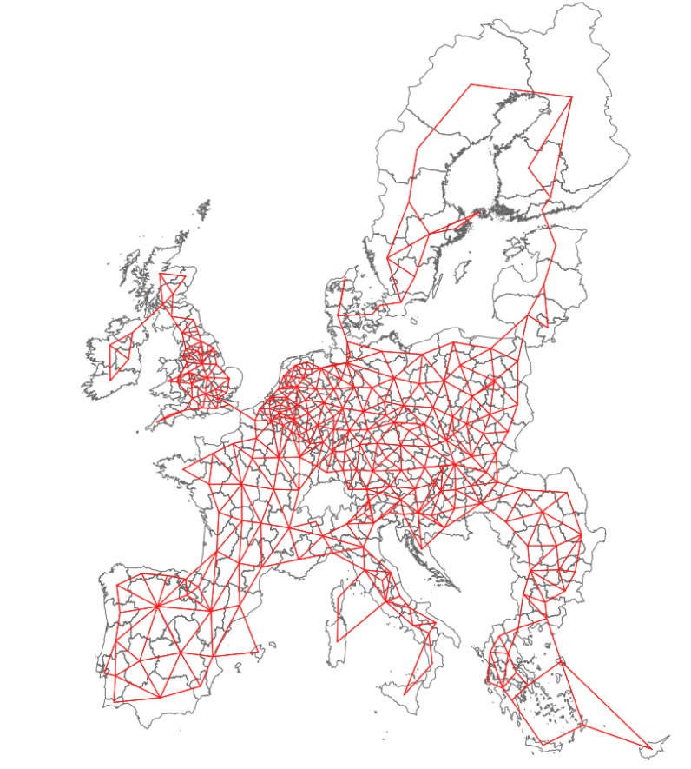
Figure S1: Network of neighbourhood relationships between NUTS2 regions. Two regions are identified as neighbours if they are adjacent (i.e., they share boundaries) with at least two other regions. For regions without shared boundaries, their neighbourhood relationship is determined by proximity to the nearest two regions

Appendix III: Graphical representation of the response variable and the covariates

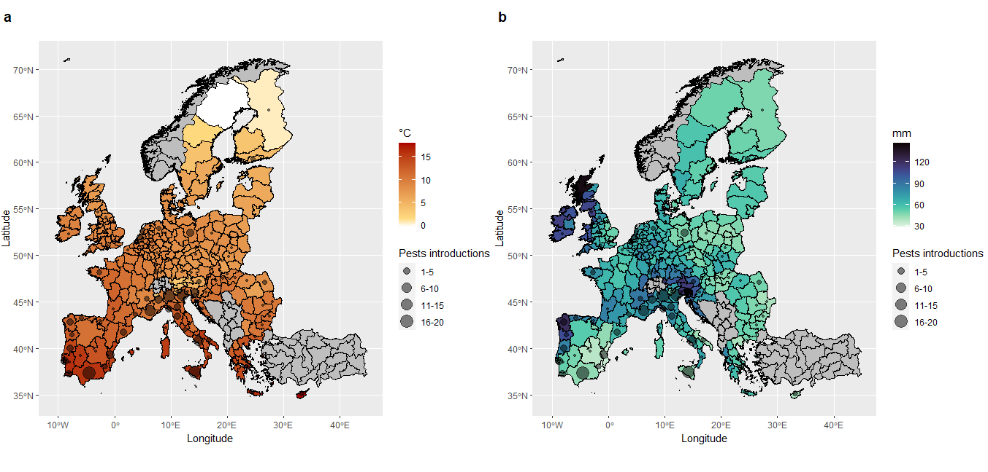
Figure S1: Maps of average temperature (S1a. figure on the left) and average precipitation (S1b. figure on the right) for NUTS2 regions in the EU. Data from WorldClim v2.1. The circles represent the pests’ first introduction cumulative counts for each NUTS2 region (Rosace et al. 2023)
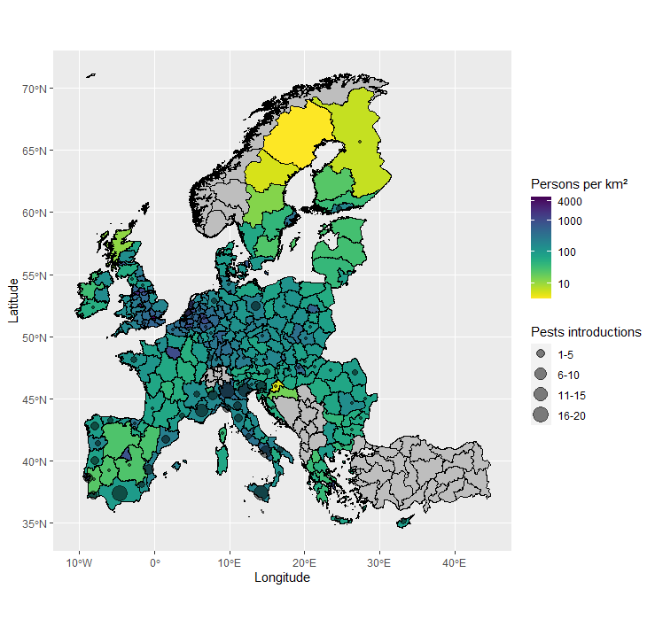
Figure S2: Map of human population density from Eurostat. Data were normalised by the area for each NUTS2 region. This normalised population density indicates how densely populated each NUTS2 region is, relative to its size. The circles represent the pests’ first introduction cumulative counts for each NUTS2 region (Rosace et al. 2023).

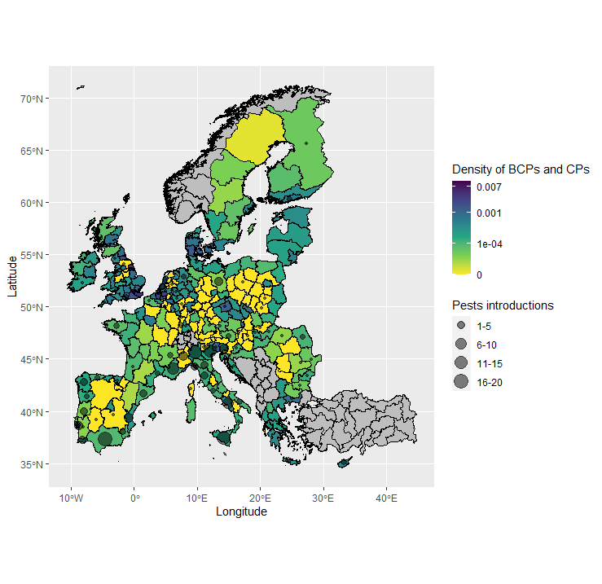
Figure S3: Map of the number of Border Control Posts (BCPs) and Control Posts (CPs) collected as described in Appendix I Table S1. The density of BCPs and CPs per unit NUTS2 area was calculated by dividing the number of BCPs and CPs in each NUTS2 region by the area of that region. The circles represent the pests’ first introduction cumulative counts for each NUTS2 region (Rosace et al. 2023).

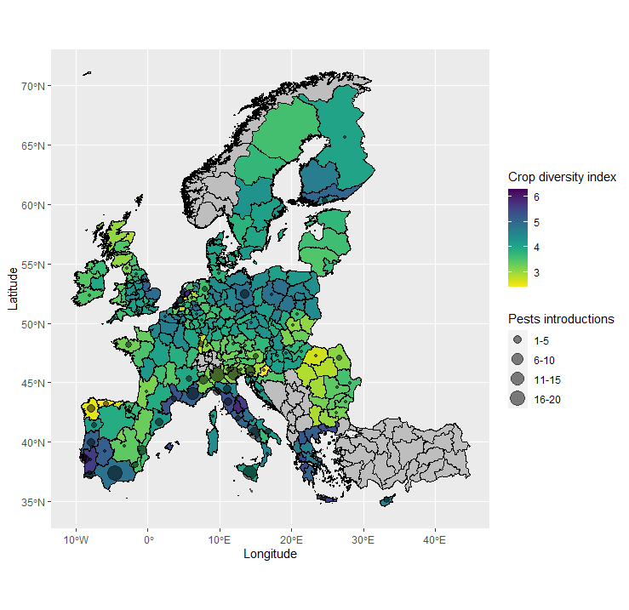
Figure S4: The map shows the EU crop diversity in 2018 (D’andrimont et al. 2022; Machefer et al. 2023). Data were normalised by area for each NUTS2 region. The circles represent the pests’ first introduction cumulative counts for each NUTS2 region (Rosace et al. 2023).

Appendix IV: The Pearson correlation matrix

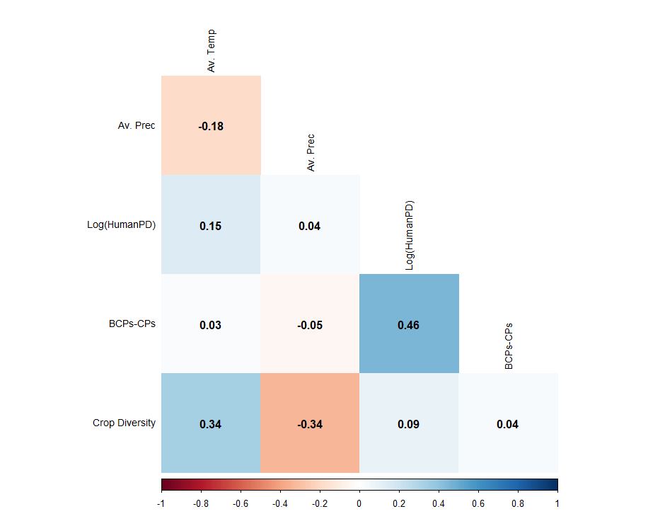
Figure S1: Pearson correlation matrix showing the correlation coefficients between variables. Each cell represents the correlation coefficient between two variables. A coefficient close to 1 indicates a strong positive correlation, meaning that as one variable increases, the other tends to increase as well. A coefficient close to -1 indicates a strong negative correlation, meaning that as one variable increases, the other tends to decrease. A coefficient close to 0 indicates little to no linear relationship between the variables. Av. Temp = Average Temperature; Av. Prec = Average Precipitation; Log(HumanPD) = Logarithm of Human Population Density; BCPs-CPs = Border Control Posts and Control Posts; Crop Diversity = Crop Diversity Index from (Machefer et al. 2023)

Appendix V: Model selection

Table 1: Best models for the relative risk of pest introductions in NUTS2 regions in the EU based on the Watanabe Akaike information criterion (WAIC) and deviance information criterion (DIC). Temp. = average temperature; Prec. = average precipitation; HumanPD = human population density; S = spatial random effect (u) + independent random effect (v)
Model | WAIC | DIC
Temp. + Prec. + log(HumanPD) + S | 457.70 | 456.04
Temp. + Prec. + log(HumanPD) + CropD + S | 458.61 | 456.11
Prec. + log(HumanPD) + S | 460.05 | 459.68
Temp. + log(HumanPD) + S | 461.36 | 458.69
log(HumanPD) + S | 461.64 | 460.55
Prec. + log(HumanPD) + CropD + S | 462.02 | 460.55
Temp. + log(HumanPD) + CropD + S | 462.04 | 459.14
log(HumanPD) + CropD + S | 464.66 | 462.23
log(HumanPD) + BCPs-CPs+ S | 476.96 | 462.75
Prec. + log(HumanPD) + BCPs-CPs + S | 488.51 | 461.49

