Supplementary information

Application of Gaussian Process to Various Plume Sizes
This part focuses on the behavior of the Gaussian process for different plume sizes. Specifically, we studied the variation of the spatial scales and the variance. GP optimization calculations were run for two different plume sizes; in the case of the big plume, the X1 and X2 scale hyperparameters along the direction of the wind are five times larger than for the small plume. The size of the plume can therefore have an impact on the hyperparameters.
The evolution of the hyperparameters values were plotted in Figure A1, for a small and large plume, to show the impact of the size of the plume on the X2 scale. In the case of the small plume, the X2 scale reaches a value of about 20, whereas it goes up to 70 for the large plume. The X1 scale, similarly to the X2 scale, reached higher values with the larger plume than for the smaller plume, and the variance was more or less unchanged.
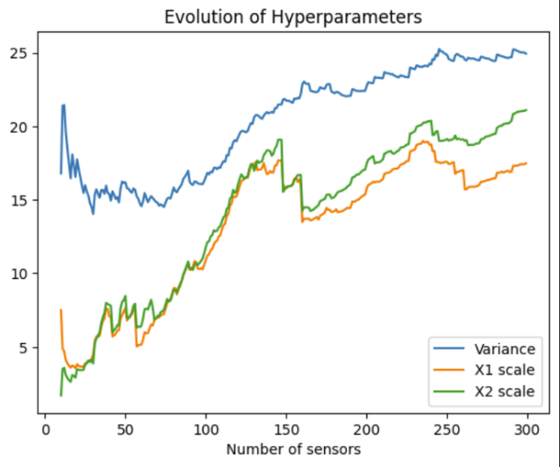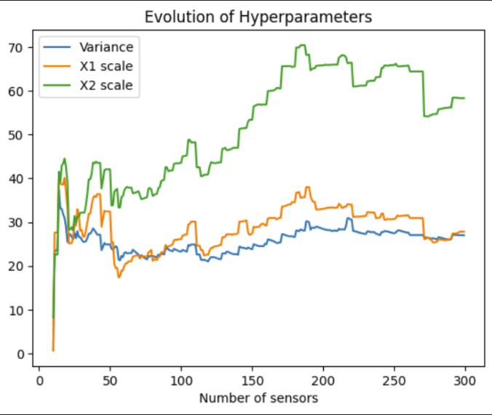
(a) (b)
Supplementary Figure A1-Hyperparameters evolution for a small plume (a) and a large plume (b)

Tuning of the Analytical Plume Generator
The analytical plumes were tuned by increasing the dispersion scales owing to the increased mixing in the region, in order to replicate a WSPEEDI plume
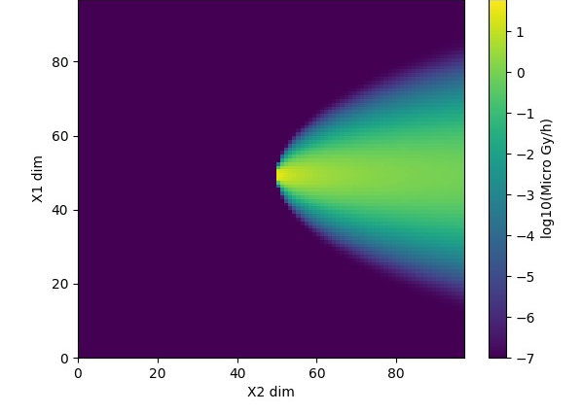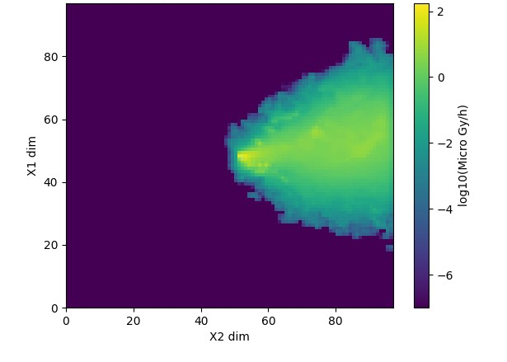
(a) (b)
Supplementary Figure A2-Plume generated by the analytical generator (a) and WSPEEDI (b)

Histograms of the R² scores for homogeneous, Adjustable grid majority-voting network and combined approach networks

- (b)

(C)
Supplementary Figure A3.-R² scores histograms of the homogeneous network: (a) Adjustable grid majority-voting network (b) and combined approach (c) for 49 sensors

