Supplementary material for
Environmental Research

Quality improvement of soybean meal by simultaneous microbial fermentation and enzymolysis and untargeted metabolomic analysis of its metabolites

Hongye Shen¹, Yongxu Li¹, Hao Song¹, Jie Bai¹, Nan Peng¹, Xiangyang Ge¹, Shumiao Zhao¹*
¹ National Key Laboratory of Agricultural Microbiology and College of Life Science and Technology, Huazhong Agricultural University, Wuhan 430070, China.
*Corresponding authors:
Shumiao Zhao, Tel. /fax: +8602787281040; E-mail address: shumiaozhao@mail.hzau.edu.cn

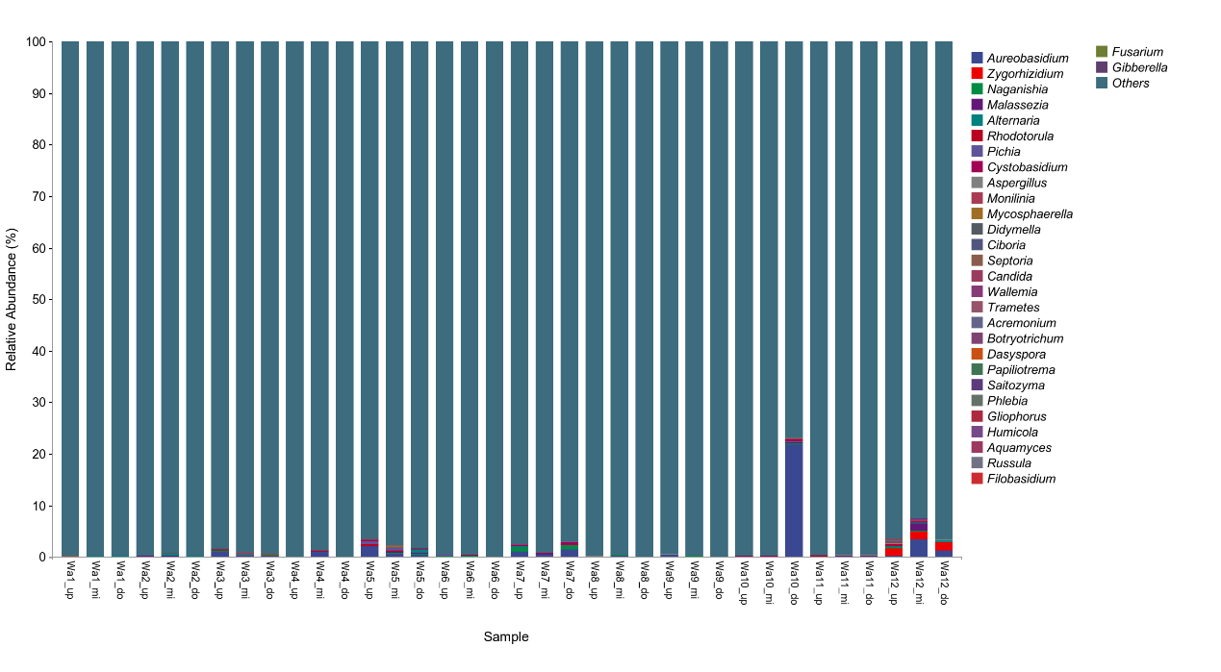
Fig. S1 Fungal community composition and structure of water samples at each site (genus level)
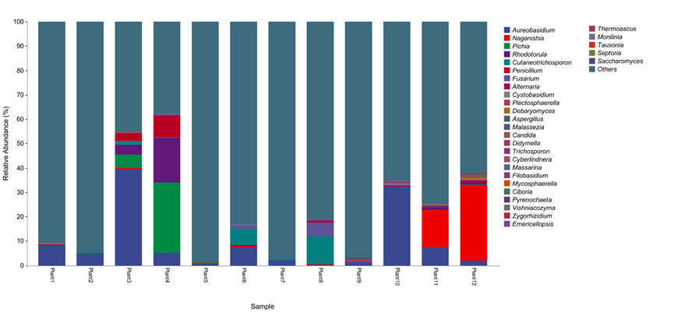
Fig. S2 Fungal community composition and structure of surface of submerged plant samples at each site (genus level)

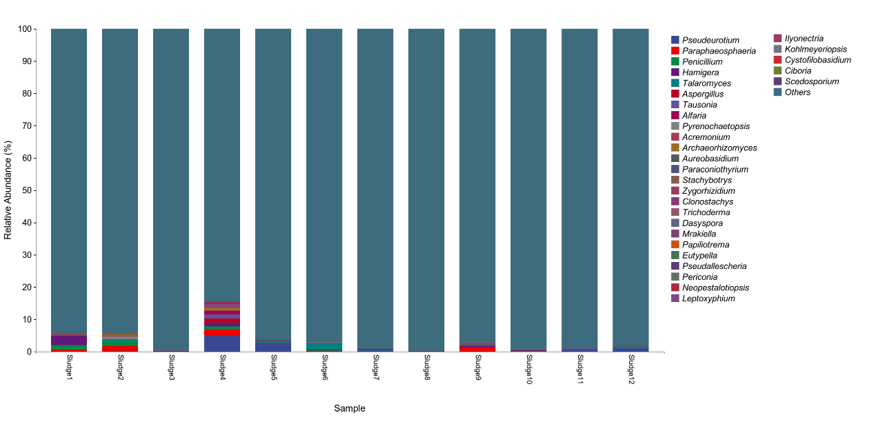
Fig. S3 Fungal community composition and structure of sludge samples at each site (genus level)

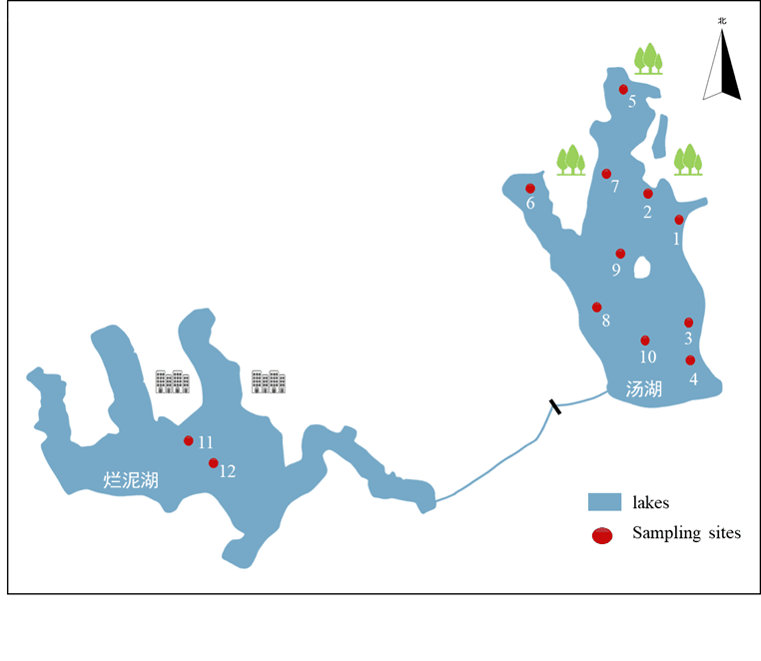
Fig. S4 Map of sampling locations

