Supplementary information
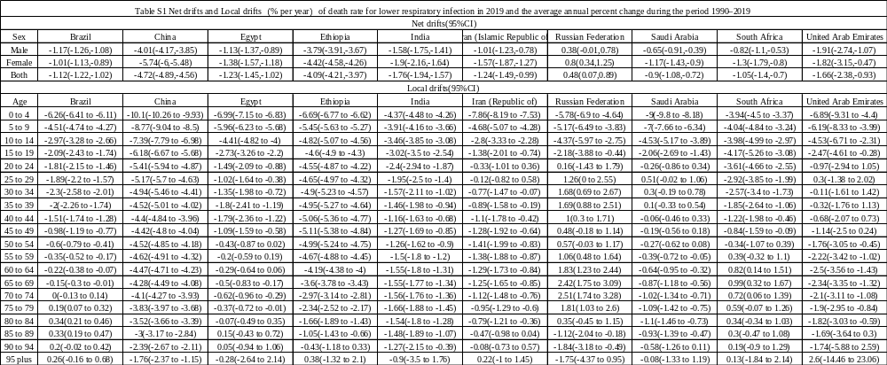
Table S1 Net drifts and Local drifts（% per year）of death rate for lower respiratory infection in 2019 and the average annual percent change during the period 1990–2019 in the BRICS+ countries

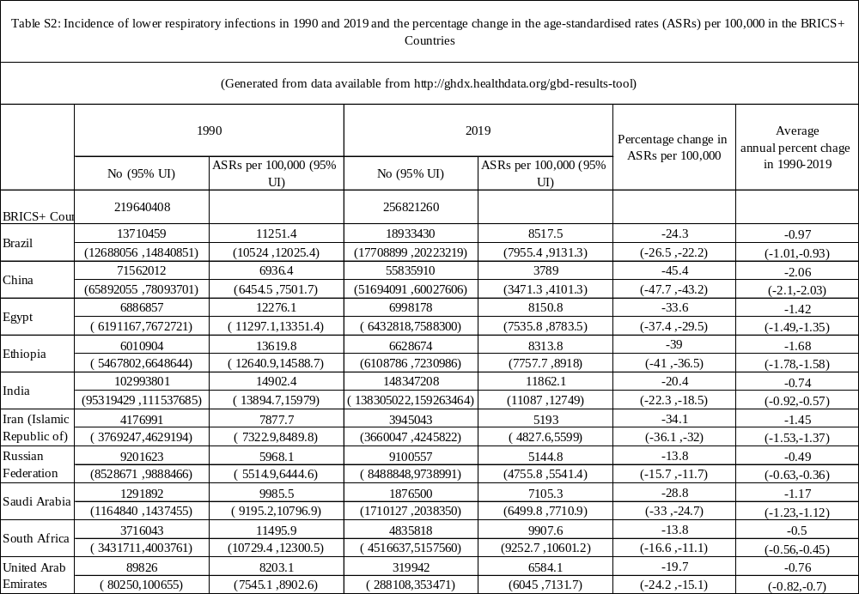
Table S2: Incidence of lower respiratory infections in 1990 and 2019 and the percentage change in the age-standardised rates (ASRs) per 100,000 in the BRICS+ Countries

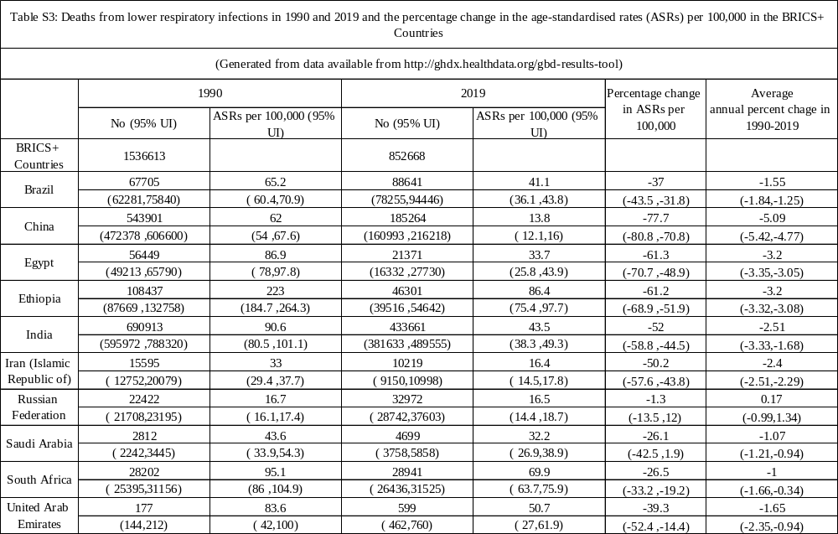
Table S3: Deaths from lower respiratory infections in 1990 and 2019 and the percentage change in the age-standardised rates (ASRs) per 100,000 in the BRICS+ Countries

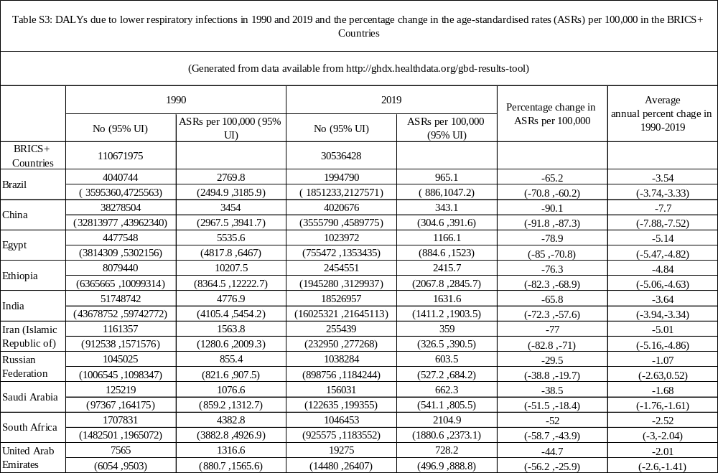
Table S4: DALYs due to lower respiratory infections in 1990 and 2019 and the percentage change in the age-standardised rates (ASRs) per 100,000 in the BRICS+ Countries

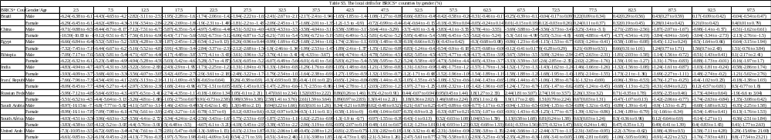
Table S5. The local drifts for BRICS+ countries by gender

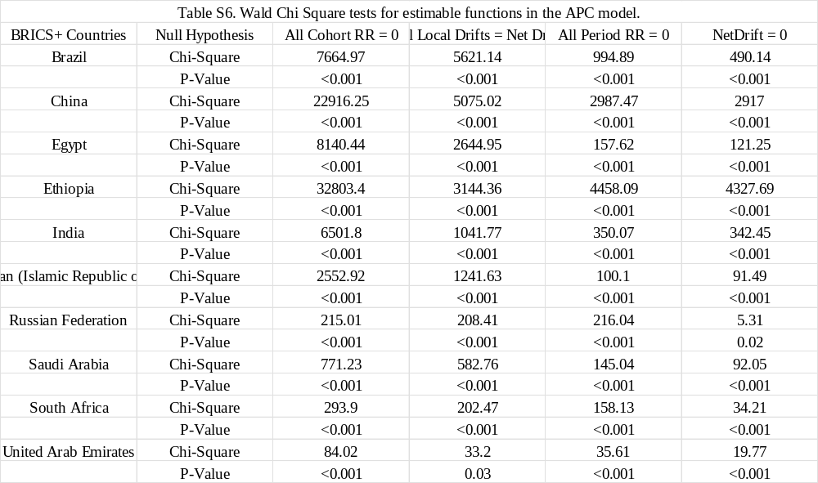
Table S6. Wald Chi Square tests for estimable functions in the APC model.

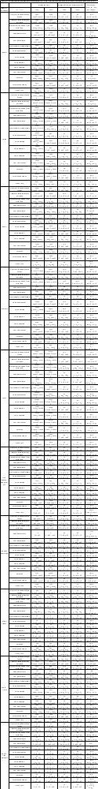
Table S7. The LRI deaths and mortality attributable to the 14 risk factors in 1990 and 2019, and trends of mortality from 2000 to 2019.

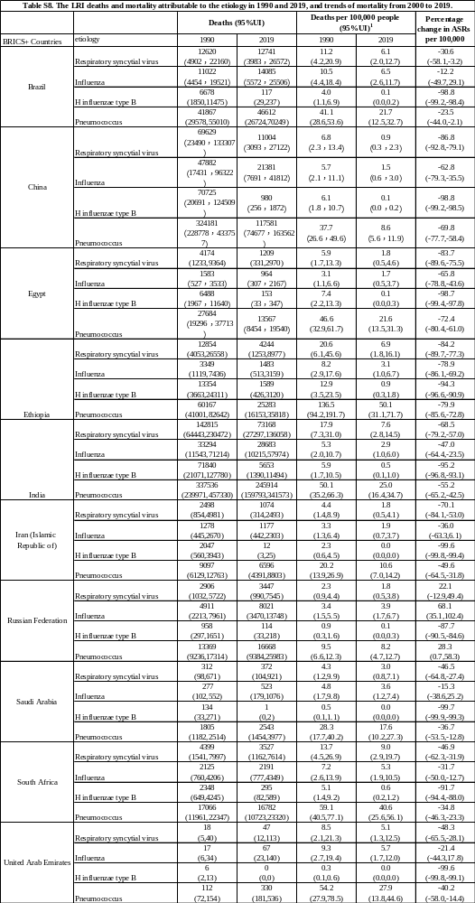
Table S8. The LRI deaths and mortality attributable to the etiology in 1990 and 2019, and trends of mortality from 2000 to 2019.

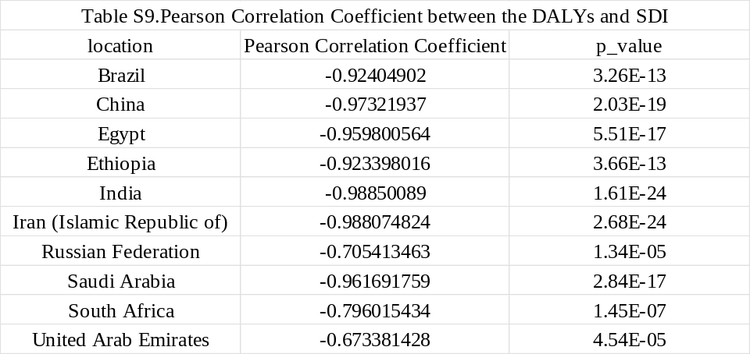
Table S9. Pearson Correlation Coefficient between the DALYs and SDI

