Biological trace element research
Health risks associated with trace elements and macrominerals in cultivars grown on Yamuna floodplain using various soil amendments: a correlation analysis
Pooja Sharma¹, Sophayo Mahongnao¹ and Sarita Nanda^{1*}
¹Department of Biochemistry, Daulat Ram College for Women, University of Delhi, Delhi - 110007,
India.
*Correspondence:
Department of Biochemistry, Daulat Ram College for Women, University of Delhi,
4, Patel Marg, Maurice Nagar, Delhi- 110007, India.
Mob.- (+91) 9999680604
saritananda123@gmail.com

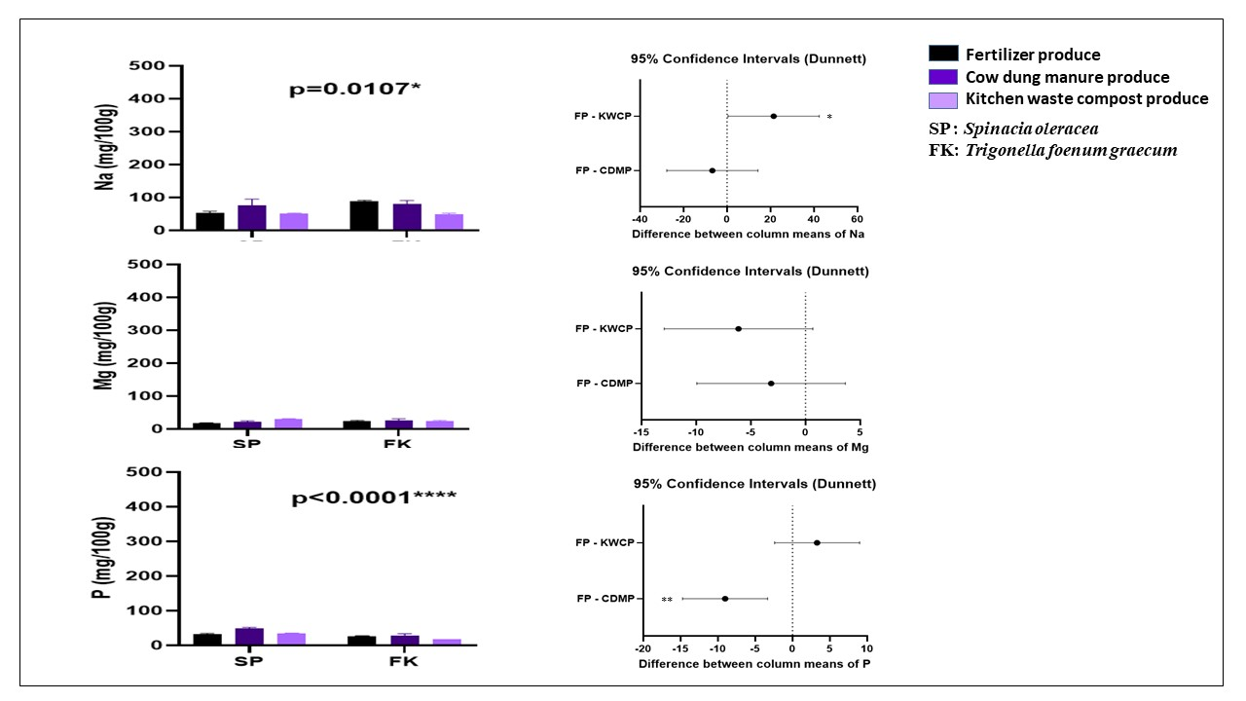
(f)
(d)
(b)
(e)
(c)
(a)
Fig. S1 Macro-minerals (mean ± standard error) of winter season (n=3) YFP cultivars
These graphs show (a) Sodium (Na) content. (b) Dunette for Na. (c) Magnesium (Mg) content. (d) Dunette for Mg. (e) Phosphorus (P) content. (f) Dunette for P. Asterisk (*) indicates statistical significance
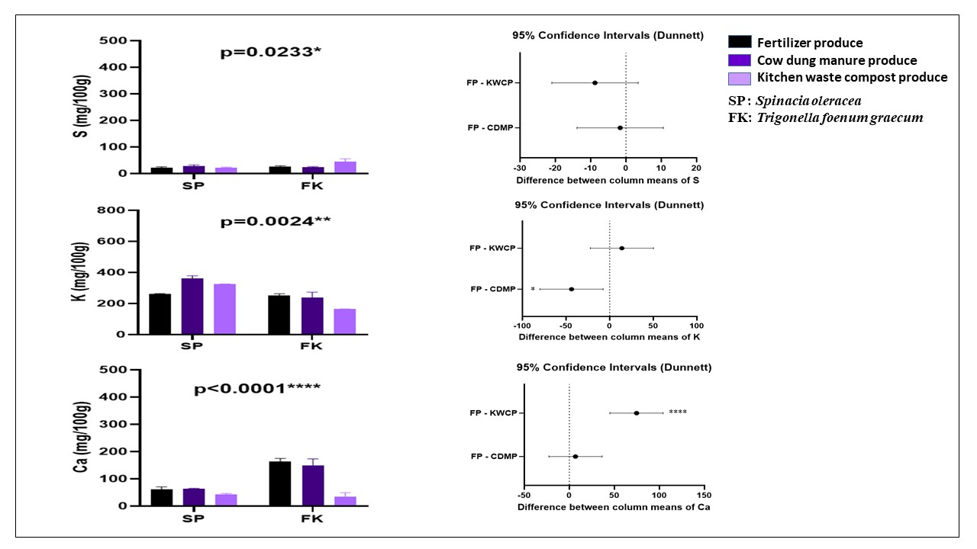
(d)
(f)
(e)
(c)
(b)
(a)
Fig. S2 Macro-minerals (mean ± standard error) of winter season (n=3) YFP cultivars
These graphs show (a) Sulphur (S) content. (b) Dunette for S. (c) Potassium (K) content. (d) Dunette for K. (e) Calcium (Ca) content. (f) Dunette for Ca. Asterisk (*) indicates statistical significance
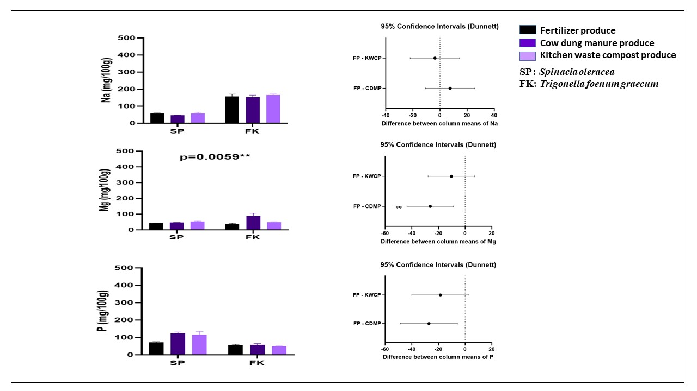
(f)
(e)
(c)
(d)
(b)
(a)
Fig. S3 Macro-minerals (mean ± standard error) of winter season (n=3) garden cultivars
These graphs show (a) Sodium (Na) content. (b) Dunette for Na. (c) Magnesium (Mg) content. (d) Dunette for Mg. (e) Phosphorus (P) content. (f) Dunette for P. Asterisk (*) indicates statistical significance

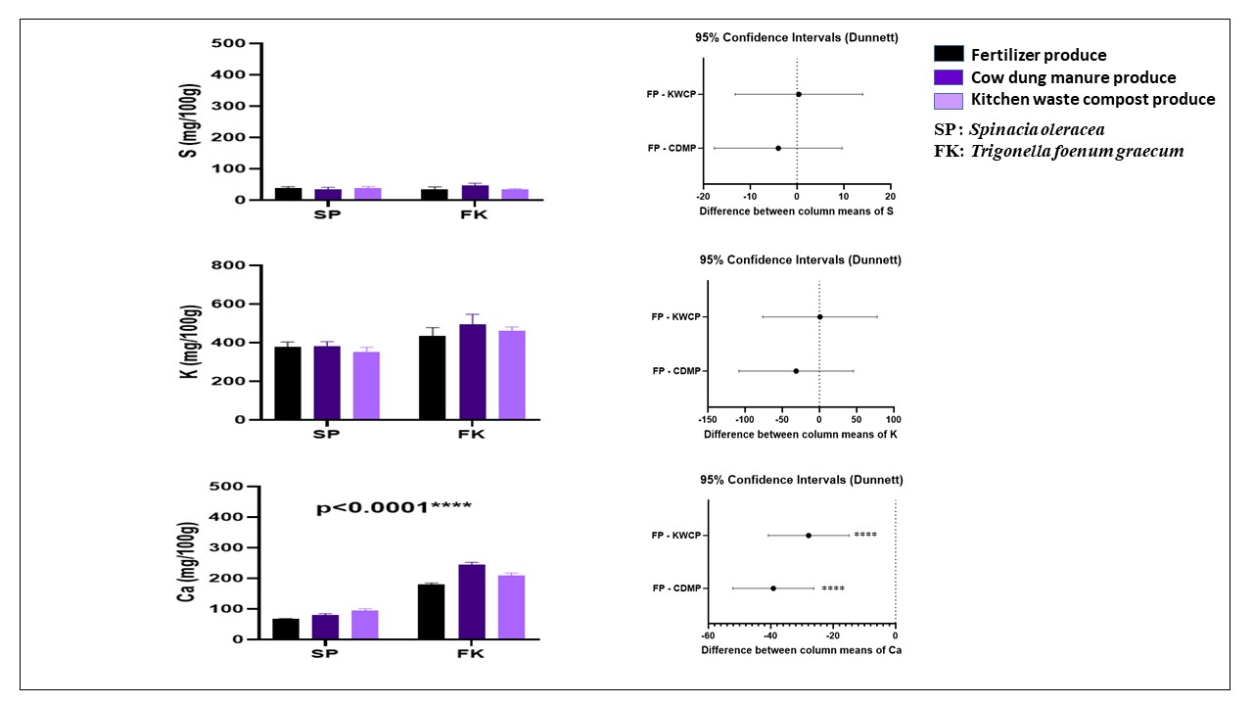
(d)
(f)
(e)
(b)
(c)
(a)
Fig. S4 Macro-minerals (mean ± standard error) of winter season (n=3) garden cultivars
These graphs show (a) Sulphur (S) content. (b) Dunette for S. (c) Potassium (K) content. (d) Dunette for K. (e) Calcium (Ca) content. (f) Dunette for Ca. Asterisk (*) indicates statistical significance
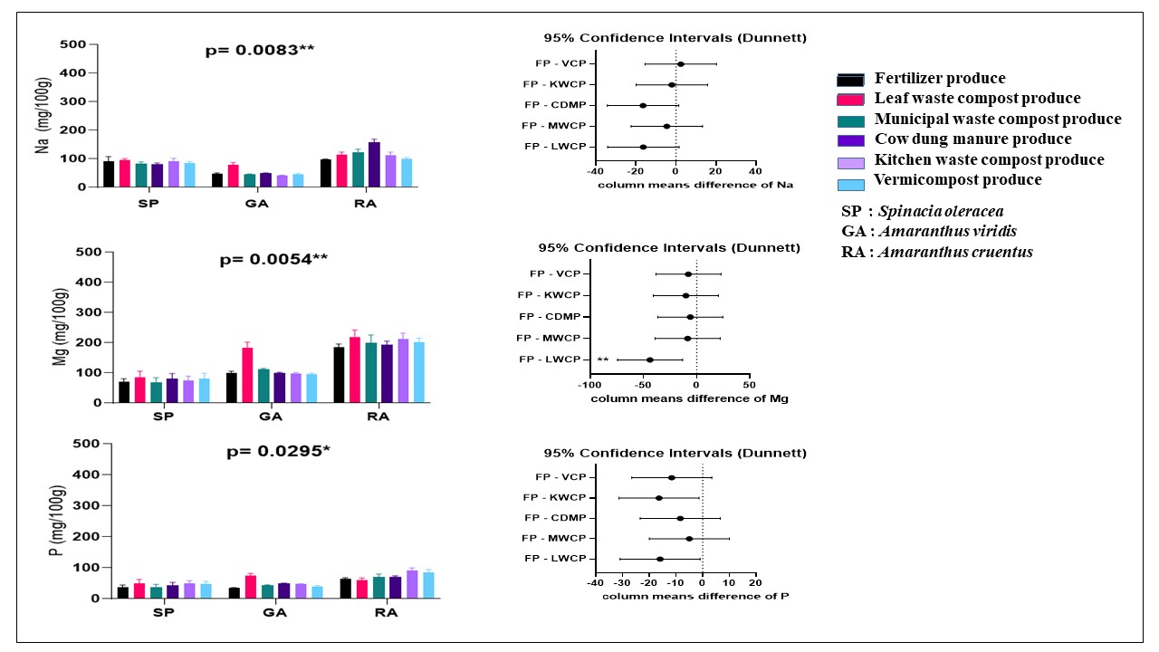
(d)
(f)
(e)
(c)
(a)
(b)
Fig. S5 Macro-minerals (mean ± standard error) of summer season (n=3) YFP cultivars
These graphs show (a) Sodium (Na) content. (b) Dunette for Na (c) Magnesium (Mg) content. (d) Dunette for Mg (e) Phosphorus (P) content. (f) Dunette for P. Asterisk (*) indicates statistical significance
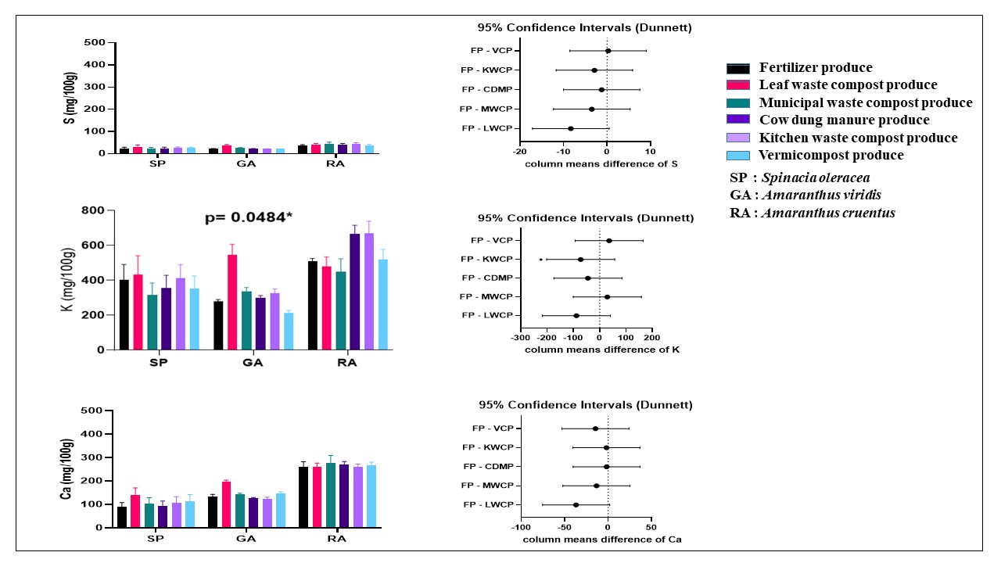
(d)
(f)
(e)
(c)
(b)
(a)
Fig. S6 Macro-minerals (mean ± standard error) of summer season (n=3) YFP cultivars
These graphs show (a) Sulphur (S) content. (b) Dunette for S. (c) Potassium (K) content. (d) Dunette for K. (e) Calcium (Ca) content. (f) Dunette for Ca. Asterisk (*) indicates statistical significance
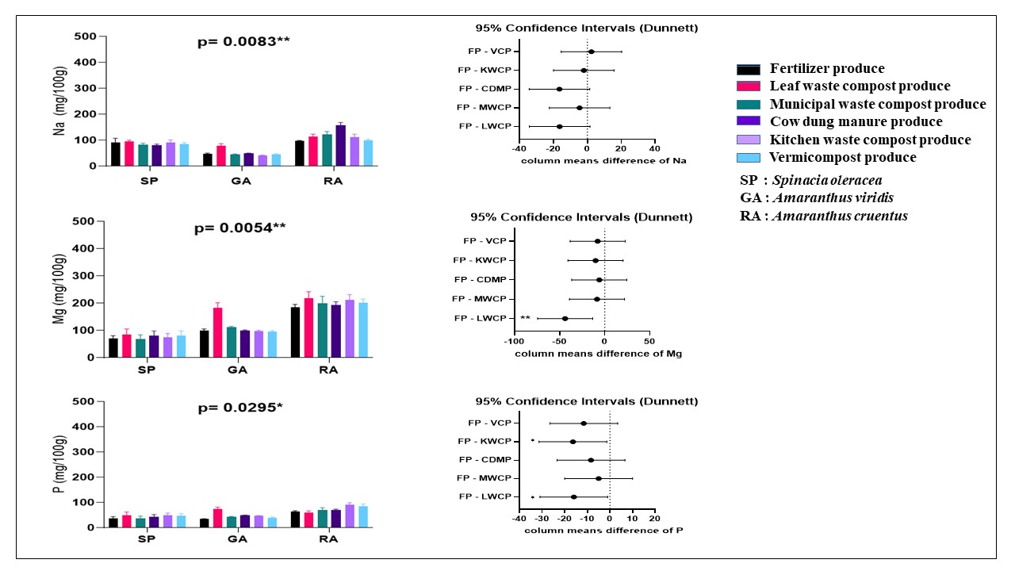
(b)
(a)
(d)
(f)
(e)
(c)
Fig. S7 Macro-minerals (mean ± standard error) of summer season (n=3) garden cultivars
These graphs show (a) Sodium (Na) content. (b) Dunette for Na (c) Magnesium (Mg) content. (d) Dunette for Mg (e) Phosphorus (P) content. (f) Dunette for P. Asterisk (*) indicates statistical significance
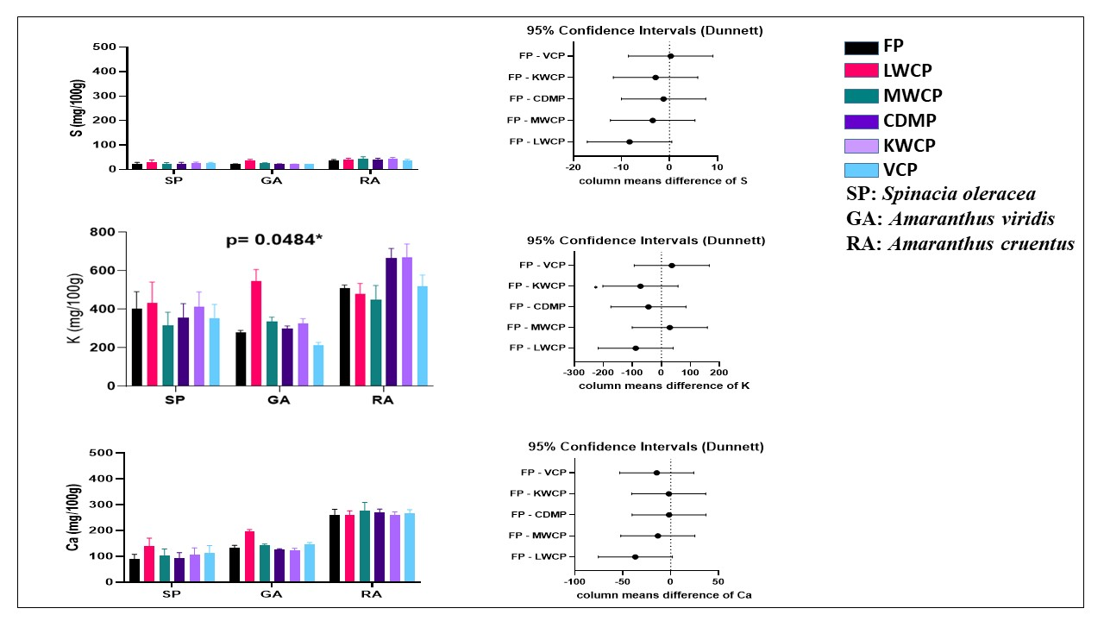
(c)
(d)
(f)
(e)
(b)
(a)
Fig. S8 Macro-minerals (mean ± standard error) of summer season (n=3) garden cultivars
These graphs show (a) Sulphur (S) content. (b) Dunette for S. (c) Potassium (K) content. (d) Dunette for K. (e) Calcium (Ca) content. (f) Dunette for Ca. Asterisk (*) indicates statistical significance
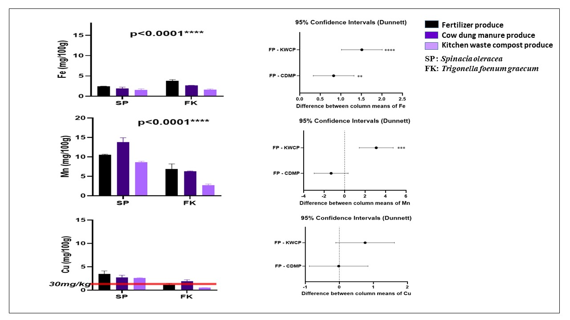

Fig. S9 Trace elements (mean ± standard error) of winter season (n=3) YFP cultivars
(e)
(f)
(d)
(c)
(b)
(a)
These graphs show (a) Iron (Fe) content. (b) Dunette for Fe. (c) Manganese (Mn) content. (d) Dunette for Mn. (e) Copper (Cu) content. (f) Dunette for Cu. Asterisk (*) indicates statistical significance
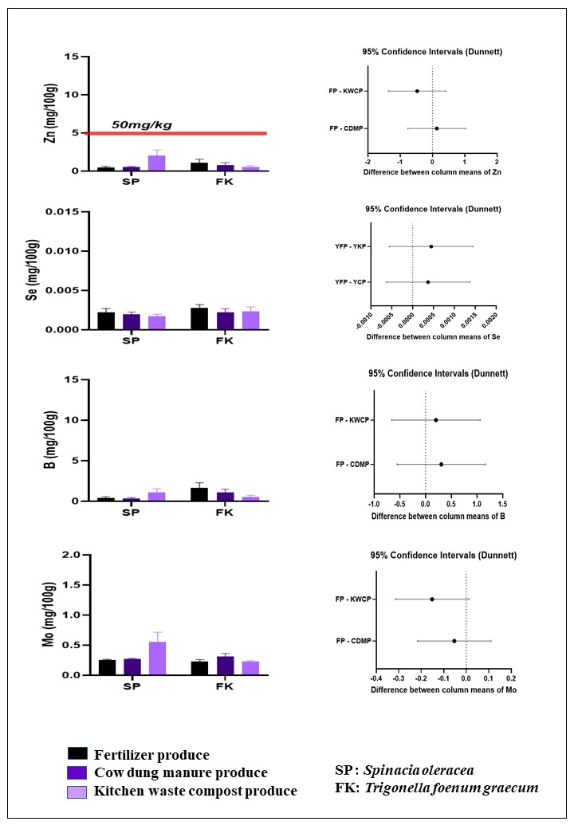
(h)
(f)
(d)
(a)
(g)
(c)
(e)
(b)
Fig. S10 Trace elements (mean ± standard error) of winter season (n=3) YFP cultivars
These graphs show (a) Zinc (Zn) content. (b) Dunette for Zn. (c) Selenium (Se) content. (d) Dunette for Se. (e) Boron (B) content. (f) Dunette for B. (g) Molybdenum (Mo) content. (h) Dunette for Mo. Asterisk (*) indicates statistical significance
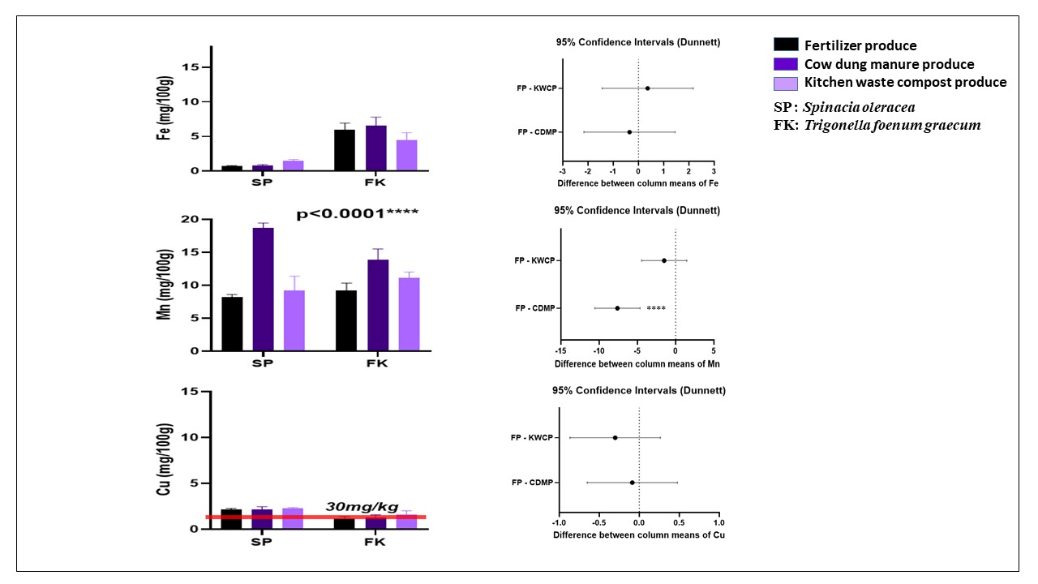
(b)
(d)
(f)
(e)
(c)
(a)
Fig. S11 Trace elements (mean ± standard error) of winter season (n=3) garden cultivars
These graphs show (a) Iron (Fe) content. (b) Dunette for Fe. (c) Manganese (Mn) content. (d) Dunette for Mn. (e) Copper (Cu) content. (f) Dunette for Cu. Asterisk (*) indicates statistical significance
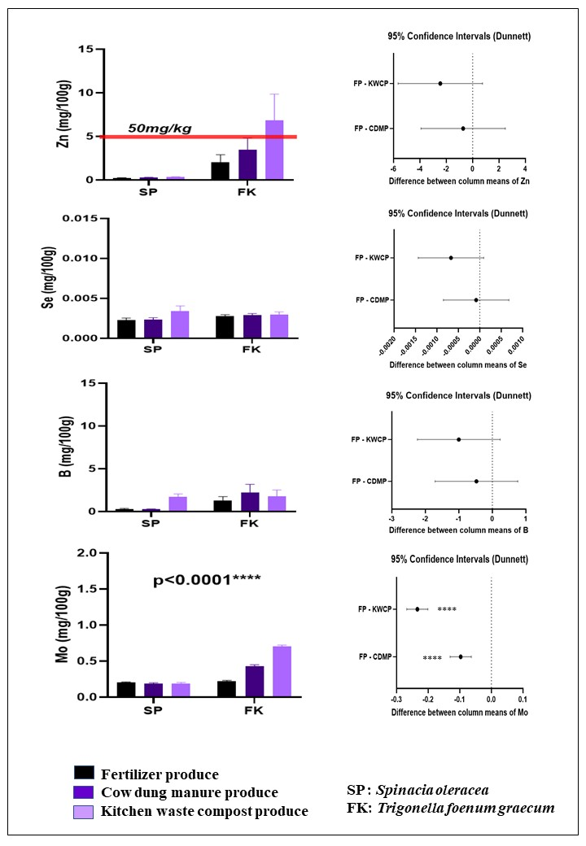
(b)
(d)
(f)
(h)
(g)
(e)
(a)
(c)
Fig. S12 Trace elements (mean ± standard error) of winter season (n=3) garden cultivars
These graphs show (a) Zinc (Zn) content. (b) Dunette for Zn. (c) Selenium (Se) content. (d) Dunette for Se. (e) Boron (B) content. (f) Dunette for B. (g) Molybdenum (Mo) content. (h) Dunette for Mo. Asterisk (*) indicates statistical significance
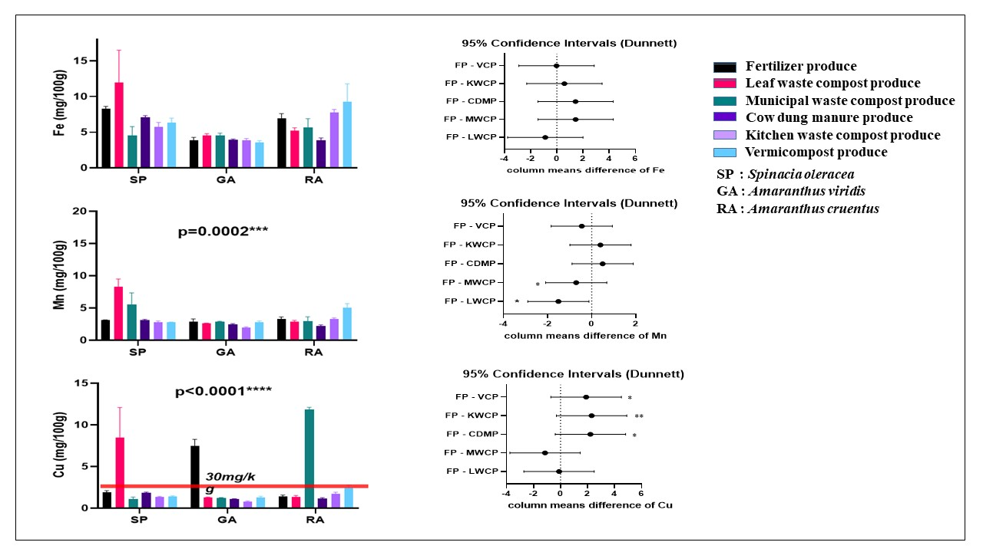
(f)
(b)
(d)
(e)
(c)
(a)
Fig. S13 Trace elements (mean ± standard error) of summer season (n=3) YFP cultivars
These graphs show (a) Iron (Fe) content. (b) Dunette for Fe. (c) Manganese (Mn) content. (d) Dunette for Mn. (e) Copper (Cu) content. (f) Dunette for Cu. Asterisk (*) indicates statistical significance
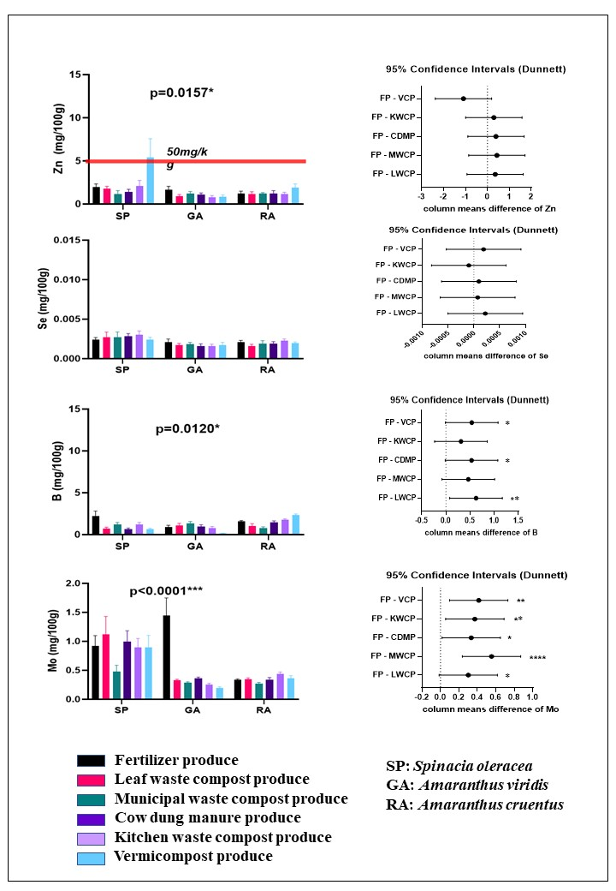Fig. S14 Trace elements (mean ± standard error) of summer season (n=3) YFP cultivars
(e)
(g)
(h)
(f)
(d)
(a)
(c)
(b)
These graphs show (a) Zinc (Zn) content. (b) Dunette for Zn. (c) Selenium (Se) content. (d) Dunette for Se. (e) Boron (B) content. (f) Dunette for B (g) Molybdenum (Mo) content. (h) Dunette for Mo. Asterisk (*) indicates statistical significance
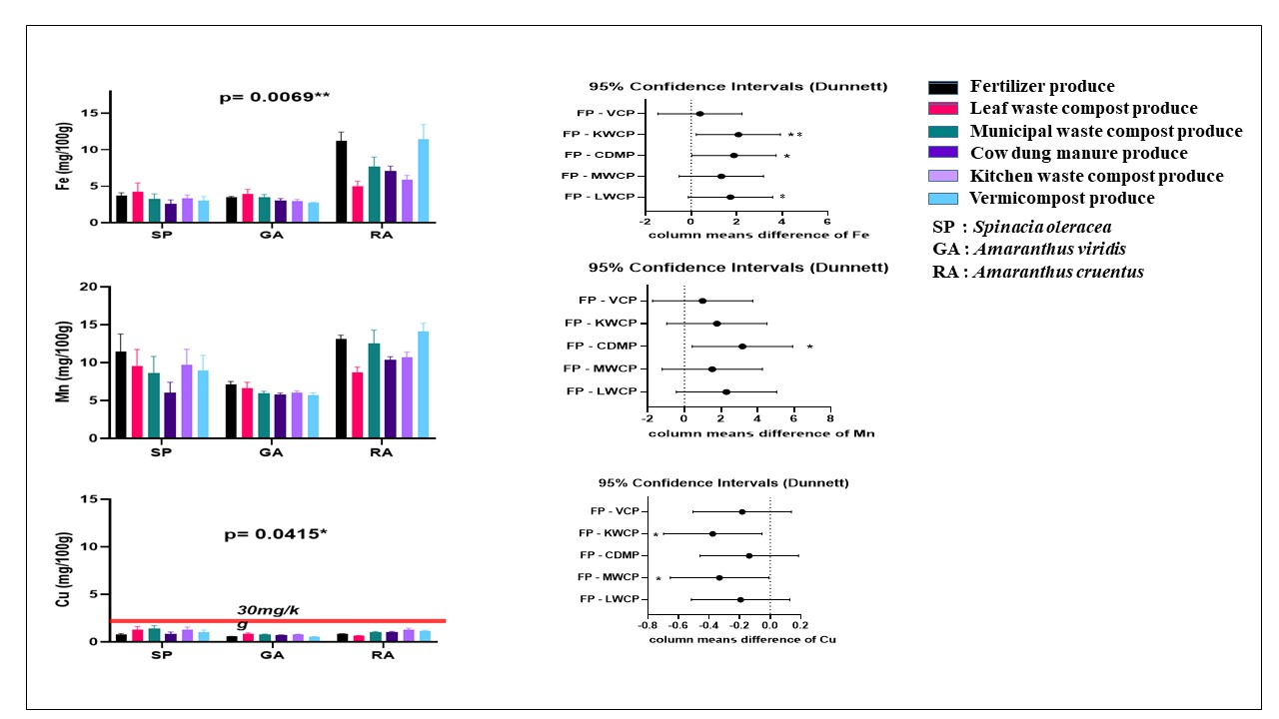Fig. S15 Trace elements (mean ± standard error) of summer season (n=3) garden cultivars
(a)
(b)
(d)
(f)
(e)
(c)
These graphs show (a) Iron (Fe) content. (b) Dunette for Fe (c) Manganese (Mn) content. (d) Dunette for Mn (e) Copper (Cu) content. (f) Dunette for Cu. Asterisk (*) indicates statistical significance

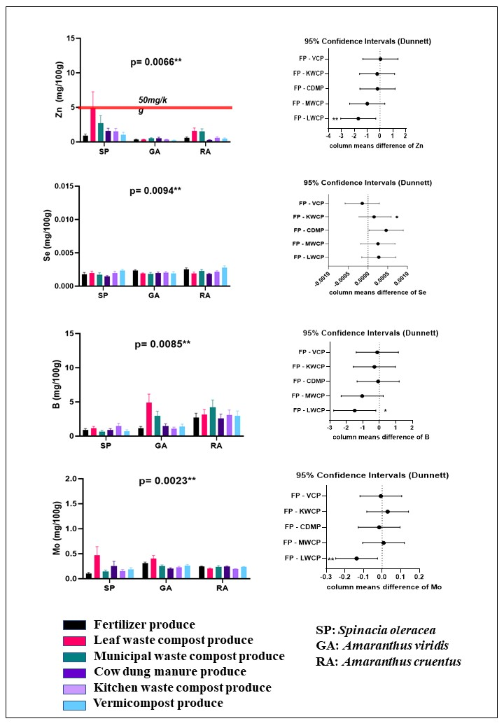
(h)
(f)
(d)
(b)
(g)
(c)
(e)
(a)
Fig. S16 Trace elements (mean ± standard error) of summer season (n=3) garden cultivars
These graphs show (a) Zinc (Zn) content. (b) Dunette for Zn (c) Selenium (Se) content. (d) Dunette for Se (e) Boron (B) content. (f) Dunette for B (g) Molybdenum (Mo) content. (h) Dunette for Mo. Asterisk (*) indicates statistical significance

