Appendix Figure 1. Distribution of kernel density of the propensity score distribution in dulaglutide and liraglutide users before and after propensity score matching

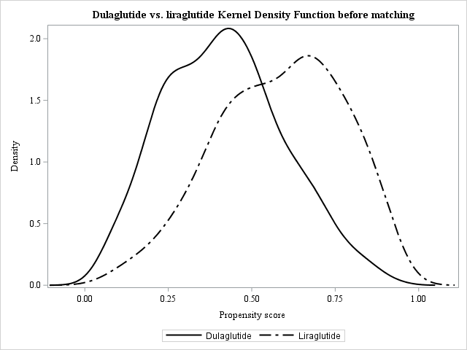
(b)
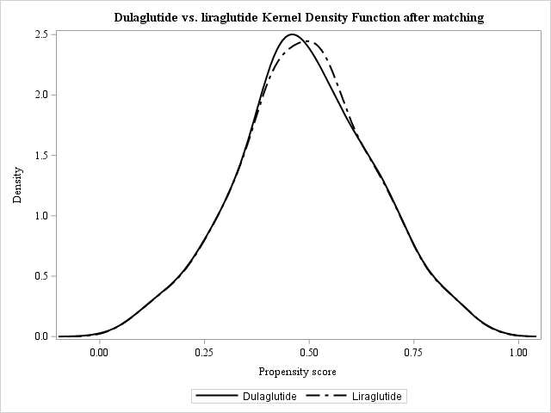
Legend: (a) Before propensity score matching, and (b) after propensity score matching.
Appendix Table 1. Search strategy and key terms for meta-analysis

# | Search
 | Patient
1 | Type 2 diabetes mellitus
 | Intervention and comparison
2 | Dulaglutide
3 | Liraglutide
 | Outcome
4 | Glycated hemoglobin
5 | HbA1c
6 | 4 or 5
7 | Body weight
8 | Body mass index
9 | 7 or 8
10 | Blood pressure
11 | Renal
12 | Glomerular filtration rate
13 | 11 or 12
14 | Liver
15 | Alanine aminotransferase
16 | 14 or 15
17 | 6 or 9 or 10 or 13 or 16
18 | 1 and 2 and 3 and 17

Appendix Table 2. Comparison of clinical effectiveness between liraglutide and dulaglutide (sensitivity analyses)
 | Dulaglutide |  | Liraglutide |  | Dulaglutide versus liraglutide
 | Baseline (SD) | Change from baseline (SE)¹ | Baseline (SD) | Change from baseline (SE)¹ | Mean difference (95% CI)²
Sensitivity 1: as-treated scenario
HbA1c (%) | 9.36 (1.66) | -1.07 (0.05)*** | 9.33 (1.57) | -0.77 (0.05)*** | -0.30 (-0.45 to -0.16)***
Weight (kg) | 77.83 (17.69) | -1.06 (0.27)*** | 77.53 (16.81) | -1.68 (0.26)*** | 0.61 (-0.11 to 1.35)
SBP (mmHg) | 140.71 (19.94) | -1.97 (0.67)** | 140.24 (20.24) | -0.49 (0.70) | -1.47 (-3.39 to 0.43)
ALT (U/L) | 36.10 (30.23) | -2.82 (0.93)** | 35.47 (32.66) | -3.19 (0.96)*** | 0.36 (-2.27 to 2.99)
eGFR (ml/min/1.73 m²) | 82.43 (38.21) | -2.71 (0.57)*** | 82.13 (35.69) | -1.95 (0.55)*** | -0.76 (-2.33 to 0.81)
Sensitivity 2: only stable users of GLP-1ra
HbA1c (%) | 9.29 (1.62) | -1.03 (0.06)*** | 9.31 (1.57) | -0.84 (0.07)*** | -0.19 (-0.38 to -0.01)*
Weight (kg) | 78.92 (18.08) | -1.50 (0.37)*** | 78.83 (16.50) | -2.27 (0.37)*** | 0.76 (-0.27 to 1.80)
SBP (mmHg) | 140.53 (19.60) | 2.38 (0.82)** | 139.90 (20.16) | -0.58 (0.91) | -1.79 (-4.21 to 0.61)
ALT (U/L) | 34.78 (28.31) | -2.03 (0.94)* | 36.18 (32.08) | -3.56 (1.12)** | 1.52 (-1.33 to 4.37)
eGFR (ml/min/1.73 m²) | 81.45 (37.91) | -1.24 (0.78) | 81.18 (33.51) | -1.64 (0.74)* | 0.40 (-1.74 to 2.54)
Sensitivity 3: healthy user bias adjustment (excluding GLP-1ra users also treated with DPP-4i or SGLT-2i)
HbA1c (%) | 9.34 (1.67) | -1.06 (0.05)*** | 9.33 (1.59) | -0.82 (0.05)*** | -0.24 (-0.39 to -0.08)**
Weight (kg) | 77.82 (17.64) | -1.19 (0.32)*** | 77.22 (16.73) | -1.61 (0.32)*** | 0.41 (-0.48 to 1.31)
SBP (mmHg) | 141.02 (19.76) | -2.50 (0.70)*** | 140.27 (20.43) | -0.49 (0.75) | -2.00 (-4.04 to 0.02)
ALT (U/L) | 36.41 (30.36) | -3.37 (0.87)*** | 35.24 (32.68) | -3.72 (0.97)*** | 0.34 (-2.21 to 2.90)
eGFR (ml/min/1.73 m²) | 83.20 (38.27) | -2.03 (0.73)** | 82.11 (35.64) | -2.04 (0.65)** | 0.01 (-1.90 to 1.93)
Sensitivity 4: IPTW-based sample
HbA1c (%) | 9.35 (2.37) | -1.06 (0.04)*** | 9.38 (2.26) | -0.86 (0.04)*** | -0.20 (-0.33 to -0.07)**
Weight (kg) | 77.71 (25.11) | -1.27 (0.27)*** | 77.44 (23.62) | -1.62 (0.27)*** | 0.35 (-0.40 to 1.10)
SBP (mmHg) | 139.80 (27.98) | -1.53 (0.58)** | 139.88 (28.11) | -1.13 (0.60) | -0.40 (-2.05 to 1.24)
ALT (U/L) | 35.38 (42.42) | -2.30 (0.70)** | 35.26 (45.30) | -2.77 (0.82)*** | 0.46 (-1.64 to 2.58)
eGFR (ml/min/1.73 m²) | 82.16 (53.94) | -2.45 (0.57)*** | 82.47 (51.24) | -2.71 (0.54)*** | 0.25 (-1.29 to 1.80)
Sensitivity 5: SMRW-based sample
HbA1c (%) | 9.42 (1.75) | -1.11 (0.04)*** | 9.46 (1.66) | -0.90 (0.04)*** | -0.20 (-0.33 to -0.07)**
Weight (kg) | 77.93 (17.78) | -1.28 (0.27)*** | 77.13 (16.52) | -1.39 (0.26)*** | 0.11 (-0.63 to 0.86)
SBP (mmHg) | 139.72 (19.77) | -1.57 (0.59)** | 139.67 (19.97) | -0.78 (0.60) | -0.79 (-2.46 to 0.88)
ALT (U/L) | 35.56 (31.49) | -2.58 (0.72)*** | 34.86 (31.52) | -2.68 (0.81)*** | 0.09 (-2.04 to 2.23)
eGFR (ml/min/1.73 m²) | 82.04 (39.17) | -2.57 (0.58)*** | 81.60 (37.36) | -2.82 (0.53)*** | 0.24 (-1.31 to 1.80)
Abbreviations: SD, standard deviation; CI, confidence interval; SBP, systolic blood pressure; eGFR, estimated glomerular filtration rate; ALT, alanine aminotransferase; GLP-1ra, glucagon-like peptide-1 receptor agonist; DPP-4i, dipeptidyl peptidase-4 inhibitor; SGLT-2i, sodium-glucose transport protein-2 inhibitor; IPTW, inverse probability of treatment weighting; SMRW, standardized mortality ratio weighting.
Notes:
- “Change from baseline” in each treatment group was tested using the paired t-test.
- “Mean difference” between treatment groups was tested using the two-sample t-test.
*, **, and *** refer to p-value < 0.05, < 0.01, and < 0.001, respectively.

Appendix Table 3. Subgroup analyses for comparison of clinical effectiveness changes between dulaglutide and liraglutide at 12 months (based on the propensity-score-matched sample)
 | Dulaglutide |  | Liraglutide |  | Dulaglutide vs. liraglutide
 | Baseline  (SD) | Change from baseline  (SE)¹ | Baseline  (SD) | Change from baseline  (SE)¹ | Mean difference  (95% CI)²
HbA1c ≥ 9% (n = 1,161)
HbA1c (%) | 10.41 (1.28) | -1.63 (0.07)*** | 10.32 (1.15) | -1.35 (0.07)*** | -0.28 (-0.48 to -0.08)**
Weight (kg) | 76.10 (16.98) | -0.39 (0.38) | 75.27 (15.94) | -0.49 (0.36) | 0.10 (-0.94 to 1.14)
SBP (mmHg) | 141.39 (20.05) | -2.33 (0.91)* | 139.82 (20.21) | 0.82 (0.95) | -3.15 (-5.75 to -0.55)*
ALT (U/L) | 36.29 (31.24) | -2.94 (1.10)** | 33.78 (28.04) | -3.54 (0.95) | 0.59 (-2.25 to 3.44)
eGFR (ml/min/1.73 m²) | 82.64 (39.29) | -2.33 (0.92)* | 81.20 (36.70) | -4.13 (0.82) | 1.79 (-0.63 to 4.22)
HbA1c < 9% (n = 805)
HbA1c (%) | 7.89 (0.78) | -0.26 (0.05)*** | 7.88 (0.76) | -0.07 (0.06) | -0.19 (-0.36 to -0.02)*
Weight (kg) | 80.27 (18.40) | -2.21 (0.49)*** | 80.87 (17.51) | -3.35 (0.54)*** | 1.13 (-0.30 to 2.57)
SBP (mmHg) | 139.76 (19.76) | -2.66 (1.06)* | 140.87 (20.29) | -2.60 (1.10)* | -0.05 (-3.06 to 2.94)
ALT (U/L) | 35.84 (28.77) | -3.27 (1.23)** | 37.97 (38.37) | -3.82 (1.78)* | 0.54 (-3.69 to 4.78)
eGFR (ml/min/1.73 m²) | 82.13 (36.68) | -1.73 (1.03) | 83.44 (34.14) | 0.33 (0.95) | -2.06 (-4.83 to 0.70)
Age ≥ 65 years (n = 621)
HbA1c (%) | 9.42 (1.59) | -1.30 (0.09)*** | 9.40 (1.47) | -0.94 (0.09)*** | -0.36 (-0.62 to -0.10)**
Weight (kg) | 69.46 (13.10) | -0.58 (0.43) | 70.71 (12.07) | -1.89 (0.40)*** | 1.30 (0.13 to 2.48)*
SBP (mmHg) | 141.42 (19.94) | -2.78 (1.27)* | 141.71 (20.35) | 0.53 (1.47) | -3.32 (-7.14 to 0.49)
ALT (U/L) | 29.01 (23.11) | -1.47 (1.17) | 27.66 (29.84) | -2.72 (1.69) | 1.24 (-2.77 to 5.27)
eGFR (ml/min/1.73 m²) | 61.78 (28.20) | -1.26 (0.99) | 61.23 (27.43) | -1.97 (0.89)* | 0.71 (-1.92 to 3.34)
Age < 65 years (n = 1,345)
HbA1c (%) | 9.34 (1.69) | -0.95 (0.06)*** | 9.30 (1.61) | -0.78 (0.06)*** | -0.16 (-0.34 to 0.01)
Weight (kg) | 81.80 (18.21) | -1.41 (0.40)*** | 80.60 (17.72) | -1.53 (0.41) | 0.12 (-1.00 to 1.25)
SBP (mmHg) | 140.38 (19.94) | -2.32 (0.82)** | 139.59 (20.17) | -1.05 (0.81) | -1.26 (-3.54 to 1.01)
ALT (U/L) | 39.46 (32.55) | -3.84 (1.07)*** | 38.98 (33.27) | -4.07 (1.08)*** | 0.22 (-2.77 to 3.23)
eGFR (ml/min/1.73 m²) | 92.21 (38.45) | -2.47 (0.90)** | 91.53 (35.00) | -2.48 (0.81)** | 0.01 (-2.37 to 2.40)
eGFR ≥ 60 ml/min/1.73 m² (n = 1,416)
HbA1c (%) | 9.31 (1.65) | -1.00 (0.06)*** | 9.29 (1.54) | -0.77 (0.06)*** | -0.23 (-0.40 to -0.06)**
Weight (kg) | 78.74 (18.21) | -1.31 (0.38)*** | 78.52 (17.29) | -1.76 (0.38)*** | 0.45 (-0.60 to 1.50)
SBP (mmHg) | 139.79 (19.29) | -1.46 (0.77) | 139.61 (19.64) | -1.40 (0.79) | -0.05 (-2.24 to 2.13)
ALT (U/L) | 40.04 (32.83) | -4.67 (1.06)*** | 38.93 (36.02) | -4.74 (1.20)*** | 0.06 (-3.08 to 3.22)
eGFR (ml/min/1.73 m²) | 99.59 (29.66) | -5.00 (0.84)*** | 98.30 (27.36) | -4.59 (0.78)*** | -0.41 (-2.67 to 1.84)
eGFR < 60 ml/min/1.73 m² (n = 550)
HbA1c (%) | 9.49 (1.68) | -1.22 (0.10)*** | 9.44 (1.62) | -1.00 (0.10)*** | -0.22 (-0.51 to 0.06)
Weight (kg) | 75.58 (16.11) | -0.71 (0.48) | 74.99 (15.23) | -1.33 (0.52)** | 0.62 (-0.78 to 2.03)
SBP (mmHg) | 143.09 (21.37) | -5.06 (1.44)*** | 141.87 (21.67) | 1.60 (1.57) | -6.67 (-10.87 to -2.47)**
ALT (U/L) | 25.97 (18.73) | 1.01 (1.01) | 26.56 (19.06) | -0.84 (1.05) | 1.86 (-1.00 to 4.73)
eGFR (ml/min/1.73 m²) | 38.24 (15.54) | 5.43 (1.04)*** | 40.50 (14.83) | 3.49 (0.88)*** | 1.94 (-0.75 to 4.64)
ALT > UNL (n = 632)
HbA1c (%) | 9.25 (1.56) | -1.01 (0.08)*** | 9.28 (1.54) | -0.99 (0.10)*** | -0.02 (-0.28 to 0.23)
Weight (kg) | 84.75 (19.28) | -2.44 (0.60)*** | 82.93 (18.85) | -2.36 (0.61)*** | -0.08 (-1.77 to 1.61)
SBP (mmHg) | 141.81 (18.60) | -3.10 (1.18)** | 141.06 (19.13) | -1.01 (1.24) | -2.09 (-5.47 to 1.28)
ALT (U/L) | 65.07 (36.98) | -19.13 (2.00)*** | 67.79 (42.57) | -22.79 (2.40)*** | 3.65 (-2.45 to 9.76)
eGFR (ml/min/1.73 m²) | 92.08 (31.85) | -2.88 (1.22)* | 91.38 (32.71) | -1.81 (1.06) | -1.07 (-4.28 to 2.14)
ALT ≤ UNL (n = 1,334)
HbA1c (%) | 9.42 (1.71) | -1.09 (0.06)*** | 9.35 (1.58) | -0.76 (0.06)*** | -0.32 (-0.51 to -0.14)***
Weight (kg) | 74.37 (15.76) | -0.50 (0.34) | 75.11 (15.21) | -1.32 (0.35)*** | 0.82 (-0.14 to 1.80)
SBP (mmHg) | 140.16 (20.57) | -2.15 (0.85)* | 139.88 (20.72) | -0.36 (0.89) | -1.78 (-4.21 to 0.63)
ALT (U/L) | 21.60 (7.52) | 4.95 (0.47)*** | 21.00 (7.54) | 4.19 (0.51)*** | 0.04 (-1.32 to 1.41)
eGFR (ml/min/1.73 m²) | 77.59 (40.18) | -1.68 (0.83)* | 77.99 (36.21) | -2.56 (0.77)** | 0.87 (-1.35 to 3.11)
BMI ≥ 27 kg/m² (n = 1,197)
HbA1c (%) | 9.22 (1.63) | -0.95 (0.06)*** | 9.13 (1.55) | -0.70 (0.06)*** | -0.24 (-0.43 to -0.05)**
Weight (kg) | 86.80 (16.11) | -3.23 (0.41)*** | 85.67 (15.11) | -3.64 (0.40)*** | 0.40 (-0.73 to 1.54)
SBP (mmHg) | 142.80 (19.13) | -2.67 (0.90)** | 142.44 (19.14) | -1.46 (0.89) | -1.21 (-3.70 to 1.28)
ALT (U/L) | 40.40 (33.50) | -4.66 (1.14)*** | 38.46 (33.23) | -3.85 (1.13)*** | -0.81 (-3.97 to 2.34)
eGFR (ml/min/1.73 m²) | 83.24 (36.42) | -1.34 (0.90) | 82.51 (34.62) | -1.67 (0.79)* | 0.32 (-2.04 to 2.69)
BMI < 27 kg/m² (n = 769)
HbA1c (%) | 9.58 (1.68) | -1.24 (0.09)*** | 9.65 (1.54) | -1.03 (0.08) | -0.20 (-0.45 to 0.03)
Weight (kg) | 63.85 (8.72) | 2.11 (0.40)*** | 64.89 (10.21) | 1.45 (0.43)*** | 0.66 (-0.49 to 1.82)
SBP (mmHg) | 137.46 (20.75) | -2.15 (1.08)* | 136.84 (21.42) | 0.82 (1.21) | -2.98 (-6.18 to 0.22)
ALT (U/L) | 29.40 (22.72) | -0.61 (1.10) | 30.83 (31.23) | -3.35 (1.54)* | 2.73 (-0.99 to 6.47)
eGFR (ml/min/1.73 m²) | 81.16 (40.85) | -3.24 (1.06)** | 81.53 (37.33) | -3.35 (1.01)** | 0.11 (-2.78 to 3.00)

Abbreviations: SD, standard deviation; CI, confidence interval; SBP, systolic blood pressure; eGFR, estimated glomerular filtration rate; ALT, alanine aminotransferase; UNL, upper normal limit; BMI, body mass index.
Notes:
- “Change from baseline” in each treatment group was tested using the paired t-test.
- “Mean difference” between treatment groups was tested using the two-sample t-test.
*, **, and *** refer to p-value < 0.05, < 0.01, and < 0.001, respectively.

Appendix Figure 2. Changes in clinical effectiveness between dulaglutide and liraglutide at 12 months stratified by patient subgroup (based on the propensity-score-matched sample)

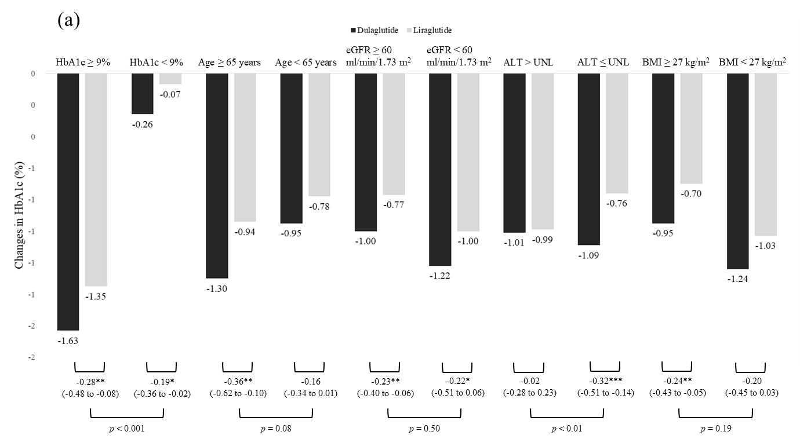
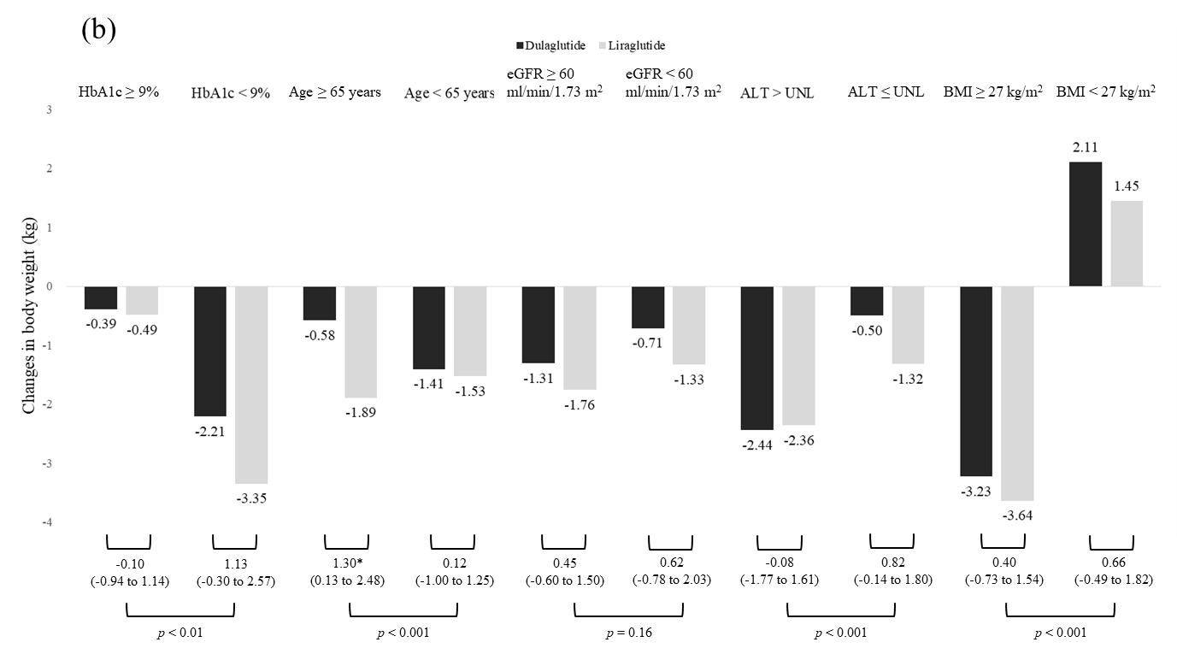
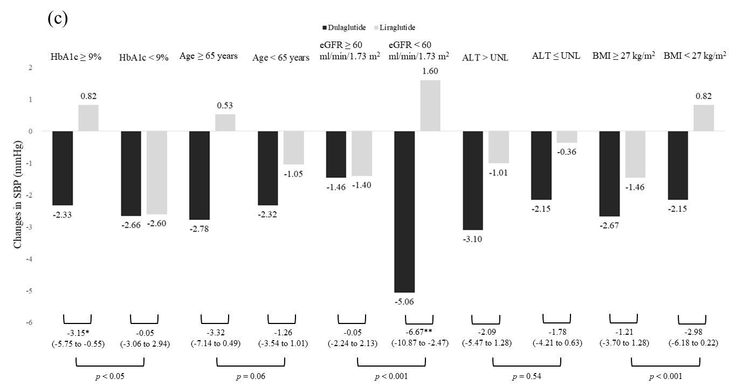
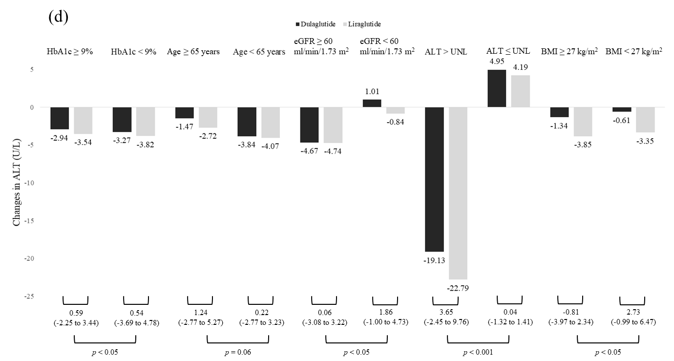
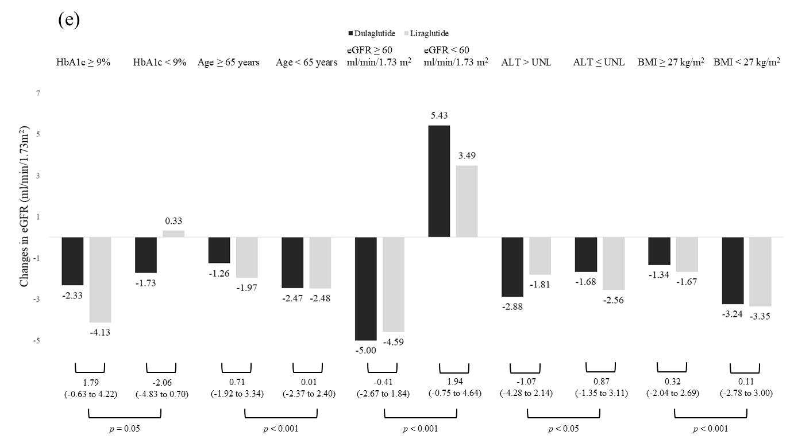

Legend: (a) Change in HbA1c from baseline to month 12 in different subgroups, (b) change in body weight from baseline to month 12 in different subgroups, (c) change in systolic blood pressure (SBP) from baseline to month 12 in different subgroups, (d) change in alanine aminotransferase (ALT) from baseline to month 12 in different subgroups, and (e) change in estimated glomerular filtration rate (eGFR) from baseline to month 12 in different subgroups.

Notes:
The interaction between treatment status (i.e., dulaglutide and liraglutide) and patient characteristics (e.g., HbA1c ≥ 9% versus < 9%) was tested by including the interaction term in the mixed-model analysis.
*, **, and *** refer to p-values < 0.05, < 0.01, and < 0.001, respectively.

Appendix Figure 3. Flow chart of selection of studies included in the meta-analysis
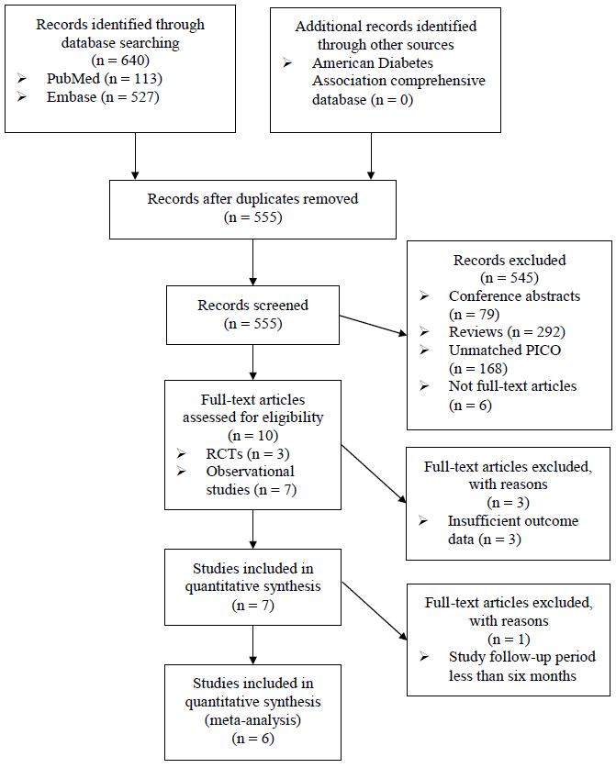
Abbreviation: PICO, patient intervention comparison outcome; RCTs, randomized control trials.

Appendix Table 4. Summary of existing studies that head-to-head compared dulaglutide and liraglutide
Authors, year | Dungan et al. 2014 | Miyagawa et al. 2015 | Odawara et al. 2016 | Mody et al. 2018 | Brown et al. 2019 | Morieri et al. 2020 | This study
Country | Global | Japan | Japan | United States | Canada | Italy | Taiwan
Study design | RCT | RCT | RCT | Observational study | Observational study | Observational study | Observational study
Data source | - | - | - | Longitudinal administrative claims data | Multiple institutions in Canada | Multiple institutions in Italy | Multiple institutions in Taiwan
Period | 2012/06/20-2013/11/25 | 2012/04/01-2013/10/31 | 2012/04/01-2013/10/31 | 2014/11/01-2016/05/31 (follow to 2017/05/31) | 2017/04/01-2018/01/30 | 2010/01/01-2018/12/31 | 2016/01/01-2018/12/31 (follow to 2019/12/31)
Other therapies | Metformin | None | None | Other anti-hyperglycemic drugs | Other anti-hyperglycemic drugs | Other anti-hyperglycemic drugs | Other anti-hyperglycemic drugs
Sample size | 599 | 417 | 417 | 1,170 (1:1 matching) | 638 (1:1 matching) | 1,344 (1:1 matching) | 1,966 (1:1 matching)
Follow-up time | 6 months | 6 months | 12 months | 12 months | 6 months | 5.9 months | 12 months
Age | 56.6 | 57.4 | 57.4 | 53.5 | 57.6 | 61.7 | 57.1
Sex (Men) | 48% | 81.7% | 81.7% | 50.1% | 57.3% | 64.5% | 47.9%
Baseline HbA1c | 8.1% | 8.12% | 8.12% | 8.77% | 8.4% | 8.2% | 9.35%
Baseline weight | 94.1 kg | 70.9 kg | 70.9 kg | NA | 97.9 kg | 96.6 kg | 77.7 kg
Baseline SBP | 131.5 mmHg | NA | NA | NA | 127.5 mmHg | 142.2 mmHg | 140.5 mmHg
Abbreviations: RCT, randomized control trial; SBP, systolic blood pressure. NA: not available. “NA“ means that data/information was not available or indicated in the original paper.
Appendix Figure 4. Forest plot of 6-month difference in HbA1c between dulaglutide and liraglutide
(a)
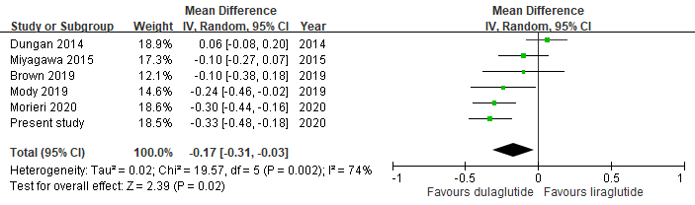

(b)
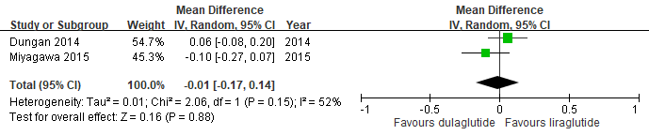
(c)
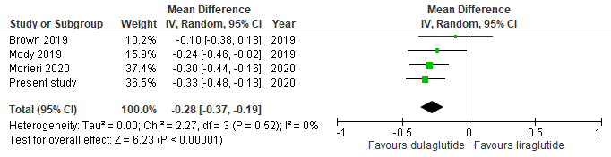

Legend: (a) All studies (including randomized controlled trials [RCTs] and observational studies), (b) RCTs only, and (c) observational studies only.

Appendix Figure 5. Forest plot of 12-month difference in weight loss between dulaglutide and liraglutide
(a)
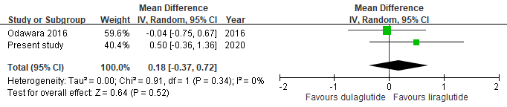
(b)
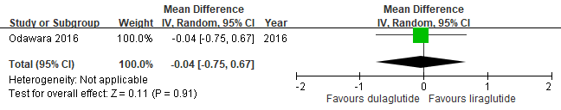
(c)
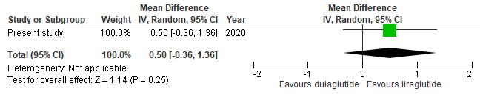
Legend: (a) All studies (including randomized controlled trials [RCTs] and observational studies), (b) RCTs only, and (c) observational studies only.

Appendix Figure 6. Forest plot of 6-month difference in weight loss between dulaglutide and liraglutide
(a)
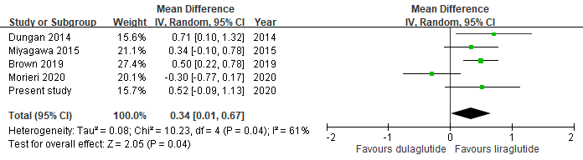
(b)
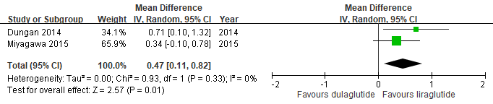
(c)
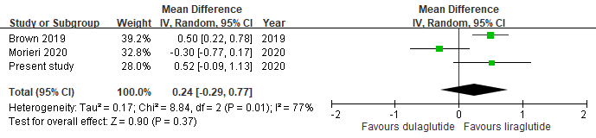

Legend: (a) All studies (including randomized controlled trials [RCTs] and observational studies), (b) RCTs only, and (c) observational studies only.

Appendix Figure 7. Forest plot of 12-month difference in systolic blood pressure change between dulaglutide and liraglutide
(a)
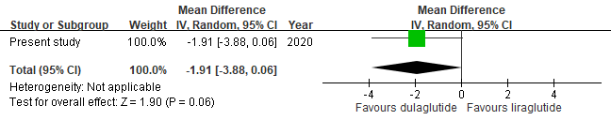
Legend: (a) All studies.

Appendix Figure 8. Forest plot of 6-month difference in systolic blood pressure change between dulaglutide and liraglutide
(a)
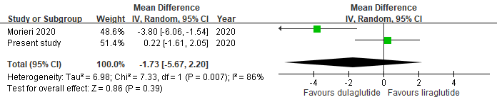
Legend: (a) All studies.

