SUPPLEMENTS
METHODS

Klebsiella pneumoniae cultivation
Minimal inhibitory concentration test used for the determination of ampicillin concentration.
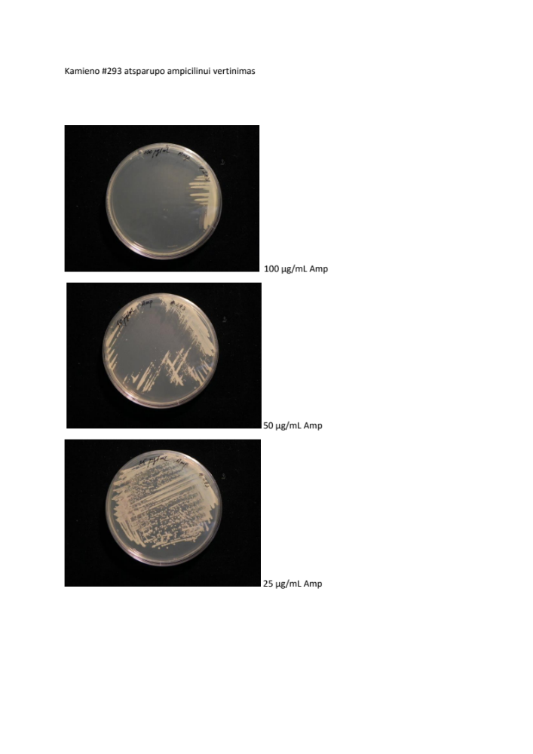
1 Fig. K. pneumoniae resistance to ampicilin
K. pneumoniae strain ATCC 43816 resistances to ampicilin from 25 ug/mL to 100 ug/mL.

DNA-based standard curve for K. pneumoniae detection. 10², 10³, 10⁵, 10⁶, 10⁸, 10⁹ and 10¹⁰ CFU of K. pneumoniae in 200 µl were subjected to DNA extraction with QIAamp Fast DNA Stool Mini Kit (protocol for liquid sample). DNA was eluted in 50 µl and 2 µl of DNA of each sample were taken for qRT-PCR. qRT-PCR procedures were performed as described in the methods section (see the manuscript).
DNA-based standard curve. qRT-PCR was validated by setting up the standard curves for detection of K. pneumoniae strains ATCC 12657 and ATCC 43816 using khe gene. As demonstrated in Fig. 1, the standard curves showed the expected linear relationship between the CT values and the concentration of bacteria cells at the DNA level.
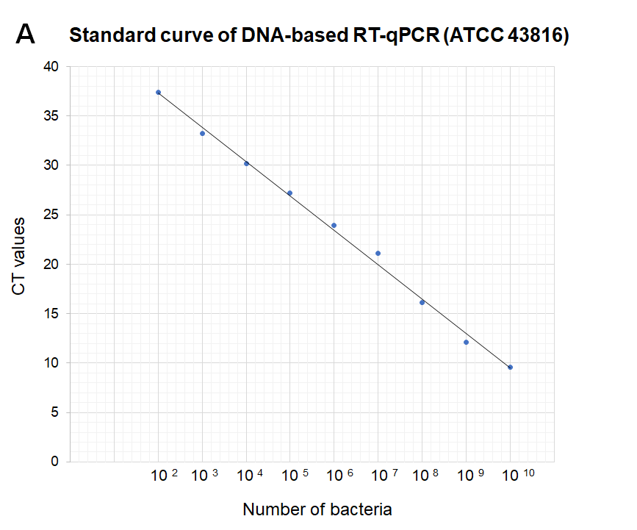

2 Fig. Standard curves for the detection of K. pneumoniae
A – DNA-based standard curve of K. pneumoniae strain ATCC 43816 (y = -3.4797x + 44.31 with R²=0,9959). The standard curves were generated by plotting the mean CT values in the range of bacteria concentrations from 10² CFU to 10¹⁰ CFU.

ANTIBIOTIC SENSITIVITY
The correct antibiotic for the experimental designs was chosen depending on K. pneumoniae strain ATCC 43816 resistance.

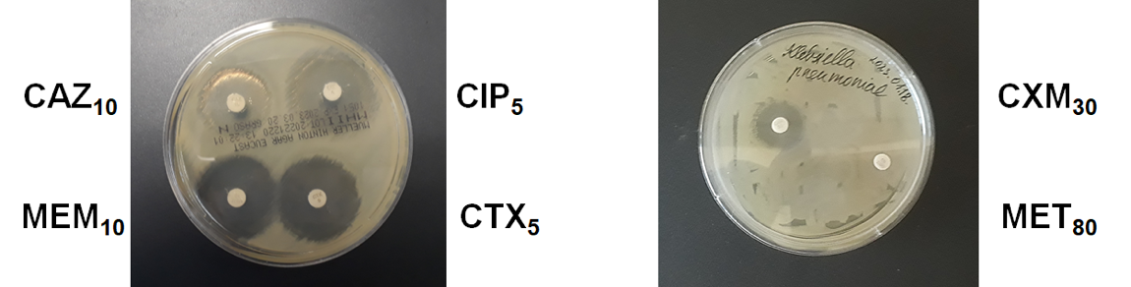
3 Fig. Antibiotic sensitivity test
MEM₁₀ (meropenem) inhibitory zone diameter – 30 mm; CIP₅ (ciprofloxacin) inhibitory zone diameter - 30 mm ; CAZ₁₀ (ceftazidime) inhibitory zone diameter - 25 mm; CTX₅ (cefotaxime) inhibitory zone diameter – 29 mm ; CXM 30 (cefuroxime) inhibitory zone diameter – 19 mm; MET 80 (metronidazole) inhibitory zone diameter – 7.5 mm

1 table. Antibiotic sensitivity test
Antibiotics | Inhibitory zone diameter (mm)
MEM₁₀ (meropenem) | 30
CIP₅ (ciprofloxacin) | 30
CAZ₁₀ (ceftazidime) | 25
CTX₅ (cefotaxime) | 29
CXM 30 (cefuroxime) | 19
MET 80 (metronidazole) | 7.5

RESULTS

Klebicin KvarM therapy does not affect composition of microbiota in mice compared to antibiotic treatments
The biostatistical analysis using Permanova test was completed to see the differences in microbiome between groups.
2 table. Values of the Permanova analysis using biostatistical tool R
 | Phylum |  | Class |  | Order |  | Family |  | Genus |  | Species |  | ASV
 | p value | F | p value | F | p value | F | p value | F | p value | F | p value | F | p value | F
Natural microbiome group vs AB group | 0,729 | 0,1757 | 0,867 | 0,1583 | 0,706 | 0,3416 | 0,171 | 1,6907 | 0,013 | 3,4559 | 0,006 | 10,145 | 0,01 | 3,7178
KvarM+Eudragit groups vs AB group | 0,178 | 2,3788 | 0,42 | 0,9331 | 0,312 | 1,345 | 0,04 | 2,7499 | 0,012 | 4,1582 | 0,007 | 8,0709 | 0,009 | 4,5703

