Building bridges to operationalise One Health — A longitudinal two years’ AMR study in England using clinical and wastewater-based surveillance approaches
Like Xu¹, Nicola Ceolotto^{1,2}, Kishore Jagadeesan¹, Richard Standerwick³, Megan Robertson³, Ruth Barden³, Helen Lambert⁴, Barbara Kasprzyk-Hordern^{1,2*}

¹ Department of Chemistry, University of Bath, BA2 7AY, Bath UK
² Institute for Sustainability, University of Bath, BA2 7AY, Bath UK
³ Wessex Water Service Ltd., Claverton Down, BA2 7WW, Bath, UK
⁴ Population Health Sciences, Bristol Medical School, University of Bristol, Bristol, BS8 1TH, UK

* Email address: b.kasprzyk-hordern@bath.ac.uk

Table of contents

Figure S1. Site information of studied wastewater treatment plants (WWTPs)………….........p3
Figure S2. Yearly differences for PNDI and PNDP for individual antibiotics………………….p4
Figure S3. Yearly differences for ARGs and 16S rRNA………………………………………….p4
Figure S4. Comparison of PNDI (Population-normalised daily intake) and PNDP (Population-normalised daily prescription) for individual antibiotics at four sampling sites…………...…p5-7
Figure S5. Heatmap showing the Spearman correlations between Covid infection rates and population-normalised daily intake (PNDI) of antibiotics.……………………..………………...p8
Figure S6. Heatmap showing the Spearman correlations between Covid infection rates and population-normalised daily prescription (PNDP) of antibiotics.………………………….…….p8
Figure S7. Heatmap showing the Spearman correlations between Covid infection rates and ARG abundance (normalisation to bacterial 16S rRNA)…………………………………...……p9
Table S1. Target antimicrobials and abbreviations, ordered by drug classes………………p10
Table S2. Spearman correlations between PNDI and PNDP………………………………….p11
Table S3. Spearman correlations between antibiotics (PNDI & PNDP) and target genes…..p11
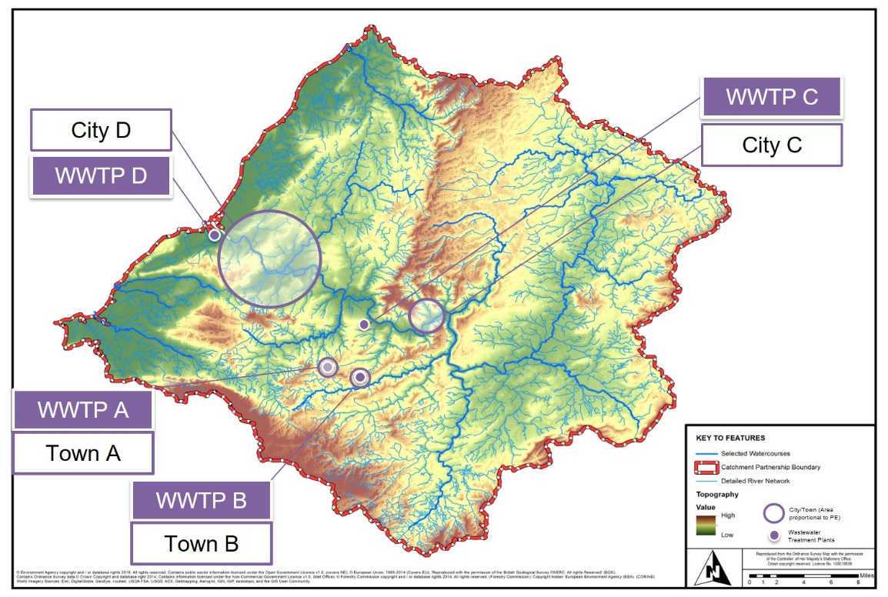
 | WWTP-A | WWTP-B | WWTP-C | WWTP-D
Population - 2020 | 11,895 | 26,967 | 120,646 | 938,749
Population - 2021 | 12,300 | 28,021 | 125,932 | 966,296
Population - 2022 | 12,429 | 27,965 | 125,617 | 890,154
No. of samples | 150 | 159 | 144 | 137
Type | Domestic | Domestic | Domestic | Mixed
Industrial/hospital | - | - | Hospital input | Industrial input
Served town/city | Paulton (town) | Radstock (town) | Bath (city) | Bristol (city)

Figure S1. Site information of studied wastewater treatment plants (WWTPs).

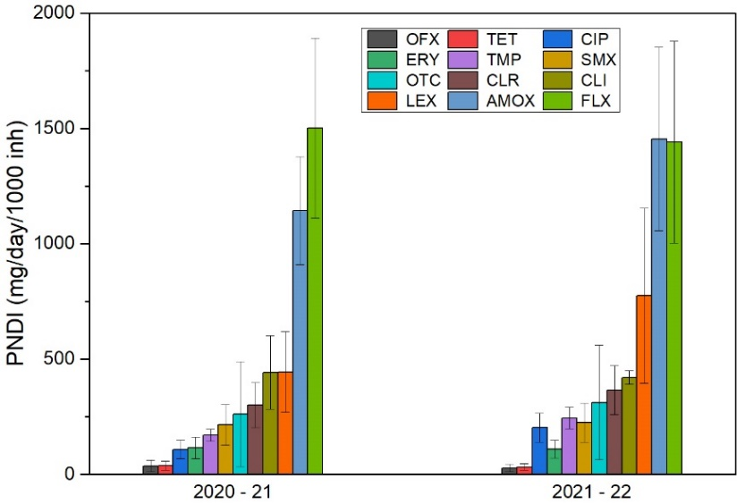 | 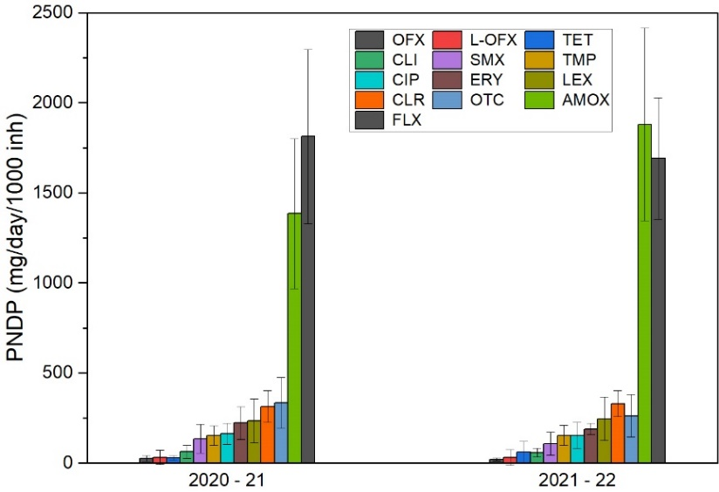
Figure S2. Yearly differences for PNDI (population-normalised daily intake) and PNDP (population-normalised daily prescription)
for individual antibiotics.

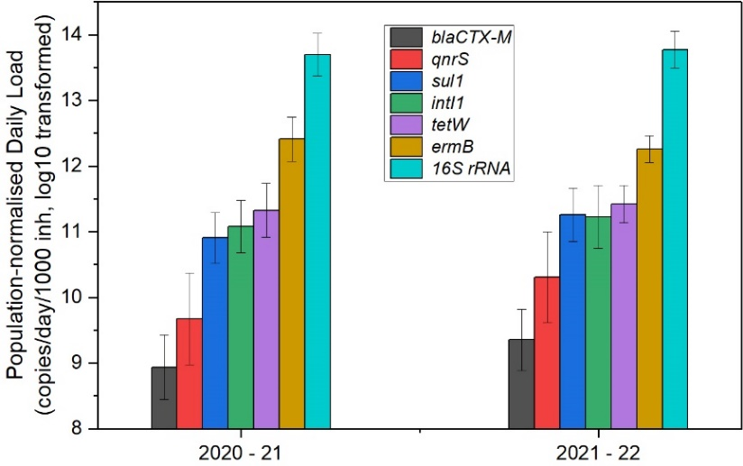
Figure S3. Yearly differences for ARGs and 16S rRNA (expressed as population-normalised daily load, log10 transformed).
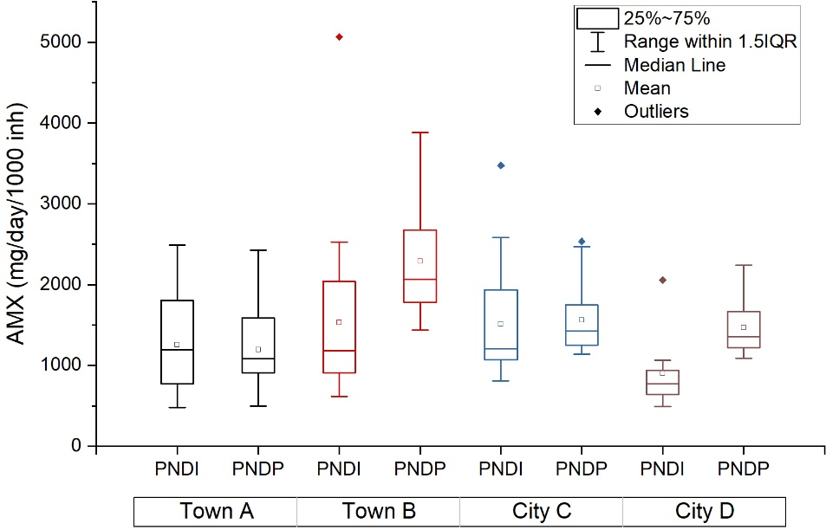 | 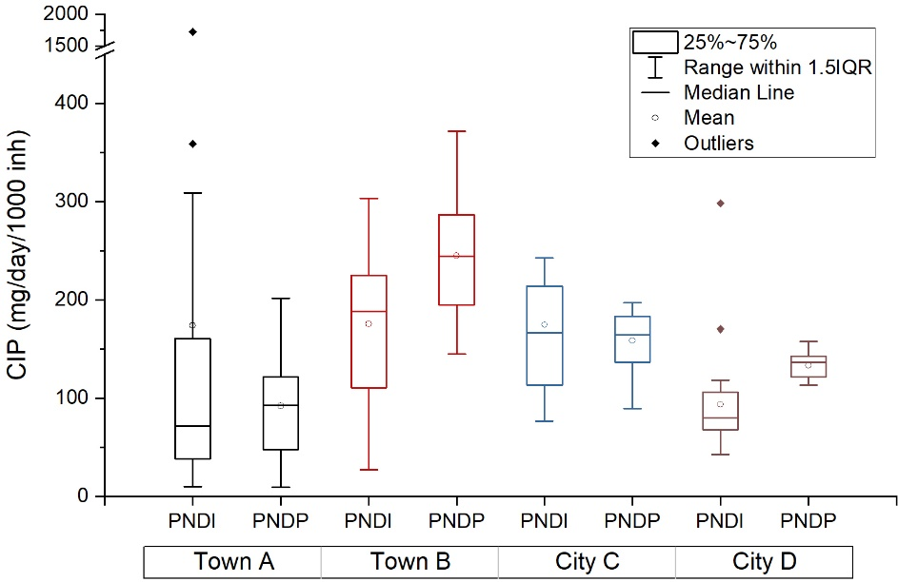
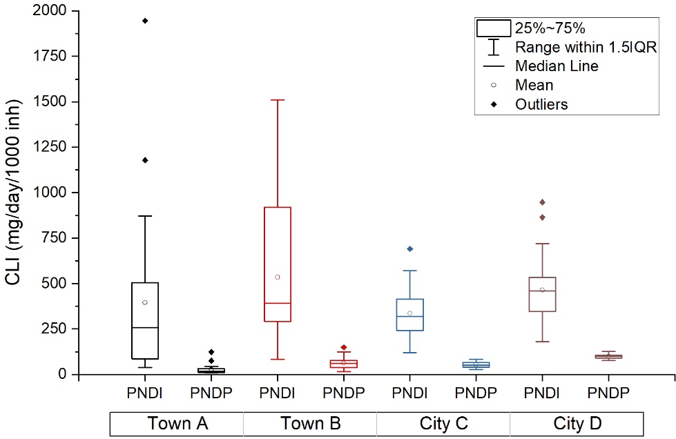 | 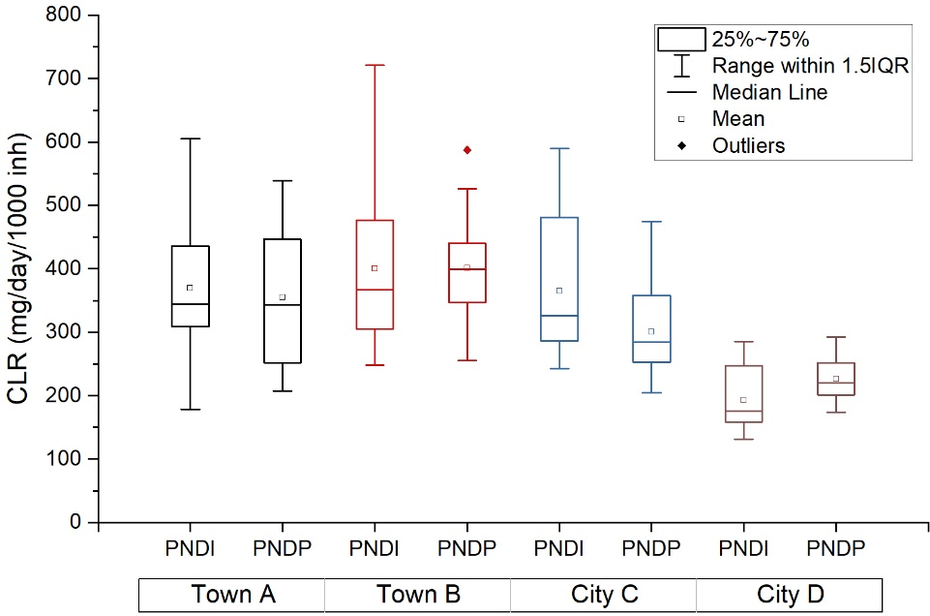

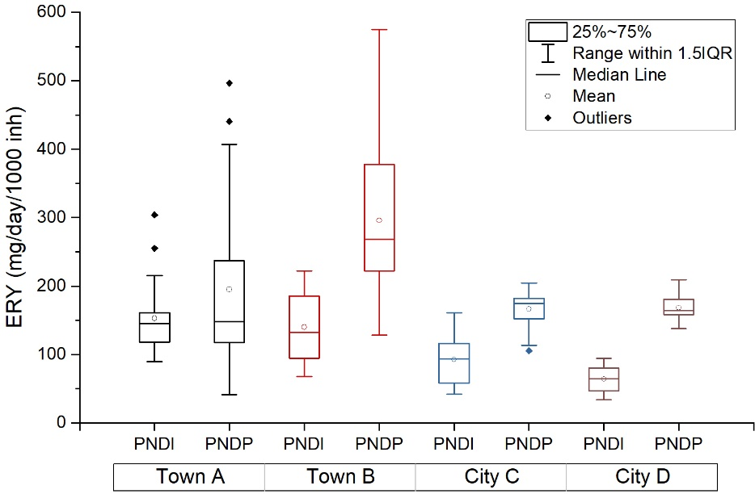 | 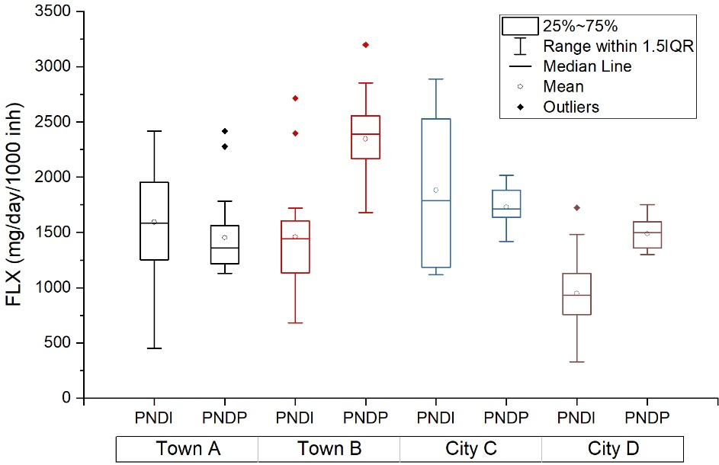
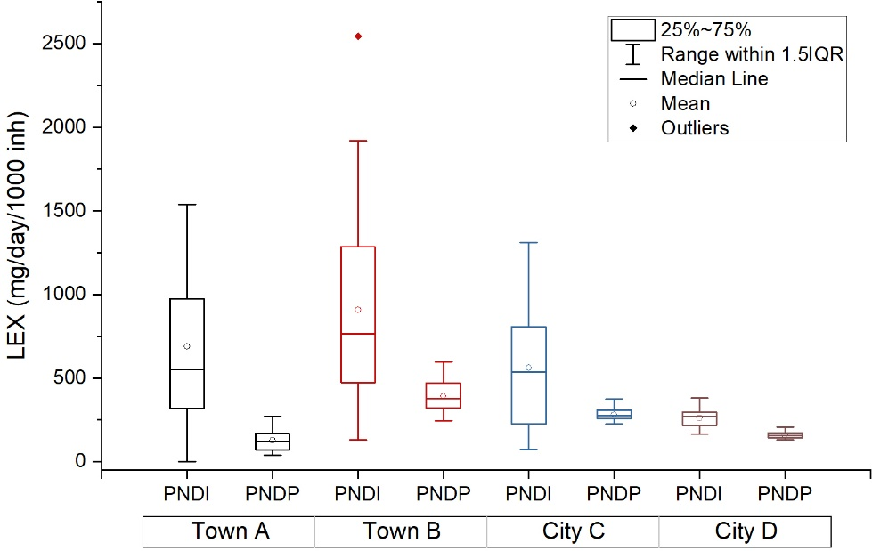 | 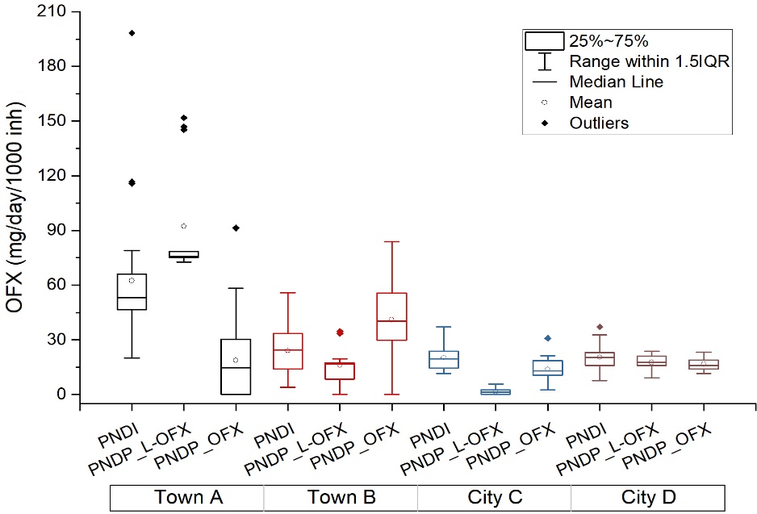

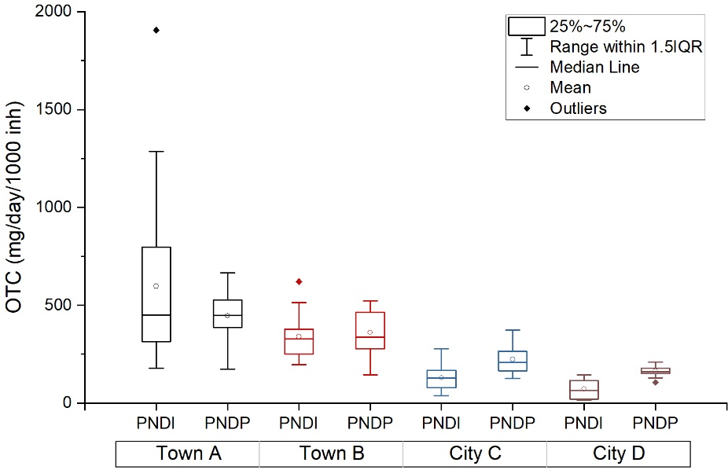 | 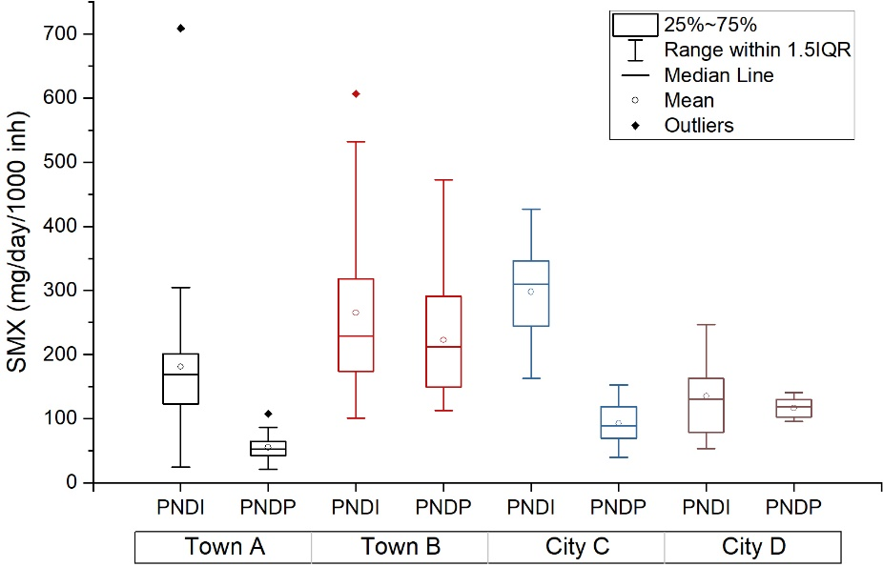
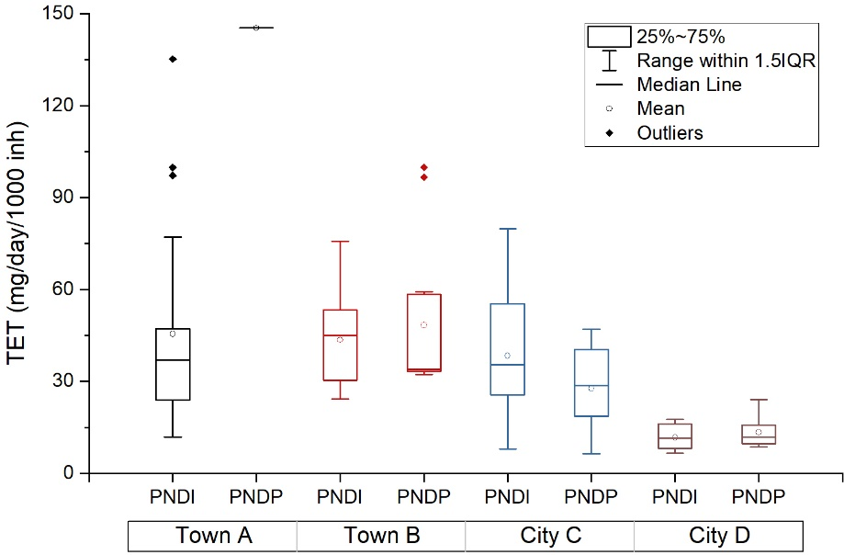 | 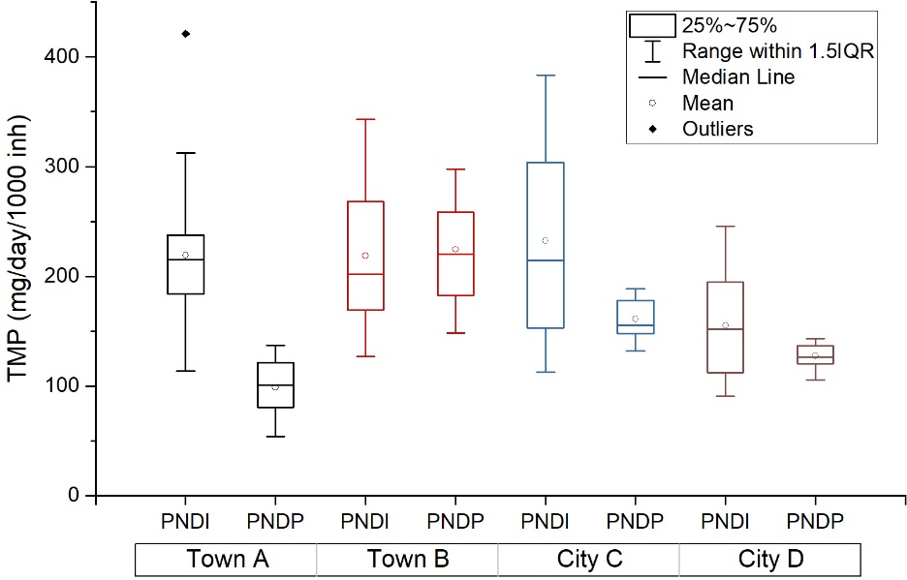
Figure S4. Comparison of PNDI (Population-normalised daily intake) and PNDP (Population-normalised daily prescription) for individual antibiotics
at four sampling sites during April 2020 - March 2022. Monthly average data points were used to generate the box plot.

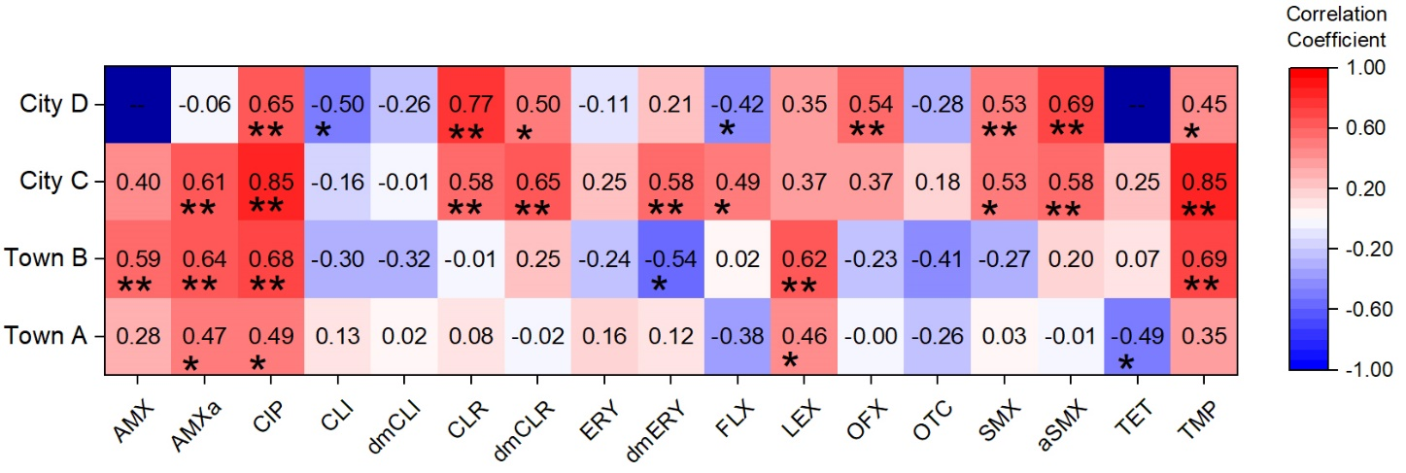
Figure S5. Heatmap showing the Spearman correlations between Covid-19 infection rates and
population-normalised daily intake (PNDI) of antibiotics. * indicates significance level at 0.05;
** indicates significance level at 0.01.

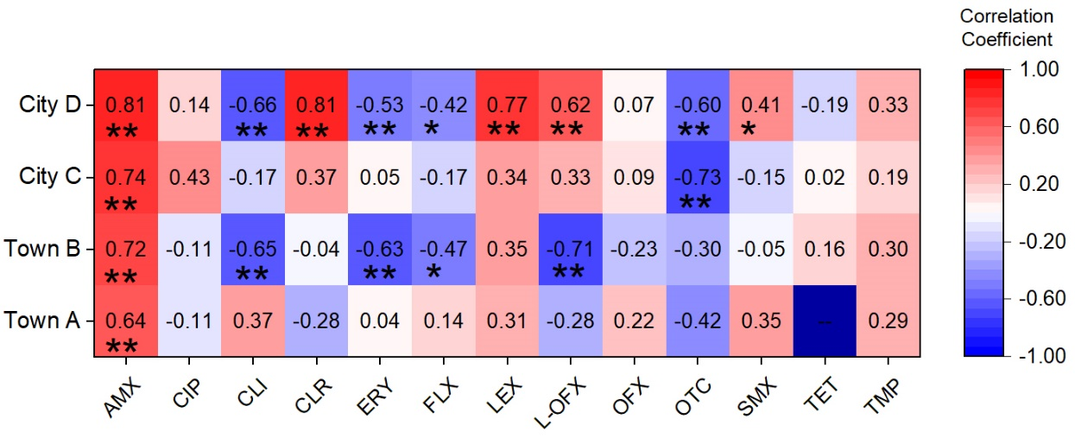
Figure S6. Heatmap showing the Spearman correlations between Covid-19 infection rates and population-normalised daily prescription (PNDP) of antibiotics. * indicates significance level at 0.05; ** indicates significance level at 0.01.

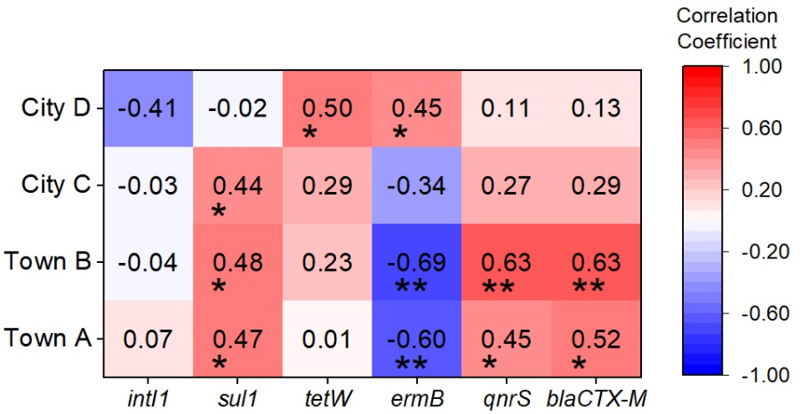
Figure S7. Heatmap showing the Spearman correlations between Covid-19 infection rates and ARG abundance (normalisation to bacterial 16S rRNA). * indicates significance level at 0.05;
** indicates significance level at 0.01.

Table S1. Target antimicrobials and abbreviations, ordered by drug classes.
Drug class | Compounds | Parent/  Metabolite | Abbrev. | Drug class | Compounds | Parent/  Metabolite | Abbrev.
β-lactam | Amoxicillin | Parent | AMX | Quinolone | Ciprofloxacin | Parent & active  metabolite | CIP
β-lactam | Flucloxacillin | Parent | FLX | Quinolone | Ofloxacin | Parent | OFX
β-lactam | Amoxicilloic acid | Metabolite | AMXa | Quinolone | Levofloxacin | Parent | L-OFX
β-lactam | Cefalexin | Parent | LEX | Quinolone | *Ofloxacin-d3 | - | OFX-d3
β-lactam | *Amoxicillin-d4 | - | AMOX-d4 | Cycline | Oxytetracycline | Parent | OTC
β-lactam | *Cefalexin-d5 | - | LEX-d5 | Cycline | Tetracycline | Parent | TET
Macrolide &  lincosamide | Clarithromycin | Parent | CLR | Cycline | *Tetracycline-d6 | - | TET-d6
Macrolide &  lincosamide | Clindamycin | Parent | CLI | Sulfonamide &  Trimethoprim | Sulfamethoxazole | Parent | SMX
Macrolide &  lincosamide | Erythromycin | Parent | ERY | Sulfonamide &  Trimethoprim | N-acetyl sulfamethoxazole | Metabolite | aSMX
Macrolide &  lincosamide | N-desmethyl erythromycin | Metabolite | dmERY | Sulfonamide &  Trimethoprim | Trimethoprim | Parent | TMP
Macrolide &  lincosamide | N-desmethyl clarithromycin | Metabolite | dmCLR | Sulfonamide &  Trimethoprim | *Sulfamethoxazole-d4 | - | SMX-d4
Macrolide &  lincosamide | N-desmethyl clindamycin | Metabolite | dmCLI | Sulfonamide &  Trimethoprim | *Trimethoprim-d9 | - | TMP-d9
Macrolide &  lincosamide | *Clarithromycin-d3 | - | CLR-d3 | Sulfonamide &  Trimethoprim
Macrolide &  lincosamide | *Erythromycin-13C,D3 | - | ERY-13C | Sulfonamide &  Trimethoprim

Table S2. Spearman correlations between PNDI (Population-normalised daily intake) and PNDP (Population-normalised daily prescription).

PNDP  PNDI | AMX | CIP | CLI | CLR | ERY | FLX | LEX | L-OFX | OFX | OTC | SMX | TET | TMP
AMX | 0.33
AMXa | 0.39
CIP |  | 0.35
CLI |  |  | -0.04
dmCLI |  |  | 0.32
CLR |  |  |  | 0.65
dmCLR |  |  |  | 0.59
ERY |  |  |  |  | 0.29
dmERY |  |  |  |  | 0.20
FLX |  |  |  |  |  | 0.07
LEX |  |  |  |  |  |  | 0.35
OFX |  |  |  |  |  |  |  | 0.66 | 0.05
OTC |  |  |  |  |  |  |  |  |  | 0.64
SMX |  |  |  |  |  |  |  |  |  |  | -0.12
aSMX |  |  |  |  |  |  |  |  |  |  | 0.13
TET |  |  |  |  |  |  |  |  |  |  |  | 0.59
TMP |  |  |  |  |  |  |  |  |  |  |  |  | 0.17
* Light and dark green indicate significance level at 0.05 and 0.01, respectively.

Compounds | PNDI vs ARGs |  |  |  |  |  | PNDP vs ARGs
Compounds | intI1 | sul1 | tetW | ermB | qnrS | bla_{CTX-M} | intI1 | sul1 | tetW | ermB | qnrS | bla_{CTX-M}
*AMX | 0.34 | 0.39 | 0.53 | 0.22 | 0.44 | 0.45 |  |  |  |  |  | 0.21
CIP | 0.30 | 0.40 | 0.47 |  | 0.46 | 0.46
*CLI |  |  | -0.24 | -0.23 |  |  | -0.21 | -0.20 | -0.31 | -0.21 | -0.31 | -0.31
CLR | 0.36 | 0.39 | 0.41 | 0.29 | 0.49 | 0.51 |  |  |  |  | 0.22 | 0.29
ERY | 0.30 | 0.27 | 0.33 |  | 0.39 | 0.48
LEX | 0.38 | 0.50 | 0.47 |  | 0.59 | 0.63 | 0.22 | 0.23 | 0.27 | 0.34 | 0.26 | 0.28
OTC |  |  |  | -0.28 |  | 0.25
*SMX | 0.24 | 0.23 | 0.37 | 0.36 | 0.26 | 0.20 | -0.35 | -0.30 |  |  | -0.23
TET |  |  | 0.31 |  | 0.22 | 0.30 | 0.45 | 0.48 | 0.30 | 0.35 | 0.41 | 0.46
TMP |  | 0.41 | 0.22 |  | 0.29 | 0.31 | 0.20 |  |  | 0.36

Table S3. Spearman correlations between antibiotics (PNDI & PNDP) and target genes.
*Metabolites were used for PNDI calculation and correlation analysis. Gene data were log10-transformed.
Empty cells indicate lack of significant correlations (p > 0.05). Cells with bold number indicate significance level at 0.01.

