Table 1 Ligand structures, Zinc ID and Molecular formular and weight.
Ligands | 3D structures | Molecular formular | Molecular weight | Zinc id
Tunicamycin | 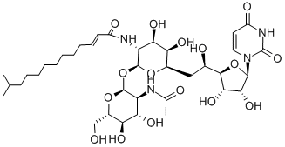 | C38H62N4O16 | 718.71 | 94437816
1-(4-acetylaminophenyl) carbamoylethyl | 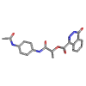 | C20H18N4O5 | 394.387 | 6605913
N-(4-(4-acetylaminophenyl) thiazol-2-yl)-3-(1H-indol-3-yl) propenamide | 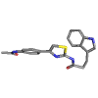 | C22H20N4O2S | 404.495 | 06905586
(4-Acetamidophenyl) 2-oxo-1,3-dihydrobenzimidazole-5-sulfonate | 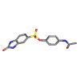 | C15H13N3O5S | 347.352 | 07974328
4-(Acetylamino)-1-naphthyl 2-oxo-1,2-dihydrobenzo[cd]indole-6-sulfonate | 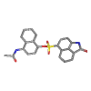 | C23H16N2O5S | 432.457 | 08691846
4-[[2-(1H-indol-3-yl)ethylcarbamoyl-methylamino]methyl]-N-methylbenzamide | 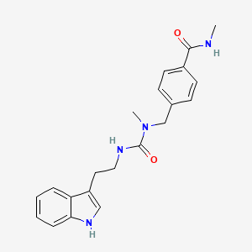 | C21H24N4O2 | 364.4 | 08709412
3-(2,4-dioxo-1,2,3,4-tetrahydroquinazolin-1-yl)-N-(4-acetamidophenyl)propanamide | 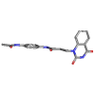 | C19H18N4O4 | 366.377 | 14141392
5-{1-[(3,5-dimethyl-1H-pyrazol-4-yl)sulfonyl]piperidin-3-yl}-N-(4-fluorophenyl)-1,3,4-thiadiazole-2-carboxamide | 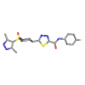 | C19H21FN6O3S2 | 464.548 | 21663101
5-{1-[(3,5-dimethyl-1H-pyrazol-4-yl)sulfonyl]piperidin-3-yl}-N-(4-methylphenyl)-1,3,4-thiadiazole-2-carboxamide | 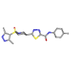 | C20H24N6O3S2 | 460.585 | 21663117
5-[1-[(3,5-dimethyl-1H-pyrazol-4-yl)sulfonyl]piperidin-3-yl]-N-phenyl-1,3,4-thiadiazole-2-carboxamide | 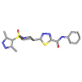 | C19H22N6O3S2 | 446.558 | 21663130
Zinc90417652 | 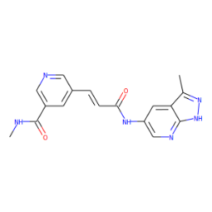 | C17H16N6O2 | 336.35 | 90417652
(4-acetamidonaphthalen-1-yl) 2-oxo- 1,3-dihydrobenzimidazole-5-sulfonate | 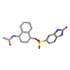 | C19H15N3O5S | 397.4 | 41091368
N-(4-(thiazol-2-ylcarbamoyl)phenyl)-1H-indole-6-carboxamide | 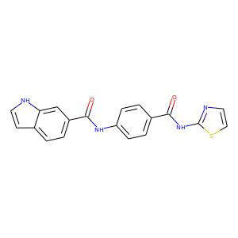 | C19H14N4O2S | 362.4 | 77618967
N-cyclopropyl-4-((2-(1,4,6-trimethyl-3-oxo2H-pyrazolo(3,4-b)pyridine-5-yl)amino)benzamide | 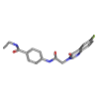 | C21H23N5O3 | 393.44 | 71103804
N-ethyl-3-methyl-4-((2-(1,4,6trimethyl-3-oxo-2H-pyrazolo(3,4-b)pyridine-5-yl)acetyl)amino)benzamide | 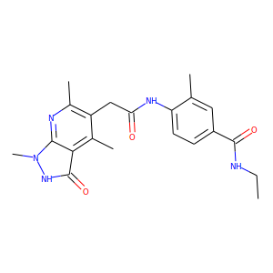 | C21H25N5O3 | 395.46 | 71117836
Zinc86023051 | 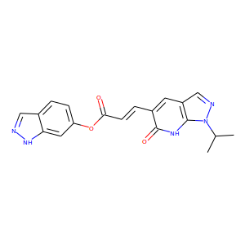 | C19H17N5O3 | 363.37 | 86023051
N-[3-[2-(1H-indazol-6-ylamino)-2-oxoethoxy]phenyl]benzamide | 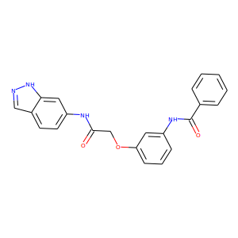 | C22H18N4O3 | 386.4 | 40483736
N-[3-[2-oxo-2-[(2-oxo-1,3-dihydrobenzimidazol-5-yl)amino]ethoxy]phenyl]benzamide | 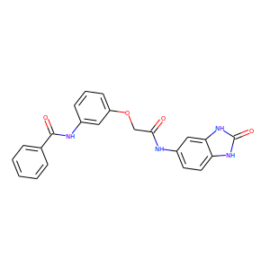 | C22H18N4O4 | 402.4 | 40483738
N-(1H-benzimidazol-2-ylmethyl)-1-[2-[(4-oxopyrido[1,2-a]pyrimidin-3-yl)amino]acetyl]piperidine-4-carboxamide | 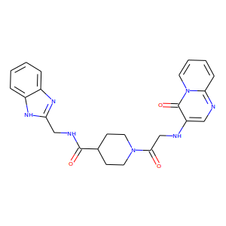 | C24H25N7O3 | 459.5 | 35022243
N-[4-[[2-(5,7-dimethyl-2-oxo-1H-pyrazolo[1,5-a]pyrimidin-6-yl)acetyl]amino]-3-(trifluoromethyl)phenyl]furan-2-carboxamide | 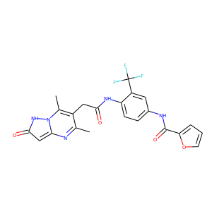 | C22H18F3N5O4 | 473.4 | 78451115
Zinc85428484 | 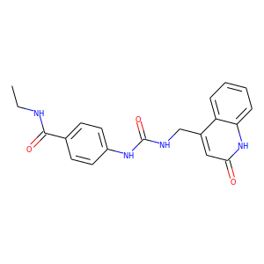 | C20H20N4O3 | 364.4 | 85428484
(4-acetamidonaphthalen-1-yl) 2-oxo-3H-1,3-benzoxazole-6-sulfonate | 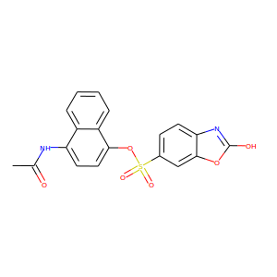 | C19H14N2O6S | 398.4 | 41125021

