Supplementary Table S1. Biochemical tests for identification of Staphylococcus spp.
Species |  | Characteristics
Species | Coagulase | Expression of |  | Novo | Sugar fermentation from:
Species | Coagulase | Alk | Ure | Novo | Tre | Man | Mann | A | Mal | Lac | Suc | VP
S. aureus | + | + | d | - | + | + | + | - | + | + | + | +
S. epidermidis | - | +^{m} | + | - | - | - | + | - | + | d | + | +
S. haemolyticus | - | - | - | - | + | d | - | - | + | d | + | +
S. hominis | - | - | + | - | d | - | - | - | + | d | + | +
S. xylosus | - | d | + | + | + | + | + | d | + | d | + | +
d; 11-89% of strain positive., Alk: Alkaline phosphatase, Ure: Urease, Novo: Novobiocin resistance, Tre: Trehalose, Man: Mannitol, Mann: Mannose, A: Arabinose, Mal: Maltose, Lac: Lactose, Suc: Sucrose and VP: Voges–Proskauer.

Supplementary Table S2. Oligonucleotide primers
Gene | Primer | Sequence 5’ to 3’ | Amplicon size (bp) | Reference
nuc | Nuc-alF1  Nuc-alR | CCNAAYACNCCNGTNCARCCN NADCCANACRTANGCNARNGT | 359 | (8)
mecA | mecA-F  mecA-R | AAAATCGATGGTAAAGGTTGGC AGTTCTGCAGTACCGGATTTGC | 532 | (9)
mupA | mupA-F  mupB-R | TATATTATGCGATGGAAGGTTGG AATAAAATCAGCTGGAAAGTGTTG | 458 | (10)
fusA | fusA-F  fusA-R | CGGTATCATGGCTCACATTG GTACCGCGACCTTGAGTGTT | 1962 | (18)

Supplementary Table S3. Severity scores in children (n=30) and adults with AD (n=30)
Score | Mean | SD | p-value
EASI in adults | 6.47 | 8.84 | 0.001*
EASI in children | 33.09 | 14.09 | 0.001*
SCORAD in adults | 17.32 | 14.82 | <0.001*
SCORAD in children | 63.37 | 22.14 | <0.001*
*p<0.05

Supplementary Table S4. Type of treatments in AD patients
Type of treatments |  | Children (n=30) |  | Adults (n=30) |  | P-value
 |  | Number | Percent | Number | Percent | P-value
1. Topical treatments |  | 30 | 100 | 29 | 96.7 | 0.31
corticosteroids |  | 27 | 90 | 27 | 90 | 1.00
immune modulators |  | 7 | 23.3 | 11 | 36.7 | 0.32
antibiotics |  | 16 | 53.3 | 10 | 33.3 | 0.04*
 | - fusidic acid | 6 | 20 | 8 | 26.7
 | - mupirocin | 4 | 13.3 | 1 | 3.3
 | - mupirocin+fusidic acid | 6 | 20 | 1 | 3.3
emollient |  | 28 | 93.3 | 30 | 100 | 0.15
other topical treatments  (e.g., intranasal steroid, steroid eye ointment) |  | 7 | 23.3 | 2 | 6.7 | 0.03*
2. Systemic treatments |  | 21 | 70 | 24 | 80 | 0.37
Systemic steroid |  | 4 | 13.3 | 7 | 23.3 | 0.31
Systemic immune modulators and biological drugs |  | 0 | 0 | 0 | 0 | -
Antihistamine |  | 21 | 70 | 22 | 73.3 | 0.77
Phototherapy |  | 0 | 0 | 2 | 6.6 | 0.33
Allergen specific immunotherapy |  | 1 | 3.4 | 0 | 0 | 0.31
Systemic antibiotic (e.g., cloxacillin, cephalexin) |  | 11 | 36.7 | 4 | 13.3 | 0.03*

*p<0.05

Supplementary Table S5. Mutations of fusidic acid-resistant strain of S. aureus (N=4) from lesions of children with AD using nucleotide and amino acid sequencing
S. aureus isolates | Amino acid substitution | Nucleotide substation | Zone diameter of fusidic acid (mm) | MICª of fusidic acid  (µg/mL)
FusA_1 and | P404Q | CAG AAG | 20 (R) | 2
FusA_2 | Q505H | AAT ACT | 20 (R) | 2
FusA_3 | S238W | TTC TGC | 20 (R) | 2
FusA_3 | C258W | TAA AAA | 20 (R) | 2
FusA_4 | H457Y | TTC TTT | 0 (R) | 4
ªMinimum inhibitory concentration, R: resistant
Supplementary Fig.S1 S. aureus and coagulase-negative staphylococci (CoNS) in children (n=30) and adults (n=30) with AD

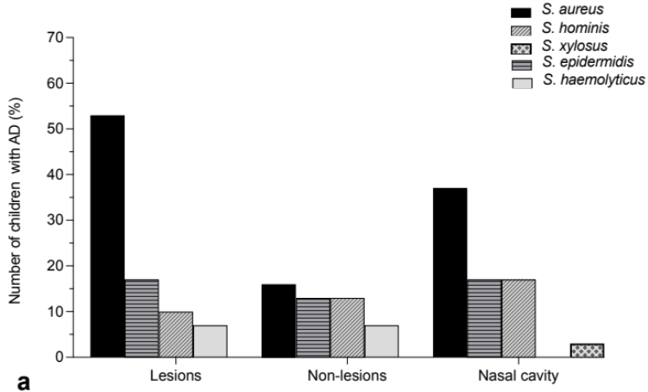
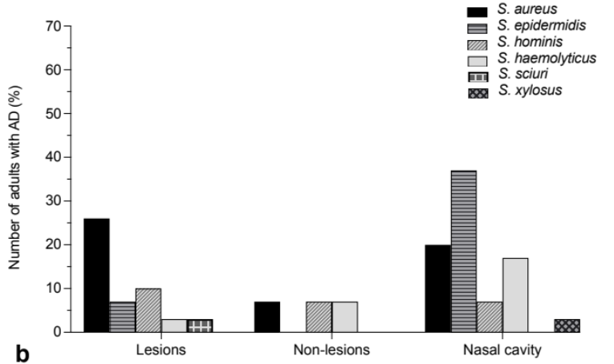

Supplementary Fig.S2 PCR analysis of antimicrobial-resistance genes. a) MRSA harboring mecA-like (532 bp) gene. Lanes: M; 100-bp plus DNA ladder, 1; positive control, 2; clinical sample, 3-4; methicillin-susceptible S. aureus, 5; negative control. b) Mupirocin-resistant S. aureus showing mupA-like (458 bp) gene. Lanes: M; 100-bp plus DNA ladder, 1; positive control, 2; clinical sample 3; mupirocin-susceptible S. aureus, 4; negative control
M
1
2
3
4
M
1
2
3
4
5
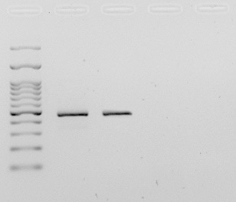

600 bp
500 bp
100 bp
200 bp
400 bp
100 bp
200 bp
500 bp
400 bp

b
a

Supplementary Fig.S3 The inhibitory effect of monolaurin on antimicrobial-resistant
S. aureus
MICª 32 16 8 4 2 1 0.5 0.25 0.125 0.063 GC^{b} SC^{c}
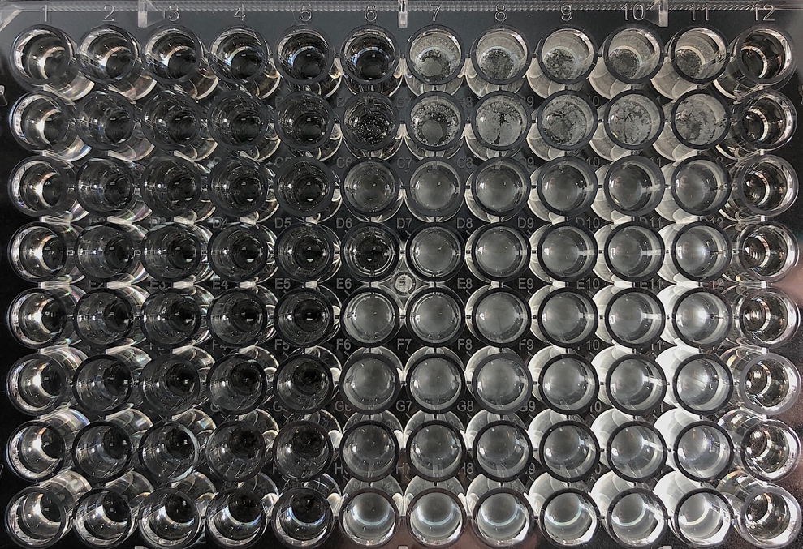
S. aureus^{d}
(ATCC 29213)

MRSA^{e}
MupRSA^{f}
FAR^{g}

ª MIC: lowest concentration at which drug can inhibit microorganism. Concentration for monolaurin is µg/ml.

^{b} GC: growth control

^{c} SC: Sterile control

^{d} S. aureus ATCC 29213: Control

^{e} MRSA: Methicillin-resistant S. aureus

^{f} MupRSA: Mupirocin-resistant S. aureus

^{g} FusA: Fusidic acid-resistant S. aureus

