Supplemental Material for Pollen-derived fatty acids and amino acids mediate variance in pollinator visitation
Anne F. Murray, Sara Leonhardt, Jane C. Stout, Fabian Ruedenauer, Maryse Vanderplanck, Laura Russo

Supplemental Methods
Pollen Amino Acids
Adapted from Vanderplanck et al 2014
First, we weighed the subsamples (3-6mg each) into glass tubes with 1mL hydrochloric acid (HCL) and mixed them. For analysis of total amino acids, 1 mL of hydrolysis solution (6 N HCl, 0.1 % phenol, and 500 μM norleucine) was added to the pollen. Then we aerated the tubes with N₂ gas for 1 minute. We capped the tubes and incubated them at 110°C for 24 hours. We then evaporated the samples and filtered them using a 50mL syringe (with a 0.22µm – 13mm filter) and a citrate buffer (pH 2.2) into a 1.5mL glass vial with a rubber seal for the high-performance liquid chromatography (HPLC) injection. We used a spectrum analyser to identify the peaks of the individual amino acids, and the area under the curve of the spectra corresponded to the quantity of individual amino acids. Each amino acid was measured separately with an ion exchange chromatograph (Biochrom 20 Plus Amino Acid analyser). A post-column ninhydrin reaction produced coloured derivatives, which was monitored via a UV detector. For the amino acid extractions, norleucine was used as the internal standard (Vanderplanck et al 2014).
Pollen Fatty Acids
We quantified the fatty acids in the pollen of each of six plant species and four treatments and analysed two subsamples of each pollen sample (48 total samples) (Trinkl et al 2020). First, we dried the pollen samples overnight at 30°C in a drying oven. Then, we sifted the pollen through a pollen sieve and weighed two subsamples (5-10mg each) of each pollen type into 1.5mL vials. The pollen samples were mixed with 1mL hexane and kept at 60C and 300rpm in a dry block heating thermostat thermomixer (Thermomixer Compact, Eppendorf, Hamburg, Germany) for 24 hours. We pre-conditioned paired 3mL silica gel columns (Macherey Nagel, Düren, Germany) using 2mL of an ethyl acetate/hexane solvent (80/1) (Sigma Aldrich, Taufkirchen, Germany and Merck, Darmstadt, Germany), and transferred the sample to the column using 0.5mL of the same solvent with 20µL of an internal fatty acid standard (0.2mg/mL nonadecanoic acid in methanol, both Sigma Aldrich). Then we washed the vial with another 0.5mL of the solvent to ensure we captured all of the pollen. The next steps were to elute the triglycerides, cholesterol and diacylglycerols: (1) we added 5mL of isooctane/ethyl acetate (20/1) (both Sigma Aldrich), (2) we rinsed the vial twice with 0.5mL of isooctane/ethyl acetate (75/25) and poured on the column, and (3) we added 5mL of isooctane/ethyl acetate (75/25). Finally, we eluted the free fatty acids by adding 5mL of isooctane/ethyl acetate/acetic acid (75/25/2) to the column. In each step, we additionally rinsed the original vial with two times 0.5mL of the corresponding solvent to wash out all fatty acids. We transferred the two the free fatty acid fractions (free and bound) to a glass vial with dichloromethane/methanol (2/1) and added 20µL of trimethylsulfonium hydroxide (TMSH) as derivatization agent to receive fatty acid methyl esters (FAMEs) which can be analysed via gas chromatography/mass spectrometry (GCMS).
We used a GCMS (5975C inert XL MSD, Agilent Technologies, Santa Clara, USA) to generate mass spectra chromatograms, which we analysed to identify the molecular weights of individual fatty acids. Via automatic liquid sampler, 1µL of each sample was injected in splitless mode. We used Helium as carrier gas. The oven temperature was 60°C, held for 1 min before heating at a rate of 15°C/minute to 150°C, held for 10 min. Afterward, the temperature was increased at 10°C/minute to 320°C, held for 10 min. Electron ionization mass spectra were recorded from m/z 40 to 650. Ion source and transfer line temperature were constant at 250°C. We used a FAME Mix, C4-C24 (Supelco, Bellefonte, USA) and the NIST MS Search 2.0 library to identify fatty acids via mass spectra. MSD ChemStation F.01.00.1903 was used to manually integrate FAME peaks in chromatograms. The peaks of oleic acid and linolenic acid could not be separated and were integrated as one mixed peak. The integrated area of the internal standard (nonadecanoic acid) was used to calculate the concentrations of identified fatty acids. Total fat content was calculated by summing up amounts of all fatty acids.
Insect traits
We collected trait data on one to three randomly selected individuals of males and females of 30 bee and hoverfly species collected in our study. These data were included in the larger analysis on pollinator pollimetry published by Kendall et al (2019), and the raw data are accessible at: https://doi.org/10.5281/zenodo.1313905.
First, we measured the intertegular distance (ITD), or the distance between the two wing bases, using a light microscope with a calibrated reticle. We also measured body length of the insects using a side view of the specimen and measuring from the front of the face to the end of the abdomen. Next, we dried the specimens in a drying oven overnight and measured their dry body weight (mg).
To generate the trait data for this study, we used the average body weight of the specimens we measured, supplemented with data from the literature for species which we did not measure ourselves (Table S1). To standardize across different measures provided in the literature, we used the pollimetry package in R (Kendall et al 2019) to calculate body weight from reported ITD or body length.
Data on nesting behavior and sociality was assumed based on typical behavior at the genus level. In other words, all Andrena were assumed to be ground-nesting and solitary and all Bombus were considered cavity nesting and social, etc (Table S1). Our dataset comprised only bees and hoverflies, so our insect identity trait was binary: bee (1) or hoverfly (2).
Supplementary References
Andersen, S., 1996. The Siphonini (Diptera: Tachinidae) of Europe (Vol. 33). Brill.
Cariveau, D.P., Nayak, G.K., Bartomeus, I., Zientek, J., Ascher, J.S., Gibbs, J. and Winfree, R., 2016. The allometry of bee proboscis length and its uses in ecology. PLoS ONE, 11(3), p.e0151482.
Gilbert, F.S., 1985. Ecomorphological relationships in hoverflies (Diptera, Syrphidae). Proceedings of the Royal society of London. Series B. Biological Sciences, 224(1234), pp.91-105.
Greenleaf, S.S., Williams, N.M., Winfree, R. and Kremen, C., 2007. Bee foraging ranges and their relationship to body size. Oecologia, 153, pp.589-596.
Kendall, L.K., Rader, R., Gagic, V., Cariveau, D.P., Albrecht, M., Baldock, K.C., Freitas, B.M., Hall, M., Holzschuh, A., Molina, F.P. and Morten, J.M., 2019. Pollinator size and its consequences: Robust estimates of body size in pollinating insects. Ecology and Evolution, 9(4), pp.1702-1714.
Klecka, J., Hadrava, J., Biella, P. and Akter, A., 2018. Flower visitation by hoverflies (Diptera: Syrphidae) in a temperate plant-pollinator network. PeerJ, 6, p.e6025.
Maeta, Y., Takahashi, K. and Shimada, N., 1998. Host body size as a factor determining the egg complement of Strepsiptera, an insect parasite. International Journal of Insect Morphology and Embryology, 27(1), pp.27-37.
Sydenham, M.A., Häusler, L.D., Moe, S.R. and Eldegard, K., 2016. Inter‐assemblage facilitation: The functional diversity of cavity‐producing beetles drives the size diversity of cavity‐nesting bees. Ecology and Evolution, 6(2), pp.412-425.
Trinkl M, Kaluza BF, Wallace H, Heard TA, Keller A, Leonhardt SD. 2020 Floral species richness correlates with changes in the nutritional quality of larval diets in a stingless bee. Insects 11, 125. (doi:10.3390/insects11020125)
Vanderplanck M, Moerman R, Rasmont P, Lognay G, Wathelet B, Wattiez R, Michez D. 2014 How does pollen chemistry impact development and feeding behaviour of polylectic bees? PLOS ONE 9, e86209. (doi:10.1371/journal.pone.0086209)
Wright, I.R., Roberts, S.P. and Collins, B.E., 2015. Evidence of forage distance limitations for small bees (Hymenoptera: Apidae). European Journal of Entomology, 112(2).

Table S1. Traits used in the analysis, including traits we measured ourselves and traits collected from the literature (cited).
 | Nesting behavior | Sociality | Bee | Weight (mg) | Length (mm) | ITD (mm) | Source
Andrena bicolor | 1 | 2 | 1 | 11.36 | 9.4 | 2.23
Andrena minitula | 1 | 2 | 1 | 3.6 |  | 1.45 | Maeta et al 1998
Andrena subopaca | 1 | 2 | 1 | 1.67 | 5.1 | 1.4 | Wright et al 2015
Apis mellifera | 3 | 1 | 1 | 28.27* |  | 3.03 | Cariveau et al 2015
Bombus hortorum | 3 | 1 | 1 | 47.83 | 13 | 5
Bombus lapidarius | 3 | 1 | 1 | 41.875 | 11.4 | 4.35
Bombus lucorum agg. | 3 | 1 | 1 | 65.19 | 13.35 | 4.98
Bombus muscorum | 3 | 1 | 1 | 35.9* |  | 3.1 | Greenleaf et al 2007
Bombus pascuorum | 3 | 1 | 1 | 37.07 | 10.78 | 4.33
Bombus pratorum | 3 | 1 | 1 | 29.14 | 9.72 | 3.78
Bombus terrestris | 3 | 1 | 1 | 74.13 | 14.18 | 5.33
Chrysogaster solstitialis | 0 | 2 | 2 | 3.64* | 7.39 |  | Klecka et al 2018
Chrysotoxum bicinctum | 0 | 2 | 2 | 19.27 | 11.2 | 3.3
Epistrophe grossulariae | 0 | 2 | 2 | 13.68* | 13.01 |  | Klecka et al 2018
Episyrphus balteatus | 0 | 2 | 2 | 6.72 | 9.43 | 2.55
Eristalis horticola | 0 | 2 | 2 | 11.06* | 11.9 |  | Klecka et al 2018
Eristalis pertinax | 0 | 2 | 2 | 36.92* | 13.98 | 3.88 | Klecka et al 2018, Gilbert 1985
Eristalis tenax | 0 | 2 | 2 | 28.63 | 13.6 | 4.5
Eupeodes corollae | 0 | 2 | 2 | 3.57 | 8 | 2.1
Eupeodes luniger | 0 | 2 | 2 | 15.77 | 10.27 | 2.73
Ferdinandea cuprea | 0 | 2 | 2 | 15.27 | 10.1 | 3.5
Halictus rubicundus | 1 | 1 | 1 | 14.17 | 10.3 | 2.4
Helophilus pendulus | 0 | 2 | 2 | 20.36* | 12.12 | 3.07 | Klecka et al 2018, Gilbert 1985
Hylaeus communis | 2 | 2 | 1 | 5.31 | 5.075 | 1.575
Hylaeus confusus | 2 | 2 | 1 | 5.48* | 6 | 1.5 | Sydenham et al 2016
Lasioglossum albipes | 1 | 1 | 1 | 6.87* |  | 1.65 | Wright et al 2015
Lasioglossum calceatum | 1 | 1 | 1 | 8.33 | 7.43 | 1.97
Lasioglossum cupromicans | 1 | 1 | 1 | 2.15 | 5 | 1.2
Lasioglossum leucopus | 1 | 1 | 1 | 2.34 | 4.925 | 1.2
Lasioglossum villosulum | 1 | 1 | 1 | 4.77 | 6.5 | 1.7
Megachile versicolor | 2 | 2 | 1 | 39.11* |  | 3.5 | Sydenham et al 2016
Melanostoma mellinum | 0 | 2 | 2 | 3.87 | 8.43 | 1.73
Melanostoma scalare | 0 | 2 | 2 | 4.9* | 8.26 | 1.72 | Klecka et al 2018, Gilbert 1985
Meliscaeva auricollis | 0 | 2 | 2 | 2.47 | 8 | 2
Myathropa florea | 0 | 2 | 2 | 26.72 | 13.1 | 4.5
Neoascia podagrica | 0 | 2 | 2 | 1.4* | 4.83 | 1 | Klecka et al 2018, Gilbert 1985
Platycheirus albimanus | 0 | 2 | 2 | 3.5 | 8.07 | 1.88
Platycheirus clypeatus | 0 | 2 | 2 | 5.94* |  | 1.71 | Gilbert 1985
Platycheirus scutatus | 0 | 2 | 2 | 3.47* |  | 1.55 | Gilbert 1985
Ripponesia splendens | 0 | 2 | 2 | 4.07 | 6.5 | 1.9
Scaeva pyrastri | 0 | 2 | 2 | 28.67 | 12.5 | 3.1
Siphona geniculata | 0 | 2 | 2 | 1.88* | 5.5 |  | Andersen 1996
Sphaerophoria scripta | 0 | 2 | 2 | 7.73 | 11.8 | 1.87
Syritta pipiens | 0 | 2 | 2 | 6.87 | 9.3 | 1.9
Syrphus ribesii | 0 | 2 | 2 | 16.39 | 10.93 | 3.32
Syrphus torvus | 0 | 2 | 2 | 8.73* | 10.77 |  | Klecka et al 2018
Syrphus vitripennis | 0 | 2 | 2 | 14.47* | 10.23 | 2.7 | Klecka et al2018, Gilbert 1985
*Calculated using the pollimetry package

Table S2. Results of multivariate analysis of treatment and species on fatty acid, amino acid, and insect visitor matrices. We include the fixed effect, contrast, Wald value, P value, and test statistic. P < 0.05 is in bold. C = Control, F = Fertilizer, H = Herbicide, HF = combination Herbicide and Fertilizer
Response | Fixed Effect | Contrasts | Wald value | P value | Test statistic
Fatty Acid Matrix | Treatment | C-F | 1.16 | 0.16 | 5.64
 |  | C-H | 0.7 | 0.66
 |  | C-HF | 0.87 | 0.44
 | Species | C. vulgare - E. hirsutum | 2.99 | 0.001
 |  | C. vulgare – F. ulmaria | 3.35 | 0.001
 |  | C. vulgare – H. radicata | 3.16 | 0.001
 |  | C. vulgare – P. tanacetifolia | 2.78 | 0.001
 |  | C. vulgare – P. lanceolata | 1.76 | 0.003
Amino Acid Matrix | Treatment | C-F | 1.51 | 0.92 | 9.12
 |  | C-H | 1.12 | 0.99
 |  | C-HF | 1.29 | 0.98
 | Species | C. vulgare - E. hirsutum | 5.72 | 0.001
 |  | C. vulgare - F. ulmaria | 5.76 | 0.001
 |  | C. vulgare - H. radicata | 1.1 | 0.99
 |  | C. vulgare - P. tanacetifolia | 1.55 | 0.89
 |  | C. vulgare - P. lanceolata | 3.87 | 0.001
Visitor Matrix | Treatment | C-F | 8.33 | 0.001 | 38.28
 |  | C-H | 6.43 | 0.002
 |  | C-HF | 8.43 | 0.02
 | Species | C. vulgare - E. hirsutum | 5.2 | 0.001
 |  | C. vulgare - F. ulmaria | 4.41 | 0.006
 |  | C. vulgare - H. radicata | 9.1 | 0.001
 |  | C. vulgare - P. tanacetifolia | 19.22 | 0.001
 |  | C. vulgare - P. lanceolata | 3.42 | 0.007

Table S3.
Raw fatty acid and amino acid concentrations – See separate Excel File

Table S4.
Raw LASSO coefficients for associations between fatty acids and insect species – See separate Excel File

Table S5. AIC values and R² values from separate SEM iterations, including the fixed effects that changed with each model (the distribution and random effect structure were held constant). Each model also included the log of the floral display as a fixed effect, but this did not change among the models.

Model | AIC | Marginal R² | Conditional R²
Female Bee Abundance ~ Montanic + Cysteine + Proline | -17254.305 | 0.46 | 0.48
Female Bee Abundance ~ TAA + TFA + AA:FA ratio | 9408.724 | 0.42 | 0.44
Female Bee Abundance ~ AAPC1 + FAPC1 + FAPC2 | 9621.798 | 0.36 | 0.43
Total Abundance ~ Montanic + Cysteine + Proline | -16091.542 | 0.34 | 0.63
Total Abundance ~ TAA + TFA + AA:FA ratio | 10607.135 | 0.61 | 0.69
Total Abundance ~ AAPC1 + FAPC1 + FAPC2 | 10777.359 | 0.36 | 0.66

Figure S1. Path model of expected relationships among the experimental treatments, plant traits, and pollinator responses that formed the basis of our initial SEMs. Final models were based on the
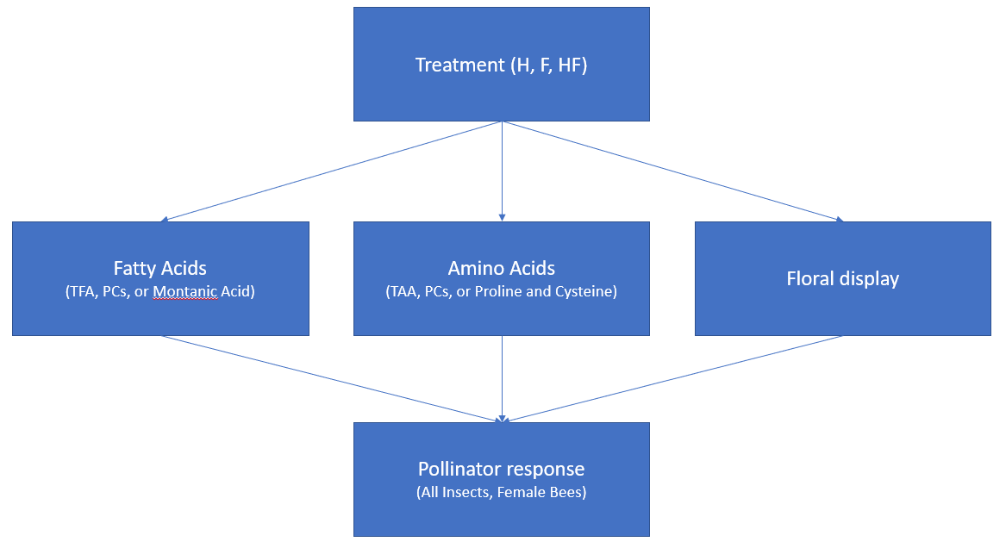

Figure S2. Correlation between flower-visitor abundance and floral display (average inflorescence size * number of inflorescences). The Pearson Correlation Coefficient r and p value are provided. The six species were C. vulgare (circle), E. hirsutum (triangle), F. ulmaria (square), H. radicata (cross), P. tanacetifolia (square with cross), P. lanceolata (asterisk). The four treatments were control (C: red), fertilizer (F: green), herbicide (H: blue), and combination (HF: purple).
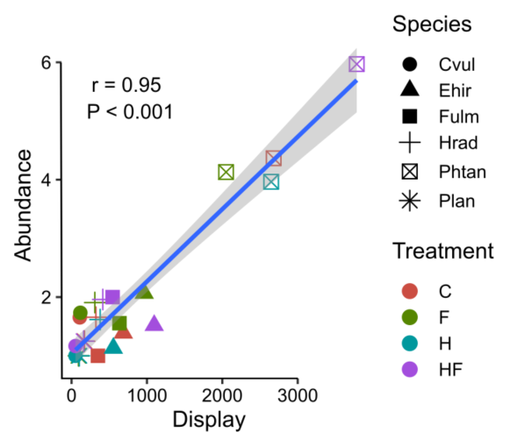

Figure S3. Visitation rate of insect visitors to the six plant species included in this study; letters above bars indicate significant differences (P < 0.05) between individual contrasts.
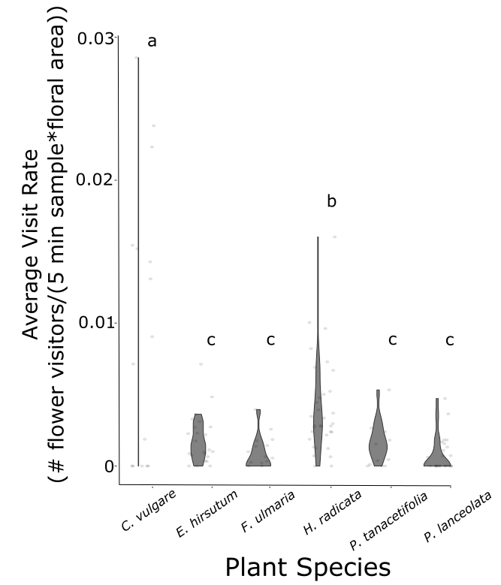

Figure S4. Correlations between insect traits and (a) pollen fatty acids and (b) pollen amino acids. Significant relationships are shown as colored squares, the strength of the correlation is indicated by the color. Negative correlations are shown in shades of blue, with darker blues indicating stronger negative associations, and positive correlations are shown in red, with darker reds indicating stronger positive associations.
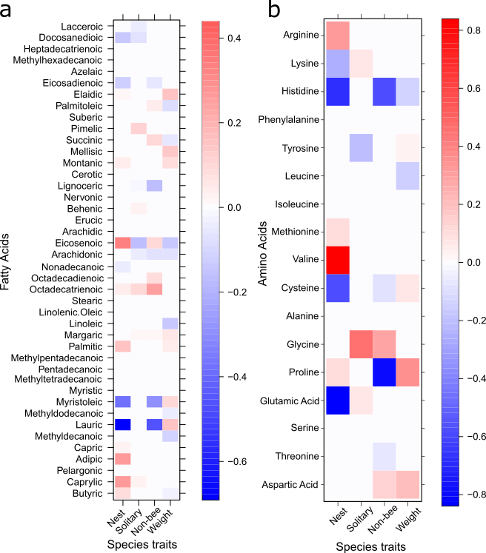

Figure S5. Best fit linear models testing predicted relationships between montanic acid, cysteine, and proline for bumble bee abundance (a-c), honeybee abundance (d), and hoverfly abundance (e). For these plots, we used predicted responses based on the model output. Model structure included a negative binomial distribution with a nested plot within site random effect structure. Individual compounds generated significantly better models (lower AIC) for bumble bee and honeybee abundance, but not hoverfly abundance, so we include the significant effect of the best fit model (TAA) for hoverflies (e).
