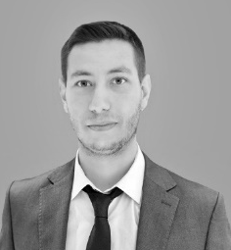
E. MEHTER was born in Çankaya, Ankara, TURKEY in 1997. He received his B.S. degree in 2020 and M.S. degree in 2024, all in electrical and electronics engineering department from the Başkent University Ankara, TURKEY. He currently works for defense electronic company RFTR Electronics Inc., Ankara, TURKEY as RF&Microwave design engineer.

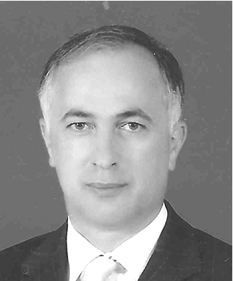
M. ÜÇÜNCÜ was born in Iskenderli Village, Trabzon, TURKEY in 1958. He received his B.S. degree in 1983, M.S. degree in 1985 and Ph.D. degree in 1989, all in electrical and electronics engineering department from Boğaziçi University Istanbul, TURKEY. From 1980 to 2012, he worked in military for different positions and retired in 2012. He worked as a board member of defense electronic company ASELSAN for 6 years from 2013 to 2019. Dr. Üçüncü currently works at Başkent University, Ankara, TURKEY, as an assistant professor.

