Extended data
Extended Data Figs. 1 to 9
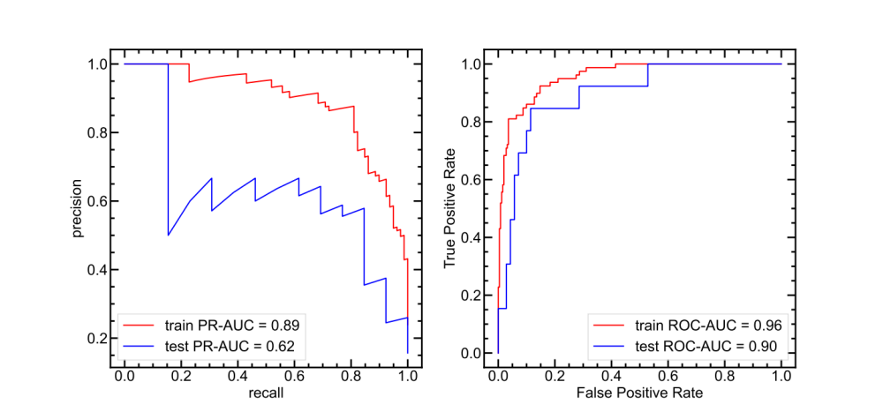
Extended Data Fig 1. Precision recall and receiver operating characteristic curves. Precision recall (left) and receiver operating characteristic (right) curves of an ANN classifier based on modified RAC features predicting the probability of low F_{max} with the data obtained from the initial random screen. The training set curve is shown in red and the test set curve is shown in blue. Areas under the curve are shown in the legend.

Extended Data Fig 2. CoGEF simulations of scissile ferrocenes. CoGEF simulation plots of ORIMEJ (left) and NAGBEE (right) complexes. Both complexes are scissile ferrocenes with no covalent crosslinks between two Cp ligands. Each complex features a favorable non-covalent interaction between two Cp ligands, with hydrogen bonding present in ORIMEJ and extended 𝜋-stacking interaction present in NAGBEE. Both structures undergo a peeling ligand dissociation mechanism that doesn’t involve Cp ring rotation. The displacement distance at F_{max} is shown by a light green line. Several structures are shown as insets, including initial structures, structures associated with F_{max} (red arrow), and structures associated with E_{max} (blue arrow). Atoms in the structures are colored as follows: iron in orange, oxygen in red, carbon in gray, hydrogen in white, fluorine in cyan.

Extended Data Fig 3. CoGEF simulation relationship between F_{max} and dihedral angle. CoGEF simulated F_{max} values as a function of the absolute value of the dihedral angle between attachment points for the subset of scissile ferrocene complexes with favorable (ΔE < 0) ligand–ligand non-covalent interaction energies. A linear fit is shown as a black line.
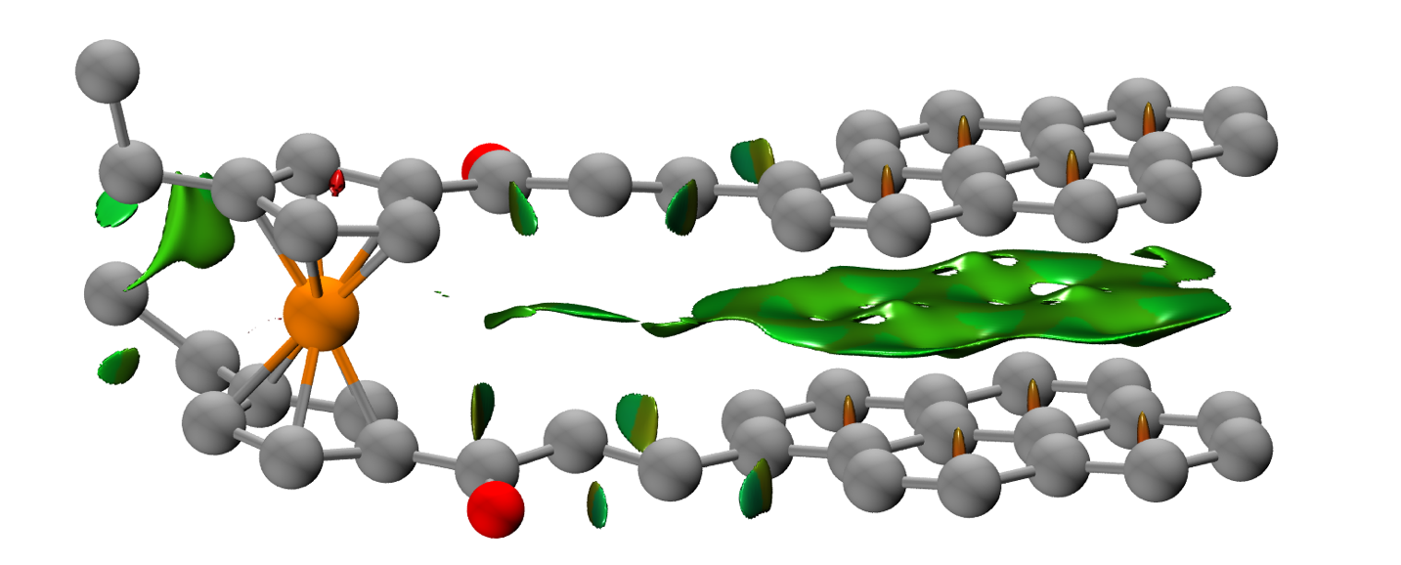
Extended Data Fig 4. Non-covalent interaction visualization of a representative structure, NAGBEE. NCIPLOT analysis of the ground state NAGBEE structure. Hydrogens are omitted. An isovalue of 0.4 was used to construct the NCI surface. Red corresponds to unfavorable interactions, green corresponds to weakly favorable interactions, and blue corresponds to strongly favorable interactions.
Extended Data Fig 5. Non-covalent interaction visualization of a representative structure, ORIMEJ. NCIPLOT analysis of the ground state ORIMEJ structure. An isovalue of 0.4 was used to construct the NCI surface. Red corresponds to unfavorable interactions, green corresponds to weakly favorable interactions, and blue corresponds to strongly favorable interactions. Hydrogen bonding interaction strength was analyzed using the atoms-in-molecules critical point density using Multiwfn and is shown in the label.
Extended Data Fig 6. Force-modified activation energies for unsubstituted and ansa-cis/trans ferrocenes. Computed force-modified activation energies (in kcal/mol) versus external force (in nN) for the dissociation of unsubstituted, ansa-cis, and ansa-trans ferrocenes. Linear force response curves are shown as gray lines with associated linear fits as insets. The threshold energy of 16.6 kcal/mol that can be used to estimate single molecule force spectroscopy forces is shown as the bolded black line. Example transition state structures are shown as insets. Atoms are colored as follows: Fe in orange, C in gray, H in white. Coordination bonds are shown as hollow blue bonds and transition state bonds are shown as purple dashed lines.
Extended Data Fig 7. Non-covalent interaction analysis of EFILAI in the ground and transition states. NCIPLOT analysis of EFILAI complex under 1 nN external applied force in the ground (GS) and transition (TS) states. Atoms are colored as follows: C in gray, H in white, N in blue, Fe in orange. The ligand–ligand interaction is 25 kcal/mol more favorable than the median computed over all studied ferrocenes.
Extended Data Figure 8. Hydrogen bonding analysis of EGIPER under force in the ground and transition states. QTAIM hydrogen bonding analysis of EGIPER complex under 1 nN external applied force in the ground (GS) and transition (TS) states. Atoms are colored as follows: C in gray, H in white, Fe in brown, P in orange, O in red. Coordination bonds are shown as hollow blue lines and hydrogen bonds are shown as dashed blue lines. Hydrogen bonding strengths calculated using QTAIM for each bond are shown as labels. The ligand–ligand interaction is 14 kcal/mol more favorable than the median computed over all studied ferrocenes.

Extended Data Figure 9. Synthesis of copolymers P1 and P2, competition graphic and ring opening values. a, Synthesis of P1 ferrocene-gDCC copolymer and P2 NUSZEG-gDCC copolymer by ED-ROMP. b, Schematic depiction of the competition between scissile ferrocene bonds and nonscissile gDCC. Picture is illustrative only, and it is likely that the specific sites of mechanochemistry are not rigorously central to the overall polymer. c, Ring opening values as a functi

