Extended data figure 1 Typical HPLC chromatogram of licorice extract where: (1) Liquiritin, 2.28% (2) Liquiritigenin, 0.18% (3) Glycyrrhizin, 2.95% (4) Isoliquiritigenin, 0.035%
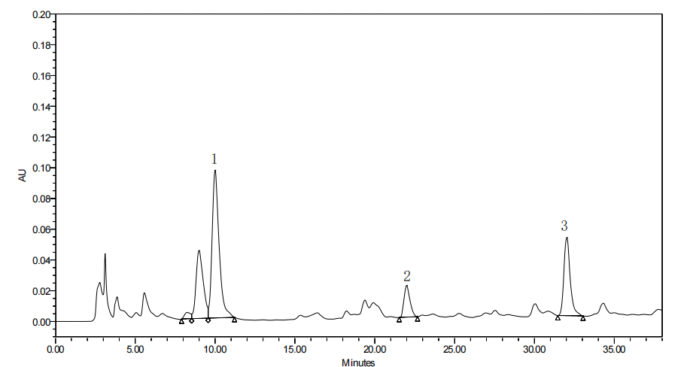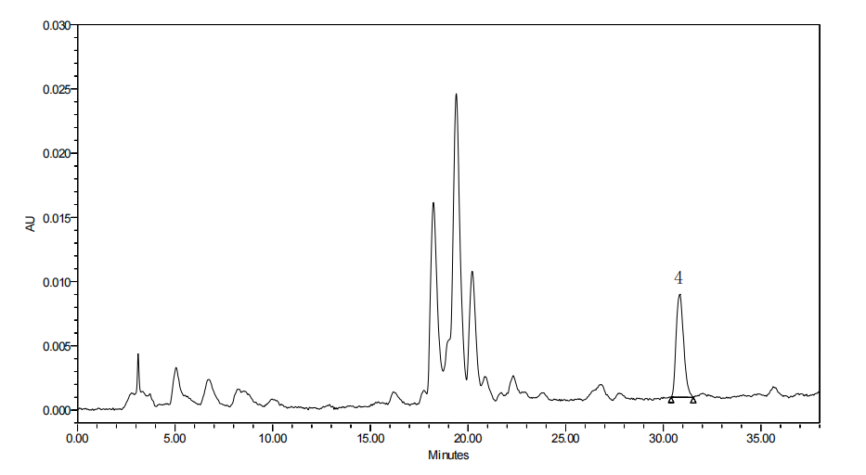
Extended data figure 2 Licorice influenced infiltration of CD8⁺ T cell
a Heatmap of Pearson’s correlation coefficients (PCCs) between gene expression level of targets of licorice and immune phenotypes, the x-axis represents different analysis methods.
b Heatmap of Pearson’s correlation coefficients (PCCs) between gene expression level of targets of licorice and immune phenotypes, the x-axis represents the targets of licorice.
c Gating strategy for CD8⁺ T cell among cells of tumor tissue, T cells were assessed as CD45⁺; CD8⁺T cells were assessed as CD3⁺CD8⁺, plots are representative of two experimental replicates.
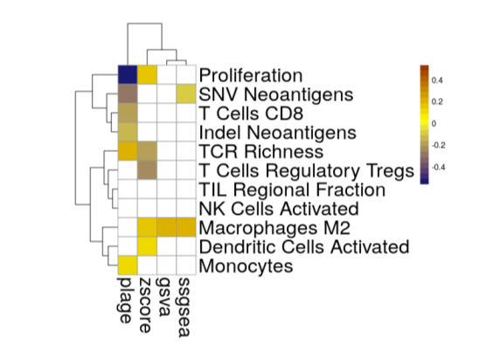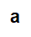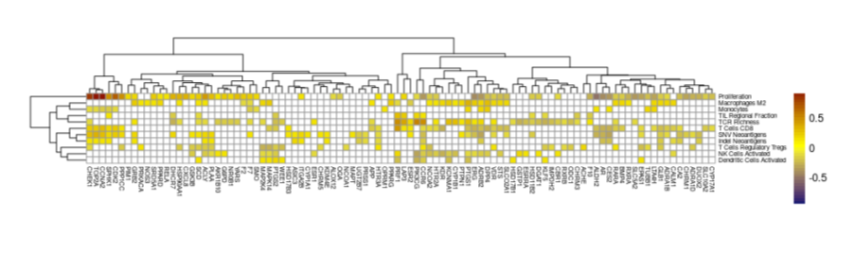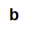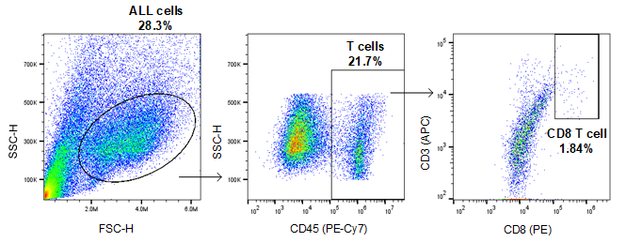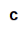
Extended data Table 1. Candidate targets for each active compound.
NO. | MOL-ID | Compounds | Potential targets
M-158 | MOL001484 | Inermine | CALM1, ADRA1B, IGHG1, CA2, PTPN1, HTR3A, CHRM3, PTGS1, SCN5A, PRSS1, PRKACA, CHEK1, PIM1, NOS2, PTGS2, DPP4, MAPK14, PIK3CG, AR, GSK3B, CDK2, ESR2, HSP90AA1, CCNA2, KDM4E, SCD, ADCY5, STS, ESRRA, BMP4, CBR1, HTR2A, NR0B1, EPAS1, PLAA
M-226 | MOL000211 | Mairin | AKR1B10 , CYP17A1, RARA, G6PD, VDR, UGT2B7, SRD5A1, RXRA, PPP1CC, HSD11B2, ADCY1, SLC10A2, DUOX2, DHCR7, ESR1, AR
M-142 | MOL002311 | Glycyrol | F2, PIM1, PTGS2, NOS2, PPARG, MAPK14, GSK3B, CCNA2, ESR1, CHEK1, ADCY5, ESRRA, CBR1, WEE1
M-131 | MOL004808 | glyasperin B | CES2, SCD, APP, LTA4H, MAPT, ESRRA, HTR2A, RELA, ACHE, NCOA2, CA2, CALM1, DPP4, TOP2A, KDR, F10, PIM1, F2, NOS2, PTGS2, F7, PRSS1, PTPN1, AR, CHEK1, GSK3B, PPARG, CCNA2, ESR2, CDK2, HSP90AA1
M-134 | MOL004810 | glyasperin F | CALM1, F2, F10, DPP4, CA2, PRSS1, GSK3B, PTGS1, TOP2A, SCN5A, NOS2, PIM1, AR, PTGS2, PTPN1, CHEK1, PPARG, MAPK14, CCNA2, ESR2, ESR1, CDK2, HSP90AA1, CES2, ADCY5, STS, LTA4H, ODC1, HSD17B1, CBR1, ALOX12, HTR2A, ASIC3
M-184 | MOL004820 | kanzonols W | SCD, APP, ALDH2, MAPT, ESRRA, ODC1, HSD17B1, ALOX12, HTR2A, HSD17B3, NR0B1, RELA, KLF5, ASIC3, NCOA2, TOP2A, SCN5A, F10, ACHE, F2, PTGS1, CALM1, CA2, NCOA1, NOS2, PTGS2, CHEK1, GSK3B, AR, PTPN1, PRSS1, PIM1, RXRA, MAPK14, PPARG, CCNA2, ESR2, CDK2
M-219 | MOL004855 | Licoricone | CA2, NCOA2, CALM1, TOP2A, PRSS1, F10, PIM1, AR, KCNH2, F2, PTGS2, NOS2, PTPN1, KDR, CHEK1, PPARG, CES2, STS, ESRRA, ODC1, CBR1, HTR2A, TUBB1
M-48 | MOL004863 | 3-(3,4-dihydroxyphenyl)-5,7-dihydroxy-8-(3-methylbut-2-enyl)chromone | NCOA2, CALM1, F10, F2, NOS2, PIM1, AR, PRSS1, PTPN1, CHEK1, PTGS2, PPARG, GSK3B, CCNA2, MAPK14, CDK2, HSP90AA1, ADCY5, CYP1A1, LTA4H, ESRRA, ACHE, HTR2A, RELA, ASIC3, PLAA
M-141 | MOL004879 | Glycyrin | NCOA2, CA2, CALM1, TOP2A, DPP4, F10, PRSS1, KCNH2, PIM1, AR F2, KDR, PTGS2, NOS2, CHEK1, ESR2, PPARG, ESRRA, IMPDH2, HTR2A, RELA, TUBB1
M-198 | MOL004885 | licoisoflavanone | PTGS1, F2, ACHE, F10, CALM1, CA2, SCN5A, F7, TOP2A, NOS2, NCOA1, PTGS2, GSK3B, PIM1, AR, PRSS1, CHEK1, PTPN1, PPARG, CCNA2, ESR1, ESR2, CDK2, HSP90AA1, CES2, STS, ODC1, ALOX12, HTR2A, ASIC3, PLAA
M-262 | MOL004891 | shinpterocarpin | ADCY5, ALDH2, STS, ERG, ODC1, HSD17B1, HTR2A, MAP2K4, ASIC3, CA2, F2, ADRA1B, CALM1, ADRA1D, CHRNA7, NCOA1, PTGS1, ACHE, PRSS1, DPP4, PRKACA, RXRB, CHRM3, PTPN1, SCN5A, CHEK1, PIK3CG, PTGS2, PIM1, GSK3B, MAPK14, NOS2, CHRM5, CHRM1, PPARG, ADRB2, OPRM1, RXRA, AR, CDK2, CCNA2, OPRD1, ESR2, ESR1
M-223 | MOL004903 | liquiritin | CA2, AR, CALM1, F7, F10, NOS2, CCNA2, F2, PPARG, DPP4, ESR1, OGA, ITGA2B, STS, LTA4H, GLB1, HTR2A, LAP3, SLC5A2, ACLY, YARS
M-202 | MOL004904 | licopyranocoumarin | SCD, APP, STS, LTA4H, MAPT, HTR2A, RELA, ASIC3, CA2, ACHE, CALM1, TOP2A, F10, F2, PTGS2, KDR, F7, PRSS1,, PIM1, AR, NOS2, PTPN1, CCNA2, PPARG, CDK2
M-123 | MOL004908 | Glabridin | DPP4, NCOA2, F2, ADRA1B, IGHG1, CALM1, CA2, ACHE, PRKACA, CHRM1, SCN5A, NOS2, GSK3B, NCOA1, CHEK1, PTGS2, PTPN1, PRSS1, PIM1, MAPK14, RXRB, ADRB2, AR, RXRA, PPARG, CCNA2, CDK2, ESR2, SCD, APP, STS, LTA4H, MAPT, ESRRA, ODC1, HSD17B1, HTR2A, NR0B1, ASIC3
M-126 | MOL004912 | Glabrone | CES2, SCD, DGAT1, APP, ALDH2, STS, LTA4H, MAPT, ODC1, ALOX12, HTR2A, HSD17B3, NR0B1, EPAS1, ASIC3, DPP4, ACHE, F10, CALM1, PTGS1, F2, CA2, SCN5A, NOS2, PTGS2, PRSS1, AR, GSK3B, PIM1, PTPN1, RXRA, CHEK1, MAPK14, PPARG, CCNA2, ESR2, ESR1, CDK2
M-22 | MOL004914 | 1,3-dihydroxy-8,9-dimethoxy-6-benzofurano[3,2-c]chromenone | AR, MAPK14, GSK3B, PTPN1, PRKACA, PPARG, ESR1, CHEK1, CDK2, HSP90AA1, CCNA2, ESR2, ADCY5, CYP1A1, PRF1, CBR1, WEE1, CCR6, NR0B1, TUBB1
M-29 | MOL004959 | 1-Methoxyphaseollidin | CYP1A1, CYP1A2, CYP1B1, SLCO2A1, NOS3, NCOA2, ADRA1D, CALM1, TOP2A, F10, ADRA1B, PRSS1, NCOA1, KDR, KCNH2, F2, PIM1, DPP4, PTGS1, PPARG, NOS2, GSK3B, AR, RXRA, MAPK14, CHEK1, PTGS2, ADRB2, SCN5A, CDK2, PIK3CG, ESR2, CCNA2, ESR1, HSP90AA1
M-112 | MOL005001 | Gancaonin H | NCOA2, CA2, CALM1, PTGS2, PIM1, AR, TOP2A, KDR, F10, CCNA2, PRSS1, PTPN1, ESR1, HSP90AA1, SCD, DGAT1, CYP3A4, F7, GSTP1, LTA4H, MAPT, ESRRA, ODC1, HSD17B1, ALOX12, HTR2A, RELA, SMO, SPHK1, ASIC3
M-187 | MOL005003 | Licoagrocarpin | SCD, APP, STS, LTA4H, MAPT, ESRRA, CBR1, HTR2A, MTNR1A, TUBB1, NCOA2, NOS3, CA2, CALM1, F10, ACHE, ADRA1B, DPP4, CHRM3, F2, PRSS1, PIM1, KCNH2, CHEK1, PTGS2, MAPK14, NOS2, RXRA, GSK3B, SCN5A, CDK2, AR, PPARG, ADRB2, CCNA2, ESR2, HSP90AA1
M-137 | MOL005007 | Glyasperins M | NCOA2, KCNMA1, PTGS1, DPP4, CA2, CALM1, F2, ACHE, F10, TOP2A, KDR, PTGS2, KCNH2, PRKACA, F7, PIM1, GSK3B, NOS2, NCOA1, PPARD, PRSS1, CHEK1, PTPN1, SCN5A, AR, PPARG, CCNA2, ESR1, CDK2, ESR2, HSP90AA1, CES2, STS, LTA4H, CXCL8, ODC1, HTR2A, TUBB1, ASIC3
M-188 | MOL005012 | Licoagroisoflavone | CES2, SCD, DGAT1, CYP1A1, APP, ALDH2, STS, GSTP1, MAPT, ESRRA, ALOX12, HTR2A, NR0B1, KLF5, EPAS1, ASIC3, F10, CA2, CALM1, SCN5A, F2, DPP4, NOS2, PIM1, PTGS2, PTPN1, AR, PRSS1, CHEK1, ESR2, MAPK14, GSK3B, PPARG, CCNA2, ESR1, CDK2
M-250 | MOL005017 | Phaseol | AR, KDR, F2, NOS2, PIM1, PTPN1, PTGS2, MAPK14, PPARG, GSK3B, PRKACA, CDK2, CCNA2, HSP90AA1, CHEK1, ESR2, ADCY5, CBR1, ALOX12, WEE1, CCR6
M-145 | MOL005008 | Glycyrrhiza flavonol A | ACHE, TOP2A, CALM1, F10, DPP4, CA2, F7, PIM1, PTGS2, AR, PRSS1, NOS2, PTPN1, GSK3B, CCNA2, ESR2, HSP90AA1, ESR1, CDK2, SCD, STS, MAPT, ESRRA, ODC1, HTR2A, HSD17B3, NR0B1, GRB2, HSD11B2, ASIC3

