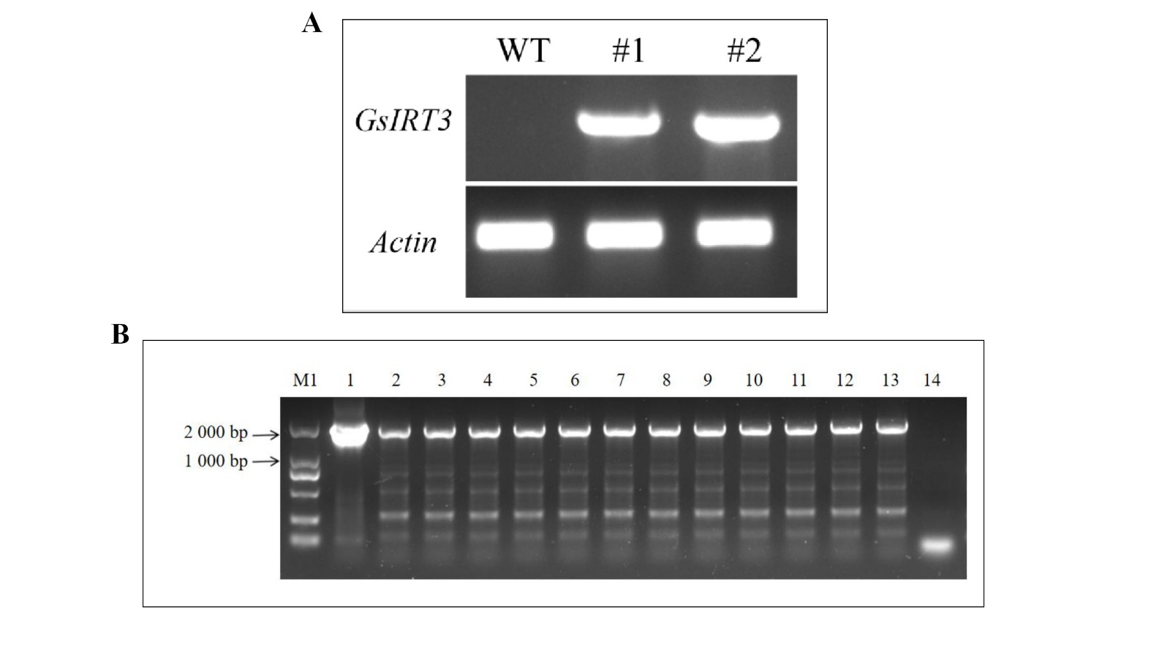
Figure S1. Agarose gel electrophoresis of PCR products. (A) Agarose gel electrophoresis of PCR products amplified using primers specific for GsIRT3 and Actin genes. WT: Wild-type control; #1, #2: Experimental samples. (B) Agarose gel electrophoresis of PCR products from 14 different samples.

