SUPPORTING INFORMATION

X-ray structures, thermal stabilities and kinetics of guest desolvation of complexes of three fluorenone-derived host compounds with the polar aprotic guest solvent, tetramethylurea

Duncan W. McFarlane,*ª Benita Bartonª and Mino R. Caira^{b}

ªDepartment of Chemistry, PO Box 77000, Nelson Mandela University, Port Elizabeth, 6031, South Africa
E-mail s220590028@mandela.ac.za
^{b}Department of Chemistry, University of Cape Town, Rondebosch 7701, South Africa
E-mail mino.caira@uct.ac.za
a)
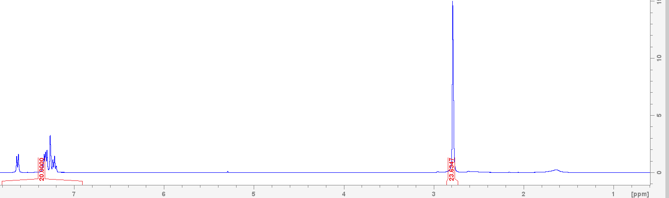
b)
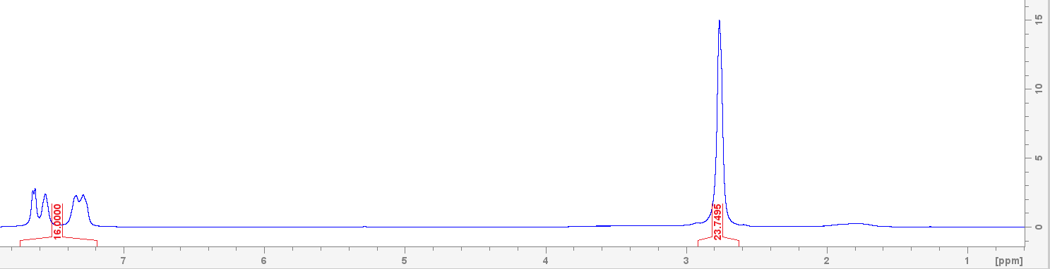

c)
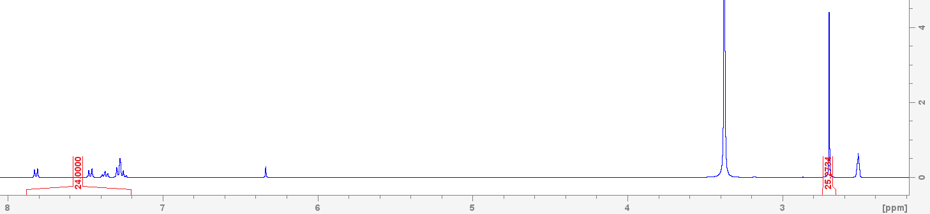
Figure S1 ¹H NMR spectra of (a) H1·2(TMU), (b) H2·2(TMU) and (c) H3·2(TMU) (CDCl₃ was the solvent for the first two of these, and DMSO-d₆ for the third complex).

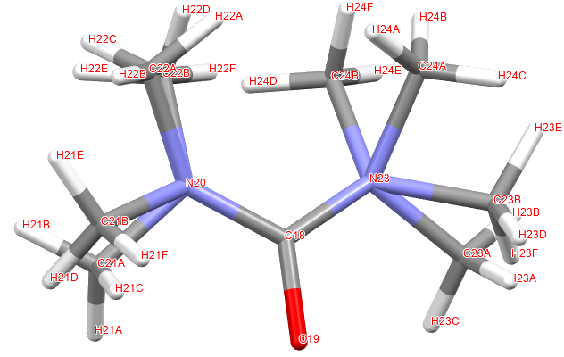

Figure S2 Atom labels for the disordered guest molecule in H1·2(TMU).

Table S1 Activation energy data for the desolvation of H1·2(TMU).
Extent of guest desorption/% | Slope/K | Activation energy/kJ·mol^{‒1}
10 | 19.092 | 158.730888
20 | 20.157 | 167.585298
30 | 20.166 | 167.660124
40 | 19.195 | 159.58723
50 | 18.097 | 150.458458
60 | 17.188 | 142.901032
70 | 16.497 | 137.156058
80 | 15.743 | 130.887302
90 | 14.849 | 123.454586

Table S2 Activation energy data for the desolvation of H2·2(TMU).
Extent of guest desorption/% | Slope/K | Activation energy/kJ·mol^{‒1}
10 | 18.909 | 157.209426
20 | 19.061 | 158.473154
30 | 18.64 | 154.97296
40 | 17.29 | 143.74906
50 | 15.695 | 130.48823
60 | 15.345 | 127.57833
70 | 14.695 | 122.17423
80 | 12.864 | 106.951296
90 | 6.7039 | 55.7362246

Table S3 Activation energy data for desolvation of H3·2(TMU).
Extent of guest desorption/% | Slope/K | Activation energy/kJ·mol^{‒1}
10 | 17.465 | 145.20401
20 | 17.977 | 149.460778
30 | 18.27 | 151.89678
40 | 18.288 | 152.046432
50 | 18.227 | 151.539278
60 | 18.11 | 150.56654
70 | 17.955 | 149.27787
80 | 17.839 | 148.313446
90 | 17.59 | 146.24326

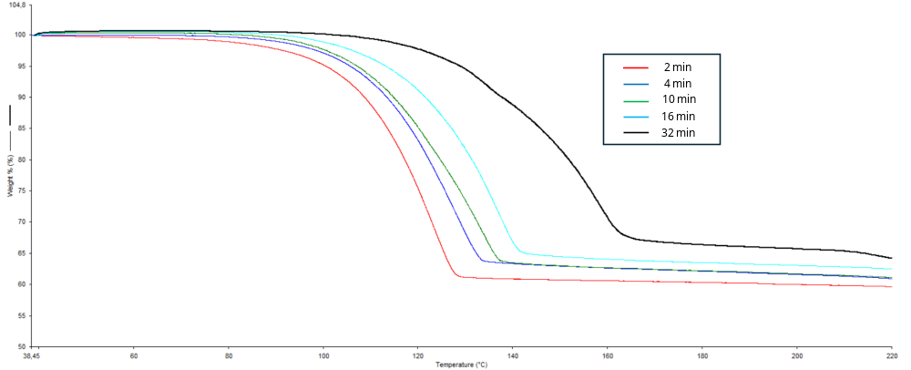

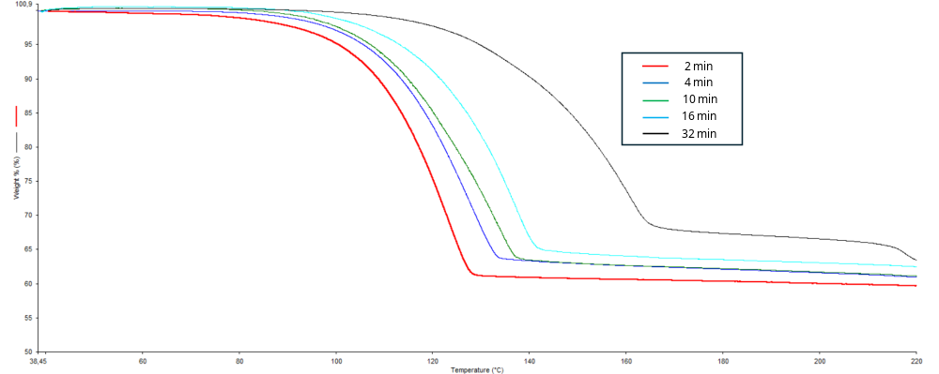

Figure S3 TG experiments at heating rates of 2, 4, 10, 16 and 32 °C·min^{‒1} for H2·2(TMU) showing the two repeat experiments at 32 °C·min^{‒1}. These experiments show that this particular curve was not an outlier and suggests a mechanism change for the desolvation process at this temperature.

Figure S4 Plots of ln(β/β_{o}) against 1000 K/T at 10, 20, 30, 40, 50, 60, 70, 80 and 90% of the total mass loss observed for H2·2(TMU) showing, again, that the plot obtained at 32 °C·min^{‒1} is repeatedly obtained and is not an outlier.

Table S4 Repeat experiment at 32 °C showing the activation energy data for desolvation of H2·2(TMU).
Extent of guest desorption/% | Slope/K | Activation energy/kJ·mol^{‒1}
10 | 13.924 | 115.764136
20 | 14.05 | 116.8117
30 | 13.591 | 112.995574
40 | 12.873 | 107.026122
50 | 12.169 | 101.173066
60 | 12.202 | 101.447428
70 | 12.174 | 101.214636
80 | 11.99 | 99.68486
90 | 8.7411 | 72.6735054

Table S5 Another repeat experiment at 32 °C showing the activation energy data for desolvation of H2·2(TMU).
Extent of guest desorption/% | Slope/K | Activation energy/kJ·mol^{‒1}
10 | 13.551 | 112.663
20 | 13.074 | 108.6972
30 | 12.327 | 102.4867
40 | 11.813 | 98.21328
50 | 11.311 | 94.03965
60 | 11.38 | 94.61332
70 | 11.34 | 94.28076
80 | 11.134 | 92.56808
90 | 5.6671 | 47.11627

