TABLE OF CONTENTS ENTRY

X-ray structures, thermal stabilities and kinetics of guest desolvation of complexes of three fluorenone-derived host compounds with the polar aprotic guest solvent, tetramethylurea

Duncan W. McFarlane,*ª Benita Bartonª and Mino R. Caira^{b}

ªDepartment of Chemistry, PO Box 77000, Nelson Mandela University, Port Elizabeth, 6031, South Africa
E-mail s220590028@mandela.ac.za
^{b}Department of Chemistry, University of Cape Town, Rondebosch 7701, South Africa
E-mail mino.caira@uct.ac.za

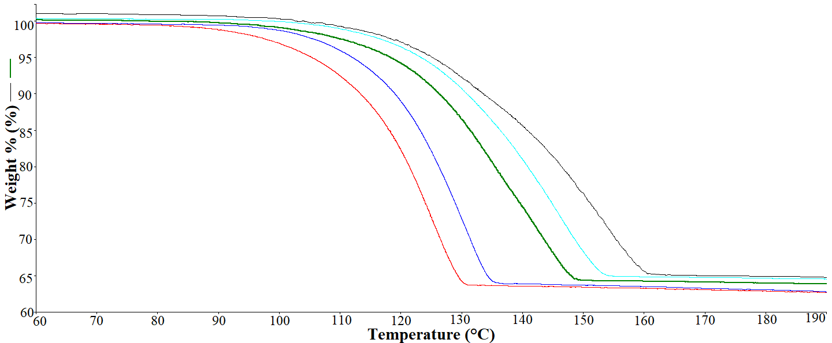
2 min
4 min
10 min
16 min
32 min

Host compounds 9,9’-(1,4-phenylene)bis(fluoren-9-ol) (H1), 9,9’-(ethyne-1,2-diyl)bis(fluoren-9-ol) (H2) and 9,9’-(biphenyl-4,4’-diyl)bis(fluoren-9-ol) (H3) formed complexes with tetramethylurea (TMU). Shown here are plots obtained when determining the kinetics of the guest release event at different heating rates for the complex of H1 with TMU.

