Needs and vision
●Patient ideas and needs
●Individualized instruction

Current situation
● Cognitive differences in doctors, nurses and patients
●No standard operating procedure
●Emphasizing treatment over rehabilitation
●Poor patient willingness

Major tertiary hospitals
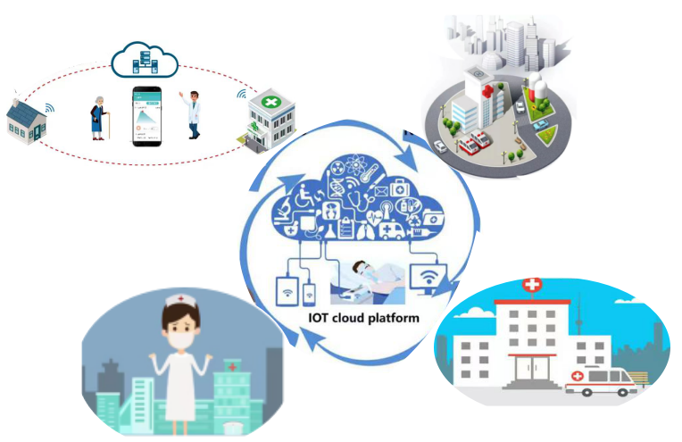
IoT Integrated Management Centre

Internet of Things + pulmonary rehabilitation

Local hospitals
Community hospital
Implementation
●Diverse social supportst
●Systematic PR plans
●Internet based/Digital Rehabilitation Healthcare

