Supplementary Material
Method
Comparison of three primers targeting the nucleocapsid gene
SARS-CoV-2 levels in aircraft samples were very close to the detection limit for several weeks during the monitoring period. For this reason, we evaluated whether the detection limit could be improved or if there was any difference among the well-known primers that target the N-gene. Therefore, two types of samples were selected: one with high Ct values (low viral levels, Aircraft) and one with low Ct values (high viral levels, Käppala). The three sets of primers and probes (N1, N2 and N3) were ordered from Sigma-Aldrich (Merck KGaA, Germany) and the primers sequences were according to Lu et al., (2020). Quantification was performed using 5 μL Reliance One-Step Multiplex RT-qPCR Supermix Kit (Bio-Rad), 5 μL of RNA template, 2 μL of primers (final concentration of 500 nM), 0.25 μL probe (final concentration of 125 nM), 1 μL BSA and the rest was nuclease-free water for a total reaction volume of 20 μL. Thermal cycling (50 °C 10 min, 95 °C 10 min, followed by 45 cycles of 95 °C 10 s, 60 °C for 30 s) on an Applied Biosystems Quantstudio 3 (Fisher Scientific™, Sweden) machine was performed. Positive, negative, and cross-plate controls were the same as those described above.
To compare N1, N2 and N3 primers, the third calculation method has been applied (N-gene copies per 100 mL wastewater) because unnormalized data was preferred to have a clearer comparison of raw data. In this calculation approach, Ct values of either N1, N2 or N3 were converted to gene copy number per reaction (copies per 20 µL of reaction volume) using the corresponding standard curves. Then, the respective dilutions (5µL template, 80 µL RNA extracted and 40 mL initial sample) were considered to calculate the gene copy number per mL of wastewater. The data was expressed as gene copy numbers per 100 mL of wastewater.

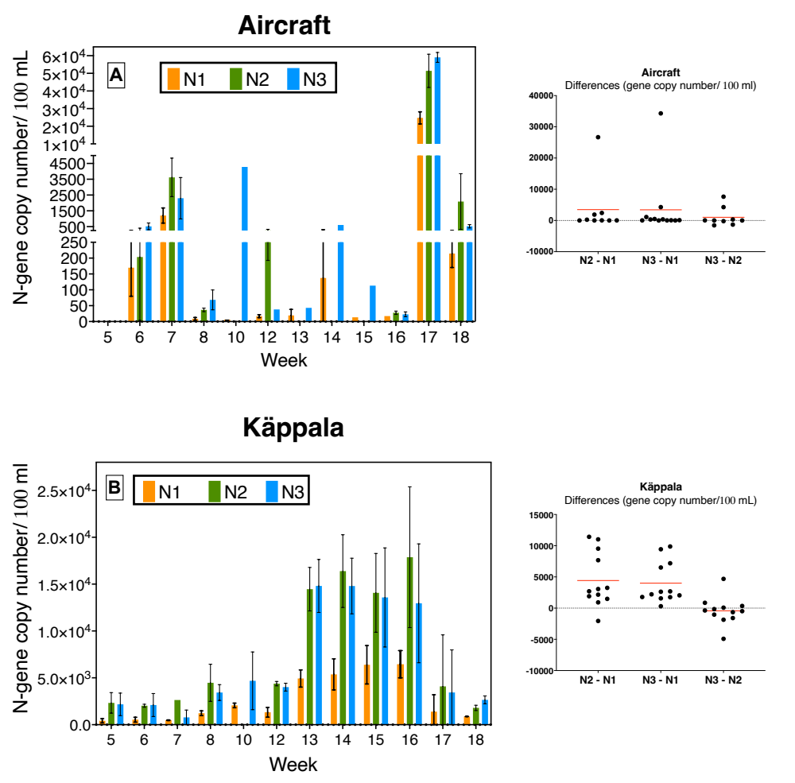
Figure S1. Comparison of N1, N2 and N3 primers for SARS-CoV-2 detection using aircraft (A) and Käppala (B) samples. One-way analysis of variance (ANOVA) was used to determine whether there were any statistically significant differences among the three tested primers. Käppala was used as a reference as these samples had low Ct values throughout the monitoring period. no significant difference between the N2 and N3 primer sets when the Käppala samples were analyzed, and the N1 primer set was different from both the N2 and N3 primer sets
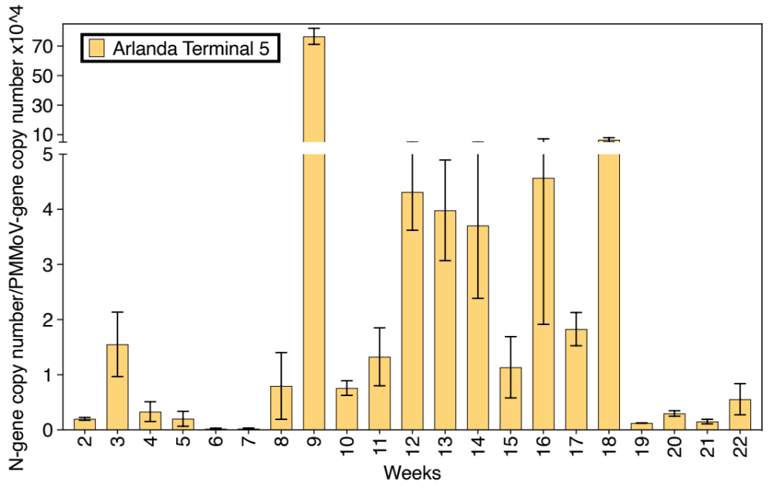
Figure S2. SARS-CoV-2 content presented as N-gene copy number per PMMoV gene copy of Stockholm Arlanda Airport Terminal 5
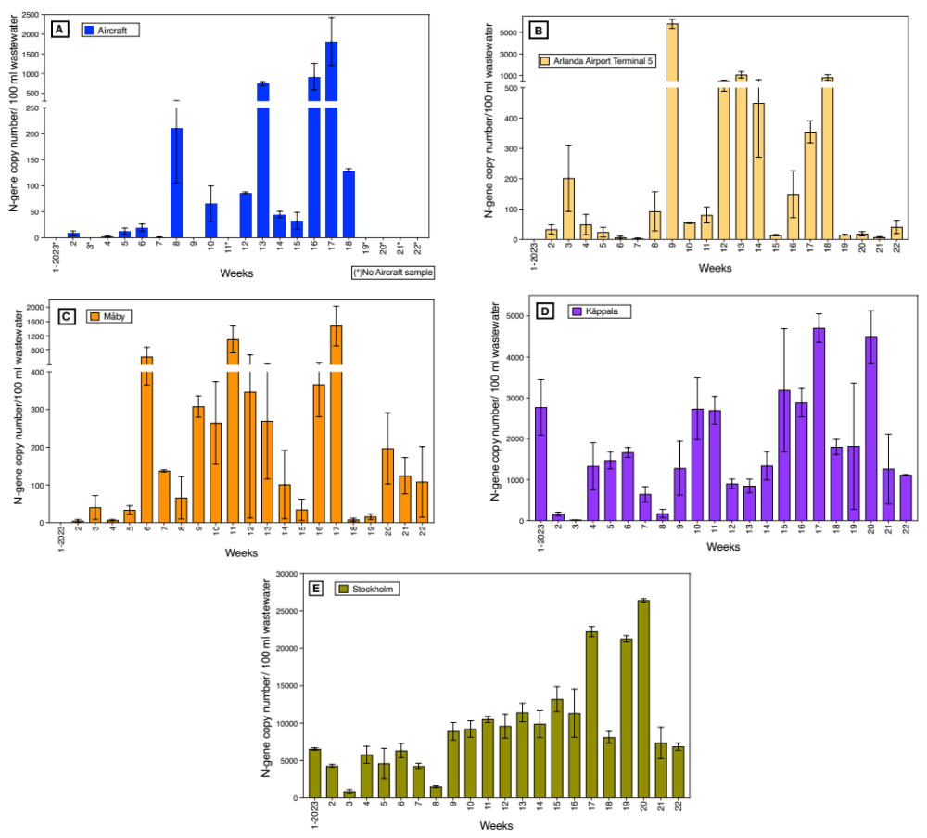
Figure S3. SARS-CoV-2 content per 100 mL raw wastewater. (A) aircraft (B) Arlanda Airport Terminal 5 (C) Måby (D) Käppala WWTP (E) Stockholm.
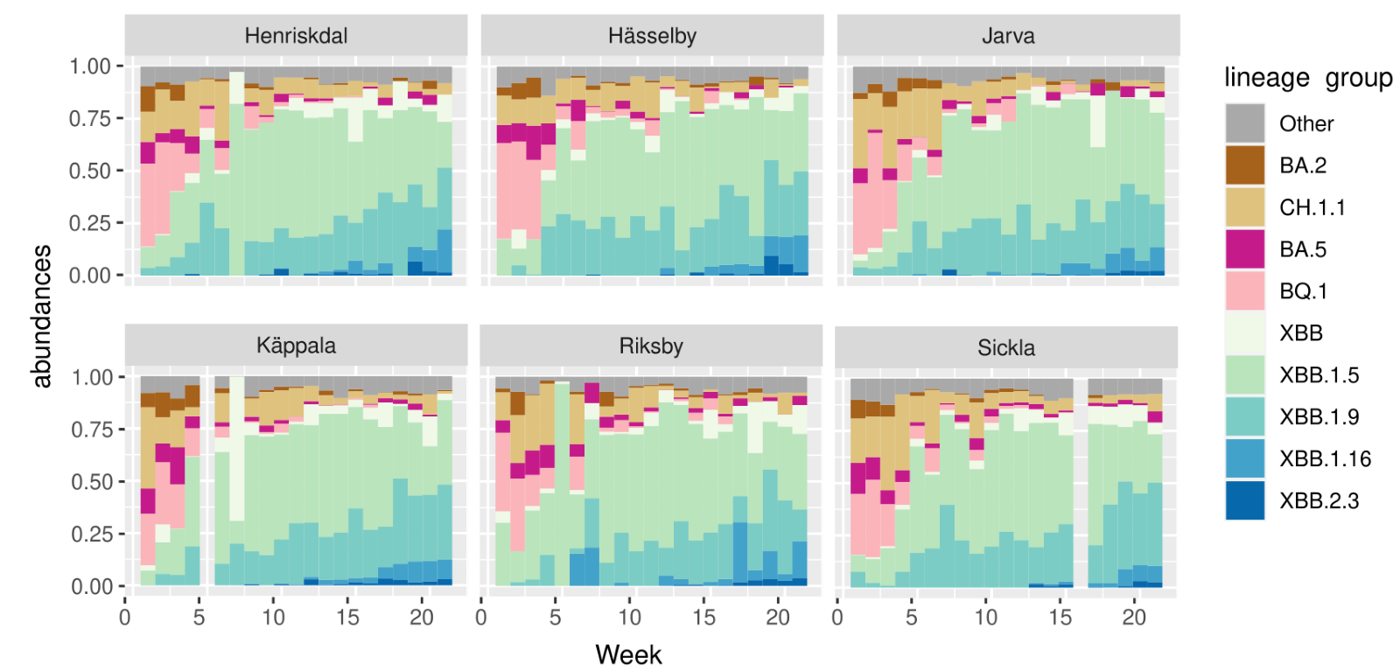
Figure S4: Detected lineage groups for each week in each of the six WWTP inlets in the Stockholm metropolitan area.

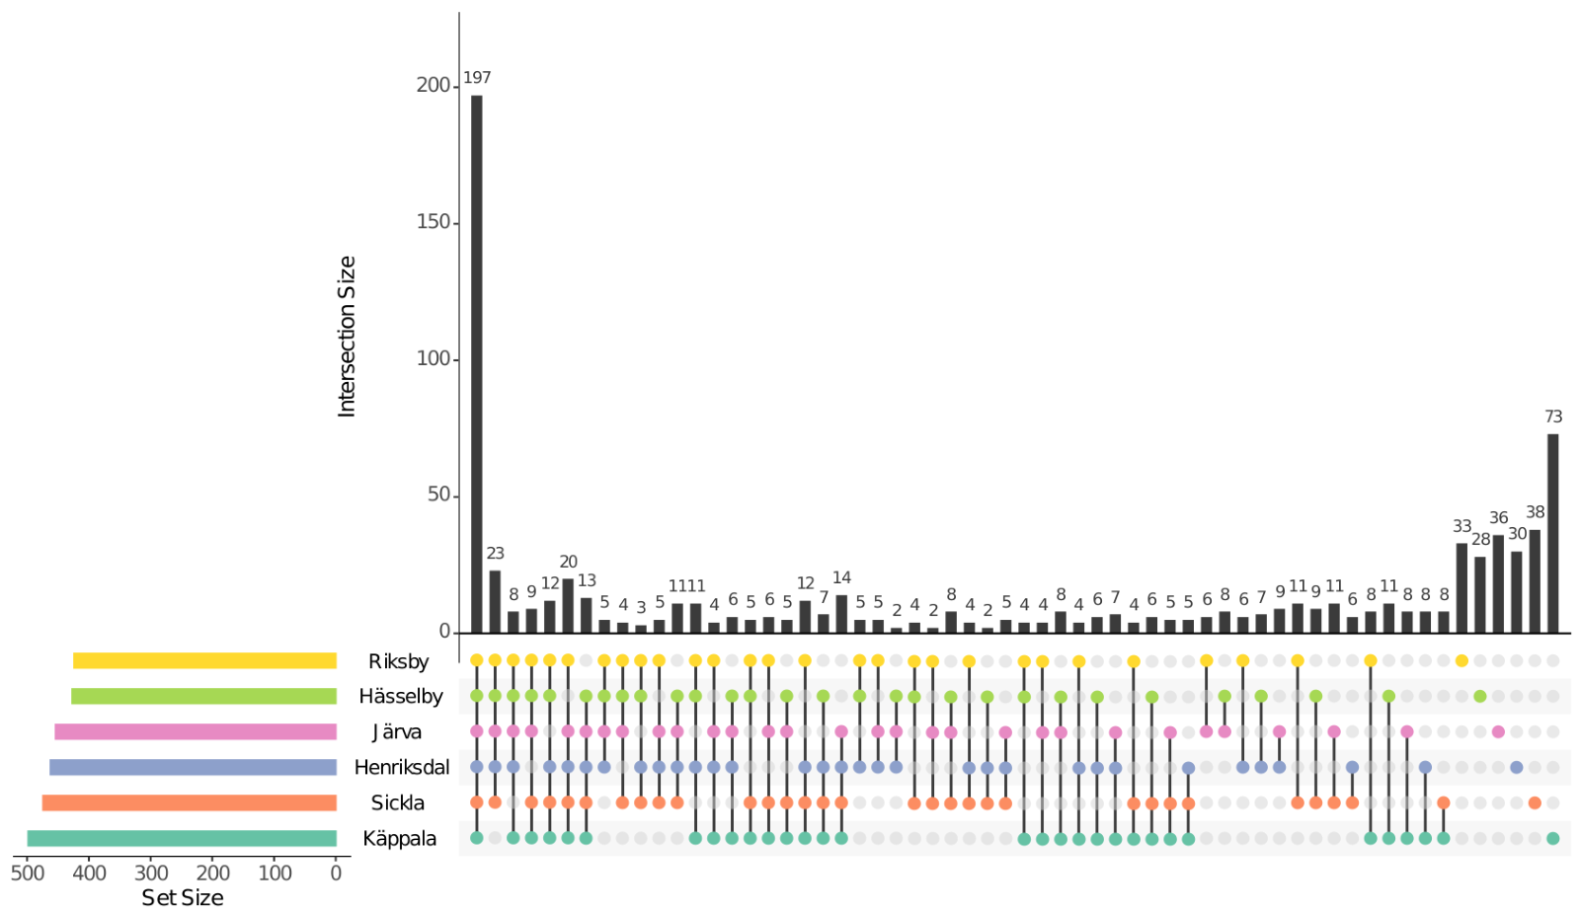
Figure S5: Upset plot of each of the six wastewater inlets in the Stockholm metropolitan area. An Upset plot shows a horizontal barplot of the total number of lineages found at each site and on the vertical barplot the number of lineages found at each combination of sites. Combinations are depicted as colored dots corresponding to the sites on the left.

