Removal of traces of highly explosive trinitrotoluene from TNT Red water by using graphene nanocomposites prepared from solid wastes:
An example of circular economy

Anshika Yadav^{1,2}, Mohammad O. Aquatar^{1,2}, Reddithota J. Krupadam^{1,2*}
¹Climate Change & Green Materials Division, CSIR-National Environmental Engineering Research Institute (NEERI), Nehru Marg, Nagpur 440020, India; ²Academy of Scientific & Innovative Research, Kamla Nehru Marg, Ghaziabad – 201 002, India

Support Information
SI-Fig.1: Schematic of graphene nanocomposites preparation using chemical exfoliation method. GN-G, graphene nanocomposite prepared from commercial graphite and GN-S, graphene nanocomposite prepared from sludge generated during chemical coagulation of TNT red water.
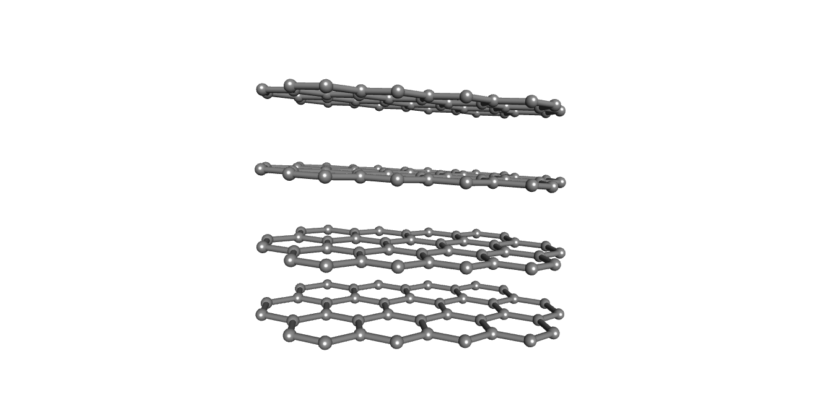
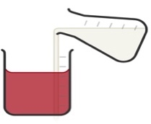
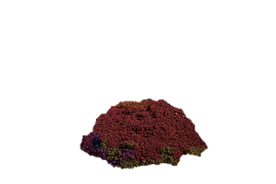
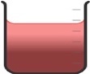
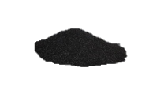
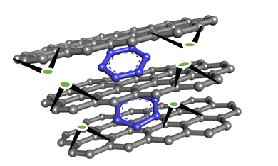
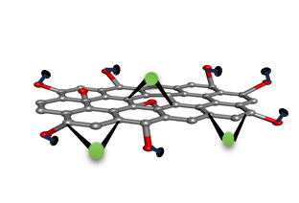
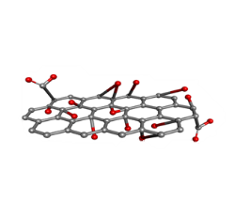
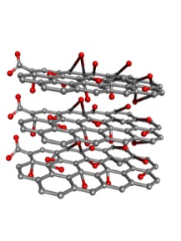
TNT red water
Chemical coagulation
Sludge
Chemical treatment
Filtration
KOH/150°C
organic acid mixture
Graphite
Commercial Graphite
Oxidation
Graphite oxide
Exfoliation
Fe(acac)₃ +oleic acid
Reduction
NaNO₃ + H₂SO₄ + KMnO₄
GN-G
GN-S
Graphene

Support Information SI-1
Experimental Procedure of Adsorption Studies
A stock solution of TNT with concentration 100 mg L⁻¹ was prepared by dissolution of appropriate quantity of TNT in deionised water. To prepare, TNT stock solution, TNT certified reference material (CRM) procured from AccuStandard (M-8330-11) of concentration 1000 mg L⁻¹ was used. 50 mg of each adsorbent (Gs or GNCs) was dispersed separately in 100 mL of an aqueous TNT solution at pH 7±0.5 in reagent bottles. The samples were agitated at 300 rpm in temperature-controlled water bath. After fixed time intervals, TNT concentration was monitored using GC (Varian/Saturn 2000 MSD) equipped with capillary column CP-Sil8 CB/Low Bleed – MS (Dawidziuk et al. 2018). The adsorption removal efficiency $(RE\%)$ and equilibrium adsorption capacity $(q_{e})$ of Gs and GNCs were calculated as per mathematical equations [1] and [2] respectively
$RE\%=[(C_{i}-C_{e})/C_{i}]×100\%$ [1]
$q_{e}=\left[\left(C_{i}-C_{e}\right)×V\right]/C_{i}$ [2]
where C_{i} and C_{e} are initial and residual aqueous TNT concentration (mg L⁻¹) respectively, V represents total volume of contaminant solution used (L), and m here represents adsorbent’s mass (g).
Adsorption kinetic studies were performed in 100 mL reagent bottles at solution pH 7.0±0.5. Each adsorbent (Gs or GNCs) was added at a quantity of 50 mg to a 100 mL TNT solution, which had a concentration of 100 mg L⁻¹. Following this, solutions were agitated for 1-120 min in a horizontal shaking system. The temperature of the solution was kept at 298 K throughout the experiments. The solutions after time intervals of 1, 5, 10, 15, 30, 45, 60 and 120 min were collected and centrifuged at 20,000 rpm to settle-down the particles of Gs or GNCs. The concentration of TNT in supernatant solutions was monitored using gas chromatography (GC-MS/MS).
Adsorption isotherm experiments were conducted at temperatures 298 K, 308 K and 318 K. The concentration of TNT solutions used in the isotherm experiments ranged from 1, 5, 10, 25, 50 and 100 mg L⁻¹. The quantity of adsorbents (Gs or GNCs) used for each experiment was 50 mg. The contact time of 30 min. was used for all adsorption isotherm experiments.

Reference Cited:
Dawidziuk, B., Nawała, J., Dziedzic, D., Gordon, D., Popiel, S., 2018. Development, validation and comparison of three methods of sample preparation used for identification and quantification of 2,4,6-trinitrotoluene and products of its degradation in sediments by GC-MS/MS. Anal. Methods 10(43), 5188–5196. https://doi.org/10.1039/C8AY01939H

Support Information
SI-Table 1: Elemental composition of GNCs

Material | Elemental Composition (wt%) |  |  |  |  | N/C* | H/C* | Fe^{b} (wt%)
Material | Nª | Cª | Oª | Hª | Others | N/C* | H/C* | Fe^{b} (wt%)
G | 4.3 | 76.1 | 2.1 | 4.1 | 13.4 | 0.056 | 0.054 | 0.02
G-G | 4.5 | 75.6 | 2.3 | 3.9 | 13.7 | 0.059 | 0.051 | 0.07
G-S | 31.2 | 59.9 | 1.1 | 4.7 | 3.1 | 0.521 | 0.078 | 0.09
GN-G | 4.3 | 76.2 | 1.9 | 4.4 | 13.2 | 0.056 | 0.058 | 8.47
GN-S | 16.9 | 70.5 | 1.6 | 2.1 | 8.9 | 0.239 | 0.029 | 8.15
ªcalculated through organic elemental analysis; ^{b}calculated through XRF; *weight ratios.

Support Information
SI-Table 2: Comparison of adsorption capacity of prepared GNC with reported adsorbents.

Adsorbent | Maximum adsorption capacity q_{max} (mg g⁻¹) | Adsorption conditions  [Contact time/Temp./solution pH] | References
4-AING | 168.6 | 8 h/298K/ pH 7.0 | (Wang et al., 2022)
nZVI-rGO | 41.9 | 303K/pH 6.0 | (Bharti et al., 2018)
AP-SiO₂ + Fe/Co | 74 | 8 h/298K/ pH 6.0 | (Mangal et al., 2017)
AP-SiO₂ + Fe | 57.8 | 8 h/298K/ pH 6.0 | (Mangal et al., 2017)
HINFA | 117.5 | 1.5h/293K | (Wang et al., 2020)
Fe@SiO₂-NH₂ | 6.71 | 293K | (Li et al., 2021)
Isoxazoline based porous polymer | 177.3 | 4 h/298K | (Deng et al., 2020)
PAIN | 163.8 | 10 h | (Wang et al., 2019)
Fe₃O₄ NHS | 70 | 298K/pH 6.5 | (Rehman et al., 2022)
GO | 62.7 | 10 h/298K | (Raad et al., 2017)
rGO | 67.8 | 10 h/298K | (Raad et al., 2017)
rGO/SiO₂ | 76.7 | 10 h/298K | (Raad et al., 2017)
GN-G | 116.2 | 0.5 h/298K | This work
GN-S | 151.6 | 0.5 h/298K | This work

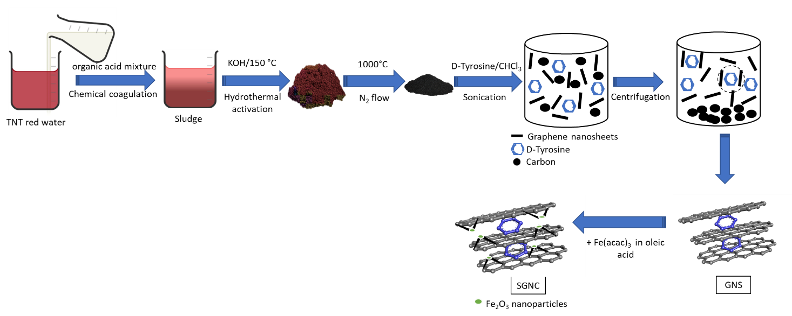
4-AING, 4-aminoindole-based aerogel; nZVI-rGO, nano zerovalent iron impregnated reduced graphene oxide; AP-SiO₂ + Fe/Co, silica nanoparticles prepared using aerogel process impregnated with bimetallic Fe/Co; AP-SiO₂ + Fe, silica nanoparticles prepared using aerogel process impregnated with Fe; PCR, porous carbon rods; Fe-PCR, iron containing porous carbon rods; HINFA, hybrid hierarchically porous indole based aerogel; Fe@SiO₂-NH₂; amino-modified nanosized zero valent iron; PAIN, indole based polymer with amine units; Fe₃O₄NHS, magnetic nano hollow spheres; GO, graphene oxide; rGO, reduced graphene oxide; rGO-SiO2, reduced graphene oxide coated silica nanoparticles..

