Spatio-temporal disparities in phytoplankton dynamics and metabolite production depending on weather conditions
Fanny Noirmain¹, Benjamin Marie², Benjamin Legrand³, Joël Van Baelen⁴, Delphine Latour¹

Supplementary materials

Table S1: Limit of detection (LOD) and of quantification (LOQ), expressed in µg L⁻¹ from the ionic chromatograph.
ions | LOD (µg L-1) | LOQ (µg L-1)
Cl- | 2,3 | 6,8
NO3- | 0,9 | 2,8
SO42- | 1,7 | 5,1
PO43- | 0,7 | 2,1
Na+ | 4,2 | 12,6
NH4+ | 16 | 50
K+ | 0,7 | 2,1
Mg2+ | 5 | 15
Ca2+ | 7,6 | 22,7

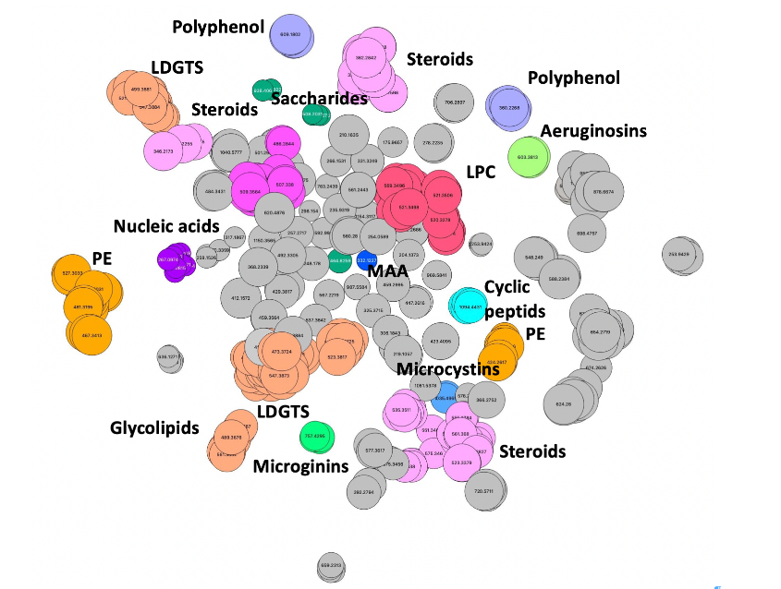
Suppl. Fig. 1: T-SNE molecular network generated with Metgem 1.3.6 based on LC-MSMS dataset obtained for all samples. The various colors show the different molecules constituting annotated clusters based on molecular fragment similarities.

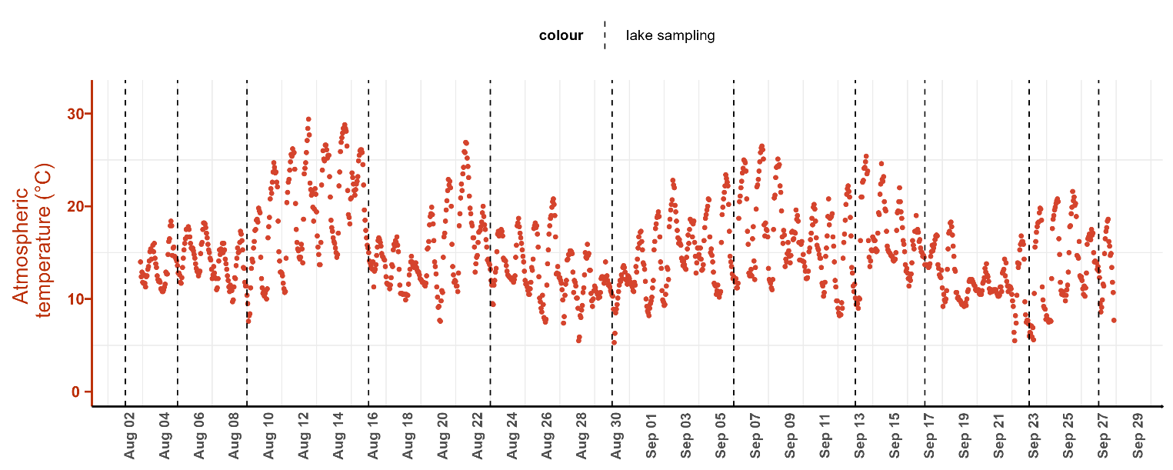
Suppl. Fig.2: Atmospheric temperature recorded at St Genes Champanelle from the meteo France station.

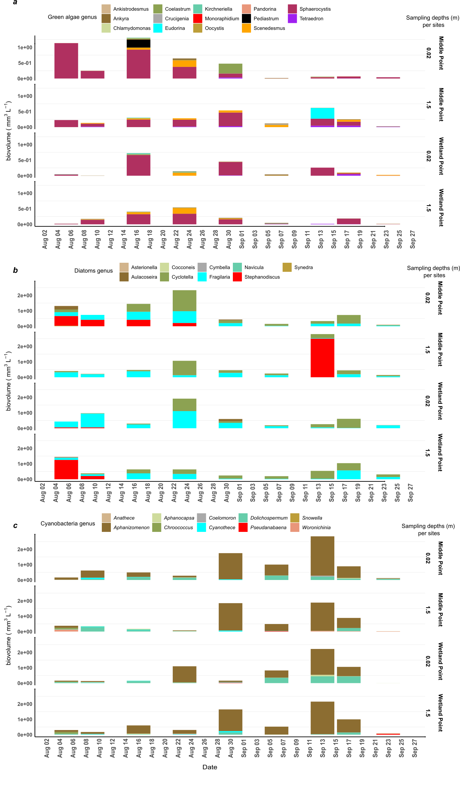
Suppl. Fig 3: Biovolumes of green algae (a), diatoms (b) and cyanobacteria (c) according to their genus, determined from lake samples collected at the middle point (MP) & wetland point (WP) and at surface and 1.5 m from the lake surface.

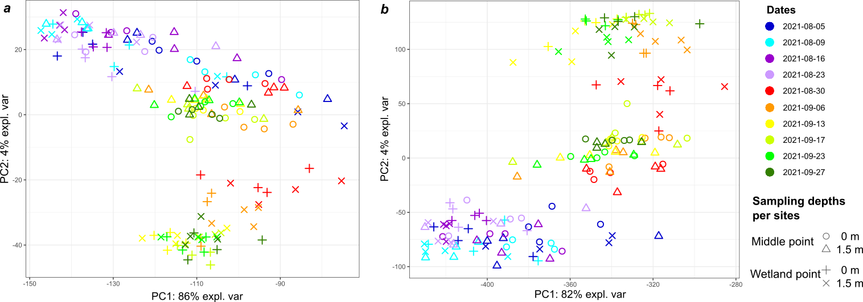
Suppl. Fig 4. Multivariate analysis (ACP) with metabolomics data, (a) untargeted metabolites(n=4440) and (b) annotated untargeted metabolites. Samples are color-coded based on the date and represented with symbols according to the sampling site and to the depths.

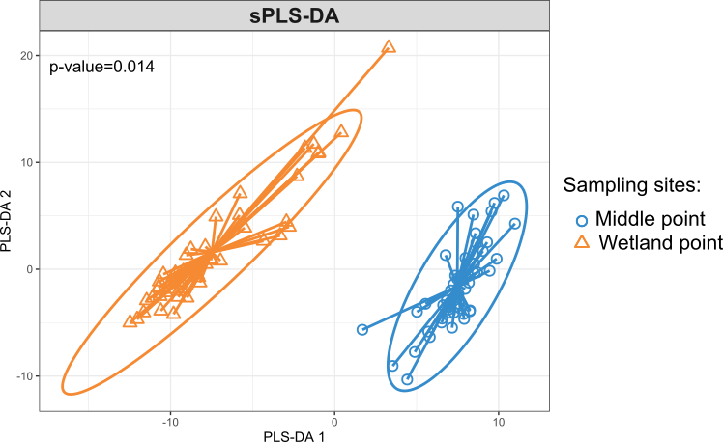
Suppl. Fig.5: sPLS-DA with annotated metabolites collected from August 30th until September 27th. The p-value is estimated by PERMANOVA with 999 permutation tests based on Euclidean distance (Betadisper function)

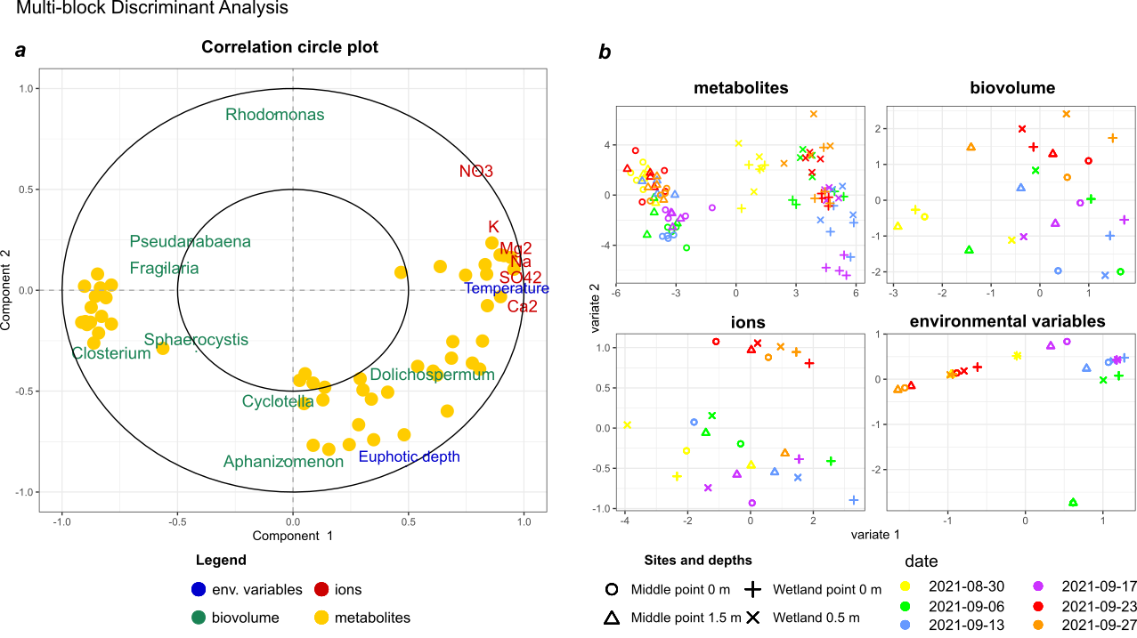

Suppl. Fig. 6: Multi-block Discriminant Analysis with Data Integration Analysis for Biomarker discovery using a Latent cOmponent (DIABLO): (a) correlation circle plot between component 1 and 2 with a correlation cutoff threshold set at 0.4, and (b) sample plots with metabolites, biovolume of phytoplankton, ions, and environmental variables, from August 30th until September 27th, 2021. The concentrations of ions are expressed in mg L⁻¹, the biovolumes of phytoplankton are expressed in mm³ L⁻¹, the metabolites are expressed in relative unit abundance.

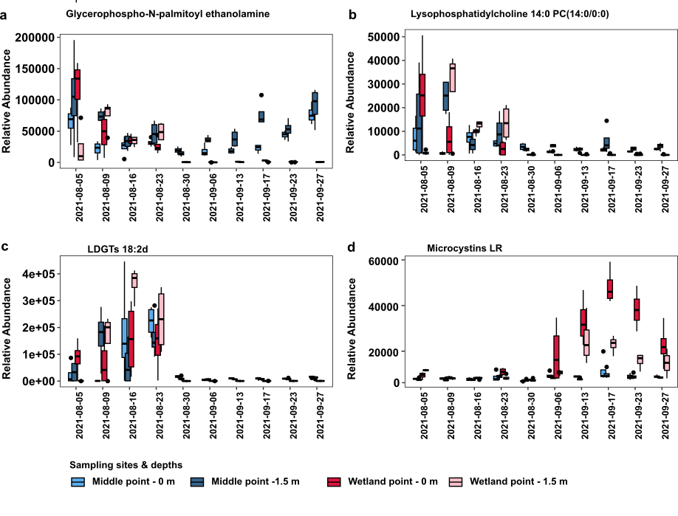
Suppl. Fig. 7: Metabolite spatial and temporal variations exemplified with (a) glycero-phospholipids, identified as Glycerophospho-N-palmitoyl ethanolamine, (b) phosphatidylcholine identified as Lysophosphatidylcholine 14:0 PC(14:0/0:0), (c) betaine lipid identified as lyso-diacylglyceryltrimethylhomoserine (LDGTs 18:2d) and (d) Microcystin LR, within samples collected at the middle of the lake, (MP) and close to the wetland area (WP), at two depths, surface and 1.5 m deeper.

