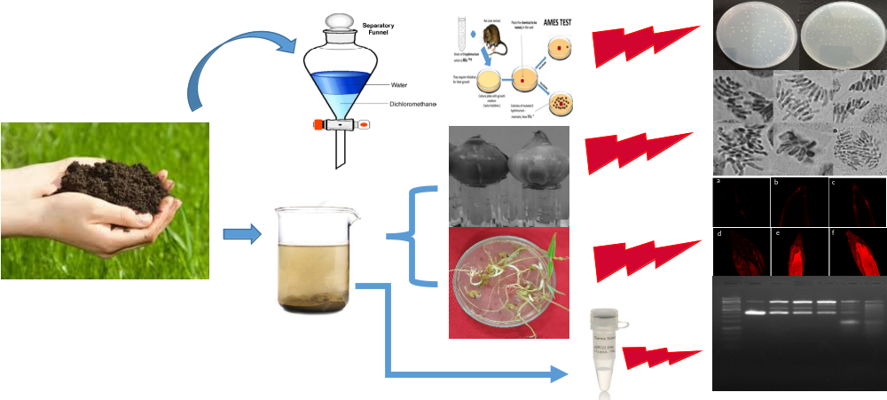
Fig. Graphical Abstract.

