SUPPLEMENTARY INFORMATION
From Freeze to Function: Optimised Cryopreservation and Mitochondrial Analysis Workflow for Skeletal Muscle Biopsies

Maheen Wahid*¹, Graeme Mackenzie¹, Liam M. Rooney¹, Justin C. Greig¹, Gail McConnell¹, Emilie Combet², Stuart Gray³, James T. Murray⁴, Susan Currie¹, Gwyn W. Gould¹, and Margaret R. Cunningham*¹.
- Strathclyde Institute for Pharmacy and Biomedical Sciences (SIPBS), University of Strathclyde, 161 Cathedral Street, Glasgow.
- School of Medicine, Dentistry & Nursing, College of Medical, Veterinary and Life Sciences, University of Glasgow, Glasgow, UK.
- School of Cardiovascular and Metabolic Health, College of Medical Veterinary and Life Sciences, University of Glasgow, Glasgow, UK.
- Swansea University Medical School, Swansea University, UK

Corresponding Authors
Maheen Wahid - maheen.wahid.2022@uni.strath.ac.uk
Strathclyde Institute for Pharmacy and Biomedical Sciences (SIPBS), University of Strathclyde, 161 Cathedral Street, Glasgow.

Margaret Cunningham – margaret.cunningham@strath.ac.uk
Strathclyde Institute for Pharmacy and Biomedical Sciences (SIPBS), University of Strathclyde, 161 Cathedral Street, Glasgow.
Supplementary Figures 1-3
Supplementary Tables 1-5

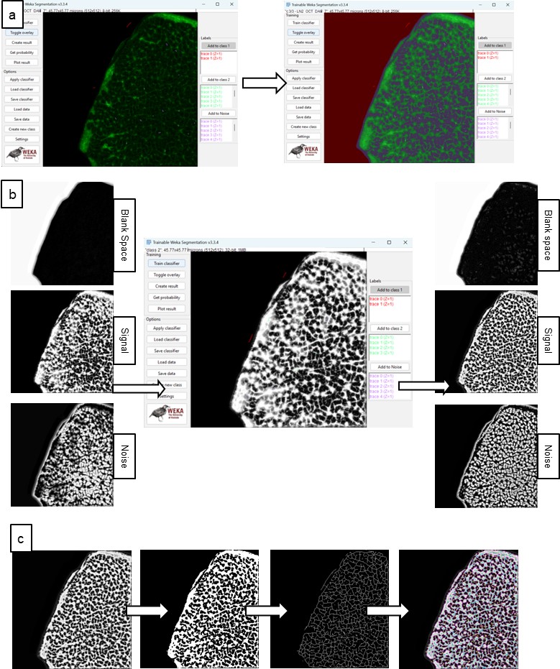
Supplementary Figure 1

Supplementary Figure 1: Using Trainable Weka Segmentation for mitochondrial analysis. a) Trainable Weka Segmentation plugin interface showing the addition of traces for identification of blank spaces, signal, and noise. The classifier is then trained, and segmented image overlaid over the original one with colours corresponding to those employed for tracing can be seen; b) Probability maps showing the probability of each pixel belonging to one of the traced classes are shown. This ‘signal mask’ is rerun through the plugin to remove the spurious low-intensity signal around the mitochondrial signal; c) Final signal mask is then binarised, skeletonised for confirmation, and run through MiNA plugin for quantification.
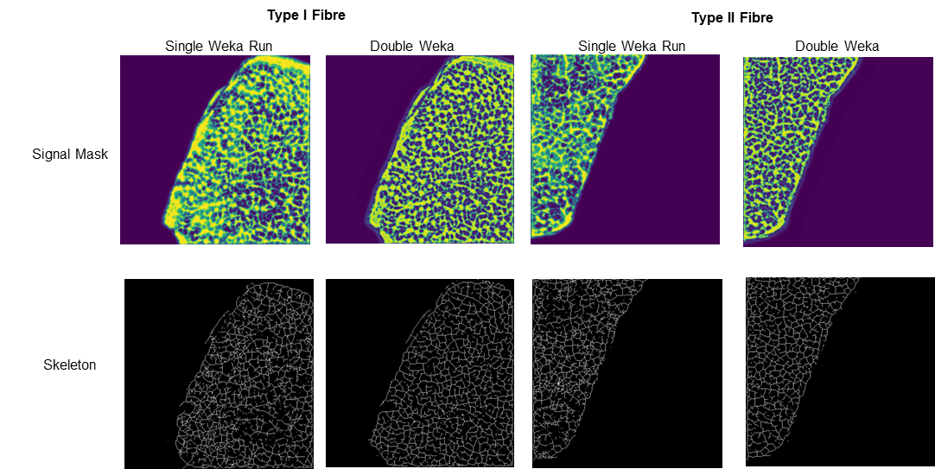
Supplementary Figure 2

Supplementary Figure 2: Improvement in signal masks after being rerun through Trainable Weka Segmentation plugin. The spurious low-intensity signal observed in the signal mask limits accurate binarisation of the mitochondrial network and leads to inadequate skeletonization. Double Weka run trains the plugin to differentiate the actual signal from the spurious signal and provides an accurate representation of the mitochondrial network in both type I and II myofibres

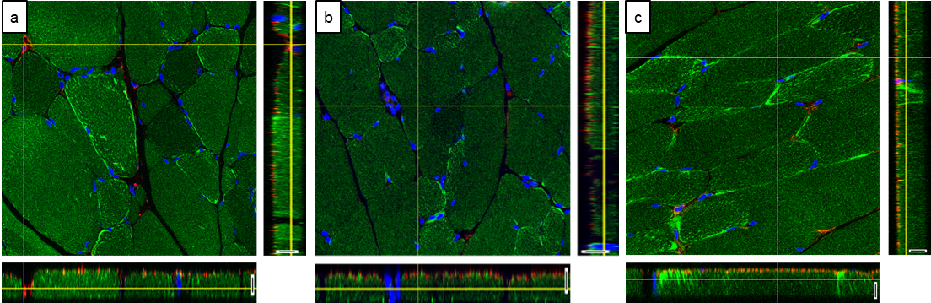
Supplementary Figure 3
Supplementary Figure 3: Orthogonal views depicting distribution of VDAC (red), MitoView (green) and DAPI (blue) in the XZ and YZ planes of the z-stack. Orthogonal views are shown for tissue sections permeabilised with 0.25 % Triton (a), 0.5 % Triton (b), and PBT (c). The yellow intersection depicts the point being analysed. Both XZ and YZ planes show that the VDAC layers on the top-most region of the tissue section, as opposed to complete penetration by mitochondrial and nuclear dyes. The only regions where VDAC antibody is seen present deeper in the section are where there is lack of skeletal tissue thickness (Scale bar 5 µm).
Supplementary Table 1: List of chemicals/products with their manufacturers, solutions with recipes, and equipment with their use
Manufacturer | Chemical/Product | Catalogue Number
Acros Organics (Geel, Belgium) | Isopentane (2-methyl butane) | 126470025
Sigma-Aldrich (Missouri, USA) | Peel-A-Way embedding moulds (square S-22)  Triton X-100  Formaldehyde solution (36 %)  Formalin solution (neutral buffered 10 %) | E6032-1CS  T-8787  47608-1L-F  HT501128
Thermo Fischer Scientific (Massachusetts, USA) | Phosphate buffered saline (PBS) tablets | BR0014G
VWR international (Leuven, Belgium) | Optimal cutting temperature compound (OCT) | 361603E
Abcam (Cambridge, UK) | Picrosirius Red (PSR) Kit  Haematoxylin & Eosin (H&E) Kit | AB245887  AB245880
Epredia (Runcorn, UK) | SuperfrostTM Plus Adhesion Microscope Slides | J1810AMNZ
National Diagnostics (Georgia, USA) | Histomount Histological Mounting Medium | HS-103
Vector Laboratories (California, USA) | VectaMount® AQ Aqueous Mounting Medium  ImmEdge® hydrophobic barrier PAP pen | H-5501  H-4000
Merck Millipore (Illinois, USA) | Probumin® Bovine Serum Albumin Universal Grade | 810033
Equipment | Use
EVOS FL Autosystem (Thermofisher Scientific) | For brightfield microscopy
Leica SP8 confocal microscope (Leica Microsystems) | For fluorescence microscopy
Leica CM1950 clinical cryostat (Leica Biosystems) | Tissue sectioning

Supplementary Table 2: List of antibodies and stains
Stain/Antibody | Reference ID | Concentration | Dilution
4’,6-diamidino-2-phenylindole (DAPI) (Sigma) | D-9542 | 1mM | 1:2000 in PBS
Rhodamine phalloidin (ThermoFisher) | R415 | 300U | 1:40 in PBS
MitoView Green (Biotium) | 70055 | 200 µM | 1:2000 in PBS
VDAC1/Porin + VDAC 3 (abcam) Mouse (monoclonal) | ab14734 | 1 mg/mL | 1:200 in 0.1 % BSA
Alexa Fluor 555 goat anti-mouse IgG (Invitrogen) | A21422 | 2 mg/mL | 1:100 in 0.1 % BSA

Supplementary Table 3: List of software used and their application
Software | Version | Application
GraphPad Prism | Version 8.0.2 | Generation of bar graphs and statistical analysis
(Fiji is Just) ImageJ | 2.14.0/1.54f; Java 1.8.0_322 [64-bit] | Ice crystal quantification  EVOS/Confocal image composition
EndNote | 21.3.0.17918 | Reference manager
Microsoft PowerPoint | Version 2404 | Figure composition
Microsoft Excel | Version 2406 | Data organisation and structuring of measurements

Supplementary Table 4: Quantitative analysis of area occupied by ice crystals in the core and periphery of both edge and belly regions

 | Percentage Area Occupied by Ice Crystals (median (IQR))
 | Edge | Belly | p value
Core | 16.07 (11.10-17.20) | 6.11 (4.18-10.24) | 0.0047
Periphery | 37.58 (20.58-47.05) | 27.56 (17.44-41.16) | 0.1854
p value | 0.0002 | 0.0002

Supplementary Table 5: Quantitative analysis of various mitochondrial network parameters obtained using MiNA plugins in type I and II myofibres

Parameter (mean (SD)) | Type I Myofibre | Type II Myofibre | p value
Mitochondrial footprint (µm²) | 67.51 (0.97) | 63.61 (0.79) | 0.0008
Mean branched length (µm) | 1.20 (0.06) | 1.08 (0.04) | 0.0190
Mean summed branch length (µm) | 13.96 (4.42) | 11.62 (2.55) | 0.3941
Mean network branches | 11.68 (3.55) | 10.74 (2.47) | 0.6783

