Supplementary material
Exposure to air pollutants and breast cancer risk: mediating effects of metabolic health biomarkers in a nested case-control study within the E3N-Generations cohort

Benoît Mercoeur^{a,b}, Béatrice Fervers^{a,b}, Delphine Praud^{a,b}, Hwayoung Noh^{a,b}, Thomas Coudon^{a,b}, Camille Giampiccolo^{a,b,c,d}, Lény Grassot^{a,b}, Elodie Faure^{e}, Florian Couvidat^{f}, Gianluca Severi^{e,g}, Francesca Romana Mancini^{e}, Pascal Roy^{c,d,h}, and Amina Amadou^{a,b}

Affiliations :
ª Department of Prevention Cancer Environnement, Centre Léon Bérard, Lyon, France
^{b} Inserm U1296 Radiations : Défense, Santé, Environnement, Lyon, France
^{c} Laboratoire de Biométrie Et Biologie Evolutive, CNRS UMR 5558, Villeurbanne, France
^{d} Service de Biostatistique-Bioinformatique, Pole Sante Publique, Hospices Civils de Lyon, Lyon, France
^{e} Universite Paris-Saclay, UVSQ, Inserm, Gustave Roussy, CESP, 94805 Villejuif, France
^{f} National Institute for industrial Environment and Risks (INERIS), Verneuil-en-Halatte, France
^{g} Department of Statistics, Computer Science and Applications (DISIA), University of Florence, Florence, Italy
^{h} Université Claude Bernard Lyon 1, Lyon, France

Table of contents
Fig. S1: Flowchart of the selection of the study participants
Fig. S2: Directed Acyclic Graph showing the relationship between potential confounders in the association between air pollutants and breast cancer risk
Table S1: Demographic and lifestyle characteristics of breast cancer cases and matched controls in a nested case-control study within the French E3N-Generations cohort,1990-2011
Table S2: Biomarker levels of breast cancer cases and matched controls in a nested case-control study within the French E3N-Generations cohort, 1990-2011
Table S3: Pollutant levels exposition of breast cancer cases and matched controls in a nested case-control study within the French E3N-Generations cohort, 1990-2011

E3N Cohort
N=98,995

Matched Controls
N=6,298
Breast cancers cases
N=6,298

Paget disease, phyllodes tumors and their matched controls
N=19 + 19

Subjects with missing data on matching variables, and their matched subjects
N= 3 + 3

Subjects with missing address or outside the continental mainland France, and their matched subjects
N=1,054 + 1,054

Xenair study
N=5222 + 5222

Subjects without biomarker measurements, and their matched subjects
N=4,687 + 4,687

Matched Controls
N=523
Breast cancers cases
N=523

Supplementary Figure 1: Flowchart of study participant selection

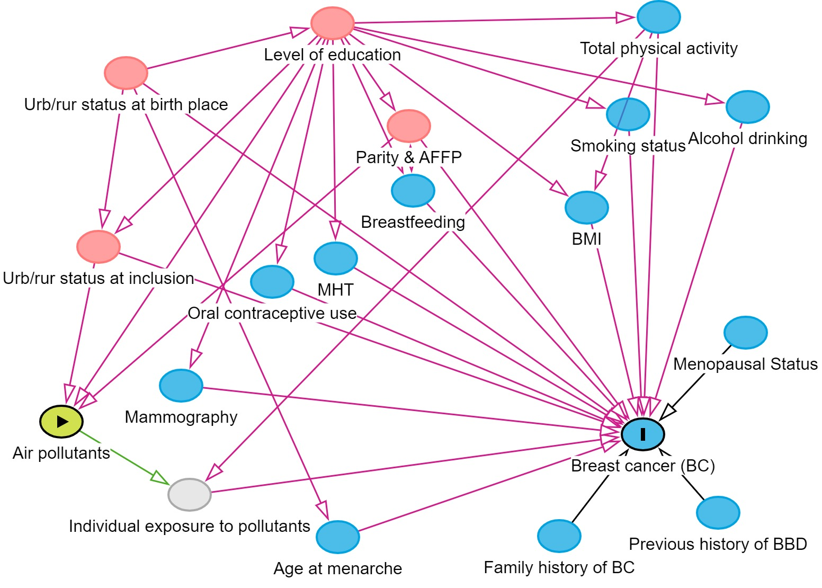
Supplementary Figure 2: Directed Acyclic Graph showing the relationship between potential confounders in the association between air pollutants and breast cancer risk.
BBD: benign breast disease, MHT: menopause hormone treatment, BMI: body mass index, AFFP: age at first full-term pregnancy

Supplementary Table 1: Demographic and lifestyle characteristics of breast cancer cases and matched controls in a nested case-control study within the French E3N-Generations cohort,1990-2011
Characteristics | Cases (523) | Controls (523) | Total
Age at inclusion (years)
Mean (SD) | 49.91 (6.3) | 49.9 (6.3) | 49.9 (6.3)
Median | 49.1 | 49.0 | 49.0
Q1-Q3 | 44.3 - 54.7 | 44.5 - 54.7 | 44.4 - 54.7
Min-Max | 40.1 - 64.7 | 40.2 - 64.4 | 40.1 - 64.7
Body Mass Index (kg/m²), n (%)
< 25 | 459 (87.8%) | 436 (83.4%) | 895 (85.6%)
[25-30[ | 50 (9.6%) | 71 (13.6%) | 121 (11.6%)
≥ 30 | 14 (2.7%) | 16 (3.1%) | 30 (2.9%)
Physical activity (METs-h/week), n (%)
<25.3 | 121 (23.1%) | 128 (24.5%) | 249 (23.8%)
25.3-35.6 | 156 (29.8%) | 151 (28.9%) | 307 (29.3%)
35.6-51.8 | 130 (24.9%) | 125 (23.9%) | 255 (24.4%)
≥51.8 | 116 (22.2%) | 119 (22.8%) | 235 (22.5%)
Alcohol consumption (g/day), n (%)
0 | 58 (11.1%) | 50 (9.6%) | 108 (10.3%)
0-6.7 | 193 (36.9%) | 179 (34.2%) | 372 (35.6%)
>6.7 | 272 (52.0%) | 294 (56.2%) | 566 (54.1%)
Smoking status, n (%)
Non-smoker | 280 (53.5%) | 274 (52.4%) | 554 (53.0%)
Smoker | 71 (13.6%) | 73 (14.0%) | 144 (13.8%)
Ex-smoker | 172 (32.9%) | 176 (33.7%) | 348 (33.3%)
Level of education, n (%)
Secondary | 72 (13.8%) | 67 (12.8%) | 139 (13.3%)
1- to 2-year university degree | 231 (44.2%) | 231 (44.2%) | 462 (44.2%)
≥ 3-year university degree | 220 (42.1%) | 225 (43.0%) | 445 (42.5%)
Age at first menstruation (years), n (%)
<12 | 103 (19.7%) | 102 (19.5%) | 205 (19.6%)
12-14 | 263 (50.3%) | 287 (54.9%) | 550 (52.6%)
≥14 | 157 (30.0%) | 134 (25.6%) | 291 (27.8%)
Number of children and age at 1st pregnancy, n (%)
No children | 62 (11.9%) | 77 (14.7%) | 139 (13.3%)
Between 0 and 2 and age < 30 y.o | 238 (45.5%) | 234 (44.7%) | 472 (45.1%)
Between 0 and 2 and age ≥ 30 y.o | 52 (9.9%) | 53 (10.1%) | 105 (10.0%)
More than 3 y.o | 171 (32.7%) | 159 (30.4%) | 330 (31.5%)
Breastfeeding, n (%)
No | 196 (37.5%) | 214 (40.9%) | 410 (39.2%)
Yes | 327 (62.5%) | 309 (59.1%) | 636 (60.8%)
Use of oral contraceptives until the index date, n (%)
No | 207 (39.6%) | 217 (41.5%) | 424 (40.5%)
Yes | 316 (60.4%) | 306 (58.5%) | 622 (59.5%)
Personal history of benign breast disease at inclusion, n (%)
No | 394 (75.3%) | 384 (73.4%) | 778 (74.4%)
Yes | 129 (24.7%) | 139 (26.6%) | 268 (25.6%)
Family history at inclusion, n (%)
No | 454 (86.8%) | 419 (80.1%) | 873 (83.5%)
Yes | 69 (13.2%) | 104 (19.9%) | 173 (16.5%)
Mammography performed before inclusion, n (%)
No | 111 (21.2%) | 101 (19.3%) | 212 (20.3%)
Yes | 412 (78.8%) | 422 (80.7%) | 834 (79.7%)
Menopausal status at inclusion, n (%)
Premenopausal | 306 (58.5%) | 293 (56.0%) | 599 (57.3%)
Postmenopausal | 217 (41.5%) | 230 (44.0%) | 447 (42.7%)
Menopausal status at index date, n (%)
Premenopausal | 38 (7.3%) | 48 (9.2%) | 86 (8.2%)
Postmenopausal | 485 (92.7%) | 475 (90.8%) | 960 (91.8%)
Menopause hormone treatment (MHT), n (%)
No | 146 (27.9%) | 135 (25.8%) | 281 (26.9%)
Yes | 363 (69.4%) | 381 (72.8%) | 744 (71.1%)
Missing | 14 (2.7%) | 7 (1.3%) | 21 (2.0%)
Urban-rural status at birth, n (%)
Rural | 123 (23.5%) | 117 (22.4%) | 240 (22.9%)
Urban | 343 (65.6%) | 355 (67.9%) | 698 (66.7%)
Missing | 57 (10.9%) | 51 (9.8%) | 108 (10.3%)
Urban-rural status at inclusion, n (%)
Rural | 103 (19.7%) | 98 (18.7%) | 201 (19.2%)
Urban | 420 (80.3%) | 425 (81.3%) | 845 (80.8%)
SD: standard deviation, Q1: 1st quartile, Q3: 3rd quartile, y.o: years old

Supplementary Table 2: Biomarker levels of breast cancer cases and matched controls in a nested case-control study within the French E3N-Generations cohort, 1990-2011
Biomarkers | Cases (523) | Controls (523) | Total (1046)
Albumin
Mean (SD) | 41.57 (3.48) | 41.44 (3.53) | 41.50 (3.50)
Median | 42.00 | 42.00 | 42.00
Q1-Q3 | 40.00 - 44.00 | 39.00 - 44.00 | 39.00 - 44.00
Min-Max | 27.00 - 58.00 | 28.00 - 51.00 | 27.00 - 58.00
Missing | 18 | 27 | 45
Protein C-reactive
Mean (SD) | 0.86 (0.53) | 0.85 (0.59) | 0.86 (0.56)
Median | 0.69 | 0.69 | 0.69
Q1-Q3 | 0.69 - 1.10 | 0.69 - 1.10 | 0.69 - 1.10
Min-Max | 0.00 - 3.37 | 0.00 - 3.83 | 0.00 - 3.83
Missing | 19 | 24 | 43
Triglycerides
Mean (SD) | 0.68 (0.21) | 0.68 (0.21) | 0.68 (0.21)
Median | 0.64 | 0.65 | 0.65
Q1-Q3 | 0.54 - 0.78 | 0.54 - 0.78 | 0.54 - 0.78
Min-Max | 0.28 - 1.88 | 0.10 - 1.65 | 0.10 - 1.88
Missing | 44 | 57 | 101
Cholesterol
Mean (SD) | 5.22 (0.85) | 5.25 (0.83) | 5.24 (0.84)
Median | 5.22 | 5.20 | 5.21
Q1-Q3 | 4.66 - 5.76 | 4.67 - 5.72 | 4.66 - 5.74
Min-Max | 2.35 - 8.25 | 2.86 - 8.08 | 2.35 - 8.25
Missing | 34 | 40 | 74
HDL cholesterol
Mean (SD) | 1.15 (0.26) | 1.15 (0.27) | 1.15 (0.27)
Median | 1.11 | 1.11 | 1.11
Q1-Q3 | 0.95 - 1.36 | 0.95 - 1.36 | 0.95 - 1.36
Min-Max | 0.43 - 1.81 | 0.55 - 1.75 | 0.43 - 1.81
Missing | 53 | 57 | 110
LDL cholesterol
Mean (SD) | 1.19 (0.27) | 1.20 (0.26) | 1.20 (0.27)
Median | 1.18 | 1.21 | 1.20
Q1-Q3 | 0.97 - 1.42 | 1.00 - 1.40 | 0.98 - 1.41
Min-Max | 0.55 - 1.82 | 0.31 - 1.87 | 0.31 - 1.87
Missing | 47 | 62 | 109
Parathormone
Mean (SD) | 1.26 (0.28) | 1.27 (0.26) | 1.27 (0.27)
Median | 1.25 | 1.27 | 1.26
Q1-Q3 | 1.08 - 1.41 | 1.10 - 1.43 | 1.09 - 1.43
Min-Max | 0.44 - 2.42 | 0.48 - 2.16 | 0.44 - 2.42
Missing | 23 | 31 | 54
TSH
Mean (SD) | 0.93 (0.39) | 0.98 (0.41) | 0.95 (0.40)
Median | 0.89 | 0.93 | 0.91
Q1-Q3 | 0.68 - 1.13 | 0.74 - 1.17 | 0.71 - 1.15
Min-Max | 0.01 - 4.06 | 0.01 - 4.13 | 0.01 - 4.13
Missing | 22 | 21 | 43
Prolactin
Mean (SD) | 5.31 (0.50) | 5.30 (0.51) | 5.31 (0.51)
Median | 5.28 | 5.28 | 5.28
Q1-Q3 | 5.01 - 5.60 | 4.97 - 5.61 | 4.99 - 5.60
Min-Max | 2.87 - 8.33 | 4.17 - 8.17 | 2.87 - 8.33
Missing | 16 | 23 | 39
Estradiol
Mean (SD) | 4.98 (1.20) | 4.82 (1.20) | 4.90 (1.20)
Median | 5.06 | 4.83 | 4.98
Q1-Q3 | 4.20 - 5.80 | 3.88 - 5.70 | 4.04 - 5.76
Min-Max | 2.96 - 8.27 | 2.96 - 9.25 | 2.96 - 9.25
Missing | 18 | 26 | 44
Testosterone
Mean (SD) | 0.68 (0.40) | 0.69 (0.40) | 0.69 (0.40)
Median | 0.64 | 0.65 | 0.65
Q1-Q3 | 0.42 - 0.90 | 0.44 - 0.89 | 0.43 - 0.90
Min-Max | 0.07 - 3.51 | 0.07 - 3.72 | 0.07 - 3.72
Missing | 23 | 30 | 53
SHBG
Mean (SD) | 4.07 (0.48) | 4.11 (0.50) | 4.09 (0.49)
Median | 4.10 | 4.09 | 4.09
Q1-Q3 | 3.74 - 4.38 | 3.80 - 4.44 | 3.76 - 4.42
Min-Max | 2.59 - 5.30 | 1.91 - 5.45 | 1.91 - 5.45
Missing | 36 | 50 | 86
Progesterone
Mean (SD) | 1.05 (1.02) | 1.00 (0.94) | 1.03 (0.98)
Median | 0.67 | 0.66 | 0.67
Q1-Q3 | 0.44 - 1.04 | 0.44 - 1.04 | 0.44 - 1.04
Min-Max | 0.00 - 5.24 | 0.00 - 4.67 | 0.00 - 5.24
Missing | 17 | 25 | 42

SD: standard deviation, Q1: 1st quartile, Q3: 3rd quartile, HDL cholesterol: High-density lipoprotein cholesterol, LDL cholesterol: Light-density lipoprotein cholesterol, TSH: Thyroid-stimulating hormone, SHGB: Sex Hormone-binding globulin.

Supplementary Table 3: Pollutant levels exposition of breast cancer cases and matched controls in a nested case-control study within the French E3N-Generations cohort, 1990-2011
Pollutants | Cases (523) | Controls (523) | Total (1046)
NO₂
Mean (SD) | 37.31 (16.91) | 36.85 (16.99) | 37.08 (16.94)
Median | 32.93 | 32.44 | 32.78
Q1-Q3 | 25.09 - 46.87 | 24.21 - 46.47 | 24.58 - 46.64
Min-Max | 9.93 - 91.41 | 10.89 - 94.14 | 9.93 - 94.14
BaP
Mean (SD) | 0.21 (0.12) | 0.21 (0.13) | 0.21 (0.12)
Median | 0.18 | 0.18 | 0.18
Q1-Q3 | 0.14 - 0.24 | 0.13 - 0.24 | 0.14 - 0.24
Min-Max | 0.07 - 1.12 | 0.06 - 1.12 | 0.06 - 1.12
PCB153
Mean (SD) | 11.17 (4.15) | 10.95 (3.92) | 11.06 (4.04)
Median | 10.56 | 10.12 | 10.39
Q1-Q3 | 8.19 - 12.94 | 8.13 - 12.91 | 8.16 - 12.93
Min-Max | 3.17 - 24.96 | 3.83 - 24.96 | 3.17 - 24.96

SD: standard deviation, Q1: 1st quartile, Q3: 3rd quartile, NO₂: nitrogen dioxide, BaP: benzo[a]pyrene, PCB153: polychlorinated biphenyls

