Supporting Information

Comparative study of biochar modified with different functional groups for efficient removal of Pb(II) and Ni(II)

Chengchen Liu^{a#}, Jiaxin Lin^{b,c#}, Haojia Chen^{b,c}, Wanjun Wang^{b,c*}, Yan Yang^{a,b,c*}

ª School of Environmental and Safety Engineering, Changzhou University, Jiangsu, 213164, China
^{b} School of Environmental Science and Engineering, Institute of Environmental Health and Pollution Control, Guangdong University of Technology, Guangzhou, 510006, Guangdong, China
^{c} Synergy Innovation Institute of GDUT, Shantou, 515041, Guangdong, China

#These authors contributed equally to this work.
*Corresponding author:
E-mail address: Prof. Wanjun Wang, wanjun@gdut.edu.cn; Prof. Yan Yang, yangyan1209@gdut.edu.cn.
Characterizations
The microscopic surface textures of the samples were examined by field emission scanning electron microscopy (S-3400N, S-570, Hitachi, Japan). The crystal structure of each biochar was examined by X-ray diffraction (D8 Advance, Bruker Co., Japan) analysis at 45 kV and with 100 mA CuKα radiation. Fourier transform-infrared spectroscopy was conducted to characterize the functional groups on the as-obtained biochar samples. The specific surface area of each test material was measured using a specific surface area and pore size analyzer (3H-2000PS2, Beijing). In the static volume method, 99.999% N₂ was used as the adsorbate and the saturated vapor pressure was 1.0360 bar. Before sampling, all samples were degassed at 150°C under vacuum for 240 min to remove the substances adsorbed on the sample surfaces. The multipoint Brunauer–Emmett–Teller adsorption isotherm was employed to determine the specific surface area.

Figures

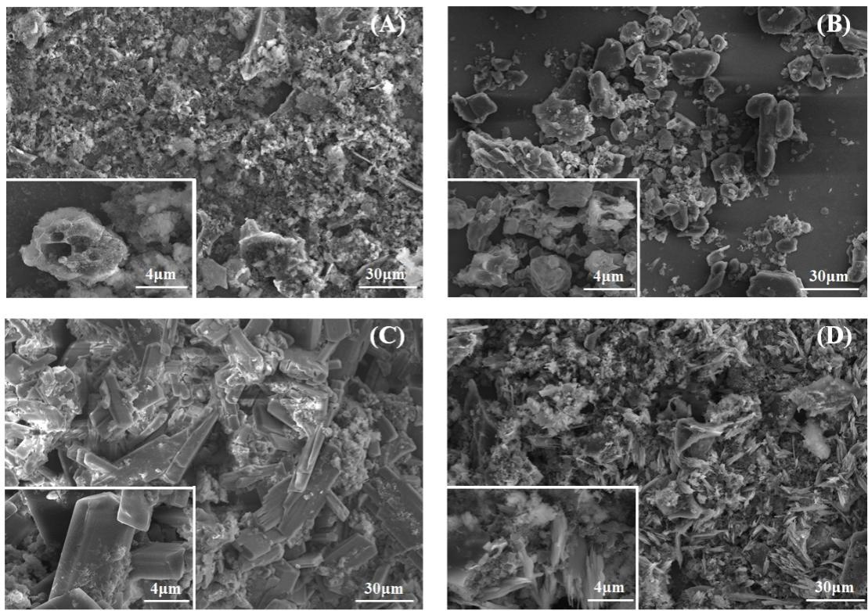
Fig. S1 Scanning electron microscopy images of (A) PBC; (B) E-PBC; (C) O-PBC, and (D) H-PBC.

Fig. S2 Plots of lnK_{c} versus 1/T for the adsorption of (A) Ni²⁺ and (B) Pb²⁺ by PBC, H-PCB, E-PBC, and O-PBC

Tables
Table S1 Thermodynamic parameters for the adsorption of Ni²⁺ by PBC, H-PCB, E-PBC, and O-PBC at different temperatures
Adsorbate |  | adsorbent | ∆H  (kJ mol⁻¹) |  | ∆S  (J mol⁻¹ K⁻¹) | ∆G  (kJ mol⁻¹)
 |  |  |  |  |  | 288.15 K | 298.15K | 308.15 K | 318.1K
Ni (II) | PBC  H-PBC |  |  | 6.79  15.15 | 23.6  57.00 | −0.02  −1.27 | −0.25  −1.84 | −0.48  −2.41 | −0.72  −2.98
Ni (II) | E-PBC |  |  | 15.98 | 56.00 | −0.16 | −0.72 | −1.27 | −1.83
Ni (II) | O-PBC |  |  | 12.23 | 46.00 | −1.02 | −1.48 | −1.94 | −2.40

Table S2 Thermodynamic parameters for the adsorption of Pb²⁺ by PBC, H-PCB, E-PBC, and O-PBC at different temperatures
Adsorbate | adsorbent |  | ∆H  (kJ mol⁻¹) | ∆S  (J mol⁻¹ K⁻¹) | ∆G  (kJ mol⁻¹)
 |  |  |  |  | 288.15 K | 298.15K | 308.15 K | 318.1K
Pb (II) | PBC  H-PCB | 8.62  4.27 |  | 31.00  32.00 | −0.31  −4.95 | −0.62  −5.27 | −0.93  −5.59 | −1.24  −5.91
Pb (II) | E-PBC | 5.85 |  | 34.00 | −3.94 | −4.28 | −4.62 | −4.96
Pb (II) | O-PBC | 4.68 |  | 33.00 | −4.83 | −5.16 | −5.49 | −5.82

Table S3 Comparison of various representative Ni²⁺ adsorbents
Years | Biomass feedstock | Finishing materials | Maximum adsorption capacity (mg.g⁻¹) | Reference
2017 | Straw |  | 25.06 | (Shen et al., 2017)
2017 | Rice husk |  | 10.15 | (Shen et al., 2017)
2013 | Figs | H₃PO₄ | 18.78 | (Gupta et al., 2017)
2017 | Sludge | Mercaptan | 52.40 | (Li et al., 2018)
2017 | Sawdust | KOH | 94.49 | (Nayak et al., 2017)
2017 | Sawdust | ZnCl₂ | 19.36 | (Nayak et al., 2017)
2020 | Cactus | NaOH | 44.35 | (Choudhary et al., 2020)
2020 | Rice bran | Al(NO₃)₃、Mg(NO₃)₂、FeSO₄ | 201.62 | (Guo et al., 2020)
 | Corn |  | 19.80 | This study
 | Corn | H₃PO₄ | 64.94 | This study
 | Corn | EDTA | 47.17 | This study
 | Corn | NaOH | 60.24 | This study

Table S4 Comparison of various representative Pb²⁺ adsorbents.
Years | Biomass feedstock | Finishing materials | Maximum adsorption capacity（mg.g⁻¹） | Reference
2014 | Eggshell | ALG and PEI | 344.8 | (Godiya et al., 2019)
2014 | Bean shell |  | 45.3 | (Elaigwu et al., 2014)
2014 | Sawdust | H₃PO₄ | 80.65 | (Ghasemi et al., 2014)
2017 | Banana peel | Ammonium sulfate persulfate | 315.16 | (Zhou et al., 2017)
2018 | Straw |  | 134.68 | (Cao et al., 2019)
2019 | Shell | EDTA | 129.31 | (Li et al., 2019)
2019 | Peanut shells | H₃PO₄ | 353.4 | (Jiang et al., 2019)
2019 | Peanut shells | PEI | 214.0 | (Jiang et al., 2019)
2019 | Lignin | PEI和CS₂ | 79.9 | (Wang et al., 2019)
 | Corn |  | 38.31 | This study
 | Corn | H₃PO₄ | 243.90 | This study
 | Corn | EDTA | 156.25 | This study
 | Corn | NaOH | 192.31 | This study
References
Cao Y, Xiao W, Shen G, Ji G, Zhang Y, Gao C, Han L (2019) Carbonization and ball milling on the enhancement of Pb(II) adsorption by wheat straw: competitive effects of ion exchange and precipitation. Bioresour Technol 273:70–76.
Choudhary M, Kumar R, Neogi S (2020) Activated biochar derived from opuntia ficus-indica for the efficient adsorption of malachite green dye, Cu⁽⁺²⁾ and Ni⁽⁺²⁾ from water. J Hazard Mater 392:122441
Elaigwu SE, Rocher V, Kyriakou G, Greenway GM (2014) Removal of Pb²⁺ and Cd²⁺ from aqueous solution using chars from pyrolysis and microwave-assisted hydrothermal carbonization of prosopis africana shell. J Ind Eng Chem 20:3467–3473.
Ghasemi M, Naushad M, Ghasemi N, Khosravi-fard Y (2014) A novel agricultural waste based adsorbent for the removal of Pb(II) from aqueous solution: kinetics, equilibrium and thermodynamic studies. J Ind Eng Chem 20:454–461.
Godiya CB, Liang M, Sayed SM, Li D, Lu X (2019) Novel alginate/polyethyleneimine hydrogel adsorbent for cascaded removal and utilization of Cu⁽²⁺⁾ and Pb⁽²⁺⁾ ions. J Environ Manage 232:829–841.
Guo Z, Chen R, Yang R, Yang F, Chen J, Li Y, Zhou R, Xu J (2020) Synthesis of amino-functionalized biochar/spinel ferrite magnetic composites for low-cost and efficient elimination of Ni(II) from wastewater. Sci Total Environ 722:137822.
Gupta VK, Pathania D, Sharma S (2017) Adsorptive remediation of Cu(II) and Ni(II) by microwave assisted H₃PO₄ activated carbon. Arab J Chem 10:S2836–S2844.
Jiang Q, Xie W, Han S, Wang Y, Zhang Y (2019) Enhanced adsorption of Pb(II) onto modified hydrochar by polyethyleneimine or H₃PO₄: an analysis of surface property and interface mechanism. Colloid Surf A: Physicochem Eng Asp 583:123962.
Li J, Xing X, Li J, Shi M, Lin A, Xu C, Zheng J, Li R (2018) Preparation of thiol-functionalized activated carbon from sewage sludge with coal blending for heavy metal removal from contaminated water. Environ Pollut 234:677–683.
Li M, Wei D, Liu T, Liu Y, Yan L, Wei Q, Du B, Xu W (2019) EDTA functionalized magnetic biochar for Pb(II) removal: adsorption performance, mechanism and SVM model prediction. Sep Purif Technol 227:10.
Nayak A, Bhushan B, Gupta V, Sharma P (2017) Chemically activated carbon from lignocellulosic wastes for heavy metal wastewater remediation: effect of activation conditions. J Colloid Interface Sci 493:228–240.
Shen ZT, Zhang YH, McMillan O, Jin F, Al-Tabbaa A (2017) Characteristics and mechanisms of nickel adsorption on biochars produced from wheat straw pellets and rice husk. Environ Sci Pollut Res 24:12809–12819.
Wang Q, Zheng C, Shen Z, Lu Q, He C, Zhang TC, Liu J (2019) Polyethyleneimine and carbon disulfide co-modified alkaline lignin for removal of Pb²⁺ ions from water. Chem Eng J 359:265–274.
Zhou N, Chen H, Xi J, Yao D, Zhou Z, Tian Y, Lu X (2017) Biochars with excellent Pb(II) adsorption property produced from fresh and dehydrated banana peels via hydrothermal carbonization. Bioresour Technol 232:204–210.

