Supplementary Materials for
Lactylation-driven USP4-mediated ANXA2 stabilization and activation promotes maintenance and radioresistance of glioblastoma stem cells

Supplementary Figures
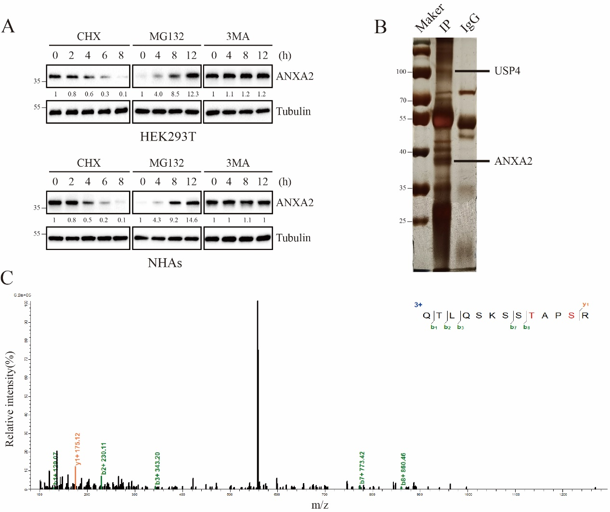
Supplementary Figure 1 (related to Figure 1)
A. HEK293T and NHAs were treated with CHX (10 µM), MG132 (20 μM), 3MA (20 μM), and collected at the indicated times for immunoblot. B. Silver staining is used to reveal all proteins bound to ANXA2 antibody. C. Mass spectrometry analysis identified USP4 as the only deubiquitinating enzymes in the extracted protein from HEK293T cells.

Supplementary Figure 2 (related to Figure 2)
A. Clonogenic survival curves for indicated GSCs irradiated (0–8 Gy). B. Immunodetection of γ-H2AX foci in GSCs transduced with shCtrl or USP4 shRNA with irradiated (4 Gy, 12 hours later). Scale bar represents 20 μm. C. Immunodetection of γ-H2AX foci in GSCs transduced with USP4 overexpression or vector control with irradiated (4 Gy, 12 hours later). Scale bar represents 20 μm. D. Quantitation of cells containing >10 γ-H2AX foci in GSCs transduced with shCtrl or USP4 shRNA with irradiated (4 Gy, 12 hours later). E. Quantitation of cells containing >10 γ-H2AX foci in GSCs transduced with USP4 overexpression or vector control with irradiated (4 Gy, 12 hours later). F. TUNEL images in GSCs transduced with shCtrl or USP4 shRNA with irradiated (4 Gy, 12 hours later). Scale bar represents 200 μm. G. Quantitation of TUNEL-positive cells with irradiated (4 Gy, 12 hours later). H. TUNEL images in GSCs transduced with USP4 overexpression or vector control with irradiated (4 Gy, 12 hours later). Scale bar represents 200 μm. I. Quantitation of TUNEL-positive cells with irradiated (4 Gy, 12 hours later). *P < 0.05, **P < 0.01, ***P < 0.001
Supplementary Figure 3 (related to Figure 2)
A. USP4 knockdown or control GSCs transfected with a lentivirus containing luciferase were implanted into the intracranial of nude mice, and tumor formation was assessed using bioluminescence imaging at days 10, 15, 20, and 25 after implantation. B. Bioluminescence imaging signals of all mice in each experimental group. C. Survival analysis of USP4 knockdown or control GSCs–derived intracranial xenografts. D and E IHC images of SOX2 and Ki67 are shown in consecutive brain sections from mice implanted with indicated GSCs. Scale bars represents 20μm. *P < 0.05, **P < 0.01, ***P < 0.001
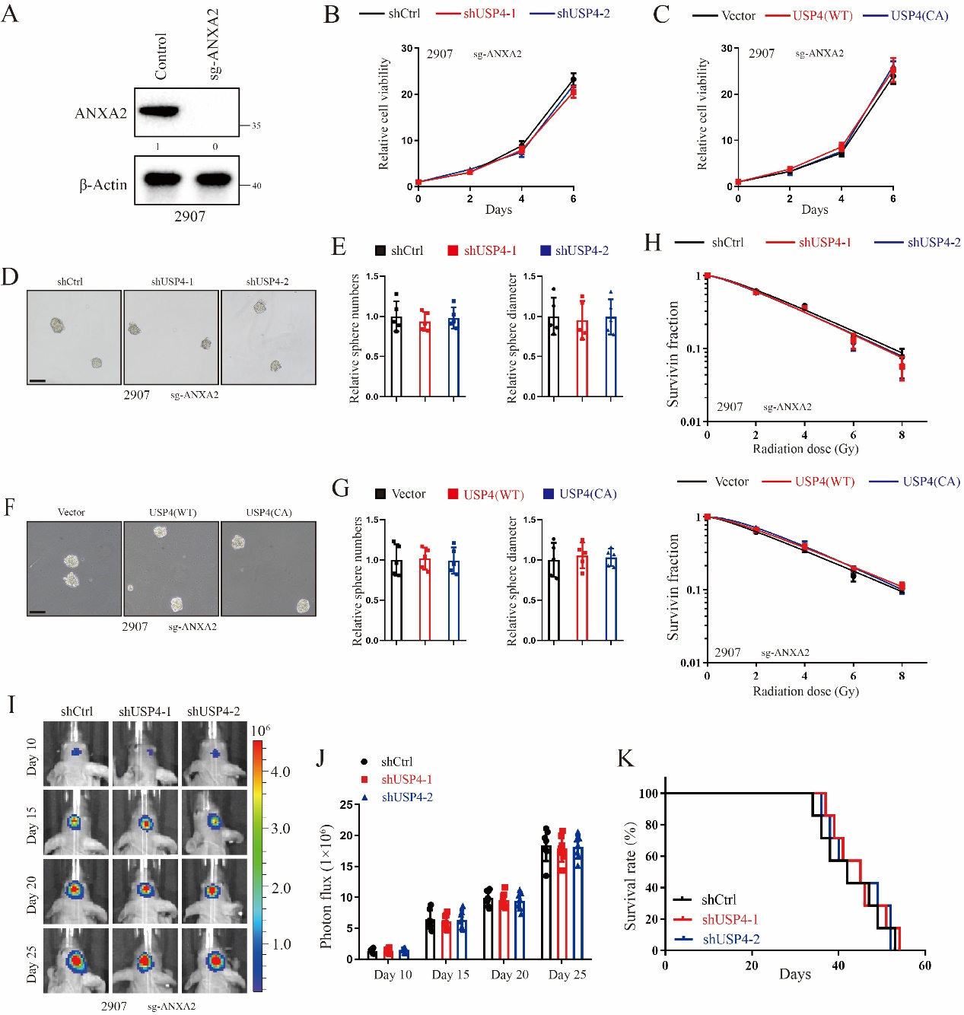
Supplementary Figure 4 (related to Figure 2)
A. Immunoblotting analyses of ANXA2 expression in GSCs transduced with sg-ANXA2 or Control. B. Cell viability of sg-ANXA2 2907 GSCs transduced with shCtrl or shUSP4. C. Cell viability assay of sg-ANXA2 2907 GSCs after transduction with USP4 overexpression or vector control. D. Tumorsphere images of g-ANXA2 2907 GSCs transduced with shCtrl or shUSP4. Scale Bar represents 250μm. E. Quantification of the diameter or number of tumorspheres formed by sg-ANXA2 2907 GSCs expressing shCtrl or shUSP4 (diameter: n = 5; number: n = 5). F. Tumorsphere images of sg-ANXA2 2907 GSCs after transduction with USP4 overexpression or vector control. Scale Bar represents 250μm. G. Quantification of the diameter or number of tumorspheres formed by sg-ANXA2 2907 GSCs after transduction with USP4 overexpression or vector control (diameter: n = 5; number: n = 5). H. Clonogenic survival curves for indicated GSCs irradiated (0–8 Gy). I. sg-ANXA2 2907 GSCs expressing shCtrl or shUSP4 transfected with a lentivirus containing luciferase were implanted into the intracranial of nude mice, and tumor formation was assessed using bioluminescence imaging at days 10, 15, 20, and 25 after implantation. J. Bioluminescence imaging signals of all mice in each experimental group. K. Survival analysis of sg-ANXA2 2907 GSCs expressing shCtrl or shUSP4–derived intracranial xenografts. *P < 0.05, **P < 0.01, ***P < 0.001
Supplementary Figure 5 (related to Figure 3)
A and B. Quantification of ANXA2 levels of indicated cells relative to β-actin is shown. *P < 0.05, **P < 0.01, ***P < 0.001
Supplementary Figure 6 (related to Figure 6)
A. K10 acetylation of ANXA2 identiﬁed by mass spectrometry.
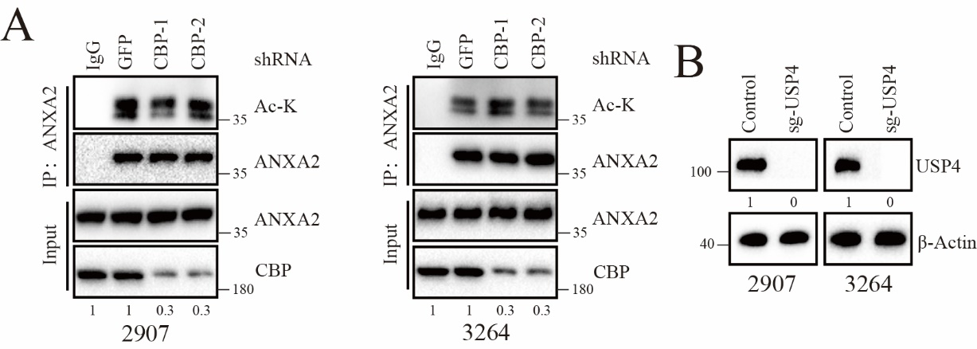
Supplementary Figure 7 (related to Figure 6)
A. GSCs were transfected with the transfected with lentiviral short hairpin RNA (shRNA) speciﬁc for GFP or CBP, followed by immunoblot with indicated antibodies.
B. Immunoblotting analyses of USP4 expression in GSCs transduced with sg-USP4 or Control.
Supplementary Figure 8 (related to Figure 7)
A. Gene Set Enrichment Analysis (GSEA) to explore ANXA2-correlated signaling pathways from TCGA and CGGA data, including the IL2/JAK2/STAT3 signaling.
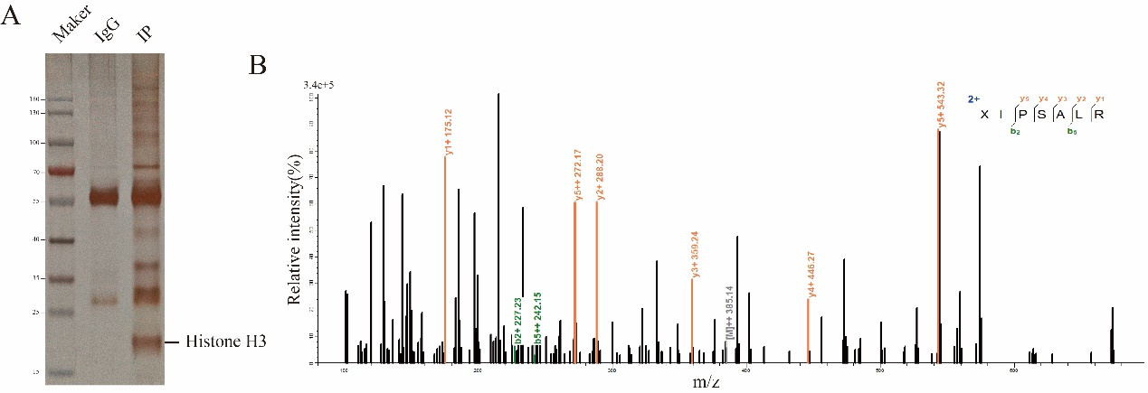
Supplementary Figure 9 (related to Figure 8)
A. Silver staining-mass spectrometry of lactylated proteins. B. Mass spectrometry identified the band as Histone H3.
Supplementary Figure 10. A proposed model of this study. H3K18 lactylation is responsible for the upregulation of USP4 in GSCs. USP4 deubiquitnates ANXA2, which mediates its proteasomal degradation and phosphorylation. USP4 directly cleaves Lys48- and Lys63-linked poly-ubiquitin chains of ANXA2, with Lys63-linked poly-ubiquitin chains of ANXA2 K28 mediating its Y24 phosphorylation. K10 acetylation of ANXA2 enhances its interaction with the two proteins. USP4/ANXA2 axis promotes GSCs maintenance and radioresistance by activating BMX-mediated STAT3 activation.

