Table 1 Shape definitions, as observed and developed iteratively during shapes survey. The visible teal grid in each image represents a 1m² area. Shapes in the example images are outlined in red, with a pale blue dashed line indicating the major axis L. All example images are from Str17a-b except for the “hoop”, which was observed in data from the eruption of Cumbre Vieja 2021.
Shape Category | Shape Name | Definition | Sketch | Example
Rounded | Spheroid | $AR≤1.33$ with circular appearance in 2D. | 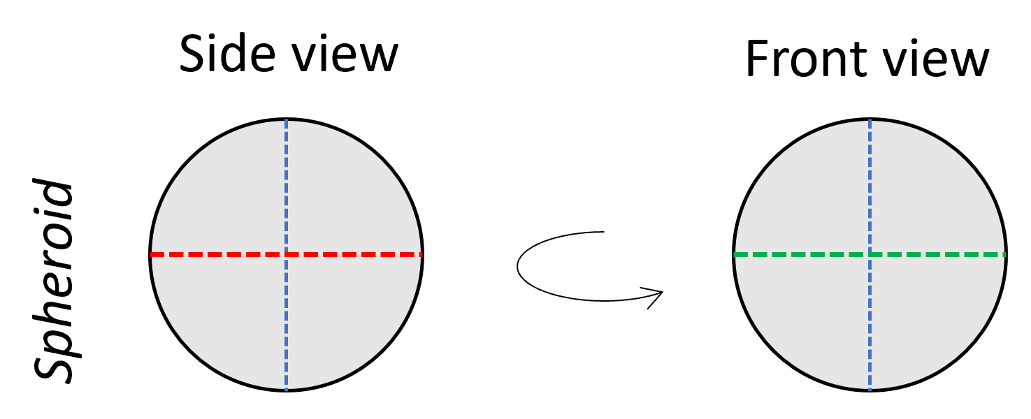 | 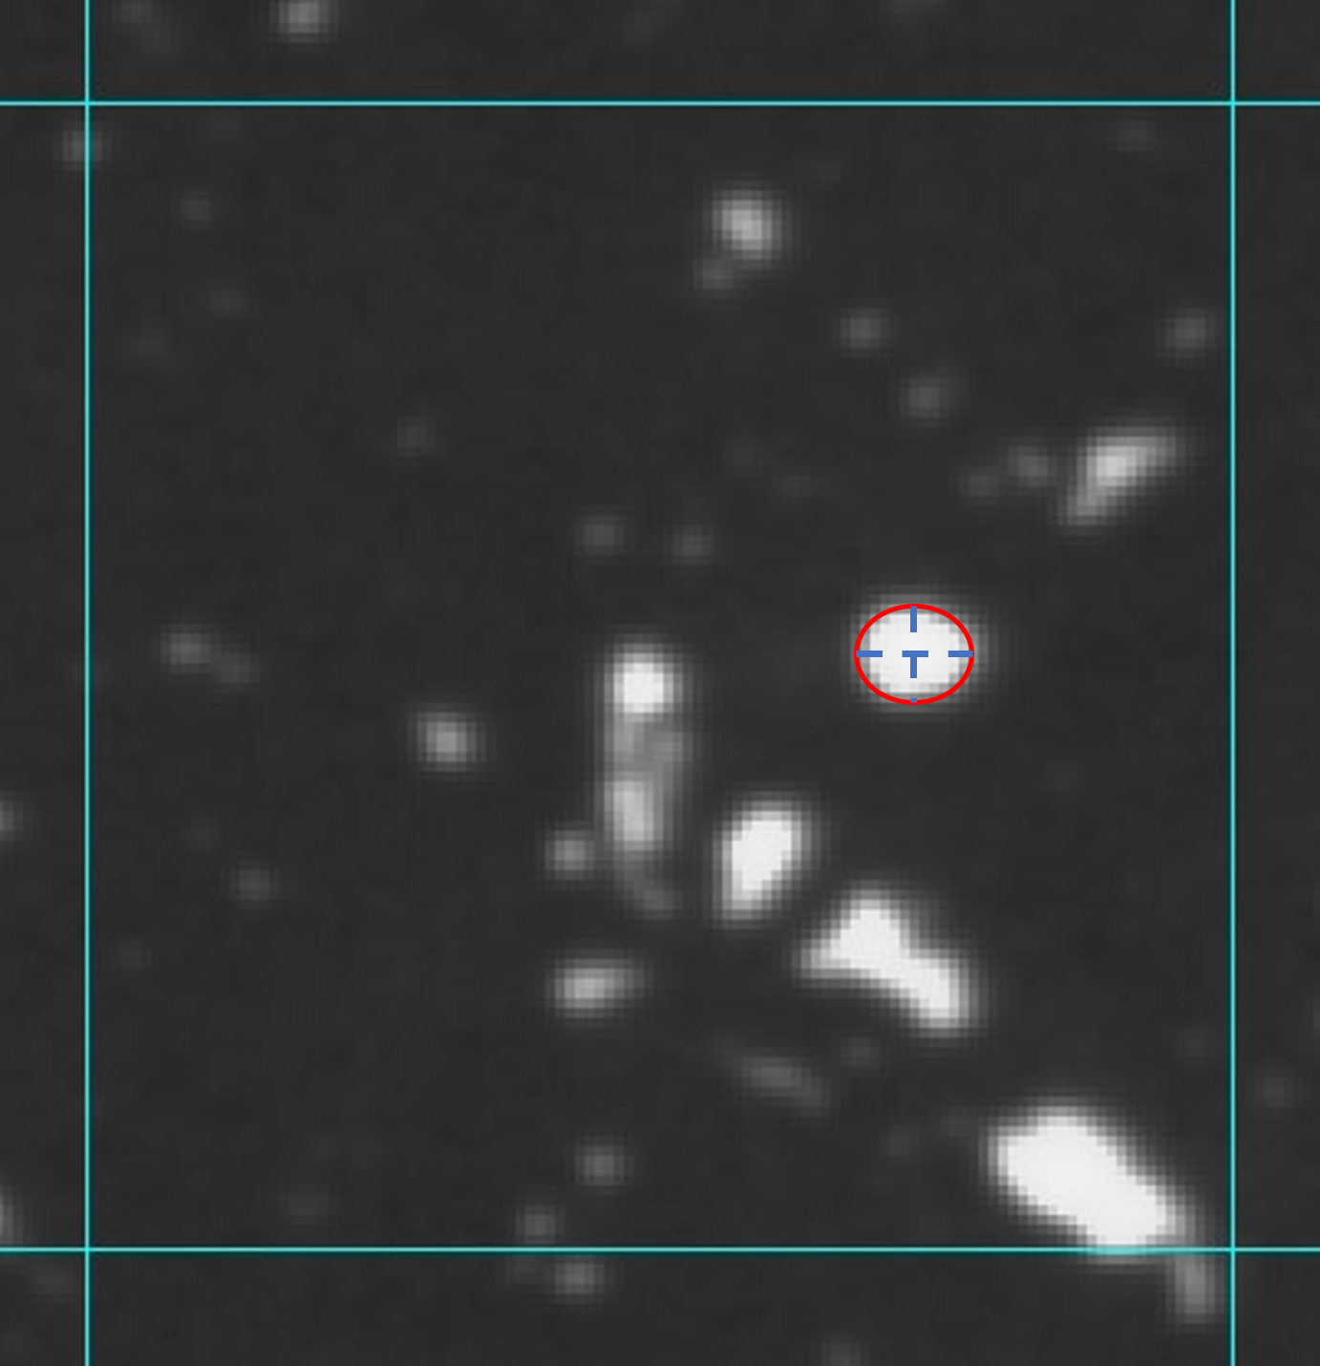
 | Ellipsoid | $1.33<AR ≤2$ with ellipse-like appearance in 2D. | 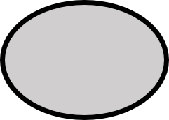 | 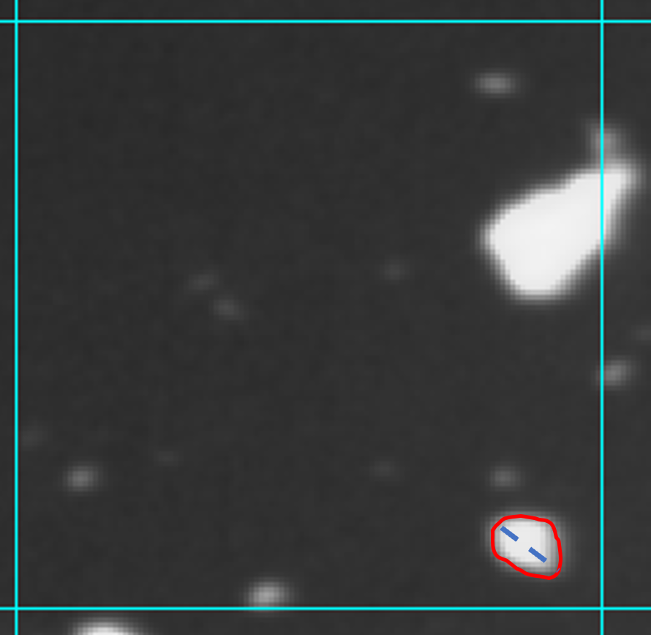
 | Trefoil | $AR ≤2$; three lobes of relatively equal size radiate from centre. |  | 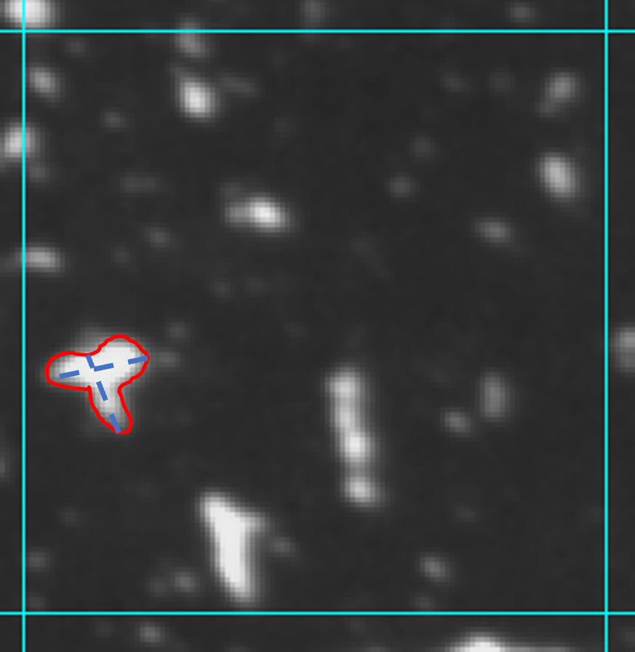
 | Fish | $AR ≤2$; one end tapers to a point. | 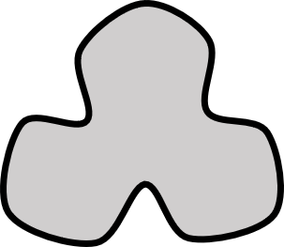  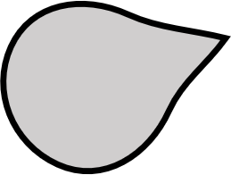 | 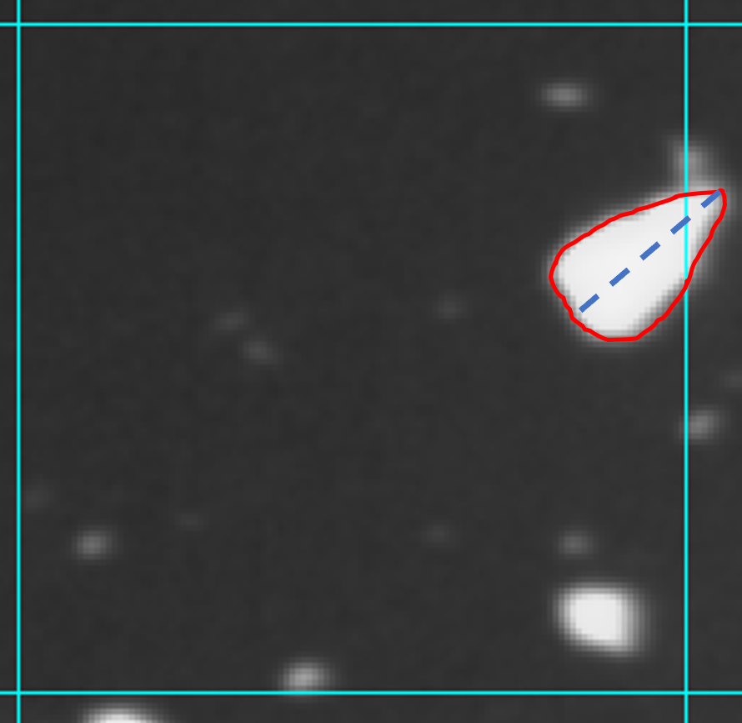
 | Spindle | $AR ≤2$; two ends taper to a point. | 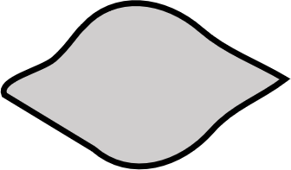 | 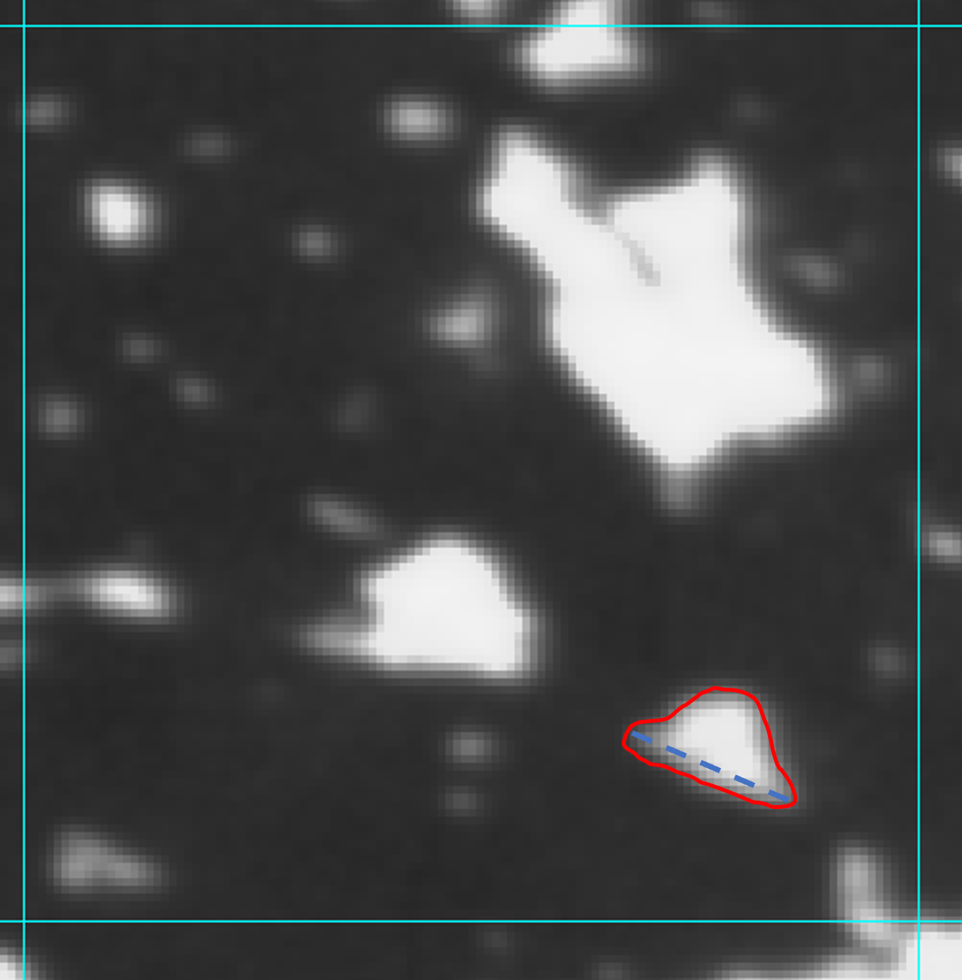
 | Comet | Consists of “head” with $AR ≤2$ and narrow “tail”, where the “tail” is assumed to be negligible to the overall mass. | 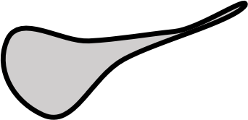 | 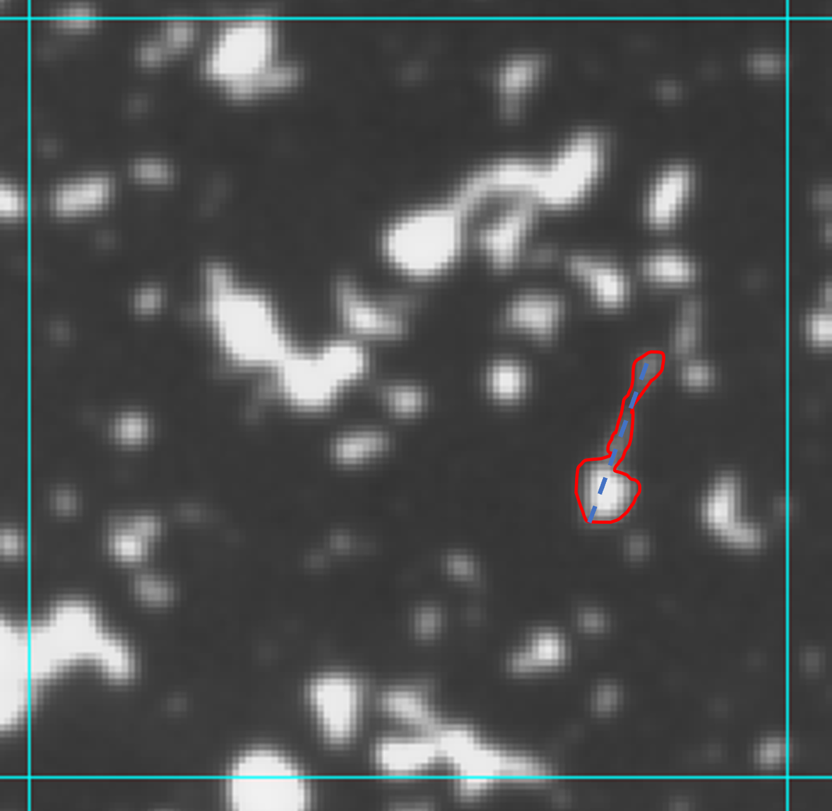
Elongate | Elongated | $AR >2$; length can be measured along one straight segment. May consist of any number of “nodes” and may be “caudate” (possessing a bifurcated tail, as shown in sketch (a) and in example). | 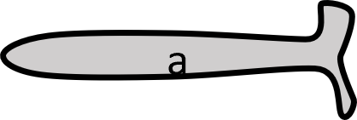  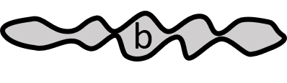 | 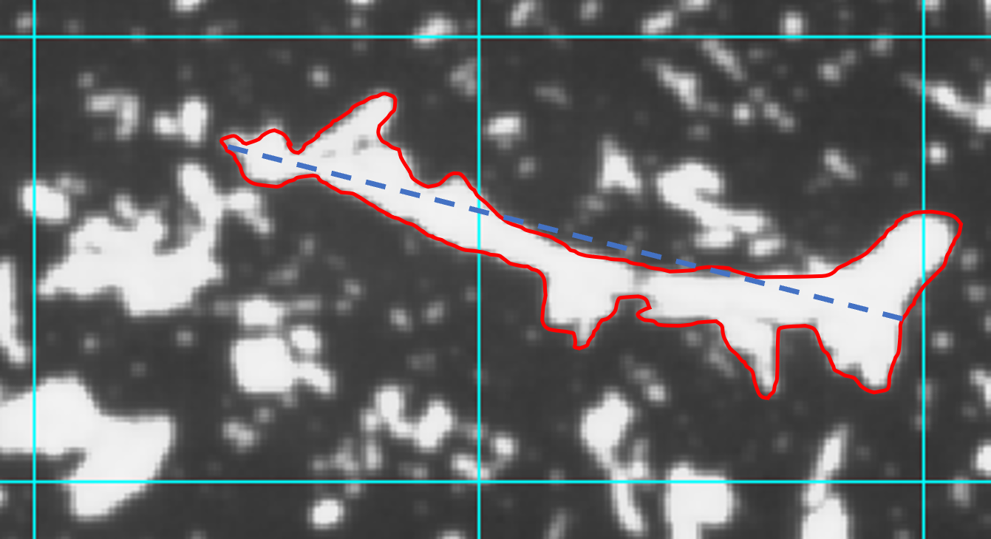
 | Crook | Curved around a central point such that length can be measured along two to four consecutive straight segments; $AR >2$ when treating the total length as the major axis length. Like elongate, may consist of any number of “nodes” and may be “caudate”. | 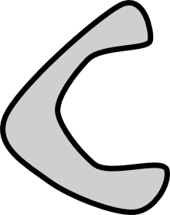 | 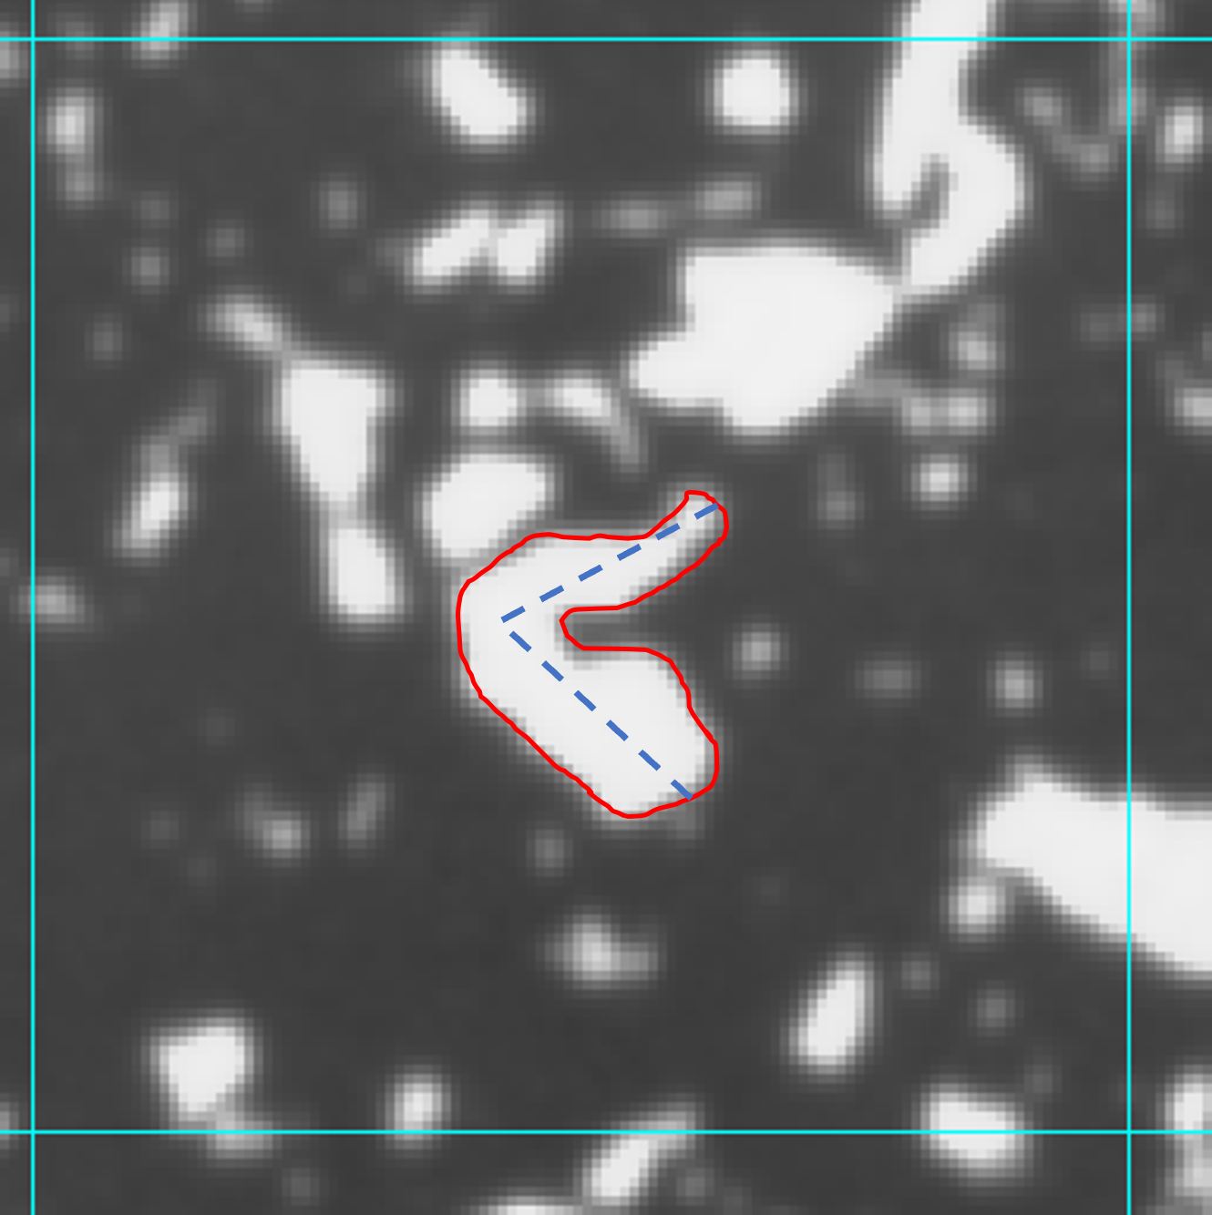
 | Hoop | A closed crook which appears as a ring with a hole through the centre. | 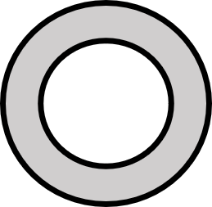 | 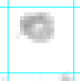
Bilobate | Bolas | Two rounded lobes some distance apart with a visible thin connection between them ($AR >2$). | 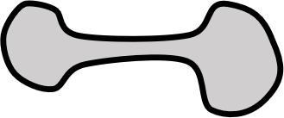 | 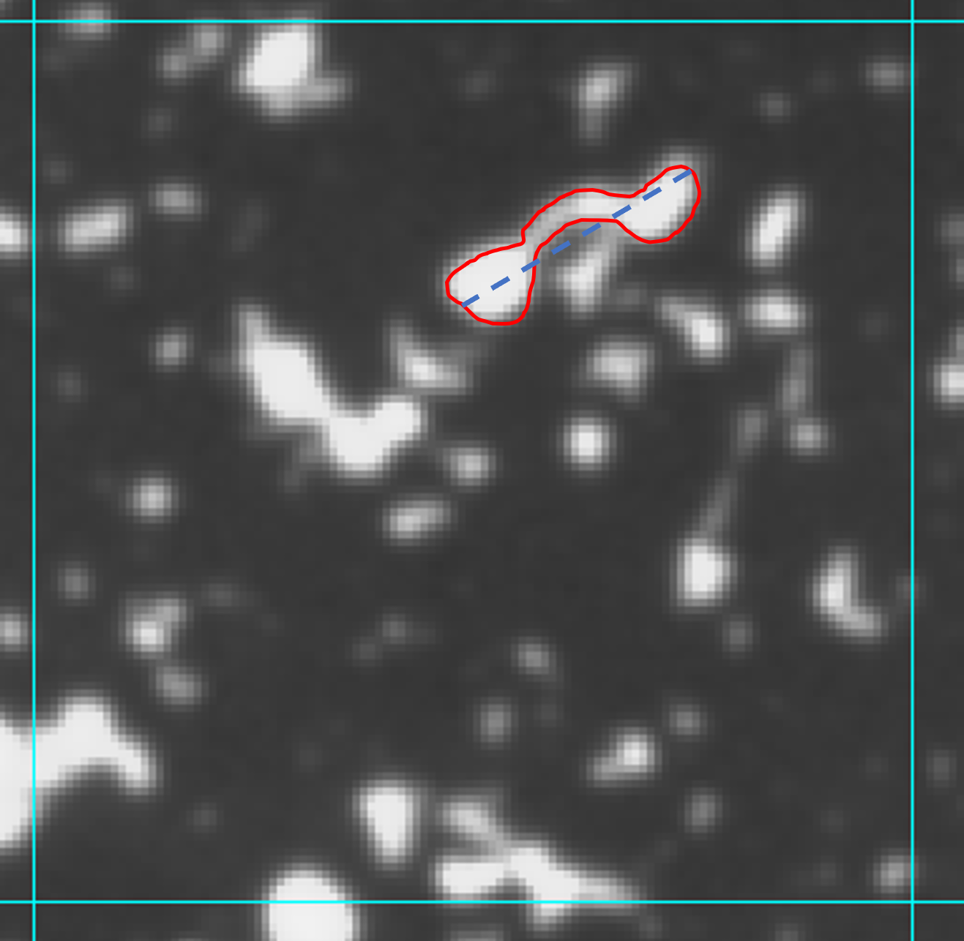
 | Snowman | Two rounded lobes directly adjacent to one another (generally, $AR >2$). | 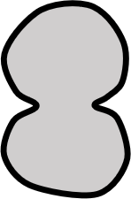 | 