Supplementary materials
Field verification of low-level biochar applications as effective ameliorants to mitigate cadmium accumulation into Brassica campestris L from polluted farmland soil
Youchi Zhangª, Jiajun Fanª, Shanna Linª, Brian J. Reid^{a.b}, Frédéric Coulon^{c}, Chao Cai^{a*}
ª Key Lab of Urban Environment and Health, Institute of Urban Environment, Chinese Academy of Sciences, Xiamen, 361021, China
^{b} School of Environmental Sciences, University of East Anglia, Norwich, NR4 7TJ, UK
^{c} School of Water, Energy and Environment, Cranfield University, Cranfield MK43 0AL, UK
* Corresponding author
Address: Key Lab of Urban Environment and Health, Institute of Urban Environment, Chinese Academy of Sciences, 1799 Jimei Road, Jimei District, Xiamen, 361021, Fujian, China
E-mail: ccai@iue.ac.cn

S1 Set-up of Cd adsorption experiment
The characterization of Cd adsorption capacity of three biochars was conducted in the laboratory. In brief, the biochar was mixed with Cd(NO₃)₂ solution at the ratio of 50 mg : 5 mL, and shaken at 25 °C at 150 rpm for 48 hours. Thereafter the suspensions were passed through 0.22 µm filters, and the concentrations of Cd²⁺ ion measured by the ICP-OES. The initial concentrations of Cd²⁺ were 0 mg/L, 25 mg/L, 50 mg/L, 100 mg/L, 150 mg/L, 200 mg/L, and 250 mg/L, respectively, and the initial solution pH were set to 5.0±0.2. In some treatments, the initial solution pH was set to 3.0±0.2 or 4.0±0.2. Metal adsorption onto biochars was fitted using Langmiur and Freundlich isotherm.

Table S1 Fitted isotherms for Cd²⁺ adsorption onto three biochars
 | Langmuir isotherm |  |  | Freundlich isotherm
 | Q⁰  (mg/g) | b | R² | K_{f}  (mg/g) | 1/n | R²
PM biochar | 33.3 | 0.02 | 0.86 | 2.74 | 0.43 | 0.94
RS biochar | 43.5 | 0.14 | 0.95 | 8.55 | 0.34 | 0.93
RH biochar | 24.4 | 0.007 | 0.90 | 0.37 | 0.68 | 0.93

Table S2 Relationship among concentrations of soil available Cd and Cd accumulation in plants
Amendment | Relationship
PM biochar | C_{edible}=21.9× C_{soil}+268 (R²=0.995, p<0.05)
 | C_{root}=17.0× C_{soil}+380 (R²=0.985, p=0.077)
 | C_{edible}=1.26× C_{root}-202 (R²=0.964, p=0.121)
RS biochar | C_{edible}=32.3× C_{soil}+40.9 (R²=0.978, p=0.096)
 | C_{root}=33.7× C_{soil}+18.0 (R²=0.995, p<0.05)
 | C_{edible}=0.97× C_{root}+20.5 (R²=0.992, p=0.059)
RH biochar | C_{edible}=19.8× C_{soil}+313 (R²=0.972, p=0.106)
 | C_{root}=44.2× C_{soil}-203 (R²=0.692, p=0.375)
 | C_{edible}=0.28× C_{root}+514 (R²=0.530, p=0.481)

Fig. S1 The SEM image of three biochars. Top left, PM biochar; Top right, RS biochar; Bottom left, RH biochar.
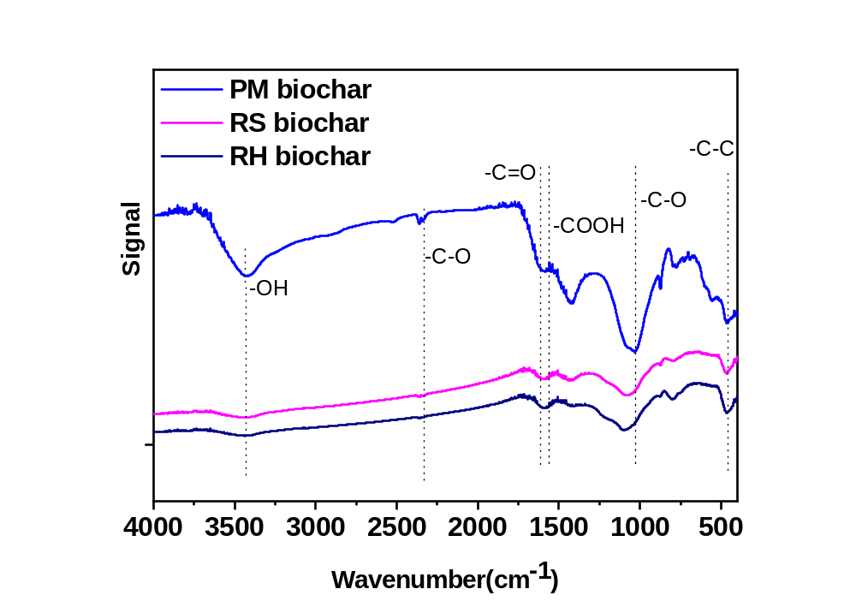
Fig. S2 Infrared spectra of PM, RS and RH biochars.
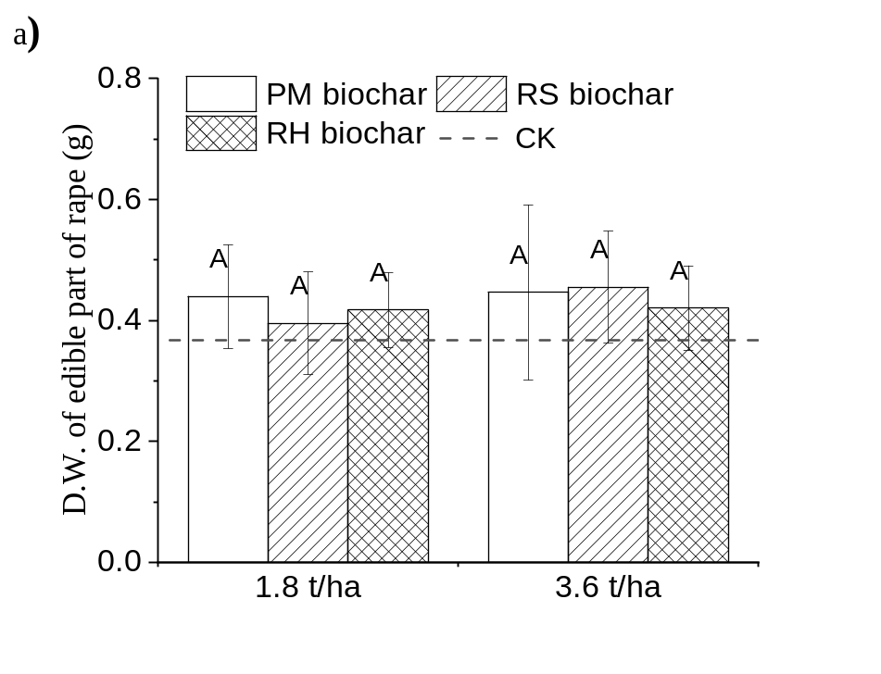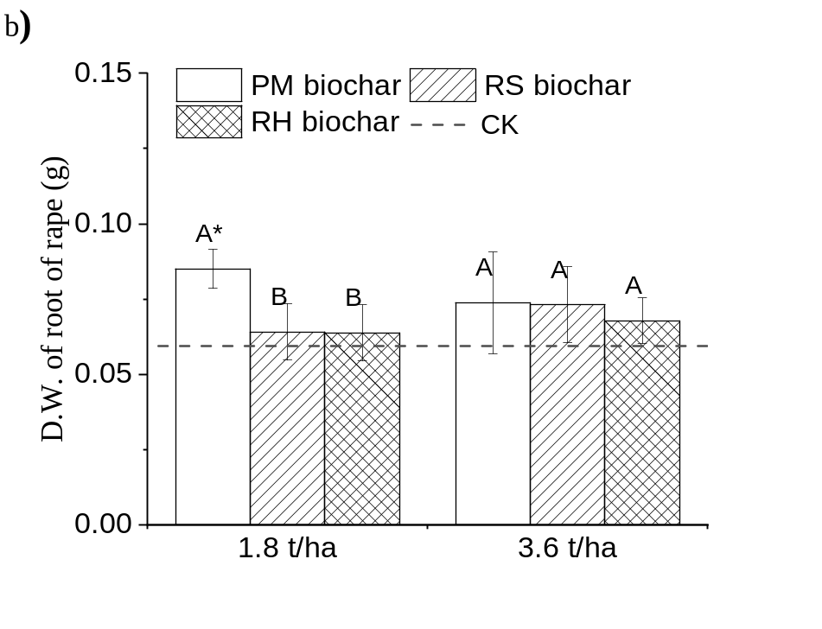
Fig. S3 Dry weight of rape plants grown in soil and soil amended with biochars. “*” indicates a value to be significantly different to the control (CK) value (p < 0.05). Like uppercase letters indicate no significant difference (p > 0.05) between groups with biochar amendment at like application rates.

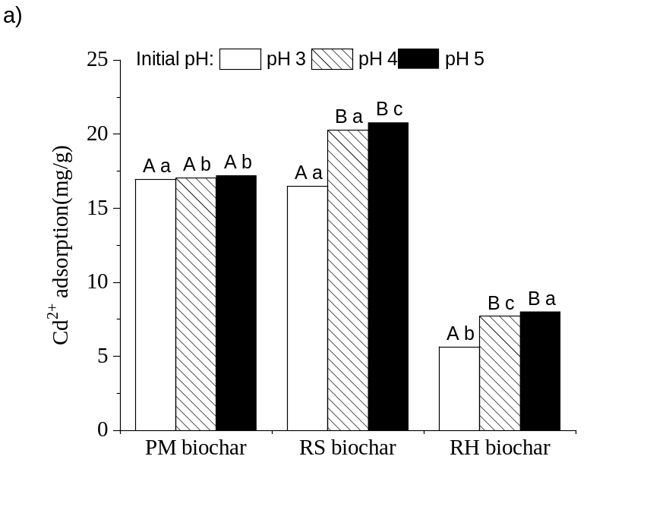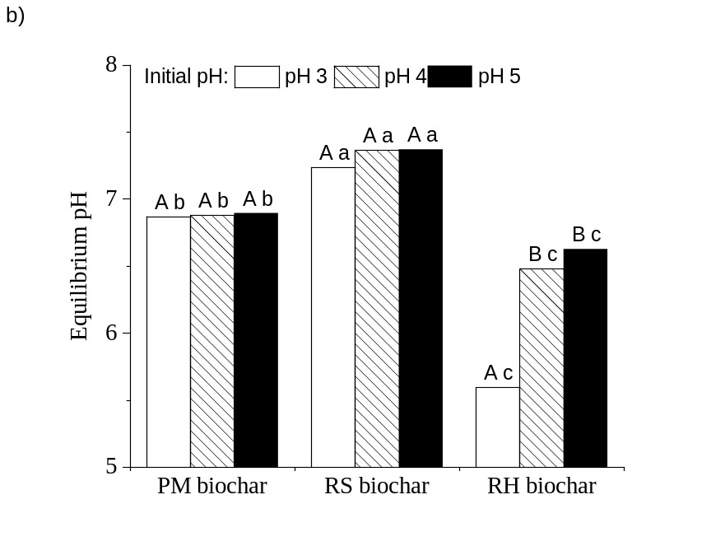
Fig. S4 Final pH of batch equilibrium experiments where initial pH was 3, 4 and 5. Uppercase letters indicated significantly (p < 0.05) different final pH for a given biochar where initial pH was different; lowercase letters indicate significantly (p < 0.05) different final pH between biochars where the initial pH was the same.
References
Liu Y, He Z, Uchimiya M (2015) Comparison of biochar formation from various agricultural by-products using FTIR spectroscopy. Modern Appl Sci 9(4): 246.
Singh B, Fang Y, Johnston CT (2016) A fourier-transform infrared study of biochar aging in soils. Soil Sci Soc Am J 80(3): 613.
Zolfi Bavariani M, Ronaghi A, Ghasemi R (2019) Influence of pyrolysis temperatures on FTIR analysis, nutrient bioavailability, and agricultural use of poultry manure biochars. Commun. Soil Sci Plan 50(4): 402-411.

